# Coding terminology – Public perception data

## Categories for habitat choice

“Coral reef” = coral reef, bommies, coral bed, coral bommie, fringing reef, reef, reef drop off, reef flat, reef itself, fringing reef, colours of corals, john brewer reef, reef wall, outer reef

“Mangroves” = mangrove forests

“Seagrass” = grass, grass beds, seagrass beds, seagrass meadows

“Protected area” = green zone, marine parks, restricted, no-go fishing zone, preservation area, open fishing area

”NA” = driving responsibly, snorkeling, land, boating, fishing, General, Trees, Birds, Glass bottom boat tours, Rainforest, Scuba diving, sky

“non-biological habitats” = coastal reef, island, lagoon, rocks, sand cay, sand flats, sandy lagoon, withsunday islands, abbot point, beach, benthic/sand/ocean floor, Deep Inter-Reefal, island-cay, , sandy substrate, (all sand related words), sediment shelf, substratum, wrek, great keppel island, inshire, rivers, rock bottom, rubble, shoalie ground, tropical island, blue-holes

Lagoon = sandy lagoon

“Other marine organisms” = fish, nudie branches, trout, turtles, coral fish, coral trout, fish life, fish types, invertebrates, marine life, pelagic species, reef fish, sea animals, anemone, endangered species, pelagic, seafloor sediments, sharks, shells, tusk fish

“Ocean” = marine, open-water, water, , open ocean

“Estuaries”

Macroalgae = kelp field, macroalgae beds, seaweed forest, algae, kelp

## Word cloud notes

Word to include: coral, reef, bommie, fish, mangroves, ocean, sand, island, estuaries, kelp, lagoon, marine, water, seagrass

## Categories for threats to corals

Boat damage (recreational)

Boat damage (commercial) = shipping,

Bleaching

Mining = coal, coal transport, oil,

Extreme events = storm damage, natural disasters

Farming = farming sugar cane

Climate change = global warming, heat, ocean acidification, rise in sea level, rising sst, sea temperature rising, temperature, global heat, hearted ocean, more frequent stroms

Direct damage =, human destroy reef, humans, people, man, physical damage, recreational activities, tourism

trawling

Pollution = chemichals, human trash, litter, plastic, fuel

Commercial fishing = commercial fishing, overfishing, over commercial fishing,

COTs = crown of thornes, stafish

Habitat loss = habitat fragmentation, species extinction

Others = media, foreign soils, greed, not enough support, political ignorance

runoff

## Word for clouds

Corals: bleaching, boats, coal, climate change, commercial fishing, cyclones, farming, habitat loss, human, global warming, sea level rise, acidification,

## Categories for threats to seagrass

Habitat / biodiviesrity loss = animal dieng, habitat damage, threats to marine species, fragmentation, destruction, degradation, species extinction

Boat damage = shipping, propellers

Trawling = bottom trawling, fishing nets damaging the bottoms

Climate change = change in water temperature, ocean acidification, sea level rise, global heat

Pollution = chemichals, human trash, litter, nutrient, eutrophication, waste, fertilizer,

Direct damage = clearing for antrhtopogenic structures, humans, people, walking on, disturbance, recreational activities, tourism

Runoff = coastal runoff, sediment, siltation, pesticides

Others = corrosion, media, dugongs, erosion, lack of public perception, dugongs, ignorant politicians, Removal of our natural filters

Extreme weather events = Cyclones, floods, weather events, natural disaster, storms

Dredging

Coastal development = Urban development, tourism development, human land-based impact

farming

## Seagrass image

Image 1 = very_poor

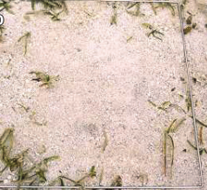

Image 2 = very_good

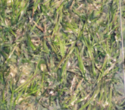

Image 3 = good

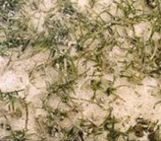

Image 4 = poor

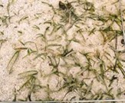

## Coral Image

Image 1 = very_good

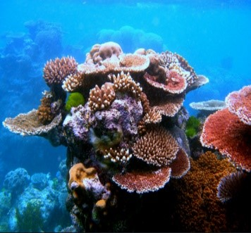

Image 2 = good

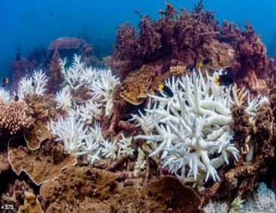

Image 3 = poor

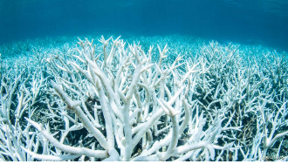

Image 4 = very poor

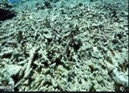

## Benefits

Availability of locally sourced seafood - Importance of the benefit to you = **seafood_ben**

Enjoying recreational fishing - Importance of the benefit to you = **recr_fish_ben**

Presence of a wide variety of marine plants and animals - Importance of the benefit to you = **biodiversity_ben**

Enjoying clear coastal water - Importance of the benefit to you = **water_ben**

Presence of extensive beaches - Importance of the benefit to you = **beach_ben**

Climate change mitigation - Importance of the benefit to you = **cc_ben**

Provision of cultural heritage - Importance of the benefit to you = **her_ben**

Protection of coastal areas from erosion, storm surge and strong waves - Importance of the benefit to you = **coast_ben**

Presence of iconic marine species (e.g. dugongs, marine turtles) - Importance of the benefit to you = **iconic_ben**

Opportunity for scientific research - Importance of the benefit to you = **sci_ben**

Opportunity for environmental education - Importance of the benefit to you = **edu_ben**

**Relation with coral (same as above_cor)**

**Relation with seagrass (same as above _sea)**

## Willingness to pay

Willingenss to pay for coral (yes or no) **= wtp_cor**

Willingenss to pay for seagrass (yes or no) **= wtp_sea**

*Copy and paste all values from raw data and then calculate min and max for each individual respondent.*

Qualitative responses pasted on a different excel spreadsheet (Qualitative_responses)

## Threats

Climate change belief = **cc_bel**

Threats to coral reef = **threat_cor1, threat_cor2, threat_cor3**

Threats to seagrass = **threat_sea1, threat_sea2, threat_sea3**

Climate change is a threat to coral = **cc_cor**

Climate change is a threat to seagrass = **cc_sea**

*Responses*

Climate change is an immediate threat to the coral reef habitat = **immediate**

Climate change impacts on the coral reef habitat are a far away in time and not for immediate concern = **far_away**

Climate change is not a threat to the coral reef habitat = **no_threat**

I do not have an opinion on climate change impacts on the coral reef habitat = **no_opinion**

**NB = if other was selected, the comment has been inserted within the response grid (see red corners)**

How much do you think each human activity negatively impacts the coral reef habitat within the GBR?Rank from 1 (no negative impact) to 5 (high negative impact)

***Human impacts***

Port development = **p_d_cor**

Coastal Urban development = **c_u_d_cor**

Recreational fishing = **r_f_cor**

Tourism = **t_cor**

Dredging = **d_cor**

Commercial fishing = **c_f_cor**

Commercial trawling **= c_t_cor**

Agriculture run-off = **a_r_cor**

Impact of Aquaculture = **i_a_cor**

Urban run-off **= u_r_cor**

***Climate change impacts***

Increase in sea surface temperature = **sst_cor**

Ocean acidification **= o_a_cor**

Increase in severity of tropical cyclones = **cyc_cor**

Reduction in water quality = **w_q_cor**

Crown of thorns = **cots_cor**

**(Same coding for seagrass with the last _sea)**

## Place attachment

The GBR is the best place to perform my favorite activity = **soc_gbr**

I feel that the GBR is part of my identity = **cul_gbr**

*Responses*

Strongly agree = **5**

Agree = **4**

Neither = **3**

Disagree = **2**

Strongly disagree = **1**

## Qualitative data

**reason_cor** = open ended question for the reason of willing or not willing to pay for restoration of corals

**reason_sea** = open ended question for the reason of willing or not willing to pay for restoration of seagrass