101-2 Digital System Design Homework 2
TA Information
周維中，電二 232實驗室
middle@access.ee.ntu.edu.tw

- 8-bit arithmetic logic unit (ALU) (40%)
In problem 1, you are asked to model an 8-bit arithmetic logic unit (ALU). The input and output ports are defined in Figure 1. The functions of ALU are defined in Table 1.
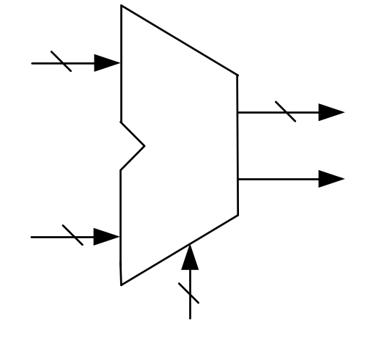
x [7:0]

out [7:0]
ALU
carry
y[7:0]

ctrl[3:0]

Figure 1

Table 1
Control Signal(ctrl) | Description | Function
0000 | Add(signed) | out = x + y
0001 | Sub(signed) | out = x - y
0010 | And | out = and(x, y)
0011 | Or | out = or(x , y)
0100 | Not | out = not(x)
0101 | Xor | out = xor(x , y)
0110 | Nor | out = nor(x , y)
0111 | Shift left logical variable | out = y << x[2:0]
1000 | Shift right logical variable | out = y >> x[2:0]
1001 | Shift right arithmetic | out ={x[7],x[7:1]}
1010 | Rotate left | out = {x[6:0] , x[7]}
1011 | Rotate right | out = {x[0] , x[7:1]}
1100 | Equal | out = (x==y)?1:0
1101 | NOP(No operation) | out = 0
1110 | NOP | out = 0
1111 | NOP | out = 0
- (10%)
Use Verilog to implement the RT-level (use continuous assignment, assign) model of the 8-bit ALU. Modify the “alu_rtl.v” file, which contains the module name and input/output ports. Use the given test bench, “alu_tb.v” to verify you design. To simulate, use the following command
ncverilog alu_tb.v alu_rtl.v +access+r

- (15%)
Use Verilog to implement the behavior–level (use event-driven construct, always block) model of the 8-bit ALU. The input and output ports are the same as previous one. Modify the “alu.v” file, and use the given test bench, “alu_tb.v” to verify you design. To simulate, use the following command

ncverilog alu_tb.v alu.v +access+r

- (15%)
The given test bench “alu_tb.v” doesn’t check the all required functions of the ALU. You need to modify the given test bench and rename the test bench to ”alu_tb2.v”. Use your modified test bench to verify if all functions of your design are correct. Show the waveform results. Describe how you verify the correctness in your report.

- 8x8 Register File (30%)
A register file consists of a set of registers which can be read or written. There are 8 registers in this register file, and the width of the register is 8-bits. The input and output ports are described in Figure 2.
Clk
busW
WEN
8
8
busX
8
busY
3
3
3
RW
RX
RY
8 x 8
Register File

Figure 2

You must follow these specifications:
- I/O Port Functionality
(1)busW: 8 bit input data bus
(2)busX、busY: 8 bit output data buses
(3)WEN: active high write enable (WEN==1)
(4)RW:select one among 8 registers to be written
(5)RX: select one among 8 registers to be read, output on busX
(6)RY: select one among 8 registers to be read, output on busY

- Register File
- 8 registers.
- $r0~$r7
- $r0=zero (constant zero, don’t care any write operation)

- Write Operation
(1)BusX and busY could be an arbitrary 8-bit vector during write operation
(2)The data on busW will be written into a specified register synchronously on positive edge of Clk
(3)RW is the index of register to be written.

- Read Operation
- The register file behaves as a combinational logic block when reading
- Read the data in the register file asynchronously
- (15%)
Implement the 8 8-bit register file in Verilog. Modify “register_file.v”, which contains the module name and input/output ports.

- (15%)
Write the testbench (“register_file_tb.v”) to verify your design. Run a simulation by using the following command:

ncverilog register_file_tb.v register_file.v +access+r

You must consider the following requirement:
- You need to write a test bench and generate random test patterns to verify your register file. Don’t read a test vector from data file
- Test patterns need to toggle every bit in the register bank.
Hint:1111_1111 -> 0000_0000 ->1111_1111
- Your test bench should verify the functionally of the register file automatically.

- Simple Calculator (30%)
Combine the previous two designs into a simple calculator unit. You can use this unit to execute some simple programs. The input and output ports are defined in Figure 3. And there is a control signal “Sel” to select which data is input to ALU.
- When Sel = 0, DataIn is passed to port x of ALU.
- When Sel = 1, the data loaded to port x of ALU is from register file.

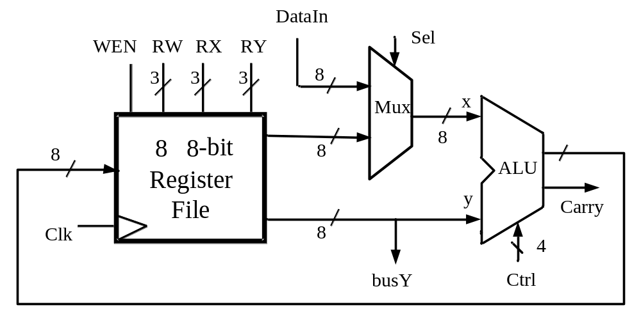
Figure 3

You must define the following ports in your design:
- Input Port
- Clk
- WEN
- RW
- RX
- RY
- DataIn
- Sel
- Ctrl
- Output Port
(1)busY
(2)Carry

- (5%)
Use the previous two modules to implement the simple calculator unit (“simple_calculator.v”). Use the always block to describe the multiplexer.

- (15%)
Write a testbench (“simple_calculator _tb.v”) to verify your design. You may use arbitrary test vector to verify the functionality of the simple calculator. Explain how you verify the simple calculator in your report.

- (10%)
Write a program for the simple calculator. Modify the testbench in 3-(2) to feed these meaningful test vectors (program of a calculator) into simple calculator and verify the result from busY automatically (if you just observe the correctness from waveform, you won’t get full 10 points in 3-(3) ). Use $display to show the whether the execution result is correct. Please explain your verification approach in details.
(Example of program: multiplication or division)

Submission requirement:
- All the files need to be compressed as a single ZIP or RAR file. Send this file to TA via FTP:
Address : 140.112.20.128 Port : 1232
Account : DSD_STUDENT Password : DSD2013

Example of filename
DSD_HW2_b00943135.zip
DSD_HW2_b00943135_v2.zip

Your submitted file should include the following files:
DSD_HW2_b00943135/
1-ALU/ 1_RTL/ alu_rtl.v
1-ALU/ 2_Behavior/ alu.v
2-RegisterFile/ register_file.v
3-SimpleCalculator/ simple_calculator.v
Report_ HW2_b00943135.pdf

- The homework will be graded ONLY IF the filename of your submission are correct!

