TFW-HW1

R04943133 林岳徵

(ii)Code:

function y =recSTFT(x,t,f,B)%r04943133 implement by fft based

t_l = length(t);

f_l = length(f);

dt = (max(t) - min(t)) / (t_l - 1);

df = (max(f) - min(f)) / (f_l - 1);

n0 = min(t)/dt;

n1 = max(t)/dt;

n = n0:1:n1;

m0 = min(f)/df;

m1 = max(f)/df;

m = m0:1:m1;

N = 1/(dt*df);

Q = round(B/dt);

Q1 = B/dt;

x_tmp = [ zeros(1,Q),x,zeros(1,Q)];

n_var = n(1);

q = 0:1:2*Q;

m_tmp = round(mod(m,N))+1;

X_1 = zeros(t_l,N+1);

X_2 = zeros(t_l,f_l);

y = zeros(t_l,f_l);

tmp=1-n0;

k=[1:1:2*Q+1];

for i = n0:1:n1

j = i + tmp;

x_1(j,k) = x_tmp(i + k - (t(1) / dt));

X_1(j,:) = fft(x_1(i + tmp,:),N + 1);

X_2(j,:) = X_1(i + tmp,m_tmp);

end

X_2 = X_2';

s = m'*(Q-n);

y = 0.02*exp(j*2*pi*s).*X_2;

(iii) 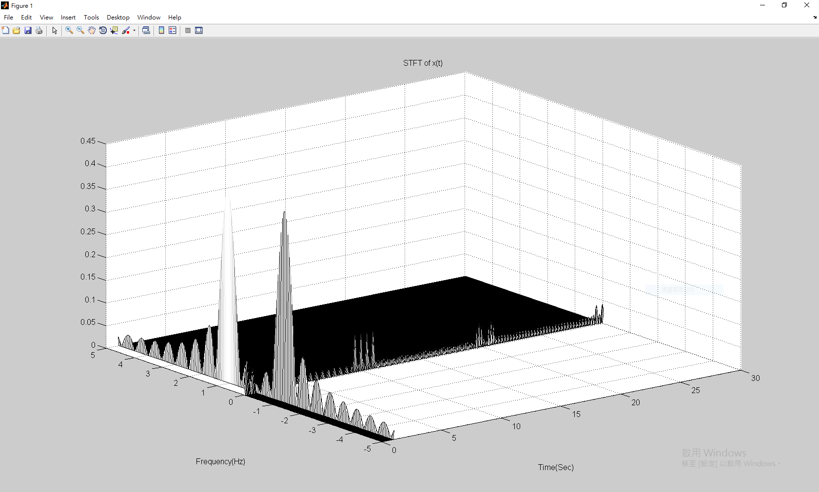

(iv)

Running time:

0.177124 sec.