TFW-HW5

R04943133 林岳徵

**[main.m]****=====================================================**

clc

clear all

close all

x=imread('lena.bmp');

figure;

imshow(x);

title('Lena','Fontsize',12);

x=double(x);

y=wavelet8D_iwavelet8D(x);

y=uint8(y);

imwrite(y,'Lena_recon.bmp','BMP');

x_recon=imread('Lena_recon.bmp');

figure;

imshow(x_recon);

title('Lena recon','Fontsize',12);

**[wavelet8D_iwavelet8D.m]========================================**

function y=wavelet8D_iwavelet8D(x)

g=[-0.0106 0.0329 0.0308 -0.1870 -0.0280 0.6309 0.7148 0.2304];

h=[ 0.2304 -0.7148 0.6309 0.0280 -0.1870 -0.0308 0.0329 0.0106];

g1=[0.2304 0.7148 0.6309 -0.0280 -0.1870 0.0308 0.0329 -0.0106];

h1=[0.0106 0.0329 -0.0308 -0.1870 0.0280 0.6309 -0.7148 0.2304];

%wavelet8D===================================================

%first compression

for m=1:size(x,1)

x_along_n = x(m,1:2:size(x,2));

v_1L(m,:) = conv(x_along_n,g);

v_1H(m,:) = conv(x_along_n,h);

end

%second compression

for n=1:size(v_1L,2)

x_along_m1 = v_1L(1:2:size(v_1L,1),n);

x_1L(:,n) = conv(x_along_m1,g);

x_H1(:,n) = conv(x_along_m1,h);

end

for n=1:size(v_1H,2)

x_along_m2 = v_1H(1:2:size(v_1H,1),n);

x_H2(:,n) = conv(x_along_m2,g);

x_H3(:,n) = conv(x_along_m2,h);

end

%show Lena wavelet photo

y_wavelet=[x_1L(:,:),x_H1(:,:);x_H2(:,:),x_H3(:,:)];

y_wavelet=uint8(y_wavelet);

imwrite(y_wavelet,'Lena_wavelet.bmp','BMP');

x_wavelet=imread('Lena_wavelet.bmp');

figure;

imshow(x_wavelet);

title('Lena wavelet','Fontsize',12);

%iwavelet8D==================================================

%first reconstruction

for m=1:2*size(x_1L,1)

for n=1:size(x_1L,2)

if mod(m,2)==1

x_along_m1_r(m,n) = 0;

else

x_along_m1_r(m,n) = x_1L(m/2,n);

end

end

end

for m=1:2*size(x_1L,1)

x_1L_r(m,:) = conv(x_along_m1_r(m,:),g1);

x_H1_r(m,:) = conv(x_along_m1_r(m,:),h1);

end

v_1L_r=x_1L_r+x_H1_r;

for m=1:2*size(x_H2,1)

for n=1:size(x_H2,2)

if mod(m,2)==1

x_along_m2_r(m,n) = 0;

else

x_along_m2_r(m,n) = x_H2(m/2,n);

end

end

end

for m=1:2*size(x_H2,1)

x_H2_r(m,:) = conv(x_along_m2_r(m,:),g1);

x_H3_r(m,:) = conv(x_along_m2_r(m,:),h1);

end

v_1H_r=x_H2_r+x_H3_r;

%second reconstruction

for n=1:2*size(v_1L_r,2)

for m=1:size(v_1L_r,1)

if mod(n,2)==1

x_along_n1_r(m,n) = 0;

else

x_along_n1_r(m,n) = v_1L_r(m,n/2);

end

end

end

for n=1:2*size(v_1L_r,2)

x_r1(:,n) = conv(x_along_n1_r(:,n),g1);

end

for n=1:2*size(v_1H_r,2)

for m=1:size(v_1H_r,1)

if mod(n,2)==1

x_along_n2_r(m,n) = 0;

else

x_along_n2_r(m,n) = v_1H_r(m,n/2);

end

end

end

for n=1:2*size(v_1H_r,2)

x_r2(:,n) = conv(x_along_n2_r(:,n),h1);

end

%remove border parts

y_r=x_r1+x_r2;

for m=1:size(y_r,1)-28

for n=1:size(y_r,2)-28

y(m,n)=y_r(m+14,n+14);

end

end

end

**執行結果**

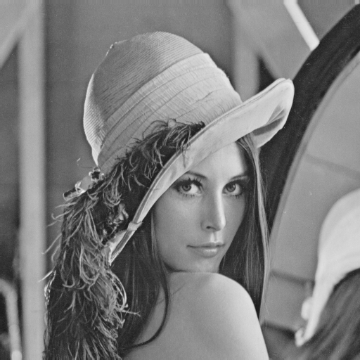

Fig. 1. Lena.bmp

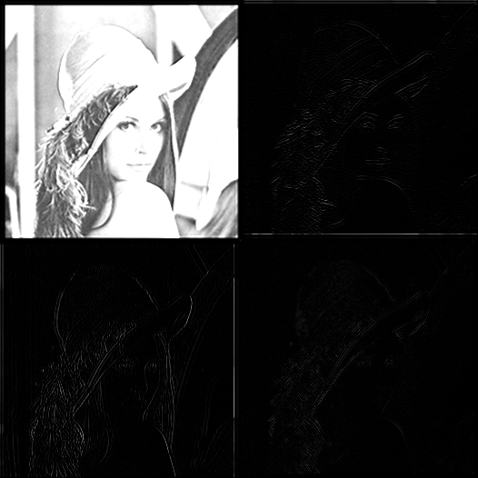

Fig. 2. Lena_wavelet.bmp

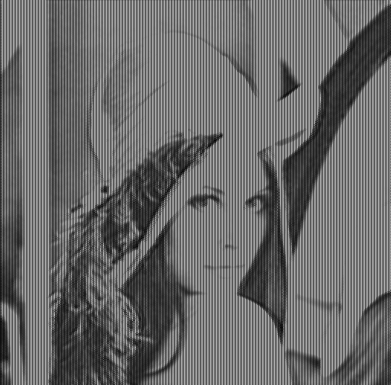

Fig. 3. Lena_recon.bmp