Day2 Assignment

1. Two branches (Feat1 & Feat2) creation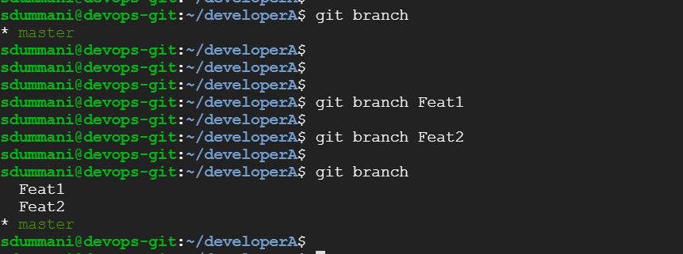
2. Creation of Python file to print some output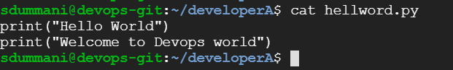
3. Modifying the source code from Feat1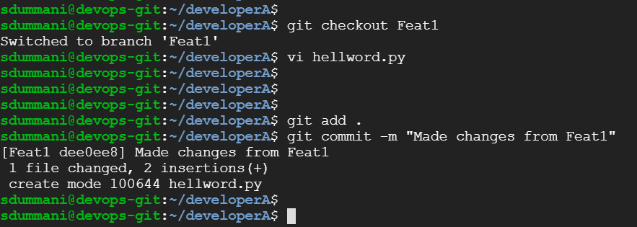
4. Merging the changes done from Feat1 to master branch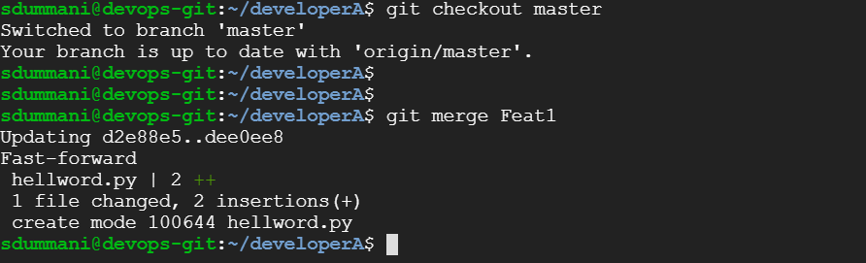
5. Changes to same line of source code from Feat2

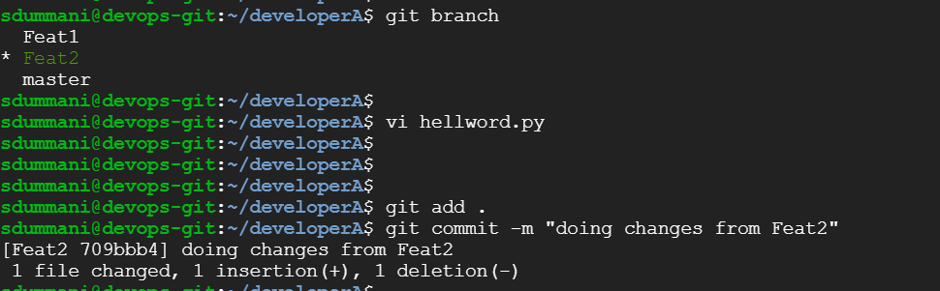

1. Merging to Master from Feat2 (Conflicts)



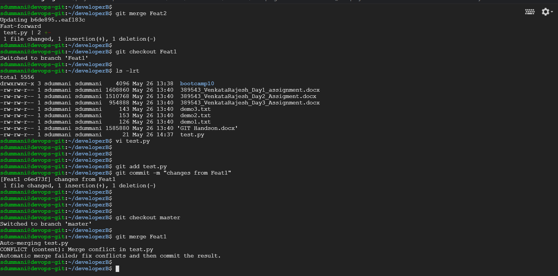

1. Removal of Conflicts using and merge the same and displaying final code 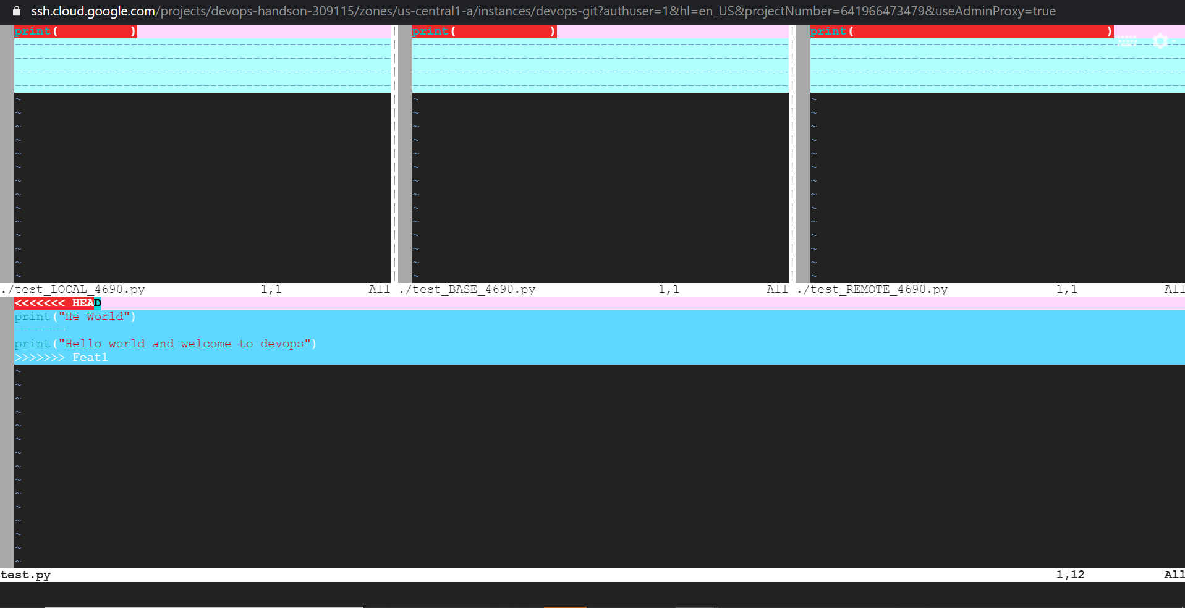

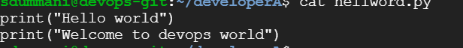

1. Jenkins Code Check out Job

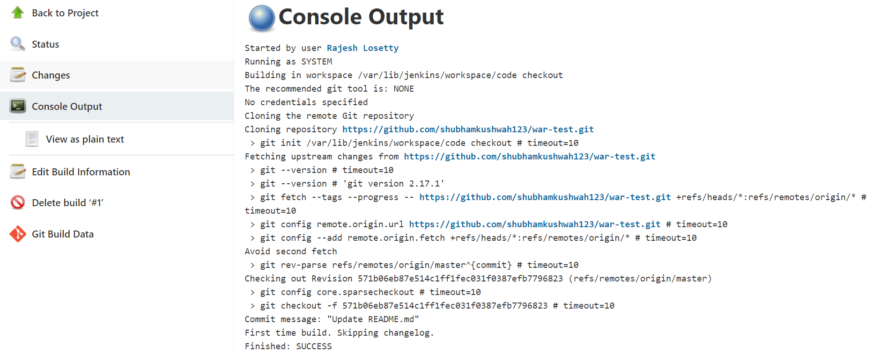

1. Jenkins Build, Test, Package

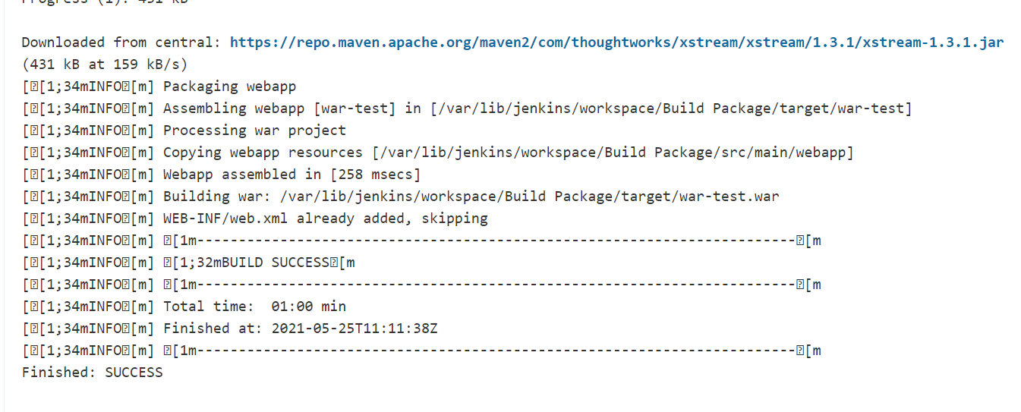

1. Jenkins’s deployment into a Container

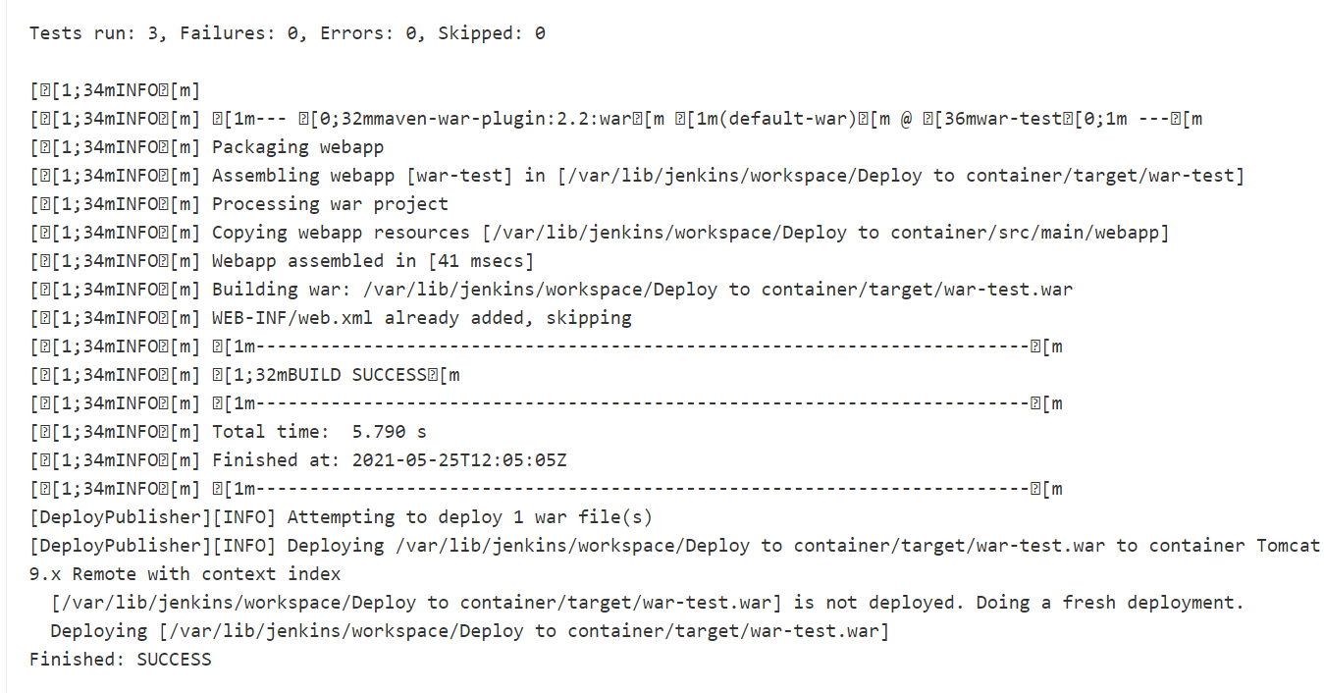

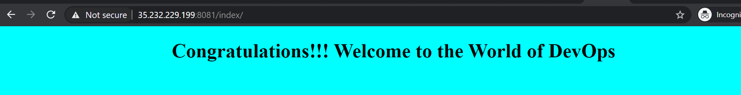

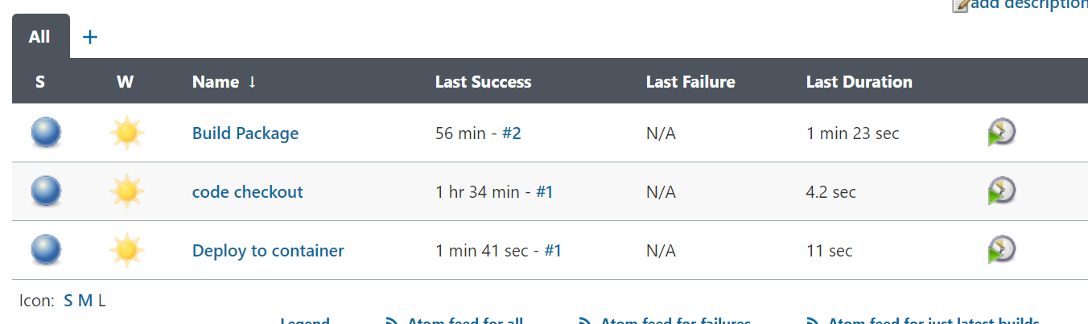

1. Jenkins Pipeline Creation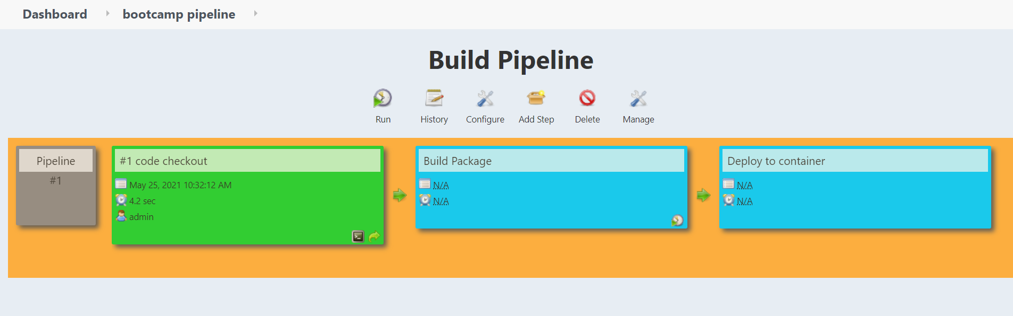
2. Jenkins Pipeline Deployment 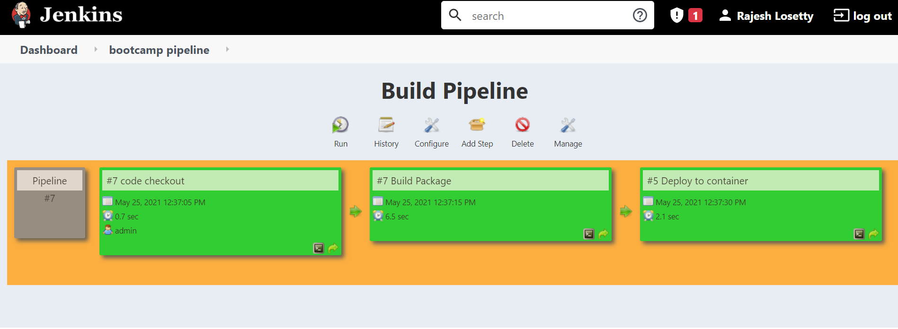
3. Pipeline script

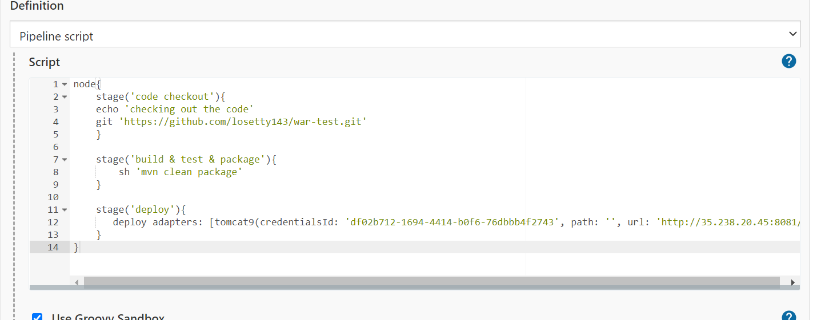

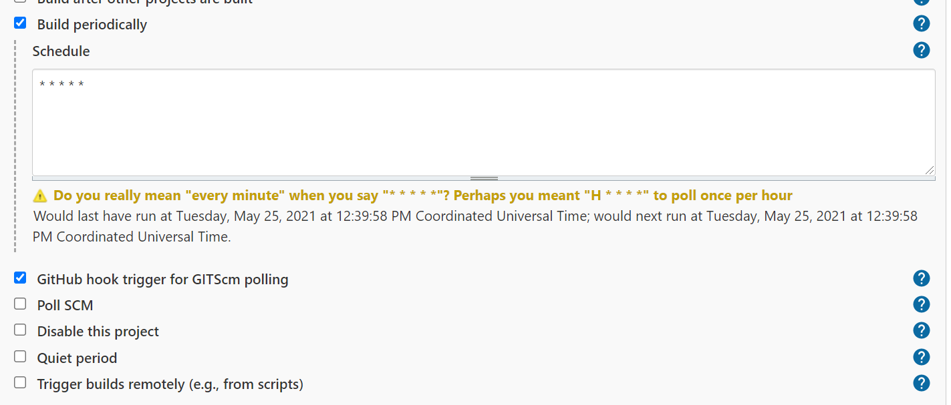

1. Execution of Pipeline script

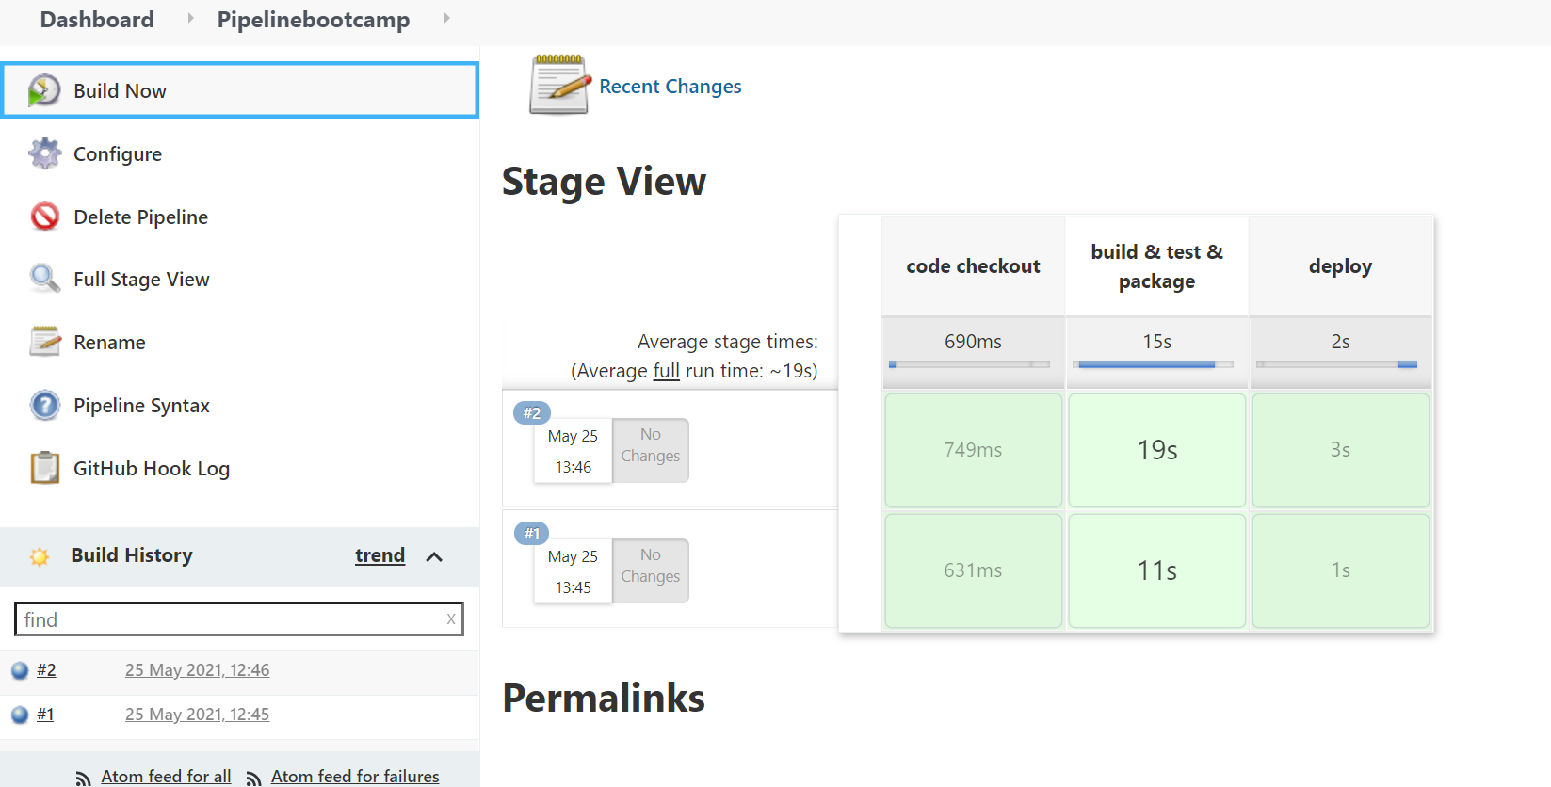

1. Successful Webhook Creation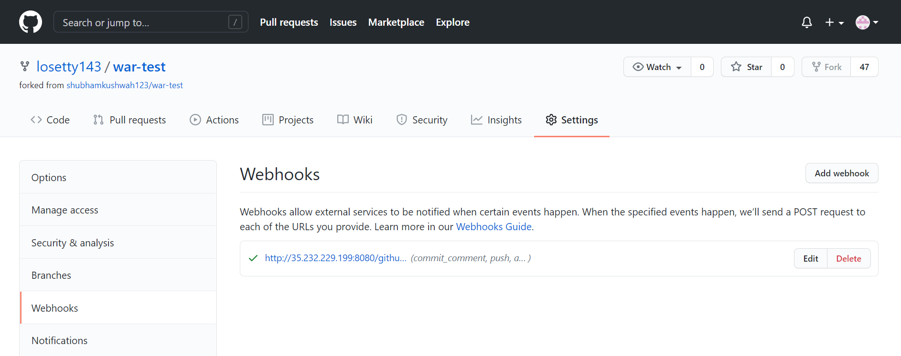
2. As soon commit happening to any of the files in Repo Jenkins Pipeline job running.

