Day3 Assignment

1. Docker installation 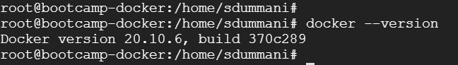
2. Creation of Docker file

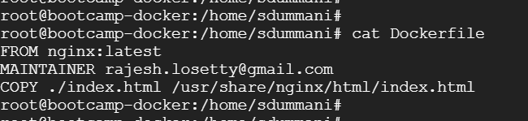

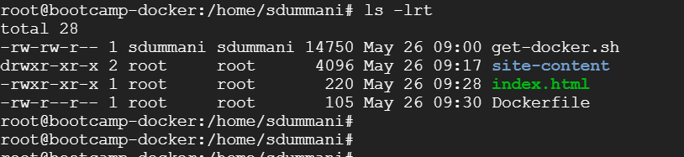

1. Creation of Nginx image 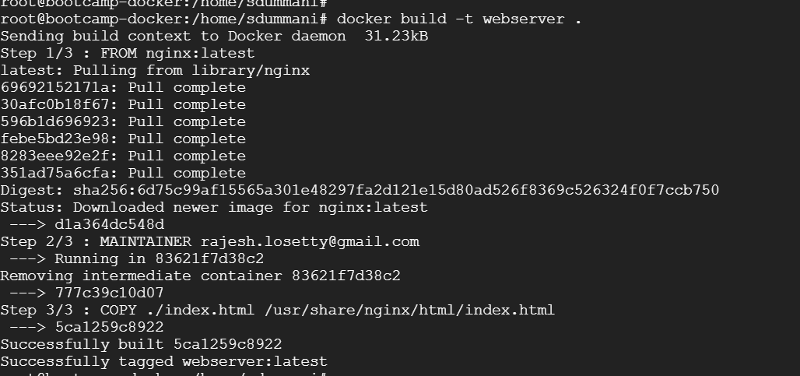
2. Running the image as container in the same machine
3. Access the Ngnix container as webserver from browser

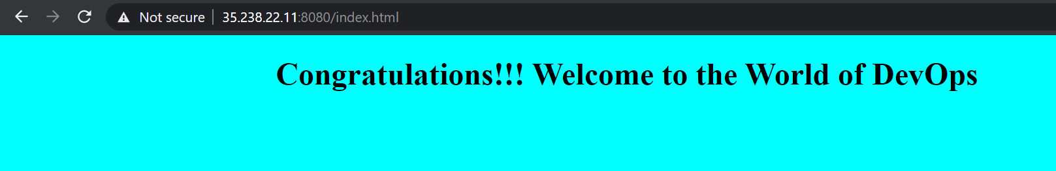

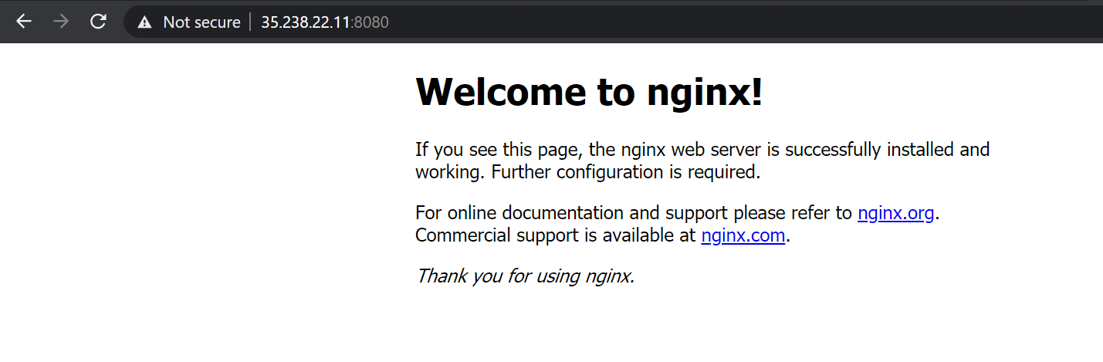

GCP VM to match above server ip :

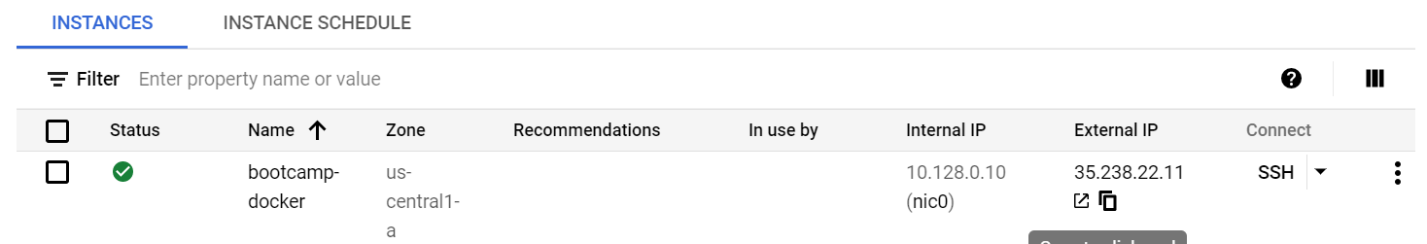

1. Pushing the Webserver image to Docker hub
2. Image list

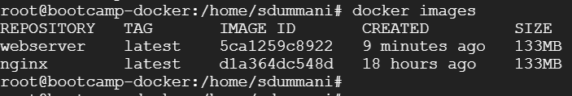

1. Login to Docker Hub before pushing

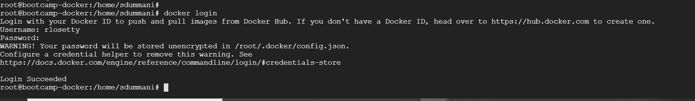

1. Pushing image to Docker hub

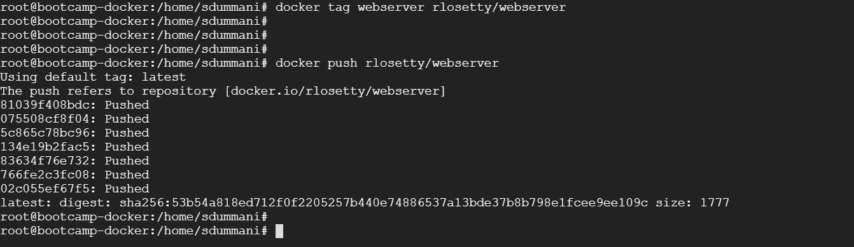

1. Created another VM to pull the image from Docker Hub



1. Login to Docker Hub

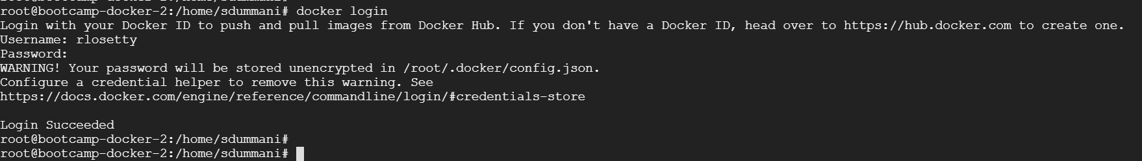

1. Pulling the image from Docker Hub

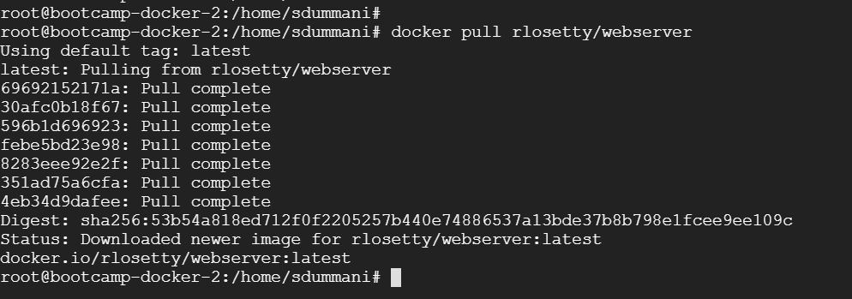

1. Running Pulled image as container
2. List the images
3. Running image as container 
4. Display the running containers



1. Access Index file contents from browser

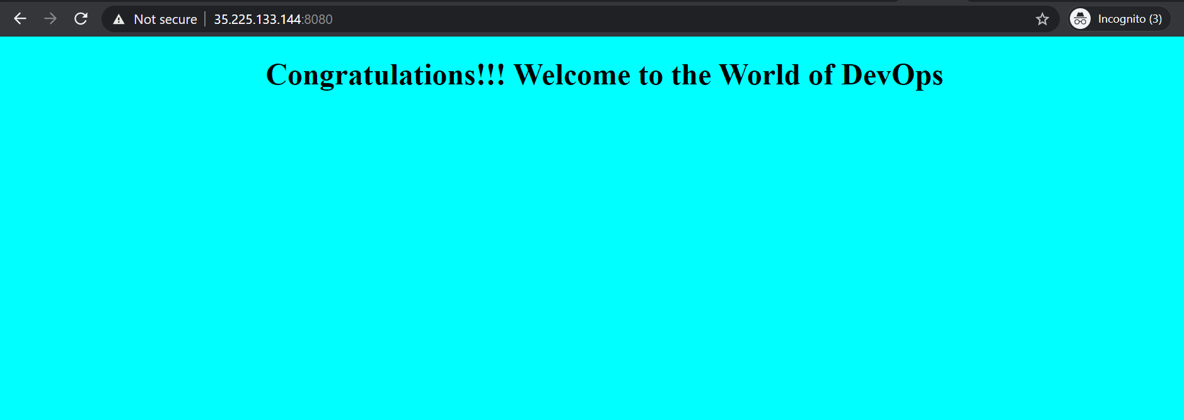

1. Docker compose installation

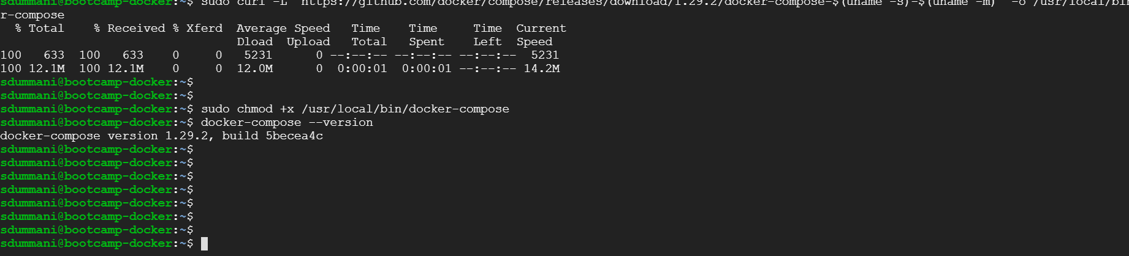

1. Docker compose YAML file creation 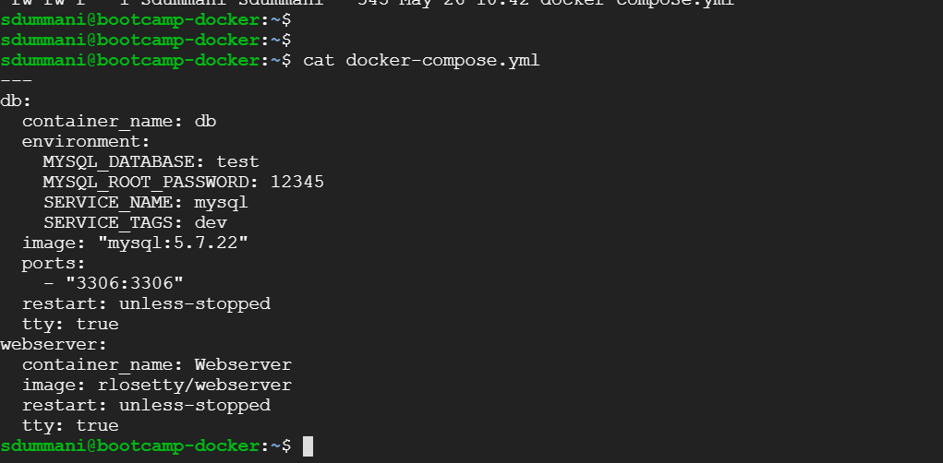
2. Execution of Docker compose file

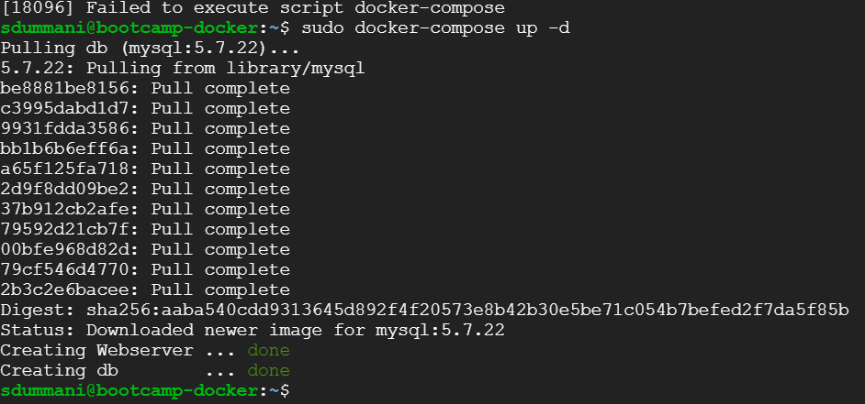

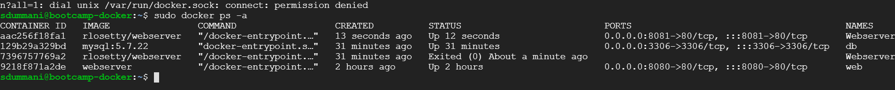

Changed the port of another Nginx web server to 8081 created from compose file to access from browser

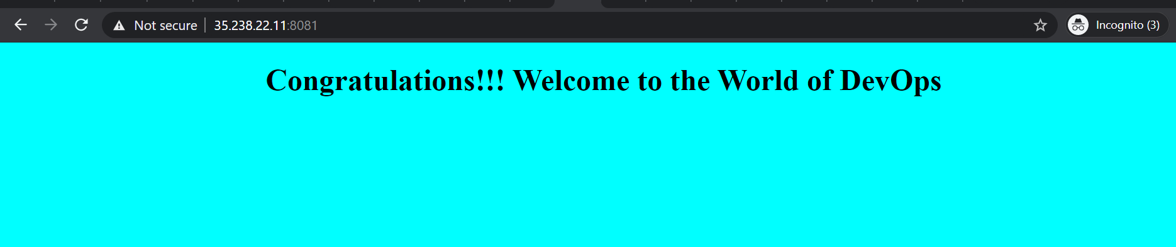

1. Successful connection to MY SQL DB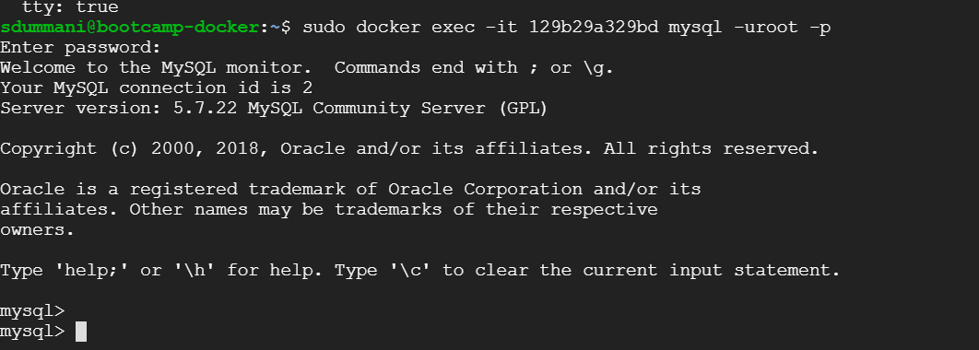
2. Creation of Table with name test
3. List out the data bases

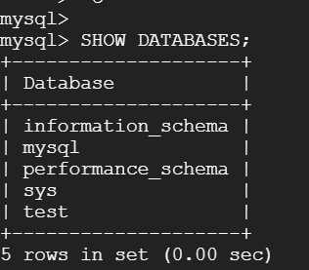

1. Per assignment DB also will be same as Table asked to create, hence dropping the DB

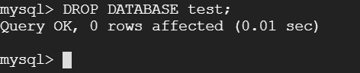

1. Creation of new DB with name bootcamp

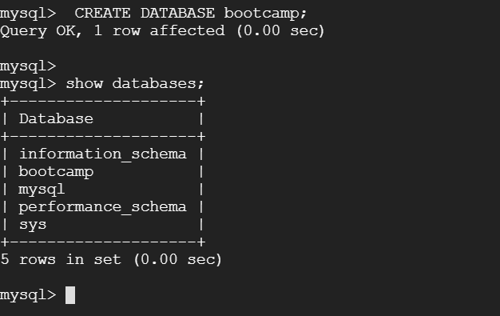

1. Creation of Table with name test

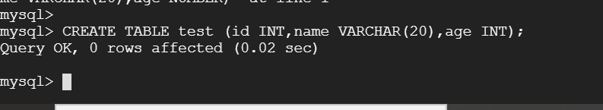

1. Showing tables 