DAY4 assignment

1. Successful Ansible Installation

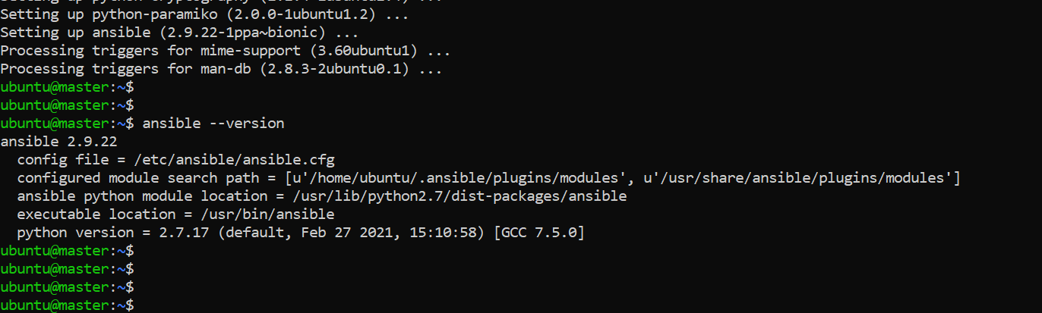

1. Adding Node as a host to mater node and checking the ping to host server

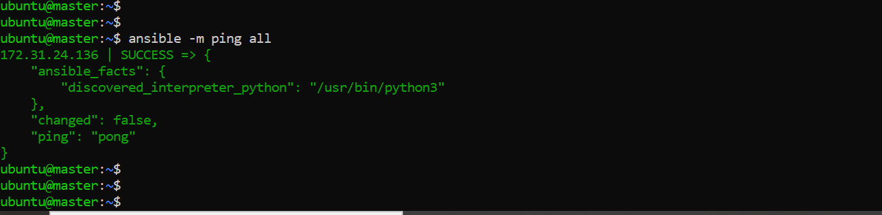

1. Installation of Java, Maven, Docker and Nginx 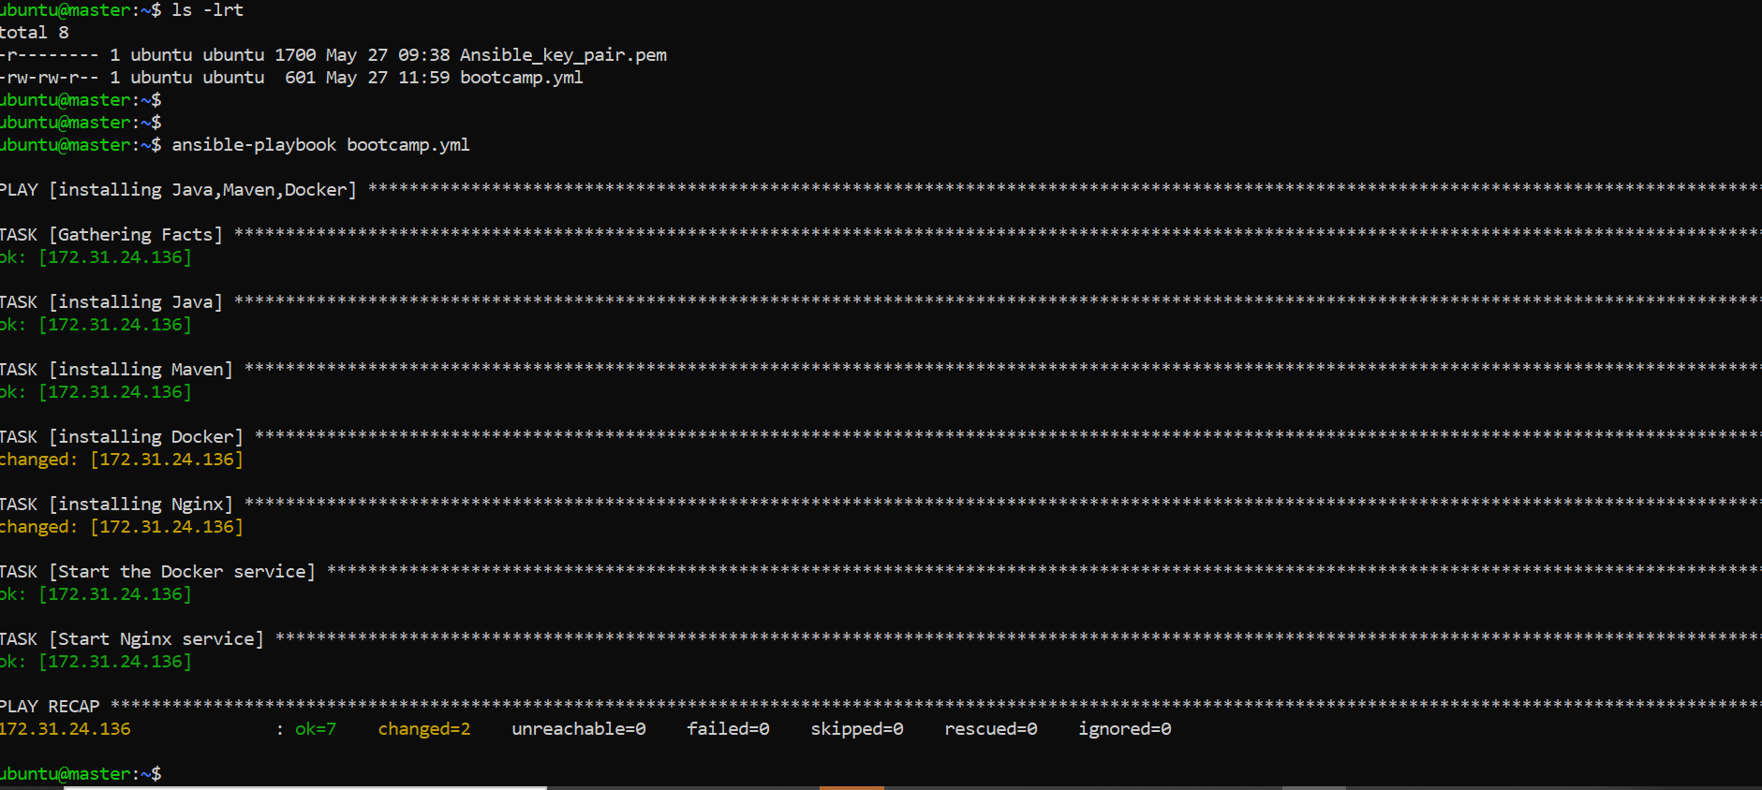

YAML file:

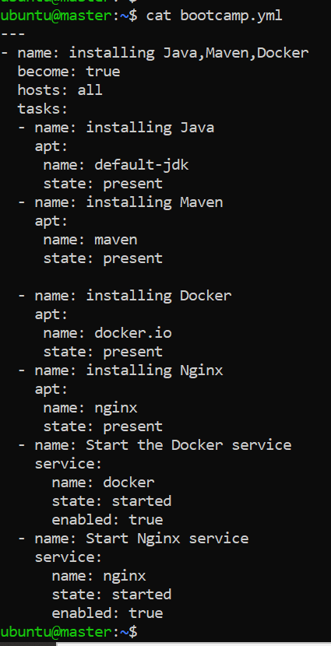

1. Verification of components installed.

Java version:

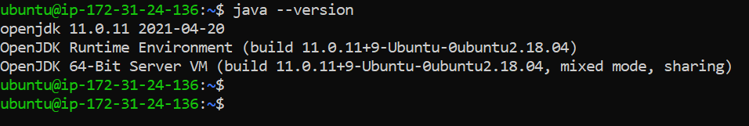

Maven Version:

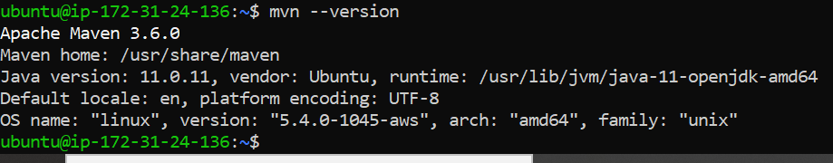

Docker Version:

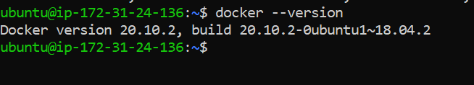

Nginx services:

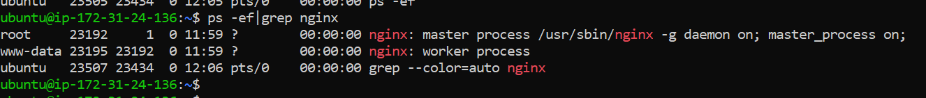

1. Successful connection to Docker Hub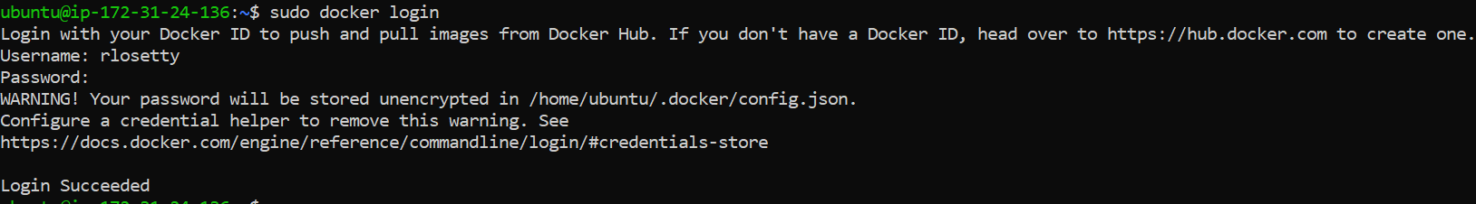
2. Docker file to create image from war file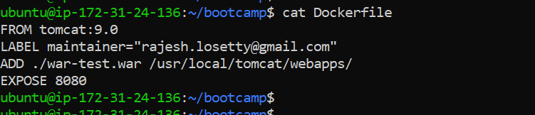
3. Creation of Image to deploy as Container 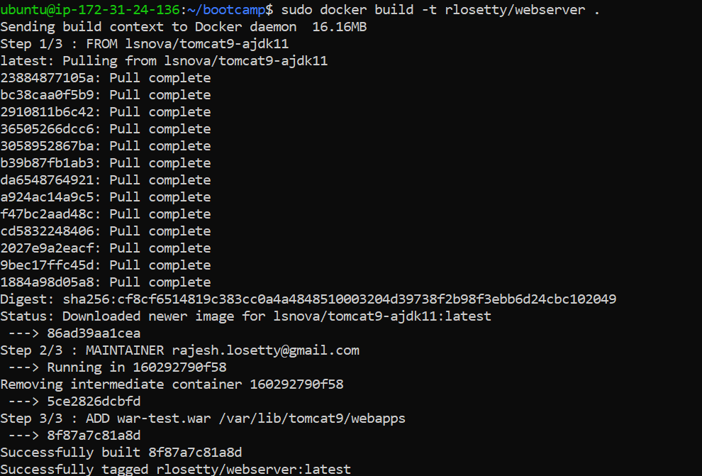
4. Displaying images 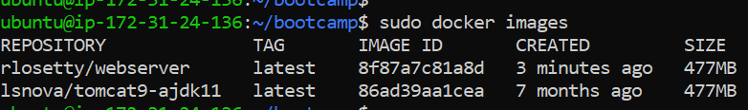
5. Pushing image to Docker hub

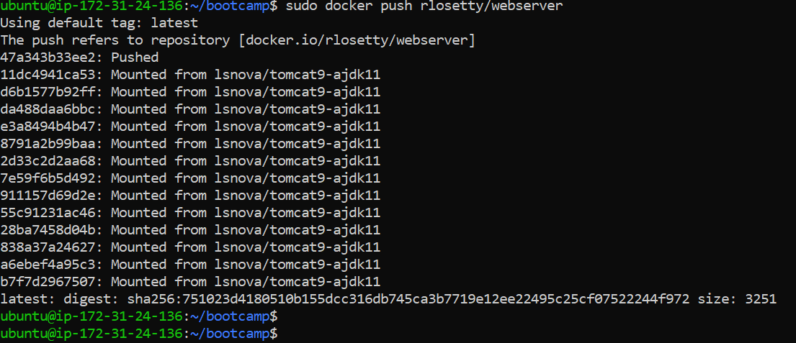

1. Deploying application using Ansible