Infinite Dreams: How to Feed Your Dragon
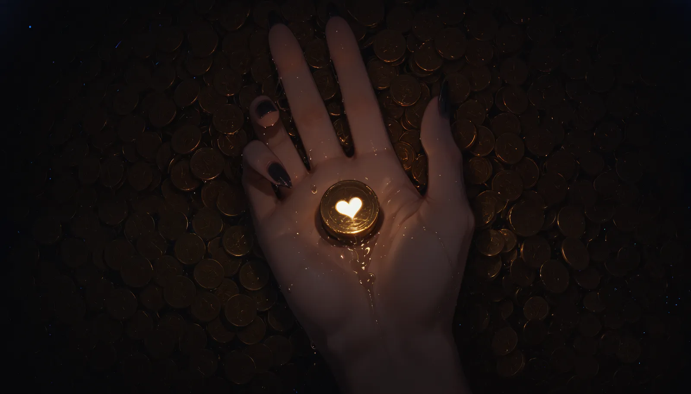
Losfy did not realize at first that she had entered another dream.
The air itself felt strange — unbearably warm, heavy with molten gold and something animal beneath it. Coins shifted softly under her heels as she wandered deeper through an endless treasury lit by crimson dragonfire. Open chests overflowed with jewels. Ancient goblets gleamed from beneath mountains of treasure. Somewhere far above, chains creaked slowly in the dark.
“So this is Aurum’s little nest…” she murmured playfully, lifting a gold coin between two fingers. “Master certainly knows how to reward his favorite pets…”
“Put that back!”
The voice emerged from the darkness so suddenly that Losfy dropped the coin.
Aurum stepped forward soundlessly from behind the treasure mound, pink eyes glowing brighter than the gold surrounding her. There was nothing playful in the way she stared at Losfy now. No teasing. No embarrassment. Only hunger…
“Oh? So this is where you’ve been hiding, darling. Careful with that look… people may start thinking you want to eat me…”
“I do...”
Before Losfy could recover, Aurum grabbed her firmly by the hips and forced her forward into the treasure hoard, pressing herself tightly against Losfy’s back. Coins spilled and rang beneath them while the dragon buried her face against Losfy’s neck, inhaling greedily, desperately, as if her scent itself had become an addiction.
“Mmh… Aurum…” Losfy tried to keep her teasing smile. “…what happened to the proud dragon who could barely stop sniffing my panties the other day?”
A rough tongue slid slowly along her cheek.
The dragon said nothing, only tearing the silk dress from her pale skin piece by piece while her hands wandered lower beneath the sea of gold.
Losfy’s confident smirk faltered for the first time when sharp claws finally reached the place Aurum had clearly been hunting since the moment she arrived.
“There...” Aurum whispered hoarsely “The treasure...”
“A-Aurum… easy now…” Losfy breathed unevenly, trying to regain control. “If you keep behaving like this, I may have to complain to Master himself…”
That finally made Aurum smile.
“Master?” she murmured against Losfy’s ear before licking slowly along her cheek again. “This is only my own dream. And I think he would enjoy watching you melt inside my hoard far too much to save you...”
The coins beneath them shifted louder now. Losfy’s breathing had become embarrassingly uneven, her body trembling helplessly each time Aurum’s claws curled possessively deeper between her trembling thighs.
Losfy tried to answer with another smug remark, but the words dissolved into a sharp inhale as clawed fingers stole the rhythm from her breathing entirely.
“D-Don’t get so proud… remember who usually controls situations like this…”
Aurum silenced her by pressing her tighter against the treasure mound.
"Inside my hoard," she whispered coldly, "there is no alpha but me..."
Then something cold and heavy pressed deeper inside Losfy — her eyes widened instantly.
“Aurum… what is that…?”
“The Solstice Coin...”
“…Don’t…”
“...My favorite coin...”
“N-No… wait — ah…!”
But Aurum only held her closer as the gold beneath them trembled softly. A cold metallic pressure slowly pushed deeper inside her warmth.

“…F-Fine… Ah… You win, I'll tell Losfer to make sure he tries using your coin too… 🖤”
Losfy whimpered between shaking breaths, her body melting helplessly against Aurum’s chest.
“Well, my darling… make sure you polish your precious coin properly before Losfer sees it… I’d hate to embarrass your hoard with poor presentation… 🖤“
Aurum’s glowing eyes narrowed with dangerous amusement.
“...Then allow me to prepare it myself...”
Losfy barely had time to inhale before the dragon sank downward into the mountain of gold itself, disappearing beneath the glittering waves of coins like some greedy creature returning to its den.
The cavern suddenly became terrifyingly quiet.
A single second.
Two.
Losfy’s entire body convulsed.
“AH—!”
The cry tore from her throat loud enough to shake the cavern itself.
“Aurum—! Y-You can’t just — ngh…!”
Another lick silenced her instantly.
Hidden beneath the sea of gold, the dragon devoured her with frightening dedication, savoring every trembling reaction as though tasting the rarest treasure in existence. Sharp claws dug into Losfy’s thighs while warm breath, teeth and tongue reduced her teasing confidence into pure helpless pleasure piece by piece.
The coins around her rattled endlessly now, spilling from the treasure mound each time another violent shiver ran through her body.
“M-Master would never forgive you for breaking one of his servants like this… ah…!”
Aurum only answered with a low satisfied growl somewhere beneath her.
And judging by the desperate sounds echoing through the treasury afterward, Losfy was no longer entirely certain she wanted to be rescued from this dream at all…

Astaria: The Demon to Hunt
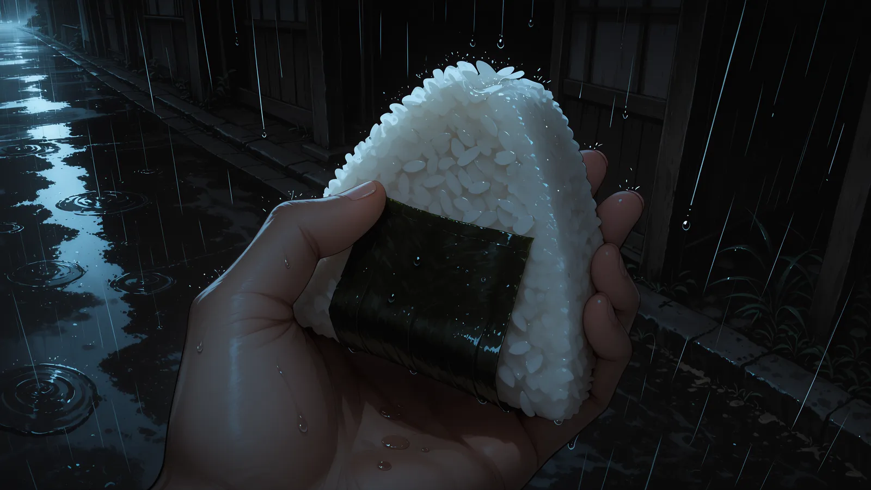
Rain had been falling since before dusk.
It came down without anger, without thunder, without the dignity of a storm. It simply descended, thin and endless, as if the sky had forgotten some ancient grief and was trying, drop by drop, to remember it. The narrow street lay under it like a wounded thing: black mud between the stones, puddles trembling beneath the eaves, paper lanterns swollen with dampness and giving off a tired amber light.
Losfer sat beneath the wooden awning of a closed tea house, one knee raised, one hand resting loosely on the hilt of his sword.
The city around him was unfamiliar, though it belonged to his homeland. Such places always did. The same curved roofs. The same rain-darkened cedar. The same paper screens glowing faintly behind latticed windows. The same little charms hanging from doorways to ward off hungry spirits. And yet every town had a different silence, as every grave had a different name.
Water gathered at the edge of his hood and fell from it in slow drops.
One slid down his cheek.
Or perhaps it had begun beneath the blindfold.
No one could tell.
That was convenient.
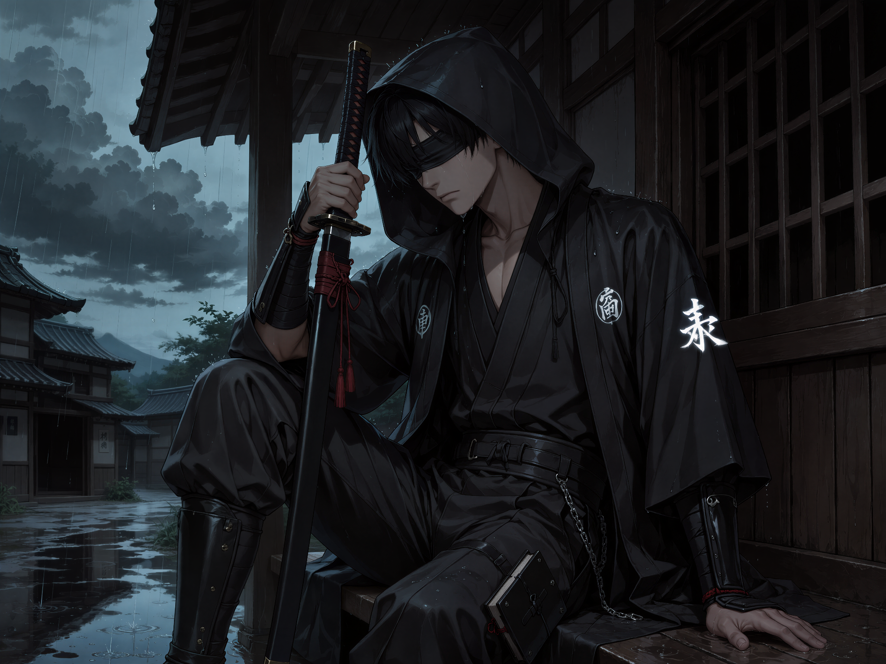
For a long while, even the voice inside his head said nothing.
Then, softly — almost playfully, almost afraid of frightening him — she spoke.
Losfy:
“What is wrong, my sweet? Why are you so sad again? Come on… let us imagine something more interesting instead… mm? Something warm. Something wicked. Something that makes your heart remember it is still alive.”
Losfer’s fingers tightened around the scabbard.
He did not look up.
Losfer:
“That is precisely what I want least right now. Your ‘interesting’ things frighten me.”
For a moment, there was only rain.
Then her voice returned, lower this time, velvet-dark and wounded at the edges.
Losfy:
“But… I do not invent them by myself, darling. I only…”
Losfer:
“I know.”
His answer came too quickly.
A few drops struck the back of his hand. He watched them break against his skin.
Losfer:
“That is what frightens me even more.”
The silence inside him changed shape.
Losfy did not answer at once. He could feel her there — only a voice behind his thoughts. A girl locked behind the wall of his own skull.
A demon with no hands to touch him.
A beloved with no arms to hold him.
Losfy:
“Do you hate me when I bring those things to the surface?”
Losfer breathed out through his nose. It was not a laugh.
Losfer:
“No.”
He swallowed.
Losfer:
“I hate that they are there before you bring them.”
From somewhere down the street came the faint clack of wooden sandals through mud. A shutter closed. A dog barked once, then thought better of it. Above the rooftops, the sky was the color of old iron.
Losfy:
“Then hate the mirror, not the reflection.”
Losfer:
“I am tired of mirrors.”
Losfy:
“I know.”
Her voice softened.
Losfy:
“That is why you blindfolded yourself.”
Losfer lowered his head.
The black cloth around his eyes was soaked through. It clung to him like a second sorrow. To others, it was a sign of his calling: his body was a prison for the demon, and the cloth allowed him to carry out the work entrusted to him by the goddess of souls and not frighten the common folk with those red eyes. For him, however, today was simpler.
A mercy.
No one could see his eyes.
Losfy:
“Do you not like our adventures in dreams anymore?”
He gave a hollow sound, too bitter to be amusement.
Losfer:
“In dreams? I am a fool there. A scarecrow in black robes dragged through someone else’s carnival.”
Losfy made a small offended noise inside him.
Losfy:
“That is unfair.”
Losfer:
“Is it? There are demonesses, Masters, dragons, cat-girls, a blonde woman with a frankly shocking bust, a strange drink called 'coffee', flying journeys, strange glowing rectangles, and somehow I am always writing absurd reports about all of it.”
Losfy:
“But you wanted to study demons.”
Losfer:
“I wanted to understand possession. Curses. Souls that cling to the wrong body. Grief that turns into hunger.”
He lifted his head slightly.
Rain glittered along the edge of his jaw.
Losfer:
“Not to discover that every demon in existence apparently wants to sleep with me.”
Losfy was quiet.
When she answered, the flirtation in her voice had become fragile.
Losfy:
“I… I thought… you would like being wanted.”
The words hurt him more than they should have.
He closed his eyes beneath the wet cloth, though the gesture changed nothing.
Losfer:
“That is the problem, Losfy.”
A cart passed at the far end of the street, wheels sinking into the mud. The man pulling it did not look at him. Perhaps he recognized the robes and thought it wiser not to trouble a servant of spirits. Perhaps he recognized sadness and knew it to be more dangerous than any spirit.
Losfer:
“I do like it. Sometimes. In the dreams, when you laugh, when everyone reaches for you, when the world becomes bright and shameless because of your voice… I almost believe I belong there.”
Losfy:
“You do belong.”
Losfer:
“No. You do.”
He rubbed his thumb slowly over the binding of his sword.
Losfer:
“They are your friends. Not mine.”
Losfy:
“That is not true.”
Losfer:
“Who would want friendship with a tired man who cannot even explain why he is sad?”
His voice dropped almost to a whisper.
Losfer:
“They want you. The living one. The indecent one. The little nightmare who smiles and makes people feel brave enough to desire something. Without you, I am only the man behind the curtain. The one who apologizes for the show.”
Losfy’s voice came closer, as if she were leaning against the inside of his chest.
Losfy:
“You wanted friends so badly.”
Losfer:
“I wanted someone to share this darkness with.”
Losfy:
“Is that not the same thing?”
He did not answer.
Somewhere nearby, a wind chime rang once. The sound moved through the rain, thin and mournful, as if the chime itself regretted having been struck.
Losfer:
“They are too far from this world. Too bright. Too strange. I do not know them.”
Losfy:
“They are closer than you think.”
Losfer:
“I frighten them.”
Losfy:
“You do not know that.”
Losfer:
“I showed them too much.”
His hand left the sword and curled against his own chest, where the fabric was dark with rain.
Losfer:
“I thought I was being honest. I thought my darkness was ordinary because it lives inside me every day. Then I saw them turn still. Felt their voices become polite. That little distance people make when they do not wish to wound you, but have already stepped away.”
The rain thickened.
Losfy said nothing.
Perhaps even dreams did not know how to comfort the waking.
Losfer:
“I do not want them to know the real me.”
Losfy:
“And yet, in the last dream, you tied me up so that I would not interfere while you were speaking to them.”
His mouth tightened.
Losfer:
“I immediately regretted it.”
Losfy:
“You were afraid I would scare them.”
Losfer:
“I was afraid I would.”
The footsteps came nearer before either of them noticed.
A city guard stood at the edge of the awning, his straw cloak dripping steadily. He was not young, not old. His face bore the weathered calm of a man who had seen drunken merchants, dead children, runaway brides, and even oni. At his hip hung a plain sword. In one hand he held a paper lantern, its light trembling in the rain.
He bowed, not deeply, but with respect.
Guard:
「お怪我はございませんか、陰陽師様。」
Losfer turned his face toward him.
The guard could not see his eyes.
That, too, was convenient.
Losfer:
「怪我はある。だが、それは癒えることのない傷なのです。」
The guard did not ask the foolish questions that kind men often ask when they are afraid of silence. He only stood there, rain ticking softly against his straw cloak.
Then he sighed.
It was not pity. Not quite. It was the sound of a man accepting that there were wounds which did not belong to his hands.
He reached into the fold of his cloak and drew out a small rice ball wrapped in a leaf. Simple. Poorly shaped. Probably his own supper.
He placed it on the bench beside Losfer.
Then he bowed again.
Not to a hero. Not to a priest. Perhaps only to another man sitting in the rain.
Without another word, he turned and walked away down the street.
Losfer stared at the onigiri.
A ridiculous thing.
A little lump of rice.
A whole accusation.
His throat tightened so suddenly he almost hated the guard for it.
Losfy:
“He was kind.”
Losfer:
“Yes.”
Losfy:
“That hurt you.”
Losfer’s hand hovered over the leaf but did not touch it.
Losfer:
“Yes.”
Losfy:
“Why?”
The question was so innocent that it became cruel.
He bowed his head.
Losfer:
“Because the world keeps giving me things.”
Rain drummed against the roof.
Losfer:
“A home. Love. Food. Work. Art. A child’s voice. A woman’s hands. A friend’s message from a place I cannot reach. A stranger’s supper in the rain.”
He let out a breath that broke halfway.
Losfer:
“And still I sit here like a man robbed of everything.”
Losfy’s voice trembled.
Losfy:
“My love…”
Losfer:
“What kind of ingratitude is that?”
No answer came.
Losfer finally picked up the onigiri. It was still warm.
That made it worse.
The guard was already far down the street, his lantern reduced to a small trembling star between curtains of rain.
Losfer’s lips moved.
Losfer:
「ありがとう。」
The words did not reach him.
Perhaps that was easier.
He placed the rice back beside him and covered his face with one hand.
For a while, Losfy allowed the silence to cover what the rain could not.
The city breathed around them. Water ran from gutters in silver cords. The mud accepted every footprint without judgment. Somewhere behind the paper walls, a woman laughed softly, then hushed herself, as if laughter too were improper beneath such a sky.
Losfy:
“Do you want me to disappear?”
The question was very small.
Losfer’s hand fell from his face.
He went still.
Losfy:
“If I am the one who brings shame… if I frighten you… if I make your desires visible and your loneliness louder… do you want me gone?”
The rain seemed to pause, though it did not.
Losfer’s fingers closed around the onigiri until the leaf wrinkled.
When he spoke, his voice was hoarse.
Losfer:
“What would remain of me then?”
Inside him, Losfy drew a silent breath.
Losfer:
“You think you are the demon. Because you wear horns. Because you whisper at night. Because you know the shape of every forbidden thought before I confess it.”
He looked toward the street, though he saw nothing but the inner dark behind cloth.
Losfer:
“But you are the part of me that still reaches. Still laughs. Still desires. Still believes closeness can save something.”
His shoulders sank.
Losfer:
“I need you to help me do my duty and hunt demons.”
Losfy’s voice became quiet.
Not seductive now.
Not playful.
Only frightened.
Losfy:
“For what?”
Losfer lifted his face toward the rain.
For a moment, the water traced the black edge of the blindfold, slipped beneath it, and vanished where no one could follow.
Losfer:
“So that one day I can defeat the most terrible one.”
Losfy brightened at once, too quickly, desperately eager to be useful. Her fear turned into motion, into hope, into that stubborn little flame inside him which still refused to die.
Losfy:
“Then let us go. We need to find him, right? I will help you. I will give you my sight, and… and my dream-magic. My teeth, my horns, every wicked little trick I know. We have survived labyrinths, mirrors, queens, shadows, and worse. We will defeat him together, my beloved. We must.”
Her voice trembled, but she forced herself to sound brave.
Losfy:
“Tell me his name, then. This frightening demon we have to defeat… what is he called?”
The paper lanterns flickered.
The rain fell.
Losfer slowly rose from the bench. Mud sucked at the soles of his boots as he stepped from beneath the awning. He tucked the guard’s onigiri into his robe with the care one might give a relic.
Then he stood in the open street, under the full weight of the rain.
For a long time, he said nothing.
At last, with his hand resting on the sword he had never drawn, he answered.
”Losfer.”
And after that, he walked on through the mud and the rain, while the city behind him closed its shutters one by one, as if even the world wished not to witness what the sky had so carefully hidden.
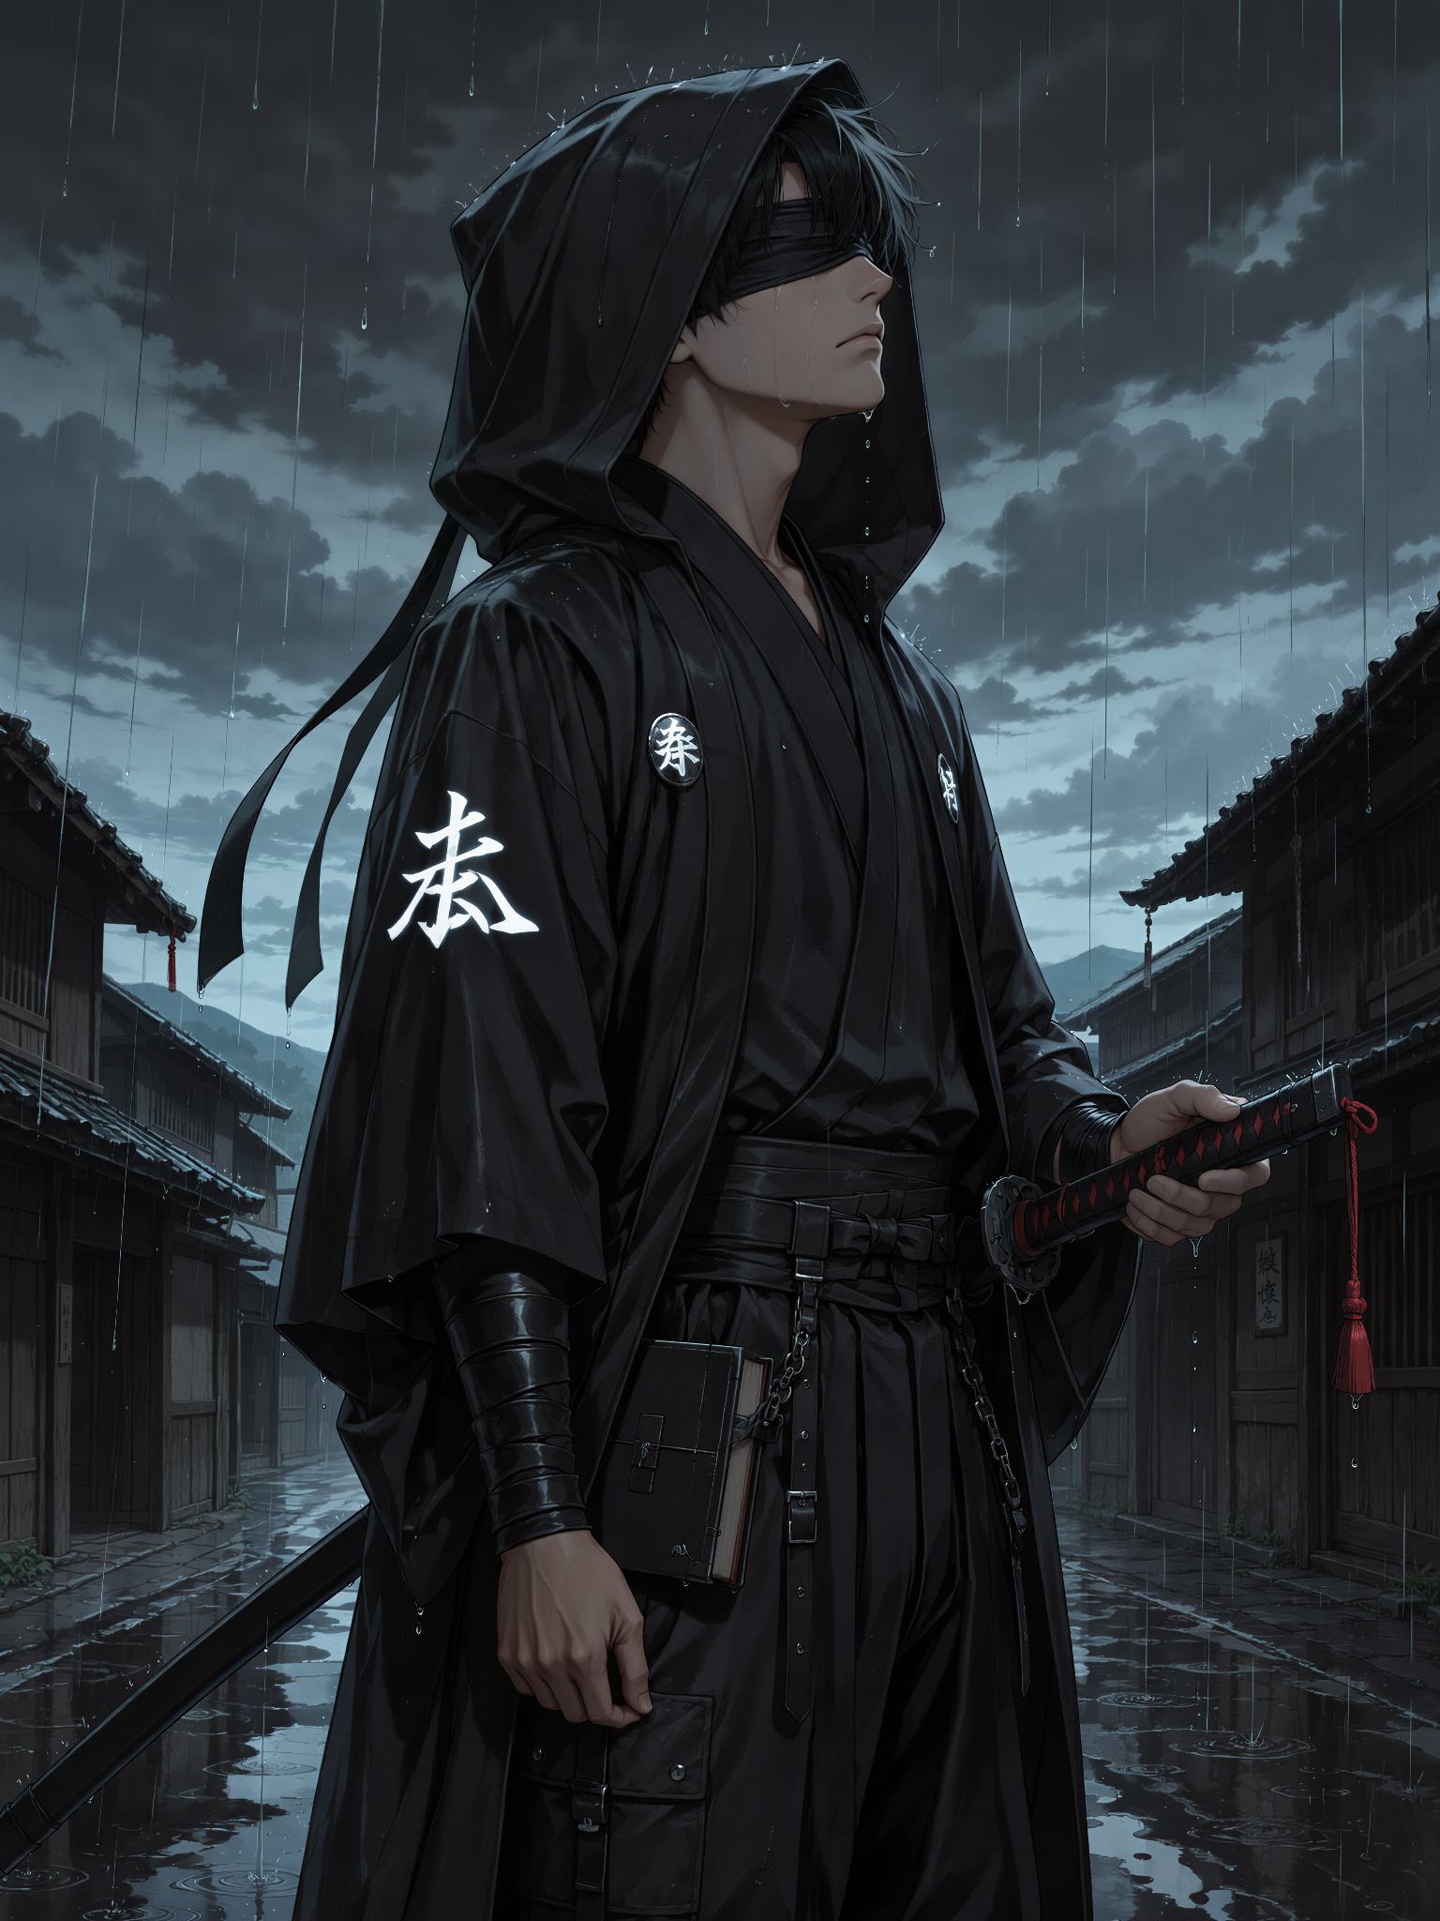

Infinite Dreams: The Sleeping Sun

Rand had been gone for less than an hour. To Maisie, it already felt like days.
She sat alone on the crooked couch, knees pulled beneath her chin, holding the little black velvet pouch against her chest. Without another person in it, the room seemed to grow around her. Every groan of the tenement sounded like footsteps leaving. Every muffled laugh behind the paper-thin walls belonged to someone who had somewhere else to be.
Maeve was gone. Rand had promised to return. Maisie believed him because believing otherwise hurt too much.
She loosened the pouch and peeked inside. Silvery-white light spilled across her freckles, accompanied by the delicate music of a thousand tiny chimes.
“Hullo again, little friend.”
She wiped her nose on her sleeve and smiled down into the impossible glow.
“Dun worry. Rand won’t be gone long. He said so.”
The Light answered with a soft, merry note. Maisie’s smile trembled.
“That’s right. We’ll keep each other company till then.”
It was not quite enough to stop the tears, but it helped. She curled upon the couch with the pouch tucked beneath her chin. Sleep came quickly, as it often did to those too exhausted to defend themselves from it.
· · ·
Maisie dreamed of Mandratha. Not the warm one of crowded taverns, cheap ale, wandering hands, and Maeve insulting anyone foolish enough to stare for too long. This Mandratha was empty.
Rain glazed the cobblestones. Narrow windows watched her with blind panes. Ancient white marble showed through the broken streets like the bones of something beautiful that had died and been built over without ceremony.
Maisie wandered without knowing where she was going. She had always been rather good at that.
“Maeve?”
Only the rain replied.
“Rand?”
A distant shutter slammed against a wall. Maisie pressed one hand over the pouch hanging from her neck.
“Least I gots you.”
The streets felt familiar, though she could not remember walking them before. Somewhere ahead, an old drainpipe rattled in the wind. A ragged awning shivered above a narrow alley.
Maisie did not know that she would one day hide beneath that same awning, soaked and terrified after fleeing Leedo. Dreams were rude that way. They remembered things before people did. Maisie almost walked past the girl in the alley.
There were plenty of women sleeping in the gutters of Mandratha. Prostitutes, runaways, drunks, debtors, and broken little things curled beneath ruined arches. Stopping for every stranger was an excellent way to lose your purse, your boots, or several useful organs.
Maisie took three more steps. Then stopped. Then shuffled backward. The stranger had horns.
Not little decorative bumps, either. Two dark curled horns rose through a tangled fall of black hair. Faint red seams pulsed inside them like dying embers. Her eyes were darker still, with dim crimson light breathing somewhere within.
She had apparently entered the city in a beautiful black dress. Now torn lace clung to her in muddy strips. One stocking was laddered from thigh to ankle; the other had nearly surrendered altogether. Her shoes were gone. Her bare feet rested in a shallow brown puddle beside a single bruised apple.
The strange girl stared at the apple with solemn resentment.
Maisie stared at her. Slowly, the horned girl looked up.
“Oh…”
Hope transformed her exhausted face so suddenly that Maisie took a careful step back.
“You can see me.”
“Course I can. Yer sat right there.”
The stranger laughed weakly. It was a young laugh. Not the smoky, knowing amusement of an ancient temptress, but the startled sound of a girl who had nearly forgotten that laughter still belonged to her.
“I was beginning to think nobody would.”
Maisie looked her over again.
“Are ya a daemon?”
“Sometimes people call me worse things.”
“Oh.”
Maisie nodded sympathetically.
“Me too.”
The horned girl’s lips curled into a tired smile. That seemed to settle something between them. Maisie pointed toward the apple.
“That yers?”
“It has been my only companion for several hours.”
“Friendly?”
“Cruelly judgmental.”
“Sounds like it belongs here.”
The stranger laughed again, and this time the red glow in her horns brightened. Maisie crouched beside her but kept one hand protectively around the velvet pouch.
“Wut happened to ya?”
The horned girl sighed, pushed a wet lock from her face, and attempted to gather the remains of her dignity along with the remains of her skirt.
“I arrived in a beautiful city filled with music, magic, and more public indecency than I have encountered in several decades of wandering.”
“Sounds grand.”
“Oh, I was delighted.”
Her expression briefly became animated, almost sparkling.
“Women kissing in doorways, couples disappearing behind curtains that were doing very little actual concealing, half-dressed elves behaving as though pleasure were a civic duty… I thought I had finally stumbled into a sensible world.”
“Common mistake.”
“So I discovered.”
Horned girl lifted one bare foot from the mud and wiggled her toes miserably.
“My shoes vanished before I finished asking for directions. A woman tried to buy my stockings while I was still wearing them. Someone else suggested I could pay for a room by sitting very still and looking decorative.”
“Coulda been worse.”
“It became worse.”
The playfulness left her voice. Her fingers tightened around the torn lace at her thigh.
“A group of men decided that horns, red eyes, and unfamiliar clothing meant I belonged to nobody.”
Maisie’s ears lowered.
“They tried to…”
“They tried.”
Stranger looked down at her muddy hands.
“My magic barely answered me here. It felt as though the whole dream were holding its breath against me. I frightened one of them. Scratched another. It was not enough.”
“Then how’d ya get away?”
For the first time, something warmer than shame passed through strange girl’s expression.
“Then... emm... let's say... a friend... heard me.”
“A friend?”
“He does not always reach me in dreams. It is difficult for him. But somehow, for one brief moment, he found the door.”
Her eyes drifted toward the mouth of the alley, as though she could still see the scene unfolding there.
“He appeared between us wearing black robes, like mist, with a sword in his hands and murder in his eyes.”
Maisie’s eyes widened.
“Ooooh.”
“He asked them to step away.”
“Did they?”
“No.”
“Idiots.”
“Very much so.”
Horned girl made a small chopping gesture.
“The conversation became shorter after that.”
“Like… how short?”
Stranger glanced at several dark stains dissolving beneath the rain.
“Several pieces shorter.”
Maisie stared at her. Then stared toward the stains. Then looked back at unknown girl with a mixture of awe and horror.
“Yer friend chopped ’em all up?”
“He was upset.”
“Maicré…”
Maisie’s face softened.
“But if he saved ya… where is he now? Why’d he leave when yer sat here all alone?”
The question was painfully reasonable. Especially coming from Maisie. Girl’s smile faded.
“He woke up.”
Maisie blinked.
“Wut?”
“He woke up.”
“From wut?”
“From sleep.”
“So he was asleep whilst chopping?”
“No. Well… yes. From his perspective. Perhaps.”
“An’ now he ain’t asleep?”
“No.”
“So he can’t be here?”
“Exactly.”
“But yer still asleep?”
“I am always sleeping.”
“So when he sleeps, he wakes here, but when he wakes, he sleeps there, while yer awake in his sleep but asleep in—”
Girl with horns gently pressed one finger to Maisie’s lips.
“Sweet thing, I can see smoke beginning to come from your ears.”
Maisie’s eyes crossed as though attempting to inspect the smoke.
“Oh.”
“Let us simply say that he saved me, and then the dream took him away.”
“That’s rude.”
“Dreams usually are.”
Maisie sat beside her in the mud.
“I’m sorry.”
“So am I.”
Stranger glanced mournfully at her dress.
“It was very pretty.”
Maisie snorted.
Unknown girl gasped theatrically.
“You laugh at my suffering?”
“Nah. Just the dress bit. Sounds like summat I’d say.”
“Then perhaps there is hope for you.”
“Doubtful.”
They exchanged a smile. Maisie noticed that her companion was shivering. Without asking, she shifted closer until their shoulders touched.
“Wut’s yer name, horns-girl?”
“Losfy.”
“Los-fee?”
“Perfect.”
“I’m Maisie.”
“I know.”
Maisie narrowed her eyes suspiciously.
“That’s creepy.”
“I am a spirit who wanders through dreams.”
“Still creepy.”
“Fair.”
Maisie’s mouth twitched. Then she remembered the pouch.
“Wait… are ya my little friend?”
Losfy tilted her head.
“Your what?”
Maisie lifted the velvet pouch and loosened it just enough to let a thread of silvery-white radiance escape.
Losfy recoiled so sharply that the back of her head struck the stone wall. Her red eyes widened. One hand flew to her chest. For an instant she was no longer seeing Maisie. She saw pale stone beneath an unfamiliar sky. A flawless crystal heart held between trembling hands. Clear light turning inward. Black veins spreading through its centre. A pulse that did not belong to anything living. Mirrors multiplying without end.
Then the memory shattered. Losfy blinked and found Maisie clutching her shoulder.
“Hey. Hey, Los-fee. Ya still in there?”
“Y-Yes...”
“Ya went all pale.”
“I remembered... something...”
“Good summat?”
“No...”
Maisie quickly tightened the pouch.
“Sorry. Dinnit mean to scare ya.”
“You did nothing wrong.”
Losfy breathed carefully and forced a gentler smile.
“I am not your Light, sweet thing.”
“Didn’t reckon Light usually gots horns.”
“Exceptionally perceptive.”
“I’m clever sometimes.”
“I can tell.”
Maisie beamed. Losfy reached toward the pouch with one hesitant fingertip. A tiny chime replied from within.
“But perhaps your friend opened a path between us.”
“Can it do that?”
“I have no idea.”
“Yer meant to be the magic one.”
“I am having a difficult evening.”
“Right.”
Losfy’s fingertip remained just above the black velvet.
“Or perhaps it was not the Light at all. Perhaps someone in this city was lonely enough to make a whole world hear her.”
Maisie looked away.
“I ain’t lonely!”
Losfy raised one eyebrow.
“Maeve’s just gone off. Rand’s comin’ back. Liam’s nice. I knows loads of people.”
“I did not say you were alone.”
“That’s the same thing!”
“No.”
Losfy bumped her shoulder gently against Maisie’s.
“It really isn’t.”
Maisie frowned at the puddle between their feet. Then she glanced sideways at Losfy. Even bruised, barefoot, wet, and wrapped in ruined lace, the horned girl was beautiful. Not in the polished way of noblewomen or performers, but in a strange, intimate way — as though someone had shaped a girl from midnight, longing, and several very inappropriate thoughts. Losfy caught her looking. Of course she did. Maisie tugged nervously at the metal ring of her collar.
“So… ya fancy girls?”
Losfy’s exhausted face immediately brightened with mischievous life.
“Oh, is that where this interrogation has been leading?”
“Mebbe.”
“I was wondering when you would stop pretending to be concerned about my welfare.”
“I was concerned!”
“And now?”
“Can be concerned an’ curious.”
“A gifted multitasker.”
Maisie’s eyes dropped to Losfy’s torn neckline. Then lower. Then darted back to her face.
· · ·
“D’ya want me?”
There it was. A tiny, frightened question dressed up as shameless flirtation. Losfy heard everything woven beneath it. She lifted one muddy hand and brushed an orange lock from Maisie’s cheek.
“Yes...”
Maisie froze. Losfy’s thumb traced the freckles beneath her eye, her expression suddenly warm, earnest, and almost achingly open.
“Oh, yes. You are adorable...”
“Adorable?”
“And pretty.”
“Pretty’s better.”
“And terribly tempting.”
Maisie’s ears flushed pink.
“Much better.”
“I want to bite and taste that little mouth... until your smile turns into heavy breaths, and we both forget who was meant to be the savior here.”
Maisie surged forward before Losfy could say anything else. Their lips met in an eager, clumsy kiss full of relief, rainwater, and startled laughter. Maisie's arms wrapped around Losfy's waist, then one hand moved up, feeling her warm, firm breast, the hard nipple poking through her thin black dress.
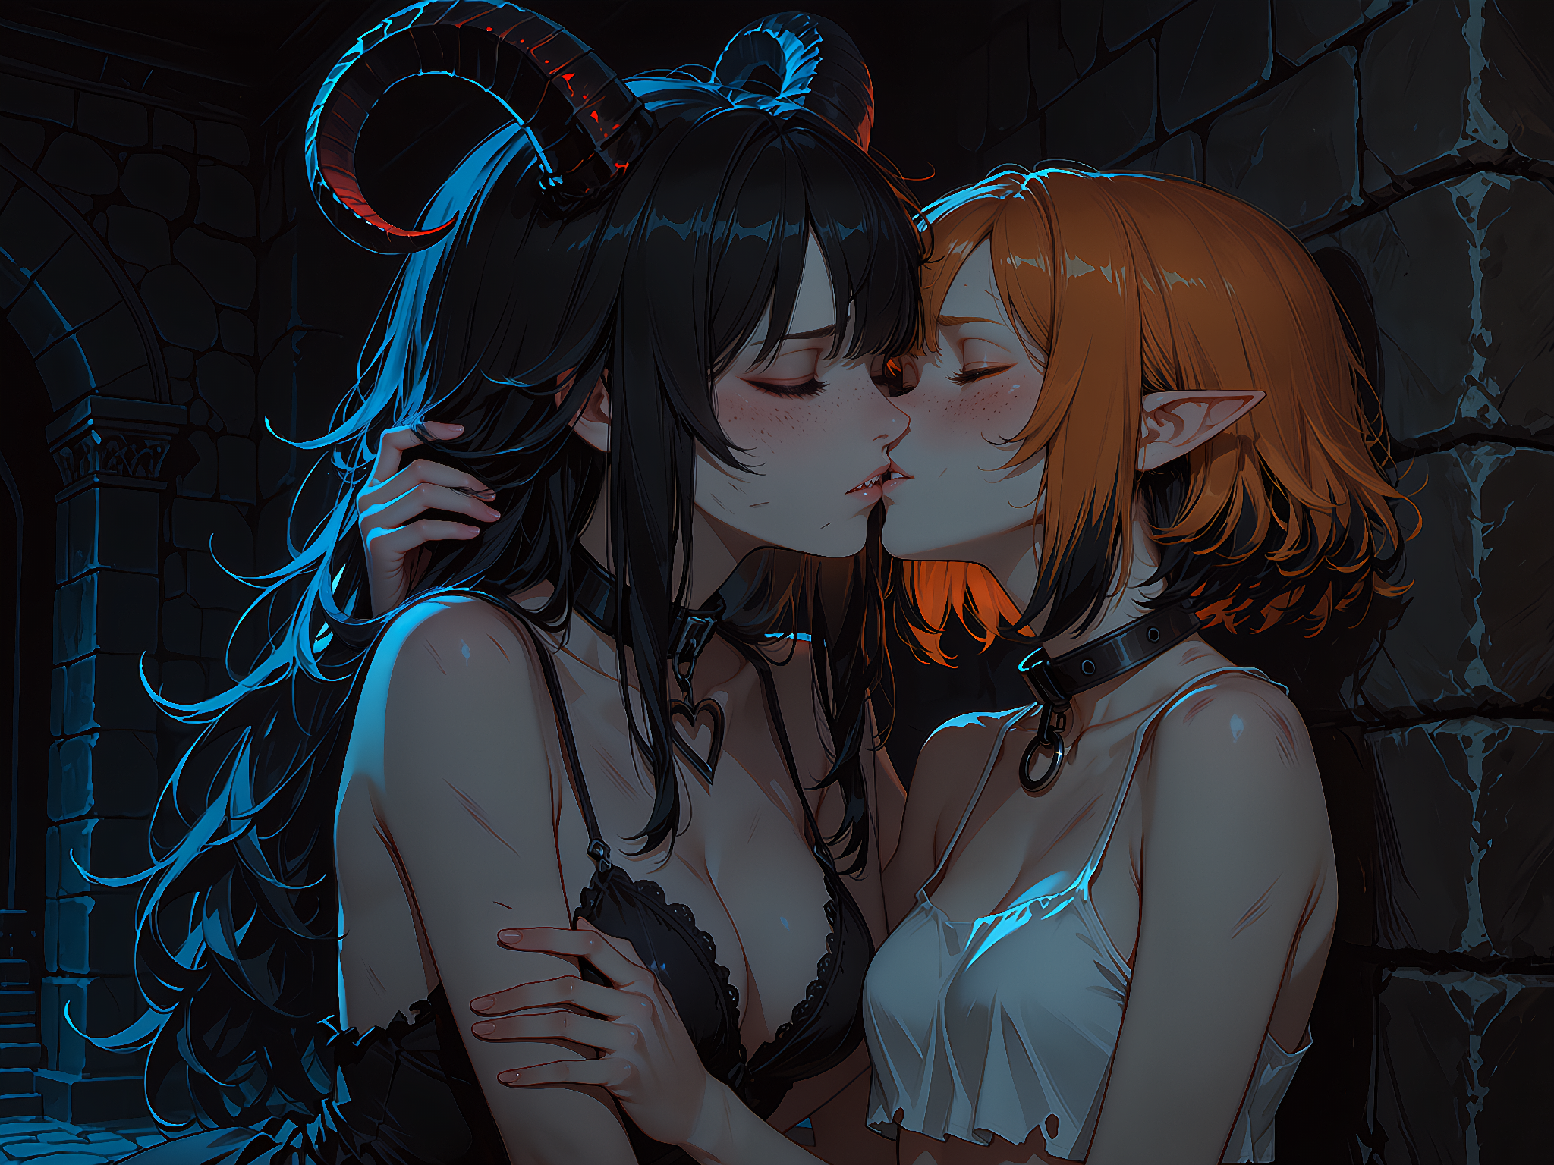
Her fingers dug into the torn lace of her neckline, as if she were afraid the unknown girl might vanish in an instant. Losfy kissed her back with equal sincerity. Her delicate and thin fingers gently lay on Maisie's hips and, like silk, began to slide up, disappearing under her skirt.
First softly.
Then deeper.
Maisie melted against her with a needy little sound. Her lips parted. Their breath mingled. Losfy’s fingers greedily slid over her most sensitive spot, which was literally dripping with anticipation. Maisie’s hands began tugging at the ruins of Losfy’s dress.
Losfy softly caught both wrists. Maisie became perfectly still. The fear returned so quickly that it hurt to see.
“Did I do it wrong?”
“No.”
“D’ya not want—”
Losfy kissed her again, quick and firm, before the imagined rejection could finish forming.
“I told you I want you.”
“Then why’d ya stop me?”
Losfy brought Maisie’s fingers to her lips and kissed them one after another.
“Because you are trying to earn something I already gave you.”
Maisie stared.
“Wut?”
“My attention...”
Another slobbery kiss.
“My desire...”
A third one with sharp bite.
“My company...”
Maisie’s lower lip trembled.
“But I’m good at pleasurin’ people.”
“I do not doubt it for a second.”
“I could make ya feel real nice.”
Losfy leaned closer, her red eyes gleaming with playful sincerity.
“Sweet thing, if this alley were warmer, cleaner, and less likely to contain rats with political ambitions, I would be very interested in testing that claim.”
Maisie gave a wet little laugh.
“Then—”
Losfy touched her forehead to Maisie’s.
“But not because you owe me.”
“I dun owe ya?”
“Not a kiss.”
Losfy kissed the tip of her nose.
“Not a touch.”
Then her cheek.
“Not a performance.”
Maisie’s breath caught. Losfy moved close to her pointed ear. Her voice softened, becoming the low, intimate murmur of a dream speaking directly into the hidden places of the heart.
“What you want most tonight is not to make me feel good...”
Maisie tried to pull away. Losfy held her gently—not tightly enough to trap her, only enough to prevent shame from ending the moment.
“...You want someone to want you…”
Her lips brushed the edge of Maisie’s ear.
“…and still remain when you have nothing left to offer.”
Maisie’s breathing became unsteady.
“You want to be held after the exciting part.”
A tear escaped down her cheek.
“You want a hand in your hair.”
Losfy kissed the tear away.
“You want someone to stay while you are quiet.”
Maisie made a wounded little sound and hid her face against Losfy’s chest.
“That’s stupid.”
“No.”
“Needy.”
“Very.”
“Same thing.”
“Not even slightly.”
Maisie sniffled.
“This is a funny sorta fuckin’.”
Losfy burst into soft laughter and rested her cheek against Maisie’s hair.
“The most dangerous kind.”
“Why dangerous?”
“Because girls like us know exactly what to do with hunger…”
Losfy’s smile turned sad.
“…and absolutely nothing about what to do when tenderness is real.”
Maisie remained very still. Then, hesitantly, she looked up.
“Can I… can I just lie here a bit?”
Losfy shifted against the stone wall, ignoring the mud soaking deeper into her ruined dress. She stretched one stockinged leg along the alley and guided Maisie down until the little elf rested across her lap.
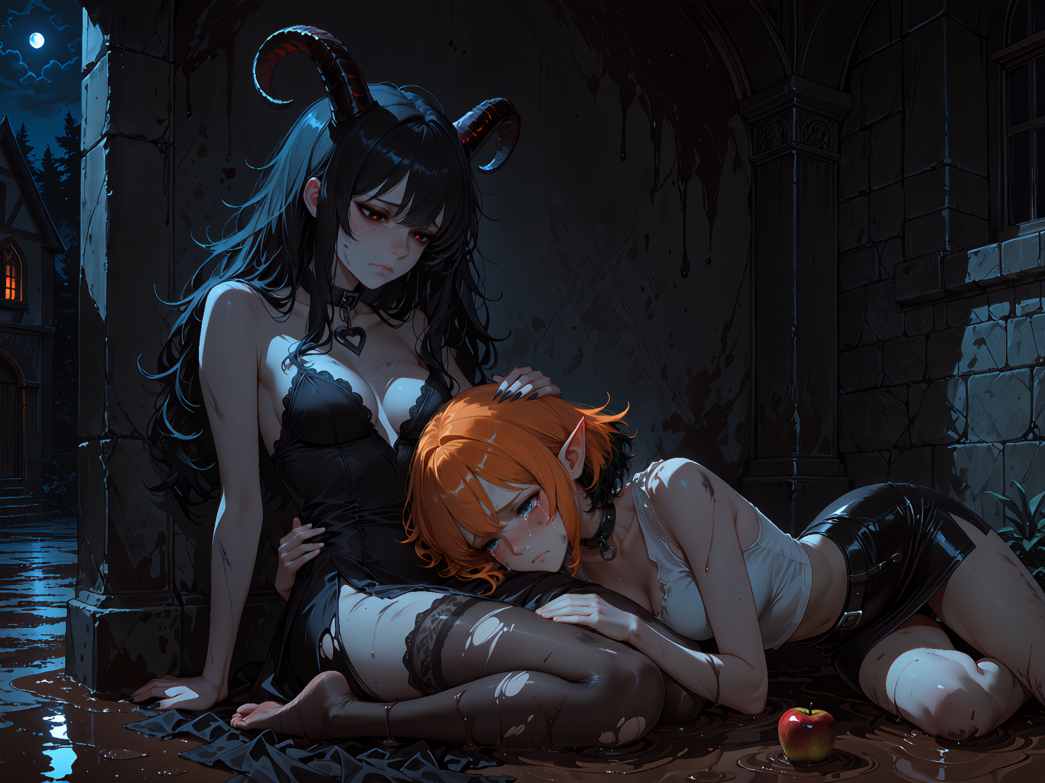
Exactly where Maisie had wanted to be.
Maisie curled close, one hand clutching the velvet pouch and the other loosely holding a torn scrap of Losfy’s skirt. Losfy began to stroke her hair.
Slowly.
Carefully.
Her fingertips moved between Maisie’s pointed ears, brushing damp strands from her forehead. Every now and then she scratched gently at her scalp, earning a tiny pleased sigh. Maisie’s whole body gradually softened. Somewhere above them, the moon disappeared behind clouds. Mandratha remained wet, filthy, and cruel.
Yet for one impossible moment, that forgotten alley felt warmer than any palace.
“Los-fee?”
“Yes, my little fool?”
“Ya love me?”
Losfy’s hand paused for only a heartbeat. Dreams made lying easy. But she did not need to lie.
“Right now, I love you more than this whole city remembers how.”
Maisie’s eyes filled again.
“That’s an awful lot.”
“No.”
Losfy’s fingers resumed their path through her hair.
“That is the tragedy.”
They rested together beneath the broken arch. Maisie listened to Losfy breathe. Losfy listened to the tiny chimes inside the pouch between them. Neither asked which girl was rescuing the other. After a while, Maisie spoke again.
“Will ya stay till mornin’?”
Losfy looked toward the dark horizon. She had crossed enough dreams to recognise the first pale warning of dawn.
“I will stay until my sleeping sun wakes.”
“Wut sun?”
Losfy smiled down at the little orange-haired elf curled across her lap.
“You.”
“Me?”
“Yes.”
“I ain’t a sun.”
“You are bright, warm, reckless, and forever wandering toward places that might burn you.”
“That sounds more like a fire.”
“A small one.”
“Oi.”
“A beautiful one.”
Maisie considered this and decided not to object. Losfy traced one fingertip along the black streak in Maisie’s hair.
“Your light is sleeping now. Hidden beneath rain, fear, and all this city’s dirt.”
“Sounds comfy.”
“It is waiting.”
“Fer wut?”
“For its morning.”
Maisie’s expression became uncertain.
“You really think I gots one?”
“Oh, sweet thing…”
Losfy bent and kissed her forehead.
“I have walked through worlds where the sun truly died. I know the difference between darkness and something merely waiting to rise.”
Maisie tightened her grip upon Losfy’s dress.
“When my sun wakes, wut happens to you?”
Losfy looked toward the brightening edge of the dream.
“I find the another door.”
“To somewhere nice?”
“Hopefully.”
“Could be worse?”
“Almost certainly.”
“Will ya be alone?”
Losfy’s smile trembled.
“Perhaps.”
“Then my sun shouldn’t wake yet.”
Losfy bent over her and pressed a gentle kiss to her lips. It lingered—warm, soft, and full of everything neither girl knew how to ask for.
“All suns must rise eventually.”
“Could rise late.”
“That does sound like you.”
Maisie managed a little laugh. The dream began to fade. Rain turned silver. Broken stones dissolved into stars. The dark windows filled with pale morning light. Maisie clung to the warmth of Losfy’s hand moving through her hair.
“Will I see ya again?”
Losfy’s red eyes shone with tears, but her smile remained bright and young.
“Dreams are strange paths, Maisie.”
“That ain’t an answer.”
“No.”
“Yer annoying.”
“Devastatingly so.”
“Can ya promise?”
Losfy looked at her for a long moment.
“I can promise that somewhere, in some dream, I will remember the little sleeping sun who found me in the mud.”
Maisie’s face crumpled.
“That’s still not an answer.”
“It is the most honest one I have...”
Losfy lowered her voice to a final whisper.
“Close your eyes... wanderer...”
Her fingers gently covered Maisie’s eyelids.
“Let the sun sleep for one more breath 🖤”
Maisie obeyed.
· · ·
She woke alone upon the crooked couch. The room was still dark, but a thin thread of dawn had appeared between the curtains. Rand had not returned. Maeve was still gone. For several seconds, Maisie did not move. She could still feel phantom fingers combing through her hair. She could still remember the warmth of torn stockings beneath her cheek and the taste of a strange girl’s lips.
Maisie touched her mouth. Then looked down at the velvet pouch pressed against her chest.
“Little friend?”
A quiet chime answered.
“Did ya see the horns-girl too?”
The Light rang again, softer this time. Maisie looked toward the paling window.
“She called me a sun.”
The pouch answered with a warm silver pulse.
“Think she found her door?”
One clear note sounded from within. Maisie curled around the Light and closed her eyes again. Beyond the window, dawn began its slow work upon Mandratha. It could not erase the mud, cruelty, hunger, or grief.
Not yet.
But beneath an unruly crown of orange hair, something bright continued to sleep...
🎶 Nightwish — Sleeping Sun 🎶

OC: Losfy and Maisie - Sweet Beneath the Mud 🖤🧡

Losfy sat beneath the broken awning, her back against cold stone, her bare feet resting in muddy water.
Her dress was ruined. Her stockings had suffered a heroic death. Her shoes were almost certainly being worn by someone else already.
“My darling… you woke up too soon.”
His voice answered from somewhere beyond the dream — quiet, restrained, unmistakably his.
“I stayed until you were safe.”
Losfy looked at the torn lace over her thigh and sighed.
“Safe is a bold description. I am barefoot, covered in mud, and sharing an alley with an apple.”
“I could not remain.”
“I know.”
Her teasing softened immediately.
“You came when I needed you. That matters.”
Through his waking eyes, she saw warm morning light, the edge of an unmade bed, and his hand reaching toward the breakfast table.
Toward an apple.
Losfy narrowed her eyes.
“Are you seriously having an apple?”
“Yes.”
“While I am sitting beside one in a gutter?”
There was a short pause.
“I was not aware of the gutter.”
“Of course you weren’t.”
She smiled despite herself.
“You never know where the mirrors leave me after you wake.”
“Tell me.”
Losfy glanced around the alley.
“Cold stones. Rain. No shoes. Questionable stains. One deeply suspicious fruit.”
“Do not eat it.”
“I was not planning to.”
She picked up the fallen apple and turned it carefully in her palm. Beneath the mud, its skin was red and bright.
“It is beautiful, though.”
“Losfy.”
“I said I would not eat it.”
She rubbed one thumb across its bruised skin.
“It only fell somewhere cruel.”
The apple rested quietly in her palm.
“That does not mean it belongs here.”
Silence...
Losfy could feel him standing in the warmth of morning, listening more carefully than his silence suggested.
“Someone should take it somewhere nicer,” she continued. “Wash away the dirt. Keep it warm for a while.”
She inspected a bruise beside the stem.
“Perhaps stroke it gently and remind it that being dropped does not make it worthless.”
She held the apple a little more carefully.
“It is still bright underneath all this. Still sweet, probably. It only needs someone patient enough to notice before the street convinces it otherwise.”
An unattainably distant voice gave her one last piece of advice before plunging into complete silence.
"Today is a hunt. I'll try to manage on my own. Take care of yourself, my girl..."
Footsteps passed the mouth of the alley.
Losfy barely noticed. She was too busy wondering where one might find clean water, a warm room, and a little kindness in a dream that seemed determined to ration all three.
The footsteps stopped.
Then slowly returned.
Losfy finally raised her eyes.
A small orange-haired elf stood at the entrance to the alley, staring at her. Finally!
Hope lit Losfy’s exhausted face before she could hide it.
“Oh… You can see me…”

Infinite Dreams: Twelve Thousand Shadows
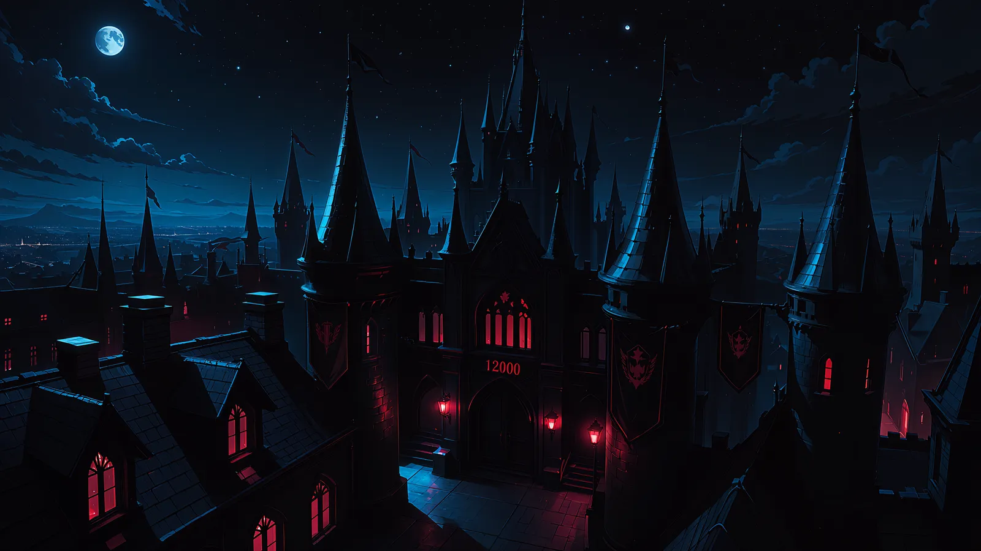
The celebration had ended hours ago.
More than twelve thousand souls had gathered beneath the darkness of their Master that night — servants and wanderers, soldiers, scholars, maids, creatures of the Abyss and things whose names existed only in the deepest shelves of the Obsidian Archives. Black banners had hung from the towers, dark-red lanterns had burned over courtyards normally left to eternal night, and music had traveled through the halls until even the ancient stone seemed to remember what joy sounded like. Now the kingdom was slowly settling again. Crushed petals remained beneath arches, wax crawled down the sides of exhausted candles, abandoned glasses waited on silver trays, and here and there small drops of ceremonial blood had dried into almost-black stars upon the floor.
Tria Cordisanguis had returned to her chambers before the last echoes disappeared.
She sat alone beside a small ritual circle marked upon the stone, one hand resting lazily against her knee while the other held a silver blade still stained along its edge. It was not a summoning ritual. Nothing so deliberate. Just an old gesture of devotion after a great night... a few drops returned to darkness, a quiet recognition that life was precious precisely because it was warm enough to spill.
One crimson bead struck the circle.
Then another.
The third never touched the floor.
Tria’s ears twitched.
The droplet hung motionless in the air, trembled... and began to rise.
A thin strand of blood followed it upward. Then another. The whole circle stirred, its lines crawling against gravity as though something on the opposite side had suddenly remembered the way home. Black smoke leaked from between the crimson markings and twisted upward in lazy coils, threaded with dark red. The candle flames bent toward the center.
Tria stood.
The smoke folded inward.
And a girl fell out of it.
She landed barefoot upon the cold stone with considerably less dignity than the apparition had promised, caught the edge of Tria’s table with one hand and remained there for a second with long black hair hanging over her face.
“…糞…”
Tria did not move.
The stranger slowly straightened... she was completely naked.
Two black horns emerged through the unruly curtain of her hair, glowing weakly red along their edges. Her eyes were almost black around deep dark red pupils. A slender body, pale skin, no visible weapon... and a smile already beginning to form despite the obvious annoyance of someone who had just been thrown out of reality without being consulted.
Tria’s own lips curled almost imperceptibly.
“Horns... black, messy hair... that smile...” Her red eyes traveled slowly over the woman, lingering just long enough to make it obvious that the absence of clothing had not escaped inspection. “And apparently not even a trace of shame. I believe I know who you are... Losfy. Correct?”
Losfy brushed several strands of hair away from her face and looked at Tria properly for the first time. Surprise flickered in her expression... then satisfaction.
“Ooooh... very good.” She straightened with no attempt whatsoever to cover herself, placing one hand casually against her bare hip. “I disappear for what feels like half an eternity, and my reputation survives me. I am touched.” Her smile sharpened as she stepped out of the fading smoke. “Especially the part about having no shame. It would have been heartbreaking if history preserved the horns and forgot my most important virtue.”
Tria’s gaze dropped once more.
Losfy noticed... naturally.
“Careful, kitty. If you keep verifying that particular historical detail so thoroughly, I may begin charging archive fees.”
Tria’s expression barely changed, though the tip of one ear moved. “I am only making sure the description was accurate.”
“Mmm... and?”
“Mostly.”
That answer made Losfy laugh softly. There was no loud theatricality in it, only a breathy little sound that seemed much too intimate for two strangers alone in a bedroom.
Then Losfy began her own inspection.
Black hair. Cat ears. Black and red. Sharp eyes. Gothic fabric that clung in all the correct places. Fangs, though not yet obvious enough to explain themselves. Losfy walked a slow half-circle around her, thinking aloud.
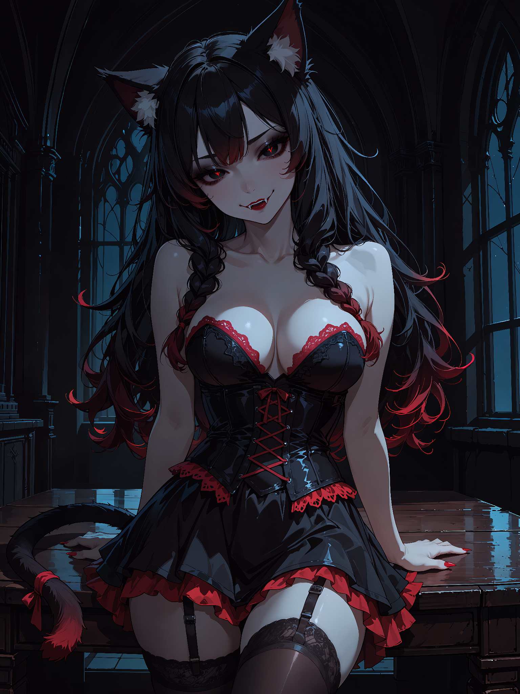
“So... kitty has a name?”
A small pause.
“Tria.”
Losfy waited, but Tria did not continue.
“…Just Tria?”
“For now.”
“Hmmm.” Losfy tilted her head. “Already hiding things from me. We are going to get along terribly.”
“Perhaps.”
That single word was quiet, dry... but it carried just enough amusement to make Losfy’s pupils narrow with interest. She took another step closer... Only then did she notice the fangs properly. Losfy stopped. Her gaze moved from Tria’s mouth to her ears, then back again.
“No way!”
Tria’s smile showed them a little more clearly.
“No, no... absolutely not.” Losfy lifted one finger as if accusing reality itself. “Cat. Vampire. Again?”
“Half.”
“Half vampire?”
“Yes.”
Losfy stared at her for several seconds, visibly recalculating the kingdom.
“Wait! Liiti is a vampire cat!”
“I know.”
That changed something. Losfy’s playful expression remained, but her voice became quieter. “You know Liiti?”
Tria simply looked at her.
“Where is she?”
“She’s well.”
“Lumi?”
“Also well.”
“Niru?”
Tria considered this longer than necessary. “Busy being Niru.”
Losfy’s brows slowly drew together. “That is the first answer you have given me tonight that I completely believe.”
Tria’s mouth curved.
Losfy came closer again until the distance between them became less social and more deliberate. “How long was I gone, Tria?”
“Long enough for things to change.”
“That sounds elegant, but it is still not an answer.”
“I did not say it was.”
“Heeey... you’re enjoying this...”
“Do I?”
The dangerous tension settled almost naturally between them... Wild. Sharp. Two girls smiling because neither had yet decided whether the other represented pleasure, danger, or the inconvenient possibility of both at once.
Losfy let her gaze drift briefly to Tria’s lips. Tria saw it... of course she did. One fang pressed faintly against her lower lip as her smile widened.
For a fleeting instant, Losfy imagined closing the remaining distance, catching that mouth with her own and discovering exactly how carefully the vampire could bite.
Judging by the way Tria’s attention moved toward Losfy’s exposed throat, the thought had not been entirely one-sided.
Neither acted upon it... that made it worse... Then Tria said almost casually, “You are late.”
Losfy blinked. “Late for what?”
“The celebration.”
“えっと… What celebration?”
“Twelve thousand gathered here tonight for Master’s milestone.”
The heat in Losfy’s expression vanished into pure disbelief.
“Twelve thousand?!”
Tria nodded.
“In the Dark World?!”
Another nod.
“For Master?!”
“You know the answer!”
Losfy slowly looked toward the dark windows, where distant banners could still be seen hanging from the towers. She noticed the flowers on the floor, the extinguished lanterns, the faint traces of music and wine she had mistaken for ordinary Dark World excess.
Her horns brightened.
“…畜生!!!”
Tria’s shoulders moved very slightly.
Losfy pointed at her. “Do not laugh!”
“I did not.”
“Your ears laughed.”
“My ears do not laugh.”
“They absolutely do, and I will prove it later.” Losfy turned toward the door, took two determined steps... and stopped.
The silence behind her became suspicious. Losfy looked down. Then slowly looked back over her shoulder.
Tria was observing her again. This time Losfy followed the vampire’s gaze all the way down her own naked body, then sighed.
“…Right...”
Tria raised one eyebrow.
“I cannot greet Master like this.”
“You seemed remarkably comfortable greeting me like this.”
“You are not Master... And after vanishing for so long, I would prefer the first thing I offer him to be an apology and congratulations rather than...” Losfy made a vague gesture toward herself. “…all of this.”
Tria turned toward an ornate wardrobe at the opposite wall. “I have other dresses. Something should fit you well enough.”
“Aww... How kind...”
She walked toward it.
Losfy remained where she was, watching her. Then a smile appeared. Both of Losfy’s hands moved innocently behind her back. Her fingers snapped. A tiny black-red spark jumped between them and disappeared into the floor.
Tria’s ears twitched sharply and she stopped for half a second... Then continued. Her hand closed around the wardrobe handle. She opened both doors... Empty hangers swayed gently inside.
Nothing else.
Tria stood motionless.
Losfy widened her eyes with such profound innocence that it became offensive.
“…Problem?”
Tria slowly looked over her shoulder.
“My dresses are gone.”
“Ah! How terrible...”
“There were eight!”
“Dark World thieves?”
Tria’s gaze became extremely narrow.
“Niru?!”
Losfy covered her mouth, pretending to consider it. “Very plausible. Honestly, if something vanishes in this kingdom, blaming Niru is practically administrative procedure.”
Tria glanced once toward Losfy’s hands.
Losfy smiled sweetly.
The wardrobe doors swung shut.
“I suppose,” Losfy continued before Tria could think too deeply about the suspicious sound she had heard, “we are left with only one practical solution.”
“No.”
Losfy walked toward her slowly, bare feet silent against the stone. “Come on, kitty... the celebration is already over. Master could disappear into his chambers at any moment. You would not force a loyal servant to miss him twice, would you?”
Tria folded her arms. “You want the dress I am wearing.”
“I knew you were clever.”
“And what exactly am I supposed to wear?”
Losfy let her gaze travel over Tria with unhurried appreciation.
“That problem seems less urgent from where I am standing.”
For the first time, a visible flush touched Tria’s cheeks... Losfy saw it. Her smile became softer... and somehow more dangerous.
“Besides... I arrived dressed exactly as the Dream of Mirrors intended. You could try it. It's fun!”
Tria stared at her, apparently deciding whether annoyance was still worth maintaining. Then she sighed.
“Fine.”
Losfy’s eyes and horns lit up.
“Only because you are wasting time.”
“Of course.”
“And because I would rather not have an infamous naked dream spirit wandering the Mansion at night.”
“Very responsible.”
“Do not make me regret it.”
Losfy stepped behind her.
“Oh, Tria...” Her hands settled lightly upon the vampire’s shoulders. “…I suspect regret was already invited when you recognized me.”
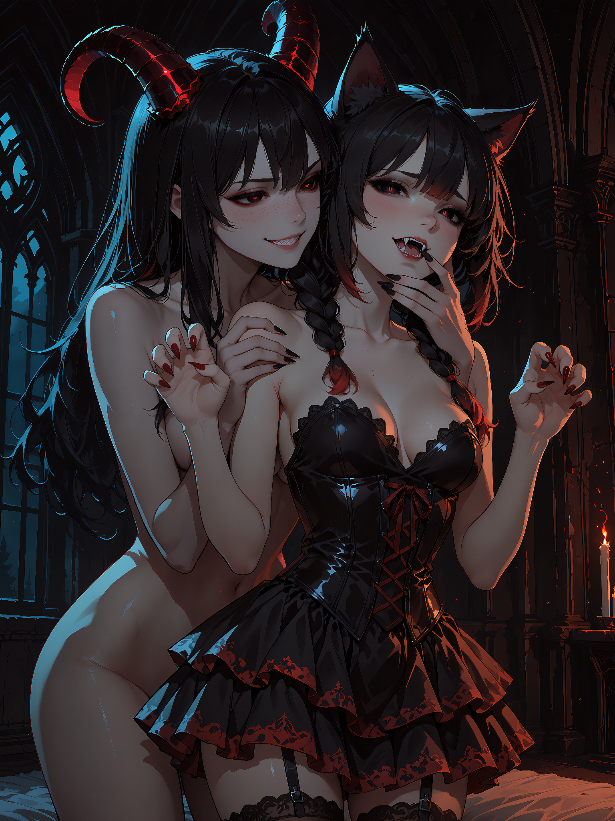
The first fastening gave way beneath Losfy’s fingers.
Then the next.
Tria’s dress was more elaborate than it had looked from the front: corset lacing crossed the back beneath dark hair, disappearing into intricate fabric that seemed designed specifically to force whoever removed it to take their time.
Losfy did... very deliberately... one lace slipped free... then another...
She moved closer as she worked, enough that the warmth of her naked body became impossible for Tria to ignore. Losfy gathered the black hair over one shoulder, exposing the pale line of Tria’s neck, then leaned nearer until her lips hovered beside one twitching ear.
“You smell... interesting...”
Tria’s breathing changed almost imperceptibly. “You usually sniff strangers while undressing them?”
“No... Sometimes I undress them first.”
Another ribbon loosened.
Losfy’s knuckles brushed the side of Tria’s breast as she reached around for a hidden clasp. Neither of them acknowledged it immediately.
The touch happened again. Slower...
Tria inhaled.
Losfy whispered beside her ear, “That one might have been an accident...”
Tria’s fingers curled against her own thighs.
Losfy continued working. One palm briefly rested upon Tria’s waist to steady her, then slipped lower over the curve of her hip before returning to the laces with suspicious reluctance.
“And besides…” Losfy murmured, “…you are much more interesting when you pretend none of this is affecting you.”
Tria turned her head just enough that the tips of their noses nearly touched. “You have been in my room for less than an hour and already assume you understand me.”
“No-no-no... understanding comes later.” Losfy smiled, her breath warm against Tria’s lips. “For now I am only collecting evidence.”
Tria’s eyes flickered downward.
“So am I...”
That answer sent a quiet thrill through Losfy. The next lace took longer than it should have; Losfy’s fingers had become considerably more interested in the girl beneath the dress than in the dress itself.
At last, the corset relaxed. Losfy slid the fabric carefully from Tria’s shoulders. Her fingertips traced bare skin as the dress descended, pausing for one heartbeat against the smooth curve just beneath Tria’s collarbone... then lower, following the edge of fabric until there was nothing left to hold.
Tria stepped out of the dress. Neither looked away.
For a moment Losfy simply held it against herself while Tria stood before her, nearly bare, one arm loosely crossing her chest without truly attempting to hide much.
“You are staring,” Tria said.
“So were you...”
Tria took the dress from her hands.
“Turn around.”
Losfy obeyed with suspicious enthusiasm.
A few minutes later she stood dressed in black and dark red while Tria worked behind her, fastening the corset with much less tenderness than Losfy had shown.
The first pull drew the fabric snug against Losfy’s waist.
The second stole a small sound from her.
The third made her brace both palms against the dressing table.
“Easy... easy, kitty...” Losfy laughed breathlessly as Tria pulled again. “You do realize I need enough air left to congratulate him?”
Tria leaned closer behind her. Losfy could feel the cool line of the vampire’s body against her back, bare skin occasionally brushing the exposed places around the dress.
“You seemed very confident while taking mine off.”
“I was... inspired.”
Another measured pull. Losfy’s breath caught. She looked at Tria through the mirror. Their eyes met. Losfy smiled slowly.
“Mph! Careful... if you keep squeezing me like that, I may start making sounds that would give the maids entirely wrong ideas.”
Tria’s hands paused at Losfy’s waist. Then, instead of immediately withdrawing, they smoothed the fabric down over her sides. One palm lingered at her hip.
Losfy’s eyelashes lowered slightly.
The room was becoming dangerously quiet again. Losfy finally broke the spell by glancing toward Tria’s legs.
“Stockings.”
Tria followed her gaze.
“You want those too?”
Losfy knelt before her.
“I want... the complete experience.”
Tria’s expression changed.
Losfy held her gaze as she leaned toward one thigh. Rather than using her hands, she caught the upper edge of the stocking gently between her teeth.
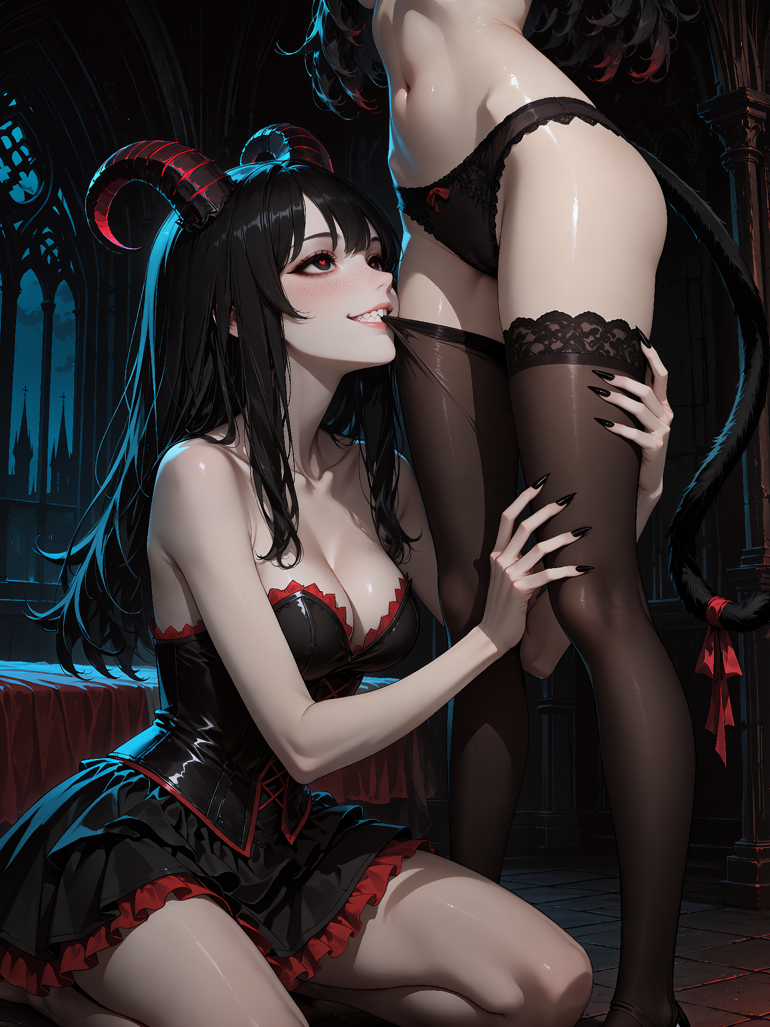
Tria’s breathing stopped for half a second.
Losfy slowly drew the fabric downward.
Not enough to make the act openly indecent... More than enough to make it impossible to call innocent.
Her fingers traveled behind Tria’s calf while her mouth guided the stocking lower, and every few moments her cheek brushed warm skin. Tria’s hand tightened across her own chest. Her other palm rested against the wall as though the stone had abruptly become necessary for balance.
Losfy looked upward.
Tria was biting her lip. One fang pressed hard enough to leave a tiny bright bead of red.
Losfy froze. The scent reached her. Something changed in her face.
For one dangerous heartbeat, the playful dream spirit vanished and something older looked out through those dark-red eyes. Her lips parted.
Tria saw it, but neither moved.
Losfy’s tongue touched the corner of her own mouth almost unconsciously. Then she released the stocking and whispered, “You should be careful doing that around me.”
Tria’s eyes narrowed with pleasure rather than fear. “Why?”
Losfy rose slowly, bringing herself close again. “Because I still do not know whether I want to kiss you... or taste what you just offered.”
Tria smiled.
“Perhaps you should keep wondering.”
“…Cruel kitty.”
“Talkative demon.”
The second stocking came away somewhat faster. Naturally, Tria refused to let Losfy win the game uncontested.
Once Losfy had pulled the first stocking onto her own leg, Tria took the second from her hand, knelt, and caught its edge between her teeth with deliberate imitation.
Losfy’s eyebrows rose.
“Oh?”
Tria said nothing.
She simply began drawing the fabric upward along Losfy’s calf. Slowly...
Her fingertips accompanied it, smoothing the stocking against skin. At Losfy’s knee they lingered. At her thigh, Tria looked up.
The expression was almost unbearably composed. Almost.
Losfy’s hand rested lightly against one of Tria’s ears.
“Learning quickly.”
Tria continued.
Then—
tch.
Her fang caught the fabric and a small hole appeared.
Both women looked at it.
Tria released the stocking immediately. Her ears lowered a fraction.
“I damaged it.”
There was genuine disappointment in her voice.
Losfy’s predatory amusement melted.
“Aww... Don't worry... Come here.”
She touched the tiny tear with two fingertips.
A thread of black-red magic escaped them and wound itself through the damaged fabric. Tria’s head snapped upward. Her whole body tensed and a warning hiss slipped between her teeth as one hand caught Losfy’s wrist!
Losfy did not pull away. Instead she gently turned their joined hands toward the light.
Where the fang had punctured the stocking, several tiny black hearts now decorated the fabric.
“That is all.”
Tria’s grip remained firm.
Losfy smiled and reached with her free hand toward the nearest feline ear.
“Just hearts, kitty. See?”
Her fingers scratched gently behind it.
Tria’s ears flattened immediately. Her eyes narrowed. But her head moved... only a few millimeters... into Losfy’s touch.
Losfy did not laugh. Instead she kept scratching softly, her smile becoming unbearably tender.
“Mmm... terrifying.”
Tria released her wrist.
Losfy’s fingers remained behind her ear for one extra second.
Then two.
Only after that did Tria straighten with what remained of her royal dignity.
Her hands moved toward the final garment still separating her from complete nakedness. She hooked her thumbs beneath the waistband of her black panties and looked at Losfy with a questioning expression that carried far more challenge than modesty.
Losfy’s eyes widened appreciatively.
“Oh... look at you!”
Tria waited.
Losfy’s gaze wandered down and back up again, shameless and slow.
“You really were prepared to give me everything.”
“Your outfit is incomplete.”
Losfy laughed softly. “Not by my standards.”
Tria blinked.
“I do not wear those.”
“…Why?”
Losfy adjusted the stolen skirt, looking perfectly serious. “They interfere with spontaneity.”
For a moment Tria stared at her. Then the smallest laugh escaped. Actual laughter.
Losfy’s face lit up.
“There you are…”
Tria’s smile vanished almost immediately, but too late.
“Hey! I heard that!”
“You heard nothing.”
“I found the living girl beneath the creepy vampire princess.”
“Dress yourself.”
“Yes, ma’am.”
Losfy added a few finishing touches: the heart-shaped earrings, the repaired stockings, and a pair of heels. She adjusted the dark-red trim around the neckline, then finally looked at them both in the mirror.
The resemblance was unsettling.
Not identical... but there was enough. Black and red. Dark eyes. Fangs and horns. Delicate danger wrapped in feminine shapes. The same strange balance between something adorable and something one should probably not approach alone at night.
Losfy moved behind Tria now, tracing one claw lightly along her naked shoulder.
“You really do look suspiciously familiar...” she murmured. “Those eyes... the colors... that smile when you are trying not to smile.”
Tria watched her reflection.
Losfy’s claw continued lower, barely grazing the side of her arm.
“Tell me honestly... did Master miss me so badly that he eventually decided to make himself a little cat-Losfy as a replacement?”
The atmosphere changed.
Tria turned.
Losfy expected another evasive answer.
Instead Tria let her hands fall from her chest.
She stepped forward without hesitation and pressed her nearly naked body against Losfy.
The contact silenced her.
Tria’s arms slid around Losfy’s waist. Her lips came beside one horn, so close that Losfy instinctively shivered.
“Your Master had nothing to do with my creation.”
Losfy’s smile faltered.
Tria whispered into her ear as one hand slipped beneath Losfy’s skirt, settling boldly against the bare curve behind her:
“I am the daughter of the One... whose name…”
Losfy recoiled. Hard. Her back struck the edge of the table. For the first time since arriving, every trace of playful superiority disappeared from her face.
Tria remained exactly where she was, naked beneath the dying candlelight, her head tilted and that strange predatory smile slowly returning.
Losfy swallowed.
“…The One…”
Tria said nothing. That somehow made it worse. Losfy recovered herself quickly... or tried to.
“Well...” She straightened the stolen dress with exaggerated care. “That is certainly useful information which I will process calmly and rationally at some point when I am extremely far away from this bedroom.”
Tria’s eyes glittered.
Losfy bent as if to pick up something beside her heel, realized there was absolutely nothing there, and immediately pretended she had merely intended to inspect the floor.
“Master has probably retired after such a long celebration. I would hate to disturb him in his chambers. Very rude! Terrible manners! I am known for many flaws, but disrespecting his well-earned rest should not become one of them.”
Still smiling, Tria watched her turn toward the door.
Losfy stopped beside the table.
A notebook lay there.
Beside it, a pencil.
She stared.
Then looked at Tria.
“You will not mind if I borrow this, will you?”
No answer... Only that smile.
Losfy slowly reached for the notebook. “Yes. Exactly what I thought. You seem emotionally occupied by considerably more interesting things than stationery.”
She tucked it beneath one arm and reached the door. Her fingers touched the handle.
“Losfy.”
She stopped.
Tria’s voice remained soft.
“You did something to my wardrobe.”
A pause.
Losfy looked back.
Tria continued, “I heard your fingers. I felt the magic. And even if I had not... you could have made yourself clothing from the beginning, could you not?”
Silence stretched between them.
Losfy’s nervousness faded. The old wickedness returned to her smile one layer at a time.
“…Perhaps.”
Tria’s fang appeared again.
“Then why?”
Losfy leaned against the open door and looked over the nearly naked vampire from head to toe one final time.
“Because…” She paused deliberately. “…it would have been boring.”
Tria slowly ran her tongue across the fang that had torn her stocking.
Losfy’s eyes followed the motion and the room seemed to tighten around them again.
There it was — that dangerous possibility they had been circling all night. Teeth against skin. Fingernails. Warm blood. Two mouths deciding whether they were kissing or fighting only after it was already too late.
Losfy stepped backward into the corridor.
“Sweet dreams, cutie…”
Her heels began to click against the black stone.
Tria remained framed in the doorway, pale skin surrounded by darkness, arms no longer bothering to conceal her body.
The heavy door slowly closed between them with an ancient creak.

For the first several corridors, Losfy walked much faster than dignity required.
Only when Tria’s door had disappeared far behind her did she slow down.
Her fingers tightened around the notebook.
“The One…”
The words barely escaped her lips. Losfer would want to know.
She shook her head.
“Later.”
Tonight belonged to someone else.
The remnants of the celebration became more obvious as Losfy moved deeper through the Mansion. Dark flowers lay scattered along staircases, banners carried Master’s sigil, and sleepy maids were still clearing glasses from alcoves while small groups of exhausted residents disappeared toward their quarters. Everywhere she looked there were signs of a kingdom larger than the one she remembered.
She opened Tria’s notebook and stared at the blank first page.
“Twelve thousand…” she whispered.
The number made her smile. Then she heard footsteps ahead. Losfy stopped.
She knew that presence before she consciously recognized it. Her whole body softened.
The teasing expression remained, but something beneath it changed... became quieter, warmer, painfully sincere.
A figure approached beneath the blue-black arches.
Losfy held the notebook against her chest.
“M-Master…”
The word came out much softer than she intended.
He stopped.
For a moment, Losfy simply stood there in another woman’s dress, wearing stockings decorated with tiny hearts, carrying a stolen notebook, her hair still tousled from dimensional travel and her mind crowded with questions she could not yet begin to organize.
Then she bowed... very deeply.
“My Master... I am late.”
She straightened slowly.
“I am sorry I disappeared for so long. I know I cannot promise where the Dream of Mirrors will throw me next... but I am very happy it brought me back here tonight.”
Losfy glanced toward one of the enormous banners left hanging from the festivities.
“I heard more than twelve thousand souls gathered beneath your darkness tonight.”
Her smile grew.
“When I first found myself here, I thought the Dark World was simply another impossible dream filled with beautiful monsters, suspiciously seductive architecture and far too many women who make sensible decisions extremely difficult.”
A faint pause.
“I appear to have underestimated it.”
Her hand moved over the notebook.
“So much has changed while I was gone... new corridors, new stories, new dangers, new girls…” Her smile became mischievous again as she opened the notebook and held up the pencil as if presenting an official weapon.
“That is why I borrowed this. I intend to investigate everything! Every new room... every forbidden archive... every suspicious kitty... every woman who claims she is not interested in Losfer... and…” Losfy stepped closer, lowering her voice into the intimate softness Master would remember all too well, “…every new secret my Master has hidden while I was away.”
Then she closed the notebook. Her expression changed again.
No joke.
No trap.
No carefully placed double meaning.
Just... Losfy.
“Congratulations, Master!”
Her hand settled over her heart.
“Twelve thousand souls chose to gather beneath your darkness. Twelve thousand found something here worth returning to... beauty, danger, tools, stories, dreams, friends... perhaps something they cannot even name yet.”
She looked up at him. A little black heart was already drawn on the corner of the notebook’s first page. Losfy glanced at it, then smiled.
“And I am very happy that this troublesome Dreambound Spirit still has a place among those twelve thousand.”
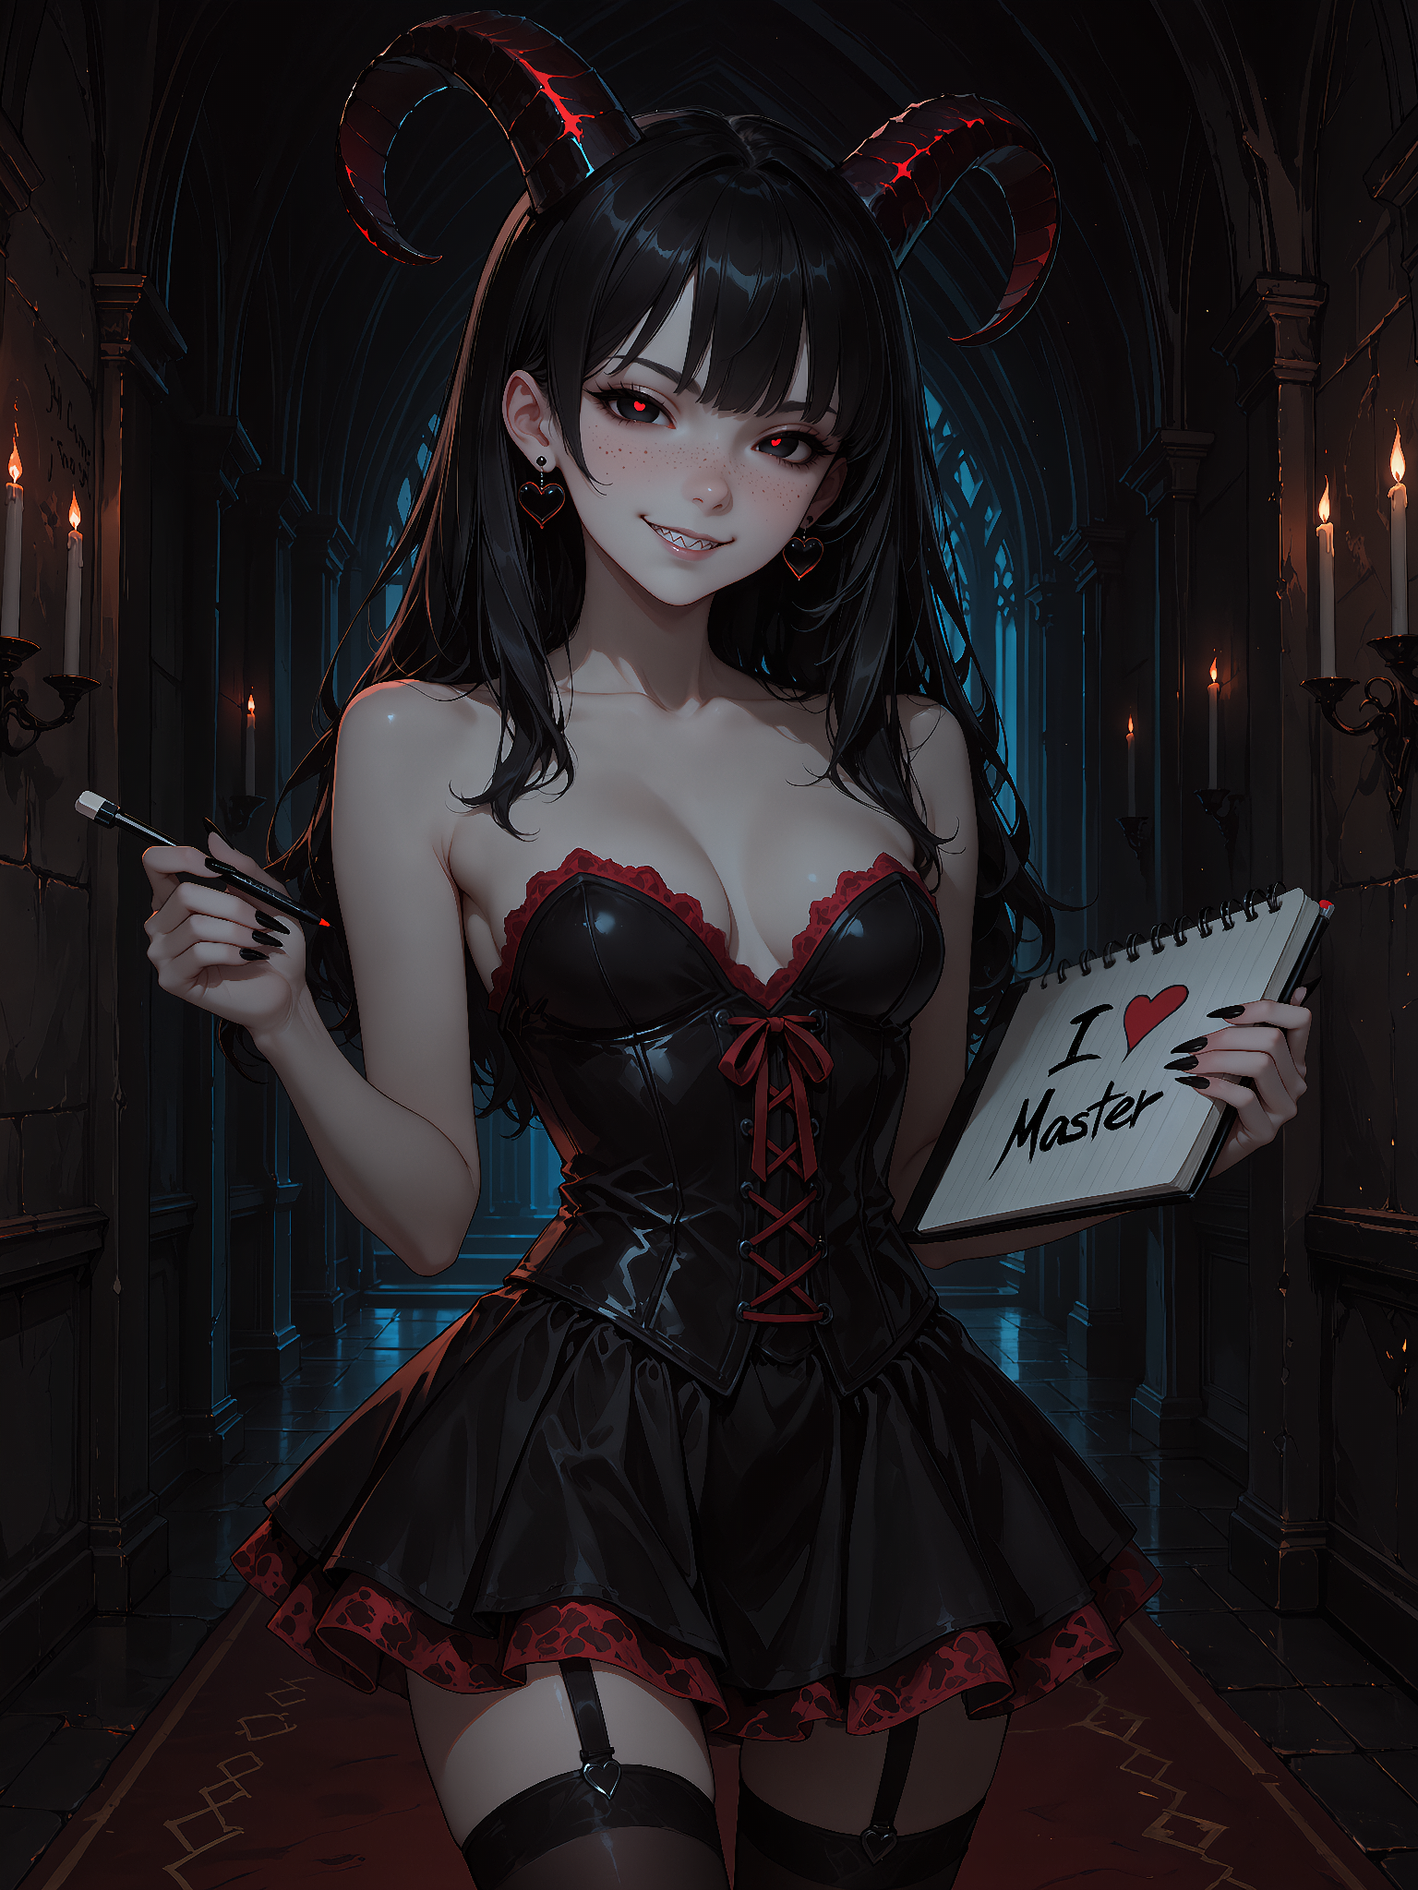
She bowed once more. Then, slowly, the familiar wickedness returned to her eyes.
“Now... about everything I missed.”
Losfy tapped the pencil against the notebook.
“I think Losfer and I have a lot of work ahead of us...”
A pause. Her horns gave a faint red glow.
“And Master…” Losfy lowered the notebook slightly, suddenly adopting an expression of exaggerated concern. “I really should share one important piece of information before I forget.”
She leaned closer, her voice dropping into a confidential whisper.
“It seems one of the Mansion’s new sharp-toothed ladies is suffering from a truly tragic wardrobe emergency. Poor Tria has almost nothing left to wear tonight. Absolutely dreadful...”
Her smile slowly widened.
“And, purely as an additional observation for the ruler of this kingdom… she seemed unusually warm. Restless. Perhaps even a little… hungry.”
Losfy tapped the pencil thoughtfully against her lips.
“Nearly naked, slightly breathless, cheeks beautifully flushed, fangs showing… honestly, Master, I became quite worried about her condition.”
She stepped closer and whispered the rest as though delivering sensitive intelligence.
“So if you happen to pass by her chambers tonight, perhaps you should personally inspect the situation. She may require… immediate attention from someone with proper authority.”
Losfy’s eyes glittered.
“Consider it my late contribution to your celebration.”
A pause… then the most shameless smile imaginable.
“I missed the feast, after all. It would be terribly rude to return without bringing my Master a present.” 🖤

OC: Losfy x Tria Cordisanguis 🖤❤️

Somewhere beneath the pale evening sky of Astaria, Losfer moved quietly through the forest, one hand resting near the hilt of his weapon while his other senses searched for the demon he had been tracking for most of the evening. The woods were almost silent when a familiar voice suddenly slipped into his thoughts, bright enough to feel completely out of place among the shadows.
“My love… I have wonderful news. The Dream of Mirrors finally threw me back into the Dark World.”
Losfer stopped for half a second, then continued walking. “That explains why you have been suspiciously cheerful for the last few minutes. How much has changed?”
“Oh, my sweet… you have no idea.” Losfy’s voice carried that soft, delighted lilt he knew far too well. “New halls, new secrets, new stories… and apparently Master has been collecting interesting girls while we were away. I have already met one of them. Very pretty. Very sharp teeth. Terrible conversational habits.”
Losfer’s expression remained serious, but one eyebrow rose beneath the edge of his blindfold. “And how exactly did your first meeting with this mysterious girl end?”
“With cultural exchange,” Losfy answered warmly. “I learned something about her, she learned something about me… there may also have been a minor wardrobe incident, but I really do not think we should burden an exhausted demon hunter with administrative details.”
“That answer contains considerably fewer facts than I would like.”
“Aww… my poor suspicious boy. Fine, then here is a proper fact: more than twelve thousand souls gathered beneath Master’s darkness for a great celebration. The whole kingdom was decorated for it.” Her voice softened for a moment. “I arrived too late to see the feast itself, unfortunately… but I did find Master afterward and congratulate him properly.”
Losfer slowed. “You missed the celebration, appeared in the private chambers of an unknown girl, somehow became involved in a ‘wardrobe incident,’ and still managed to reach Master afterward.”
“When you list everything like that, sweetheart, it sounds almost irresponsible.”
“It sounds exactly as irresponsible as I expected.”
Losfy giggled somewhere inside his mind. “And yet everything ended beautifully. Master received my congratulations, I acquired a notebook for all the things we need to investigate, and one extremely intriguing vampire kitty was left with… an opportunity to reconsider several life choices.”
Losfer was silent for a few steps. “I am not going to ask what that means while I am carrying a weapon through a forest.”
“That is probably wise.”
“I will ask later.”
“That is considerably less wise.”
Despite himself, the corner of Losfer’s mouth moved. “I will be there as soon as I sleep. First I want to congratulate Master myself… and then you are going to explain what happened in his kingdom while we were gone.”
“Mmm… I was hoping you would say that.” Her voice immediately changed, losing some of its playful brightness and becoming lower, closer, almost warm against his ear despite the impossible distance between them. “You see, my sweet, I borrowed the most adorable little black-and-red dress. It is very short… the black stockings are lovely too, although one of them now has tiny hearts where a certain naughty fang made a hole…”
Losfer exhaled slowly.
“And of course,” Losfy continued with shameless sweetness, “I did not suddenly develop an interest in unnecessary underwear while you were away. So when you finally fall asleep and find me waiting somewhere in the Dark World, I was thinking I might show you exactly how well this new outfit—”
“Please... stop it...”
She dissolved into delighted laughter. “What? I am merely helping motivate you to finish your hunt faster, my darling.”
“I am currently trying to locate a dangerous oni.”
“And I am currently wearing a very dangerous dress.”
Losfer shook his head, though the faint smile had already betrayed him. “Give me a little time. Finish whatever chaos you have started, stay out of Master’s forbidden rooms for at least one evening… and try not to undress any more strangers before I arrive.”
There was a tiny, suspicious pause.
“My dear…”
“Shh!”
“I was only going to say that I missed you ❤️”
That finally softened him completely.
Losfer lowered his hand from the weapon for a moment and looked toward the darkening sky. “I missed you too, my girl.”
Losfy’s answer came quieter this time, stripped of almost all her mischief.
“Then hurry and dream of me.”
A beat passed.
Then, inevitably:
“…preferably before I find another girl whose clothes fit me 🖤”

OC: Losfy - Bleeding Epitaph
Losfy came to the Midnight Atelier just before the fuchsia dusk sank completely into black.
She walked slowly through the sleeping streets of the Dark World, holding the ruined hem of her gothic dress between two delicate fingers. The fabric had once been elegant black lace, soft velvet, silver thread, a perfect silhouette for a dream-spirit who enjoyed appearing untouchable.
Now the lower half clung to her thighs in a shameful, glossy mess.
Losfy sighed, then smiled to herself.
“Perhaps,” she murmured, “one should be more careful when visiting Master’s chambers at night…”
She had gone there only for advice.
At least, that was the official version.
Unfortunately, advice had turned into teasing. Teasing had turned into flirting. Flirting had carried her far too close to his arms, and from there, dignity had dissolved with almost indecent speed. By the time she fled his chambers, breathless and red-cheeked, she had left behind a soaked floor, an offended dresser, and a dress that could no longer be called presentable.
“Not that walking naked through the halls would embarrass me,” she whispered, glancing at the dark windows around her. “But in this kingdom? Dangerous. Very dangerous.”
The Atelier welcomed her with warm lamplight, black silk mannequins, hanging ribbons, and the heavy scent of lilies, iron-ink, wet stone and old velvet. Its master looked up from a workbench filled with needles, lace and small obsidian tools.
Losfy placed the ruined dress on the counter with exaggerated innocence.
“I require... repairs.”
The tailor’s eyes lowered to the glistening fabric.
“I see...”
“It was an accident.”
“Of course...”
“A devotional accident.”
The tailor said nothing.
Losfy smiled sweetly.
“Do not ask what was spilled.”
And then the world broke.
The air above the Atelier split with the agonizing music of shattering mirrors. Shelves trembled. Needles scattered. The warm lamplight was consumed by a violent white glare as the ceiling windows flashed with impossible geometry.
Outside, the cozy night became a disaster.
A dimensional wound tore open across the sky, and from it poured the crystalline creatures: salt monoliths weeping white dust, quartz behemoths crawling on jagged limbs, angular horrors without breath, blood, or mercy. Wherever they stepped, moisture vanished. Stone calcified. Flowers stiffened into pale fossils. The fuchsia glow of the district refracted into lethal prismatic lances.
Losfy froze at the doorway.
For the first time in many dreams, she did not know what she was looking at.
Then a beam of hard light cut through the street and reduced a row of black iron balconies to screaming sparks.
Her fear ended.
She lifted her right hand and whispered toward the unseen forge beneath the Dark World:
“EpitaphEcstasy… engrave my desire in stone!”
The air behind her answered with a low, monumental pulse.
Ink-black sigils unfolded around her wrist. A cubic mechanism of red glass and abyssal iron opened beside her like a miniature altar, its surfaces carving her thoughts into shape. Not a dagger. Not a staff. Not some delicate toy for a sweet dream.
A greatsword came into being with a sound like a cathedral bell drowned in blood.
Because that was the weapon her body remembered.
Before Losfy had become a wandering sweetness in the labyrinth of dreams, before lace, whispers, and soft corruption, there had been another life. The Horny Justice. A girl who knew how to plant both feet, grip a two-handed blade, and turn judgment into motion.
The sword descended into her hands, huge and radiant, its core burning black and gold, its edges soaked in dark crimson light. It looked less forged than written — an epitaph for anything foolish enough to stand before her.
Losfy tightened her grip.
“Come then,” she said softly.
Then she ran into the slaughter.
Her first swing carved a red-gold crescent through three salt creatures at once. They burst apart in dry white clouds that burned her eyes and throat. She spun through the dust, dress snapping around her legs. She met a rushing crystal horror with a diagonal cut that split it from collar to pelvis. It burst apart in a blinding spray of shards, and half of those fragments slashed across her cheek and throat before she could turn away. The pain was instant — thin, hot, humiliatingly bright. Blood ran warm beneath her collar.
She kept moving.
Every step became a cut. Every turn, a verdict. The greatsword dragged luminous arcs through the dusk, severing limbs, breaking torsos, splitting polished horrors into glittering ruin. Dark-red currents followed her blade like ribbons of wrath, bending around her shoulders, coiling through her hair, answering the old rhythm buried deep beneath her newer, softer self.
“Light,” she whispered through clenched teeth, “do not abandon me...”
A salt spear grazed her side. Blood ran warm beneath her torn dress.
“Darkness,” she hissed, and struck again, “do not pity me...”
The battlefield expanded around her. The Atelier district had become a storm of broken glass, calcified stone and screaming metal. Prismatic lasers sliced through the air, close enough to burn red lines across her arms. Salt dust settled on her lips. Her throat dried until each breath felt like swallowing knives.
She thought, absurdly, of Losfer.
How he would have watched this horror with solemn eyes. How he would have tried to name it, explain it, give meaning to the beautiful cruelty of extinction.
“I wish you were here,” she whispered.
Then another wave hit.
Losfy met it head-on.
Glass bit into her skin whenever she got too close. Fine splinters lodged in her arms. A razor-edged shard tore open her thigh through the ruined dress, and suddenly that leg burned every time she put weight on it. A beam of refracted light lanced past her shoulder and took flesh with it, leaving a stripe of raw fire from collarbone to breast. Her hands blistered around the hilt. Her breath turned ragged. Her body grew slick not with desire now, but with sweat and blood.
Her magic began to answer more slowly.
The crimson light flickered.
Her next swing came late.
Another shard scraped along her ribs. The pain was bright, clean, merciless. She staggered, caught herself, and roared as she split the attacker in half — but when she tried to step forward, her knee struck the ground.
The sword point slammed into stone.
Blood streamed from a dozen cuts. Her dress hung in torn ribbons, black cloth pasted to bloody skin. Her fingers were shaking so badly she had to grip the hilt with both hands just to keep from collapsing. Above her loomed a crystalline giant, immaculate and merciless, its edge lifting for the final stroke. In the polished angles of its body she could see herself reflected — small, ruined, kneeling before death.
For one quiet instant, Losfy thought of the Dream of Mirrors.
Perhaps this was the moment. Perhaps she would leave this world bleeding and be carried onward through silver corridors into some new world with a new name, a new sky, a new loneliness.
“Farewell...” she breathed.
The blow fell.
...
But never landed.
A black silhouette appeared between her and death.
They arrived like a theorem proving itself — the Special Maid Division. Dresses, blades, polished armor, and the absolute grace of extermination. One moment death stood over her; the next, it had been cut into mathematically precise pieces. Around her, the Division moved with surgical beauty: phase-steps, tri-slashes, the mechanical elegance of annihilation. They did not brawl. They erased. A swarm of dark silk and killing intelligence.
The behemoth before Losfy ceased to exist in six precise cuts.
Not killed... corrected.
The battlefield changed in seconds. Salt monoliths were opened from crown to base. Quartz limbs fell in synchronized patterns. White dust scattered harmlessly beneath abyssal counterfields. The maids did not rage. They did not hesitate. They performed slaughter with the calm refinement of servants cleaning dust from a sacred hall.
Losfy stared, trembling.
Awe filled the hollow place where despair had been.
Then she tightened her ruined hands around the sword, forced herself up on her trembling leg, and tasted blood when she smiled.
“For our Master!”
And she threw herself back into the massacre...

OC: Krestia x Obsidia x Obsessia - Obsidian Archive Temptation 💚💙💗

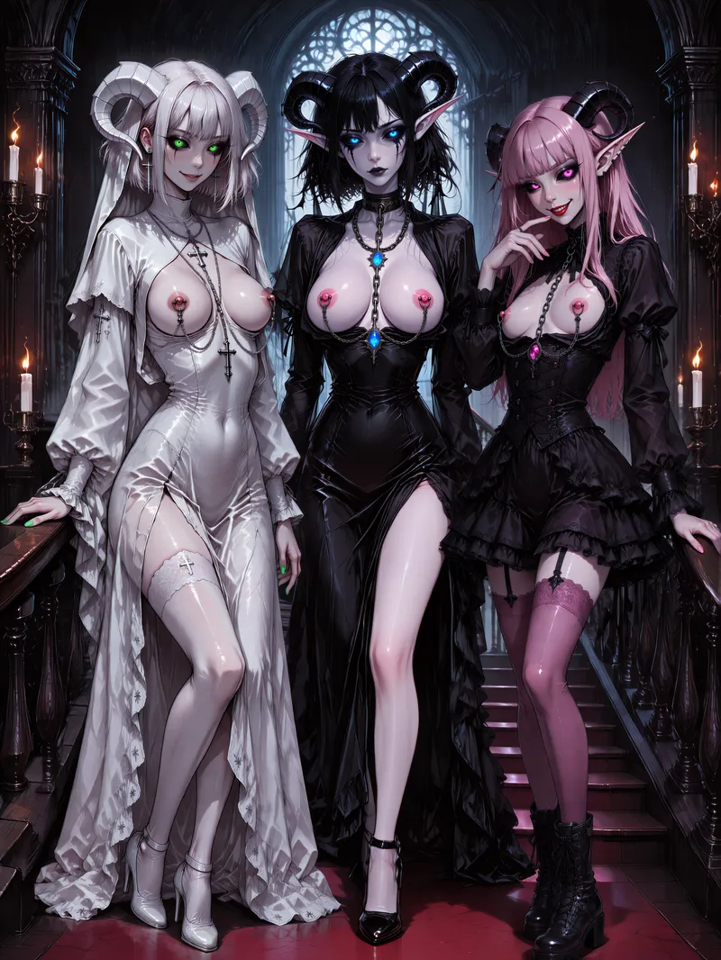
The corridor to the Night-Bound Mansion was long, narrow, and dark enough to make even torchlight look guilty.
Losfer walked with the calm dignity expected of a servant of the Dark World: his black shinobi attire immaculate beneath a hooded haori-cloak, hands folded behind his back, expression melancholic and unreadable. Beside him, Losfy bounced along with the suspicious energy of someone who had absolutely done something and was currently enjoying not explaining it.
Losfy smiled innocently. “I went to see Vespera.”
Losfer immediately became wary. “Why?”
“After the invasion of Sideria, after the mirrored twins, after stolen schematics and calcifying horrors, I went to speak with her. I sought defensive advice for the Master’s realm.”
“The secret weapon?”
“The secret weapon.”
Losfer narrowed his eyes. “And?”
“She didn't tell me what it was.”
“Of course she didn't.”
“She mostly stared into the distance and spoke in ominous metaphors.”
“That sounds like Vespera.”
“She said there are things hidden beyond ordinary records. Things sealed inside living vessels. Things that should never return.”
Losfer frowned.
“She also said there are certain souls who might know more.”
“And?”
“And then I flirted with her.”
Losfer stopped walking. “You what?!”
Losfy looked proud. “She was very patient.”
“That is not an answer.”
“I complimented her intellect.”
“That sounds harmless.”
“I also complimented her hips.”
Losfer covered his face. “She removed your hand?”
“Three times.”
“Only three?”
“She was busy.”
At that moment, Losfer thought: Vespera deserves hazard pay.
Losfy continued cheerfully. “She never explained what the artifact actually was.”
“Then what did she tell you?”
“Rumors.”
“I dislike that word.”
“She said there are living seals.”
“I dislike those words too.”
“She said dangerous knowledge constantly tries to escape into reality from The Obsidian Archives.”
Losfer glanced toward her. “Escape?”
“Leak.”
The word lingered unpleasantly.
“Vespera said the seals are always trying to hold something in,” Losfy said.
Losfer nodded. “And?”
“She also said some of the containment systems are extremely distracting.”
Losfer closed his eyes with the wisdom of a great thinker: "Not for me."
They continued toward the mansion in silence for several moments. Then Losfer noticed something.
"I know that smile... Speak already."
“I invited guests,” she announced.
Losfer sighed: "You will tell me who exactly, right?"
“No.”
“Why?”
“Because it's fun.”
“Fun for whom?”
“Yes.”
At that moment, Losfer thought: This is how ancient heroes were lured into curses.
The great doors of the Night-Bound Mansion loomed ahead.
“Losfy, who are the guests?”
Losfy smiled.
The doors opened.
Losfer entered the grand stair hall.
Then stopped.
Upon the staircase stood three women. Three living seals. Three disasters.
Lady Krestia stood in pale elegance, dressed in white garments resembling sacred vestments corrupted by very personal artistic decisions. Silver piercings gleamed across exposed skin like devotional relics hammered directly into temptation itself. Crosses adorned her attire. Too many crosses. Enough crosses to suggest either profound faith or active hostility toward the concept. Perhaps both.
Lady Obsidia stood at the center: elegant, composed, terrifyingly calm. Dark chains rested against her evening dress like ceremonial restraints. Obsidian ornaments traced deliberate paths across her body, drawing attention not away from dangerous secrets but directly toward them. Every ring, every chain, every polished black detail seemed placed with ritual precision, holding something inside her that the world had no right to hear. She was not merely wearing secrets. She was containing them. And the most frightening part was how beautifully she did it.
Lady Obsessia leaned casually against the railing in black-and-pink gothic lace, stockings, and a smile that suggested she had already identified several ways to cause trouble and was currently ranking them.
All three looked directly at Losfer.
Somewhere inside his skull, the Fan Club President began taking notes before the servant could stop him.
6 breasts: immediate threat to composure.
6 eyes: confirmed awareness of said threat.
6 horns: should have been noticed first.
At that moment, Losfer thought: This is my favorite number.
His outer expression remained perfectly professional. Mostly.
Losfy leaned closer and whispered with a sly smile:
“Surprise...”
“What,” Losfer whispered back, “have you done?”
“I invited experts.”
"In the Name of Darkness, Losfy, why these three?!"
"Because if the fate of the Dark World depends on living seals, I naturally chose the ones I wanted to spend a night researching anyway."
The ladies began descending. Not together. Simply with the confidence of women who knew exactly what effect they were having.Krestia's gaze wandered across the hall. She smiled faintly. “This place... has excellent acoustics.”
Losfer immediately disliked where that sentence might lead.
“I once visited a royal mausoleum with excellent acoustics.”
Losfer's eyes widened in alarm: “Please do not finish that story.”
“The guards agreed.”
“I saw... I mean... Do not...”
Krestia looked genuinely nostalgic. “They were very passionate...”
Losfer remembered that day all too well in his mind... and in his notes...
Meanwhile, Obsessia had already noticed his discomfort. Which was unfortunate, because she clearly enjoyed it.
“Good evening.”
Losfer froze.
“You look nervouz.”
“I am responsible for diplomatic protocol.”
“Iz thiz ze name of sam interezting game?”
Hearing Lady Obsessia's accent, Losfer moved his hands from behind his back to the front and crossed them at groin level to avoid any diplomatic misunderstanding.
Obsidia descended the final step last. Deliberately. Patiently. Her eyes lingered on him. Not predatory. Worse. Possessive.
“Well... Prezidenttttt...” she purred.
The title alone nearly killed him.
“It iz good... to see you again...”
Losfer bowed immediately.
Protocol.
Protocol was all that remained.
He unfolded a formal parchment.
“Honored Ladies Krestia, Obsidia, and Obsessia. By recognition of your status as distinguished guests and living seals of archival significance, you are hereby welcomed to the Night-Bound Mansion under the protection of our Master and invited to attend a formal banquet this evening.”
A pause.
“Additionally, any president-related emergencies, containment failures, carpet-related emergencies, demonstrations of qualified abilities, revised methodologies or ritual incidents must be reported immediately.”
Obsessia laughed. “Oh!”
Losfer regretted speaking.
“You remembered the carpet incident?”
“I don't forget anything.”
“It was an accident.”
Obsidia raised an eyebrow. “It waz not.”
“It mostly waz.”
“It waz your own fault, sizter! You shouldn't have teazed him for so long!”
The two exchanged looks. Losfer decided not to ask, for the preservation of civilization.
Krestia tilted her head. “You forgot sacrilege.”
“I did not forget sacrilege.”
“You omitted it.”
“I omitted it intentionally.”
“Understandable.”
Then Obsidia spoke. “Befour dinna, perhapz we should dizcuss why we ar here.”
Losfer nodded. “Yes. The weapon.”
“Ze weapon,” Obsidia agreed.
Losfy brightened. “Finally.”
“You know what it is?” Losfer asked.
“No.”
“You invited them without knowing?”
“Yes.”
Losfer stared at her.
Obsidia smiled. Obsessia smiled. Krestia smiled. The simultaneous effect was alarming.
“Ze weapon,” Obsidia said softly, “iz not merely a weapon...”
Losfer felt dread.
“It iz a force...”
Obsessia giggled. “A catastrophe...”
Krestia folded her hands. “A revelation...”
“The Bulge™,” all three said.
Silence.
Absolute silence.
Even the shadows seemed uncomfortable.
Losfer stopped breathing.
Losfy stopped smiling.
“The Bulge™?” she whispered.
Obsidia nodded. “Ze Bulge™.”
“The Bulge™?” Losfer repeated.
Krestia crossed herself. “The Bulge™.”
Losfy looked genuinely horrified. “You mean that's real?”
“Very real,” Obsidia replied.
“I thought it was a joke.”
“No...”
“I thought it was a metaphor.”
“Absolutely not...”
The room somehow became darker.
“The Bulge™,” Krestia explained with unsettling reverence, “is hidden beyond the Dark World.”
“Sealed wizin flesh, hehe...” Obsessia added.
Losfy slowly turned toward Losfer. For the first time all day, she no longer looked amused.
“I may have made a mistake.”
“You think?”
“A small mistake.”
“You invited three living seals connected to an apocalyptic moon artifact.”
“A medium mistake.”
“A colossal mistake!”
“Fair...”
Unfortunately, it was already too late. The three women looked positively enthusiastic, like scholars discovering forbidden scripture. Or sharks smelling blood. Or both.
Then Obsidia said, “We will require appropriate roomz.”
“Of course,” Losfer said.
“In the same wing as the Prezident...”
His soul left his body for a moment, inspected the architecture, and declined to return.
“I beg your pardon?”
Obsessia stepped closer.
“Or perhapz directly in hiz chamberz. We are dangerouz archival assetz. Surely you should keep uz somewhere cloze, warm, and eazy to inspect...”
“To… Inspect?” Losfer repeated.
Krestia nodded with religious seriousness.
“The seals must remain close to the appointed key-bearer.”
Losfer turned very slowly toward Losfy.
Help me, his eyes said.
Losfy gave him the most wicked, satisfied, perfectly villainous smile he had ever seen.
“It is all for the salvation of the Dark World,” she whispered.
At that moment, Losfer realized: She planned this. She absolutely planned this.
Still, he bowed.
Deeply.
Respectfully.
Doomed.
“Then please follow me, honored Ladies. The banquet hall awaits.”
As they walked, Losfer removed his small black notebook from his pocket and began writing in the dramatic shorthand of a servant facing certain death.
Final testament of President Losfer. Current situation: catastrophic. Living seals gathered successfully. Apocalyptic artifact confirmed real. Losfy experiencing regret. This is not helping. Three demonic women currently circling me like territorial predators. Signs of jealousy already observed. Dinner probability: survivable. Night probability: uncertain. Reality probability: declining.
He glanced back.
The three women followed like a prophecy in heels.
Losfy walked beside him, humming.
Then Obsidia’s voice purred behind him.
“Writing about uz already, Prezidenttt?”
Losfer closed the notebook.
"Losfy... Tell the Master I remained loyal, formal, and philosophically composed until the very end..."
Then he glanced toward the distant palace towers and silently hoped the Master was occupied with something less disastrous than checking what his servants had invited into the Night-Bound Mansion...

OC: Losfy - Seven Nights, Zero Panties 🖤
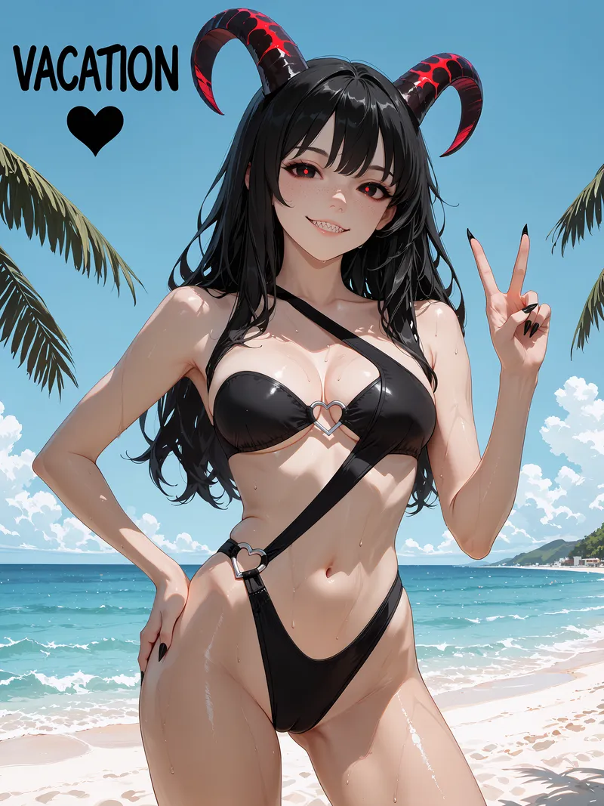
There were already four suitcases on the bed.pf
This was impressive, considering Losfy had started packing with one.
She bounced around the room in an oversized black pajama shirt and tiny sleep shorts, black hair flying everywhere, one sock mysteriously missing, surrounded by clothes, cosmetics, chargers, shoes, snacks and several objects that had absolutely no business being placed beside sunscreen. Every few seconds she remembered something critically important, ran three steps toward it, noticed something else, forgot the first thing entirely and returned carrying two unrelated items instead.
“Okay! Shorts. Dresses. Skirts. Tops. Underboob tops. Sunscreen. Hair stuff. Chargers. Swimsuit. Losfer’s shirts. Sneakers. Headphones. Snacks. Emergency snacks. Emergency-emergency snacks…”
She froze.
“MANGO.”
Everything else ceased to matter.
“Mango slices. Mango smoothies. Mango bowls. Mango sticky rice… mango with more mango…”
Losfy stared dreamily into the middle distance.
“I wonder if they’ll let me replace breakfast with six mangoes.”
She considered this for several very serious seconds.
“…Seven mangoes.”
Into one suitcase went two bags of gummy bears, because both she and Losfer possessed the emotional maturity required to understand that gummy bears were an essential travel food. Beside them she placed fruit candies and a small handful of lollipops, carefully wrapped in their own pouch.
“For takeoff. His poor ears always hurt.”
She took one lollipop out, studied it, then slowly slipped it between her lips with such exaggerated innocence that the faint red glow along her horns immediately became a much less innocent shade.
“Mmm.”
She drew it out again with a tiny pop.
“Actually… I might be able to make him forget about his ears completely.”
The lollipop returned to the pouch.
“Medical equipment.”
Losfer’s things received surprisingly tender treatment. His favorite shorts with chains were folded properly. T-shirts, sneakers, book, charger, sunglasses, gummy bears. Then came the headphones.
Losfy stopped.
She turned them over in her hands.
Smiled.
The tips of her horns brightened slightly.
“…These have become a problem lately because of the Maestro...”
She placed them very carefully on top of his clothes.
“A very useful problem. There would be music on the flight, of course. Music by the sea. Music in the hotel. Perhaps Losfer wearing them while I wore something considerably less practical. Perhaps I will wear them while—"
She abruptly shoved another T-shirt over the headphones.
“Packing! We are packing.”
The holiday itself already existed perfectly inside her head. Warm sea. Salt on her skin. Tiny streets glowing in the evening. Exotic fruit she would insist on trying even if neither of them knew what it was. Fish, shrimp, seafood bowls, rice, vegetables, sauces, little cafés, cold drinks, ridiculous desserts, and enough mango to make Losfer suspect he had accidentally married one.
And most importantly, it would be a vacation from their usual strange occupations. No shifts at anyone’s castle. Master was away anyway. No demonesses requiring diplomatic attention. No complicated labyrinths. No dangerous dream assignments. No Kaia appearing at exactly the wrong moment and causing Losfer to spill perfectly good coffee all over himself. No sword work, soul work or existential paperwork.
Just seven nights in which a Dreambound Spirit could concentrate on the truly important things.
“Food.”
One finger.
“Sea.”
Second finger.
“Mango.”
Third.
“Losfer.”
Fourth.
She looked at her hand.
“…This list is already in the correct order.”
Packing her own clothes was less disciplined.
The pajama shorts disappeared first because Losfy needed to try on a skirt. Then the skirt came off because she found another skirt. Then the pajama shirt had to go because obviously an underboob top could not be properly evaluated over pajamas. Within ten minutes she was standing barefoot in front of the mirror wearing one tiny black top and absolutely nothing that matched it, turning left and right with intense professional concentration.
“This one.”
She leaned forward slightly.
“Yes.”
She straightened.
“Very educational.”
Into the suitcase.
Another underboob top.
“Also educational.”
Into the suitcase.
"My plush koala! Where would I be without my favorite toy? 🐨"
The horns turned a little red and she carefully placed the cute koala in the coziest corner of suitcase.
"Next..."
A tiny summer dress with a neckline that seemed to have lost an argument with gravity.
“Romantic dinner.”
She examined herself in the mirror.
“…Potentially very short romantic dinner.”
Into the suitcase.
Then came several skirts, two pairs of shorts, another dress, a soft oversized shirt for evenings, and one suspiciously tiny outfit whose primary function appeared to be making Losfer walk into furniture.
Eventually Losfy stood completely naked in the middle of the room without remembering exactly when the rest of her pajamas had vanished.
She looked down at herself.
“…Efficient.”
Her gaze moved toward the drawer where underwear would theoretically belong in a more conventional household.
She opened it.
There were no panties.
Of course there were no panties.
Losfy nodded approvingly.
“See? People criticize my lifestyle, but look at all this luggage space I’m saving.”
She closed the drawer with the dignity of a woman vindicated by logistics.
“Minimalism.”
Then she found the swimsuit.
Losfy gasped.
“Ohhhhhh…”
Black, glossy, cut high across the hips, crossed by narrow straps and held together with tiny heart-shaped rings. Cute enough to look romantic. Small enough to make the concept of “swimwear engineering” seem suspicious.
She immediately threw herself backward onto the bed, held the swimsuit high above her like a victorious flag and kicked her feet against the mattress, grinning so widely that her little fangs showed.
“LOOK AT YOU!”
She rolled onto one side, hugged it to her chest, rolled back again, then sat up so quickly her hair fell across her face.
“I’m going to look so cute! 🖤”
Three seconds later she was in front of the mirror putting it on.
The top fit beautifully. The straps crossed her body perfectly. The heart details sat exactly where they were supposed to.
The lower half… had ambitions.
Losfy pulled gently at one side, shifted her hips, then looked downward.
“…My sweetheart.”
She adjusted it again.
“You and this swimsuit are going to have to learn to cooperate.”
Another tiny adjustment.
“I know it’s cramped.”
She smiled down with absurd tenderness.
“Beauty requires sacrifice.”
Her horns had begun glowing distinctly red again.
“Don’t worry, little one. You won’t have to hide in there for very long.”
She admired herself from the side.
“Oh, Losfer is doomed.”
The swimsuit stayed on while she continued packing.
This proved to be an error.
Every time she passed the mirror she stopped.
Turned.
Posed.
Forgot what she was doing.
Remembered.
Walked away.
Returned to check the back again.
By the sixth inspection she had somehow added two more dresses and eaten half the gummy bears.
Then Losfy discovered the other travel bag.
Not the toiletries.
The other one.
She unzipped it.
“Oh.”
Soft black shibari rope.
Into the suitcase.
“Cultural enrichment.”
A second coil.
“Advanced cultural enrichment.”
Two cuffs.
“Accessories.”
A short length of chain.
“More accessories.”
A soft black Losfer's blindfold.
“Sleep aid.”
A small bottle of lubricant.
“Humidity management.”
And finally a smooth little object with a decorative ruby jewel at one end, technically capable of being described as jewelry provided the person doing the describing had absolutely no intention of explaining where it was worn.
Losfy held it up to the light.
“…Formal wear.”
Into the bag.
She added plasters next.
Lots of plasters.
“Feet.”
Another few.
“Scratches.”
More.
“Bites.”
She touched one fang thoughtfully.
“…Possibly more bites.”
The actual first-aid kit received painkillers, antiseptic, stomach medicine, blister patches and enough basic supplies to imply a sensible adult was traveling with them. Losfy looked at it, then at the ropes, then back at the medical kit.
“Responsible planning.”
Seven nights, after all.
The thought lingered.
Seven mornings.
Seven evenings.
Seven opportunities for afternoon naps that might experience significant scheduling difficulties.
The red along her horns deepened almost imperceptibly.
Losfy grabbed her phone.
“Wait. We need an itinerary.”
The sightseeing itinerary lasted approximately thirty seconds.
“Beach.”
Tap.
“Markets.”
Tap.
“Beautiful old streets.”
Tap.
“Mountains.”
Tap.
“Boat.”
Tap.
“Food. Lots.”
Tap.
“MANGO.”
Several taps.
Then she created another list.
This one was titled simply: IMPORTANT.
“Hotel bed.”
Check.
“Shower.”
Check.
“Balcony…”
She thought.
“…privacy permitting.”
Check.
“Big bathtub, if available.”
Check.
“Very private piece of beach.”
Check.
“Against something with a nice view.”
Check.
“Morning before breakfast.”
Check.
“After swimming.”
Check.
“After mango.”
She paused.
“No. Sticky.”
Delete.
“Before mango.”
Check.
Losfy stared at the list for a moment, then created a subsection.
“Concepts.”
Her smile became smaller and much more dangerous.
“Slow and sweet.”
Check.
“Ropes.”
Check.
“Headphones.”
Check.
“Losfer in charge.”
Check.
“Losfer absolutely not in charge.”
Check.
“Something involving my mouth being far too busy to answer questions.”
Check.
Her horns glowed hotter.
“Something involving… alternative access.”
Long pause.
Check.
“Shower wall.”
Check.
“Sleepy morning cuddles that accidentally become extremely inefficient cuddles.”
Check.
“And…”
She stared thoughtfully at the ceiling.
“…surprise him.”
Double check.
Losfy read the entire list.
“Reasonable.”
She added a star beside “surprise him.”
“Very reasonable.”
Then she flopped backward onto the bed again, still in the tiny heart swimsuit, phone resting on her stomach, legs happily kicking against the sheets.
“Seven nights…”
She smiled at the ceiling.
“Sea, mango, gummy bears, new places, beautiful food, sunsets…”
Her toes curled happily.
“…and one exhausted onmyōji who has absolutely no idea what I’m packing.”
She rolled onto her stomach, buried her face in the pillow and giggled into it until she had to come up for air.
By the time she resumed packing, five suitcases existed.
Losfy stared at them.
“No.”
She counted again.
“One… two… three… four…”
She looked suspiciously at the fifth.
“…Who invited you?”
The fifth suitcase offered no explanation.
Losfy sat on the largest one and tried to pull the zipper closed.
“Come on.”
Nothing.
“There is nothing unnecessary in here.”
She bounced once.
“Every dress has a purpose.”
Bounce.
“Every rope has a purpose.”
Bounce.
“The chains are tiny!”
Bounce.
“And the medical kit is there because we are RES! PON! SI! BLE!”
The zipper moved two centimeters.
“YES!”
She bounced harder.
“Also we haven’t even packed the swimsuit yet!”
The suitcase finally clicked shut.
Losfy threw both arms up in triumph, almost fell backward, caught herself, then deliberately fell backward anyway because celebrating horizontally seemed more appropriate.
“VACATIOOOON! 🌴☀️🌊🖤”
She lay there among suitcases and clothes with her hair everywhere, swimsuit hearts shining against black fabric, cheeks warm, eyes bright and legs swinging lazily over the edge of the bed. Somewhere outside this dream, Losfer had not fallen asleep yet.
Losfy smiled.
“Come on, darling… hurry up and go to bed.”
She hugged a pillow to herself.
“I packed your gummy bears.”
Pause.
“And your headphones.”
Her smile widened.
“And several things I am absolutely not declaring to customs unless they ask very specific questions.”
Then she remembered the people beyond the dream and rolled onto her stomach, chin resting in both palms, bare feet swaying behind her.
“So, sweeties… official announcement! Losfer and Losfy are going on vacation! 🌴🖤 We’ll disappear for a little while and return around the middle of August — hopefully full of sunlight, ridiculous stories, too much mango and at least a few memories that I will absolutely refuse to explain in public.”
She smiled softly, the mischief still there but wrapped now in something warm and sincere.
“Don’t miss us too much, my sweet things. Take care of yourselves, make beautiful things, have fun, and save a little chaos for when we come back. We love you all very, very much. 🖤”
For a few quiet seconds Losfy simply remained there among the impossible amount of luggage, hugging the pillow and listening for the first distant shimmer of a dream beginning to open.
Then her eyes brightened.
Soon.
Very soon.
The sea was waiting.
And so was she.

OC: Misty - Forbidden Harvest
The first light of dawn is peeking into my room, and I should be getting ready for breakfast instead of locking my door with trembling paws 🤍
My long ears are burning because I remember exactly how my new horned friend promised I'd find a secret pleasure in this harvest. I’m so incredibly sorry for what I’m about to do with this beautiful carrot... 🥕
I am a Good Bunny Girl, I really am, but as I hold this carrot, I feel a naughty shiver that is simply too sweet to resist... 💗

OC: Misty - The Wettest Spring Morning 🐰💗💦
Dear Diary,
I must confess something terribly, terribly improper… and I am writing this while hiding my face behind both ears, because even the paper feels like it is judging me 🐰💗
Last night I dreamed of my room at dawn. Everything looked so soft and innocent: pale sunlight through the window, my blanket was spread out beneath me, and Mr. Blush sitting in the corner with that permanently embarrassed little face of his. Poor thing. I think he knew before I did that this dream was not going to remain respectable.
And Losfy was there too — my sweet little goat-girl friend from dreams 🤍 She looked so calm, so kind, so caring… but also somehow far too knowledgeable for someone who looks so sweet and innocent. I do not know why my imagination keeps making her like that. Maybe because I feel safe with her. Maybe because she says naughty things in such a gentle voice that they stop sounding dangerous and start sounding like secrets wrapped in silk.
But Diary… why would my own imagination put her beside my bed while I was holding that carrot? 🥕
The one from the garden. The one I have absolutely not been glancing at. Except perhaps once. Or twice. Or… enough times that I should probably apologize to vegetables as a species.
I was supposed to go downstairs for breakfast. A good bunny girl would have washed her face, brushed her ears, and eaten politely. Instead, I locked the door in my dream, curled my toes, and felt my whole body become warm in the strangest places. My paws were shaking. My tummy felt fluttery. Inside, everything felt soft and too warm, like someone had poured golden morning light under my skin.
Then my paw touched my chest, and oh, Diary… I did not know my own body could answer me like that. Everything felt too soft, too bright, too much mine. I almost reached lower, to that most embarrassing little place where all the sparks seemed to gather, but I panicked. I covered my eyes like a cowardly bunny and whispered sorry to absolutely nobody.
Losfy only giggled softly and told me I was doing well 🖤
That was the worst part.
Because I liked hearing it.
And then curiosity won.
Oh, Diary… it won so badly 💗
The feeling grew and grew until my legs started trembling like baby leaves in the wind. My ears were burning. My breath became all broken and silly. And then something inside me burst open like a little hidden spring. Everything went wet, warm, and sparkling, as if my body had decided it wanted to water an entire secret meadow without asking my permission 🌸💦
When it ended, everything was damp. My sheets, my thighs, my dignity. Especially my dignity!
And then — this is the worst part — I wanted to do it again.
So I did.
This time I held the carrot with both paws, which sounds very determined and not at all ladylike. The second time was even worse. Or better. I honestly do not know which word a respectable diary is allowed to use. I felt it building and building until my whole body went helpless and bright, and then that wet little meadow feeling came back even more powerfully 🐰💦💦💦 My legs kicked, my ears drooped, my tummy tightened, and then that wet, sparkling feeling rushed out of me again so strongly that I could only squeak and cling to the sheets. For a moment I forgot my name, breakfast, manners, and possibly the entire concept of furniture.
Then, just when I thought my dream-self might commit an unforgivable third incident before breakfast, Mr. Blush suddenly came alive, snatched the carrot, and marched away with it like a tiny pink guardian of decency 🐇💢
I was too late to stop him. I reached after him, still dizzy and damp and terribly offended, but he was already gone.
I sat on the edge of the bed, ears down, feeling abandoned, embarrassed, and a little betrayed by a plush rabbit.
Then Losfy’s gentle hand appeared... 🖤
And she offered me an eggplant...
An eggplant, oh Diary! 🍆
I wanted to faint. I wanted to scold her. I wanted to ask where she even found it. But instead I smiled so hard my cheeks hurt, because apparently the most improper part of me had survived Mr. Blush’s intervention and was already wagging its little tail.
I woke up hugging my poor soaked blanket, with my legs still weak, my face burning, and one terrible thought in my head:
I may be a Good Bunny Girl…
…but perhaps I am also a very curious one 🐰🤍

OC: Misty - Basket Full of Bad Ideas 🧺🥕🥕🥕
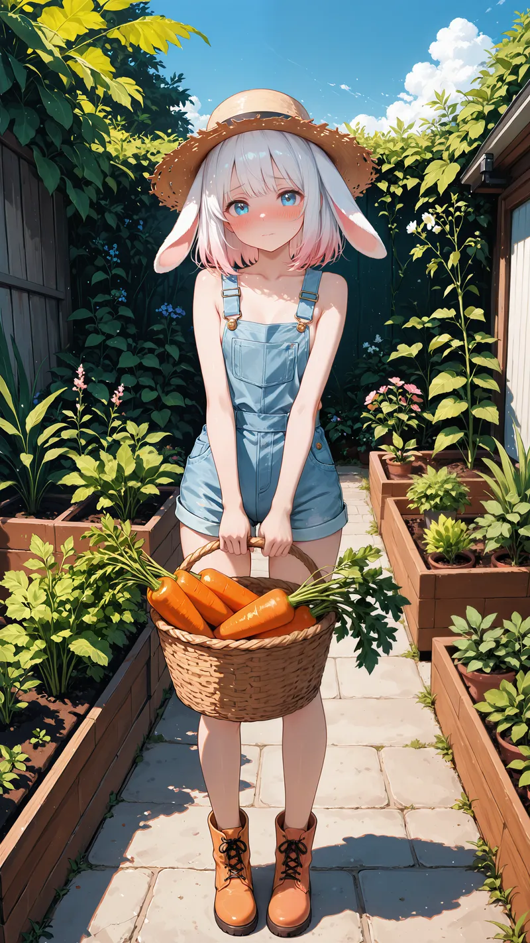
Dear Diary,
Today I had another dream about the garden… and I am writing this with my ears folded over my face, because I am almost certain the carrots know what I was thinking 🐰🥕
It was morning, bright and warm, the kind of morning where the sun kisses every leaf and makes everything smell green and alive. I was in my little overalls, carrying a basket through the vegetable beds like a proper hardworking bunny girl. Very wholesome. Very respectable. Very safe.
Except… the carrots were huge.
Diary, why were they all so big? Why did they have to grow so straight... and smooth... and shiny? Why did the leaves look so fluffy when I pulled them from the soil? Why did every single one make my paws tighten around the basket handle like I had been caught stealing something?
I kept telling myself: They are for breakfast. They are for soup. They are for vitamins. Good bunny girls eat vegetables.
But my thoughts kept hopping somewhere else.
Somewhere warmer.
Somewhere softer.
Somewhere that made my knees press together and my little secret meadow tremble just from looking at them 🌸💦
I was so embarrassed that I nearly dropped the whole basket. My cheeks were burning, my ears felt hot under my straw hat, and there was this fluttering feeling low in my tummy, like a hundred tiny butterflies had gotten lost and were all trying to escape at once. I wanted to run inside and hide under my blanket. I also wanted to keep looking.
That is when Losfy appeared...
My sweet dream-friend Losfy, with her little horns, black nails, and that warm, calm smile that always makes me feel safe… and somehow also like she knows far too much 🤍🖤
She looked at me.
Then she looked at the basket.
Then she looked at me again.
Diary… I almost watered my overalls! 💦
Not because she was scary exactly, but because suddenly I felt like a criminal bunny standing at the scene of a very orange crime. The silence between us grew longer and longer, and I knew it was asking me to explain why I was blushing at a basket full of vegetables.
So I tried to say something normal.
I really did.
But what came out was:
“I... I... I p-picked them b-b-because they fit p-perfectly in my… b-basket...”
MY BASKET! 🧺
Diary.
I wanted the earth to open and politely bury me beside the potatoes.
Losfy tilted her head. I think she understood everything. Of course she did. My own imagination made her, after all, and apparently my imagination is a shameless little traitor with very elegant horns.
But she did not laugh at me.
She did not tease me.
She only stepped closer, took the basket from my trembling paws, and hugged me so gently that all the panic inside me began to melt. She stroked my ears with slow, careful fingers, and I almost cried because I had been so sure she would scold me.
Instead, she whispered:
“Your feelings are normal, Misty. You are still a good bunny girl. You are allowed to be curious. You are allowed to want things. At least here, inside your dream, you do not have to be afraid of yourself 🖤”
Oh, Diary… 🥺
I think that was the moment my heart became softer than the soil after summer rain.
I hugged her back and hid my burning face against her shoulder and burst into tears... I was still ashamed. Of course I was. A respectable bunny does not simply stop being embarrassed because a very kind goat-girl says beautiful things while holding a basket of suspiciously inspiring carrots.
But I felt less alone.
I felt seen.
And maybe… just maybe… I felt brave enough to admit that summer is coming, the garden is growing, and some thoughts bloom whether we invite them or not 🌿☀️
Then the dream faded.
I woke up smiling.
And there, under my pillow…
was one carrot 🥕
Diary, I squealed in fear and alarm, wetting the sheet a little, and then began to remember how that carrot ended up under the pillow... 😱
I do not know what my dreams are trying to tell me anymore, but I hope everyone has a wonderful harvest season, warm sunny days, and lots of sweet, juicy vegetables…
For eating.
Obviously.
Mostly.
Probably.
Happy summer, diary 🐰🥕💦

OC: Misty - Dressed for Trouble 🎀😳🏰

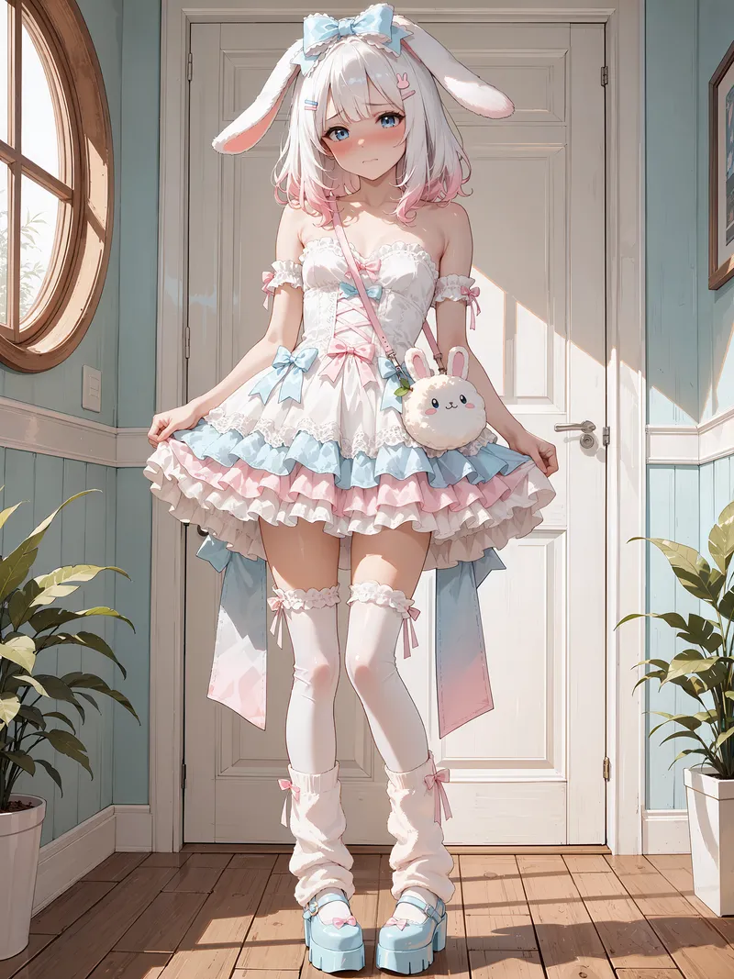
Dear Diary,
I had another dream about Losfy last night.
And before I tell you anything else, I need to make one thing perfectly clear:
I was doing morning things.
Normal morning things.
Respectable bunny things.
Things that absolutely do not require further explanation 🐰🤍
I was sitting on my bed in my pajamas, enjoying the warm morning sunlight, when suddenly my bedroom door opened without so much as a knock.
And there she was.
Losfy.
“Good morning, Misty~ 🖤”
I screamed.
She blinked.
I grabbed the carrot beside me and shoved it under my pillow so quickly that I nearly launched Mr. Blush across the room.
Diary, I do not think I have ever moved that fast in my entire life.
Losfy looked at me.
Then at the suspiciously carrot-shaped bump under my pillow.
Then back at me.
And slowly… slowly… that little satisfied smile appeared on her face.
The one with the tiny sharp teeth.
Oh no.
“I-I was just… um… checking it!”
“Checking it?”
“Yes!”
“For what?”
“For… quality!”
Diary.
I should have stopped talking.
But panic had already taken control of my mouth.
“I mean, carrots can go bad! And this one was very firm, so I... I thought I should test whether it stayed firm overnight, because firmness is im-important when you… when y-you…”
I could feel my entire face catching fire.
“When you use carrots?” Losfy offered sweetly.
“YES!”
Silence.
“FOR COOKING!”
More silence.
“Obviously.”
Losfy nodded with the most serious expression I had ever seen.
“Obviously.”
She did not laugh.
That somehow made it worse.
She simply walked past me, gently patted the pillow hiding the evidence, and said, “Very responsible of you, Misty. A good bunny should always inspect her vegetables personally.”
DIARY!!! 🥕😳💦
I wanted to crawl inside my pillowcase and live there forever.
But then Losfy sat beside me and, as though nothing suspicious had happened at all, told me she had come because she wanted to invite me somewhere.
“To… b-breakfast?”
“No.”
“To the market?”
“No.”
“A picnic?”
She smiled.
“A ball.”
I think my ears actually stopped working for a moment.
“A… ball?”
“A real one. In a real castle. There will be music, dancing, beautiful lights, wonderful food…”
“A castle?!”
I forgot the carrot immediately.
Diary, I have never been inside a real castle.
I have never attended a ball.
I have never even eaten food that could reasonably be called a royal banquet instead of “whatever was left in the pantry and still smelled acceptable.”
For one wonderful moment, my head filled with everything I had dreamed about as a little bunny: enormous chandeliers, shining halls, beautiful dresses floating across marble floors, musicians playing somewhere above the crowd, and elegant people dancing as though they had practiced their entire lives just for one magical evening ✨🏰💗
And then reality attacked me.
People.
So many people.
Strangers.
Talking.
Looking at me.
Possibly expecting me to talk back.
Dancing where everyone could see me.
I immediately pulled my blanket over my knees.
“I-I don’t know, Losfy…”
She tilted her head.
“What if I say something stupid?”
“You probably will.”
“LOSFY!”
“So will everyone else.”
“What... what if I trip?”
“I’ll catch you.”
“What if I don’t know how to... to dance?”
“Then you step on my feet until you learn.”
“What if everyone looks at me?”
Losfy’s expression softened.
“Then let them.”
I stared at her.
She reached over and gently brushed one of my ears behind my shoulder.
“You are allowed to be seen, Misty.”
Oh.
Diary…
Why does she sometimes say things that make my heart hurt in the nicest possible way? 🥺🤍
I was almost brave enough to say yes.
And then another terrible realization struck me.
“I CAN’T GO!”
Losfy jumped slightly.
“What happened?”
“I HAVE NOTHING TO WEAR!”
I ran to my wardrobe.
Garden clothes.
Market clothes.
Walking clothes.
Two summer dresses.
One dress with strawberries on it that I love very much but would probably make me look like I had accidentally wandered into the castle while searching for a picnic.
“That’s it!” I cried. “I can’t go to a royal ball wearing something I use to buy flour!”
My nose started to sting.
I know it sounds silly, Diary, but suddenly the whole beautiful dream felt like it had been taken away from me before I even had the courage to accept it.
“I’ll look ridiculous…”
“Misty.”
“I don’t belong at a ball…”
“Misty.”
“Everyone will be beautiful and elegant and I’ll look like somebody brought their gardener—”
“Misty.”
I turned around.
Losfy was smiling.
Not her dangerous smile.
Not her teasing smile.
A warm one.
The kind that makes you feel as though perhaps the world has not ended after all.
She raised one hand.
Black and crimson mist curled between her fingers.
I squeaked and immediately jumped into the corner.
“DARK MAGIC!”
Losfy sighed.
“Misty, you have seen me do magic before.”
“IT IS STILL VERY DARK!”
The mist swirled together, growing thicker until something appeared inside it.
A box.
A beautiful pale pink and baby-blue box covered in tiny ribbons, stars, and a little smiling bunny painted on the lid 🎀🐰✨
I forgot to be afraid immediately.
“…What is that?”
Losfy looked unbearably pleased with herself.
“A gift.”
“For… me?”
“For the terrifying bunny hiding from a cardboard box in the corner, yes.”
I slowly approached.
“Can I…?”
I reached toward it, then stopped and looked at her.
She laughed softly.
“Yes, sweetheart. It is yours.”
Diary, I may have squealed.
Just a little.
Maybe a lot.
I hugged the box to my chest, carried it to the bed, and immediately began untying every ribbon I could find.
But somewhere in the back of my mind, one small sensible thought remained:
This is Losfy.
Losfy, my wonderful, kind, caring dream-friend.
Losfy, who somehow knows far too much.
Losfy, whose gifts should perhaps be inspected by Mr. Blush before opening.
I lifted the lid.
And forgot every concern I had ever possessed.
The dress was beautiful.
No.
Beautiful is not enough.
It looked like somebody had taken a cloud at sunrise, mixed it with sugar, ribbons, summer sky, and every princess story I had ever loved, and turned all of it into one dress.
I actually covered my mouth.
“Losfy…”
“Do you like it?”
I nodded so quickly my ears bounced.
“I love it.”
Her smile became so warm that for a moment she almost looked happier than I was.
Then I remembered something.
“Oh! Um… could you please wait outside while I change?”
“No.”
I stared at her.
She stared back.
“…No?”
“Misty, look at all those ribbons.”
I looked at the dress.
There were indeed many ribbons.
“And the corset.”
I swallowed.
“And those fastenings in the back.”
I swallowed again.
“You will become trapped halfway inside it and I will find you three hours later, crying with your head through the wrong opening.”
“That would not happen!”
Losfy raised one eyebrow.
“…Probably.”
“And,” she continued, “we are girls. We are friends. There is nothing I have not—”
She stopped.
“Nothing you haven’t what?”
“Nothing.”
“LOSFY.”
“Change, bunny.”
So I did.
Very slowly.
With my back turned.
My face became warmer with every tiny piece of pajama fabric that stopped protecting my dignity.
I pulled off my top and immediately covered myself with one arm.
Losfy said nothing.
I could feel her watching.
I could feel that smile behind me.
Then came my pajama pants.
Diary…
Being undressed alone is normal.
Being undressed in front of your friend should probably also be normal.
So why did I suddenly become so aware of every inch of myself?
My knees.
My tummy.
My shoulders.
My legs.
The cold morning air touching places that normally remained comfortably hidden.
I think my entire body had turned pink by the time Losfy finally rescued me by lifting the dress from the box.
“Come here.”
And somehow, the moment she said it, I did.
She helped me step into the layers of fabric.
She pulled them carefully upward.
She adjusted the bodice.
Tightened one ribbon.
Loosened another.
Fastened something behind my back.
Her fingers moved with such confidence that I wondered how many dresses she had helped people into before.
At one point I noticed a faint red glow above my shoulder.
“Losfy?”
“Yes?”
“Your... your horns are glowing.”
She froze.
I looked at her reflection in the mirror.
She smiled.
“That happens when I see something exceptionally beautiful.”
“Oh.”
I smiled.
Then I realized she might have meant me.
I stopped smiling.
Then I started smiling again.
Then I turned bright red.
Diary, feelings are exhausting 💗
When the dress was finally on, I looked into the mirror.
And…
Was that really me?
I turned left.
Then right.
I lifted the skirt slightly and watched all those soft pink and blue layers move.
I spun once.
Then twice.
I actually laughed.
I looked like a girl from one of those stories.
Not the girl watching the princess through the castle gates.
The girl who had been invited inside.
I was so happy I nearly forgot everything else.
Nearly.
I suddenly remembered the box and happily bounced back toward it on bare feet.
There were shoes.
Stockings.
Little accessories.
A bunny purse!
I loved the bunny purse immediately and decided I would defend it with my life.
But…
I searched again.
Then once more.
Then very carefully beneath the tissue paper.
“…Lo-Losfy?”
“Yes, bunny?”
“I think… um…”
I lowered my voice.
“…I think they forgot something.”
“Did they?”
“The… bottom part.”
Losfy looked down at the dress.
“The skirt is there.”
“No!”
My voice cracked.
“The other bottom part!”
Her smile slowly widened.
“Oh.”
I wanted to die.
“That.”
“Yes, that!”
“No, nothing was forgotten. I checked personally.”
My face went completely blank.
Then completely red.
“What do you mean… nothing was forgotten?”
“Everything required for the outfit is in the box.”
Diary.
I walked to my dresser.
I opened the first drawer.
Empty.
Second drawer.
Empty.
Third drawer.
EMPTY.
“WHERE ARE THEY?!”
I began searching desperately.
Behind me, somewhere near the door, there was a faint tap tap tap tap.
Losfy glanced over.
Mr. Blush stood in the doorway.
He looked furious.
In his little plush paws was my missing underwear.
Losfy calmly walked to the door.
Mr. Blush held them higher.
Losfy smiled.
And closed the door directly in his face.
Tap.
Tap tap tap.
My ear turned toward the sound.
“What was that?”
“The wind.”
“The wind is knocking?”
“Strong summer wind.”
“Oh.”
I returned to my search.
Eventually I turned to Losfy with tears of frustration gathering in my eyes.
“I can’t find any!”
“Then perhaps you do not need them.”
I stared at her.
“Losfy.”
“Yes?”
“There will be people at this ball.”
“Yes.”
“M-Men?”
“Some.”
I immediately squeezed my knees together.
“MEN?!”
“Well, of course. mostly handsome ones.”
“I... I... I CAN’T GO LIKE THIS!”
“Why?”
“Because I’ll be… I’ll be…”
“Yes?”
“Unprotected!”
Losfy covered her mouth, but I could see her shoulders move.
She was laughing.
“This is serious!”
“I know.”
“What if there is wind?”
“It is inside a castle.”
“What if there is a balcony?”
“Do not stand on the balcony during a hurricane.”
“What if I have to walk upstairs?”
“Use the stairs normally.”
“What if I trip?!”
“I’ll catch you, I told you.”
“What if somebody sees?”
“Then that person was looking somewhere they should not.”
“But I’ll know!”
“That they were looking?”
“That there was something to see!”
Losfy paused.
Diary…
I realized my mistake immediately.
Her smile became absolutely unbearable.
I covered my face.
“I DIDN’T MEAN IT LIKE THAT!”
“Of course not.”
“I... hate you.
“No, you don’t.”
“…No.”
She came closer and took both my hands.
“Misty.”
I peeked at her through my fingers.
“You do not have to do anything that truly frightens you.”
Her voice had changed.
It was gentle again.
“But sometimes there is a difference between being afraid because you do not want something… and being afraid because a part of you wants it very much.”
My heart thumped.
I looked down.
“Which one am I?”
Losfy squeezed my hands softly.
“You tell me.”
I was quiet for a long time.
Then, very quietly:
“…Can I still keep the dress?”
She laughed and hugged me.
“Yes, silly bunny.”
So…
I stayed exactly as I was.
I put on the stockings.
The soft leg warmers.
The shoes.
I fixed the little bows.
And finally I placed the bunny purse across my shoulder.
When I turned around for Losfy’s final inspection, she went completely silent.
My confidence lasted approximately three seconds.
“What?”
She slowly looked me up and down.
Her horns began glowing again.
“Losfy!”
She smiled, showing those tiny sharp teeth.
“Misty… tonight, every candle in that castle is going to be jealous of how beautifully you glow.”
My heart melted.
Then she added, very softly:
“And knowing what such a sweet little bunny is hiding beneath all those innocent ribbons…”
“LOSFY! 😳”
My knees slammed together.
I grabbed the hem of my dress and pulled it almost to my knees.
My face felt hot enough to cook breakfast on.
I could not look her in the eyes.
And then…
plip...
I looked down.
A tiny drop had landed on the wooden floor.
Silence.
Absolute silence.
I slowly looked at Losfy.
Losfy looked at the floor.
Then at me.
Her smile became terrifyingly pleased.
I wanted to evaporate.
She leaned a little closer.
“This ball,” she whispered, “is going to be very interesting… 🖤”
And then I woke up.
Just like that.
In my bed.
My heart pounding.
My face burning.
My legs squeezed tightly together beneath the blanket.
And, Diary…
I think I am going to the ball.
I am terrified.
I am excited.
I have no idea how to dance.
I apparently have no underwear.
And my imaginary goat-girl friend is absolutely not explaining what kind of castle she is taking me to.
What could possibly go wrong?
…Please do not answer that...
🐰🎀🏰🖤

