**Day : Arrays (6-8-2025)**

CODE: CSA0238

NAME: LOSHINI.L

REG NO: 192571015

1. **Write a program to read and print elements of an array.**

**IPO**

* **Input:**

Get a value as input say n

* **Process:**

Use a loop to read n elements and store them in the array

Use another loop to print all the elements

* **Output:**

The output is to print elements of an array.

**Program**

#include <stdio.h>

void main()

{

int arr[100],i,n;

scanf("%d",&n);

for(i=0;i<n;i++)

{

scanf("%d",&arr[i]);

}

printf("The array elements are:\n");

for(i=0;i<n;i++)

{

printf("%d",arr[i]);

}

}

**Output**

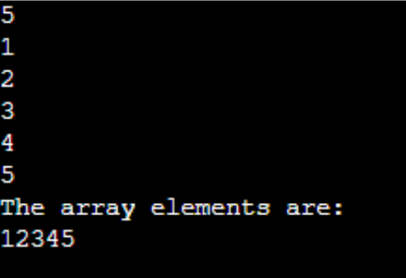

**2. Write a program to find the sum of elements of an array.**

**IPO**

* **Input:**  
  Get a value as input say n  
  Get n elements and store them in the array
* **Process:**

Use a loop to read n elements and store them in the array

Use another loop to calculate the sum of all elements

* **Output:**  
   The output is to print the sum of elements of the array

**Program**

#include<stdio.h>

void main()

{

int a[5]={1,2,3,4,5};

int i,n,sum=0;

printf("enter number of elements:");

scanf("%d",&n);

printf("enter %d elements:\n",n);

for(i=0;i<n;i++)

{

scanf("%d",&a[i]);

sum=sum+a[i];

}

printf("sum of array:%d\n",sum);

}

**Output**

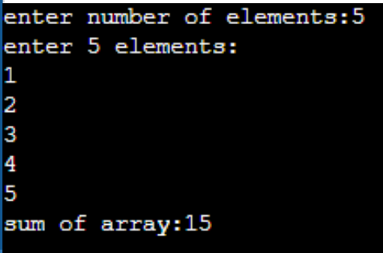

**3. Write a program to find the maximum and minimum element in an array.**

**IPO**

* **Input:**

Get a value as input say n  
Get n elements and store them in the array

* **Process:**

Use a loop to read n elements and store them in the array

Initialize max and min to the first element of the array

Traverse the array to compare and update max and min

* **Output:**

The output is to print the maximum and minimum element in the array

**Program**

#include <stdio.h>

void main()

{

int arr[5] = {1, 3, 2, 5, 10};

int n=5;

int i,max,min;

max=arr[0];

for(i=0;i<n;i++)

{

if(arr[i]>max)

{

max=arr[i];

}

}

min=arr[0];

for(i=0;i<n;i++)

{

if(arr[i]<min)

{

min=arr[i];

}

}

printf("Max: %d\n", max);

printf("Min: %d\n", min);

}

Output

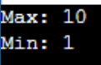

**4. Write a program to reverse an array.**

**IPO**

* Input:

Get a value as input say n

Get n elements and store them in the array

* Process:

Use a loop to read n elements and store them in the array

Use another loop to print elements from the last index to the first index

* Output:

The output is to print the array elements in reverse order

**Program**

#include <stdio.h>

void main()

{

int arr[100]={1,2,3,4,5};

int n=5, i;

for(i = 0; i < n; i++)

{

scanf("%d", &arr[i]);

}

printf("Reversed numbers:\n");

for(i = n - 1; i >= 0; i--)

{

printf("%d", arr[i]);

}

}

**Output**

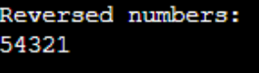

**5. Write a program to search for an element in an array (linear search).**

**IPO**

* Input:

Get a value as input say n

* Process:

Use a loop to compare each element of the array with the search element

If a match is found, print the position

If not found, print"Element not found"

* Output:

Print the position if the element is found

Print "Element not found" if it doesn’t found in the array

**Program**

#include <stdio.h>

void main()

{

int a[100], n, i, b, found = 0;

printf("Enter number of elements: ");

scanf("%d", &n);

printf("Enter %d elements:\n", n);

for(i = 0; i < n; i++)

{

scanf("%d", &a[i]);

}

printf("Enter the element to search: ");

scanf("%d", &b);

for(i = 0; i < n; i++)

{

if(a[i] == b)

{

found = 1;break;

}

}

if(found)

printf("Element %d found at position %d\n", b, i + 1);

else

printf("Element not found in the array.\n");

}

Output

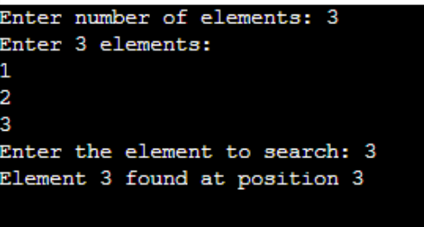

**6. Write a program to sort an array in ascending order.**

**IPO**

* **Input:**

Get a value n (number of elements)

Get n elements into an array

* **Process:**

Use nested loops to compare and swap elements if needed

Sort array in ascending order

* **Output:**

Print the sorted array in ascending order

**Program**

#include<stdio.h>

void main()

{

int a[100], n, i, j, temp;

scanf("%d", &n);

for(i = 0; i < n; i++)

scanf("%d", &a[i]);

for(i = 0; i < n - 1; i++)

{

for(j = i + 1; j < n; j++)

{

if(a[i] > a[j])

{

temp = a[i];

a[i] = a[j];

a[j] = temp;

}

}

}

printf("Sorted array: ");

for(i = 0; i < n; i++)

printf("%d ", a[i]);

}

**Output**

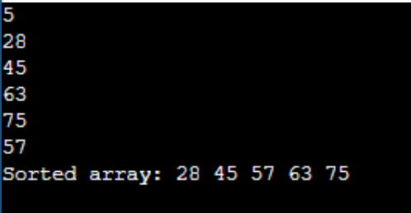

7. Write a program to insert an element in an array.

IPO

* **Input:**

Get number of elements n

Get array elements

Get element to insert and position to insert

* **Process:**

Shift elements to the right from the given position

Insert new element

* **Output:**

Print array after insertion

**Program**

#include <stdio.h>

void main()

{

int a[100], n, i, x, y;

scanf("%d", &n);

for(i = 0; i < n; i++)

scanf("%d", &a[i]);

scanf("%d", &y);

scanf("%d", &x);

for(i = n; i > y; i--)

a[i] = a[i - 1];

a[y] = x;

n++;

printf("Array after insertion: ");

for(i = 0; i < n; i++)

printf("%d ", a[i]);

}

**Output**

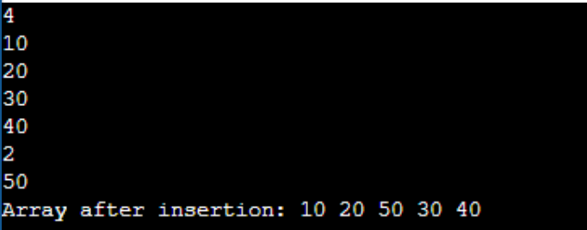

**8. Write a program to delete an element from an array.**

**IPO**

* Input:

Get number of elements n

Get array elements

Get the position to delete

* Process:

Shift all elements to the left from that position

* Output:

Print array after deletion

**Program**

#include<stdio.h>

void main()

{

int a[100],n,i,p;

scanf("%d",&n);

for(i=0;i<n;i++)

scanf("%d",&a[i]);

scanf("%d",&p);

for(i=p;i<n-1;i++)

a[i]=a[i+1];

n--;

printf("Array after deletion: ");

for(i=0;i<n;i++)

printf("%d ",a[i]);

}

**Output**

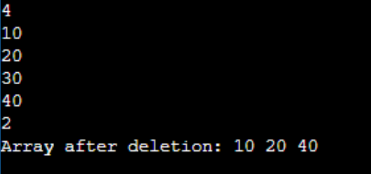

**9. Write a program to find the frequency of elements in an array.**

* Input:

Get number of elements n

Get array elements

* Process:

Use a loop to count how many times each unique element appears

Mark counted elements

* Output:

Print frequency of each unique element

**Program**

#include<stdio.h>

void main()

{

int a[100], n, i, j, count;

printf("enter number of elements: ");

scanf("%d", &n);

printf("enter %d elements:\n", n);

for(i = 0; i < n; i++)

{

scanf("%d", &a[i]);

}

printf("frequincies:\n");

for(i = 0; i < n; i++)

{

count = 0;

for(j = 0; j < i; j++)

{

if(a[i] == a[j])

{

count = 1;

break;

}

}

if(count == 0)

{

count = 1;

for(j = i + 1; j < n; j++)

{

if(a[i] == a[j])

count++;

}

printf("%d appears %d times\n", a[i], count);

}

}

}

**Output**

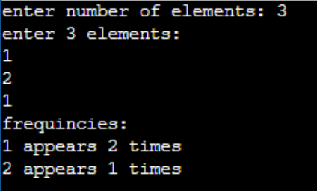

**10. Write a program to merge two arrays.**

**IPO**

* Input:

Get two values n1 and n2

Get n1 elements in first array

Get n2 elements in second array

* Process:

Copy elements of both arrays into a third array

* Output:

Print the merged array

**Program**

#include <stdio.h>

void main()

{

int a1[50], a2[50], me[100];

int n1, n2, i, j;

scanf("%d", &n1);

for(i = 0; i < n1; i++)

scanf("%d", &a1[i]);

scanf("%d", &n2);

for(i = 0; i < n2; i++)

scanf("%d", &a2[i]);

for(i = 0; i < n1; i++)

m[i] = a1[i];

for(j = 0; j < n2; j++)

m[i + j] = a2[j];

for(i = 0; i < n1 + n2; i++)

printf("%d ", m[i]);

}

**Output**

