SUBJECT : ME 210

REG. NO : E/21/047

NAME : BANDARA B.S.M.L.U

DATE : 19/05/2025

VAPOUR COMPRESSION REFRIGERATION

1. Briefly describe industrial applications of vapour compression refrigeration.

Vapour compression refrigeration systems are widely used across various industrial applications due to their efficiency and reliability.

1. **Food and Beverage Industry:** Large-scale refrigeration for food processing plants, cold storage warehouses, dairy processing facilities, and beverage production lines. These systems maintain precise temperature control for food preservation and processing.
2. **Chemical and Pharmaceutical Industries:** Process cooling for chemical reactions, pharmaceutical manufacturing where temperature control is critical for product quality, and storage of temperature-sensitive materials and vaccines
3. .**HVAC Systems:** Commercial and industrial air conditioning systems for large buildings, shopping malls, hospitals, and manufacturing facilities where climate control is essential for comfort and process requirements.
4. **Ice Manufacturing:** Industrial ice production for fisheries, food processing, concrete cooling in construction, and commercial ice supply.
5. **Data Centers:** Cooling of server rooms and data centers where precise temperature control is crucial for equipment reliability and performance.
6. **Petrochemical Industry:** Gas liquefaction processes, separation of hydrocarbon components, and cooling in refinery operations.

1. Use the following observations and calculate the mentioned parameters.

Consider the **pth** set of readings from Table 01 below. p is the remainder of your registration number when it is divided from 15. (If the reminder is 0, then select the last data set)

Table 01:

|  |  |  |  |  |  |  |  |  |  |
| --- | --- | --- | --- | --- | --- | --- | --- | --- | --- |
| No. | TIME | REFRIGERANT | | | | | | | LOAD |
| COMPRESSOR | | | | EXP. VALVE INLET | FLOW METER | DRIVE MOTOR | ICE VESSEL |
| (min.) | P1 (kgf/cm2) | P2 (kgf/cm2) | (0C) | (0C) | (0C) | F (ltr.) | W (kW) | (0C) |
| **1.** | 0 | 0.5 | 8 | 25 | 78 | 36 | 5734.04 | 0.828 | 23.2 |
| **2.** | 5 | 0.5 | 8 | 25 | 78 | 36 | 5748.32 | 0.828 | 23.1 |
| **3.** | 10 | 0.5 | 8 | 25 | 78 | 36 | 5761.76 | 0.828 | 23.0 |
| **4.** | 15 | 0.5 | 8 | 25 | 78 | 36 | 5775.12 | 0.828 | 22.8 |
| **5.** | 20 | 0.5 | 8 | 25 | 78 | 36 | 5786.27 | 0.828 | 22.7 |
| **6.** | 25 | 0.5 | 8 | 25 | 79 | 36 | 5799.65 | 0.828 | 22.6 |
| **7.** | 30 | 0.5 | 8 | 25 | 79 | 36 | 5812.54 | 0.828 | 22.5 |
| **8.** | 35 | 0.5 | 8 | 25 | 79 | 36 | 5825.02 | 0.828 | 22.4 |
| **9.** | 40 | 0.5 | 8 | 25 | 79 | 36 | 5839.25 | 0.828 | 22.3 |
| **10.** | 45 | 0.5 | 8 | 25 | 79 | 36 | 5853.14 | 0.828 | 22.2 |
| **11.** | 50 | 0.5 | 8 | 25 | 79 | 36 | 5867.42 | 0.828 | 22.1 |
| **12.** | 55 | 0.5 | 8 | 25 | 80 | 36 | 5880.06 | 0.828 | 22.1 |
| **13.** | 60 | 0.5 | 8 | 25 | 80 | 36 | 5893.44 | 0.828 | 22.0 |

**Given data**

* Atmospheric pressure – 718 mm Hg
* Ambient temperature – 25 C
* Density of refrigerant (R134a) – 0.00425 g/cm3
* CP value of refrigerant (R134a) – 0.8509 KJ/KgK

1. Calculate the specific enthalpy values of refrigerant at point 1 (Inlet/Suction side of compressor) & point 2 (Outlet/Delivery side of compressor).

(Hint: First convert P1 & P2 pressure values to Pascals & refer to refrigerant property tables)

Consider the 2nd data set from table 01,

Point 1,

P1 = 49033.25 + (718 \* 13600\*9.81)/1000 = 144.825 KPa

T1 = 25°C

h1 = 424 KJ/Kg

Point 2,

P2 = 784532+ (718 \* 13600\*9.81)/1000 = 880.324 Kpa

T2 = 78 °C

h2 = 462KJ/Kg

1. Calculate the volumetric flow rate & mass flow rate of the refrigerant (GR).

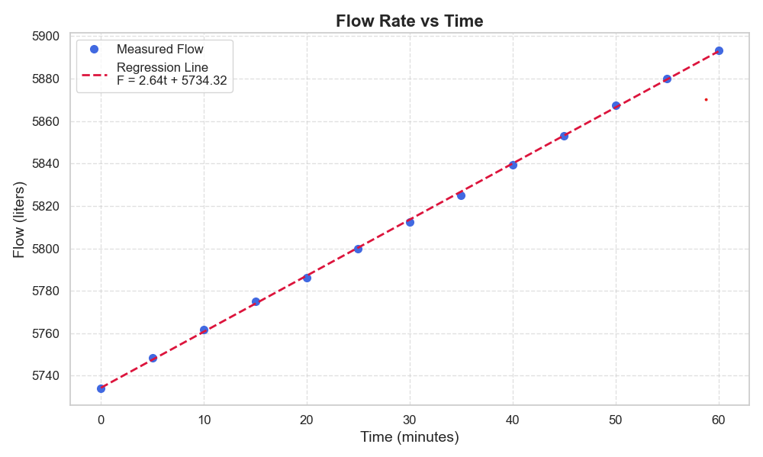

**Figure 01**

Flow Rate (ltr/min) = (5890 - 5760)/(60 - 10) = 2.64ltr/min

Mass Flow Rate = 2.6 ltr/min × 0.00425 kg/ltr = 0.01105 Kg/min = 1.87 × 10-4 kg/s

1. Calculate the temperature difference corresponding to point 2 & point 3. (ΔT1)

From the 2nd data set,

(ΔT) = T2 - T3

= 78 - 36

= 42 °C

1. Calculate the specific enthalpy values of refrigerant at point 3 (Inlet/Suction side of compressor) & point 4 (Outlet/Delivery side of compressor).

(Hint: Consider the condensing process and ΔT1 value)

Consider 2nd data set,

Pressure of the condensor P2 = 880.326 Kpa

From property table,

Tsat = 34.68°C

Hf g(latent heat) = 168.51KJ/Kg

Considering energy balance,

ℎ3 = ℎ2 − 𝐶𝑝∆𝑇1 − ℎ𝑓𝑔

=462𝑘𝐽/𝑘𝑔 − 0.8509 𝑘𝐽/𝑘𝑔.𝐾 × 42𝐾 − 168.51 𝑘𝐽/𝑘𝑔

= 258.04 𝑘𝐽/𝑘𝑔

Assuming the expansion valve works as an isenthalpic process,

∴ ℎ4 = 258.04 𝑘𝐽/𝑘

1. Calculate the efficiency of the compressor (h)

𝜂% = [GR (ℎ2 − ℎ1)] × 100%

W

= 1.87× 10−4kg/s × (462 – 424) kJ/kg × 100%

0.828kJ/s

= 0.865 %

1. Calculate the refrigerant effect (Q0).

𝑄0 = 𝐺𝑅 (ℎ1 − ℎ4)

= 1.87× 10−4kg/s× (424 –258.04) kJ/kg

= 0.03103 kW

1. Calculate the coefficient of performance. (COP)

COP = (h1 – h3)/(h2 – h1)

= (h1 – h4)/(h2 – h1)

= ( 424 –258.04) / (462– 424 )

= 4.33

1. Calculate the temperature difference between the evaporator chamber & the surrounding. (ΔT2)

Δ𝑇2 = 𝑇s𝑢𝑟𝑟𝑜𝑢𝑛𝑑 − 𝑇v

= 25 – 23.1 ℃

= 1.9 ℃

1. Tabulate the results.

Table 02: Enthalpy values of the refrigerant

|  |  |  |  |  |  |  |  |
| --- | --- | --- | --- | --- | --- | --- | --- |
| TIME (min.) | P1 (kPa) | P2 (kPa) | h1 (kJ/kg) | h2 (kJ/kg) | ΔT1 (0C) | h3 (kJ/kg) | h4 (kJ/kg) |
| 0 | 144.826 | 880.324 | 424 | 462.29 | 42 | 258.04 | 258.04 |
| 5 | 144.826 | 880.324 | 424 | 462.29 | 42 | 258.04 | 258.04 |
| 10 | 144.826 | 880.324 | 424 | 462.29 | 42 | 258.04 | 258.04 |
| 15 | 144.826 | 880.324 | 424 | 462.29 | 42 | 258.04 | 258.04 |
| 20 | 144.826 | 880.324 | 424 | 462.29 | 42 | 258.04 | 258.04 |
| 25 | 144.826 | 880.324 | 424 | 463.31 | 43 | 258.21 | 258.21 |
| 30 | 144.826 | 880.324 | 424 | 463.31 | 43 | 258.21 | 258.21 |
| 35 | 144.826 | 880.324 | 424 | 463.31 | 43 | 258.21 | 258.21 |
| 40 | 144.826 | 880.324 | 424 | 463.31 | 43 | 258.21 | 258.21 |
| 45 | 144.826 | 880.324 | 424 | 463.31 | 43 | 258.21 | 258.21 |
| 50 | 144.826 | 880.324 | 424 | 463.31 | 43 | 258.21 | 258.21 |
| 55 | 144.826 | 880.324 | 424 | 464.34 | 44 | 257.36 | 257.36 |
| 60 | 144.826 | 880.324 | 424 | 464.34 | 44 | 257.36 | 257.36 |

Table 03: Variation of ΔT2, h, Q0 & COP with time

|  |  |  |  |  |
| --- | --- | --- | --- | --- |
| TIME (min.) | Temperature difference ΔT2 (0C) | Efficiency of the compressor h  (%) | Refrigerant effect  Q0  (kW × 10-3) | Coefficient of performance  COP |
| 0 | 1.8 | 0.865 | 31.03 | 4.33 |
| 5 | 1.9 | 0.865 | 31.03 | 4.33 |
| 10 | 2.0 | 0.865 | 31.03 | 4.33 |
| 15 | 2.2 | 0.865 | 31.03 | 4.33 |
| 20 | 2.3 | 0.865 | 31.03 | 4.33 |
| 25 | 2.4 | 0.888 | 31.00 | 4.22 |
| 30 | 2.5 | 0.888 | 31.00 | 4.22 |
| 35 | 2.6 | 0.888 | 31.00 | 4.22 |
| 40 | 2.7 | 0.888 | 31.00 | 4.22 |
| 45 | 2.8 | 0.888 | 31.00 | 4.22 |
| 50 | 2.9 | 0.888 | 31.00 | 4.22 |
| 55 | 2.9 | 0.911 | 31.16 | 4.13 |
| 60 | 3.0 | 0.911 | 31.16 | 4.13 |

**DISCUSSION**

1. Explain all assumptions with reasons which you have to made during the observations and calculations.
2. Steady state operation :

We assumed that the system operates under steady-state conditions, meaning that the operating conditions do not change with time. Although the experimental data shows gradual variations over the 60-minute period.

1. **Isenthalpic Expansion Process:**

We assumed that the expansion valve does not transfer heat to or from its surroundings, considering the expansion process as a constant enthalpy (isenthalpic) process.

1. **Constant Specific Heat Capacity:**

We assumed that the specific heat capacity (Cp = 0.8509 kJ/kg·K) remains constant for the working fluid (R134a) over the entire temperature range. This assumption is made because:

× The temperature range in the experiment (25-80°C) is relatively narrow

× Variation in Cp over this range is typically less than 5% for R134a

1. **Interpolation Method for Enthalpy Values:**

We used linear interpolation between tabulated property values, assuming that the interpolated values represent the actual values. This is reasonable because:

× Thermodynamic properties vary smoothly with temperature and pressure

× Linear interpolation provides good accuracy for small intervals

1. **Constant Mass Flow Rate:**

We assumed the mass flow rate to be constant throughout the system and over time. This assumption is justified because:

× The refrigeration system operates as a closed loop

× Mass conservation requires constant mass flow rate in steady state

1. Compare your results & comment on it from an engineer’s point of view.

The experimental data shows a concerning trend where COP decreases over time (from 4.33 to 4.13) while the calculated compressor efficiency appears to increase (from 0.865% to 0.911%). This counterintuitive behavior is likely attributed to:

**· **Sensor accuracy limitations:**** Temperature and pressure measurements may have systematic errors that become more pronounced as operating conditions change

**· **Data interpolation effects**:** The use of interpolated property values may introducecumulative errors in enthalpy calculations

**· **Transient system behavior:**** The system may still be approaching true steady-state conditions, affecting the validity of our steady-state assumptions

An interesting observation is that the refrigerating effect (Q₀) initially decreased with COP but later increased despite continued COP decline (from 31.03 to 31.16 kW×10⁻³). This seemingly contradictory trend may indicate:

**Increased cooling output:** The evaporator may be absorbing more heat as the system stabilizes

**Measurement sensitivity:** Small changes in mass flow rate calculations significantly affect the refrigerating effect

The refrigeration system works properly, but our experimental setup and calculation methods could be improved for more accurate results. The trends we observed match basic refrigeration principles, even though some specific values seem off.

**REFERENCES**

1. **ARANER.** (n.d.) Vapor compression refrigeration cycle: how does it work? [online] ARANER. Available at: [https://www.araner.com/blog/vapor-compression-refrigeration-cycle#:~:text=applicable%20in%20the%20industrial%20sphere,that%20utilize%20vapor%20compression%20refrigeration](https://www.araner.com/blog/vapor-compression-refrigeration-cycle" \l ":~:text=applicable in the industrial sphere,that utilize vapor compression refrigeration" \t "_new) [Accessed 24 May 2025].

2.**Wikipedia.** (2024) Vapor-compression refrigeration. [online] Available at: [https://en.wikipedia.org/wiki/Vapor-compression\_refrigeration#:~:text=domestic%20and%20commercial%20refrigerators%20%2C,be%20implemented%20using%20two%20compressors](https://en.wikipedia.org/wiki/Vapor-compression_refrigeration" \l ":~:text=domestic and commercial refrigerators ,,be implemented using two compressors" \t "_new) [Accessed 24 May 2025].