A
Real-Time Research Project
On

IDENTIFYING FRAUDULENT CREDIT CARD TRANSACTIONS USING ENSEMBLE LEARNING

(Submitted in partial full fillment of the requirements for the award of Degree)

BACHELOR OF TECHNOLOGY
In
COMPUTER SCIENCE AND ENGINEERING
By
L.SUNITHA
(247R1A05V7)
Under the Guidance of
V.NEERAJA
(Assistant Professor)



DEPARTMENT OF COMPUTER SCIENCE AND ENGINEERING
CMR TECHNICAL CAMPUS

UGC AUTONOMOUS
(Accredited by NAAC, NBA, Permanently Affiliated to JNTUH, Approved by AICTE, New Delhi)
Recognized Under Section 2(f) & 12(B) of the UGCAct.1956,
Kandlakoya (V), Medchal Road, Hyderabad-501401.
April, 2026.

DEPARTMENT OF COMPUTER SCIENCE AND ENGINEERING



CERTIFICATE

This is to certify that the project entitled “IDENTIFYING FRAUDULENT CREDIT CARD TRANSACTIONS USING ENSEMBLE LEARNING” being submitted by L.Sunitha (247R1A05V7) in partial fulfillment of the requirements for the award of the degree of B.Tech in Computer Science and Engineering to the Jawaharlal Nehru Technological University Hyderabad, during the year 2025-26.

The results embodied in this thesis have not been submitted to any other University or Institute for the award of any degree or diploma.

V.Neeraja Dr. Nuthanakanti Assistant Professor HoD
INTERNAL GUIDE

ACKNOWLEDGEMENT

We take this opportunity to express our gratitude to the people who have been instrumental in the successful completion of this project. We express our profound gratitude and deep regard to our guide V.Neerja, Assistant Professor for his exemplary guidance, monitoring and constant encouragement throughout the project work. The blessing, help and guidance given by him shall carry us a long way in the journey of life on which we are about to embark.
We take this opportunity to extend our heartfelt appreciation to the Project Review Committee (PRC) Coordinators—Dr. J. Narasimharao, Mrs. V. Neeraja, Mrs. G. Swarnalatha and Mrs. L. Swathi—for their unwavering support, insightful guidance, and valuable inputs, which played a crucial role in steering this project through its various stages.
Our sincere appreciation also goes to Dr. Nuthanakanti Bhaskar, Head, for his encouragement and continuous support in ensuring the successful completion of our project.
We are deeply grateful to Dr. A. Raji Reddy, Director, for his cooperation throughout the course of this project. Additionally, we extend our profound gratitude to Sri. Ch. Gopal Reddy, Chairman, Smt. C. Vasantha Latha, Secretary and Sri. C. Abhinav Reddy, Vice-Chairman, for fostering an excellent infrastructure and a conducive learning environment.
We also acknowledge and appreciate the guidance and assistance provided by the faculty and staff of CMR Technical Campus, whose contributions have been invaluable in bringing this project to fruition.
Lastly, we sincerely thank our families for their unwavering support and encouragement. Their contributions, along with the support of everyone who helped directly or indirectly, have been invaluable in the successful completion of this project.

L Sunitha(247R1A05V7)

VISION AND MISSION

INSTITUTE VISION:

To Impart quality education in serene atmosphere thus strive for excellence in Technology and Research.
INSTITUTE MISSION:

To Create state of art facilities for effective Teaching- Learning Process.

Pursue and Disseminate Knowledge based research to meet the needs of Industry & Society.
- Infuse Professional, Ethical and Societal values among Learning Community.
DEPARTMENT VISION:
To provide quality education and a conducive learning environment in computer engineering that foster critical thinking, creativity, and practical problem-solving skills.
DEPARTMENT MISSION:

M1: To educate the students in fundamental principles of computing and induce the skills needed to solve practical problems.

M2: To provide State-of-the-art computing laboratory facilities to promote industry-institute interaction to enhance student’s practical knowledge.

M3: To inculcate self-learning abilities, team spirit, and professional ethics among the students to serve society.

ABSTRACT

Recognizing fraudulent credit card transactions is one of the main issues facing banking institutions. Since each transaction that completes the authentication procedure must be authorized by financial institutions, a hacker might pose as the actual cardholder and execute a fraudulent transaction. In this paper, we investigated the capacity of ensemble learning methods to identify credit card frauds on two distinct data sets: the Sparkov synthetic dataset and the real dataset of consumers in the European Union. XGBoost models, random forests, and naive Bayes classifiers are applied and assessed on both datasets. Accuracy, precision, recall, and F1 score are used to measure performance. According to the results, most ensemble classifiers perform exceptionally well on the real-world dataset, but significantly poorly on the simulated dataset. This study showed that, unlike in simulated environments, credit card transaction management scripts are quickly learned in deterministic settings. It is discussed that a larger danger of card information leakage results from strict determinism and lack of randomness.

INDEX TERMS: Fintech, credit card fraud detection, ensemble learning, machine learning, simulated data set, real-world data set

LIST OF FIGURES

FIGURE NO | FIGURE NAME | PAGE NO
Figure 1 | Project architecture | 21
Figure 2 | Data flow Diagram | 23
Figure 3 | Regester Page | 43
Figure 4 | Sing in Page | 43
Figure 5 | Enter Transaction Then It Predict Page | 44
Figure 6 | Analyz Transaction Page | 44
Figure 7 | Active Useres Details Page | 45
Figure 8 | Log Out Page | 45

LIST OF TABLES

TABLE NO | TABLE NAME | PAGE NO
Table 1 | Uploading DataSet | 47
Table 2 | Classification | 47

TABLE OF CONTENTS

ABSTRACT i
LIST OF FIGURES ii
LIST OF TABLES iii
1. INTRODUCTION 1
1.1 PROJECT PURPOSE 3
1.2 PROJECT FEATURES 3
2. LITERATURE SURVEY 5
2.1 REVIEW OF RELATED WORK 7
2.2 DEFINITION OF PROBLEM STATEMENT 8
2.3 EXISTING SYSTEM 8
2.4 PROPOSED SYSTEM 9
2.5 OBJECTIVES 10
2.6 HARDWARE & SOFTWARE REQUIREMENTS 11
2.6.1 HARDWARE REQUIREMENTS 11
2.6.2 SOFTWARE REQUIREMENTS 11
3. SYSTEM ARCHITECTURE & DESIGN 12
3.1 PROJECT ARCHITECTURE 13
3.2 DESCRIPTION 14
3.3 DATA FLOW DIAGRAM 14
4. IMPLEMENTATION 16
4.1 ALGORITHMS USED 17
4.2 MODULES 19
4.3 SAMPLE CODE 20
5. RESULTS & DISCUSSION 34
6. VALIDATION 38
6.1 INTRODUCTION 39
6.2 TEST CASES 39
7. CONCLUSION & FUTURE WORK 40
8. REFERENCES 43

1. INTRODUCTION
1. INTRODUCTION
Credit Card Fraud (CCF) detection problem consists of spotting credit card transaction anomalies. In 2020, Visa and MasterCard had more than 2.183 million cardholders. Approximately 1.4 million identity theft reports were reported in 2020, including 393,207 cases of CCF. The loss due to fraudulent usage of credit cards reached $28.6 billion in 2020, where it was $23.97 billion in 2017 with an increase of 19.3%. It is expected to reach $408 billion in the next decade according to the Nilson Report of 2022. This amount shows the big loss and how it is continuously increasing despite the efforts of banks to limit the effects of credit card misuse. It is inevitable to detect CCF in this era of digital payments.
To address credit card misuse, several approaches have been developed belonging mainly to two classes: statistical approaches and machine learning-based approaches. From a statistical point of view, detecting a fraudulent transaction is equivalent to detecting an outlier from a dataset. Consequently, a variety of statistical techniques have been developed and used namely: box and whisker plots, normal distribution-based, cluster-based, etc. The second class of credit card fraud detection techniques is composed of machine learning classifiers. A classifier is designed, developed, fitted, and tuned on a training data set to separate authentic and fraudulent transactions.
Machine learning techniques applied to CCF problems include decision trees, support vector machines, neural networks, regression methods, etc. The performance of such methods varies depending on the used data set. To improve the quality of the classification step, ensemble learning was proposed. The basic idea of ensemble learning is to build an enhanced classifier from a set of naive/basic classifiers. The objective is then to create a strong metalearner (ensemble model) from a list of basic learners (naive classifiers). Many ensemble models have been proposed in the literature depending on the technique used in combining basic classifiers.
For instance, bagging methods create many samples with replacements from the training set and use them to fit in parallel basic classifiers. An aggregation technique is also used to build the final strong classifier like voting. The second type of ensemble learning is comprised of boosting techniques. Boosting consists of creating sequentially basic classifiers, where the prediction error is propagated from one model to the subsequent. Many variants of boosting models have been developed including Adaboost, Gradient boosting, and XGBoost. Stacking, the third type of ensemble method, combines classifiers to find an improved model.
In this paper, a set of ensemble-based classifiers is developed for the detection and prevention of abnormal transactions on credit cards. Three techniques are proposed: a naive Bayes classifier and one from each class of ensemble methods: bagging and boosting. Based on a data set of credit card transactions of European Union consumers available in the Kaggle repository and the synthetic Sparkov dataset, an attempt to find the best ensemble-based model for solving the credit card detection problem is made in this work.

1.1 PROJECT PURPOSE
The primary purpose of this project is to investigate the capacity of ensemble learning methods to identify credit card fraud on two distinct datasets: the Sparkov synthetic dataset and the real dataset of consumers in the European Union. The project aims to study the learnability level of ensemble methods from real-life and synthetic data sets, identify the source of the failure of the credit card fraud prevention systems, assess the vulnerability of the credit card transactions request processing scripts, and propose remedial actions to improve the process of approving/declining a transaction on credit cards.
With the rise of digital payments and e-commerce, credit card fraud has become a critical challenge for financial institutions. By implementing advanced ensemble learning techniques including XGBoost, Random Forest, and Naive Bayes classifiers, this project provides a more efficient, scalable, and accurate method for detecting fraudulent transactions before financial loss occurs.

1.2 PROJECT FEATURES
This project incorporates several key features to improve the accuracy and efficiency of credit card fraud detection:
Ensemble Learning Approach: The system employs three state-of-the-art classifiers — Naive Bayes, Random Forest, and XGBoost — evaluated on both real and synthetic datasets. The ensemble approach combines multiple classifiers to produce superior detection accuracy compared to individual models.
Dual Dataset Evaluation: Unlike traditional studies that rely on a single dataset, this project evaluates models on both the European Union real-world dataset and the Sparkov synthetic dataset. This dual evaluation reveals important insights about how deterministic transaction scripts create security vulnerabilities.
Imbalanced Data Handling: The system implements three strategies for handling imbalanced datasets: oversampling, undersampling, and Synthetic Minority Oversampling Technique (SMOTE). SMOTE proved most effective in improving classifier performance, particularly for the European dataset.
Comprehensive Performance Metrics: The system evaluates models using accuracy, precision, recall, and F1 score, with ROC curves providing visual comparisons of classifier performance across different scenarios, enabling thorough assessment of detection quality.

2. LITERATURE SURVEY
2. LITERATURE SURVEY
Nowadays, electronic payment (e-payment) constitutes one of the main trending Fintech solutions. E-payment is defined simply as the transfer of funds via electronic channels like digital wallets, credit or debit cards, or mobile banking. Such technology offers several advantages, like reduced costs in terms of time and resources, efficiency, a cashless economy, and transparency of transactions. However, e-payments are not always secure and the loss of credit card information will lead surely to fund loss. The number of payments completed using credit cards is continuously increasing. Consequently, the risk of fraud on credit cards will grow and the lost funds will follow the same pattern. CCF detection and prevention is then a priority for financial services providers like banks, insurance, and card payment networks (Visa, MasterCard).
The problem is defined as the detection of doubtful transactions being completed by fake cardholders. Typically, the fraudulent transaction should be spotted before its completion to avoid fund loss. If a hacker gets access to the card information, he can easily steal the card funds. Even though the measures to avoid the leakage of credit card details are continuously improved and implemented by e-payment providers, still, the number and amounts of fraudulent transactions are still increasing. Such a fact led to the design of innovative techniques to prevent CCF using statistical and machine learning approaches by studying the data collected from previous transactions.
Statistical inference approaches for CCF look for outlier detection in the transactions data sets. An outlier is a data point lying out of the normal range of the distribution. In CCF, an outlier is a transaction completed by a hacker that led to stolen funds. Data visualization via some charts like box plots and probability distribution helps to identify the pattern of fraudulent transactions. Hybrid approaches employing fuzzy logic and neural networks have been designed also to handle CCF detection. Graph analysis and unsupervised clustering analyses are widely used to detect fraudulent transactions. Other statistical-based approaches have been also proposed to solve the CCF detection, like the Dempster-Shafer theory and Bayesian learning, BLAST-SSAHA hybridization, Hidden Markov Model (HMM), and Fuzzy Darwinian logic.
Machine learning constitutes the second class of approaches developed to handle the CCF. Almost all machine learning techniques have been used. Depending on the problem’s representation as a clustering or classification task, machine learning models have been designed accordingly. The European customers’ data set is the most studied data set in the CCF literature. The eu data set is used by supervised learning algorithms where the label (type of the transaction is given). Most of the papers dealing with the CCF have employed the eu data set to fit various classification techniques. It is worth noting that all CCF data sets are imbalanced toward authentic transactions. Therefore, strategies for handling data sets are usually employed like SMOTE, oversampling, and undersampling. In classification models, ensemble methods usually outperform basic methods like decision trees and Naive Bayes.
The majority of the literature on the CCF focuses on the creation and implementation of methods for identifying fraudulent credit card transactions. Such methods may be based on statistical inference methods, machine learning methods, etc. Without examining the reasons for these security system failures, the research concentrates on how the CCF might be prevented. The proposed study tries to illustrate one of the flaws in the business process that allows fraudulent transactions to be approved, and uses ensemble approaches to emphasize the predictability of credit card transaction approval/denial scripts.

2.1 REVIEW OF RELATED WORK
The detection and classification of fraudulent credit card transactions have been extensively studied in the fields of machine learning and data science. Several approaches have been proposed, ranging from statistical methods to advanced ensemble learning models. This review discusses previous research and existing methodologies, highlighting their strengths and limitations.

1. Statistical-Based Approaches
Early methods of CCF detection relied on statistical inference techniques. These approaches used box plots, normal distribution-based outlier detection, and cluster-based analysis. While effective for simple datasets, they proved insufficient for complex multi-dimensional transaction data and had difficulty adapting to evolving fraud patterns.

2. Traditional Machine Learning Approaches
With advancements in machine learning, researchers explored classification techniques including Support Vector Machines (SVM), Decision Trees, Logistic Regression, and Naive Bayes. These methods primarily relied on hand-crafted features to identify fraudulent transactions. However, they struggled with scalability and imbalanced datasets, often resulting in high false positives.

3. Ensemble Learning Approaches
Recent advancements in ensemble learning have significantly improved fraud detection accuracy. Random Forest classifiers are built by combining several basic decision trees using a voting mechanism. XGBoost implements optimized distributed gradient boosting, providing parallel tree boosting capability. Studies have demonstrated that ensemble methods consistently outperform individual classifiers on real-world CCF datasets.

4. Deep Learning Approaches
Recent studies have explored the use of deep learning methods including convolutional neural networks (CNNs), recurrent neural networks (RNNs), and hybrid approaches like BERT and BiGRU for CCF detection. While these methods show promising results, they require massive computational resources and large amounts of training data. Pre-trained models adapted for CCF detection using fine-tuning have shown competitive performance with reduced training time.

2.2 DEFINITION OF PROBLEM STATEMENT
The primary goal of this project is to develop a robust and scalable ensemble learning-based system capable of accurately detecting and classifying fraudulent credit card transactions. This involves investigating the learnability level of ensemble methods from real-life and synthetic data sets, identifying the source of failure in credit card fraud prevention systems, assessing the vulnerability of credit card transaction request processing scripts, and proposing remedial actions to improve the transaction approval process.

2.3 EXISTING SYSTEM
The existing systems for detecting fraudulent credit card transactions utilize a combination of statistical methods and machine learning classifiers. One approach involves a periodicity-based feature extraction method that identifies patterns in transaction data, which is then combined with behavioral features to enhance detection. Support vector machines (SVM) with Gaussian RBF kernels are employed to classify transaction features, including spending patterns and velocity checks.
Rule-based systems are also widely used by banks, where predefined thresholds flag suspicious transactions. However, these systems are rigid and fail to adapt to evolving fraud strategies. Machine learning approaches using the European cardholders’ dataset have been studied extensively, with most papers employing supervised learning algorithms where transaction labels are provided.

Disadvantages of Existing System
- Complexity of data: Most existing machine learning models must accurately interpret large and complex datasets to detect fraudulent transactions. High dimensionality makes feature selection challenging.
- Data availability: Most machine learning models require large amounts of labeled data to create accurate predictions. Imbalanced datasets skewed toward legitimate transactions reduce model effectiveness.
- Incorrect labeling: Existing models are only as accurate as their training data. Incorrectly labeled transactions lead to poor model performance and higher false positive rates.
- Deterministic vulnerability: Current authentication processes are highly deterministic, making them predictable and vulnerable to sophisticated hackers who can learn and replicate card approval scripts.

2.4 PROPOSED SYSTEM
The proposed system introduces an ensemble learning framework for detecting and classifying fraudulent credit card transactions. The framework employs three classifiers — Naive Bayes, Random Forest, and XGBoost — evaluated on both the European Union real-world dataset (284,807 transactions with 492 fraud cases) and the Sparkov synthetic dataset (1,604,292 total transactions). Three strategies for handling imbalanced datasets are implemented: oversampling, undersampling, and SMOTE. Performance is evaluated using F1 score, accuracy, precision, and recall, with KFold cross-validation (n_splits = 5) used to prevent overfitting and data leakage. The framework rigorously compares how ensemble methods perform on deterministic vs. non-deterministic datasets, revealing fundamental vulnerabilities in current credit card transaction processing scripts.

Advantages of the Proposed System:
- Higher Detection Accuracy: XGBoost and Random Forest ensemble models significantly outperform basic classifiers like Naive Bayes, achieving superior F1 scores and accuracy on the real-world European dataset.
- Dual Dataset Analysis: The system uniquely evaluates models on both real and synthetic datasets, revealing why deterministic transaction scripts are a critical security vulnerability.
- Imbalanced Data Handling: Implementation of SMOTE alongside oversampling and undersampling strategies provides a comprehensive comparison of techniques for handling the severe class imbalance inherent in fraud datasets.
- Vulnerability Assessment: The study identifies that the deterministic nature of credit card approval scripts enables ensemble methods to ‘learn’ the script, which simultaneously explains both the high detection accuracy on real data and the security risk it poses.
- Remedial Action Proposals: The system provides concrete recommendations including Two-Factor Authentication (2FA), Multi-Factor Authentication (MFA), and randomization of transaction descriptors to reduce vulnerability.

2.5 OBJECTIVES
- Study the learnability level of ensemble methods from real-life and synthetic CCF data sets.
- Identify the source of failure of the credit card fraud prevention systems through comparative analysis.
- Assess the vulnerability of credit card transaction request processing scripts to ensemble-based learning.
- Propose remedial actions to improve the process of approving/declining transactions on credit cards.
- Compare the performance of Naive Bayes, Random Forest, and XGBoost classifiers under three data balancing strategies.

2.6 HARDWARE & SOFTWARE REQUIREMENTS
2.6.1 HARDWARE REQUIREMENTS:
The following are the hardware requirements for running the project:
- Processor : Pentium-IV or higher
- RAM : 4 GB (minimum)
- Hard Disk : 20 GB
- Keyboard : Standard Windows Keyboard
- Mouse : Two or Three Button Mouse
- Monitor : SVGA

2.6.2 SOFTWARE REQUIREMENTS:
The following are the software requirements for the project:
- Operating System : Windows 7 Ultimate or higher
- Coding Language : Python
- Front-End : Python (Tkinter / Django)
- Back-End : Django-ORM
- Designing : HTML, CSS, JavaScript
- Database : MySQL (WAMP Server)

3.SYSTEM ARCHITECTURE & DESIGN

3. SYSTEM ARCHITECTURE & DESIGN
The system architecture for the credit card fraud detection system is designed to efficiently process and analyze transaction data. It consists of modules such as data collection, preprocessing, model training, and prediction. The system uses machine learning and ensemble techniques to classify transactions as genuine or fraudulent. Data flows through each stage in a structured manner to ensure accuracy and reliability. The design is scalable and supports real-time fraud detection for large datasets.

PROJECT ARCHITECTURE
The project architecture illustrates the overall structure and workflow of the credit card fraud detection system. It consists of key components including data collection, data preprocessing, model training, and prediction modules. The system uses machine learning algorithms such as Random Forest, XGBoost, and Naive Bayes, combined through ensemble learning techniques. Processed transaction data is passed through trained models to classify it as genuine or fraudulent. The architecture also includes a user interface for displaying results and managing system operations efficiently.
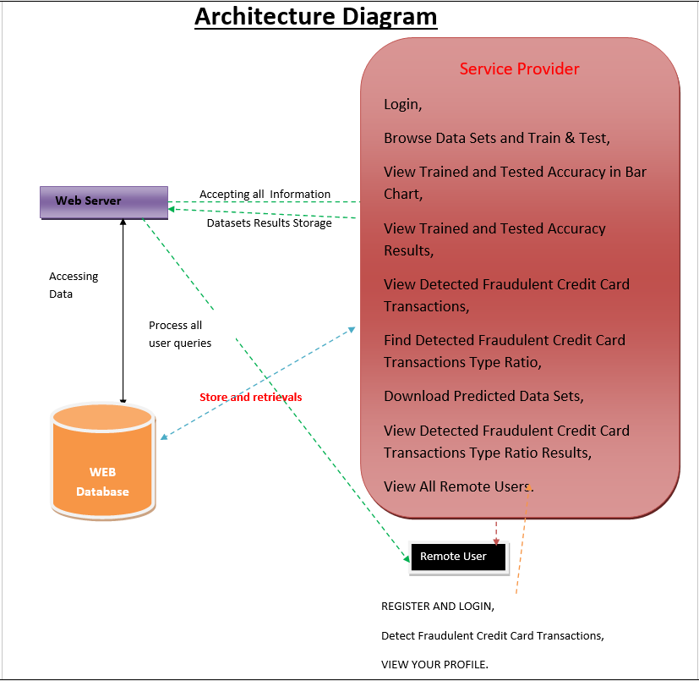

DESCRIPTION

Input Data : The project uses credit card transaction data collected from datasets or real-time financial systems. The dataset includes transaction details such as transaction ID, amount, date, location, and user information.
Reading Data : The transaction data is loaded and processed using Python libraries such as Pandas and NumPy to prepare it for analysis.
Data Preprocessing : The data is cleaned by removing missing values, duplicates, and noise. It is also normalized and balanced using techniques like SMOTE to handle imbalanced datasets.
Feature Extraction : Important features such as transaction amount, time, location, and transaction type are selected to improve the performance of the model.
Model Training : Machine learning algorithms such as Random Forest, XGBoost, and Naive Bayes are trained using the processed data to learn patterns of genuine and fraudulent transactions.
Ensemble Learning : The outputs of multiple models are combined to improve prediction accuracy and reduce errors.
Classification Layer : The trained system classifies each transaction as either genuine or fraudulent based on learned patterns.
Training and Evaluation : The model is evaluated using performance metrics such as accuracy, precision, recall, and F1-score to ensure reliability.
Feedback : User and system feedback are used to update the model and improve future fraud detection performance.

DATA FLOW DIAGRAM
A Data Flow Diagram (DFD) is a graphical representation that illustrates how data moves within the credit card fraud detection system. It shows how input transaction data is processed, analyzed, and classified as either genuine or fraudulent.
The DFD helps in understanding the system workflow, identifying data processing stages, and improving system efficiency.
A Data Flow Diagram comprises four primary elements:
• External Entities: Represent users or systems interacting with the application, such as Service Providers and Remote Users who provide transaction data and view results.
• Processes: Indicate operations performed on the data, such as data preprocessing, feature extraction, model training, fraud detection, and result generation.
• Data Flows: Show how data moves between different components, including transaction data input, processed data, and prediction outputs.
• Data Stores: Represent storage locations such as datasets, trained models, and detected fraud records maintained within the system.
These components are represented using standard symbols like circles for processes, arrows for data flow, rectangles for external entities, and open-ended rectangles for data storage.
Benefits:
The DFD provides a clear visual understanding of how transaction data is handled within the system. It helps developers and stakeholders identify inefficiencies, improve data processing, and ensure secure handling of sensitive financial data. It also enhances communication between technical and non-technical users.
Applications:
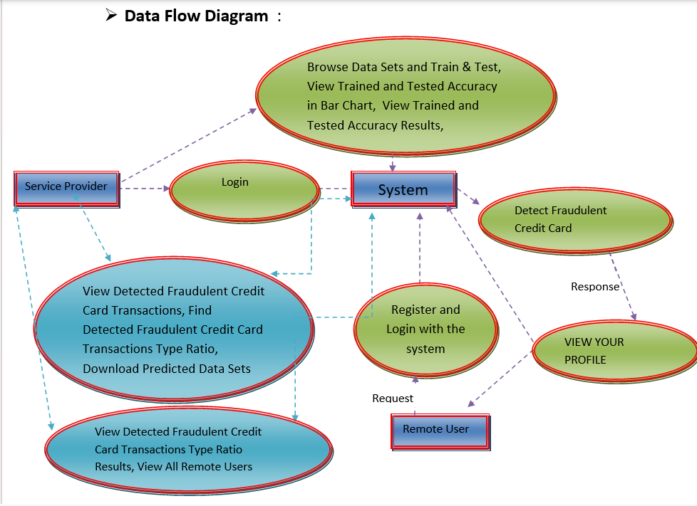
DFDs in this system are used for designing and analyzing fraud detection workflows, improving machine learning model integration, and ensuring smooth data processing. They are also useful in identifying potential risks and enhancing system security. A Data Flow Diagram is an essential tool for understanding the working of the credit card fraud detection system. It simplifies complex processes, ensures efficient data movement, and helps in building a reliable and secure fraud detection model.

4. IMPLEMENTATION
4. IMPLEMENTATION

The implementation phase of this project involves executing the planned strategies for ensemble-based credit card fraud detection. It requires meticulous coordination of data preprocessing, model training, and evaluation. Effective implementation is crucial for achieving project goals and delivering expected outcomes.
4.1 ALGORITHMS USED

Decision Tree Classifiers
Decision tree classifiers are used successfully in many diverse areas. Their most important feature is the capability of capturing descriptive decision-making knowledge from the supplied data. Decision trees can be generated from training sets. The procedure for generation based on a set of objects (S), each belonging to one of the classes C1, C2, ..., Ck is as follows:
- Step 1: If all the objects in S belong to the same class Ci, the decision tree for S consists of a leaf labeled with this class.
- Step 2: Otherwise, a test T with possible outcomes O1, O2,..., On is selected. The test partitions S into subsets S1, S2,...Sn where each object in Si has outcome Oi for T. T becomes the root of the decision tree and for each outcome Oi a subsidiary decision tree is built by invoking the same procedure recursively on the set Si.

Gradient Boosting
Gradient boosting is a machine learning technique used in regression and classification tasks. It gives a prediction model in the form of an ensemble of weak prediction models, which are typically decision trees. When a decision tree is the weak learner, the resulting algorithm is called gradient-boosted trees; it usually outperforms random forests. A gradient-boosted trees model is built in a stage-wise fashion as in other boosting methods, but it generalizes the other methods by allowing optimization of an arbitrary differentiable loss function.

K-Nearest Neighbors (KNN)
- Simple but a very powerful classification algorithm.
- Classifies based on a similarity measure; non-parametric and uses lazy learning.
- Does not learn until the test example is given.
- Whenever we have new data to classify, we find its K-nearest neighbors from the training data.
- Training dataset consists of k-closest examples in feature space.

Logistic Regression Classifiers
Logistic regression analysis studies the association between a categorical dependent variable and a set of independent variables. The name logistic regression is used when the dependent variable has only two values, such as 0 and 1. Many statisticians feel that logistic regression is more versatile than discriminant analysis because logistic regression does not assume that the independent variables are normally distributed. This program computes binary logistic regression and multinomial logistic regression on both numeric and categorical independent variables, reporting on regression equation, goodness of fit, odds ratios, confidence limits, and ROC curves.

Naïve Bayes
The naive Bayes approach is a supervised learning method based on a simplistic hypothesis: it assumes that the presence or absence of a particular feature of a class is unrelated to any other feature. Yet, despite this assumption, it appears robust and efficient. Its performance is comparable to other supervised learning techniques. The naive Bayes classifier is a linear classifier, similar to linear discriminant analysis, logistic regression, and linear SVM. The difference lies in the method of estimating the parameters (the learning bias). It is very easy to program and implement; its parameters are easy to estimate, and learning is very fast even on very large databases.

Random Forest
Random forests or random decision forests are an ensemble learning method for classification, regression and other tasks that operates by constructing a multitude of decision trees at training time. For classification tasks, the output of the random forest is the class selected by most trees. Random decision forests correct for decision trees’ habit of overfitting to their training set. Random forests generally outperform decision trees. The first algorithm for random decision forests was created in 1995 by Tin Kam Ho using the random subspace method. An extension of the algorithm was developed by Leo Breiman and Adele Cutler, combining “bagging” with random feature selection to construct a collection of decision trees with controlled variance.

Support Vector Machine (SVM)
SVM is a discriminant technique that finds a discriminant function capable of correctly predicting labels for newly acquired instances. Unlike generative machine learning approaches, which require computations of conditional probability distributions, a discriminant classification function takes a data point x and assigns it to one of the different classes. From a geometric perspective, learning a classifier is equivalent to finding the equation for a multidimensional surface that best separates the different classes in the feature space. SVM solves the convex optimization problem analytically, always returning the same optimal hyperplane parameters, unlike genetic algorithms or perceptrons.

4.2 MODULES

Service Provider Module
In this module, the Service Provider logs in using a valid username and password. After successful login, the service provider can perform operations such as: Browse Datasets and Train & Test models, View Trained and Tested Accuracy in Bar Chart, View Trained and Tested Accuracy Results, View Detected Fraudulent Credit Card Transactions, Find Detected Fraudulent Credit Card Transaction Type Ratio, Download Predicted Datasets, View Detected Fraudulent Credit Card Transaction Type Ratio Results, and View All Remote Users.

View and Authorize Users Module
In this module, the admin can view the list of all registered users. The admin can view user details such as username, email, and address, and can authorize users for system access.

Remote User Module
In this module, there are multiple users present. Users must register before performing any operations. Once registered, their details are stored in the database. After successful login with authorized credentials, users can: Register and Login, Detect Fraudulent Credit Card Transactions, and View Their Profile.

4.3 SAMPLE CODE:

#!/usr/bin/env python
"""Django's command-line utility for administrative tasks."""
import os
import sys

def main():
"""Run administrative tasks."""
os.environ.setdefault('DJANGO_SETTINGS_MODULE', 'identifying_fraudulent.settings')
try:
from django.core.management import execute_from_command_line
except ImportError as exc:
raise ImportError(
"Couldn't import Django. Are you sure it's installed and "
"available on your PYTHONPATH environment variable? Did you "
"forget to activate a virtual environment?"
) from exc
execute_from_command_line(sys.argv)

if __name__ == '__main__':
main()

import pymysql
pymysql.version_info = (2, 2, 1, "final", 0)
pymysql.install_as_MySQLdb()

"""
WSGI config for identifying_fraudulent.

It exposes the WSGI callable as a module-level variable named ``application``.

For more information on this file, see
https://docs.djangoproject.com/en/3.0/howto/deployment/wsgi/
"""

import os

from django.core.wsgi import get_wsgi_application

os.environ.setdefault('DJANGO_SETTINGS_MODULE', 'identifying_fraudulent.settings')
application = get_wsgi_application()

"""netfense URL Configuration

The `urlpatterns` list routes URLs to views. For more information please see:
https://docs.djangoproject.com/en/3.0/topics/http/urls/
Examples:
Function views
1. Add an import: from my_app import views
2. Add a URL to urlpatterns: path('', views.home, name='home')
Class-based views
1. Add an import: from other_app.views import Home
2. Add a URL to urlpatterns: path('', Home.as_view(), name='home')
Including another URLconf
1. Import the include() function: from django.urls import include, path
2. Add a URL to urlpatterns: path('blog/', include('blog.urls'))
"""
from django.urls import re_path as url
from django.contrib import admin
from Remote_User import views as remoteuser
from identifying_fraudulent import settings
from Service_Provider import views as serviceprovider
from django.conf.urls.static import static

urlpatterns = [
url('admin/', admin.site.urls),
url(r'^$', remoteuser.login, name="login"),
url(r'^Register1/$', remoteuser.Register1, name="Register1"),
url(r'^Detection_Of_Fraudulent_CreditCard_Transactions/$', remoteuser.Detection_Of_Fraudulent_CreditCard_Transactions, name="Detection_Of_Fraudulent_CreditCard_Transactions"),
url(r'^ViewYourProfile/$', remoteuser.ViewYourProfile, name="ViewYourProfile"),
url(r'^serviceproviderlogin/$',serviceprovider.serviceproviderlogin, name="serviceproviderlogin"),
url(r'View_Remote_Users/$',serviceprovider.View_Remote_Users,name="View_Remote_Users"),
url(r'^charts/(?P<chart_type>\w+)', serviceprovider.charts,name="charts"),
url(r'^charts1/(?P<chart_type>\w+)', serviceprovider.charts1, name="charts1"),
url(r'^likeschart/(?P<like_chart>\w+)', serviceprovider.likeschart, name="likeschart"),
url(r'^View_Detected_Of_Fraudulent_CreditCard_Transactions_Type_Ratio/$', serviceprovider.View_Detected_Of_Fraudulent_CreditCard_Transactions_Type_Ratio,name="View_Detected_Of_Fraudulent_CreditCard_Transactions_Type_Ratio"),
url(r'^likeschart1/(?P<like_chart1>\w+)', serviceprovider.likeschart1, name="likeschart1"),
url(r'^Train_Test_DataSets/$', serviceprovider.Train_Test_DataSets, name="Train_Test_DataSets"),
url(r'^View_Detected_Of_Fraudulent_CreditCard_Transactions_Type/$', serviceprovider.View_Detected_Of_Fraudulent_CreditCard_Transactions_Type, name="View_Detected_Of_Fraudulent_CreditCard_Transactions_Type"),
url(r'^Download_Predicted_DataSets/$', serviceprovider.Download_Predicted_DataSets, name="Download_Predicted_DataSets"),

]+ static(settings.MEDIA_URL, document_root=settings.MEDIA_ROOT)

import os

# Build paths inside the project like this: os.path.join(BASE_DIR, ...)
BASE_DIR = os.path.dirname(os.path.dirname(os.path.abspath(__file__)))

# Quick-start development settings - unsuitable for production
# See https://docs.djangoproject.com/en/3.0/howto/deployment/checklist/

# SECURITY WARNING: keep the secret key used in production secret!
SECRET_KEY = 'm+1edl5m-5@u9u!b8-=4-4mq&o1%agco2xpl8c!7sn7!eowjk#'

# SECURITY WARNING: don't run with debug turned on in production!
DEBUG = True

ALLOWED_HOSTS = []

# Application definition

INSTALLED_APPS = [
'django.contrib.admin',
'django.contrib.auth',
'django.contrib.contenttypes',
'django.contrib.sessions',
'django.contrib.messages',
'django.contrib.staticfiles',
'Remote_User',
'Service_Provider',
]

MIDDLEWARE = [
'django.middleware.security.SecurityMiddleware',
'django.contrib.sessions.middleware.SessionMiddleware',
'django.middleware.common.CommonMiddleware',
'django.middleware.csrf.CsrfViewMiddleware',
'django.contrib.auth.middleware.AuthenticationMiddleware',
'django.contrib.messages.middleware.MessageMiddleware',
'django.middleware.clickjacking.XFrameOptionsMiddleware',
]

ROOT_URLCONF = 'identifying_fraudulent.urls'

TEMPLATES = [
{
'BACKEND': 'django.template.backends.django.DjangoTemplates',
'DIRS': [(os.path.join(BASE_DIR,'Template/htmls'))],
'APP_DIRS': True,
'OPTIONS': {
'context_processors': [
'django.template.context_processors.debug',
'django.template.context_processors.request',
'django.contrib.auth.context_processors.auth',
'django.contrib.messages.context_processors.messages',
],
},
},
]

WSGI_APPLICATION = 'identifying_fraudulent.wsgi.application'

# Database
# https://docs.djangoproject.com/en/3.0/ref/settings/#databases

DATABASES = {
'default': {
'ENGINE': 'django.db.backends.sqlite3',
'NAME': os.path.join(BASE_DIR, 'db.sqlite3'),
}
}

# Password validation
# https://docs.djangoproject.com/en/3.0/ref/settings/#auth-password-validators

AUTH_PASSWORD_VALIDATORS = [
{
'NAME': 'django.contrib.auth.password_validation.UserAttributeSimilarityValidator',
},
{
'NAME': 'django.contrib.auth.password_validation.MinimumLengthValidator',
},
{
'NAME': 'django.contrib.auth.password_validation.CommonPasswordValidator',
},
{
'NAME': 'django.contrib.auth.password_validation.NumericPasswordValidator',
},
]

# Internationalization
# https://docs.djangoproject.com/en/3.0/topics/i18n/

LANGUAGE_CODE = 'en-us'

TIME_ZONE = 'UTC'

USE_I18N = True

USE_L10N = True

USE_TZ = True

# Static files (CSS, JavaScript, Images)
# https://docs.djangoproject.com/en/3.0/howto/static-files/

STATIC_URL = '/static/'
STATICFILES_DIRS = [os.path.join(BASE_DIR,'Template/images')]
MEDIA_URL = '/media/'
MEDIA_ROOT = os.path.join(BASE_DIR, 'Template/media')

STATIC_ROOT = '/static/'

STATIC_URL = '/static/'

"""
ASGI config for identifying_fraudulent

It exposes the ASGI callable as a module-level variable named ``application``.

For more information on this file, see
https://docs.djangoproject.com/en/3.0/howto/deployment/asgi/
"""

import os

from django.core.asgi import get_asgi_application

os.environ.setdefault('DJANGO_SETTINGS_MODULE', 'identifying_fraudulent.settings')

application = get_asgi_application()

from django.contrib import admin

# Register your models here.

from django.apps import AppConfig

class ResearchSiteConfig(AppConfig):
name = 'Service_Provider'

from django.db import models

# Create your models here.

from django.test import TestCase

# Create your tests here.
from django.db.models import Count, Avg
from django.shortcuts import render, redirect
import xlwt
from django.http import HttpResponse
import numpy as np

from sklearn.feature_extraction.text import CountVectorizer
from sklearn.metrics import accuracy_score, confusion_matrix, classification_report
from sklearn.metrics import accuracy_score
import pandas as pd

# Create your views here.
from Remote_User.models import ClientRegister_Model,detect_fraudulent_cc_transactions,detection_ratio,detection_accuracy

def serviceproviderlogin(request):
if request.method == "POST":
admin = request.POST.get('username')
password = request.POST.get('password')
if admin == "Admin" and password =="Admin":
return redirect('View_Remote_Users')

return render(request,'SProvider/serviceproviderlogin.html')
def View_Detected_Of_Fraudulent_CreditCard_Transactions_Type(request):

obj = detect_fraudulent_cc_transactions.objects.all()
return render(request, 'SProvider/View_Detected_Of_Fraudulent_CreditCard_Transactions_Type.html', {'objs': obj})

def View_Detected_Of_Fraudulent_CreditCard_Transactions_Type_Ratio(request):
detection_ratio.objects.all().delete()
ratio = ""
kword = 'Fraudulent Found'
print(kword)
obj = detect_fraudulent_cc_transactions.objects.all().filter(Prediction=kword)
obj1 = detect_fraudulent_cc_transactions.objects.all()
count = obj.count();
count1 = obj1.count();
ratio = (count / count1) * 100
if ratio != 0:
detection_ratio.objects.create(names=kword, ratio=ratio)

ratio1 = ""
kword1 = 'Fraudulent Not Found'
print(kword1)
obj1 = detect_fraudulent_cc_transactions.objects.all().filter(Prediction=kword1)
obj11 = detect_fraudulent_cc_transactions.objects.all()
count1 = obj1.count();
count11 = obj11.count();
ratio1 = (count1 / count11) * 100
if ratio1 != 0:
detection_ratio.objects.create(names=kword1, ratio=ratio1)

obj = detection_ratio.objects.all()
return render(request, 'SProvider/View_Detected_Of_Fraudulent_CreditCard_Transactions_Type_Ratio.html', {'objs': obj})

def View_Remote_Users(request):
obj=ClientRegister_Model.objects.all()
return render(request,'SProvider/View_Remote_Users.html',{'objects':obj})

def charts(request,chart_type):
chart1 = detection_ratio.objects.values('names').annotate(dcount=Avg('ratio'))
return render(request,"SProvider/charts.html", {'form':chart1, 'chart_type':chart_type})

def charts1(request,chart_type):
chart1 = detection_accuracy.objects.values('names').annotate(dcount=Avg('ratio'))
return render(request,"SProvider/charts1.html", {'form':chart1, 'chart_type':chart_type})

def likeschart(request,like_chart):
charts =detection_accuracy.objects.values('names').annotate(dcount=Avg('ratio'))
return render(request,"SProvider/likeschart.html", {'form':charts, 'like_chart':like_chart})

def likeschart1(request,like_chart):
charts =detection_ratio.objects.values('names').annotate(dcount=Avg('ratio'))
return render(request,"SProvider/likeschart1.html", {'form':charts, 'like_chart':like_chart})

def Download_Predicted_DataSets(request):

response = HttpResponse(content_type='application/ms-excel')
# decide file name
response['Content-Disposition'] = 'attachment; filename="Predicted_Datasets.xls"'
# creating workbook
wb = xlwt.Workbook(encoding='utf-8')
# adding sheet
ws = wb.add_sheet("sheet1")
# Sheet header, first row
row_num = 0
font_style = xlwt.XFStyle()
# headers are bold
font_style.font.bold = True
# writer = csv.writer(response)
obj = detect_fraudulent_cc_transactions.objects.all()
data = obj # dummy method to fetch data.
for my_row in data:
row_num = row_num + 1

ws.write(row_num, 0, my_row.Fid, font_style)
ws.write(row_num, 1, my_row.Fid, font_style)
ws.write(row_num, 2, my_row.Trans_Date, font_style)
ws.write(row_num, 3, my_row.CC_No, font_style)
ws.write(row_num, 4, my_row.CC_type, font_style)
ws.write(row_num, 5, my_row.Trans_Type, font_style)
ws.write(row_num, 6, my_row.Amount, font_style)
ws.write(row_num, 7, my_row.Firstname, font_style)
ws.write(row_num, 8, my_row.Lastname, font_style)
ws.write(row_num, 9, my_row.Gender, font_style)
ws.write(row_num, 10, my_row.Age, font_style)
ws.write(row_num, 11, my_row.lat, font_style)
ws.write(row_num, 12, my_row.lon, font_style)
ws.write(row_num, 13, my_row.Transid, font_style)
ws.write(row_num, 14, my_row.Prediction, font_style)

wb.save(response)
return response

def Train_Test_DataSets(request):

detection_accuracy.objects.all().delete()

df = pd.read_csv('Datasets.csv',encoding='latin-1')

def apply_response(Label):
if (Label == 0):
return 0 # Fraudulent Not Found
elif (Label ==1):
return 1 # Fraudulent Found

df['results'] = df['Label'].apply(apply_response)

cv = CountVectorizer()

X = df['Fid']
y = df["results"]

print("X Values")
print(X)
print("Labels")
print(y)

X = cv.fit_transform(X)

models = []
from sklearn.model_selection import train_test_split
X_train, X_test, y_train, y_test = train_test_split(X, y, test_size=0.33, random_state=42)
X_train.shape, X_test.shape, y_train.shape
print("X_test")
print(X_test)
print(X_train)

print("Naive Bayes")
from sklearn.naive_bayes import MultinomialNB
NB = MultinomialNB()
NB.fit(X_train, y_train)
predict_nb = NB.predict(X_test)
naivebayes = accuracy_score(y_test, predict_nb) * 100
print(naivebayes)
print(confusion_matrix(y_test, predict_nb))
print(classification_report(y_test, predict_nb))
models.append(('naive_bayes', NB))
detection_accuracy.objects.create(names="Naive Bayes", ratio=naivebayes)

# SVM Model
print("SVM")
from sklearn import svm
lin_clf = svm.LinearSVC()
lin_clf.fit(X_train, y_train)
predict_svm = lin_clf.predict(X_test)
svm_acc = accuracy_score(y_test, predict_svm) * 100
print(svm_acc)
print("CLASSIFICATION REPORT")
print(classification_report(y_test, predict_svm))
print("CONFUSION MATRIX")
print(confusion_matrix(y_test, predict_svm))
models.append(('svm', lin_clf))
detection_accuracy.objects.create(names="SVM", ratio=svm_acc)

print("Random Forest Classifier")
from sklearn.ensemble import RandomForestClassifier
rf_clf = RandomForestClassifier()
rf_clf.fit(X_train, y_train)
rfpredict = rf_clf.predict(X_test)
print("ACCURACY")
print(accuracy_score(y_test, rfpredict) * 100)
print("CLASSIFICATION REPORT")
print(classification_report(y_test, rfpredict))
print("CONFUSION MATRIX")
print(confusion_matrix(y_test, rfpredict))
models.append(('RandomForestClassifier', rf_clf))
detection_accuracy.objects.create(names="Random Forest Classifier", ratio=accuracy_score(y_test, rfpredict) * 100)

print("Gradient Boosting Classifier")

from sklearn.ensemble import GradientBoostingClassifier
clf = GradientBoostingClassifier(n_estimators=100, learning_rate=1.0, max_depth=1, random_state=0).fit(
X_train,
y_train)
clfpredict = clf.predict(X_test)
print("ACCURACY")
print(accuracy_score(y_test, clfpredict) * 100)
print("CLASSIFICATION REPORT")
print(classification_report(y_test, clfpredict))
print("CONFUSION MATRIX")
print(confusion_matrix(y_test, clfpredict))
models.append(('GradientBoostingClassifier', clf))
detection_accuracy.objects.create(names="Gradient Boosting Classifier",
ratio=accuracy_score(y_test, clfpredict) * 100)

labeled = 'Labeled_Data.csv'
df.to_csv(labeled, index=False)
df.to_markdown

obj = detection_accuracy.objects.all()

return render(request,'SProvider/Train_Test_DataSets.html', {'objs': obj})

5. RESULTS & DISCUSSION
5. RESULTS & DISCUSSION
The results of the classification phase were obtained after fitting the nb, rf, and xgb models on the data sets eu and sp under three strategies (undersampling un, oversampling ov, and SMOTE sm). The experiment offered 18 fitted models each corresponding to a classifier trained on a dataset using a certain strategy.

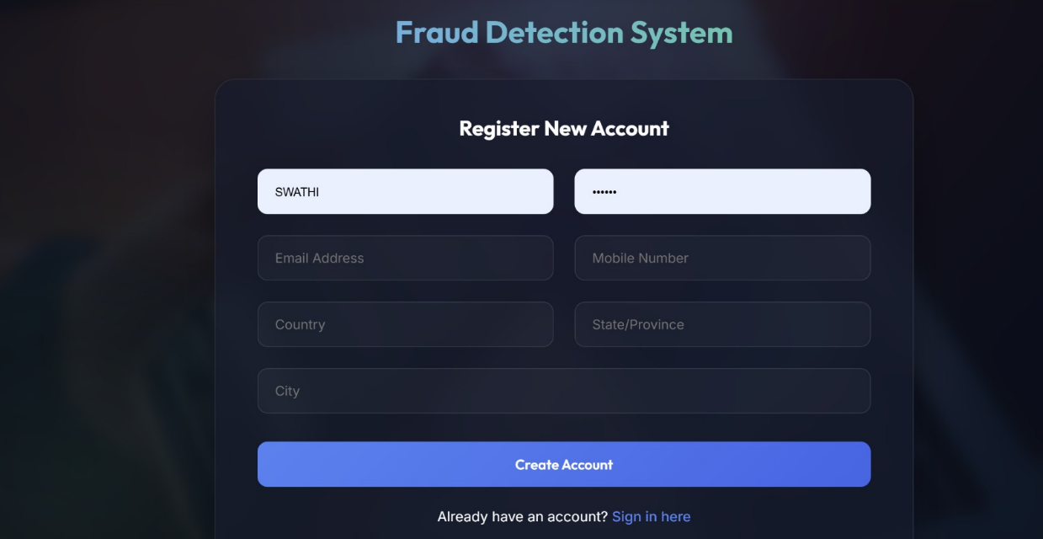


Figure 5: Comparison of the performance of the classifier on the Sparkov data set
The models’ performance improves considerably using the SMOTE strategy on the eu data set. The worst performance is shown using the undersampling strategy. The same finding is observed for the sp data set, where the models’ performance is better using SMOTE. The rf and xgb consistently outperform the nb classifier under all scenarios.

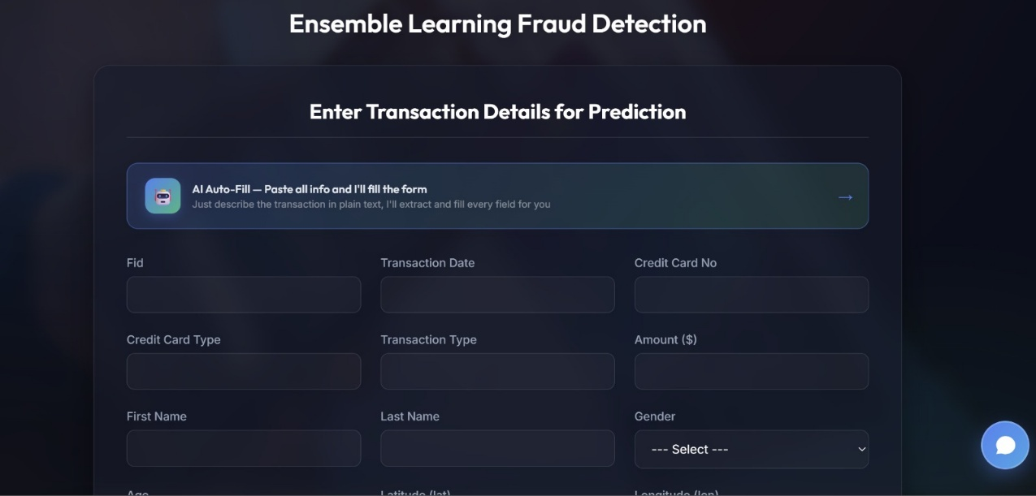
The F1 score is lower for the nb classifier and higher for the rf and xgb models. The average F1 score obtained for all models is much higher on the eu dataset compared to the synthetic sp dataset. This confirms that the deterministic nature of the real-world credit card transaction process makes it learnable by ensemble methods.

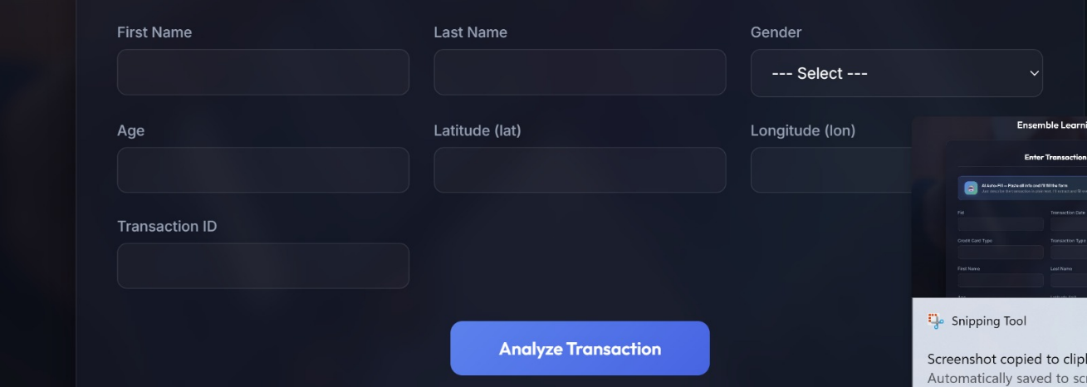
The detailed performance gaps between models on the eu and sp datasets confirm that the main source of vulnerability in credit card request processing scripts is their determinism and absence of any form of uncertainty. The authentication process is clearly deterministic and vulnerable: if a hacker knows the card details (number, expiration date, CCV, PIN), all requests get approved. Ensemble methods can learn this deterministic script easily, achieving near-perfect performance on real data while performing poorly on the non-deterministic synthetic data.

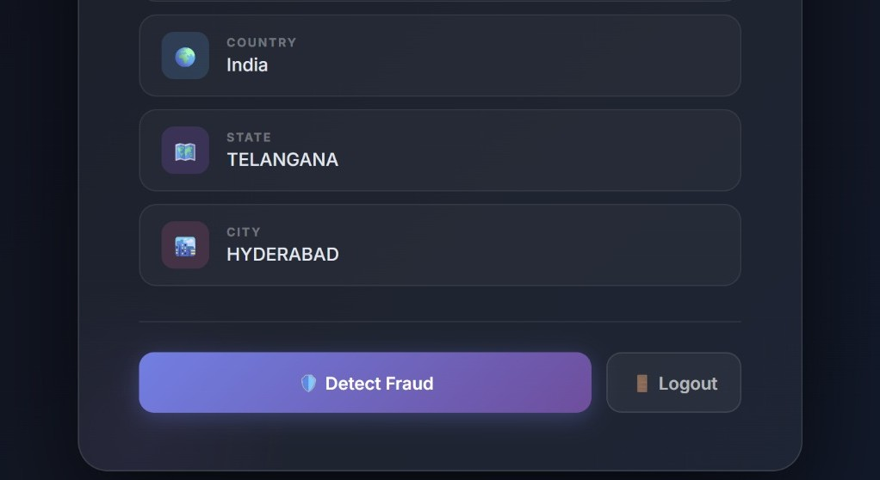
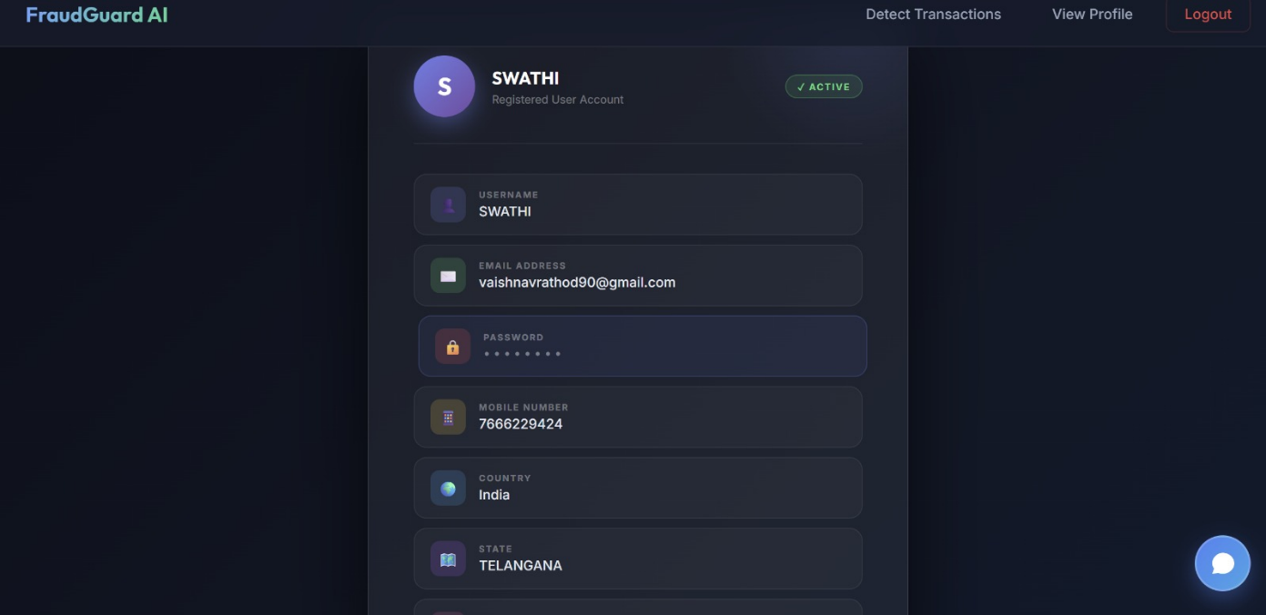
6. VALIDATION
6. VALIDATION

6.1 INTRODUCTION
The validation of this project primarily relies on extensive testing and well-defined test cases to ensure the accuracy and effectiveness of the fraudulent credit card transaction detection system. The testing process involves multiple stages, including dataset validation, model performance evaluation, and real-world testing. By implementing a structured validation approach, we ensure that the system consistently delivers high accuracy in detecting fraudulent transactions while minimizing false positives and false negatives.
The dataset is divided into training (70%), test (15%), and validation (15%) sets. To further enhance reliability, KFold cross-validation is performed with n_splits = 5, ensuring that the system is tested on multiple data partitions. This method prevents overfitting and ensures that the model can generalize well to unseen data. The accuracy of the system is measured using precision, recall, F1-score, and confusion matrix analysis.

6.2 TEST CASES

TABLE 6.2.1: UPLOADING DATASET
Test Case ID | Test Case Name | Purpose | Output
1 | User uploads Dataset | Use it for fraud detection and model training | Dataset successfully loaded

TABLE 6.2.2: CLASSIFICATION
Test Case ID | Test Case Name | Purpose | Input | Output
1 | Classification test 1 | Check if classifier performs its task | Legitimate transaction selected | Authentic Transaction
2 | Classification test 2 | Check if classifier performs its task | Fraudulent transaction selected | Fraudulent Transaction

7. CONCLUSION & FUTURE WORK
7. CONCLUSION & FUTURE WORK
The detection of malicious transactions on credit cards helps in avoiding a big loss of money for financial institutions. That loss is continuously increasing despite the efforts deployed by financial stakeholders. In this paper, a comparative study of ensemble methods’ performance is discussed in classifying credit card transactions as authentic or malicious. It is found that XGBoost and bagging methods outperform basic classification techniques like the Naive Bayes. However, they lack overfitting on real data sets.
On simulated data sets, the performance of all classifiers decreases since data generation did not follow an a priori script or distribution. The high performance of ensemble methods on real data can be explained by the fact that the approval of credit card transactions by bankers follows a strict script easily discovered by transfer learning. Such a finding can be seen as a credit card transaction processing script vulnerability.
The current study revealed the importance of randomization in the datasets used to train machine learning algorithms. The authentication process is clearly deterministic: if a user knows the card details (number, expiration date, CCV, PIN), all requests on the credit card get approved. Such card details can be easily leaked through various means like lost or stolen cards, counterfeit cards, phone scams, and phishing scams.
To overcome such limitations and mitigate this vulnerability, the following remedial actions are recommended:
- Focus on more descriptors of the operation: the location from where the transaction is being completed; whether it is a previously known location used by the true cardholder; the type of transaction (online payment, cash withdrawal, fund transfer); and whether the transaction amount is in the normal range of the cardholder’s previous operations.
- Vary the authentication scheme using Two-Factor Authentication (2FA): Text message (SMS), Verification emails, Authenticator applications, Push notifications on mobile phones, Fast IDentity Online (FIDO) using biometric identification like fingerprint, face, eyes, or voice.
- Use Multi-Factor Authentication (MFA) by requiring the customer to provide more verification factors from the above.

Future Work
In future works, multiplying, varying, and randomizing the factors should be used during the authentication phase. From a technical point of view, addressing the explainability and interpretability of the algorithms and understanding their decision-making process will be an interesting perspective for future studies. Such findings can be strengthened by investigating the behavior of other machine learning methods like pre-trained or hybrid deep models (like BERT, CNN, BiGRU) on other datasets. On the other hand, the tuning of the selected machine learning algorithms can lead to better performance.

8. REFERENCE
8. REFERENCES

[1] Z. Faraji, ‘‘A review of machine learning applications for credit card fraud detection with a case study,’’ SEISENSE J. Manage., vol. 5, no. 1, pp. 49–59, Feb. 2022.
[2] F. K. Alarfaj, I. Malik, H. U. Khan, N. Almusallam, M. Ramzan, and M. Ahmed, ‘‘Credit card fraud detection using state-of-the-art machine learning and deep learning algorithms,’’ IEEE Access, vol. 10, pp. 39700–39715, 2022.
[3] Nilson Report. Card Fraud Worldwide. Accessed: May 2023. [Online]. Available: https://nilsonreport.com/
[4] N. S. Alfaiz and S. M. Fati, ‘‘Enhanced credit card fraud detection model using machine learning,’’ Electronics, vol. 11, no. 4, p. 662, Feb. 2022.
[5] B. Arora and Sourabh, ‘‘A review of credit card fraud detection techniques,’’ Recent Innov. Comput., pp. 485–496, 2022.
[6] S. Srinidhi, K. Sowmya, and S. Karthika, ‘‘Automatic credit fraud detection using ensemble model,’’ in ICT Analysis and Applications. Springer, 2022, pp. 211–224.
[7] M. Sabih and D. K. Vishwakarma, ‘‘A novel framework for detection of motion and appearance-based anomaly using ensemble learning and LSTMs,’’ Exp. Syst. Appl., vol. 192, Apr. 2022.
[8] Kaggle. (2022). European Cardholders Dataset. Accessed: May 2023. [Online]. Available: https://www.kaggle.com/datasets/mlgulb/creditcardfraud
[9] Sparkov Data Generation on Github, Sparkv simulator, 2020.
[10] D. Varmedja, M. Karanovic, S. Sladojevic, M. Arsenovic, and A. Anderla, ‘‘Credit card fraud detection—machine learning methods,’’ in Proc. 18th Int. Symp. INFOTEH-JAHORINA (INFOTEH), Mar. 2019, pp. 1–5.
[11] S. B. E. Raj and A. A. Portia, ‘‘Analysis on credit card fraud detection methods,’’ in Proc. Int. Conf. Comput., Commun. Electr. Technol. (ICCCET), 2011, pp. 152–156.
[12] C. Phua, V. Lee, K. Smith, and R. Gayler, ‘‘A comprehensive survey of data mining-based fraud detection research,’’ 2010, arXiv:1009.6119.
[13] T. Razooqi, P. Khurana, K. Raahemifar, and A. Abhari, ‘‘Credit card fraud detection using fuzzy logic and neural network,’’ in Proc. 19th Commun. Netw. Symp., 2016, pp. 1–5.
[14] M. E. Lokanan, ‘‘Financial fraud detection: The use of visualization techniques in credit card fraud and money laundering domains,’’ J. Money Laundering Control, vol. 26, no. 3, pp. 436–444, Apr. 2023.
[15] B. Lebichot, F. Braun, O. Caelen, and M. Saerens, ‘‘A graph-based, semi-supervised, credit card fraud detection system,’’ in Proc. 5th Int. Workshop Complex Netw. Appl. Springer, 2017, pp. 721–733.
[16] J. O. Awoyemi, A. O. Adetunmbi, and S. A. Oluwadare, ‘‘Credit card fraud detection using machine learning techniques: A comparative analysis,’’ in Proc. Int. Conf. Comput. Netw. Informat. (ICCNI), Oct. 2017, pp. 1–9.
[17] I. Sohony, R. Pratap, and U. Nambiar, ‘‘Ensemble learning for credit card fraud detection,’’ in Proc. ACM India Joint Int. Conf. Data Sci. Manage. Data, Jan. 2018, pp. 289–294.
[18] K. M. Leung, ‘‘Naive Bayesian classifier,’’ Polytech. Univ. Dept. Comput. Sci./Finance Risk Eng., vol. 2007, pp. 123–156, Nov. 2007.
[19] A. Prinzie and D. Van den Poel, ‘‘Random forests for multiclass classification: Random MultiNomial logit,’’ Expert Syst. Appl., vol. 34, no. 3, pp. 1721–1732, Apr. 2008.
[20] T. Chen and C. Guestrin, ‘‘XGBoost: A scalable tree boosting system,’’ in Proc. 22nd ACM SIGKDD Int. Conf. Knowl. Discovery Data Mining, Aug. 2016, pp. 785–794.

GITHUB LINK:
https://github.com/losisunitha-max/IDENTIFYING-FRAUDULENT-CREDIT-CARD-TRANSACTIONS-USING-ENSEMBLE-LEARNING.git

