AI-Based Literature Review Workflow
A practical step-by-step template for searching, checking, downloading, and organising academic literature
Overview. This workflow keeps the original process simple: install an AI coding assistant, add two reusable skills, run a verified literature search, review the Excel output, and then download approved papers into an organised Zotero library. Replace the bracketed placeholders with the requirements of your own review.
1. Install | 2. Add skills | 3. Search | 4. Check Excel | 5. Download & Zotero

Step 1. Install Codex or Claude Code
What to do: Install and open either Codex or Claude Code on your computer.
Purpose: The coding assistant provides the workspace in which the literature-search and document-processing skills can run.
- Install your preferred coding assistant and sign in.
- Open or create a project folder for the literature-review files.
- Confirm that the assistant can create, read, and edit files in this folder.

Step 2. Add the Literature-Search and Download Skills
What to do: Paste each skill’s GitHub link into the coding assistant and ask it to install the skill in the current workspace.
Purpose: The search skill builds and verifies the literature table; the download skill processes the approved table and retrieves accessible full texts.
Literature search: ustc-ai4science/academic-search
Automatic literature downloading: Given-Dream/sciencedirect-live-session-fetcher
Please install this skill in the current workspace:
<PASTE THE GITHUB LINK HERE>


Example: asking the coding assistant to install a skill from its GitHub repository.

Step 3. Run the Literature Search
What to do: Invoke the academic-search skill and provide a structured search prompt with your topic, scope, keywords, inclusion rules, verification rules, and output fields.
Purpose: A structured prompt gives the search process enough freedom to adapt to different research topics while preserving traceability and preventing fabricated references.
$academic-search
You are a rigorous academic literature researcher. Search for and organise real publications on <research topic>.
Scope: years <start-end>; journals <unrestricted / specified list / ranking range>; document types <articles / reviews / conference papers>.
Keywords: <core terms>; synonyms and related terms: <terms>; exclusions: <terms>; target number: <number, without lowering standards to fill quotas>.
Include only studies meeting the requirements for <scenario, research object, method, and outcomes>, and state why each study is included.
Verify every publication using an official publisher page and at least one authoritative source such as DOI/Crossref, IEEE Xplore, PubMed, Scopus, or Web of Science.
Do not invent or infer titles, authors, years, journals, DOIs, methods, or findings; mark unverified information as "Not verified".
Prefer final journal versions, identify duplicate preprint/conference/journal versions, and record explicit exclusion reasons.
Output fields: <Reference, Topic, Journal, Scenario, Model/Method, Data, Objective, Metrics, Findings, Limitations, DOI/URL>.
Separate results into Core Literature, Background Literature, and Pending Verification, and report search strings, search date, sources, and verification statistics.

Output group | Meaning
Core Literature | Directly addresses the research question and is sufficiently verified for the main evidence table.
Background Literature | Provides theory, definitions, models, methods, or context but does not directly answer the main research question.
Pending Verification | Appears relevant, but publication details, full text, version, or findings still require checking.

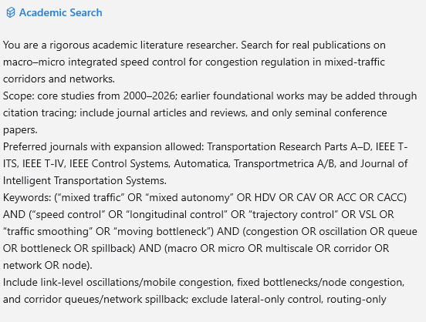
Example of a completed search prompt. Replace the topic-specific content with your own review requirements.

Step 4. Review and Adjust the Excel Output
What to do: Open the generated Excel file, check each record, correct classifications or metadata, and mark which papers are approved for downloading.
Purpose: The Excel review is the human quality-control gate. It prevents irrelevant, duplicated, incorrectly classified, or insufficiently verified records from entering the final evidence library.
- Open the DOI or official URL and confirm the title, authors, year, journal, and publication version.
- Check whether the study genuinely matches the topic and inclusion criteria.
- Resolve preprint, conference, and journal duplicates; retain the preferred final version.
- Review the assigned category and subsection, and adjust it when necessary.
- Mark missing information as "Not verified" rather than guessing.
- Add an approval field such as Approved = Yes/No before the download step.
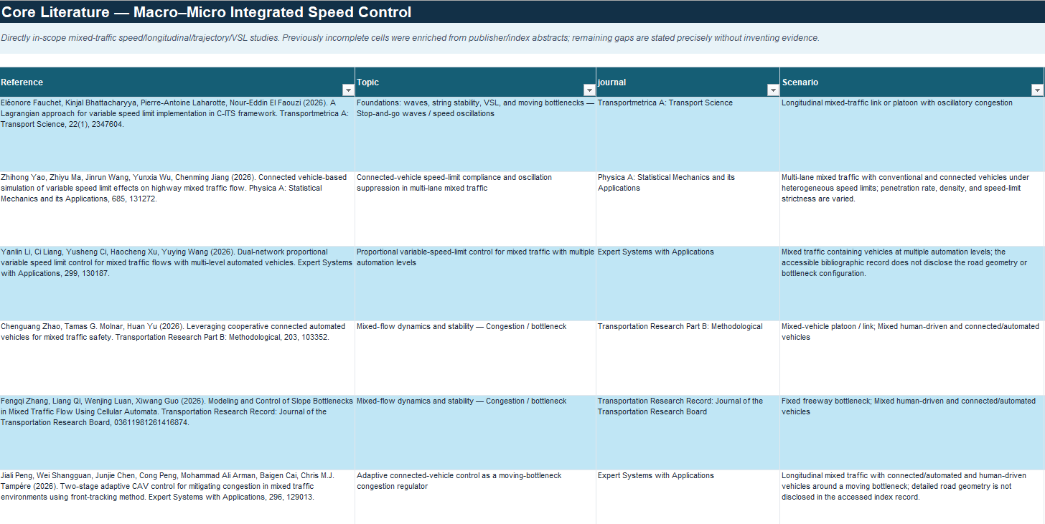
Example of a literature-search Excel output. The exact columns can be adapted to the research topic.

Step 5. Download Approved PDFs and Organise Them in Zotero
What to do: Attach the reviewed Excel file, invoke the download skill, and instruct it to process only approved records. Sign in through the open browser first when institutional access is required.
Purpose: This step converts the verified spreadsheet into an organised full-text library while preserving the categories created during screening.
$sciencedirect-live-session-fetcher
Please process the attached Excel file. Only process records marked Approved = Yes.
Download PDFs that I can lawfully access, organise them by the category or subsection recorded in the spreadsheet, and prepare or import the approved records into Zotero.
Do not bypass paywalls or access controls. Record any unavailable, failed, or unmatched items instead of substituting another paper.

Access note. When using a university or organisational subscription, sign in through the browser yourself and then tell the coding assistant that you are signed in. Do not provide your password to the assistant. The workflow should use only access that you are authorised to use.

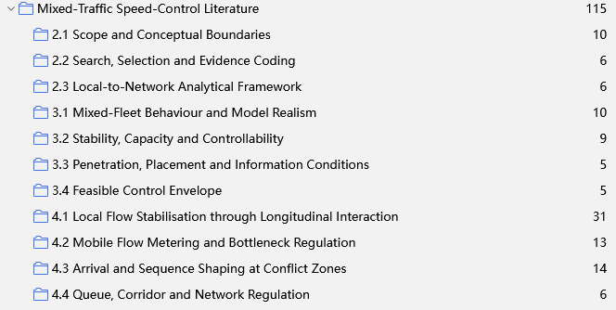
Example of papers organised into folders that mirror the review categories.
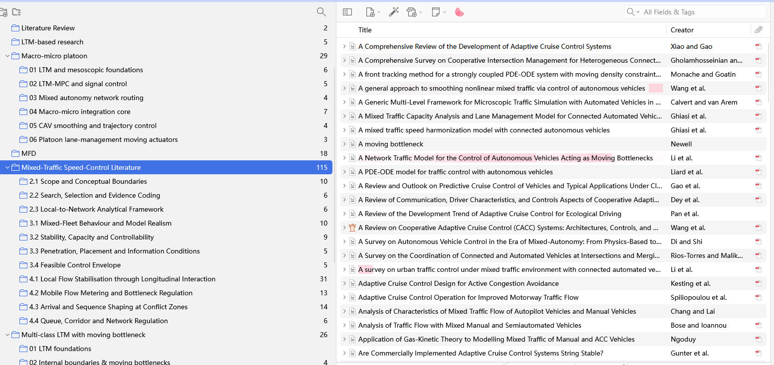
Example of an organised Zotero library with matching collections and paper records.

Step 6. Complete a Final Quality Check
What to do: Compare the approved Excel records, downloaded PDF folders, and Zotero library before beginning detailed reading or synthesis.
Purpose: A final reconciliation makes the literature collection auditable and prevents missing attachments, duplicate records, and incorrect metadata from affecting later analysis.
- Every approved Excel record has either a matching PDF or a clear unavailable/failed note.
- Zotero titles, authors, years, journals, and DOIs match the verified spreadsheet.
- Duplicate items have been merged or removed.
- Collections and folders follow the same category structure.
- The Excel file and Zotero library are backed up before coding or synthesis begins.
Workflow complete: Search -> Verify -> Review -> Approve -> Download -> Organise

