**Professor Xin Chen, Biometrics, Fall 2015**

**Assignment: Biometrics Systems Design and Evaluation**

1. Plot imposter and genuine distributions and corresponding ROC curve according to the case below.

A,B,C,D,E five subjects’ iris match scores are listed in the table. 0.0 = complete agreement; 0.5 = random agreement; 1.0 = complete difference

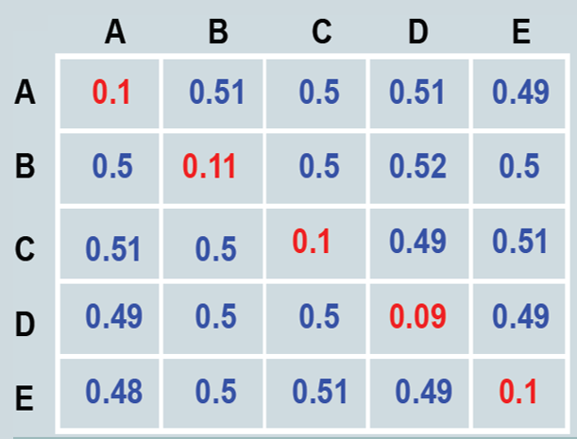

1. Draw ROC curve of a “perfect” biometrics system. “Perfect” means that the system can achieve 100% TMR and 0% FNMR.
2. Can we (NOT) estimate recognition error rates from verification error rates? Assuming (1) The identification system returns all the identities whose match score is above the threshold (2) The same threshold is used for both verification and identification scenarios.

If your answer is yes, how to derive FNR from FRR and FPR from FAR? If you answered no, please explain why? Which is challenging, verification or recognition, why?