**Professor Xin Chen, Biometrics, Fall 2015**

**Assignment: Iris Segmentation**

1. A toy example of edge pixels of an iris image. Please detect the circle boundary with r = 3 pixels using Hough Transform i.e. show the hough space voting process and plot the fitted circle on the original edge image.

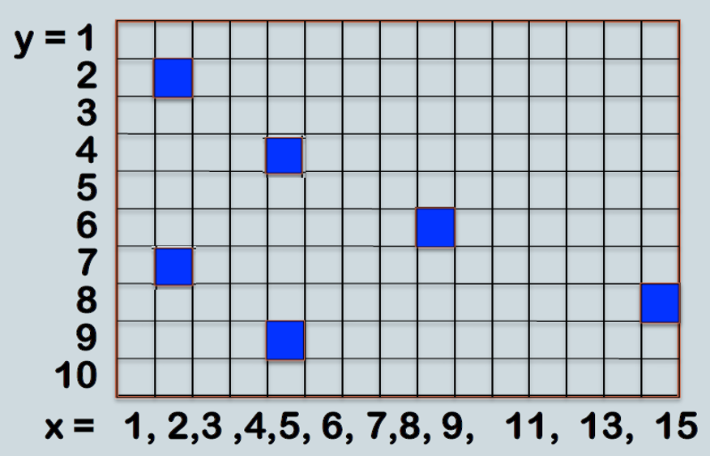

1. Write a program to automatically extract iris from all the images attached using either hough transform or integro-differential operator. Please submit an executable and your result images showing the circular boundaries.