# Chronos

## About this application

Chronos is supposed to help to get a personal overview of the own working time of the day.

This tool should serve as a daily helper for the user to get a quick overview and to keep track of the legally allowed maximum working time (also without internet or open websites). The tool can also serve as a reminder to enter the working hours correctly in the employer system. Please note: This application has been optimized for the german work laws, but it can be helpful in other countries.

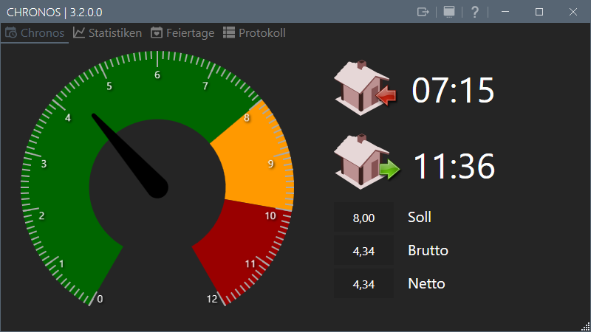

## Privacy

This program stores the times only **LOCALLY** in the **PROFILE folder of the user**. No other user specific data is stored.

Alternatively, the program can be switched to a **portable mode**. The times are then written to the **program directory**.

## How it works

The program creates the start of work dataset for the current day at startup and then updates the end of work dataset every minute until the program is closed. Ideally, the program should be started when the user profile is logged in (autostart) and stopped by logging out of the user profile (or manually closing the application). It will automatically deduct 30 minutes from the net working time as this break is legally binding in germany and does not count as working time.

### Functions

* Overview on the start page
  + Gauge/Tacho for the hours display
  + Entry time (Start of the application)
  + Exit time (updated until the application is closed)
  + Target gross and net hours view
* Statistics
* Tabular with total working time for the week/month/year
* Graphical (adjustable/bar chart)
* Overview of upcoming public holidays of the year

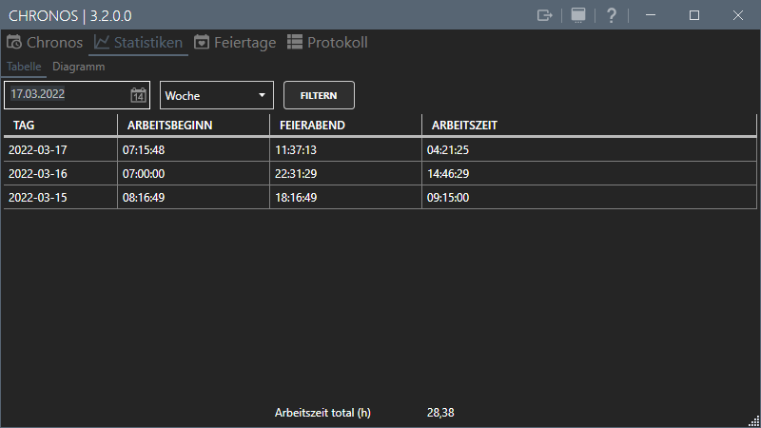

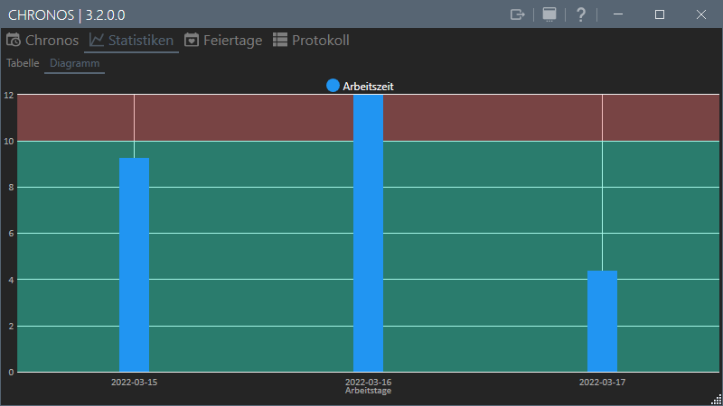

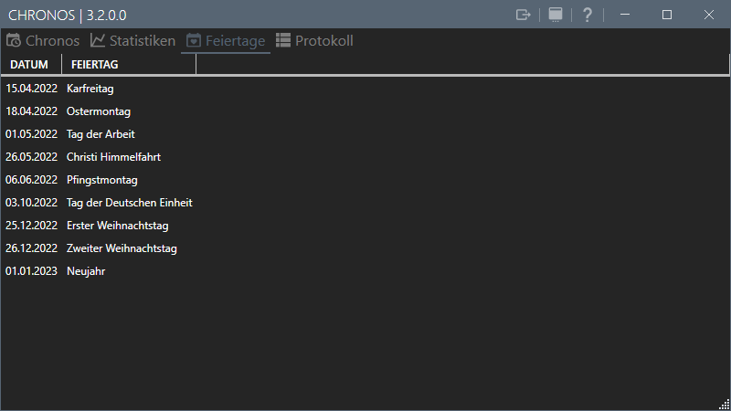

### Settings

The settings page offers the following possibilities:

* To enter the own working time (in hours).
* The maximum working time (is preset to the legally allowed 10 hours in germany)
* Saving interval of the working time into the local database (application restart necessary!)
* Start with Windows (Yes/No)
* Start minimized (Yes/No)
* Alarm function (when the defined threshold is exceeded, there are 3 warning messages and sound, then the application permanently switches to critical alarm message and sound)
* Chronos Export folder in default document folder or in your own destination

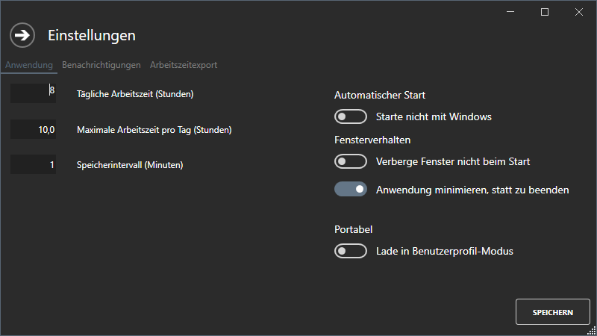

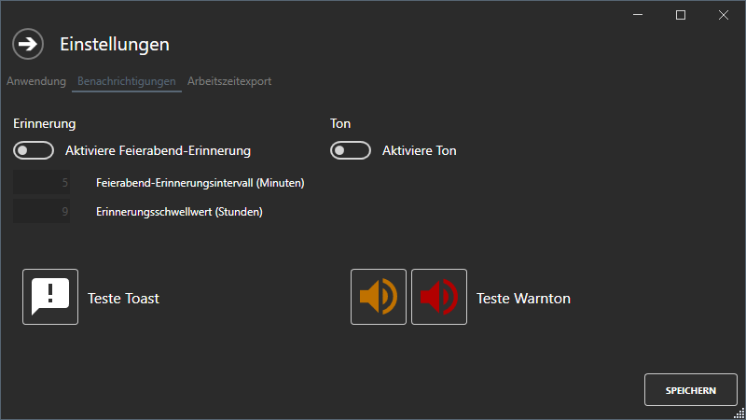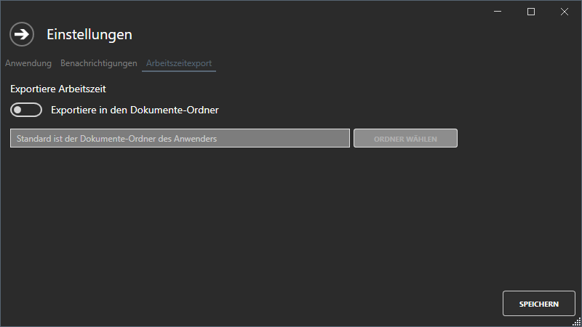

## Versionen

* 1.0.0.0: Initial version of the tool.
* 1.0.0.12: Initial Release
* 1.0.0.14: Second Release
* 1.0.0.18: Bugfixes
* 2.0.0.0: Rewrite of the complete tool, change to newer libraries/frameworks
* 2.2.0.0: Bugfixes
* 2.4.0.0: Bugfixes, gross working time added, breaks are deducted correctly
* deducted (from 6h 30 min, from 9h 45 min)
* 2.6.0.0: added option for own export folder
* 2.8.0.0: Bugfixes
* 3.0.0.0: Bugfixes, added portable mode
* 3.2.0.0: added (week, month, year) filter for tabular view

**Release date of the current version: Donnerstag, 17. März 2022**

### Implemented features

* Work start time is logged
* Work end time is logged and continuously updated
* Actual, target and gross working time is displayed
* Traffic light colored display of the legally allowed working time
* Graphical feature
* Tabular feature
  + Add day
  + Edit day
  + Delete day
* Alarm function to notify before exceeding the legally allowed working time
* Export of table data to Excel spreadsheet
  + All data records of a freely definable time period
  + All data records above the legally allowed maximum working time of a freely definable time period
* Portable Mode

### Planned Features

* Export of charts to PNG files
* Make fixed german legal settings configurable for other countries

### Future Ideas

* ---

## Featured Screens

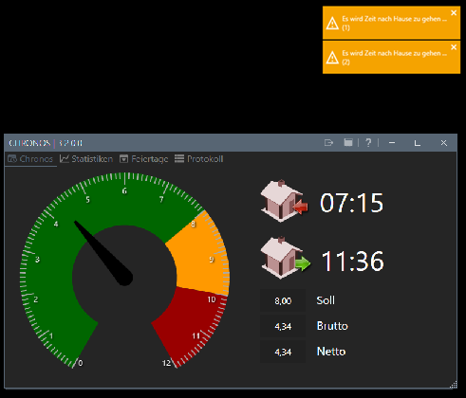

Figure 1: Alarm

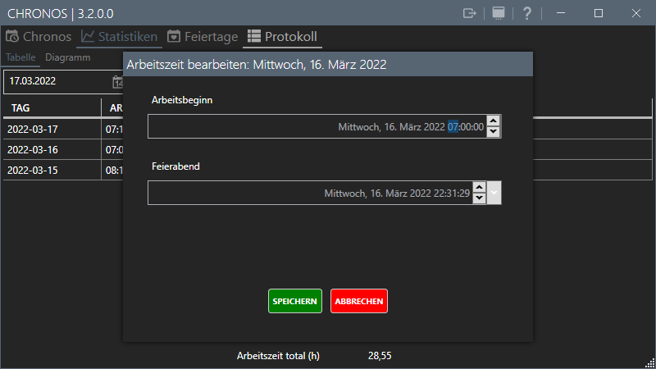

Figure 2: Zeit bearbeiten