***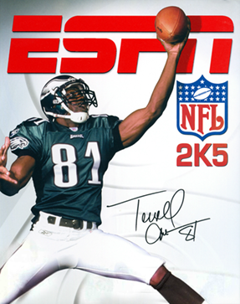*v1.5 Updates & Fixes**

- Removed Alt uniforms for BUF 69-73, ATL 66-67, TEN 74-75

- Added Bears Retro uniform (58-61)

- Added Packers Retro uniform (03 Alt 1)

- Added Vikings Color Rush uniform (04 Alt 2)

- Added Jordan, Nike, Adidas, UnderArmor gloves

- Added Nike, UnderArmor, Adidas cleats

- Updated Bengals Alt uniform

- Updated Pigskin

- Updated Stadium fans

- Updated Sideline uniforms

- Updated Jersey team selection

- Updated in-game team color icons

- Updated Jaguars Stadium + Uniforms

- Updated Cardinals Uniforms

- Updated Falcons Uniforms

- Updated Rams Uniforms

- Updated Ros scoreboard for Chargers (LA), Raiders (LVR), Rams (LAR)

- Updated Ros Redskins to WFB Team

- Custom scripts for texture selection

**Applying v1.5 Patch**

Download the v1.5 pkg version you want from the github.com project site. The v1.5 fix pkg only includes the texture updates and does not include the emulator.

***NOTE: If this is the first time you are installing the NFL2K5 Resurrected Mod, you will want to download the full pkg and install.***

**INSTALLATION**

1. Extract the v1.5 fix pkg you downloaded, and open the main folder
2. Move all included files + folders into your main *(.\PCSX2_NFL2KR)* emulator directory and say YES to REPLACE all files

1. Launch PCSX2 and enjoy NFL2K5 Resurrected

If you find additional issues, please report them in our [Discord](https://user-images.githubusercontent.com/69597675/124640725-d1e88980-de5b-11eb-926d-ec5f55b19a62.png) [Discord](https://discord.gg/sBVXzYb)

Additional Uniforms

See below to know which teams have additional uniforms.

|  |  |
| --- | --- |
|  | - Current  - 93-94  - 64-93 |
|  | - Current  - 58-61 |
|  | - Current  - 02 Alt |
|  | - Current |
|  | - Current  - 85-96 |
|  | - Current |
|  | - Current |
|  | - Current  - 93-94 |
|  | - Current  - 85-87  - 83-84 |
|  | - Current |
|  | - Current |
|  | - Current  - 94 Alt |
|  | - Current |
|  | - Current |

|  |  |
| --- | --- |
|  | - Current |
|  | - Current  - 81-99 |
|  | - Current |
|  | - Current  - 90-93 |
|  | - Current |
|  | - Current  - 03 Alt 1 |
|  | - Current  - 96  - 03 Alt |
|  | - Current |
|  | - Current |
|  | - Current  - 98-99 |
|  | - Current |
|  | - Current |
|  | - Current |
|  | - Current  - 83-02 |
|  | - Current |
|  | - Current |
|  | - Current |
|  | - Current  - 93-94 |

# Credits

The NFL2K5 Resurrected Mod is a collaborative effort by the NFL2K5 Mod Community. Many thanks to everyone who helped with the v1.5 update!

If you find additional issues, please report them in our [Discord](https://user-images.githubusercontent.com/69597675/124640725-d1e88980-de5b-11eb-926d-ec5f55b19a62.png) [Discord](https://discord.gg/sBVXzYb)