Owner and Admin Action Guide
What the firm must do as a Certified partner · How to do it · Which portal document has the full detail
Your job in one paragraph
Keep us in good standing, move us from Certified to Select, and make sure the team does the few things that earn credit: certify people, register delivery work, and publish one customer story. Everything else in the portal is either a how-to for those three things or a benefit that unlocks later.

1. The rules that matter (Program Guide, Version 2, effective 5 Oct 2026)
Tier | Certified individuals | Deployed joint customers | Public customer stories
Certified (us) | 3 or more | – | –
Select (next) | 10 or more | 2 or more | 1 or more
Preferred | 100 or more | 15 or more | 3 or more
Global Premier | 1,000 or more | 100 or more, across 3 regions | 15 or more

- All requirements must be met together, measured over the last 365 days.
- Only these exams count: Claude Certified Developer – Foundations, Architect – Foundations, Architect – Professional. The Associate exam does not count. One person counts once even with several certifications.
- Deployed joint customer: a unique customer with a live Claude production deployment where we are the registered delivery partner. Pilots and proofs of concept do not count. We must give Anthropic the customer’s Organization ID (or AWS / Google Cloud / Azure account ID).
- Public customer story: live on a public URL (no NDA or login), names Claude and a third-party client, describes a production deployment, shows at least one measurable business result, and the client approved it.
- Reviews: Certified and Select are promoted monthly (starts November 2026) – meet the requirement by month end and the promotion follows the next month. Preferred and Global Premier are reviewed 1 January and 1 July (from 1 January 2027). Once promoted we keep the tier through at least the next annual review (31 December) plus a 90-day remediation window.
- Moving up more than one tier is allowed if we meet the higher tier’s requirements.
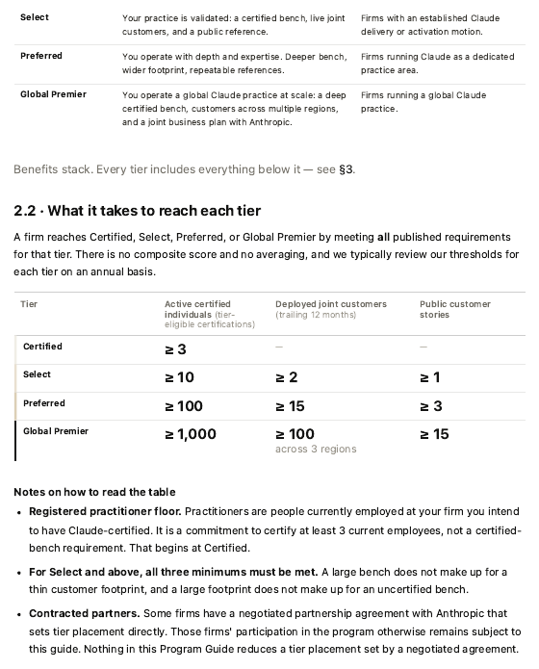
Program Guide p.4 – the tier requirements table. Source: portal document “CPN Program Guide”.
2. Our to-do list
# | Action | Owner | When | How / where
1 | Accept the Claude Partner Network Agreement | Owner | Now (overdue since 20 Jul 2026) | Partner portal > onboarding flow “Accept the Claude Partner Network Agreement”. Agreement text: anthropic.com/legal/cpna
2 | Confirm tier shows Certified in the Hub; download badge | Admin | This week | partnerhub.anthropic.com. Tier shows within 24 hours of promotion email
3 | Certify 6 more people (4 now, need 10) | Training lead | Book before 31 Dec 2026 | Folder 04_Training_and_Exams
4 | Register all live Claude engagements | Delivery lead | At scoping, no later than 60 days after work begins | Hub > Services > Submit Project (see Delivery guide)
5 | Start one customer story | Owner / Marketing | Now – slowest item | Customer Story Guidebook (portal). Ask the client for written consent; include a hard metric; publish on a public URL
6 | Announce Certified status | Marketing | After the badge email | Approved wording below
7 | Name one person for PAM AI / Hub questions and pin the contact card | Admin | This week | Contacts and intake deck, p.6
8 | Monthly: check the Hub “Current Tier” panel | Owner | Monthly | Hub dashboard refreshes weekly
9 | Draft our own SOW template and scoping worksheet | Owner / Sales | Next 30 days | Anthropic does not supply a SOW template

3. What we may say publicly about our tier
Do: use the approved line – “[Firm] is Certified in the Claude Partner Network.” Wait for the promotion email first. Post on social media only. Use the badge from the Hub.
Don’t: say “Anthropic-certified” or “certified by Anthropic”; call ourselves Select, Preferred or Global Premier; issue press releases or newswire items; quote tier requirements, incentive amounts or comparisons with other partners; name customers without their consent.

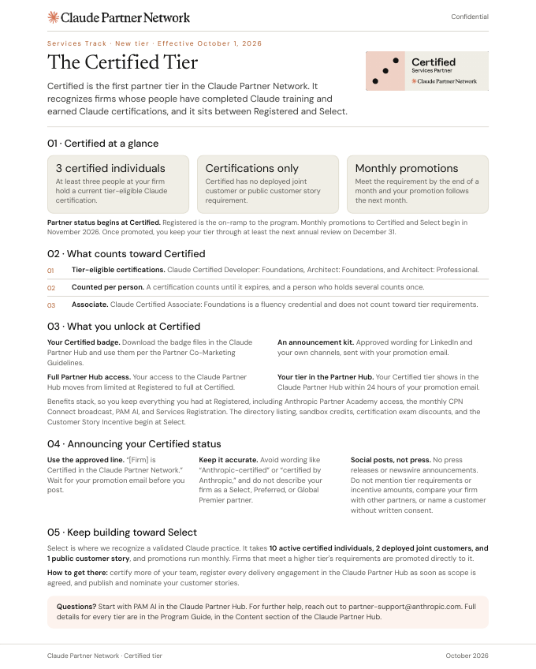
Certified Tier 1-pager – our tier at a glance, what counts, what unlocks, how to announce.
4. What we get now and what comes at Select
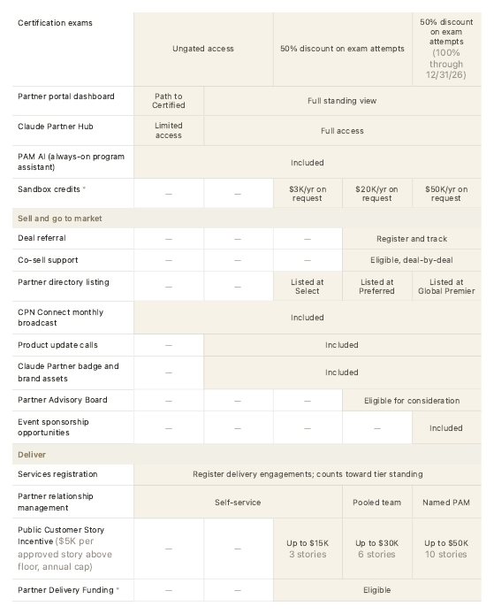
Program Guide p.8 – benefits by tier. Benefits stack: every tier includes everything below it.
Benefit | Certified | Select
Partner badge and brand assets | Yes | Yes
Services Registration (counts toward tier) | Yes | Yes
Sandbox credits (non-production Claude Enterprise, 100 seats) | No | $3K per year, on request
Partner directory listing | No | Yes
Customer Story Incentive | No | $5K per approved story above floor; up to 3 stories per year
Partner Delivery Funding | No | Eligible (separate terms; needs executed agreements and an SOW)
Exam discount | Open access to exams – check price at checkout (our booking was free; Program Guide shows 100% through 31 Dec 2026) | 50% (grid)

5. Path to Select – a 90-day plan
From “Your first 90 days” (Partner Success Hub, Topic 02). The three numbers to reach: 10 certified, 2 deployments registered, 1 customer story.
Weeks | Do
1–2 | Choose the “anchor” unit; name the ten people who will certify; open the customer-story conversation with one client; run Claude on our own teams first (“Customer Zero”).
3–8 | People certify (Academy courses, then exams); accept the agreement; sign vendor / customer paperwork.
9–12 | Register live engagements; submit the first story; check the Hub scoreboard.

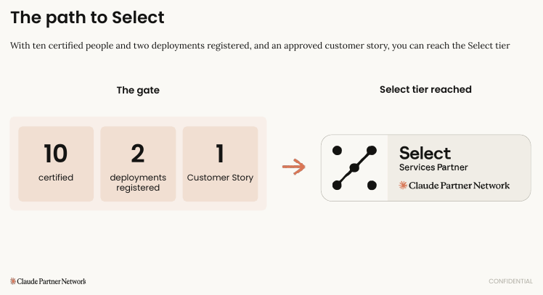
Your first 90 days, p.9 – the path to Select gate (10 certified, 2 deployments registered, 1 customer story).
6. Who to contact
For | Go to
Any question | PAM AI inside the Partner Hub (partnerhub.anthropic.com) – always on
Program, tier or registration help | Partner Operations – partner-support@anthropic.com (older decks show partner-success@anthropic.com)
Program feedback | partner-feedback@anthropic.com
Exam and certification issues | certifications-support@anthropic.com
Funded-engagement paperwork / invoices | partner-activations@anthropic.com / ap@anthropic.com (only if we ever run an Anthropic-funded engagement)
Tier or attribution dispute | Head of Partner Programs (via the escalation table)
Trust and security documents | trust.anthropic.com

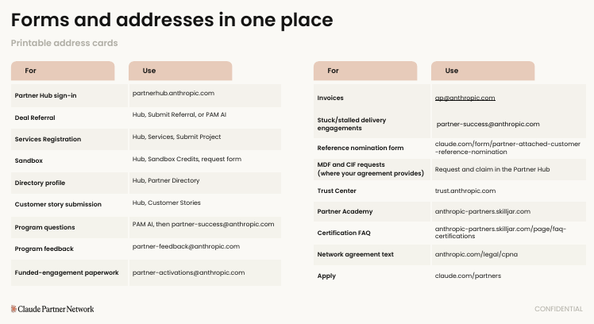
Contacts and intake deck, p.6 – forms and addresses in one place. Print and pin.
7. Know before you rely on it
- We have no named Anthropic partner manager (that starts at Global Premier; Preferred gets a pooled team). Some decks assume one – our route is PAM AI, then Partner Operations.
- Co-sell and deal referral start at Preferred. Read the Sales guide for how to sell on our own.
- Several documents have stale dates or conflicting figures; see Start Here, section 6.
- A Delivery Readiness Designation (DRD) exists for firms with 10 or more active Developer / Architect certified people, 3 documented deployments and 1 contactable customer reference. Certified is the minimum tier named for DRD engagement (contact Partner Operations). Plan for it after Select.
8. Portal documents for the Owner / Admin
Document (portal name) | Read for | Priority
CPN Program Guide (listed 5 times) | The rulebook: tiers, benefits, registration, funding, escalation – sections 2, 3, 4.3 | Must read
CPN Program Guide – Services FAQ | 28 short Q&As; fastest reference | Must read
Certified Tier 1-pager | Our tier, announcement rules | Must read
Partner Announcement Kit – Certified | Social wording and rules | Read
02 Your first 90 days | The working plan to Select | Must read
01 How the partnership works | Hub overview, what counts toward tier | Read
04 Contacts and intake | Who to contact and escalate to | Pin it
Services Registration Guidebook | How credit is earned | Read (delivery lead owns)
Customer Story Guidebook / Customer Stories – Two Paths | Story rules and form | Read (marketing owns)
03 Paperwork and commercial instruments | Contracts and exhibits – only for funded work | Later (Select+)
CPN Services Track Launch Guidance | Launch posts for Select and above | Later – no Certified line
CPN Partner Sandbox Guide / Directory profile / Referrals from the Directory | Select-tier benefits | Later

