Sales Team Guide
How we sell Claude as a Certified partner · What Anthropic will and will not do for us · Which portal documents to use
The most important fact for sales
Co-sell with Anthropic starts at the Preferred tier. At Certified, Anthropic’s own co-sell deck tells us to “plan to lead your own sales motion”. We cannot file Deal Referrals (Preferred and above), so we do not get deal protection or Anthropic account-executive involvement through the program.
What we can do: sell and deliver our own services, and register the delivery work (Services Registration) – that earns full credit toward tier at every level.

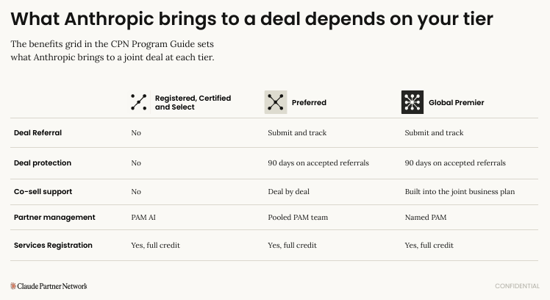
“01 The co-sell motion”, p.3 – what Anthropic brings to a deal at each tier. Deal Referral is “No” until Preferred.
1. How a Certified firm sells, step by step
Step | What to do | Portal document
1. Qualify | Open with one qualifying question: name the sponsor, the decision maker and the blocker | “04 Scoping toolkit” (tool 1: qualifying)
2. Value | Agree with the customer how value will be measured (time saved, cost, revenue) before pitching | “04 Scoping toolkit”; “03 Measuring customer value on a Claude activation”
3. Pitch | Position Claude without Anthropic in the room: lead with outcomes, then the model | “02 Positioning and sizing” p.6 and p.8 (talking points)
4. Size | Estimate the Anthropic-side consumption with the seven-step method (not our services fee). Re-check public prices each time | “02 Positioning and sizing” p.12–16
5. Scope a pilot | Use the seven-field scoping worksheet and the four pilot exit conditions; propose a time-boxed pilot | “04 Scoping toolkit” (see p.3 for the five tools)
6. Package | Offer one of the five standard adoption engagements (workshop → enterprise rollout) | “18 Partner Adoption Offerings”; “Activating Claude (Toolkit 1 of 3)”
7. Contract | Use our own SOW (Anthropic provides no SOW template). Collect the customer’s Organization ID | Delivery guide, Services Registration
8. Register | Register the engagement in the Partner Hub as soon as scoping starts | “03 Registering and working deals”
9. Prove | Ask for a public story with a measurable result | “Customer Story Guidebook”

Pitch frame and guardrails (Positioning and sizing)
• Sell one of three outcomes: smarter employees, faster processes, or transformative products.
• Land small, prove, then expand: a two-to-four-week pilot with metrics agreed first.
• Never quote price, discount, seat minimum, term or funding – “Anthropic will quote that”. Take all rates from the current public pricing page.
• Pilot burn is not ARR – size consumption from real pilot traffic, with a low / base / high range.

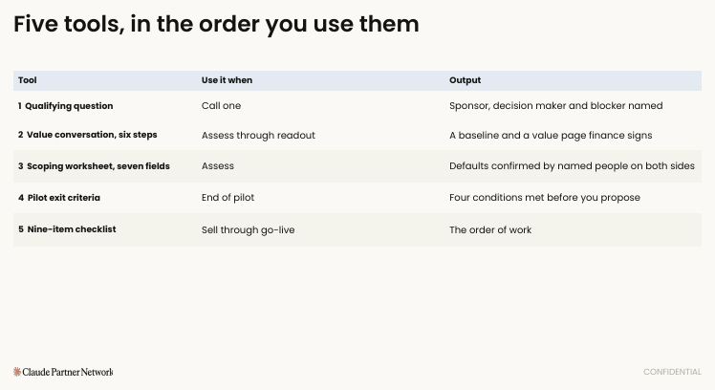
Scoping toolkit, p.3 – the five tools in the order you use them: (1) qualifying question, (2) value conversation, (3) scoping worksheet, (4) pilot exit criteria, (5) nine-item checklist through go-live.
2. Five habits from Anthropic’s co-sell playbook that still help us
These come from “01 The co-sell motion” (p.11–18). The deck assumes referrals, so use them as our own internal sales discipline and confirm with Partner Operations before relying on Anthropic involvement.
- Let the customer ask for Anthropic’s involvement – pull, not push.
- Five Checks before involving Anthropic on a deal: (1) a named sponsor who owns a budget and knows you are involving Anthropic; (2) a workload described in one sentence and tied to one of three outcomes; (3) the customer agreed a next step and the engagement is scoped (what, for whom, how long); (4) a realistic first phase sized to the users in scope; (5) our own team uses Claude every day.
- One-page brief instead of a long deck (see the Partner Opportunity Brief template).
- 20-minute first call with a fixed script (0–3 / 3–6 / 6–15 / 15–20 minutes). The worked example uses 15 minutes – pick one and standardise.
- Fortnightly update email to everyone on the deal.
3. Customer routing by size (from the co-sell deck)
Customer size | Who handles it at Anthropic
Under 50 seats | Self-serve at claude.com/solutions/enterprise
50–150 seats | Anthropic inside sales (Preferred and above tag the referral “Seed deal, 50+ seats”)
150+ seats | Commercial account executive via a standard Deal Referral (Preferred and above)

4. Product sales kits – what to use, and who may see it
Rule of thumb: the short 2-pagers are written to be handed to customers; most decks and FAQs are stamped CONFIDENTIAL or contain internal sales coaching. Confirm Anthropic’s sharing terms before sending anything outside the firm. Always use the newest model family first.
Product | Start with | Then | Sharing
Claude Haiku 5.5 – fast, low cost; high-volume work | Haiku 5.5 2-pager | Haiku 5.5 FAQ (migration from Haiku 4.5); slides | 2-pager looks customer-ready; FAQ / slides internal
Claude Sonnet 5.5 – everyday work, agents, coding | Sonnet 5.5 Sales 2-pager | Sales FAQ; slides | 2-pager customer-ready; others internal
Claude Opus 5.5 – hardest professional work | Opus 5.5 2-pager | Opus 5.5 Sales FAQ; slides | 2-pager customer-ready; others internal
Claude Fable 5.1 – top model, long-running high-stakes work | Fable 5.1 2-pager | Fable 5.1 / Mythos 5.1 / EFS Sales FAQ | FAQ is “for CPN partners”. Parts of Enterprise Frontier Safeguards are “in development” – do not promise availability
Claude Enterprise | Claude Enterprise deck | – | CONFIDENTIAL – internal
Claude Cowork – desktop agent for business teams | Claude Cowork deck | – | CONFIDENTIAL – internal
Claude Code – coding agent | Claude Code deck | Claude Code checklist (Delivery) | CONFIDENTIAL – internal
Claude for Financial Services | Financial Services 2-pager | Industry evidence pack (FSI) | Customer-style; confirm terms
Build layer: Developer Platform, MCP, Agent SDK, Agents, Agent Skills, Slack | Each product deck | – | CONFIDENTIAL – internal; mostly for technical team
Older: Opus 4.8, Sonnet 4.6 | Only for customers still on those models | – | Superseded for price and benchmark advice

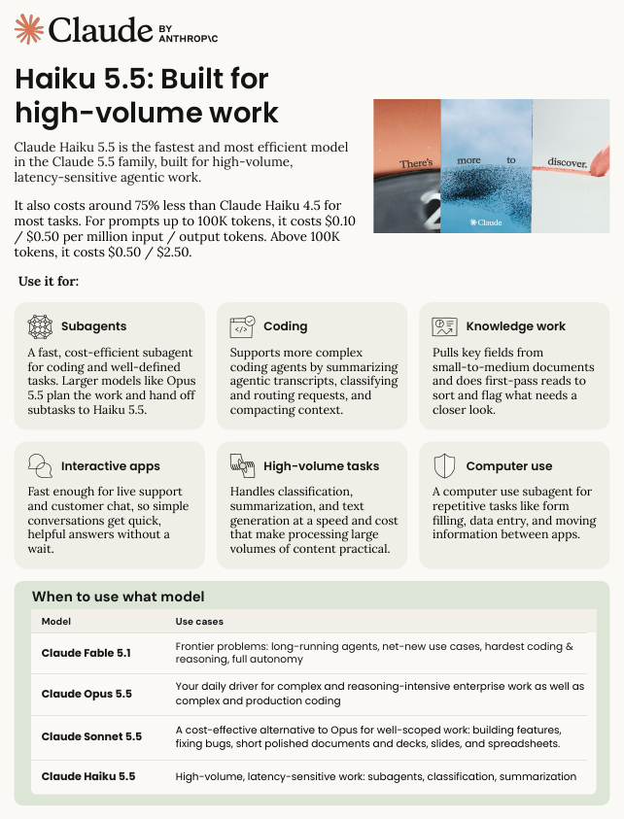
Example: Claude Haiku 5.5 2-pager – a short, customer-style summary.
Watch-outs before quoting
• The Opus 5.5 and Sonnet 5.5 documents say other 5.5 models are “coming soon” – they are now released.
• The “which model” tables in some 2-pagers still show older models (Haiku 4.5, Sonnet 5, Opus 5).
• The Opus 4.8 deck gives a benchmark (SWE-bench Pro 64.3%) that conflicts with the 2-pager (69.2%) – use the 2-pager.
• The Developer Platform deck is dated (mid-2025 market data). Always re-check live pricing.

5. Industry evidence packs – only where we have real proof
Eight blank forms (Financial services, Healthcare and life sciences, Industrial manufacturing, Retail and consumer, Technology/media/telecom, Travel/transportation/hospitality, Security (CISO), Office of the CFO). Complete one only if we have delivered work in that industry: rate our capability honestly, choose 2–3 use cases, get customer permission, record a short demo, return it to Anthropic. Read “02 Industry buildbooks” first. Starter buildbooks are visible to Select and above only.
6. Customer stories sell for us
- A public story is also a tier requirement for Select – sales should ask for it at kickoff, not at the end.
- Two paths: (1) a live public story that counts toward tier; (2) a marketing submission for Anthropic to produce and promote. See “06 Customer Stories with Anthropic – Two Paths”.
- A story needs a real number (for example hours saved or cost reduced) – “improved efficiency” is declined.
7. Later, when we reach Select or Preferred
- Select: partner directory listing – customers can find us and send inquiries (“Referrals from the Partner Directory”, “Building a great directory profile”). Pre-draft our profile now: name, website, short description, logo, city, “accepting new clients”.
- Preferred: Deal Referral (90-day deal protection), co-sell, the Partner Opportunity Brief to the Anthropic partner manager, the worked co-sell example (“04 A worked co-sell example”).
8. Portal documents for Sales
Document (portal name) | Use it for | Priority
01 The co-sell motion | What Anthropic does at each tier; deal habits | Read p.1–6
02 Positioning and sizing | Pitch and sizing method | Must read
04 Scoping toolkit | Qualify, value, scope a pilot | Must read
18 Partner Adoption Offerings | Five packaged engagements | Read
Activating Claude (Partner Toolkit 1 of 3) | Four-step method to sell as outcomes | Read
Product 2-pagers (Haiku, Sonnet, Opus, Fable) | Customer conversations | Use
Product decks and Sales FAQs | Internal coaching | Reference
06 Customer Stories – Two Paths; Customer Story Guidebook | Stories | Read
Account maturity map; Partner Opportunity Brief templates | Upsell planning; joint-conversation brief (needs partner manager) | Later
04 A worked co-sell example | Pattern for a joint deal | Later (Preferred)

