Delivery and Technical Team Guide
How we deliver Claude rollouts and get credit for them · What to register · Which portal documents to use for each job
Two jobs for the delivery team
1. Register every Claude engagement in the Partner Hub so it counts as a deployed joint customer (we need 2 for Select).
2. Deliver it the way Anthropic’s playbooks describe – 90 days, three gates, measurable adoption and value – so the result is strong enough to become a public customer story.

1. Register delivery work (Services Registration)
Open to every tier. This is how Anthropic knows we delivered a customer’s Claude deployment. Credit starts at stage 4 (Delivery Started) or later and counts once the deployment reaches sustained production use. Pilots and proofs of concept do not count.
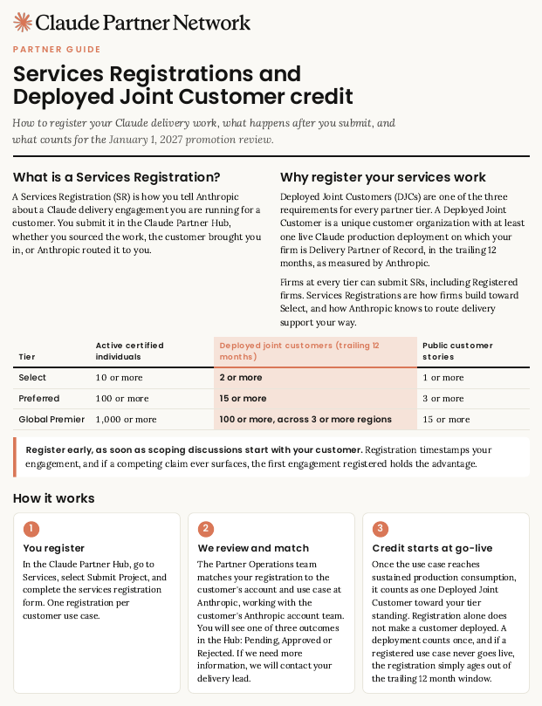
Services Registration Guidebook, p.1 – what a Services Registration is and how it works.
Step by step
☐ When: register at scoping, and no later than 60 days after delivery work begins. Anthropic reviews within five business days.
☐ Where: Partner Hub (partnerhub.anthropic.com) > Services > Submit Project. One registration per customer use case.
☐ Fill in: customer company; a decision maker with signing authority and a work email (no info@ or contact@); our delivery lead; start and end dates; Claude products; a short description of the use case.
☐ Organization ID: required for every service type except pure training or advisory. Claude.ai customers: claude.ai > Settings > Account > Organization ID. API customers: platform.claude.com > Settings > Organization. Customers on Bedrock, Vertex AI or Foundry give their AWS (12-digit), Google Cloud or Azure account ID. Without it the registration is rejected.
☐ SOW: optional, but it moves you to the front of the queue; required if the work is funding-eligible (pricing may be redacted).
☐ Keep the stage current: 1 Scoping, 2 Proposal, 3 SOW confirmed, 4 Delivery started, 5 Delivery completed. Pending and stages 1–3 do not count yet.
☐ Answer any “missing information” request by the date given or the registration is declined (you may resubmit).
☐ Check status: Hub dashboard (Current Tier panel) refreshes weekly. Status is Pending, Approved or Rejected.
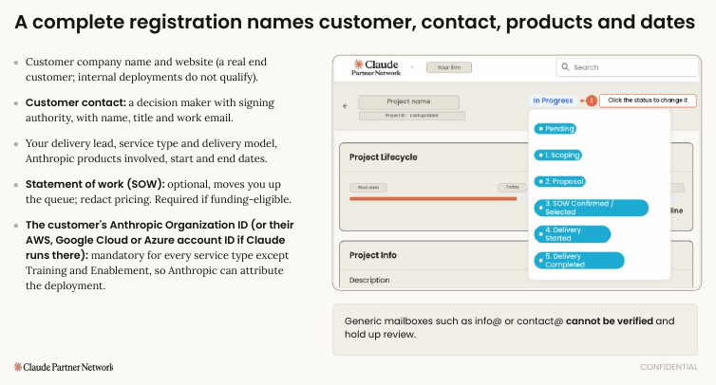
“03 Registering and working deals”, p.9 – what a complete registration needs (customer, contact, products, Organization ID).
If two partners claim the same customer: Anthropic settles delivery-lead conflicts within 10 business days, in this order of evidence: customer attestation, contracted scope, delivery activity, registration order.

2. The delivery method in one picture
Anthropic’s method has four steps (“Activating Claude”): Day One → Stand-up → Department Activation → Enterprise Rollout, run over 90 days with three gates.
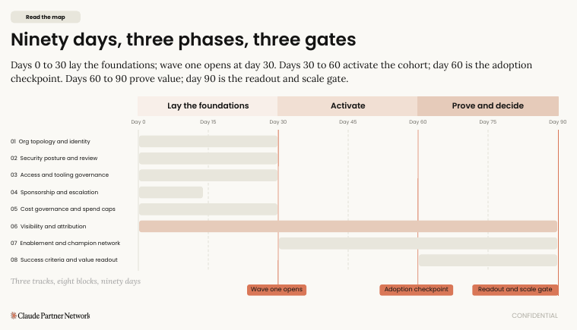
“03 The 90-day rollout map”, p.3 – days 0–30 lay the foundations, 30–60 activate, 60–90 prove and decide.
Gate | When | Evidence
Wave one opens | Day 30 | First cohort of 50–100 users across two to four whole teams; day-0 baseline recorded; about 60% weekly active and 20% beyond chat
Adoption checkpoint | About day 60 | About 70% weekly active and 35% beyond chat (example calibration – agree your own targets up front)
Readout and scale decision | About day 90 | Value against baseline, adoption and spend by week, three wins. One decision: scale, extend, adjust or stop. The customer’s sponsor presents it

3. Delivery documents – what each is for
Document (portal name) | What it is | Use it when
Claude Partner Delivery Playbook (78 pages) | The master document: 90-day yes/no checklist (p.3–15), three expert guides – Track A security and governance, B solution engineering and cost, C activation and value – and admin-console walkthroughs | Every first account. Start with the checklist; assign Tracks A / B / C to matching people
Deployment reference checklist | The playbook’s checklist as a standalone: eight blocks, sign-off, ten client FAQs, escalation list | Customer kickoff – print it and get four signatures (delivery lead, executive sponsor, security owner, budget owner)
Delivery field guides | Short tour of Tracks A, B, C, one page per decision | Briefing for practitioners before opening the full playbook
Delivery templates (Activating Claude) v4.0 | 13 fill-in templates, T1 to T13: intake page, day-0 baseline, adoption plan (nine named roles), entry and exit checklists, week-by-week plan, go-live announcement, stand-up readout, eight derailers, day-90 readout, recommendations, wave plan, two-weekly update to Anthropic | Copy into our own folder; send T5 to the sponsor at kickoff; schedule T13 every two weeks
Claude Code deployment checklist v4.0 | 12 items: where model traffic goes, sign-in, policy to laptops, network, permissions, MCP governance, telemetry, spend controls, repository readiness, then pilot 10–30 developers, widen, hand over | Any engagement that includes Claude Code
The Claude Activation Workshop set | Starter kit for the first four weeks with a customer that already has seats | Kickoff agenda for the first practitioner session
Activating Claude (Partner Toolkit 1 of 3) | Example four-step method for outcome-based activation, with visible gates | Our service menu and scoping
03 Measuring customer value | How to agree measurable value with finance on Day One: baseline (60–90 day lookback), checkpoints, day-90 readout | Every kickoff – it produces the numbers a public story needs
Account maturity map and Partner Opportunity Brief | One-page grid of what is delivered / in flight / not started per customer function; short brief for the Anthropic partner manager | Maturity map: before each proposal. Brief: only when we have a partner manager (see note)

Note on the Opportunity Brief: it is sent to an Anthropic partner manager after the deal is registered. Certified firms do not have a named partner manager – ask PAM AI who to send it to.

4. First-account checklist (do these in order)
☐ Register the engagement (Hub > Services) and collect the customer’s Organization ID.
☐ Book the customer’s platform, security and identity teams for Day One; run the Claude Code checklist items 1–4 first if Claude Code is in scope.
☐ Capture the day-0 baseline (hold first access until it is on file) and have finance sign the value target.
☐ Fill the adoption plan with nine named roles (first four by kickoff).
☐ Run the entry checklist; agree adoption targets and gates in writing.
☐ Every cohort gets the “101” within five business days of provisioning; admins trained two to three weeks before launch; 1–3 connectors live by end of week one.
☐ Send the two-weekly update (T13) and use PAM AI for escalations (data retention, encryption keys, capacity, model issues).
☐ At day 90 the sponsor presents the readout; update the Services Registration to the right stage.
☐ Ask the customer for a public story with a measurable result – tell the owner and marketing.
5. Packaging what we can repeat
- Partner Solution Buildbook framework and Industry / Horizontal buildbooks – how to describe one repeatable offering (customer, partner, Claude bands plus a bill of materials). Starter buildbooks are visible at Select and above; ask PAM whether any are available to us now.
- Horizontal buildbook outlines: Claude Code activation, Cowork department activation, security (cyber) services. Industry evidence packs (8 industries) – fill only where we have delivered proof.
- Practice self-check (“04 Practice self-check”) – a yes / not-yet scorecard to run every 30 days; “01 Building your Claude practice” explains roles and the Delivery Readiness Designation.
6. Technical product references
Topic | Portal document | Notes
Claude Code | Claude Code deck | CONFIDENTIAL – internal. p.16 six-sprint modernization example
Cowork | Claude Cowork deck | CONFIDENTIAL – internal
Developer platform and API | Claude Developer Platform deck | Dated (mid-2025 data) – check live docs
Agents, Skills, MCP, Agent SDK | Agents; Agent Skills; Claude and MCP; Claude Agent SDK | CONFIDENTIAL – internal. Plus free courses and repos in the portal (see Document Index)
Model migration and breaking changes | Sales FAQs for Haiku 5.5, Sonnet 5.5, Opus 5.5, Fable 5.1 | Read the FAQ for your model before migrating customers

7. Caveats in the delivery documents
- Prices and beta features: the Playbook’s rate card was last verified 18 August 2026 – re-check every price, model name and beta feature before quoting.
- Small inconsistencies: exit checklist has 6 items in one document and 8 in others; adoption targets are 60% in some places and 70% in others; the Workshop set’s week-4 row looks like a copy error. Agree one version with the customer and write it down.
- Tier: nothing in the delivery documents is gated to a tier except references to a named Partner Success Lead and funded engagements – confirm with PAM AI.

