How to Book Your Claude Certification Exam for Free
Step-by-step guide
Before you start
• Open this link: https://anthropic-partners.skilljar.com/
• Sign in with your company (work) account – the account provided by your organization, not a personal account. The free price only appears for the organization's partner account.
• There are 4 exams to choose from. All are free through the partner discount, and each exam can be taken once.

The 4 exams
EXAM | LEVEL | COUNTS TOWARD TIER?
Claude Certified Associate | Foundations | No
Claude Certified Developer | Foundations | Yes
Claude Certified Architect | Foundations | Yes
Claude Certified Architect | Professional | Yes

Which exam should I take?
Only the Developer and Architect exams count toward the firm’s partner tier. The Associate exam does not count. The firm needs 10 certified people (Developer or Architect) to reach the next tier – ask your Training lead which exam to book.
Book before 31 December 2026. The free price is a 100% partner discount that the Program Guide shows through that date.

How to read the screenshots: a red box with a yellow highlight and a red number shows exactly where to click or what to check. Follow the numbers in order.
Step 1 – Sign in
Go to https://anthropic-partners.skilljar.com/ and sign in with your company (work) account. If you are signed in with another account, sign out first and sign in again with the correct one.

Step 2 – Choose your exam
1. Click Certifications and badges in the top menu.
2. Under Certification exams, click the exam you want (one of the four highlighted).
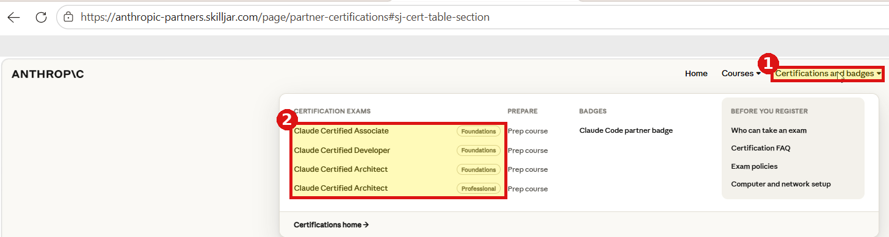
Tip: use the Prep course links in the same menu to study first – the courses are free.
Step 3 – Click “Register for the exam”
1. Click the black Register for the exam — Free button. The price is crossed out and shows Free.
2. Confirm the line “Your 100% partner discount is applied automatically at checkout.” If you do not see it, you are probably signed in with the wrong account – go back to Step 1.
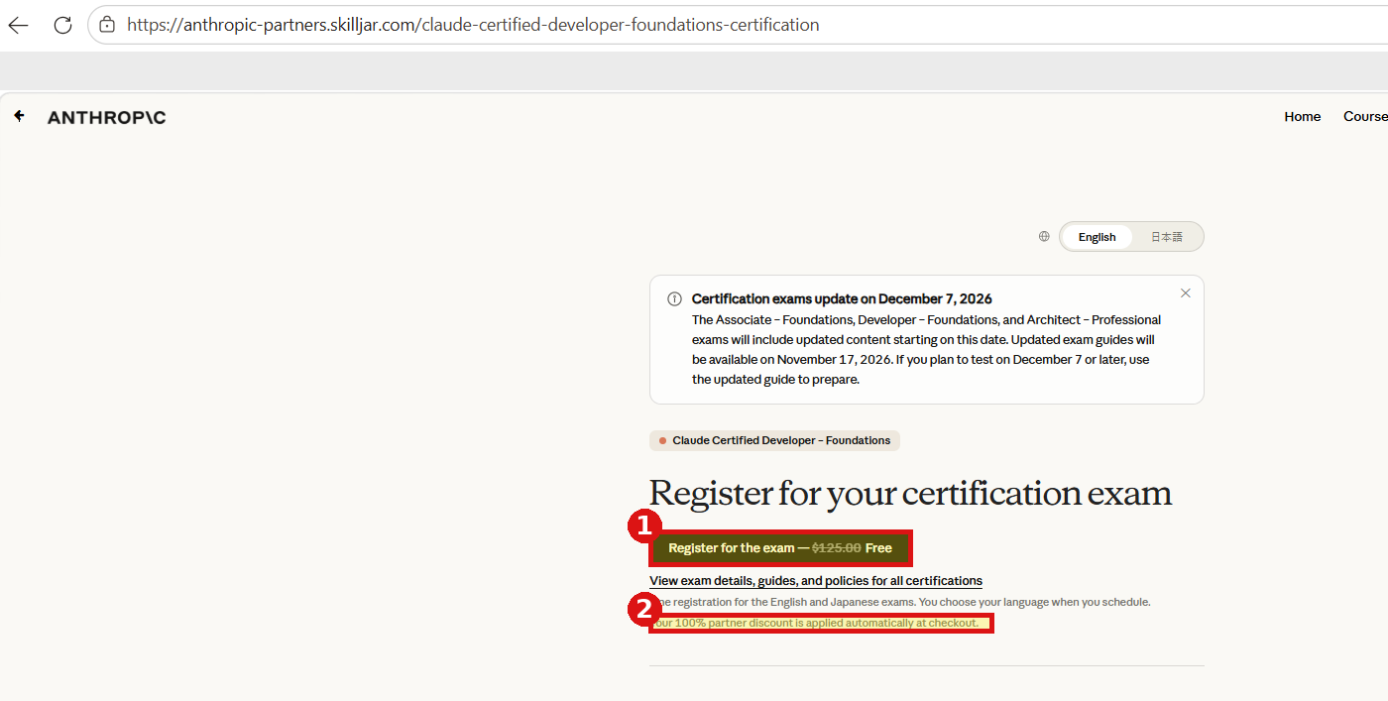
(Example shown: Developer – Foundations. All four exams follow the same steps.)

Step 4 – Review your order
1. Leave the Quantity at 1.
2. Check the Group Discount line equals the full price (for example −$125.00).
3. Check the Total is $0.00.
4. Click Review and Pay.
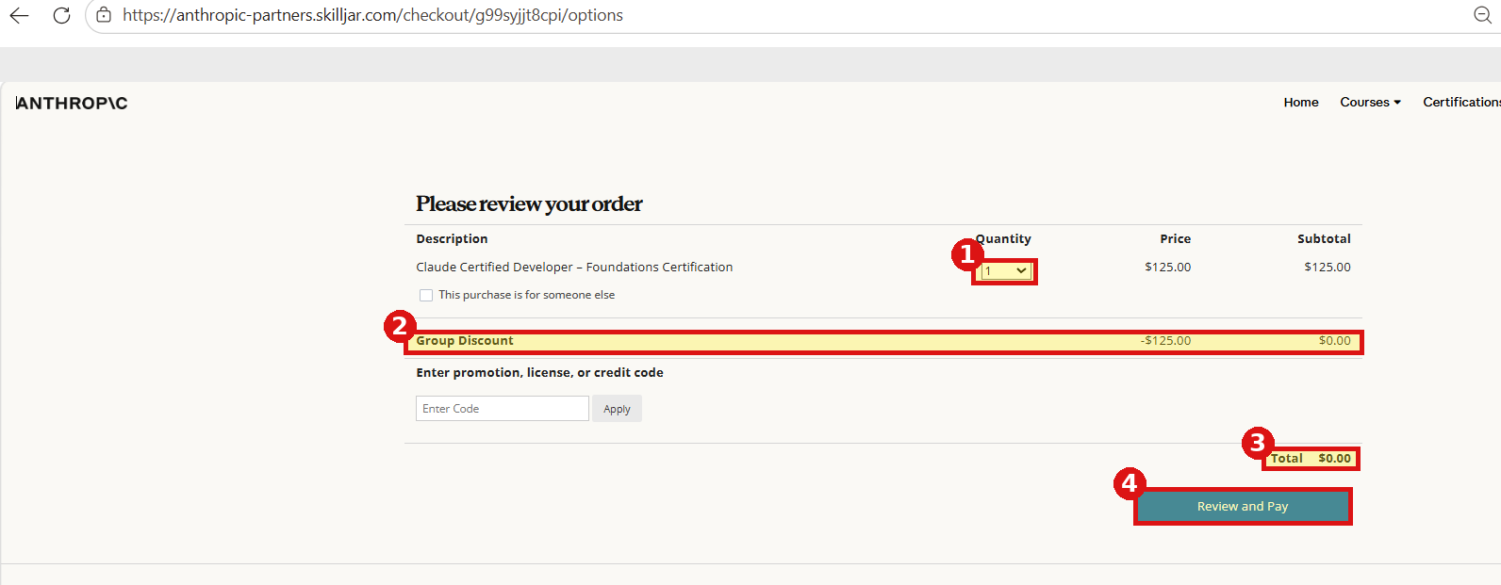
Do not enter any promotion or credit code – nothing is needed. The discount is applied automatically. If the total is not $0.00, stop and contact your administrator before paying.

Step 5 – Confirmation
You will see “Thank you. Your order ID is …”. Save your order ID. Your registration is now complete.
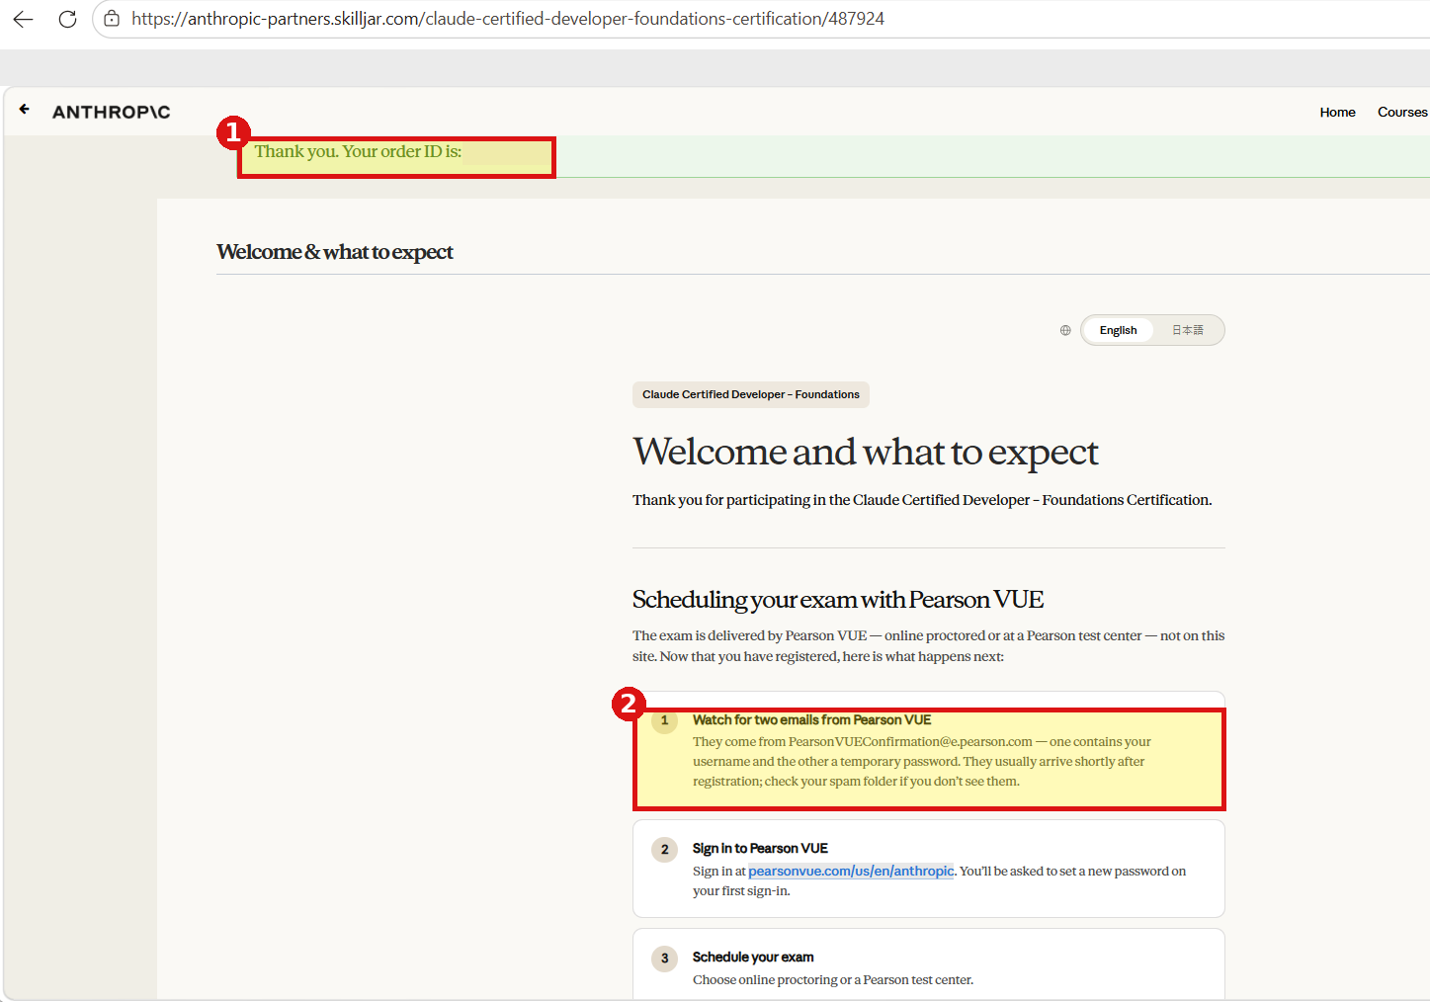

Step 6 – Check your email: two messages from Pearson VUE
Shortly after registering you will receive two separate emails from PearsonVUEConfirmation@e.pearson.com (check your spam folder if they do not arrive):
Email 1 – Temporary Password. Subject: “Pearson VUE Web Account Confirmation”. It contains your temporary password.
Email 2 – Username. Subject: “Pearson VUE Web Account Confirmation”. It contains your username.
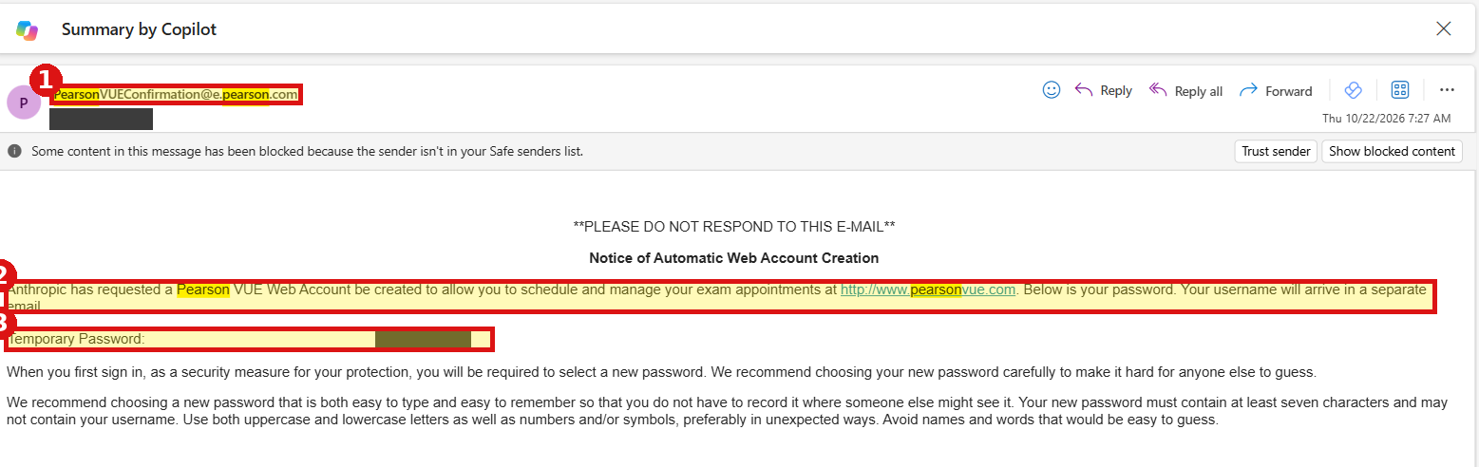
Email 1 – the temporary password (details hidden in this example).
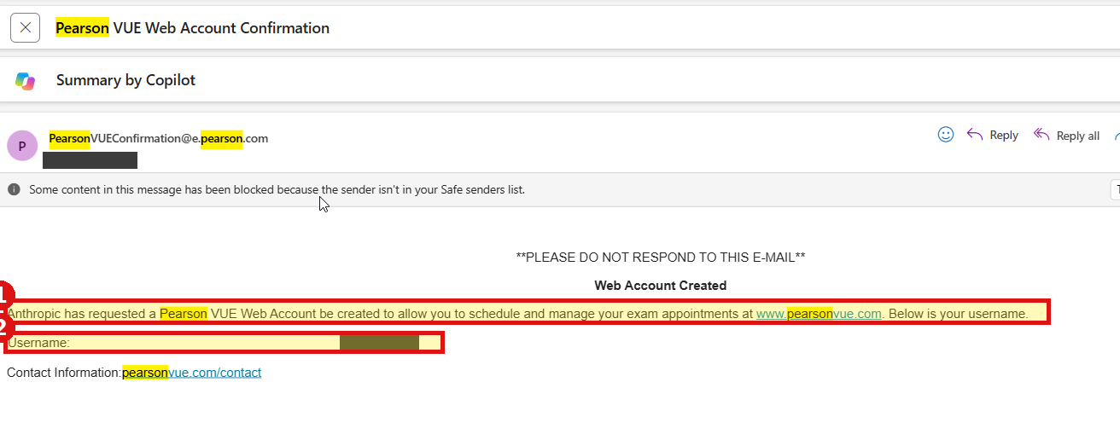
Email 2 – the username (details hidden in this example).

Step 7 – Sign in to Pearson VUE and schedule your exam
The exam is delivered by Pearson VUE (not on the Skilljar site).
1. Go to pearsonvue.com/us/en/anthropic and sign in with the username (Email 2) and the temporary password (Email 1).
2. You will be asked to choose a new password. It must be at least 7 characters, must not contain your username, and should mix upper and lower case letters with numbers or symbols.
3. Choose Schedule your exam.
4. Select online proctored or a Pearson test center, then pick your date and time.
Exam requirements (Pearson VUE)
Identification
• Carry a valid government-issued photo ID.
• The name on your registration must match the ID exactly.

Testing environment (online proctored)
• Sit in a quiet, private space with no interruptions.
• The room and desk must be clean and clear of papers, books and unrelated items.
• Use one screen only – no second monitor.
• Complete the computer and network check beforehand (see “Computer and network setup” in the Certifications menu).

Good to know
• Each exam can be taken once.
• Reschedule at least 24 hours before your slot.
• Exam content updates on 7 December 2026. If you test on or after that date, use the updated exam guide (available 17 November 2026).
• Help: certifications-support@anthropic.com (include your order ID).

