Training and Certification Guide
Which exams count · How many people we need · How to build the bench · Where to learn
The one rule to remember
Only Developer and Architect certifications count toward our tier. The Associate exam does not. We have 4 certified people today and need 10 for Select – so 6 more people should take a Developer or Architect exam.

1. The four exams
Exam | Level | List price | Counts toward tier? | Best for
Claude Certified Associate | Foundations | $99 | No | Foundational knowledge; useful for non-engineering roles
Claude Certified Developer | Foundations | $125 | Yes | People who build with Claude
Claude Certified Architect | Foundations | $125 | Yes | People who design solutions; a natural first exam for architects
Claude Certified Architect | Professional | $175 | Yes | Advanced architect level

- Price: the Training and Certification Guidebook lists these prices; the Program Guide shows a 100% exam discount through 31 December 2026, and our own booking showed Free at checkout. Book before 31 December 2026. The discount applies automatically – there is no code to enter.
- Format: 120 minutes, scenario-based, scored 100–1,000, 720 to pass; delivered by Pearson VUE online (proctored) or at a test center; results are immediate.
- Validity: a certification is valid 12 months; renewal is a free non-proctored assessment on the Partner Academy.
- Retakes: wait 14 days after the first attempt, 30 after the second, 90 after the third; maximum four attempts per exam per rolling 12 months.
- Eligibility: exams are for people at accepted Claude Partner Network firms, registering with their company-domain email. No prerequisites; prep courses are free and recommended.
- One person counts once toward tier, even with several certifications. Certifications must be current and show in the Partner Hub (updates weekly).
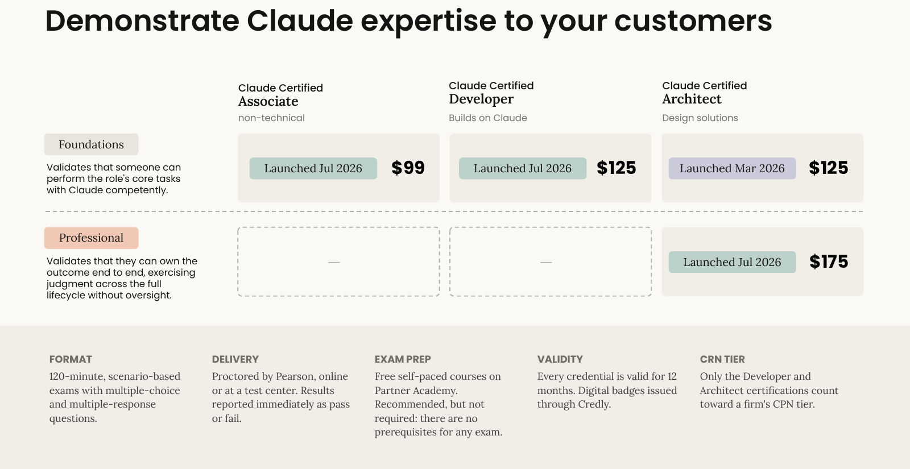
Training and Certification Guidebook, p.6 – the four certifications, price and format.
2. How to build the bench of 10
Role in our firm | Take this exam | Why
People who build with Claude (developers, engineers) | Developer – Foundations | Counts toward tier
People who design Claude solutions (architects) | Architect – Foundations, then Professional | Counts; Foundations is a natural first exam
Managers, sales and other non-technical roles | Associate (optional) | Does not count toward tier – do not use it to fill the 10

☐ Name the ten people (from the 90-day plan, weeks 1–2). Include the 4 already certified.
☐ Assign the free prep: Partner Academy courses (anthropic-partners.skilljar.com) – start with the CPN Learning Path, then the role path.
☐ Book each exam using the step-by-step Exam Booking Guide in this folder. Each person uses their own company email.
☐ Track progress monthly in the Hub (Current Tier panel).
☐ Build certification into onboarding and bench time; consider a team exam day and recognition for passes.
3. Where people learn
Resource | What it is | Access
Partner Academy | Free courses and prep for every role; also hosts exam registration | anthropic-partners.skilljar.com – sign in with company email
Role pathways (Training Playbook) | 10 role paths (data engineer, data scientist, ML engineer, software developer, platform / cloud, solutions architect, data analyst, project manager, product manager, client principal) each with courses, a build project and an exam | Portal: Partner Training and Certification Playbook
Partner Basecamp | Two-day in-person program (San Francisco and London); needs prior hands-on Claude Code experience; invite only | Ask via PAM AI; partner-basecamp@anthropic.com
Claude Code partner badge | Eight courses and a capstone; free | Via the Academy (path/partner-badge-claude-code)
Free Anthropic courses | Claude Code in Action; Introduction to Model Context Protocol; Building with the Claude API; Introduction to agent skills | Listed in the portal content library
Webinars, docs, blog | Product news and how-tos | docs.claude.com; anthropic.com/webinars; claude.com/blog

4. Beyond tier: the Delivery Readiness Designation (DRD)
DRD helps Anthropic match us to customer opportunities. It asks for: 10 or more active Developer / Architect certified people, three documented deployments (Claude Code or Cowork), one contactable customer reference, and evidence across six areas (environment and deployment, enablement, governance and administration, adoption and change management, troubleshooting and escalation, security posture). Certified is the minimum tier named; completing enablement does not automatically award it. Use the portal’s “04 Practice self-check” every 30 days and email Partner Operations when ready.
5. Documents for the training lead
Document (portal name) | Use it for
Partner Training and Certification Guidebook (listed twice) | Exam prices, rules, 5-step registration, role pages
Partner Training and Certification Playbook v1.1 | Role-by-role curriculum (26 pages)
02 Skills and certification for your Claude bench | 13-page short version of the Playbook – start here
01 Building your Claude practice | Roles, team shape, DRD, 90-day ramp
04 Practice self-check | Scorecard every 30 days; DRD prerequisites
03 Measuring customer value on a Claude activation | Proving value (shared with Delivery)
CPN Partner Sandbox Guide | Not for us now – Select and above only

6. Small errors in the portal documents
- The Training Guidebook p.10 labels the Architect Professional card “Developer – Foundations” (typo).
- Account / domain contact is partner-support@ in some documents and partner-success@ in others.
- Exam prices appear only in the Guidebook – check each exam page for the current price.

