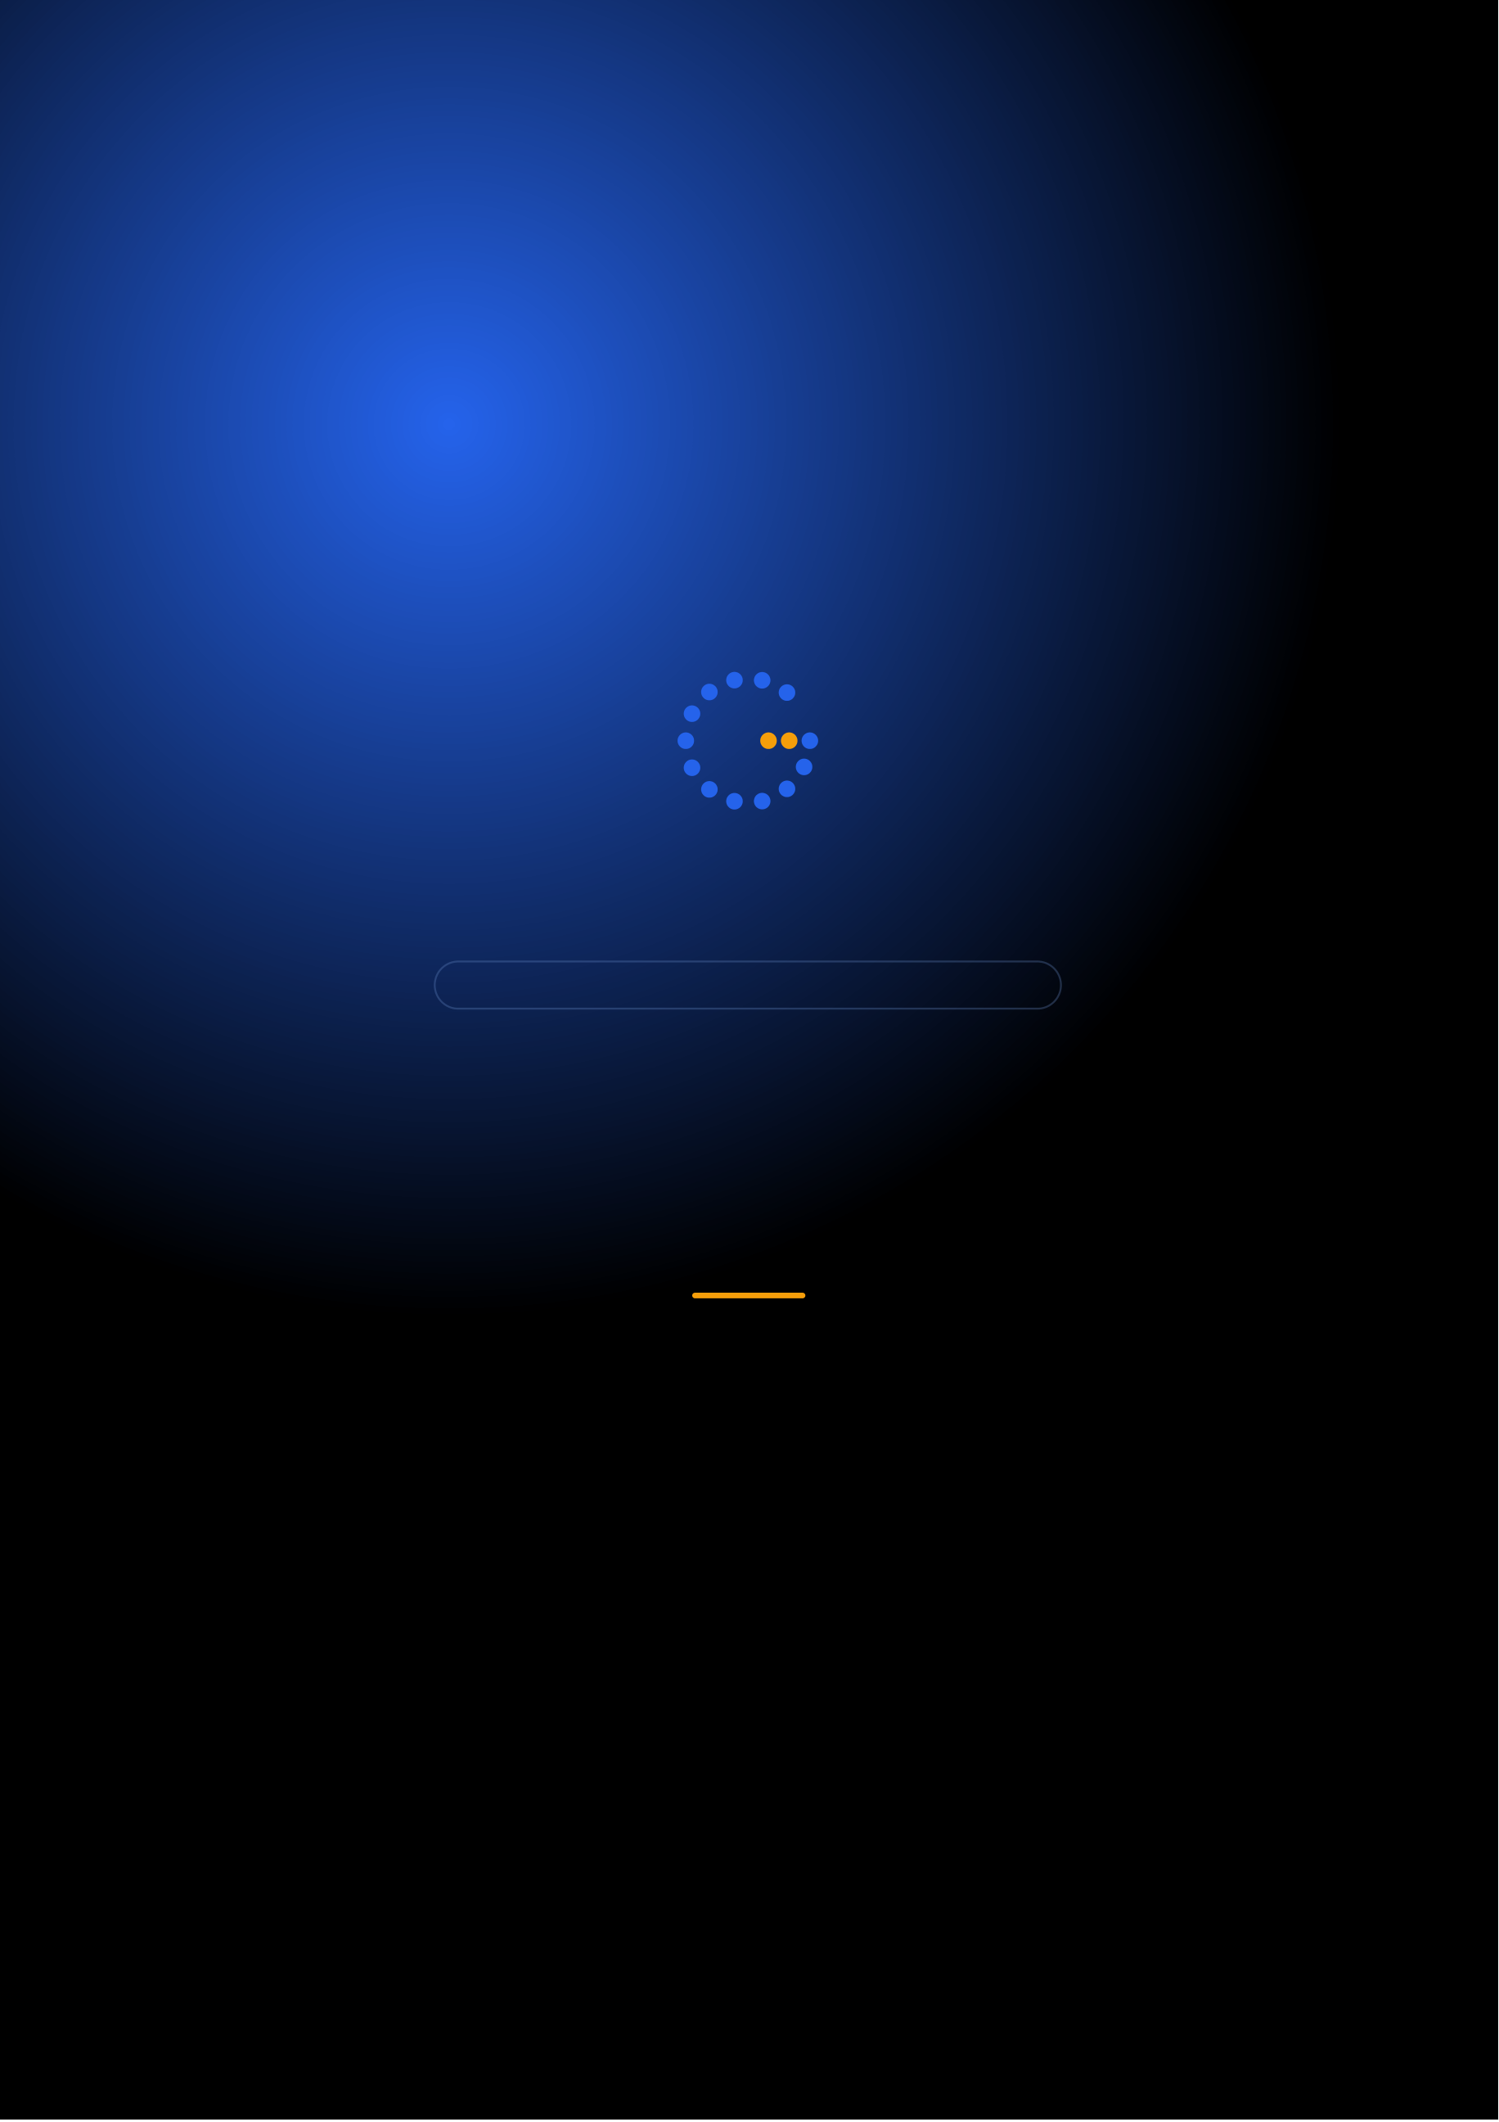
Gennoor Tech
TRAIN.INNOVATE.BUILD.
5-DAY HANDS-ON BOOTCAMP · 40 HOURS
Agentic AI Engineering
Build production AI agents with LangChain, CrewAI, and MCP
DAYS40 HOURS15+ HANDS-ON LABS5+ PROJECTS
www.gennoor.com · enquiry@gennoor.com

Gennoor Tech | A G E N T I C A I E N G I N E E R I N G
Course Overview
This 5-day hands-on bootcamp covers everything from foundational concepts to advanced techniques, combining lectures, live demos, hands-on labs, and collaborative workshops for maximum learning impact.
Prerequisites: Python programming (intermediate), REST APIs, basic cloud familiarity.
Who Is This For?
Developers

AI Architects

ML Engineers

L&D Teams
Internal trainers
Learning Outcomes

Build AI agents — with LangChain, LangGraph, and tool calling

Orchestrate multi-agent systems — using CrewAI and Semantic Kernel

Build MCP servers — from scratch connecting AI to enterprise systems

Deploy agents on — Copilot Studio with Dataverse and Power Automate

Design production agent — architectures with memory, guardrails, and monitoring
© 2026 Gennoor Tech Private Limited | www.gennoor.com | Page 2

Gennoor Tech | C O U R S E C U R R I C U L U M
5-Day Curriculum
Interactive format with live demos, hands-on labs, and collaborative workshops. Schedule and session order are fully
customizable based on your organization's needs and time zones.
01AI Agent Foundations — LangChain & Tool Calling HANDS-ON LABS + WORKSHOP

SESSION A

AI Agent Foundations
·  ·  · | Agent architectures: ReAct, Plan-and-Execute, Reflexion  LangChain core: chains, prompts, output parsers, memory  Building tool-calling agents with function calling

SESSION B

LangChain & Tool Calling
·  · | Custom tools: web search, database queries, API calls  Lab: Build a research agent & SQL agent
02LangGraph — Stateful Multi-Step Workflows DEMOS + LABS + DISCUSSION

SESSION A

LangGraph
·  ·  · | Graph-based orchestration: nodes, edges, state management  Conditional routing, branching, and persistence (checkpoints)  Human-in-the-loop: approval gates, feedback loops

SESSION B

Stateful Multi-Step Workflows |  | www.gennoor.com | Page 3
·  · | Error handling, retries, and streaming responses Lab: Loan approval agent with human review step
© 2026 Gennoor Tech Private Limited

Gennoor Tech | C O U R S E C U R R I C U L U M
03CrewAI & Multi-Agent Collaboration LECTURE + HANDS-ON LABS

SESSION A

CrewAI
·  ·  · | CrewAI architecture: agents, tasks, crews, processes  Sequential vs hierarchical crew execution  Semantic Kernel: plugins, planners, memory

SESSION B

Multi-Agent Collaboration
·  · | AutoGen: multi-agent conversation patterns  Lab: Financial research crew (analyst + writer + reviewer)
04MCP Servers & Enterprise Integration HANDS-ON LABS + WORKSHOP

SESSION A

MCP Servers
·  ·  · | Model Context Protocol: tools, resources, prompts  Building MCP servers with Python and FastAPI  Connecting MCP servers to SQL, Cosmos DB, and APIs

SESSION B

Enterprise Integration
·  · | Copilot Studio integration with MCP and Power Automate  Lab: Insurance claims processing agent (end-to-end)
05RAG, Production Architecture & Capstone DEMOS + LABS + DISCUSSION

SESSION A

RAG, Production Architecture
·  ·  · | RAG pipelines: chunking, embedding, indexing, hybrid search  Azure AI Search, FAISS, Chroma integration  Agent guardrails: content safety, prompt injection defense

SESSION B

Capstone
·  · | CI/CD for agents: testing, versioning, deployment  Capstone: Design and build a complete agentic AI system

Flexible & Customizable: Session order, timing, depth, and industry focus can be tailored to your organization's specific

requirements. Content is regularly updated to reflect the latest AI developments. |  | Page 4
© 2026 Gennoor Tech Private Limited | www.gennoor.com




Gennoor Tech | T O O L S , C E R T I F I C A T I O N & D E L I V E R Y
Tools & Platforms Covered
All tools demonstrated and practiced hands-on during the bootcamp
Amazon Lex | AutoGen | Azure AI Search | Azure AI Services | ChromaDB |  | Cosmos DB | CrewAI | FAISS | FastAPI | LangChain
Microsoft Copilot | Microsoft Copilot Studio |  | Power Automate | Python | Semantic Kernel
What You Take Home
6 Agent Projects (complete source code)

Included with course completion

Architecture Templates (BFSI, Government, Healthcare)

Included with course completion

⚡ MCP Server Starter Kit (open-source)

Included with course completion

Agent Design Canvas (roles, tools, memory, guardrails)

Included with course completion
Certification of Completion
Gennoor Tech — Certificate of Completion | Recommended Next Certifications
AB-100
Upon completing all 5 days (40 hours), each participant receives a Gennoor Tech Certificate of Completion in "Agentic AI Engineering". Digitally signed by the Founder & Director. Validates proficiency in all course topics and hands-on competency. | Agentic AI Business Solutions  AI-103  Azure AI Solutions  AI-901
Azure AI Fundamentals (New 2026)
Designed & Delivered By
Jalal Ahmed Khan
Founder & Director, Gennoor Tech Private Limited
Senior AI Consultant and Microsoft Certified Trainer (MCT) with 14+ years of 16+ | active | Microsoft | certifications
experience. Delivered AI and technology programs for Microsoft, EY, IBM, Boeing, including AB-100 (Agentic AI), AI-103, AZ-400,
Saudi Aramco, HDFC Bank, and 80+ organizations across 6+ countries including the AI-300, PL-400, and GitHub certifications.
10-day AI Leadership program for MCIT Saudi Arabia. Builder of open-source MCP servers and Copilot
Studio integrations. M.E. Mechanical
Engineering, Mumbai University.
Delivery OptionsOn-Site — customized at your office | Virtual Live — interactive via Teams/Zoom | International —

GCC, Africa, APAC, UK | www.gennoor.com | Page 5
© 2026 Gennoor Tech Private Limited


Ready to Start Your
Agentic AI Engineering Journey?
Contact us to discuss a customized program
for your organization or register for the next open batch.
✉
+91 9326 352 241
▶
Gennoor Tech
TRAIN.INNOVATE.BUILD.

