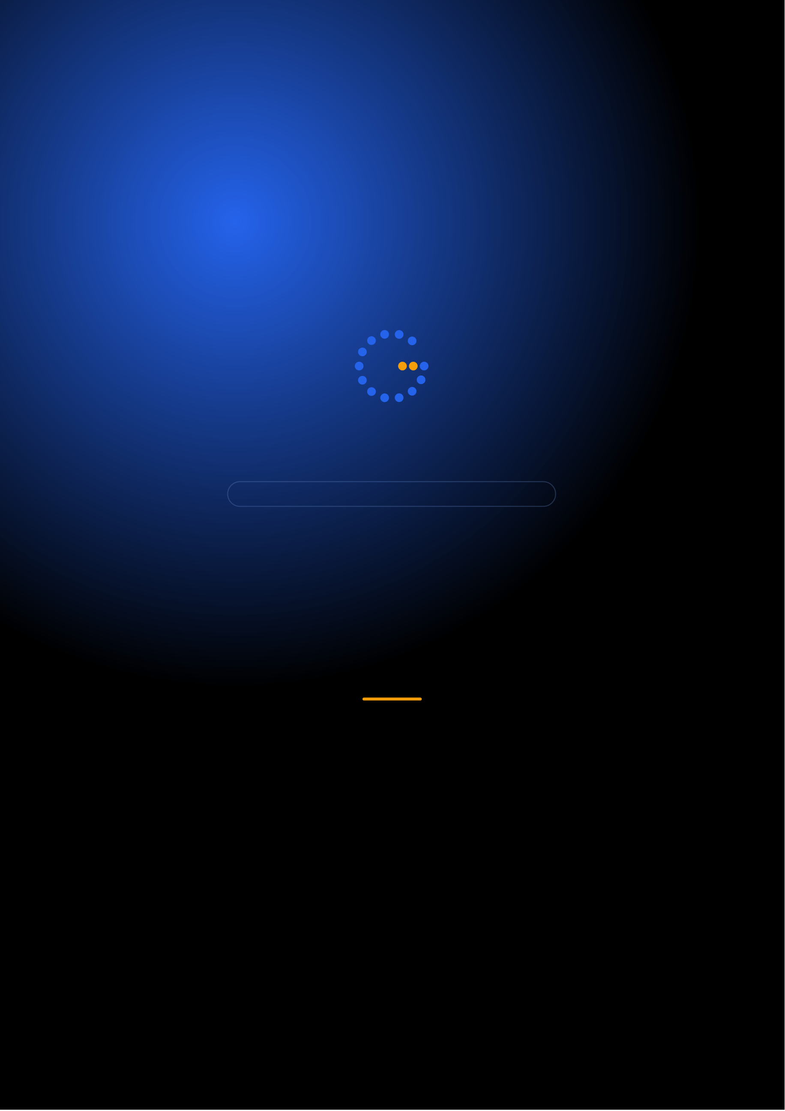
Gennoor Tech
TRAIN.INNOVATE.BUILD.
5-DAY HANDS-ON BOOTCAMP · 40 HOURS
Deep Learning &
Computer Vision
Neural networks, CNNs, and computer vision in practice
DAYS40 HOURS15+ HANDS-ON LABS5+ PROJECTS
www.gennoor.com · enquiry@gennoor.com

Gennoor Tech | D E E P L E A R N I N G & C O M P U T E R V I S I O N
Course Overview
This 5-day hands-on bootcamp covers everything from foundational concepts to advanced techniques, combining lectures, live demos, hands-on labs, and collaborative workshops for maximum learning impact.
Prerequisites: Python (intermediate), basic ML knowledge, linear algebra fundamentals.
Who Is This For?
ML Engineers

Researchers

CV Engineers

L&D Teams
Internal trainers
Learning Outcomes

Build neural networks — from scratch with NumPy, then TensorFlow/PyTorch

Master CNNs — ResNet, EfficientNet for classification and detection

Apply RNNs, LSTMs, — and Transformer architectures

Build production vision — pipelines with YOLO, OCR, and Azure AI Vision

Deploy deep learning — models with ONNX and Docker
© 2026 Gennoor Tech Private Limited | www.gennoor.com | Page 2

Gennoor Tech | C O U R S E C U R R I C U L U M
5-Day Curriculum
Interactive format with live demos, hands-on labs, and collaborative workshops. Schedule and session order are fully
customizable based on your organization's needs and time zones.
01Neural Network Foundations HANDS-ON LABS + WORKSHOP

SESSION A

Neural Network Foundations
·  ·  · | Neurons, activation functions (ReLU, sigmoid, softmax)  Backpropagation and gradient descent (SGD, Adam)  Regularization: dropout, batch normalization, L1/L2

SESSION B

Hands-On & Practice
·  · | TensorFlow 2.x: Sequential and Functional APIs  Lab: Build MNIST classifier in TensorFlow and PyTorch
02Convolutional Neural Networks DEMOS + LABS + DISCUSSION

SESSION A

Convolutional Neural Networks
·  ·  · | Convolution, pooling, stride, padding — visual intuition  Classic architectures: LeNet, VGG, ResNet, EfficientNet  Transfer learning and fine-tuning pretrained models

SESSION B

Hands-On & Practice |  | www.gennoor.com | Page 3
·  · | Data augmentation and Grad-CAM visualization Lab: Medical image classification & defect detection
© 2026 Gennoor Tech Private Limited

Gennoor Tech | C O U R S E C U R R I C U L U M
03Sequence Models & Transformers LECTURE + HANDS-ON LABS

SESSION A

Sequence Models
·  ·  · | RNNs, LSTMs, GRUs — architecture and training  Bidirectional and stacked RNN patterns  Self-attention, multi-head attention, positional encoding

SESSION B

Transformers
·  · | BERT, GPT overview, Vision Transformers (ViT)  Lab: Time-series forecasting & BERT text classification
04Object Detection, Segmentation & OCR HANDS-ON LABS + WORKSHOP

SESSION A

Object Detection, Segmentation
·  ·  · | YOLO (v8/v11), SSD, Faster R-CNN architectures  Instance segmentation (Mask R-CNN), semantic segmentation (U-Net)  OpenCV: image processing, contours, transformations

SESSION B

OCR
·  · | OCR: Tesseract, EasyOCR, Azure Document Intelligence  Lab: Real-time detection system & invoice extraction
05Generative Vision, Deployment & Capstone DEMOS + LABS + DISCUSSION

SESSION A

Generative Vision, Deployment
·  ·  · | Autoencoders, VAEs for anomaly detection  GANs: DCGAN, diffusion models overview  ONNX export, TensorRT optimization, quantization

SESSION B

Capstone
·  · | Serving with FastAPI + Docker, edge deployment  Capstone: End-to-end vision project

Flexible & Customizable: Session order, timing, depth, and industry focus can be tailored to your organization's specific

requirements. Content is regularly updated to reflect the latest AI developments. |  | Page 4
© 2026 Gennoor Tech Private Limited | www.gennoor.com

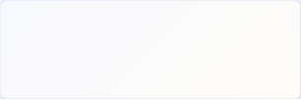

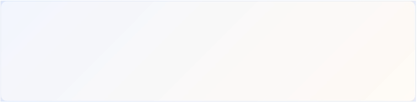
Gennoor Tech | T O O L S , C E R T I F I C A T I O N & D E L I V E R Y
Tools & Platforms Covered
All tools demonstrated and practiced hands-on during the bootcamp
Docker | FastAPI | PyTorch | TensorFlow
What You Take Home
6 DL Projects (complete notebooks)

Included with course completion

Architecture Reference (CNN, RNN, Transformer guides)

Included with course completion

⚡ Vision Pipeline Kit (YOLO + OCR templates)

Included with course completion

Model Zoo Cheat Sheet (accuracy/speed tradeoffs)

Included with course completion
Certification of Completion
Gennoor Tech — Certificate of Completion | Recommended Next Certifications
AI-103
Upon completing all 5 days (40 hours), each participant receives a Gennoor Tech Certificate of Completion in "Deep Learning & Computer Vision". Digitally signed by the Founder & Director. Validates proficiency in all course topics and hands-on competency. | Azure AI Solutions  DP-100  Azure Data Scientist  AI-901
Azure AI Fundamentals (New 2026)
Designed & Delivered By
Jalal Ahmed Khan
Founder & Director, Gennoor Tech Private Limited
Senior AI Consultant and Microsoft Certified Trainer (MCT) with 14+ years of 16+ | active | Microsoft | certifications
experience. Delivered AI and technology programs for Microsoft, EY, IBM, Boeing, including AB-100 (Agentic AI), AI-103, AZ-400,
Saudi Aramco, HDFC Bank, and 80+ organizations across 6+ countries including the AI-300, PL-400, and GitHub certifications.
10-day AI Leadership program for MCIT Saudi Arabia. Builder of open-source MCP servers and Copilot
Studio integrations. M.E. Mechanical
Engineering, Mumbai University.
Delivery OptionsOn-Site — customized at your office | Virtual Live — interactive via Teams/Zoom | International —

GCC, Africa, APAC, UK | www.gennoor.com | Page 5
© 2026 Gennoor Tech Private Limited

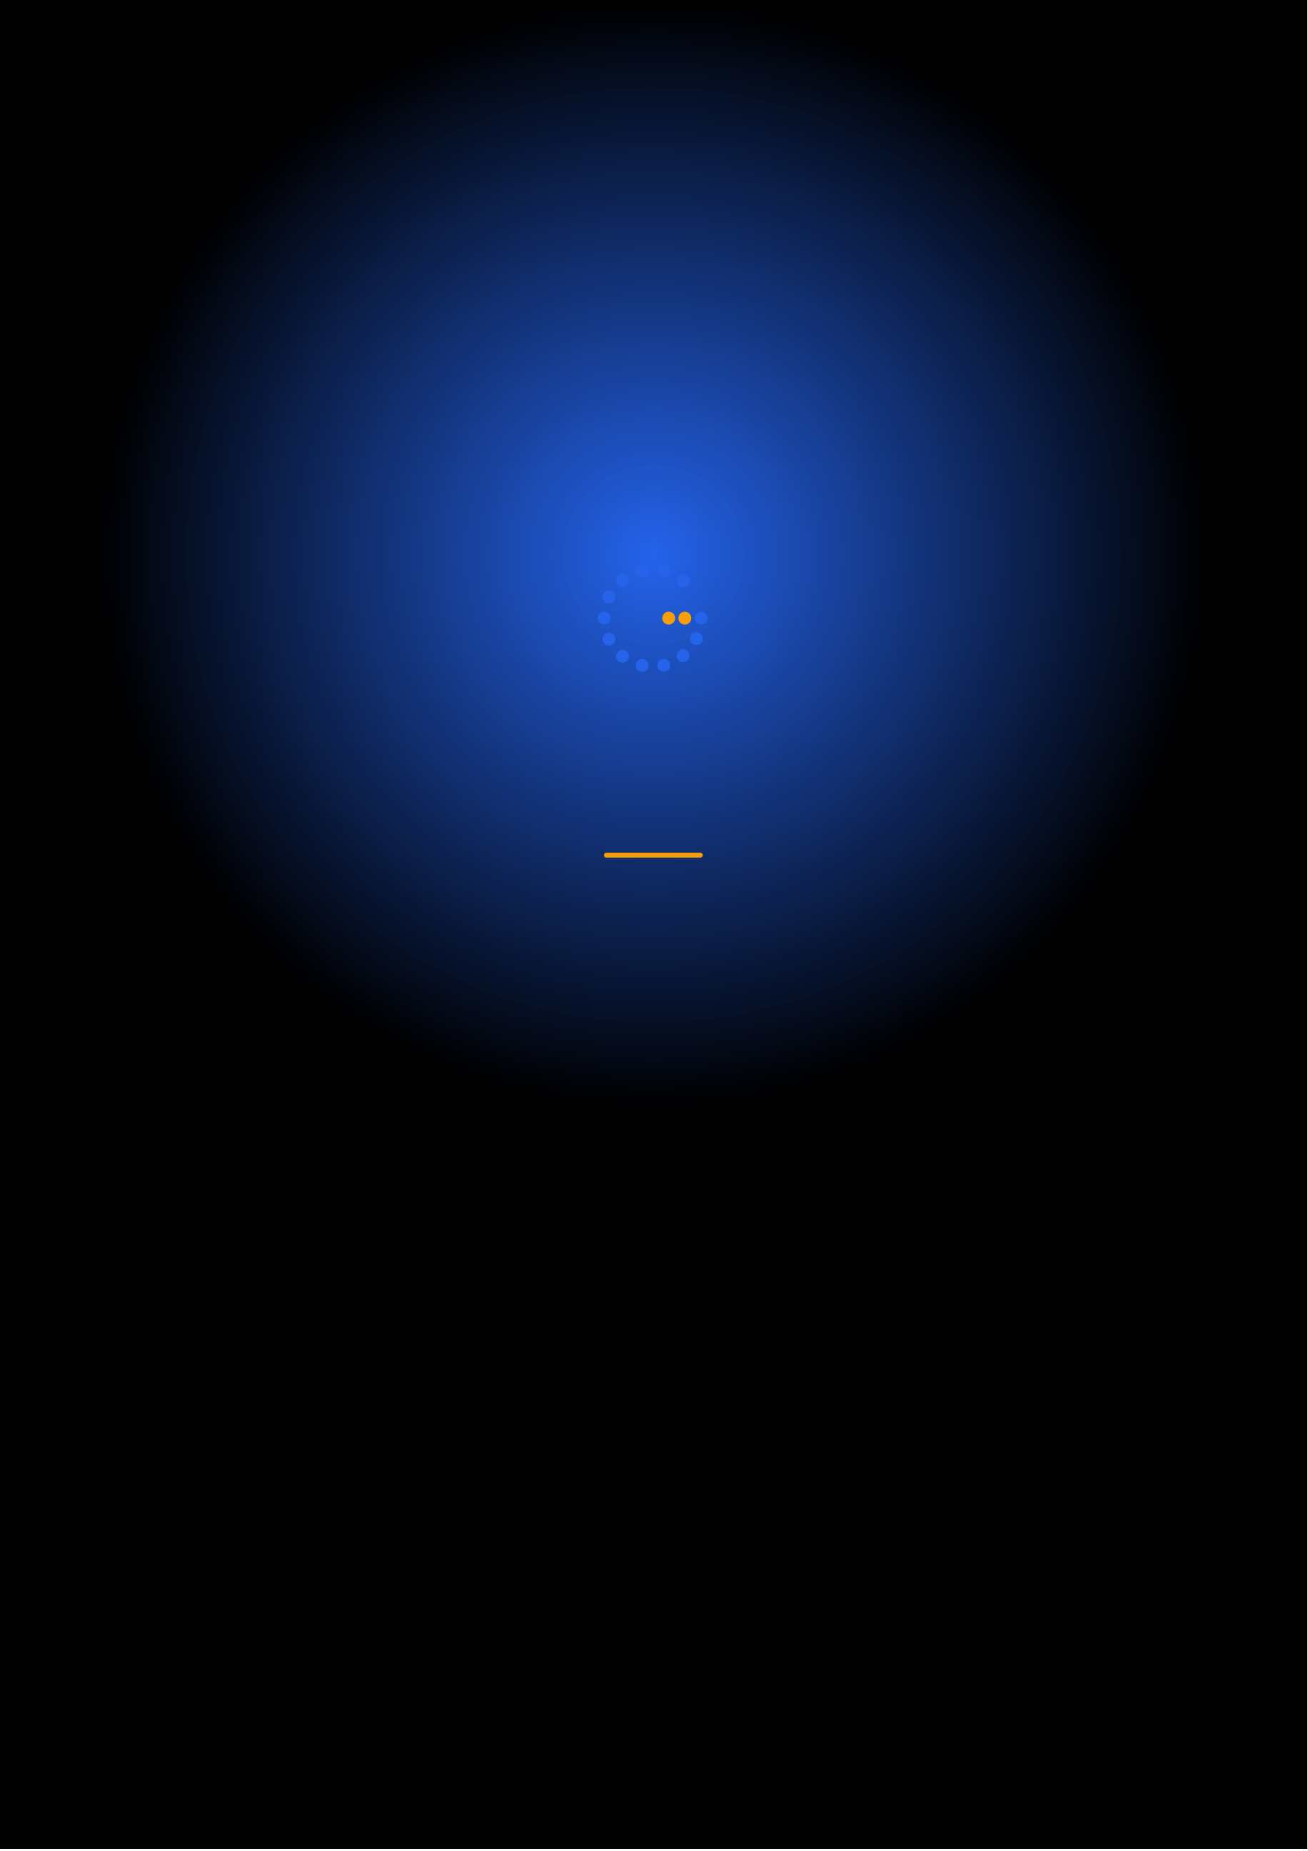
Ready to Start Your
Deep Learning & Computer Journey?
Contact us to discuss a customized program
for your organization or register for the next open batch.
✉
+91 9326 352 241
▶
Gennoor Tech
TRAIN.INNOVATE.BUILD.

