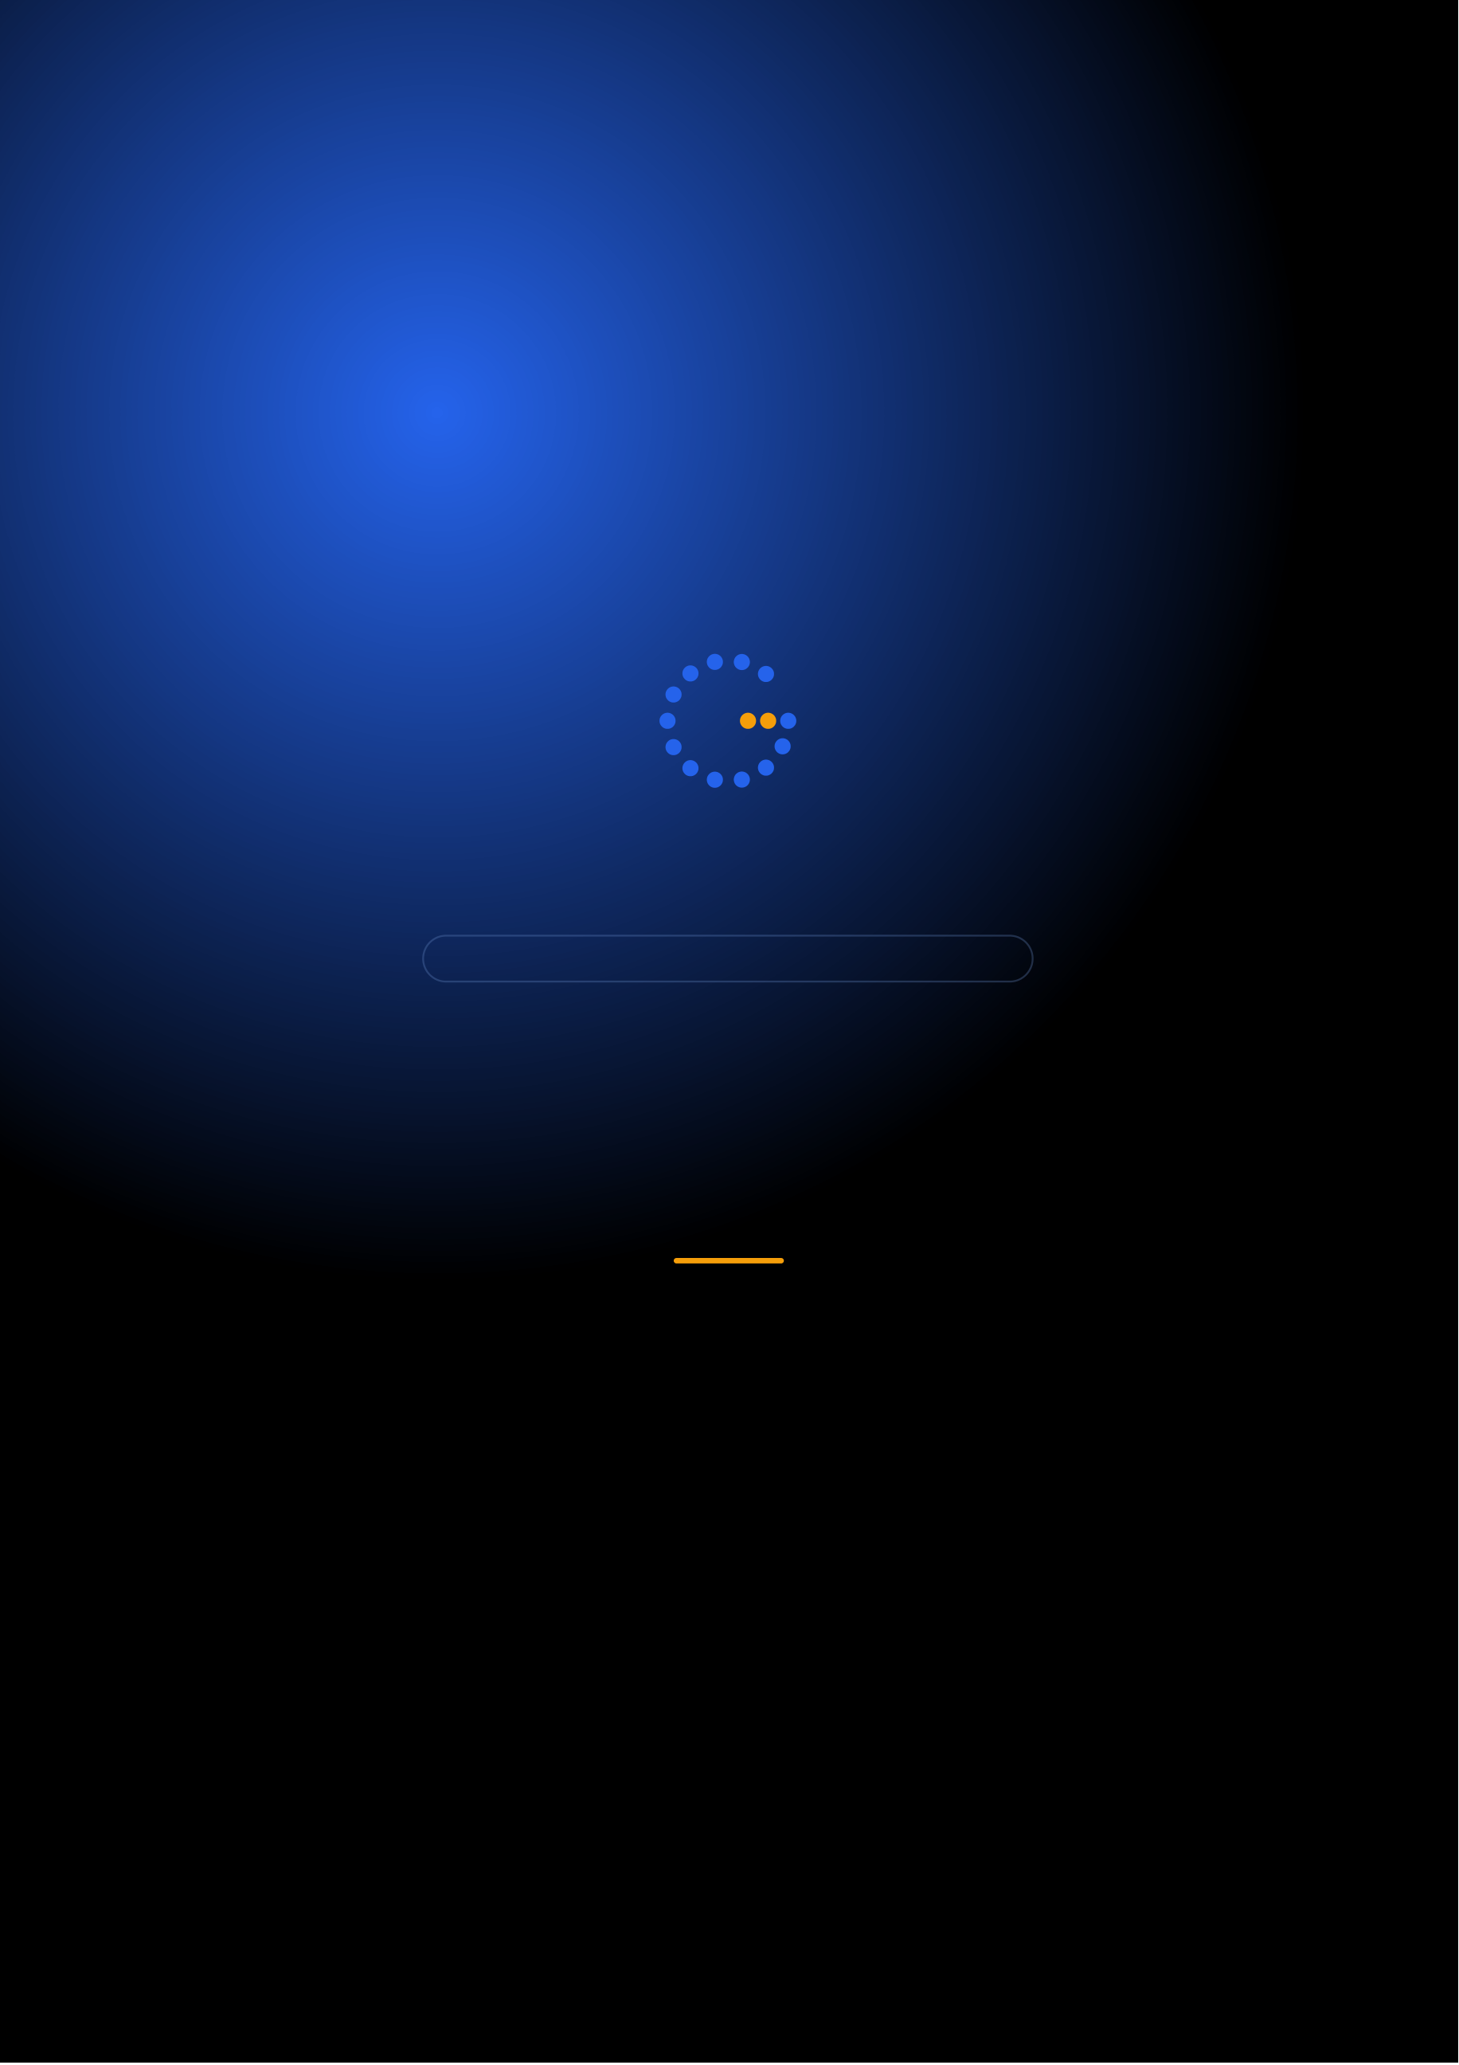
Gennoor Tech
TRAIN.INNOVATE.BUILD.
5-DAY HANDS-ON BOOTCAMP · 40 HOURS
AI Development Framework
Build AI solutions with LangChain, Semantic Kernel, and more
DAYS40 HOURS15+ HANDS-ON LABS5+ PROJECTS
www.gennoor.com · enquiry@gennoor.com

Gennoor Tech | A I D E V E L O P M E N T F R A M E W O R K
Course Overview
This 5-day hands-on bootcamp covers everything from foundational concepts to advanced techniques, combining lectures, live demos, hands-on labs, and collaborative workshops for maximum learning impact.
Prerequisites: Python (intermediate), REST APIs, basic Git knowledge.
Who Is This For?
Python Developers

Full-Stack Engineers

AI Engineers

L&D Teams
Internal trainers
Learning Outcomes

Integrate LLM APIs — Azure OpenAI, Claude, Gemini, Ollama

Master orchestration frameworks — LangChain, Semantic Kernel, CrewAI

Implement production RAG — with vector databases and hybrid search

Build full-stack AI — apps with FastAPI, Streamlit, and Gradio

Design AI agents, — MCP servers, and workflow automation
© 2026 Gennoor Tech Private Limited | www.gennoor.com | Page 2

Gennoor Tech | C O U R S E C U R R I C U L U M
5-Day Curriculum
Interactive format with live demos, hands-on labs, and collaborative workshops. Schedule and session order are fully
customizable based on your organization's needs and time zones.
01LLM APIs & Prompt Engineering for Developers HANDS-ON LABS + WORKSHOP

SESSION A

LLM APIs
·  ·  · | Azure OpenAI, Claude API, Gemini API — unified patterns  Streaming, function calling, structured output (JSON mode)  Open-source models via Ollama (Llama, Mistral, Qwen)

SESSION B

Prompt Engineering for Developers
·  · | Token management, cost tracking, rate limit handling  Lab: Multi-provider LLM gateway with fallback logic
02LangChain, Semantic Kernel & Orchestration DEMOS + LABS + DISCUSSION

SESSION A

LangChain, Semantic Kernel
·  ·  · | LangChain: chains, prompts, tools, memory  LangGraph: stateful graph workflows, conditional routing  Semantic Kernel: plugins, planners, .NET and Python SDKs

SESSION B

Orchestration |  | www.gennoor.com | Page 3
·  · | CrewAI and AutoGen: multi-agent patterns  Lab: Same app in LangChain vs Semantic Kernel — comparison
© 2026 Gennoor Tech Private Limited

Gennoor Tech | C O U R S E C U R R I C U L U M
03RAG Pipelines & Vector Databases LECTURE + HANDS-ON LABS

SESSION A

RAG Pipelines
·  ·  · | Chunking strategies: fixed, recursive, semantic, document-aware  Embedding models: OpenAI, Cohere, sentence-transformers  FAISS, Chroma, Pinecone, Azure AI Search — comparison

SESSION B

Vector Databases
·  · | Hybrid search, semantic ranking, reranking  Lab: Enterprise document Q&A with citation tracking
04Full-Stack AI Apps HANDS-ON LABS + WORKSHOP

SESSION A

Full-Stack AI Apps
·  ·  · | FastAPI: async endpoints, WebSocket streaming, authentication  MCP Server development: tools, resources, prompts protocol  Streamlit: rapid AI app prototyping with chat interfaces

SESSION B

Hands-On & Practice
·  · | Gradio: model demos, file upload, multimodal interfaces  Lab: Document Q&A app (Streamlit + RAG + FastAPI)
05Agents, Automation & Capstone DEMOS + LABS + DISCUSSION

SESSION A

Agents, Automation
·  ·  · | Tool-calling agents with function calling and MCP  Workflow automation: N8N, Power Automate, Copilot Studio  Docker containerization and cloud deployment

SESSION B

Capstone
·  · | Monitoring, logging, and cost optimization  Capstone: Full-stack AI application

Flexible & Customizable: Session order, timing, depth, and industry focus can be tailored to your organization's specific

requirements. Content is regularly updated to reflect the latest AI developments. |  | Page 4
© 2026 Gennoor Tech Private Limited | www.gennoor.com


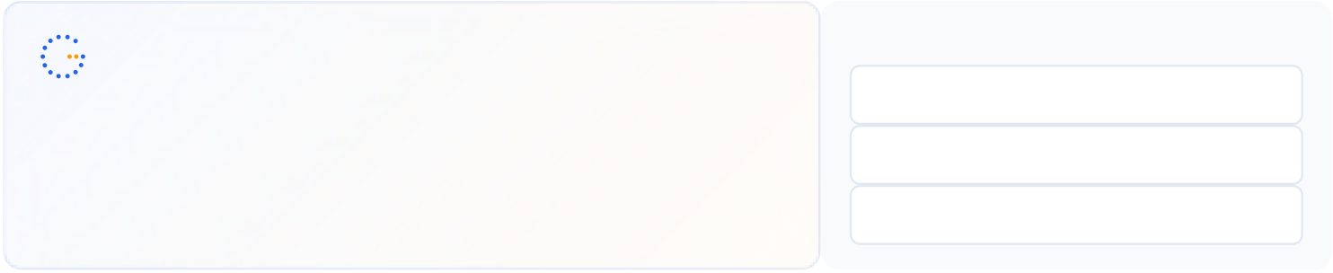
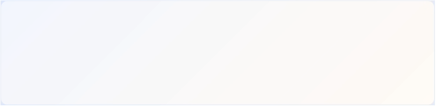
Gennoor Tech | T O O L S , C E R T I F I C A T I O N & D E L I V E R Y
Tools & Platforms Covered
All tools demonstrated and practiced hands-on during the bootcamp
AutoGen | Azure AI Search | Azure AI Services |  | Azure OpenAI |  | ChromaDB |  | Claude (Anthropic) | CrewAI | Docker | FAISS
FastAPI | Google Gemini | LangChain | LangGraph |  | Microsoft Copilot |  | Microsoft Copilot Studio |  | N8N | Ollama | Power Automate
Python | Semantic Kernel | Streamlit
What You Take Home
6 AI Applications (complete source code)

Included with course completion

Framework Decision Matrix (LangChain vs SK vs CrewAI)

Included with course completion

⚡ AI App Starter Templates (FastAPI + Streamlit + Docker)

Included with course completion

Architecture Patterns Guide (RAG, agents, caching, streaming)

Included with course completion
Certification of Completion
Gennoor Tech — Certificate of Completion | Recommended Next Certifications
AI-103
Upon completing all 5 days (40 hours), each participant receives a Gennoor Tech Certificate of Completion in "AI Development Framework". Digitally signed by the Founder & Director. Validates proficiency in all course topics and hands-on competency. | Azure AI Solutions  AZ-204  Azure Developer Associate  AI-901
Azure AI Fundamentals (New 2026)
Designed & Delivered By
Jalal Ahmed Khan
Founder & Director, Gennoor Tech Private Limited
Senior AI Consultant and Microsoft Certified Trainer (MCT) with 14+ years of 16+ active Microsoft certifications
experience. Delivered AI and technology programs for Microsoft, EY, IBM, Boeing, including AB-100 (Agentic AI), AI-103, AZ-400,
Saudi Aramco, HDFC Bank, and 80+ organizations across 6+ countries including the AI-300, PL-400, and GitHub certifications.
10-day AI Leadership program for MCIT Saudi Arabia. Builder of open-source MCP servers and Copilot
Studio integrations. M.E. Mechanical
Engineering, Mumbai University.
Delivery OptionsOn-Site — customized at your office | Virtual Live — interactive via Teams/Zoom | International —

GCC, Africa, APAC, UK | www.gennoor.com | Page 5
© 2026 Gennoor Tech Private Limited

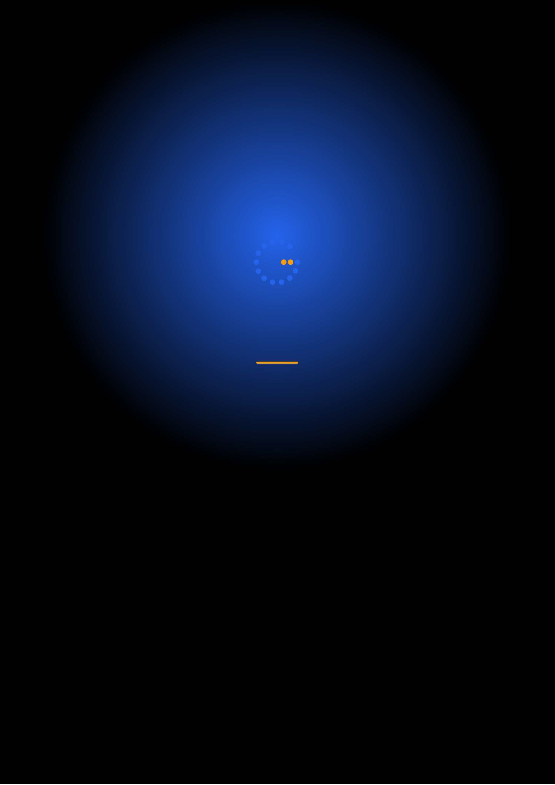
Ready to Start Your
AI Development Framework Journey?
Contact us to discuss a customized program
for your organization or register for the next open batch.
✉
+91 9326 352 241
▶
Gennoor Tech
TRAIN.INNOVATE.BUILD.

