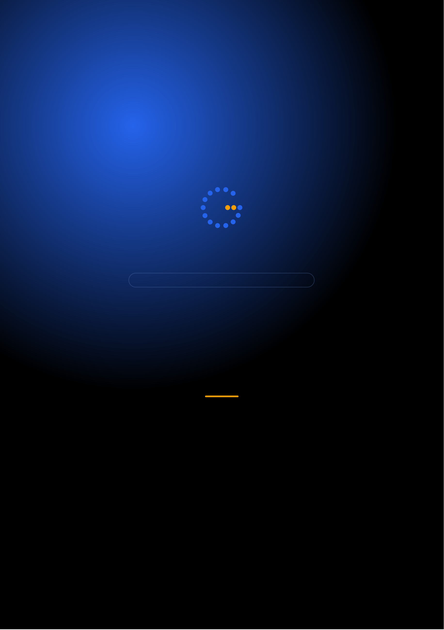
Gennoor Tech
TRAIN.INNOVATE.BUILD.
5-DAY HANDS-ON BOOTCAMP · 40 HOURS
Microsoft AI for
Developers
Azure AI services, OpenAI integration, and Cognitive Services
DAYS40 HOURS15+ HANDS-ON LABS5+ PROJECTS
www.gennoor.com · enquiry@gennoor.com

Gennoor Tech | M I C R O S O F T A I F O R D E V E L O P E R S
Course Overview
This 5-day hands-on bootcamp covers everything from foundational concepts to advanced techniques, combining lectures, live demos, hands-on labs, and collaborative workshops for maximum learning impact.
Prerequisites: Python or C#, basic Azure familiarity, REST API knowledge.
Who Is This For?
Azure Developers

.NET/Python Engineers

⚡

Power Platform Devs

L&D Teams
Internal trainers
Learning Outcomes

Master Azure OpenAI — deployment, function calling, embeddings, content safety

Build with Azure AI Foundry — prompt flows, model evaluation, lifecycle

Implement enterprise RAG — with Azure AI Search and semantic ranking

Deploy Copilot Studio — agents with MCP, Dataverse, and Power Automate

Process documents with — Azure Document Intelligence and AI Vision
© 2026 Gennoor Tech Private Limited | www.gennoor.com | Page 2

Gennoor Tech | C O U R S E C U R R I C U L U M
5-Day Curriculum
Interactive format with live demos, hands-on labs, and collaborative workshops. Schedule and session order are fully
customizable based on your organization's needs and time zones.
01Azure OpenAI Service HANDS-ON LABS + WORKSHOP

SESSION A

Azure OpenAI Service
·  ·  · | Azure OpenAI vs OpenAI: enterprise security, compliance, SLAs  Deploying GPT-4o, GPT-4 Turbo, embedding models  Chat Completions API, function calling, streaming

SESSION B

Hands-On & Practice
·  · | Content Safety filters and Responsible AI config  Lab: Semantic search engine with Azure OpenAI embeddings
02Azure AI Foundry & RAG with AI Search DEMOS + LABS + DISCUSSION

SESSION A

Azure AI Foundry
·  ·  · | AI Foundry: projects, connections, deployments, evaluations  Prompt Flow: building, testing, deploying prompt chains  Azure AI Search: indexes, skillsets, semantic ranking

SESSION B

RAG with AI Search |  | www.gennoor.com | Page 3
·  · | Integrated vectorization and hybrid search  Lab: Enterprise knowledge assistant with citations
© 2026 Gennoor Tech Private Limited

Gennoor Tech | C O U R S E C U R R I C U L U M
03Copilot Studio, Agents & MCP LECTURE + HANDS-ON LABS

SESSION A

Copilot Studio, Agents
·  ·  · | Copilot Studio: topics, entities, plugins, generative AI  MCP servers with Python/FastAPI for Copilot Studio  Azure AI Agent Service for multi-agent orchestration

SESSION B

MCP
·  · | Power Automate approval workflows triggered by agents  Lab: MCP server connecting Copilot to Azure SQL
04Document Intelligence, Vision & Speech HANDS-ON LABS + WORKSHOP

SESSION A

Document Intelligence, Vision
·  ·  · | Document Intelligence: invoices, receipts, IDs, custom models  Azure AI Vision: image analysis, OCR, Custom Vision  Azure Speech: speech-to-text, text-to-speech, translation

SESSION B

Speech
·  · | Lab: KYC document extraction system for banking  Lab: Multilingual voice assistant with Speech + OpenAI
05Power Platform AI, Semantic Kernel & Capstone DEMOS + LABS + DISCUSSION

SESSION A

Power Platform AI, Semantic Kernel
·  ·  · | AI Builder: document processing, text recognition, prediction  Copilot in Power BI: natural language queries  Semantic Kernel: plugins, planners, memory

SESSION B

Capstone
·  · | Architecture review: security, networking, cost, governance  Capstone: Enterprise Microsoft AI solution

Flexible & Customizable: Session order, timing, depth, and industry focus can be tailored to your organization's specific

requirements. Content is regularly updated to reflect the latest AI developments. |  | Page 4
© 2026 Gennoor Tech Private Limited | www.gennoor.com

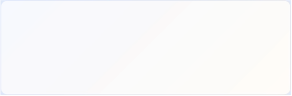
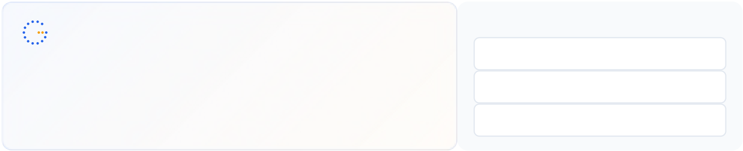
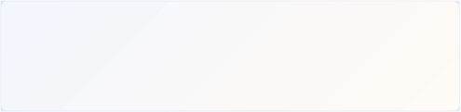
Gennoor Tech | T O O L S , C E R T I F I C A T I O N & D E L I V E R Y
Tools & Platforms Covered
All tools demonstrated and practiced hands-on during the bootcamp
AI Builder | Azure AI Search |  | Azure AI Services |  | Azure OpenAI |  | ChatGPT / GPT-4o | FastAPI | Microsoft Copilot
Microsoft Copilot Studio |  | Power Automate |  | Power BI |  | Python | Semantic Kernel
What You Take Home
7 AI Projects (complete code)

Included with course completion

Azure AI Architecture Guide (networking, RBAC, cost)

Included with course completion

⚡ ARM/Bicep Deployment Templates

Included with course completion

Microsoft AI Decision Tree

Included with course completion
Certification of Completion
Gennoor Tech — Certificate of Completion | Recommended Next Certifications
AI-103
Upon completing all 5 days (40 hours), each participant receives a Gennoor Tech Certificate of Completion in "Microsoft AI for Developers". Digitally signed by the Founder & Director. Validates proficiency in all course topics and hands-on competency. | Azure AI Solutions  AI-901  Azure AI Fundamentals (New 2026)  AZ-204
Azure Developer Associate
Designed & Delivered By
Jalal Ahmed Khan
Founder & Director, Gennoor Tech Private Limited
Senior AI Consultant and Microsoft Certified Trainer (MCT) with 14+ years of 16+ | active | Microsoft | certifications
experience. Delivered AI and technology programs for Microsoft, EY, IBM, Boeing, including AB-100 (Agentic AI), AI-103, AZ-400,
Saudi Aramco, HDFC Bank, and 80+ organizations across 6+ countries including the AI-300, PL-400, and GitHub certifications.
10-day AI Leadership program for MCIT Saudi Arabia. Builder of open-source MCP servers and Copilot
Studio integrations. M.E. Mechanical
Engineering, Mumbai University.
Delivery OptionsOn-Site — customized at your office | Virtual Live — interactive via Teams/Zoom | International —

GCC, Africa, APAC, UK | www.gennoor.com | Page 5
© 2026 Gennoor Tech Private Limited

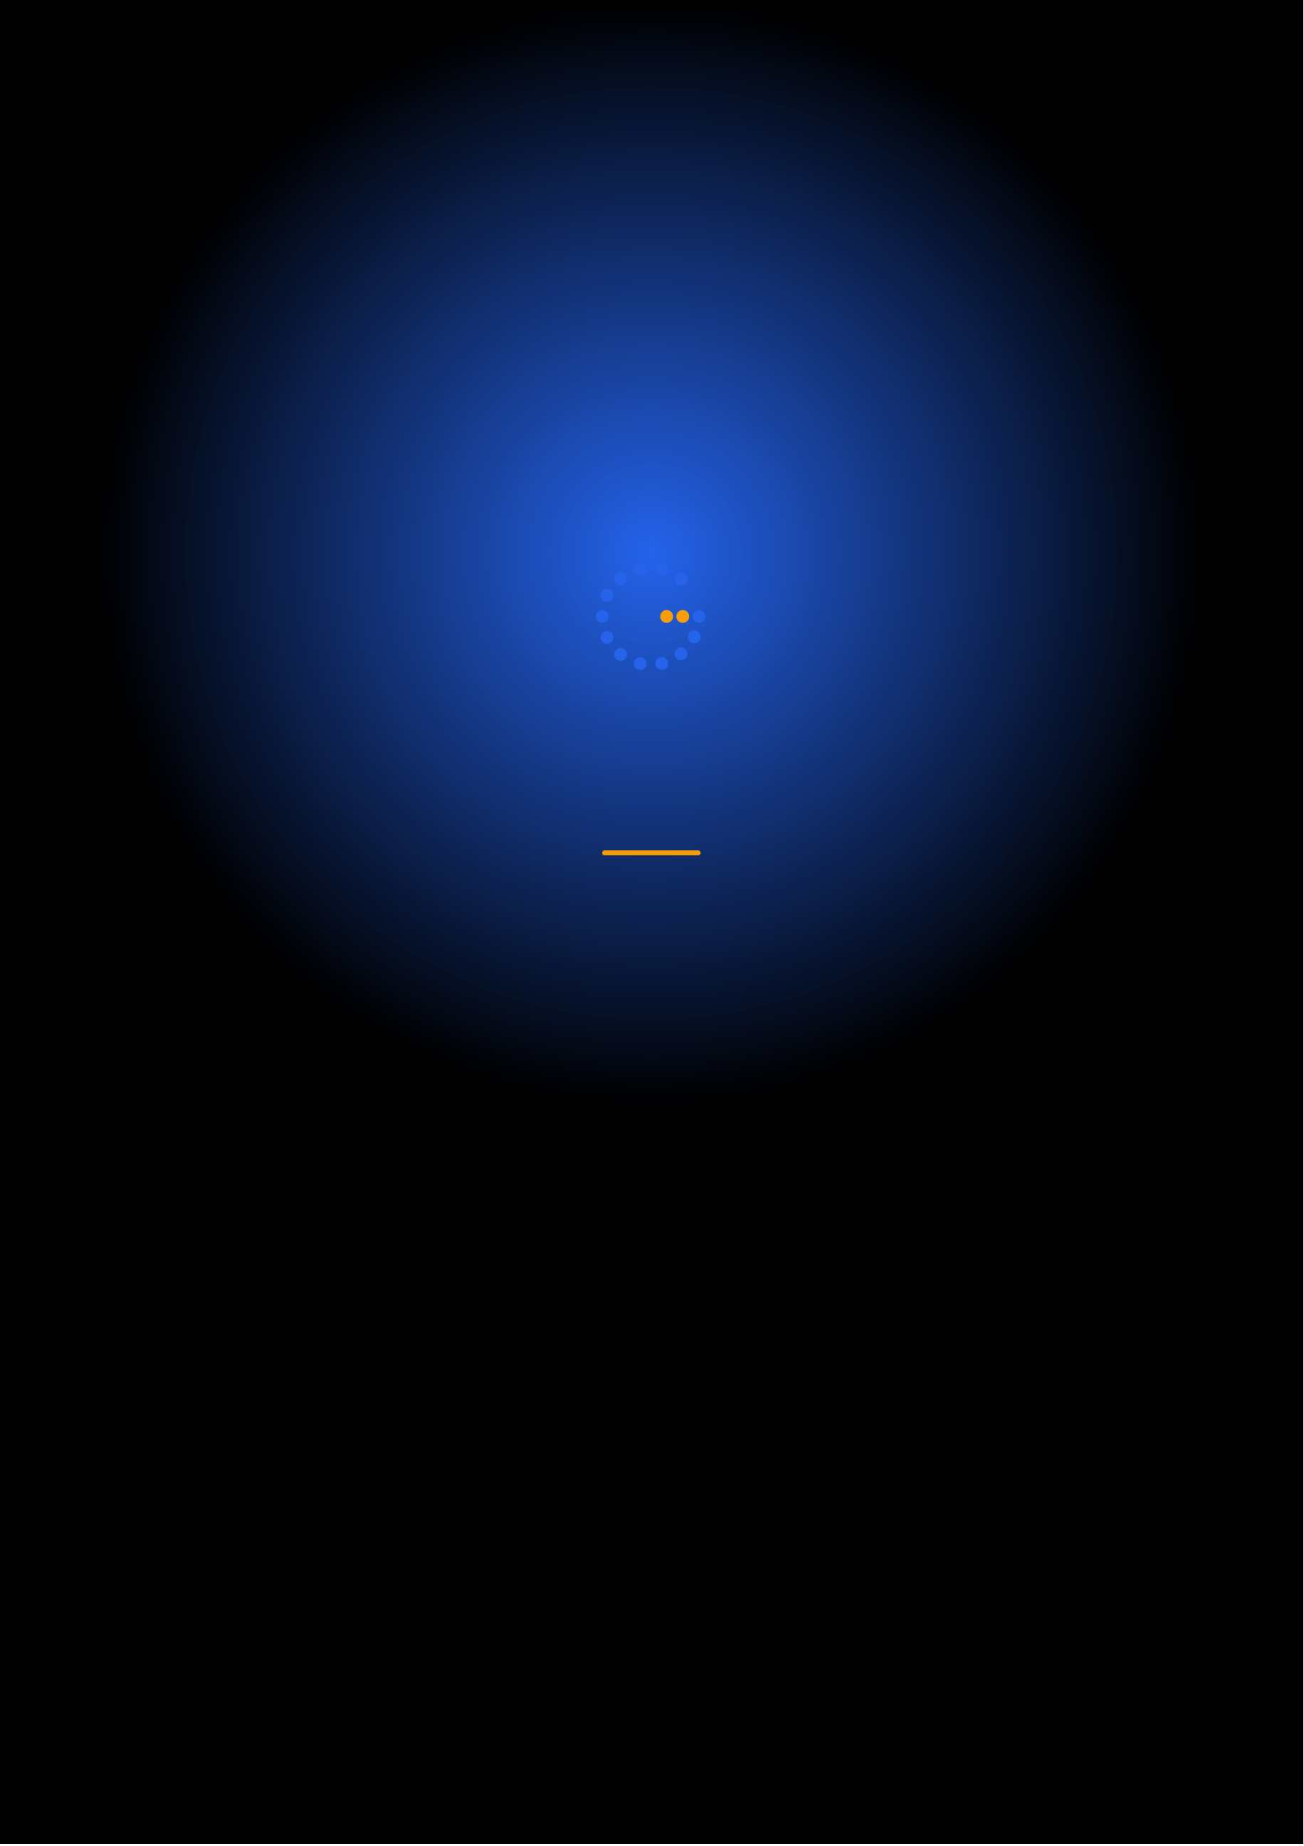
Ready to Start Your
Microsoft AI for Developers Journey?
Contact us to discuss a customized program
for your organization or register for the next open batch.
✉
+91 9326 352 241
▶
Gennoor Tech
TRAIN.INNOVATE.BUILD.

