
Gennoor Tech
TRAIN.INNOVATE.BUILD.
5-DAY HANDS-ON BOOTCAMP · 40 HOURS
AI on
Google Cloud
Vertex AI, Gemini, and Google Cloud ML services
DAYS40 HOURS10+ HANDS-ON LABSMixed
www.gennoor.com · enquiry@gennoor.com

Gennoor Tech | A I O N G O O G L E C L O U D
Course Overview
This 5-day hands-on bootcamp covers everything from foundational concepts to advanced techniques, combining lectures, live demos, hands-on labs, and collaborative workshops for maximum learning impact.
Prerequisites: Python (intermediate), basic GCP familiarity, SQL for BigQuery labs.
Who Is This For?
GCP Developers

Data Engineers

ML Engineers

L&D Teams
Internal trainers
Learning Outcomes

Build with Gemini API — multimodal, function calling, grounding

Master Vertex AI — training, pipelines, model registry, monitoring

Implement RAG with — Vertex AI Search and vector indexes

Build chatbots with — Dialogflow CX and process documents with Document AI

Train models with — BigQuery ML (SQL) and AutoML (no-code)
© 2026 Gennoor Tech Private Limited | www.gennoor.com | Page 2

Gennoor Tech | C O U R S E C U R R I C U L U M
5-Day Curriculum
Interactive format with live demos, hands-on labs, and collaborative workshops. Schedule and session order are fully
customizable based on your organization's needs and time zones.
01Gemini API & Google AI Studio HANDS-ON LABS + WORKSHOP

SESSION A

Gemini API
·  ·  · | Gemini models: Flash, Pro, Ultra — selection guide  Multimodal inputs: image, video, audio, PDF analysis  Function calling, grounding with Google Search

SESSION B

Google AI Studio
·  · | Structured output, JSON mode, schema enforcement  Lab: Multimodal product catalog assistant
02Vertex AI Platform & MLOps DEMOS + LABS + DISCUSSION

SESSION A

Vertex AI Platform
·  ·  · | Vertex AI Workbench, experiments, datasets  Custom training jobs, hyperparameter tuning (Vizier)  Model registry, versioning, deployment

SESSION B

MLOps |  | www.gennoor.com | Page 3
·  · | Vertex AI Pipelines with Kubeflow SDK  Lab: End-to-end ML pipeline with monitoring
© 2026 Gennoor Tech Private Limited

Gennoor Tech | C O U R S E C U R R I C U L U M
03RAG & Generative AI on GCP LECTURE + HANDS-ON LABS

SESSION A

RAG
·  ·  · | Vertex AI Search: enterprise search with AI ranking  Vector Search: building and querying vector indexes  Model Garden: Llama, Mistral on GCP

SESSION B

Generative AI on GCP
·  · | Model fine-tuning: supervised and RLHF  Lab: RAG pipeline with Vertex AI Search + Gemini
04Dialogflow CX, Document AI & BigQuery ML HANDS-ON LABS + WORKSHOP

SESSION A

Dialogflow CX, Document AI
·  ·  · | Dialogflow CX: flows, pages, intents, webhooks  Document AI: processors for invoices, contracts, forms  BigQuery ML: classification, regression, clustering in SQL

SESSION B

BigQuery ML
·  · | AutoML Tables, Vision, Natural Language  Lab: Churn prediction with BigQuery ML (SQL only)
05Vision, Speech & Capstone DEMOS + LABS + DISCUSSION

SESSION A

Vision, Speech
·  ·  · | Cloud Vision API, Speech-to-Text, Text-to-Speech  Cloud Translation and Natural Language APIs  Cloud Functions and Cloud Run for serverless AI

SESSION B

Capstone
·  · | Architecture: IAM, networking, cost, data residency  Capstone: Enterprise GCP AI solution

Flexible & Customizable: Session order, timing, depth, and industry focus can be tailored to your organization's specific

requirements. Content is regularly updated to reflect the latest AI developments. |  | Page 4
© 2026 Gennoor Tech Private Limited | www.gennoor.com




Gennoor Tech | T O O L S , C E R T I F I C A T I O N & D E L I V E R Y
Tools & Platforms Covered
All tools demonstrated and practiced hands-on during the bootcamp
Dialogflow | Google Document AI | Google Gemini | Google Vertex AI
What You Take Home
6 GCP AI Projects (complete code)

Included with course completion

GCP AI Architecture Guide

Included with course completion

⚡ Vertex AI Pipeline Templates

Included with course completion

GCP vs Azure vs AWS Comparison Matrix

Included with course completion
Certification of Completion
Gennoor Tech — Certificate of Completion | Recommended Next Certifications
Google Cloud ML Engineer
Upon completing all 5 days (40 hours), each participant receives a Gennoor Tech Certificate of Completion in "AI on Google Cloud". Digitally signed by the Founder & Director. Validates proficiency in all course topics and hands-on competency. | Professional ML Engineer  Google Cloud AI  Cloud Digital Leader  AI-901
Azure AI Fundamentals (New 2026)
Designed & Delivered By
Jalal Ahmed Khan
Founder & Director, Gennoor Tech Private Limited
Senior AI Consultant and Microsoft Certified Trainer (MCT) with 14+ years of 16+ | active | Microsoft | certifications
experience. Delivered AI and technology programs for Microsoft, EY, IBM, Boeing, including AB-100 (Agentic AI), AI-103, AZ-400,
Saudi Aramco, HDFC Bank, and 80+ organizations across 6+ countries including the AI-300, PL-400, and GitHub certifications.
10-day AI Leadership program for MCIT Saudi Arabia. Builder of open-source MCP servers and Copilot
Studio integrations. M.E. Mechanical
Engineering, Mumbai University.
Delivery OptionsOn-Site — customized at your office | Virtual Live — interactive via Teams/Zoom | International —

GCC, Africa, APAC, UK | www.gennoor.com | Page 5
© 2026 Gennoor Tech Private Limited

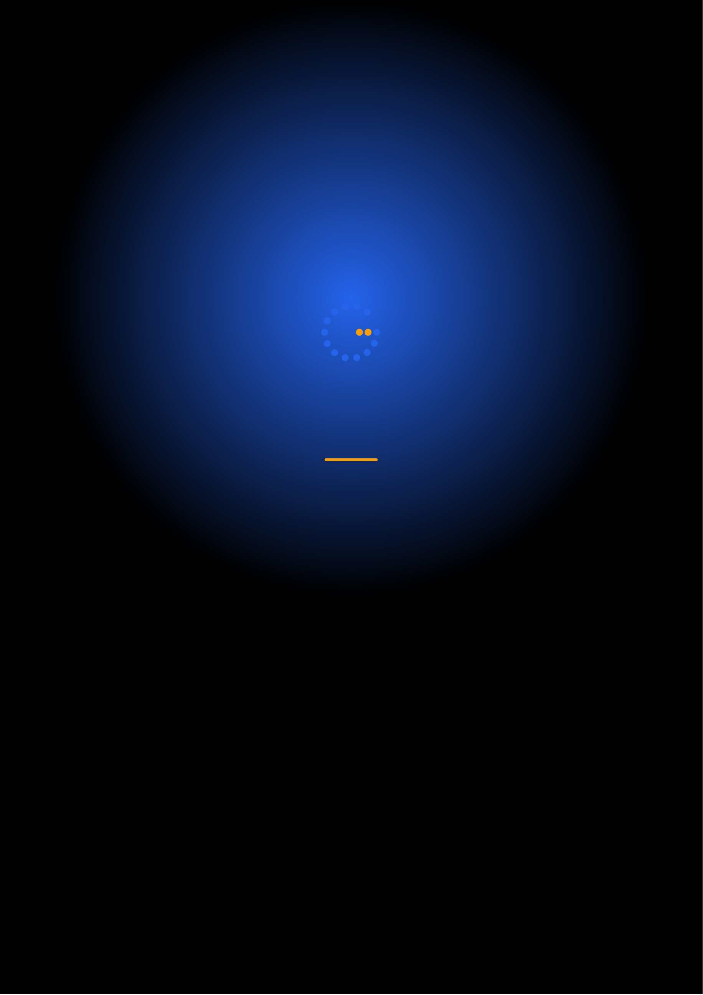
Ready to Start Your
AI on Google Cloud Journey?
Contact us to discuss a customized program
for your organization or register for the next open batch.
✉
+91 9326 352 241
▶
Gennoor Tech
TRAIN.INNOVATE.BUILD.

