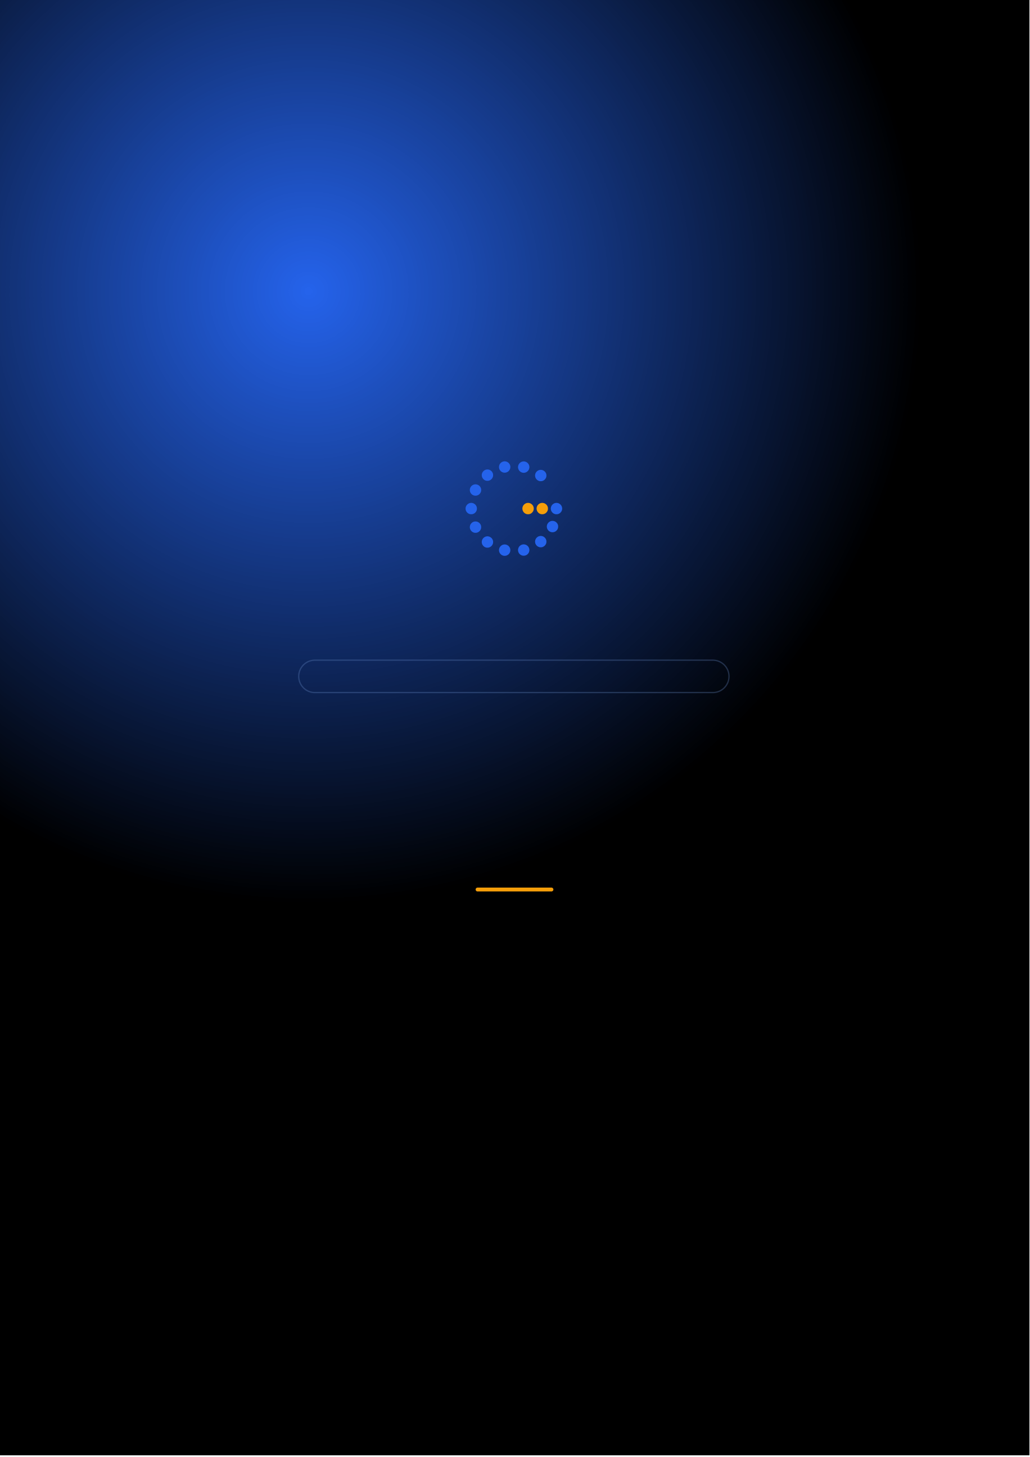
Gennoor Tech
TRAIN.INNOVATE.BUILD.
5-DAY HANDS-ON BOOTCAMP · 40 HOURS
AB-100 Certification Prep
Prepare for the Microsoft AB-100 certification exam
DAYS40 HOURS10+ PRACTICE TESTS5+
www.gennoor.com · enquiry@gennoor.com

Gennoor Tech | A B - 1 0 0 C E R T I F I C A T I O N P R E P
Course Overview
This 5-day hands-on bootcamp covers everything from foundational concepts to advanced techniques, combining lectures, live demos, hands-on labs, and collaborative workshops for maximum learning impact.
Prerequisites: Azure familiarity, Copilot Studio basics, Power Platform experience helpful.
Who Is This For?
Solution Architects

AI Developers

⚡

Power Platform Devs

L&D Teams
Internal trainers
Learning Outcomes

Design agentic AI — solutions aligned to AB-100 exam domains

Build agents with — Copilot Studio, Semantic Kernel, and Azure AI Agent Service

Integrate agents with — Dataverse, SharePoint, MCP servers, and custom APIs

Implement governance, Responsible — AI, DLP, and compliance controls

Pass the Microsoft — AB-100 certification exam
© 2026 Gennoor Tech Private Limited | www.gennoor.com | Page 2

Gennoor Tech | C O U R S E C U R R I C U L U M
5-Day Curriculum
Interactive format with live demos, hands-on labs, and collaborative workshops. Schedule and session order are fully
customizable based on your organization's needs and time zones.
01Design Agentic AI Solutions (25-30%) HANDS-ON LABS + WORKSHOP

SESSION A

Design Agentic AI Solutions (25-30%)
·  ·  · | Agent architecture patterns: single, multi-agent, orchestrator  Use case identification and platform selection  Multi-agent collaboration: delegation, specialization, consensus

SESSION B

Hands-On & Practice
·  · | Human-in-the-loop: approval gates, escalation, feedback  Practice: Design agent solutions for 5 business scenarios
02Implement with Copilot Studio (25-30%) DEMOS + LABS + DISCUSSION

SESSION A

Implement with Copilot Studio (25-30%)
·  ·  · | Copilot Studio: topics, entities, variables, plugins  Generative AI, knowledge grounding, custom connectors  Authentication: SSO, OAuth, service principal patterns

SESSION B

Hands-On & Practice |  | www.gennoor.com | Page 3
·  · | Adaptive Cards and Power Automate integration Lab: Multi-topic agent with API plugin integration
© 2026 Gennoor Tech Private Limited

Gennoor Tech | C O U R S E C U R R I C U L U M
03Semantic Kernel & Azure AI Agent Service LECTURE + HANDS-ON LABS

SESSION A

Semantic Kernel
·  ·  · | Semantic Kernel: kernel, plugins, planners, memory  Planner types: sequential, stepwise, Handlebars  Azure AI Agent Service architecture and deployment

SESSION B

Azure AI Agent Service
·  · | MCP for agent-system integration  Lab: Multi-agent delegation with Azure AI Agent Service
04Enterprise Integration & Data (20-25%) HANDS-ON LABS + WORKSHOP

SESSION A

Enterprise Integration
·  ·  · | Dataverse: tables, views, relationships for agents  SharePoint and Azure AI Search as knowledge sources  Custom connectors and Power Automate flows as actions

SESSION B

Data (20-25%)
·  · | ALM: solutions, environments, deployment pipelines  Lab: Complete business process agent (intake→process→approve)
05Governance + Exam Preparation (15-20%) DEMOS + LABS + DISCUSSION

SESSION A

Governance + Exam Preparation (15-20%)
·  ·  · | Microsoft Responsible AI for agentic systems  Content Safety, guardrails, DLP policies  Monitoring: analytics, telemetry, alerting

SESSION B

Hands-On & Practice
·  · | Full-length practice exam (timed, exam-format)  Gap analysis, study plan, and exam-day tips

Flexible & Customizable: Session order, timing, depth, and industry focus can be tailored to your organization's specific

requirements. Content is regularly updated to reflect the latest AI developments. |  | Page 4
© 2026 Gennoor Tech Private Limited | www.gennoor.com

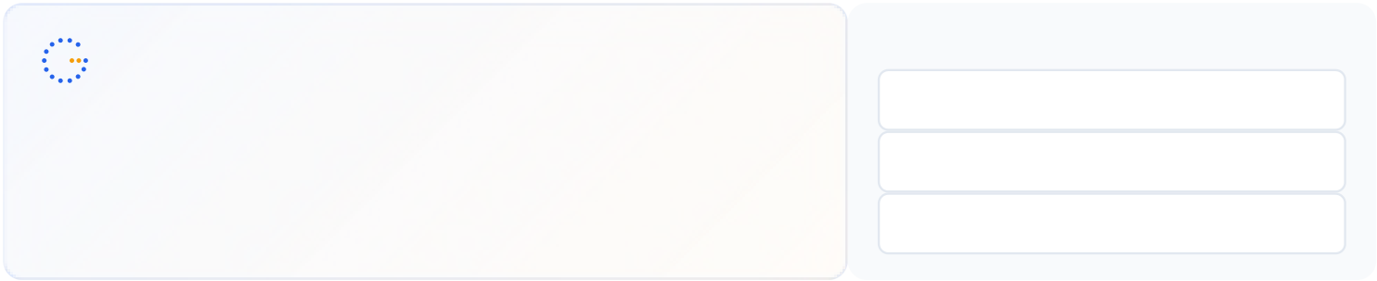
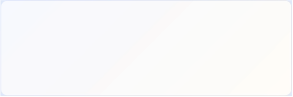
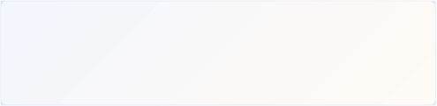
Gennoor Tech | T O O L S , C E R T I F I C A T I O N & D E L I V E R Y
Tools & Platforms Covered
All tools demonstrated and practiced hands-on during the bootcamp
Azure AI Search | Azure AI Services | Dataverse | Microsoft Copilot | Microsoft Copilot Studio | Power Automate | Semantic Kernel

SharePoint

What You Take Home
2 Practice Exams (50+ questions each)

Included with course completion

Solution Design Templates

Included with course completion

⚡ Lab Projects (complete code)

Included with course completion

Comprehensive Study Guide by domain

Included with course completion
Certification of Completion
Gennoor Tech — Certificate of Completion | Recommended Next Certifications
AI-901
Upon completing all 5 days (40 hours), each participant receives a Gennoor Tech Certificate of Completion in "AB-100 Certification Prep". Digitally signed by the Founder & Director. Validates proficiency in all course topics and hands-on competency. | Azure AI Fundamentals (New 2026)  AI-103  Azure AI Solutions  AB-100
Agentic AI Business Solutions
Designed & Delivered By
Jalal Ahmed Khan
Founder & Director, Gennoor Tech Private Limited
Senior AI Consultant and Microsoft Certified Trainer (MCT) with 14+ years of 16+ | active | Microsoft | certifications
experience. Delivered AI and technology programs for Microsoft, EY, IBM, Boeing, including AB-100 (Agentic AI), AI-103, AZ-400,
Saudi Aramco, HDFC Bank, and 80+ organizations across 6+ countries including the AI-300, PL-400, and GitHub certifications.
10-day AI Leadership program for MCIT Saudi Arabia. Builder of open-source MCP servers and Copilot
Studio integrations. M.E. Mechanical
Engineering, Mumbai University.
Delivery OptionsOn-Site — customized at your office | Virtual Live — interactive via Teams/Zoom | International —

GCC, Africa, APAC, UK | www.gennoor.com | Page 5
© 2026 Gennoor Tech Private Limited

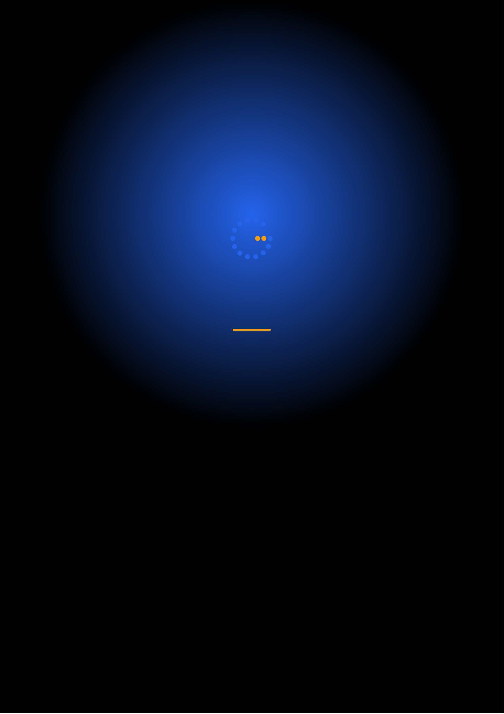
Ready to Start Your
AB-100 Certification Prep Journey?
Contact us to discuss a customized program
for your organization or register for the next open batch.
✉
+91 9326 352 241
▶
Gennoor Tech
TRAIN.INNOVATE.BUILD.

