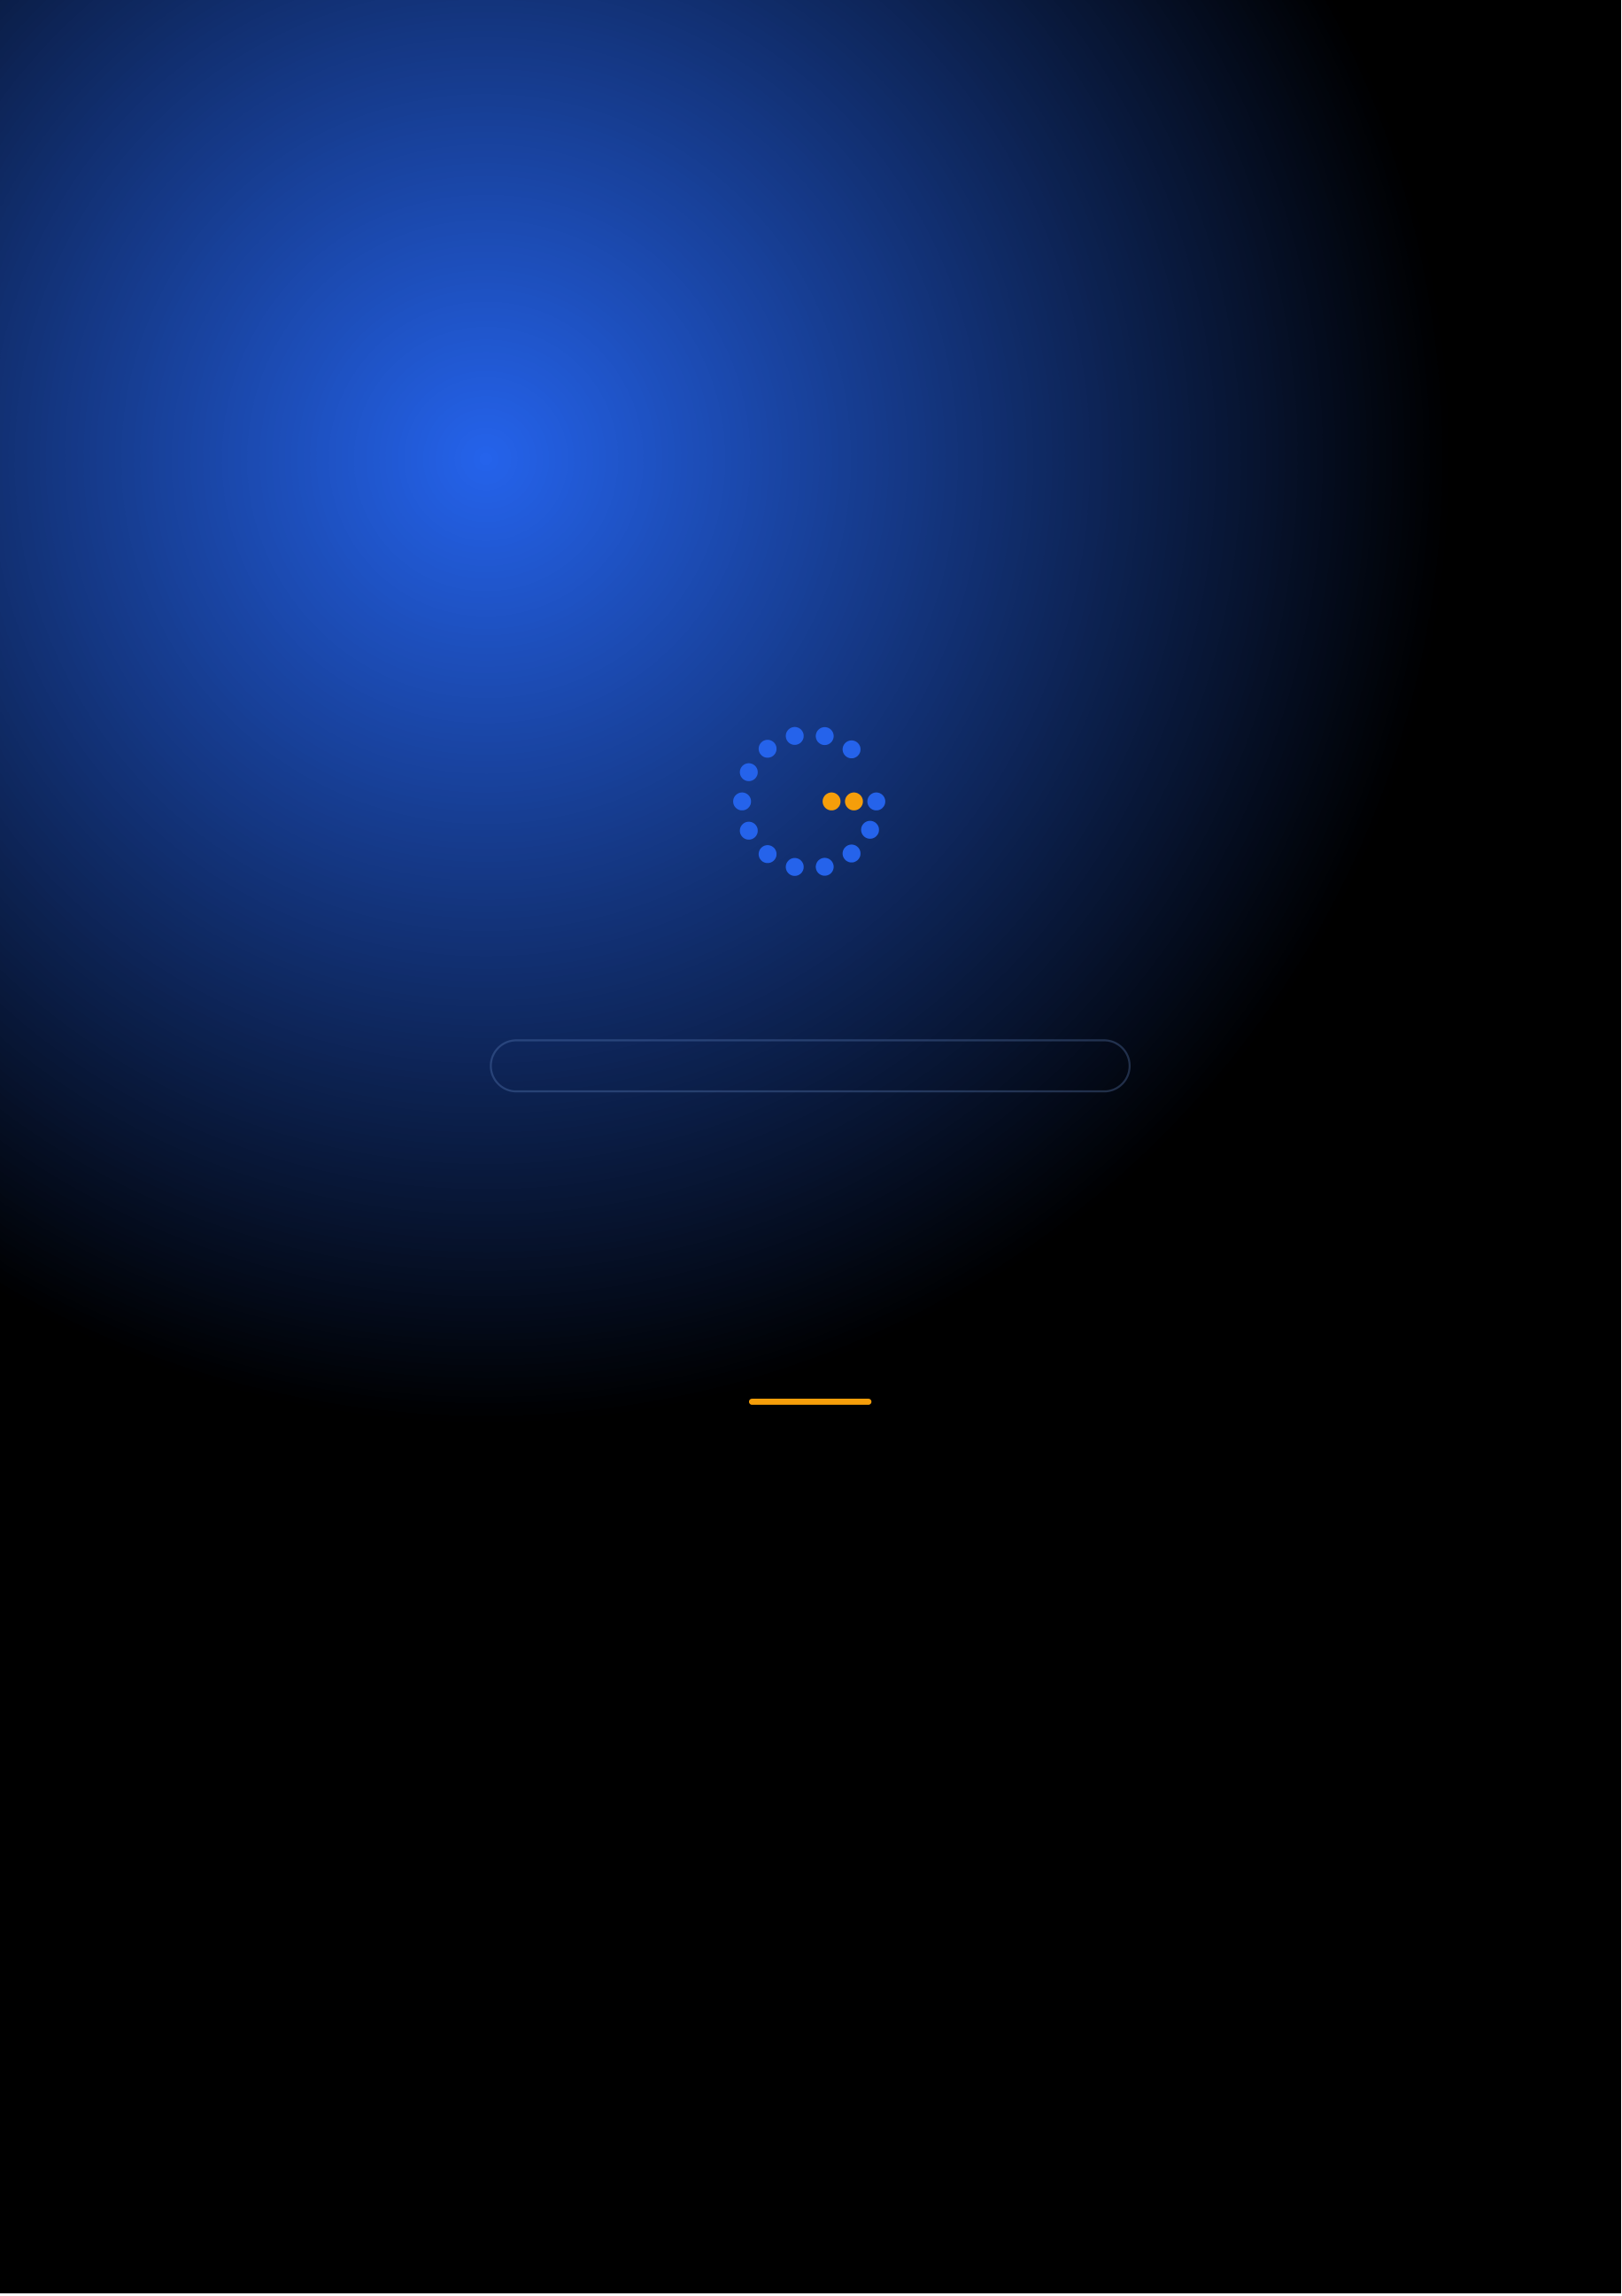
Gennoor Tech
TRAIN.INNOVATE.BUILD.
3-DAY INTENSIVE COURSE · 24 HOURS
Azure AI Fundamentals
Core AI concepts and Azure AI services for all professionals
DAYS24 HOURS10+ HANDS-ON LABSMixed
www.gennoor.com · enquiry@gennoor.com

Gennoor Tech | A Z U R E A I F U N D A M E N T A L S
Course Overview
This 3-day intensive program covers everything from foundational concepts to advanced techniques, combining lectures, live
demos, hands-on labs, and collaborative workshops for maximum learning impact.
Prerequisites: Basic Azure familiarity, Python helpful.
Who Is This For?
Developers

Data Scientists

L&D Teams

Internal trainers

Technical Leads
Team leads and architects
Learning Outcomes

Understand Azure AI — service portfolio and use case mapping

Build with Azure — OpenAI and Cognitive Services

Train and deploy — models with Azure ML Studio

Apply Responsible AI — principles
© 2026 Gennoor Tech Private Limited | www.gennoor.com | Page 2

Gennoor Tech | C O U R S E C U R R I C U L U M
3-Day Curriculum
Interactive format with live demos, hands-on labs, and collaborative workshops. Schedule and session order are fully
customizable based on your organization's needs and time zones.
01Azure OpenAI & Cognitive Services HANDS-ON LABS + WORKSHOP

SESSION A

Azure OpenAI
·  · | Azure OpenAI: deployment, chat completions, embeddings  Azure AI Vision, Speech, Language, and Translator

SESSION B

Cognitive Services
·  · | Content Safety and Responsible AI configuration  Lab: Build a chat app with Azure OpenAI
02Azure ML Studio & Document Intelligence DEMOS + LABS + DISCUSSION

SESSION A

Azure ML Studio
·  · | Azure ML: designer, automated ML, model deployment  Document Intelligence: prebuilt and custom models

SESSION B

Document Intelligence
·  · | Azure AI Search fundamentals  Lab: Build and deploy an ML model
03Integration, Architecture & Lab LECTURE + HANDS-ON LABS

SESSION A

Integration, Architecture
·  · | Azure AI architecture patterns and best practices  Security: RBAC, private endpoints, networking

SESSION B

Lab
·  · | Cost optimization strategies  Lab: End-to-end Azure AI solution

Flexible & Customizable: Session order, timing, depth, and industry focus can be tailored to your organization's specific

requirements. Content is regularly updated to reflect the latest AI developments. |  | Page 3
© 2026 Gennoor Tech Private Limited | www.gennoor.com




Gennoor Tech | T O O L S , C E R T I F I C A T I O N & D E L I V E R Y
Tools & Platforms Covered
All tools demonstrated and practiced hands-on during the course
Azure AI Search | Azure AI Services | Azure OpenAI
What You Take Home
Azure AI Service Map

Included with course completion

Lab Projects

Included with course completion

⚡ Architecture Reference

Included with course completion
Certification of Completion
Gennoor Tech — Certificate of Completion | Recommended Next Certifications
AI-901
Upon completing all 3 days (24 hours), each participant receives a Gennoor Tech Certificate of Completion in "Azure AI Fundamentals". Digitally signed by the Founder & Director. Validates proficiency in all course topics and hands-on competency. | Azure AI Fundamentals (New 2026)  AI-103  Azure AI Solutions  DP-100
Azure Data Scientist
Designed & Delivered By
Jalal Ahmed Khan
Founder & Director, Gennoor Tech Private Limited
Senior AI Consultant and Microsoft Certified Trainer (MCT) with 14+ years of 16+ | active | Microsoft | certifications
experience. Delivered AI and technology programs for Microsoft, EY, IBM, Boeing, including AB-100 (Agentic AI), AI-103, AZ-400,
Saudi Aramco, HDFC Bank, and 80+ organizations across 6+ countries including the AI-300, PL-400, and GitHub certifications.
10-day AI Leadership program for MCIT Saudi Arabia. Builder of open-source MCP servers and Copilot
Studio integrations. M.E. Mechanical
Engineering, Mumbai University.
Delivery OptionsOn-Site — customized at your office | Virtual Live — interactive via Teams/Zoom | International —

GCC, Africa, APAC, UK | www.gennoor.com | Page 4
© 2026 Gennoor Tech Private Limited


Ready to Start Your
Azure AI Fundamentals Journey?
Contact us to discuss a customized program
for your organization or register for the next open batch.
✉
+91 9326 352 241
▶
Gennoor Tech
TRAIN.INNOVATE.BUILD.

