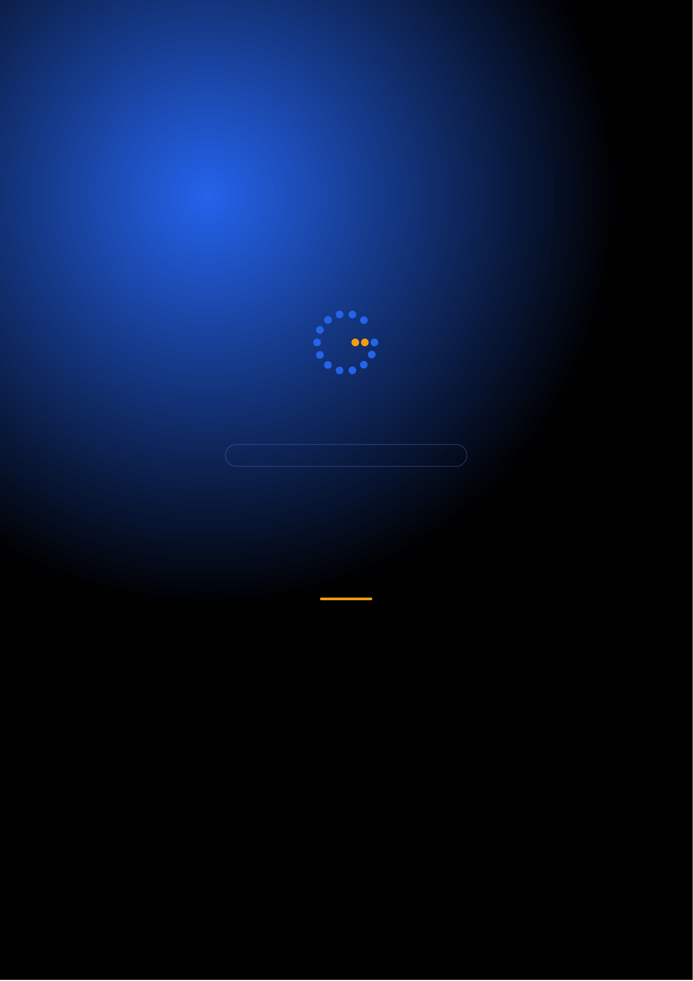
Gennoor Tech
TRAIN.INNOVATE.BUILD.
2-DAY MASTERCLASS · 16 HOURS
Microsoft Copilot Mastery
Master Microsoft 365 Copilot for enterprise productivity
DAYS16 HOURS10+ HANDS-ON LABSMixed
www.gennoor.com · enquiry@gennoor.com

Gennoor Tech | M I C R O S O F T C O P I L O T M A S T E R Y
Course Overview
This 2-day intensive program covers everything from foundational concepts to advanced techniques, combining lectures, live
demos, hands-on labs, and collaborative workshops for maximum learning impact.
Prerequisites: Basic M365 familiarity. No coding required.
Who Is This For?
Business Users

Analysts

L&D Teams

Internal trainers

Technical Leads
Team leads and architects
Learning Outcomes

Use Copilot effectively — across M365 applications

Build custom copilots — with Copilot Studio

Master prompt engineering — for business productivity

Understand Copilot governance — and administration
© 2026 Gennoor Tech Private Limited | www.gennoor.com | Page 2

Gennoor Tech | C O U R S E C U R R I C U L U M
2-Day Curriculum
Interactive format with live demos, hands-on labs, and collaborative workshops. Schedule and session order are fully
customizable based on your organization's needs and time zones.
01Copilot for M365 & Prompt Engineering HANDS-ON LABS + WORKSHOP

SESSION A

Copilot for M365
·  · | Copilot in Word, Excel, PowerPoint, Outlook, Teams  Copilot Chat for research and analysis

SESSION B

Prompt Engineering
·  · | Prompt engineering best practices for business users  Lab: Complete a business workflow using only Copilot
02Copilot Studio & Custom Copilots DEMOS + LABS + DISCUSSION

SESSION A

Copilot Studio
·  · | Building agents in Copilot Studio  Knowledge grounding with SharePoint and web

SESSION B

Custom Copilots
·  · | Copilot extensibility: plugins and connectors  Lab: Build a department-specific Copilot agent

Flexible & Customizable: Session order, timing, depth, and industry focus can be tailored to your organization's specific

requirements. Content is regularly updated to reflect the latest AI developments. |  | Page 3
© 2026 Gennoor Tech Private Limited | www.gennoor.com


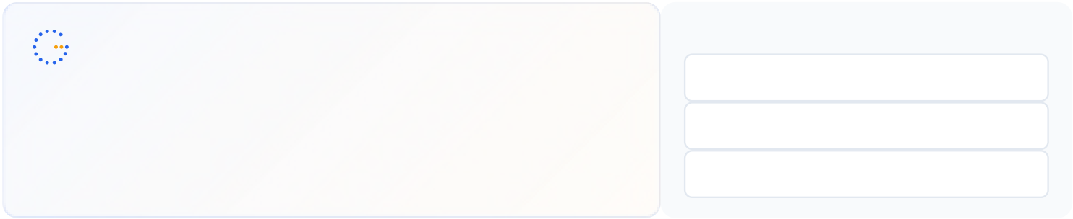
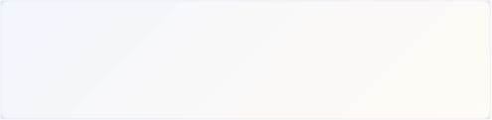
Gennoor Tech | T O O L S , C E R T I F I C A T I O N & D E L I V E R Y
Tools & Platforms Covered
All tools demonstrated and practiced hands-on during the course
Microsoft Copilot | Microsoft Copilot Studio | SharePoint
What You Take Home
Prompt Library (50+ business prompts)

Included with course completion

Copilot Studio Agent Template

Included with course completion

⚡ Copilot Adoption Guide

Included with course completion
Certification of Completion
Gennoor Tech — Certificate of Completion | Recommended Next Certifications
MS-4008
Upon completing all 2 days (16 hours), each participant receives a Gennoor Tech Certificate of Completion in "Microsoft Copilot Mastery". Digitally signed by the Founder & Director. Validates proficiency in all course topics and hands-on competency. | Copilot for M365 Interactive  AI-3018  Copilot Foundations  AB-900
M365 Copilot Administration (New)
Designed & Delivered By
Jalal Ahmed Khan
Founder & Director, Gennoor Tech Private Limited
Senior AI Consultant and Microsoft Certified Trainer (MCT) with 14+ years of 16+ | active | Microsoft | certifications
experience. Delivered AI and technology programs for Microsoft, EY, IBM, Boeing, including AB-100 (Agentic AI), AI-103, AZ-400,
Saudi Aramco, HDFC Bank, and 80+ organizations across 6+ countries including the AI-300, PL-400, and GitHub certifications.
10-day AI Leadership program for MCIT Saudi Arabia. Builder of open-source MCP servers and Copilot
Studio integrations. M.E. Mechanical
Engineering, Mumbai University.
Delivery OptionsOn-Site — customized at your office | Virtual Live — interactive via Teams/Zoom | International —

GCC, Africa, APAC, UK | www.gennoor.com | Page 4
© 2026 Gennoor Tech Private Limited


Ready to Master
Microsoft Copilot?
Contact us to discuss a customized program
for your organization or register for the next open batch.
✉
+91 9326 352 241
▶
Gennoor Tech
TRAIN.INNOVATE.BUILD.

