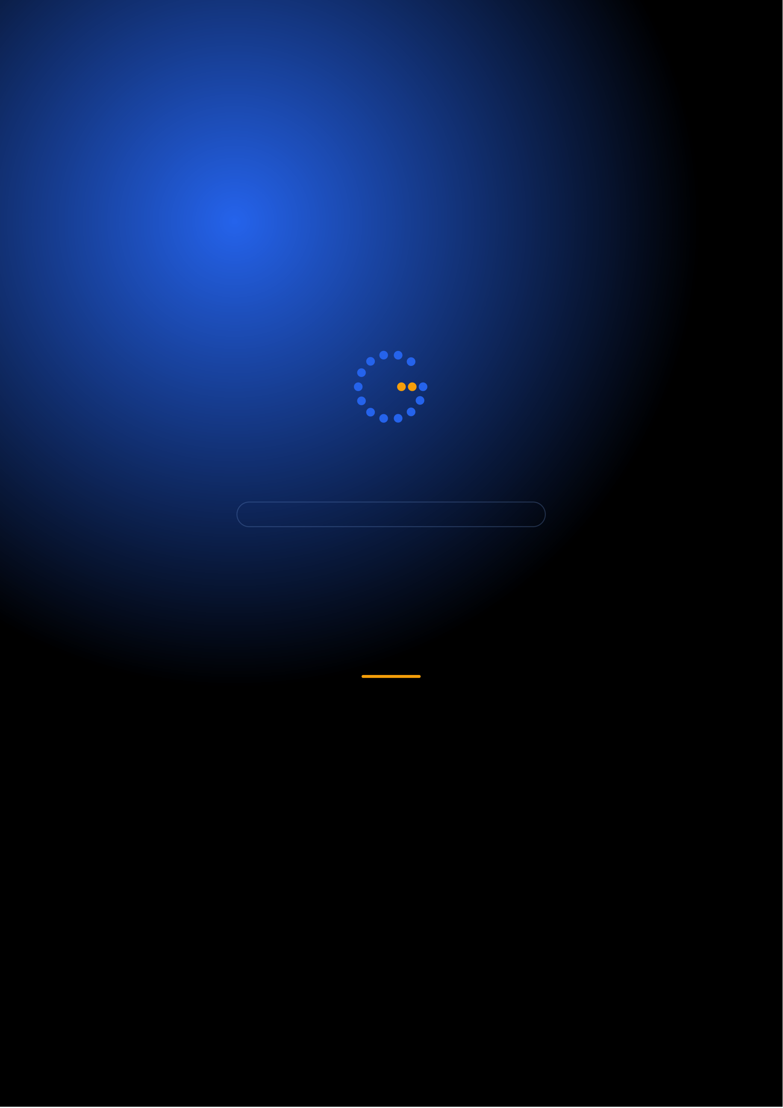
Gennoor Tech
TRAIN.INNOVATE.BUILD.
3-DAY INTENSIVE COURSE · 24 HOURS
RAG Engineering
Build retrieval-augmented generation systems for enterprise
DAYS24 HOURS15+ HANDS-ON LABS5+ PROJECTS
www.gennoor.com · enquiry@gennoor.com

Gennoor Tech | R A G E N G I N E E R I N G
Course Overview
This 3-day intensive program covers everything from foundational concepts to advanced techniques, combining lectures, live
demos, hands-on labs, and collaborative workshops for maximum learning impact.
Prerequisites: Python (intermediate), basic LLM API experience.
Who Is This For?
AI Engineers

Backend Developers

L&D Teams

Internal trainers

Technical Leads
Team leads and architects
Learning Outcomes

Design and implement — production RAG pipelines

Select and optimize — chunking, embedding, and indexing strategies

Build with vector databases — FAISS, Chroma, Pinecone, Azure AI Search

Implement hybrid search, — reranking, and citation tracking

Evaluate RAG quality — and implement guardrails
© 2026 Gennoor Tech Private Limited | www.gennoor.com | Page 2

Gennoor Tech | C O U R S E C U R R I C U L U M
3-Day Curriculum
Interactive format with live demos, hands-on labs, and collaborative workshops. Schedule and session order are fully
customizable based on your organization's needs and time zones.
01RAG Fundamentals & Chunking HANDS-ON LABS + WORKSHOP

SESSION A

RAG Fundamentals
·  ·  · | RAG architecture: ingestion, indexing, retrieval, generation  Chunking: fixed, recursive, semantic, document-aware  Embedding models: OpenAI, Cohere, sentence-transformers

SESSION B

Chunking
·  · | Lab: Compare chunking strategies on the same dataset  Document loaders for PDF, DOCX, HTML, and databases
02Vector Databases & Hybrid Search DEMOS + LABS + DISCUSSION

SESSION A

Vector Databases
·  ·  · | FAISS, Chroma, Pinecone, Weaviate — architecture comparison  Azure AI Search: indexes, skillsets, vectorization  Hybrid search: keyword + semantic + reranking

SESSION B

Hybrid Search
·  · | Metadata filtering and multi-tenant patterns  Lab: Hybrid search RAG with Azure AI Search
03Production RAG & Evaluation LECTURE + HANDS-ON LABS

SESSION A

Production RAG
·  ·  · | Citation tracking and source attribution  Query routing and multi-index strategies  RAG evaluation: faithfulness, relevancy, completeness

SESSION B

Evaluation
·  · | Guardrails: hallucination detection, content safety  Lab: Production RAG system with evaluation pipeline

Flexible & Customizable: Session order, timing, depth, and industry focus can be tailored to your organization's specific

requirements. Content is regularly updated to reflect the latest AI developments. |  | Page 3
© 2026 Gennoor Tech Private Limited | www.gennoor.com




Gennoor Tech | T O O L S , C E R T I F I C A T I O N & D E L I V E R Y
Tools & Platforms Covered
All tools demonstrated and practiced hands-on during the course
Azure AI Search | Azure AI Services | ChromaDB | FAISS
What You Take Home
RAG Pipeline Templates

Included with course completion

Vector DB Comparison Matrix

Included with course completion

⚡ Evaluation Framework

Included with course completion

Chunking Strategy Guide

Included with course completion
Certification of Completion
Gennoor Tech — Certificate of Completion | Recommended Next Certifications
AI-103
Upon completing all 3 days (24 hours), each participant receives a Gennoor Tech Certificate of Completion in "RAG Engineering". Digitally signed by the Founder & Director. Validates proficiency in all course topics and hands-on competency. | Azure AI Solutions  DP-100  Azure Data Scientist  AI-901
Azure AI Fundamentals (New 2026)
Designed & Delivered By
Jalal Ahmed Khan
Founder & Director, Gennoor Tech Private Limited
Senior AI Consultant and Microsoft Certified Trainer (MCT) with 14+ years of 16+ | active | Microsoft | certifications
experience. Delivered AI and technology programs for Microsoft, EY, IBM, Boeing, including AB-100 (Agentic AI), AI-103, AZ-400,
Saudi Aramco, HDFC Bank, and 80+ organizations across 6+ countries including the AI-300, PL-400, and GitHub certifications.
10-day AI Leadership program for MCIT Saudi Arabia. Builder of open-source MCP servers and Copilot
Studio integrations. M.E. Mechanical
Engineering, Mumbai University.
Delivery OptionsOn-Site — customized at your office | Virtual Live — interactive via Teams/Zoom | International —

GCC, Africa, APAC, UK | www.gennoor.com | Page 4
© 2026 Gennoor Tech Private Limited

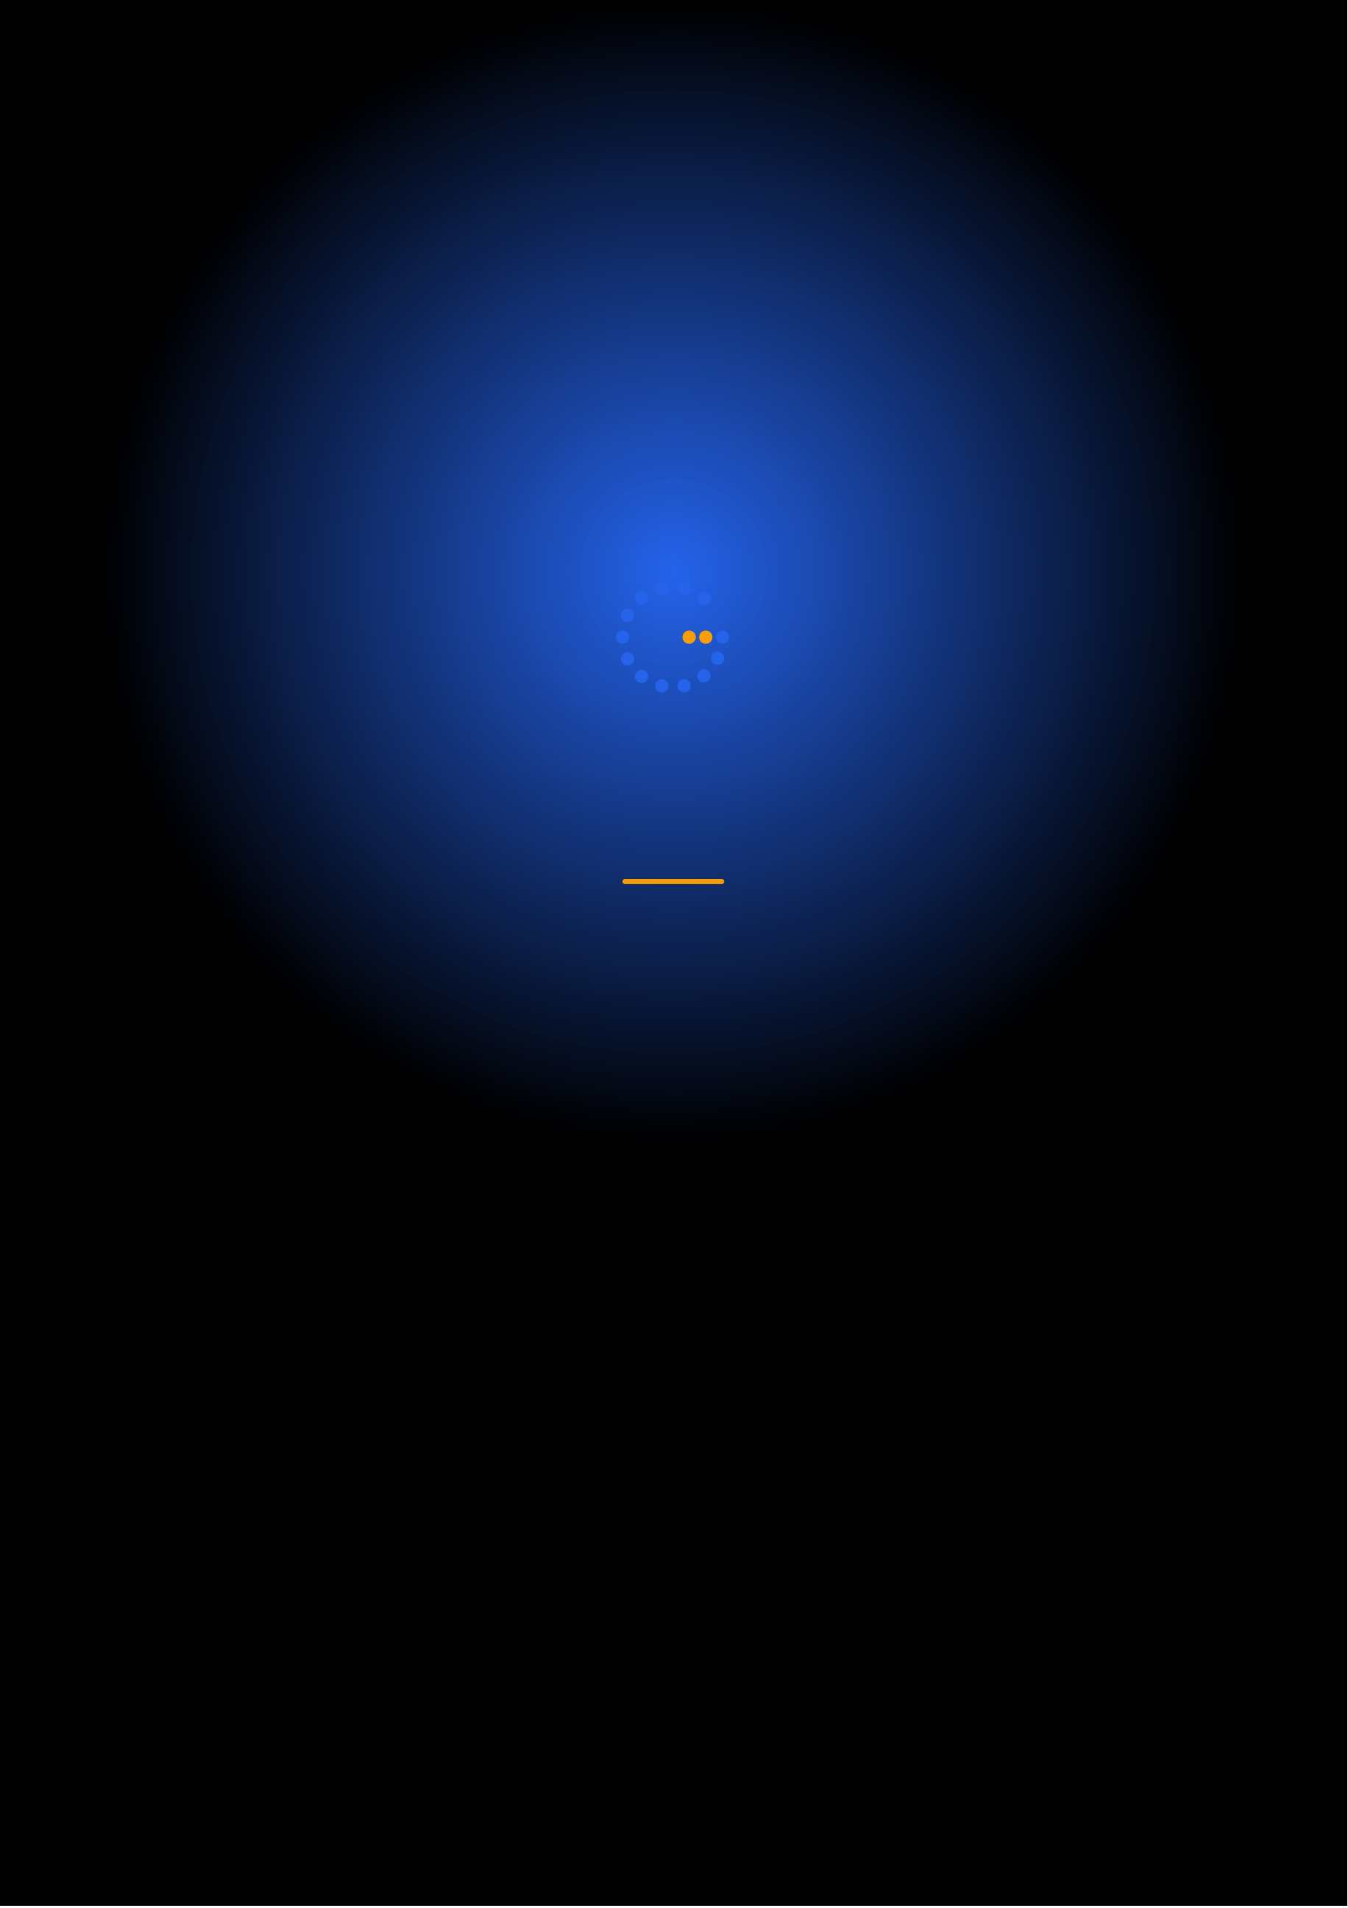
Ready to Start Your
RAG Engineering Journey?
Contact us to discuss a customized program
for your organization or register for the next open batch.
✉
+91 9326 352 241
▶
Gennoor Tech
TRAIN.INNOVATE.BUILD.

