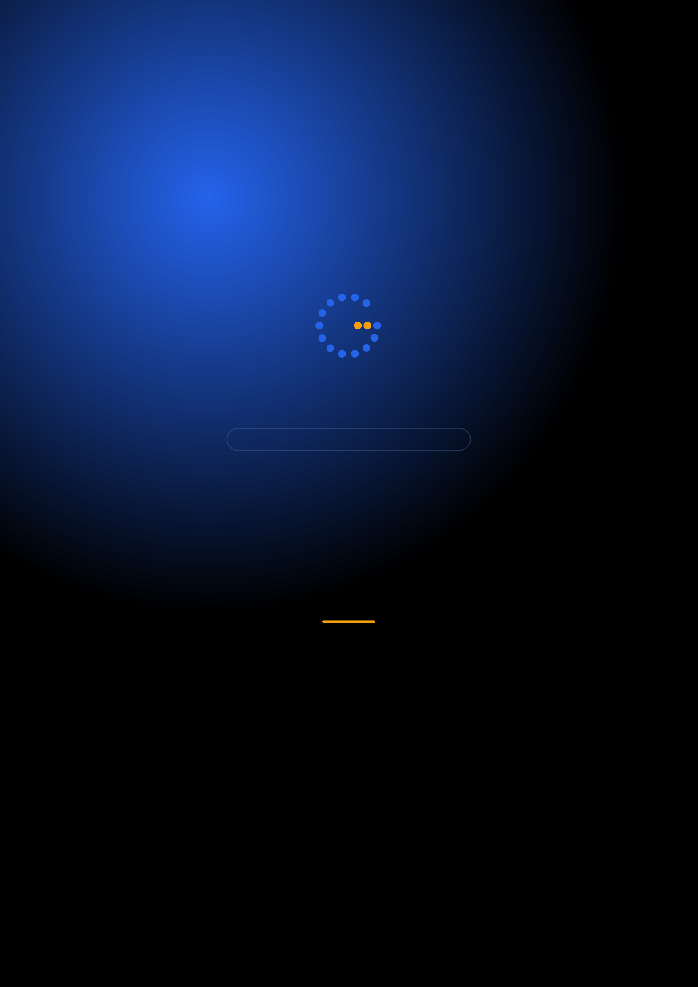
Gennoor Tech
TRAIN.INNOVATE.BUILD.
2-DAY MASTERCLASS · 16 HOURS
N8N &
AI Workflow Automation
AI-powered workflow automation with N8N and integrations
DAYS16 HOURS10+ HANDS-ON LABSMixed
www.gennoor.com · enquiry@gennoor.com

Gennoor Tech | N 8 N & A I W O R K F L O W A U T O M A T I O N
Course Overview
This 2-day intensive program covers everything from foundational concepts to advanced techniques, combining lectures, live demos, hands-on labs, and collaborative workshops for maximum learning impact.
Prerequisites: No coding required. Basic understanding of workflows helpful.
Who Is This For?
Business Analysts

IT Teams

Operations

L&D Teams
Internal trainers
Learning Outcomes

Build automated workflows — with N8N visual editor

Integrate AI nodes — OpenAI, Claude, Gemini — into workflows

Automate document processing, — email handling, and data pipelines

Connect N8N to — enterprise systems and databases
© 2026 Gennoor Tech Private Limited | www.gennoor.com | Page 2

Gennoor Tech | C O U R S E C U R R I C U L U M
2-Day Curriculum
Interactive format with live demos, hands-on labs, and collaborative workshops. Schedule and session order are fully
customizable based on your organization's needs and time zones.
01N8N Fundamentals & AI Integration HANDS-ON LABS + WORKSHOP

SESSION A

N8N Fundamentals
·  · | N8N architecture: triggers, nodes, workflows, expressions  AI nodes: OpenAI, Claude, Gemini for text and analysis

SESSION B

AI Integration
·  · | Data transformation and conditional logic  Lab: Build an automated email classifier
02Enterprise Automation & Deployment DEMOS + LABS + DISCUSSION

SESSION A

Enterprise Automation
·  ·  · | Document processing workflows with AI  Database and API integration (REST, SQL, webhooks)  Error handling, logging, and monitoring

SESSION B

Deployment
·  · | Self-hosting N8N and security configuration  Lab: End-to-end document processing pipeline

Flexible & Customizable: Session order, timing, depth, and industry focus can be tailored to your organization's specific

requirements. Content is regularly updated to reflect the latest AI developments. |  | Page 3
© 2026 Gennoor Tech Private Limited | www.gennoor.com




Gennoor Tech | T O O L S , C E R T I F I C A T I O N & D E L I V E R Y
Tools & Platforms Covered
All tools demonstrated and practiced hands-on during the course
Claude (Anthropic) | Google Gemini | N8N
What You Take Home
10 Workflow Templates

Included with course completion

AI Node Configuration Guide

Included with course completion

⚡ Deployment Checklist

Included with course completion
Certification of Completion
Gennoor Tech — Certificate of Completion | Recommended Next Certifications
PL-200
Upon completing all 2 days (16 hours), each participant receives a Gennoor Tech Certificate of Completion in "N8N & AI Workflow Automation". Digitally signed by the Founder & Director. Validates proficiency in all course topics and hands-on competency. | Power Platform Functional Consultant  AI-103  Azure AI Solutions  AI-901
Azure AI Fundamentals (New 2026)
Designed & Delivered By
Jalal Ahmed Khan
Founder & Director, Gennoor Tech Private Limited
Senior AI Consultant and Microsoft Certified Trainer (MCT) with 14+ years of 16+ | active | Microsoft | certifications
experience. Delivered AI and technology programs for Microsoft, EY, IBM, Boeing, including AB-100 (Agentic AI), AI-103, AZ-400,
Saudi Aramco, HDFC Bank, and 80+ organizations across 6+ countries including the AI-300, PL-400, and GitHub certifications.
10-day AI Leadership program for MCIT Saudi Arabia. Builder of open-source MCP servers and Copilot
Studio integrations. M.E. Mechanical
Engineering, Mumbai University.
Delivery OptionsOn-Site — customized at your office | Virtual Live — interactive via Teams/Zoom | International —

GCC, Africa, APAC, UK | www.gennoor.com | Page 4
© 2026 Gennoor Tech Private Limited

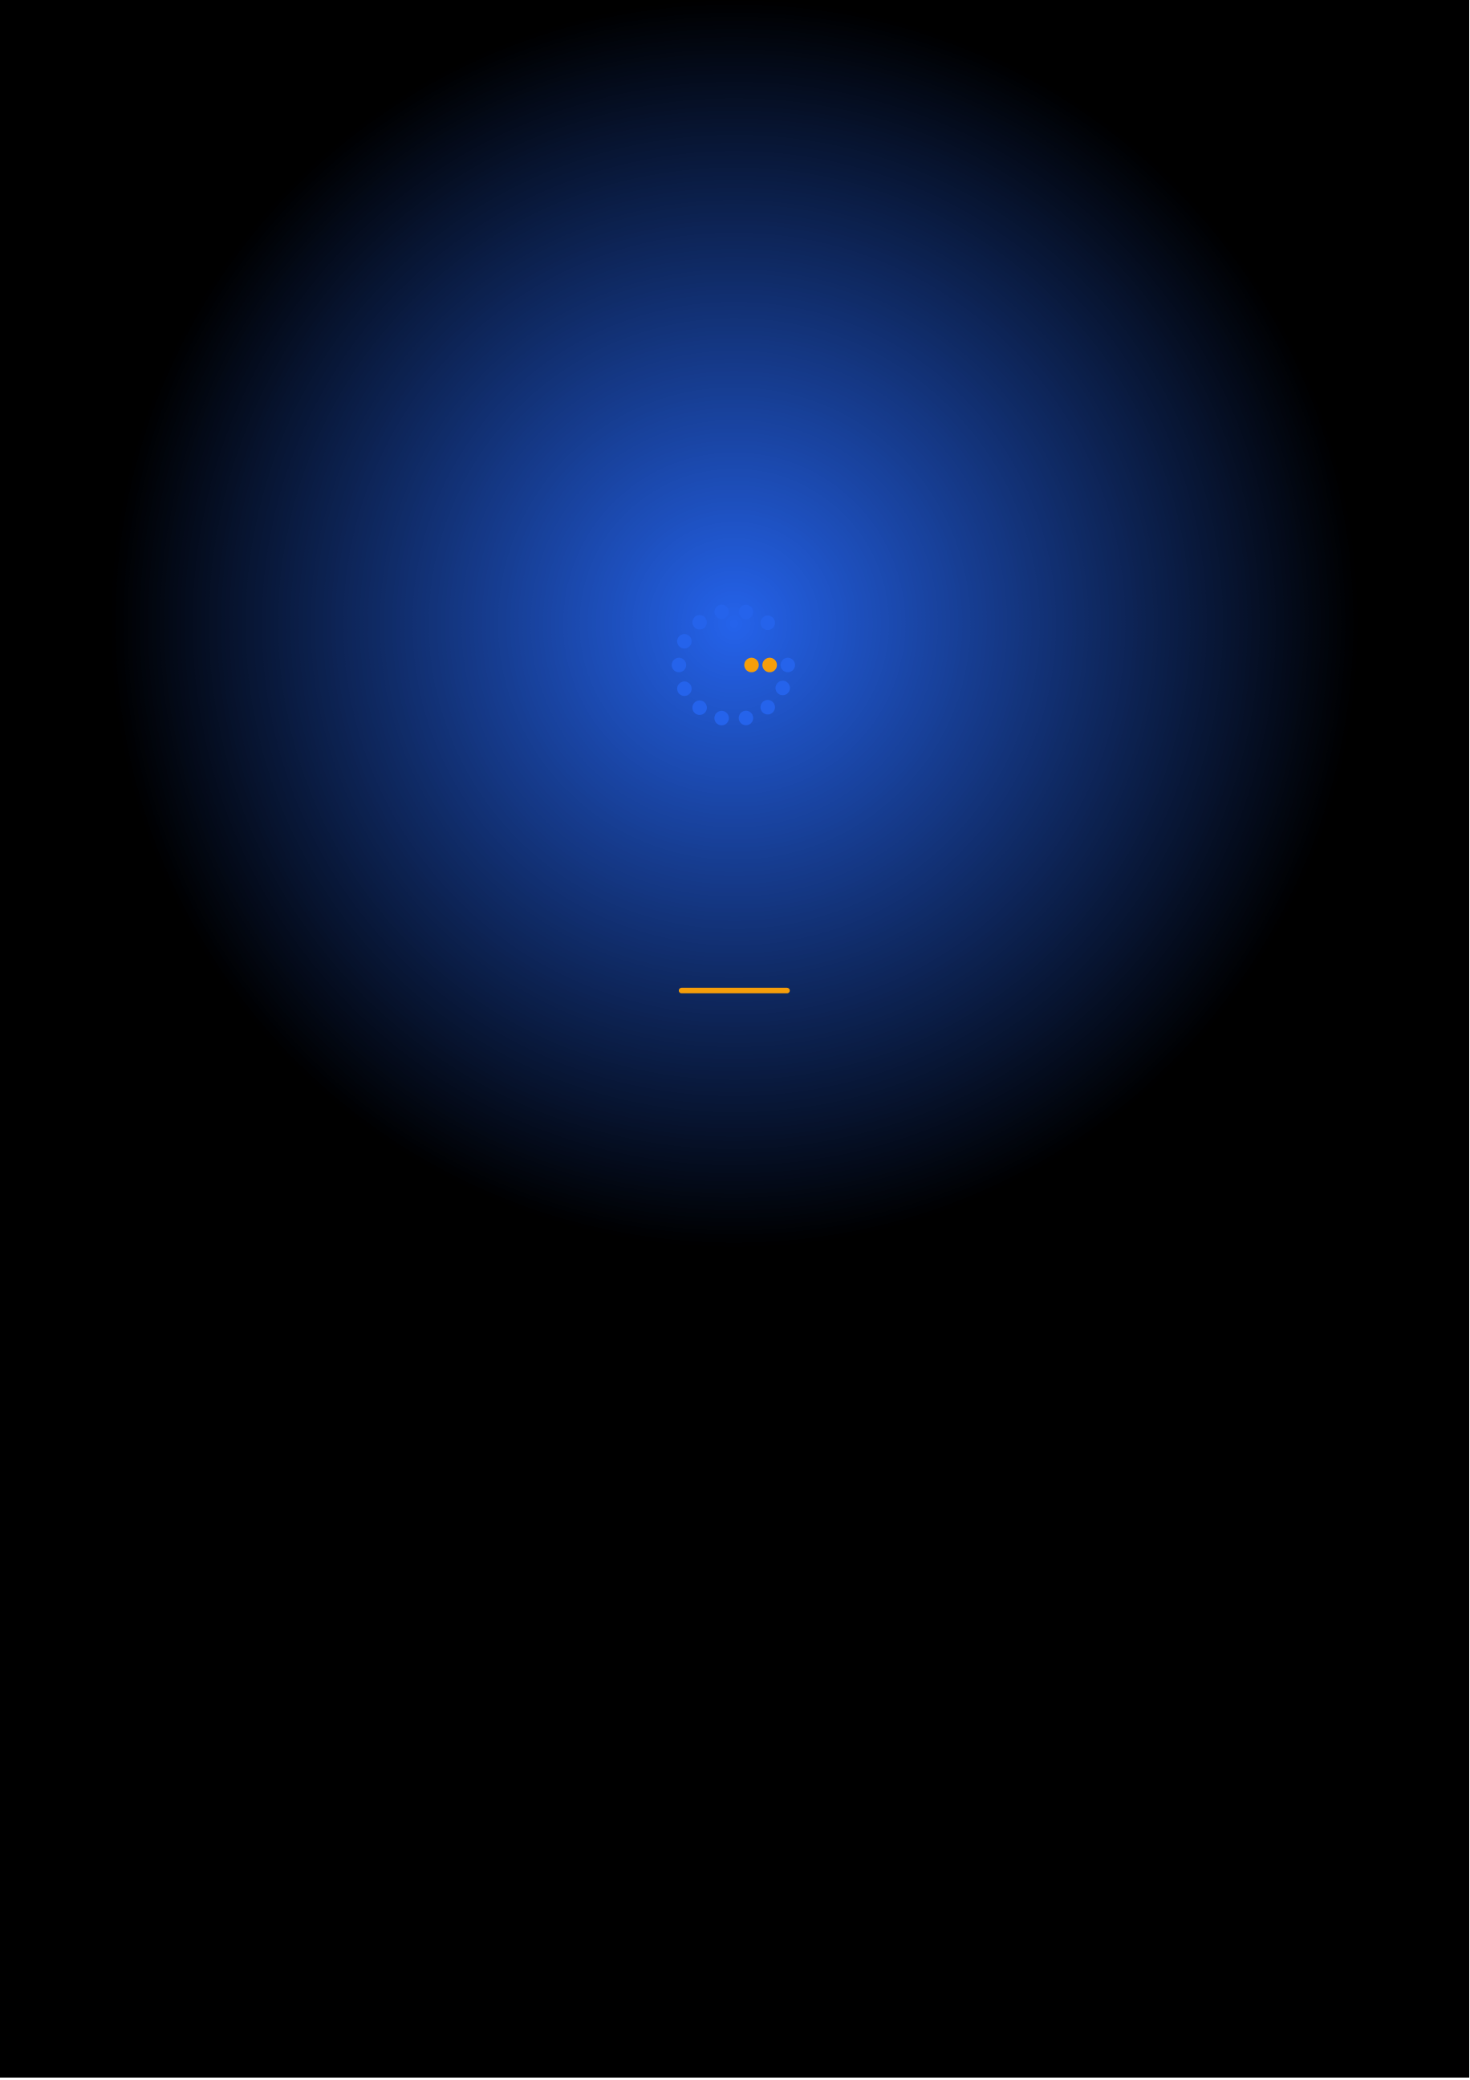
Ready to Start Your
N8N & AI Workflow Automation Journey?
Contact us to discuss a customized program
for your organization or register for the next open batch.
✉
+91 9326 352 241
▶
Gennoor Tech
TRAIN.INNOVATE.BUILD.

