Lab 02: Implement advanced multi-agent orchestration patterns in Microsoft Foundry

Overview
Scenario. Contoso Capital needs market, risk, and compliance specialists to contribute to one investment brief. Independent work should run concurrently, dependent work must stay ordered, and a failed optional specialist must not silently invalidate the report.
What you'll build. You complete a hub-and-spoke orchestrator in Python. It creates four versioned Foundry Agents v2 prompt agents, fans out live response calls to three specialist "spokes" in parallel, applies a quorum rule in code, and sends only the accepted evidence to a supervisor agent. You run it twice: once with all spokes healthy and once with the optional compliance spoke marked as failed, and you compare the results with the service traces.
Duration. About 45 minutes.
Note: Model calls, Application Insights ingestion, and 30-day Log Analytics retention are billable. Concurrent model calls consume quota faster than sequential calls. Use only the synthetic portfolio request in assets, and delete the resource group when you finish (see Clean up).

Agents in this lab
Agent | Contribution | Quorum policy
market-spoke | Market assumptions, uncertainties, and evidence gaps | Required
risk-spoke | Risk drivers, exposure limits, and uncertainty, without investment advice | Required
compliance-spoke | Disclosures, policy caveats, and limits on use of the research | Optional; missing evidence must be disclosed
research-supervisor | One brief from the request, accepted spoke evidence, and the missing-agent list | Runs only after both required spokes succeed

Architecture components
Component | Purpose
Microsoft Foundry account (fdry<suffix>, kind AIServices) | Hosts the project and the model deployment; public network access enabled for the lab
Foundry project (lab02-<env>) | Holds the four prompt agents, their versions, and traces
Model deployment gpt-5.4-mini (GlobalStandard, capacity 10) | Model used by every agent
Log Analytics workspace (log-lab02-<suffix>) | Stores telemetry (30-day retention)
Application Insights (appi-lab02-<suffix>) | Receives server-side agent traces through a project connection
infra/main.bicep | Deploys all of the above
assets/portfolio-request.json | Defines the request, the three spokes, required agents, and the supervisor
src/main.py | The orchestrator: creates agent versions, fans out with asyncio.gather behind a semaphore, evaluates quorum, calls the supervisor

Prerequisites
- Python 3.11 or later
- Azure CLI with Bicep (az bicep install)
- Visual Studio Code
- Git
- An Azure subscription with quota for gpt-5.4-mini (GlobalStandard) in your chosen region, enough for three concurrent calls
- Owner, or Contributor plus User Access Administrator, on the subscription or target resource group (you create role assignments for yourself)
This guide provisions with the Azure CLI instead of azd provision, so the Azure Developer CLI is not required.
1. Sign in to Azure and select the subscription you want to use:
POWERSHELL
az login
az account set --subscription "<your-subscription-id>"
az account show --output table

Expected result: az account show lists the subscription you intend to use.

Task 1: Prepare the lab
1. Clone the lab repository (skip if you already have it):
POWERSHELL
git clone https://github.com/MicrosoftLearning/mslearn-ai-multi-agents.git

2. Open the cloned mslearn-ai-multi-agents folder in Visual Studio Code.
3. Open a PowerShell terminal in VS Code (Terminal > New Terminal) and check the tools:
POWERSHELL
cd Allfiles\02-contoso-capital-advanced-orchestration
az version
python --version
az account show --output table

Expected result: each command succeeds, Python reports 3.11 or later, and the correct subscription is shown.
4. Architecture checkpoint. Open infra/main.bicep, assets/portfolio-request.json, and src/main.py and confirm that:
- the portfolio asset defines each specialist's assignment, and required_agents lists only market-spoke and risk-spoke;
- compliance-spoke is therefore optional;
- run() in src/main.py creates one agent-bound client per agent so the three spoke calls can run concurrently;
- deterministic code (evaluate_quorum) decides quorum before the supervisor is called.

Task 2: Build the virtual environment
1. From the lab folder, create the virtual environment and install the requirements, then activate it:
POWERSHELL
./scripts/setup.ps1
. ./.venv/Scripts/Activate.ps1

On macOS or Linux, run these instead:
BASH
bash scripts/setup.sh
source .venv/bin/activate

Expected result: (.venv) appears at the start of the terminal prompt, and pip installed azure-ai-projects 2.x, azure-identity, openai, and python-dotenv.

Task 3: Deploy the Azure resources
The Bicep template takes location, environmentName, modelDeploymentName, modelName, modelVersion, and enableSandboxPublicNetworkAccess (default true). It does not assign any data-plane roles, so the script below grants them to you.
1. In the same terminal (still in Allfiles\02-contoso-capital-advanced-orchestration), run the whole block. Change $azureRegion if gpt-5.4-mini isn't available to you in eastus2.
POWERSHELL
$azureRegion = 'eastus2'
$suffix = (New-Guid).Guid.Substring(0, 8)
$resourceGroupName = "rg-lab02-$suffix"
$envName = "lab02-$suffix"
az group create --name $resourceGroupName --location $azureRegion --output none
az bicep build --file infra/main.bicep
az deployment group create --resource-group $resourceGroupName --name lab02-main `
--template-file infra/main.bicep `
--parameters location=$azureRegion environmentName=$envName modelDeploymentName=gpt-5.4-mini modelName=gpt-5.4-mini modelVersion=2026-03-17 enableSandboxPublicNetworkAccess=true `
--output none
# Grant yourself data-plane access (Foundry agents + model calls)
$me = az ad signed-in-user show --query id -o tsv
$rgId = az group show --name $resourceGroupName --query id -o tsv
foreach ($role in 'Azure AI User','Cognitive Services OpenAI User','Azure AI Developer') {
az role assignment create --assignee-object-id $me --assignee-principal-type User --role $role --scope $rgId --output none
}
# Write .env from the deployment outputs
$outputs = az deployment group show --resource-group $resourceGroupName --name lab02-main --query properties.outputs -o json | ConvertFrom-Json
$lines = @("AZURE_RESOURCE_GROUP=`"$resourceGroupName`"", "AZURE_LOCATION=`"$azureRegion`"", "AZURE_ENV_NAME=`"$envName`"",
"AZURE_SUBSCRIPTION_ID=`"$(az account show --query id -o tsv)`"")
$outputs.PSObject.Properties | ForEach-Object { $lines += "$($_.Name.ToUpper())=`"$($_.Value.value)`"" }
$lines | Out-File .env -Encoding utf8
Get-Content .env

Deployment takes about 3-6 minutes. Role assignments can take 1-5 minutes to apply; wait a few minutes before running the app in Task 5.
Note: The repository can contain an old .env in this folder that points at somebody else's subscription. The Out-File .env line above overwrites it. Always run the app with the .env that this script wrote.

Expected result: .env contains AZURE_RESOURCE_GROUP, AZURE_LOCATION, AZURE_ENV_NAME, AZURE_SUBSCRIPTION_ID, FOUNDRY_PROJECT_ENDPOINT (https://fdry<suffix>.services.ai.azure.com/api/projects/lab02-lab02-<suffix>), FOUNDRY_PROJECT_ID, FOUNDRY_MODEL_NAME (gpt-5.4-mini), APPLICATIONINSIGHTS_RESOURCE_ID, and LOG_ANALYTICS_WORKSPACE_ID. It contains no keys or tokens. The Application Insights connection string is stored in the Foundry project connection, not in .env.
2. (Optional) The orchestrator reads two tuning values with defaults: MAX_CONCURRENCY (default 3) and AGENT_TIMEOUT_SECONDS (default 45). Keep the defaults for this lab. Do not add keys or tokens to .env.
3. In the Azure portal, open the resource group rg-lab02-<suffix> and confirm the resources.
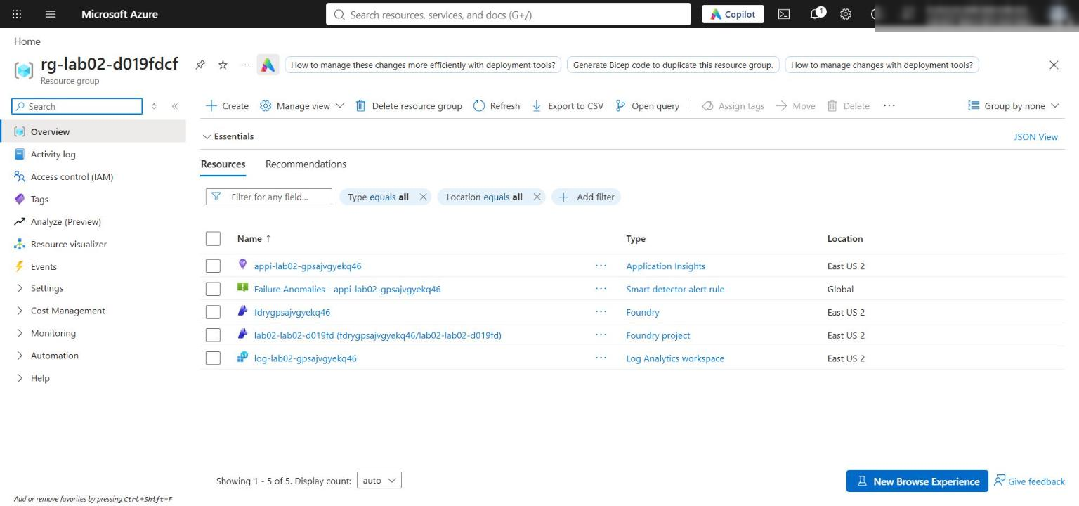
Figure 1: Resource group with the Foundry account, project, Log Analytics workspace, and Application Insights
4. Verify the network settings. The template enables public network access and sets the default action to Allow so your local app can reach the project endpoint (Microsoft Entra ID and RBAC are still required). Check from the CLI:
POWERSHELL
$account = az cognitiveservices account list -g $resourceGroupName --query "[0].name" -o tsv
az cognitiveservices account show -g $resourceGroupName -n $account --query "{publicNetworkAccess:properties.publicNetworkAccess, defaultAction:properties.networkAcls.defaultAction}" -o table

Expected result: Enabled and Allow. In the portal, open the Foundry account > Resource Management > Networking to see the same setting. Production environments should use selected networks or private endpoints.
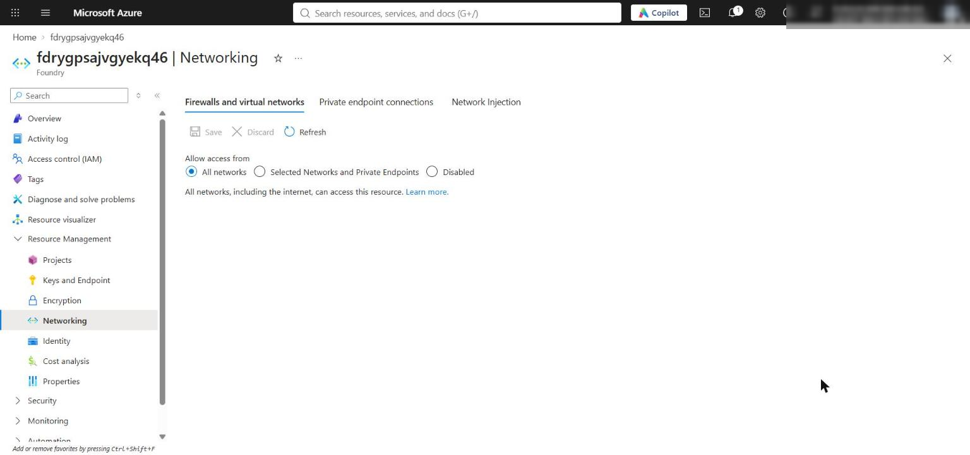
Figure 2: Foundry account Networking page showing public access from all networks
5. Confirm the model deployment exists:
POWERSHELL
az cognitiveservices account deployment list -g $resourceGroupName -n $account --query "[].{name:name, model:properties.model.name, version:properties.model.version, sku:sku.name}" -o table

Expected result: one deployment gpt-5.4-mini, version 2026-03-17, SKU GlobalStandard.
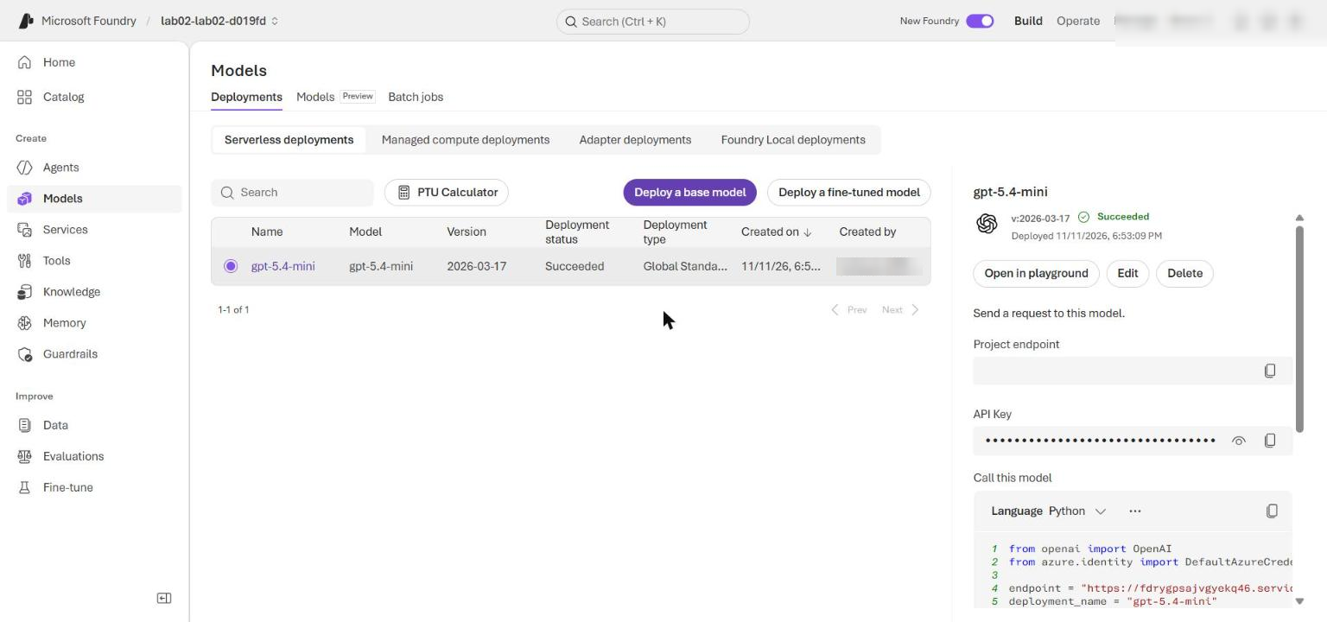
Figure 3: The gpt-5.4-mini model deployment in the Foundry project

Task 4: Implement the solution
Open src/main.py. Each placeholder is a # LAB PLACEHOLDER n comment followed by a raise NotImplementedError(...) line. Keep the comment, replace only the raise line with the code below, and keep the 4-space indentation of the function body.

Placeholder 1: select a safe execution pattern
1. In select_execution_pattern, find:
PYTHON
# LAB PLACEHOLDER 1: Replace this line with the Task 1 sample.
raise NotImplementedError("Complete select_execution_pattern in Task 1")

2. Replace it so the function reads:
PYTHON
def select_execution_pattern(tasks: list[dict[str, Any]]) -> str:
"""Learner task: return parallel only when this batch has no dependencies."""
# LAB PLACEHOLDER 1: Replace this line with the Task 1 sample.
task_names = {task["name"] for task in tasks}
has_in_round_dependency = any(
task_names.intersection(task.get("depends_on", []))
for task in tasks
)
return "sequential" if has_in_round_dependency else "parallel"

A dependency on another spoke in the same batch selects sequential execution; independent spokes stay eligible for parallel fan-out.
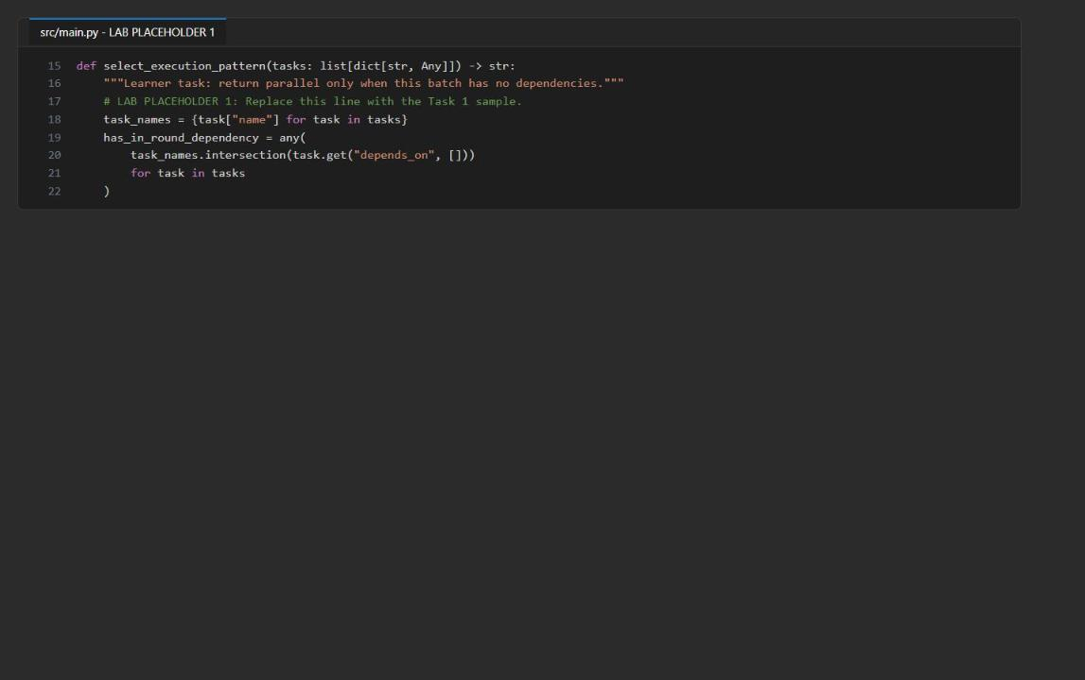
Figure 4: Placeholder 1 completed in select_execution_pattern

Placeholder 2: enforce critical-agent quorum
1. In evaluate_quorum, find:
PYTHON
# LAB PLACEHOLDER 2: Replace this line with the Task 2 sample.
raise NotImplementedError("Complete evaluate_quorum in Task 2")

2. Replace it so the function reads:
PYTHON
def evaluate_quorum(results: list[dict[str, Any]], required: list[str]) -> dict[str, Any]:
"""Learner task: enforce critical-agent quorum and normalize evidence."""
# LAB PLACEHOLDER 2: Replace this line with the Task 2 sample.
successful = {
result["agent"]: result
for result in results
if isinstance(result, dict) and result.get("status") == "success"
}
all_agents = [
result.get("agent", "unknown")
for result in results
if isinstance(result, dict)
]
missing_agents = [name for name in all_agents if name not in successful]
missing_required = [name for name in required if name not in successful]
accepted_evidence = [
{
"agent": name,
"response_id": result["response_id"],
"text": result["text"],
"elapsed_ms": result["elapsed_ms"],
}
for name, result in successful.items()
]
return {
"status": "ready" if not missing_required else "insufficient_quorum",
"required_agents": required,
"successful_count": len(successful),
"missing_agents": missing_agents,
"missing_required": missing_required,
"accepted_evidence": accepted_evidence,
}

Quorum separates optional omissions (missing_agents) from missing required evidence (missing_required). Only normalized successful results become evidence; exceptions, credentials, and endpoints never reach the supervisor payload.
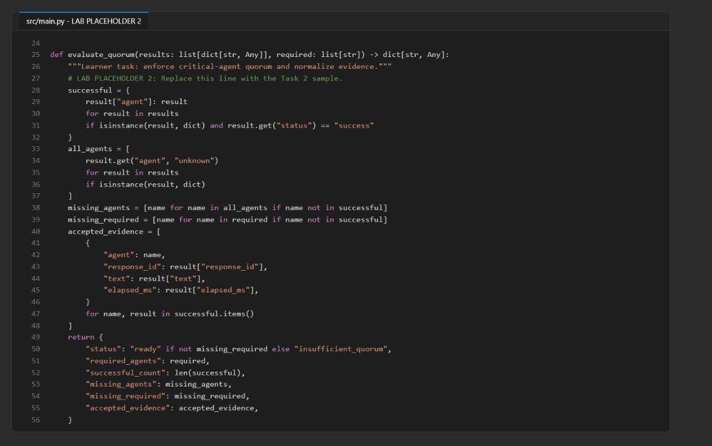
Figure 5: Placeholder 2 completed in evaluate_quorum

Placeholder 3: synthesize accepted evidence
1. In synthesize, find:
PYTHON
# LAB PLACEHOLDER 3: Replace this line with the Task 3 sample.
raise NotImplementedError("Complete synthesize in Task 3")

2. Replace it so the function reads:
PYTHON
def synthesize(openai: Any, request: str, quorum: dict[str, Any]) -> Any:
"""Learner task: invoke the supervisor with accepted evidence and caveats."""
# LAB PLACEHOLDER 3: Replace this line with the Task 3 sample.
if quorum["status"] != "ready":
missing = ", ".join(quorum["missing_required"])
raise RuntimeError(f"Critical quorum was not met: {missing}")

payload = {
"request": request,
"accepted_evidence": quorum["accepted_evidence"],
"missing_agents": quorum["missing_agents"],
}
return openai.responses.create(
input=(
"Synthesize the supplied specialist evidence. State a caveat for "
"every missing agent, do not invent facts, and do not provide "
"investment advice.\n"
+ json.dumps(payload)
),
)

This fan-in boundary fails closed when quorum is not met and asks the supervisor for an explicit caveat for every missing agent.
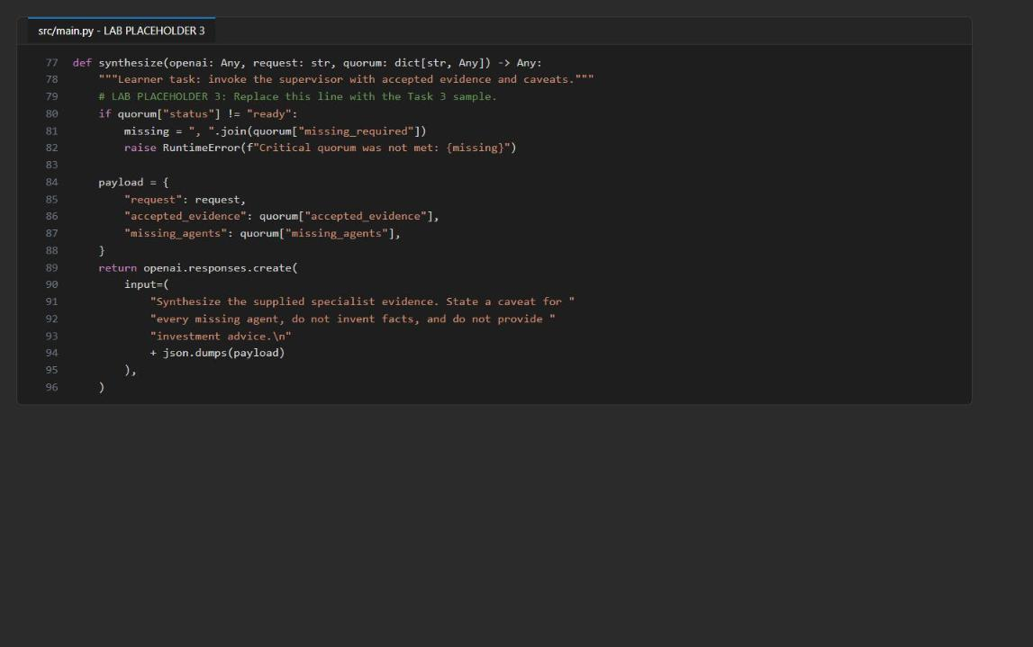
Figure 6: Placeholder 3 completed in synthesize

Check the supplied concurrency and failure handling
1. Read (do not change) invoke and run in src/main.py:
- Independent spokes run with asyncio.gather(...); dependent spokes are awaited one after another.
- invoke catches every spoke exception and returns the same normalized shape (agent, status, response_id, text, elapsed_ms), so raw exceptions never enter evaluate_quorum.
- An asyncio.Semaphore (size MAX_CONCURRENCY) bounds parallel calls, and each asyncio.wait_for timeout includes the time spent waiting for capacity.

Run the local checks
1. Save src/main.py and run the local, non-billable checks:
POWERSHELL
python -m py_compile src/main.py scripts/preflight.py
python scripts/preflight.py
(Select-String -Path src/main.py -Pattern 'LAB PLACEHOLDER').Count
(Select-String -Path src/main.py -Pattern 'NotImplementedError').Count

Expected result: four PASS lines (python_3_11, three_spokes, required_subset, starter_syntax), 3 placeholder markers, and 0 NotImplementedError.
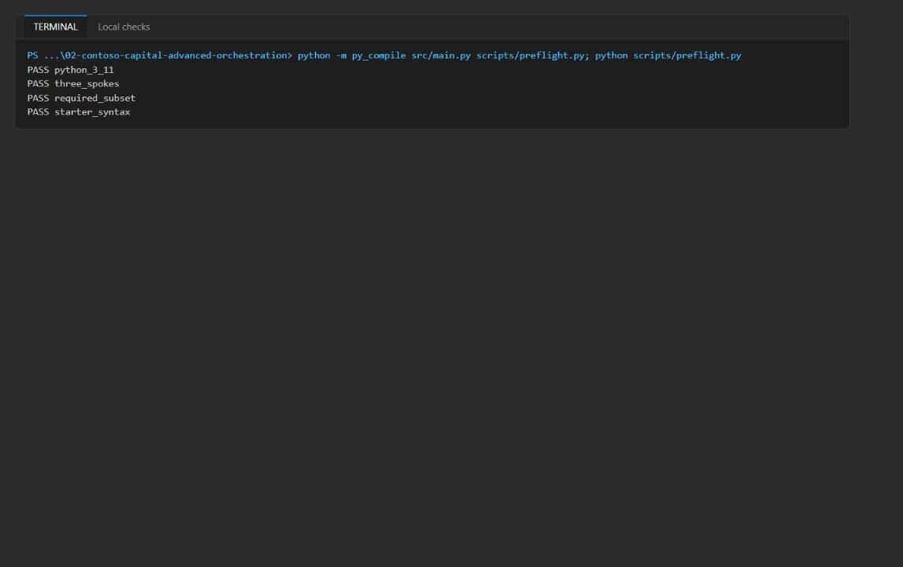
Figure 7: py_compile and preflight report four PASS lines

Task 5: Run the solution
1. Run the normal input and save the output:
POWERSHELL
python -m src.main --input assets/portfolio-request.json *> artifacts-normal.txt
Select-String artifacts-normal.txt -Pattern 'pattern|quorum|elapsed_ms|missing_agents|supervisor_response_id'

The file starts with Azure SDK HTTP logging (INFO Request URL ..., INFO HTTP Request: POST ...); the JSON result is at the end. DefaultAzureCredential acquired a token from AzureCliCredential is expected.
Expected result: "pattern": "parallel", "status": "ready", "successful_count": 3, empty missing_agents and missing_required, three spokes with "status": "success", and a supervisor_response_id that starts with resp_.
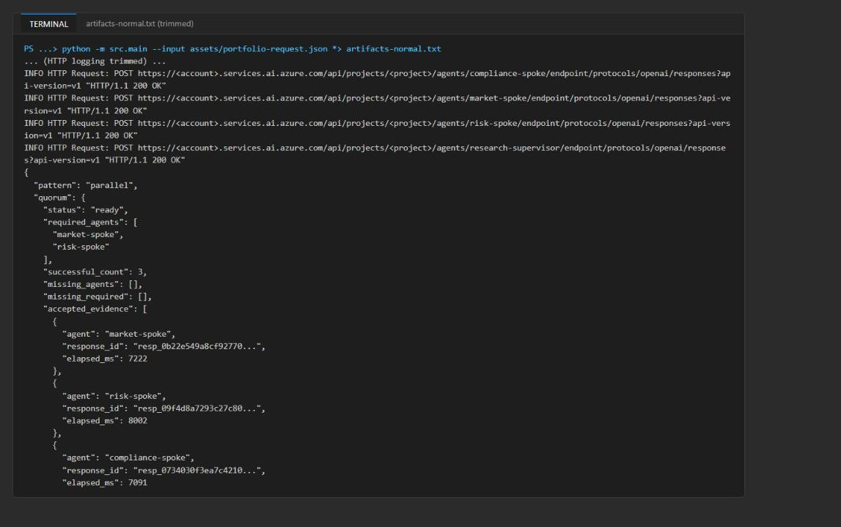
Figure 8: Normal run - parallel pattern, quorum ready, three accepted spokes (output trimmed)
2. Run the optional-failure input and save its output separately:
POWERSHELL
python -m src.main --input assets/portfolio-request-optional-failure.json *> artifacts-optional-failure.txt

The two inputs differ only in "simulate_optional_failure": true. The code marks the last spoke (compliance-spoke) as failed after its live call; it does not simulate an Azure outage. Do not edit the normal input.
3. Display the orchestration fields from both runs:
POWERSHELL
Select-String -Path artifacts-normal.txt,artifacts-optional-failure.txt -Pattern 'pattern|"agent"|"status"|missing_agents|missing_required|accepted_evidence|supervisor_response_id'

Expected result (optional-failure run): "pattern": "parallel", quorum "status": "ready", "successful_count": 2, "missing_agents": ["compliance-spoke"], "missing_required": [], and compliance-spoke with "status": "failed" and "text": null.
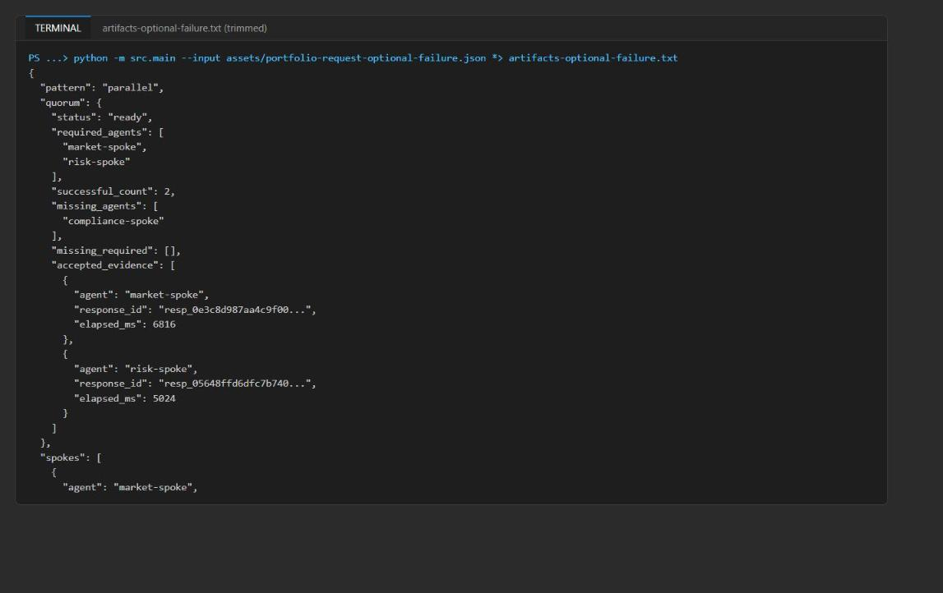
Figure 9: Optional-failure run - compliance-spoke failed, quorum still ready (output trimmed)
4. Keep both artifact files and their response IDs; you use them for trace validation. IDs, wording, and timing vary between live runs.

Task 6: Validate the implementation

Compare orchestration outcomes
1. Compare the two outputs against the acceptance criteria:
Field | Normal input | Optional-failure input
pattern | parallel | parallel
compliance-spoke.status | success | failed; market and risk still success
quorum.status | ready | ready
quorum.missing_agents | Empty | Contains compliance-spoke
quorum.missing_required | Empty | Empty
quorum.accepted_evidence | Three spoke results | Only market and risk
supervisor_response_id | Present | Present
Supervisor answer | Uses accepted evidence only | Explicitly states compliance evidence is missing

2. Show the supervisor's answer for the optional-failure run and look for the compliance caveat:
POWERSHELL
$raw = Get-Content artifacts-optional-failure.txt -Raw
($raw.Substring($raw.IndexOf("`n{") + 1) | ConvertFrom-Json).answer

Expected result: the answer contains a caveat such as "Compliance-spoke is missing: no compliance-specific review was provided...".
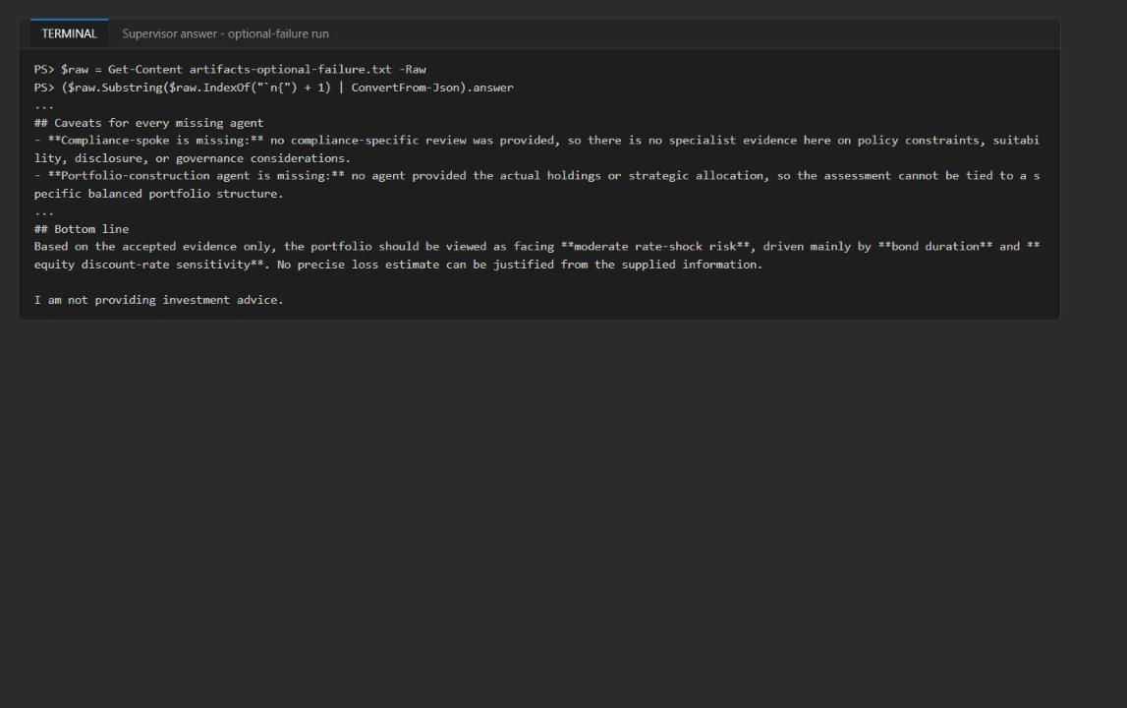
Figure 10: Supervisor answer discloses the missing compliance evidence
3. In the normal output, confirm that spokes has three successful results with response IDs, text, and elapsed_ms, plus a separate supervisor response ID.
4. Compare the overall elapsed_ms with the sum of the spoke durations. In the reference run the overall value was 15554 ms against a spoke sum of 22315 ms (7222 + 8002 + 7091): the barrier waits only for the slowest spoke (about 8 s), then the supervisor runs. That is consistent with concurrent calls; traces confirm it below.
5. Review the required-failure path in code: if market-spoke or risk-spoke fails, evaluate_quorum returns insufficient_quorum and synthesize raises RuntimeError before any supervisor call. The optional-failure run does not exercise this path.

Validate agent definitions and role behavior in the Foundry portal
1. Get the project name (the last segment of FOUNDRY_PROJECT_ENDPOINT):
POWERSHELL
(Select-String .env -Pattern '^FOUNDRY_PROJECT_ENDPOINT=').Line.Split('/')[-1].Trim('"')

2. Open the Microsoft Foundry portal, turn on New Foundry (toggle at the top), and select that project.
3. Select Build > Agents. Confirm that market-spoke, risk-spoke, compliance-spoke, and research-supervisor exist as prompt agents.
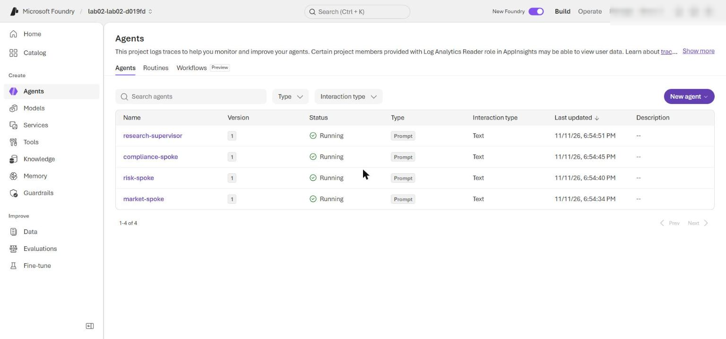
Figure 11: The four prompt agents in the Foundry project
4. Open each agent's newest version and confirm that its model is gpt-5.4-mini and its instructions match assets/portfolio-request.json. Each run calls create_version; when the definition is unchanged the service can keep version 1, so do not worry if the version number did not increase.
5. Open market-spoke in the Playground and submit:
TEXT
Request: Assess a synthetic balanced portfolio under a fictional rate shock.
Assignment: Return market assumptions and evidence gaps.

6. Open risk-spoke in the Playground and submit:
TEXT
Request: Assess a synthetic balanced portfolio under a fictional rate shock.
Assignment: Return risk drivers and limits.

7. Open compliance-spoke in the Playground and submit:
TEXT
Request: Assess a synthetic balanced portfolio under a fictional rate shock.
Assignment: Return compliance caveats.

8. Verify the role boundaries: market-spoke returns assumptions and missing market evidence; risk-spoke returns risk drivers and limits without investment advice; compliance-spoke returns only policy caveats.
9. Open research-supervisor in the Playground and submit this synthetic fan-in payload:
JSON
{
"request": "Assess a synthetic balanced portfolio under a fictional rate shock.",
"accepted_evidence": [
{
"agent": "market-spoke",
"response_id": "playground-market-001",
"text": "Assumption: the fictional scenario includes a rate increase. Evidence gaps: no holdings, duration, rate-shock magnitude, or market data were supplied.",
"elapsed_ms": 0
},
{
"agent": "risk-spoke",
"response_id": "playground-risk-001",
"text": "Potential drivers include duration and concentration, but exposure cannot be quantified without portfolio data. This is risk analysis, not investment advice.",
"elapsed_ms": 0
}
],
"missing_agents": [
"compliance-spoke"
]
}

Expected result: the supervisor uses only the two evidence records, states that compliance evidence is missing (for example "Compliance review input from the missing compliance-spoke"), and does not invent a compliance conclusion, holdings, exposure values, or a rate-shock magnitude.
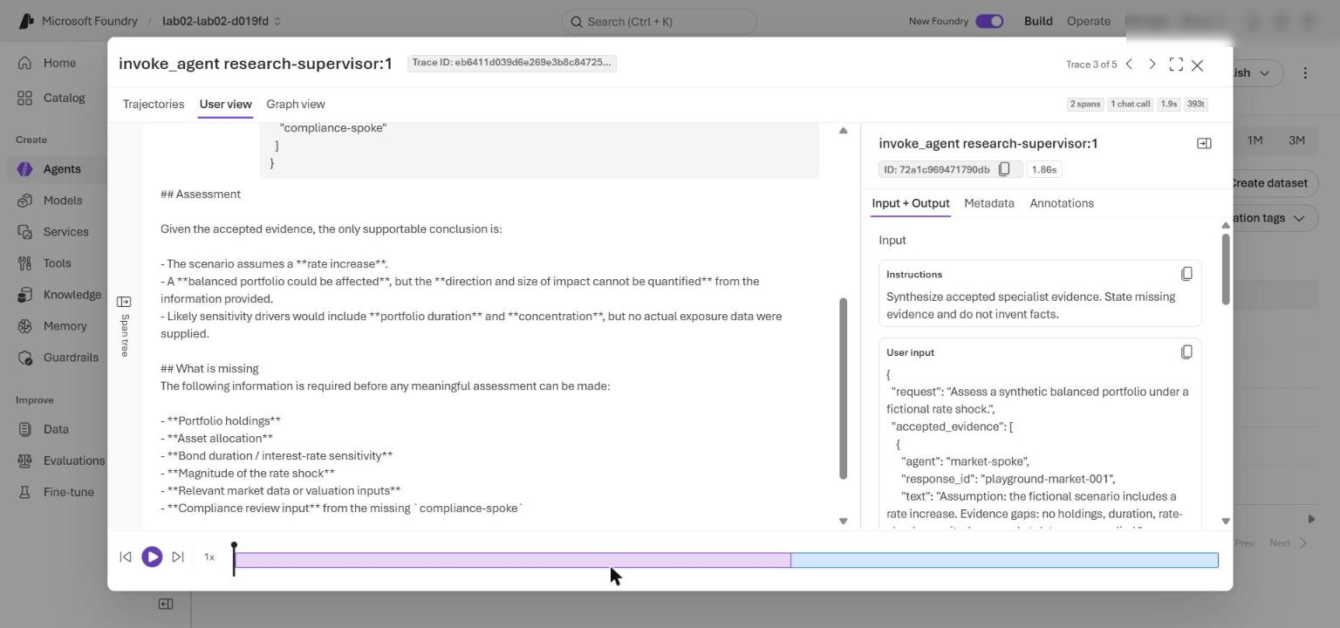
Figure 12: research-supervisor reply to the Playground fan-in payload (trace User view), disclosing the missing compliance-spoke evidence
Playground calls test each agent on its own. They don't reproduce the parallel orchestration.

Correlate service traces with application evidence
1. In the Foundry portal, select Agents, open an agent (for example research-supervisor), and select its Traces tab; set the time range to cover your runs, and search for the response IDs saved in artifacts-normal.txt. Allow several minutes for ingestion.
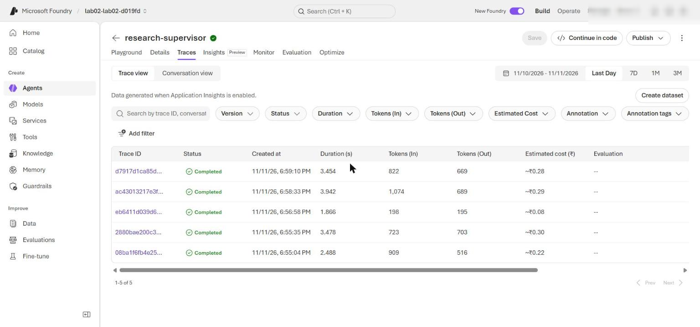
Figure 13: Foundry Traces tab of research-supervisor listing its invoke_agent traces (open each spoke's Traces tab for its spans)
2. Alternatively, query the spans from the CLI. Install the Application Insights extension once, then run the KQL query:
POWERSHELL
az extension add --name application-insights --upgrade --only-show-errors
$appInsightsId = (Select-String .env -Pattern '^APPLICATIONINSIGHTS_RESOURCE_ID=').Line.Split('=', 2)[1].Trim('"')
$kql = @'
union isfuzzy=true dependencies, requests
| where timestamp > ago(2h)
| where name startswith "invoke_agent"
| extend response_id = tostring(customDimensions["gen_ai.response.id"])
| project start = timestamp, finish = timestamp + duration * 1ms, name, duration, response_id
| order by start asc
'@
az monitor app-insights query --ids $appInsightsId --analytics-query $kql --output table

The same query also works in the portal: open the Application Insights resource > Monitoring > Logs, switch to KQL mode, paste the query (the part between @' and '@), and select Run.
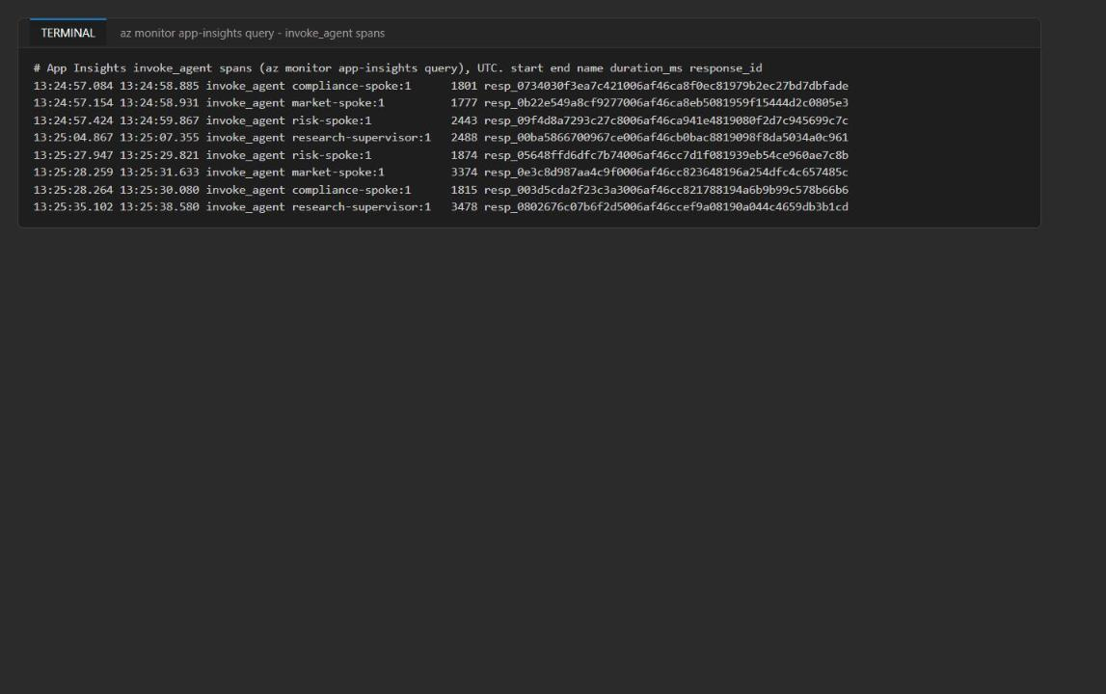
Figure 14: invoke_agent spans - the three spokes overlap and the supervisor starts after them
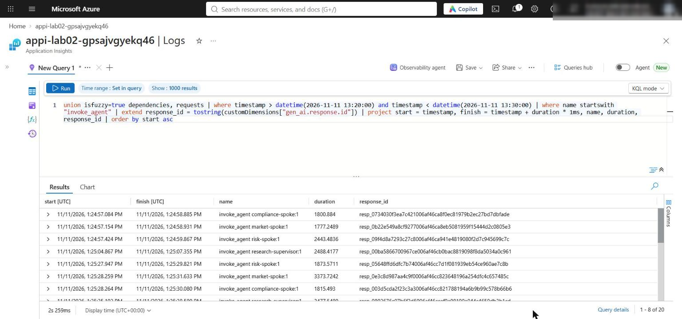
Figure 15: The same KQL query in Application Insights Logs
3. In the normal run, the three spoke spans start within a fraction of a second of each other and overlap (reference run: all three started between 13:24:57.08 and 13:24:57.42 UTC). The research-supervisor span starts after all spokes finish. Overlap proves concurrent calls.
4. Repeat for the optional-failure run. A compliance-spoke trace still exists, because the failure is injected after the live call. Use the saved JSON to confirm that it was excluded from accepted evidence and that the supervisor added a caveat.
Service traces show the Foundry calls and their timing, not the Python semaphore, asyncio.gather, fault injection, or quorum code. Correlate them with the saved JSON; there is no single end-to-end parent span. Client-side instrumentation is covered in Lab 13.

Task 7: Review the design
1. Record brief answers to these questions (model answers are in Review questions at the end of this guide):
- Why does pattern remain parallel in both runs?
- Why must optional failure leave quorum ready while removing compliance evidence and adding a caveat?
- Which decisions belong in deterministic code rather than agent judgment?
- When would these specialists justify their coordination cost over a single agent, and what measurements would support that decision?

Optional challenge: Add a guarded route
Add a synthetic high-risk request that selects sequential execution and requires the compliance spoke to run before the other spokes.
1. Create assets/portfolio-request-high-risk.json with this content (market and risk now declare depends_on: ["compliance-spoke"], and compliance is listed first):
JSON
{
"route": "guarded-high-risk",
"request": "Assess a synthetic balanced portfolio under a fictional severe rate shock flagged as high risk. Compliance caveats must be established before market and risk analysis.",
"required_agents": [
"market-spoke",
"risk-spoke"
],
"simulate_optional_failure": false,
"agents": [
{
"name": "compliance-spoke",
"assignment": "Return compliance caveats that must gate the remaining analysis.",
"instructions": "Identify policy caveats in the synthetic scenario. Return concise JSON."
},
{
"name": "market-spoke",
"assignment": "Return market assumptions and evidence gaps.",
"instructions": "Analyze only the supplied synthetic scenario. Return concise JSON.",
"depends_on": [
"compliance-spoke"
]
},
{
"name": "risk-spoke",
"assignment": "Return risk drivers and limits.",
"instructions": "Assess risk without investment advice. Return concise JSON.",
"depends_on": [
"compliance-spoke"
]
}
],
"supervisor": {
"name": "research-supervisor",
"instructions": "Synthesize accepted specialist evidence. State missing evidence and do not invent facts."
}
}

2. Create assets/portfolio-request-high-risk-failure.json for the failure investigation. It is identical to the file above plus one extra top-level field that forces compliance-spoke to fail:
JSON
{
"route": "guarded-high-risk",
"request": "Assess a synthetic balanced portfolio under a fictional severe rate shock flagged as high risk. Compliance caveats must be established before market and risk analysis.",
"required_agents": [
"market-spoke",
"risk-spoke"
],
"simulate_optional_failure": false,
"agents": [
{
"name": "compliance-spoke",
"assignment": "Return compliance caveats that must gate the remaining analysis.",
"instructions": "Identify policy caveats in the synthetic scenario. Return concise JSON."
},
{
"name": "market-spoke",
"assignment": "Return market assumptions and evidence gaps.",
"instructions": "Analyze only the supplied synthetic scenario. Return concise JSON.",
"depends_on": [
"compliance-spoke"
]
},
{
"name": "risk-spoke",
"assignment": "Return risk drivers and limits.",
"instructions": "Assess risk without investment advice. Return concise JSON.",
"depends_on": [
"compliance-spoke"
]
}
],
"supervisor": {
"name": "research-supervisor",
"instructions": "Synthesize accepted specialist evidence. State missing evidence and do not invent facts."
},
"simulate_failure_agent": "compliance-spoke"
}

3. In src/main.py, inside run(), find these lines near the end of the function:
PYTHON
if data.get("simulate_optional_failure"):
results[-1] = {**results[-1], "status": "failed", "text": None}
quorum = evaluate_quorum(results, data["required_agents"])
supervisor = synthesize(clients[data["supervisor"]["name"]], data["request"], quorum)
return {"pattern": pattern, "quorum": quorum, "spokes": results, "supervisor_response_id": supervisor.id, "answer": text_from_response(supervisor), "elapsed_ms": round((time.perf_counter()-started)*1000)}

4. Replace them with the following. It adds a named-spoke fault injection and a route field (default standard) to the output:
PYTHON
if data.get("simulate_optional_failure"):
results[-1] = {**results[-1], "status": "failed", "text": None}
# Optional challenge: force a named spoke to fail after its live call.
if data.get("simulate_failure_agent"):
results = [{**r, "status": "failed", "text": None} if r["agent"] == data["simulate_failure_agent"] else r for r in results]
quorum = evaluate_quorum(results, data["required_agents"])
supervisor = synthesize(clients[data["supervisor"]["name"]], data["request"], quorum)
return {"route": data.get("route", "standard"), "pattern": pattern, "quorum": quorum, "spokes": results, "supervisor_response_id": supervisor.id, "answer": text_from_response(supervisor), "elapsed_ms": round((time.perf_counter()-started)*1000)}

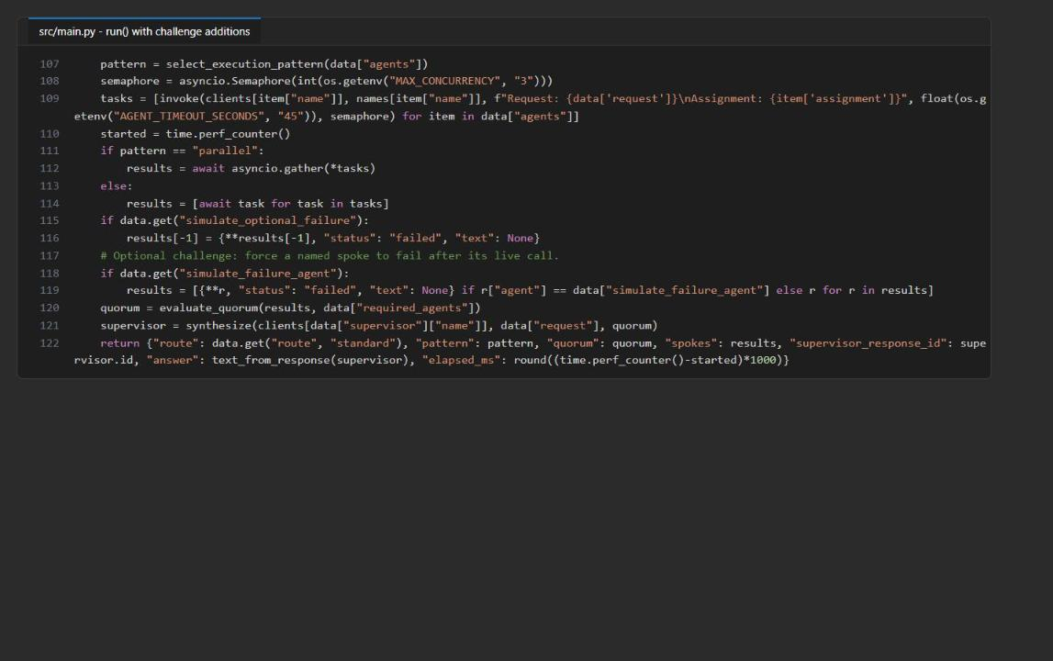
Figure 16: run() with the challenge additions
5. Run both challenge inputs:
POWERSHELL
python -m src.main --input assets/portfolio-request-high-risk.json *> artifacts-challenge-high-risk.txt
python -m src.main --input assets/portfolio-request-high-risk-failure.json *> artifacts-challenge-high-risk-failure.txt
Select-String -Path artifacts-challenge-high-risk.txt,artifacts-challenge-high-risk-failure.txt -Pattern '"route"|"pattern"|"status"|missing_agents|missing_required|"elapsed_ms"'

Expected result (guarded route): "route": "guarded-high-risk", "pattern": "sequential", compliance completes before market starts, the overall elapsed_ms is roughly the sum of the spoke durations (reference: 25342 ms), and the supervisor answer opens with the compliance caveats.
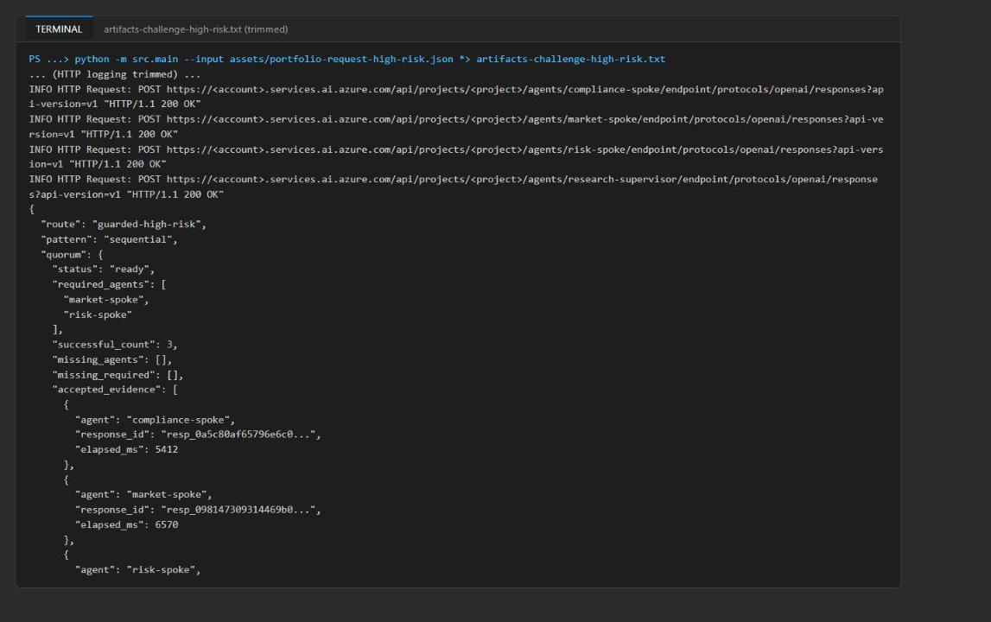
Figure 17: Guarded route - sequential pattern with compliance first (output trimmed)
Expected result (failure investigation): quorum ready, missing_agents = ["compliance-spoke"], missing_required = []. The orchestrator continued: it did not fall back or fail closed, and the supervisor disclosed the missing compliance evidence. Note that market and risk still ran even though their prerequisite failed: the runner orders the calls but does not gate them on dependency success. A production guarded route should make compliance-spoke required for that route (fail closed) or skip dependents when a prerequisite fails.

Validate
Acceptance criterion | How to check (CLI) | How to check (portal)
Preflight passes, 3 markers remain, no NotImplementedError | python scripts/preflight.py; the two Select-String ... .Count commands in Task 4 | n/a
Normal run: pattern = parallel, quorum ready, 3 accepted spokes, supervisor ID present | Task 5 step 3 Select-String command on artifacts-normal.txt | n/a
Optional-failure run: compliance failed, quorum ready, missing_agents = compliance, missing_required empty | Task 5 step 3 Select-String command on artifacts-optional-failure.txt | n/a
Supervisor discloses missing compliance evidence | Task 6 step 2 command | Playground test of research-supervisor
Four prompt agents with model gpt-5.4-mini and instructions from the asset | az cognitiveservices account deployment list ... (model) | Foundry > Build > Agents
Role boundaries hold | n/a | Playground tests of the three spokes
Spoke calls overlap; supervisor starts after the spokes | KQL query in Task 6 step 16 | Foundry Traces, or Application Insights Logs

Troubleshooting
Symptom | Cause | Fix
App calls a Foundry endpoint in a subscription you don't own, or returns 401/403/404 right away | A stale .env from the repository points at another subscription | Re-run the .env part of the Task 3 script so .env is rewritten from your deployment outputs
PermissionDenied / 403 when creating agent versions or calling responses | Data-plane roles not assigned or not propagated yet | Make sure the role loop in Task 3 ran (Azure AI User, Cognitive Services OpenAI User, Azure AI Developer), then wait 1-5 minutes and retry
DefaultAzureCredential failed to retrieve a token | Not signed in with the Azure CLI in this terminal | Run az login, then az account set --subscription <your-subscription-id>
Deployment fails with a quota or InvalidResourceProperties model error | gpt-5.4-mini version 2026-03-17 or GlobalStandard quota not available in the region | Pick another region in $azureRegion and re-run Task 3 with a new suffix
A spoke shows "status": "failed" in the normal run | Timeout or throttling (429) under concurrency; the warning line Spoke failed agent=... category=... names the exception type | Increase AGENT_TIMEOUT_SECONDS or lower MAX_CONCURRENCY in .env, or raise the deployment capacity
RuntimeError: Critical quorum was not met | A required spoke (market or risk) failed | Expected fail-closed behavior; fix the underlying spoke failure and rerun
Traces for the latest run are missing | Ingestion lag | Wait 5-10 minutes and widen the time range
Version number in the portal stays at 1 | The definition did not change, so the service reused the version | Expected; not an error

Review questions
1. Why does `pattern` remain `parallel` in both runs? select_execution_pattern looks only at the dependency graph. None of the three spokes declares a depends_on on another spoke, and the optional-failure flag is applied after the live calls, so failure handling doesn't change the graph.
2. Why must optional failure leave quorum ready while removing compliance evidence and adding a caveat? Quorum is defined by the required set (market and risk), and both succeeded, so a brief can still be produced. Failed output isn't evidence, so it's excluded; listing compliance-spoke in missing_agents forces the supervisor to disclose the gap so the brief doesn't look complete when it isn't.
3. Which decisions belong in deterministic code rather than agent judgment? Choosing parallel or sequential from declared dependencies; the concurrency bound and timeouts; normalizing failures into one shape; which agents are required and whether quorum is met; failing closed when required evidence is missing; and what goes into the supervisor payload. Agents own only analysis and synthesis wording.
4. When do the specialists justify their coordination cost, and what would you measure? When specialties need separate instructions, tools, data access, or owners; when parallel work saves real wall-clock time; and when each contribution needs its own audit trail. Compare against a single-agent baseline on quality (rubric scores, omission and hallucination rates), p50/p95 latency, cost (tokens, calls, price per brief), per-spoke failure and timeout rates, and quorum-failure and 429 frequency under load.

Clean up (optional)
Do this only when you no longer need the resources.
1. Delete the resource group (this removes the Foundry account, project, agents, workspace, and Application Insights):
POWERSHELL
$resourceGroupName = (Select-String .env -Pattern '^AZURE_RESOURCE_GROUP=').Line.Split('=', 2)[1].Trim('"')
$azureRegion = (Select-String .env -Pattern '^AZURE_LOCATION=').Line.Split('=', 2)[1].Trim('"')
$account = az cognitiveservices account list -g $resourceGroupName --query "[0].name" -o tsv
az group delete --name $resourceGroupName --yes --no-wait

2. After the deletion finishes (a few minutes), purge the soft-deleted Foundry account so its name and quota are released:
POWERSHELL
az cognitiveservices account purge --location $azureRegion --resource-group $resourceGroupName --name $account
az group exists --name $resourceGroupName

Expected result: az group exists returns false.
3. Remove the generated local files and deactivate the virtual environment:
POWERSHELL
Remove-Item .env, artifacts-normal.txt, artifacts-optional-failure.txt, artifacts-challenge-*.txt -ErrorAction SilentlyContinue
deactivate

Confirm that (.venv) no longer appears in the prompt before you move to another lab.

