Lab 03: Apply task decomposition and agent collaboration strategies in Microsoft Foundry

Overview
Scenario. Contoso Capital receives research questions that range from simple lookups to multi-source investment analyses. A fixed chain of agents over-processes simple questions and misses dependencies in complex ones. The firm wants a meta-agent (a planner) that proposes a task plan, with application code that validates the plan, runs the specialists in dependency order, passes bounded context between them, and measures the coordination overhead.
What you'll build. You complete an Agents v2 planner/executor in src/main.py:
- A research-planner agent returns a JSON task DAG (directed acyclic graph).
- validate_plan checks the DAG in code before any specialist is called.
- ready_tasks dispatches only tasks whose prerequisites succeeded and detects deadlocks.
- build_handoff builds a size-bounded handoff envelope that keeps source response IDs.
- should_replan raises at most one evidence-driven replan signal.
You then run the solution with a complex and a simple query, and verify the agents and traces in the Foundry portal and Application Insights.
Duration. About 45 minutes.
Note: Cost warning. The model deployment (planner plus every specialist call), Application Insights ingestion and 30-day Log Analytics retention are billable. Use only the synthetic input in assets/research-query.json and delete the resource group when you finish.

Architecture
Component | Resource / file | Purpose
Foundry account | Microsoft.CognitiveServices/accounts (kind AIServices, fdry<suffix>) | Hosts the project and the model deployment; public network access with default action Allow
Foundry project | lab03-<env-name> | Holds the five prompt agents and their versions
Model deployment | gpt-5.4-mini (version 2026-03-17, GlobalStandard, capacity 10) | Model used by the planner and all specialists
Application Insights + Log Analytics | appi-lab03-<suffix>, log-lab03-<suffix> | Receive server-side agent traces through a project connection
Planner agent | research-planner | Returns the JSON task DAG
Specialist agents | financial-data, macro-risk, compliance-review, thesis-synthesis | Registry in assets/research-query.json
Application | src/main.py | Validates the plan, dispatches specialists, builds handoffs, prints metrics

Prerequisites
Install these tools before you start:
- Python 3.11 or later
- Azure CLI with Bicep (az bicep install)
- Visual Studio Code with the Python extension
- Git
- PowerShell 7 (recommended; the commands below are PowerShell)
Azure requirements:
- An Azure subscription with gpt-5.4-mini (GlobalStandard) quota in the region you choose (this guide uses eastus2).
- Contributor and User Access Administrator (or Owner) on the subscription or resource group, so you can create resources and grant yourself data-plane roles.
Note: This guide provisions with the Azure CLI (az deployment group create) instead of azd provision. The result is the same set of resources; the CLI path avoids azd environment issues and lets you grant the data-plane roles explicitly.

Task 1: Prepare the lab
Clone and open the repository
1. Open a terminal and clone the lab repository:
POWERSHELL
git clone https://github.com/MicrosoftLearning/mslearn-ai-multi-agents.git

2. Open the cloned mslearn-ai-multi-agents folder in Visual Studio Code (File > Open Folder).
Verify tools and authentication
3. In VS Code, open a PowerShell terminal (Terminal > New Terminal) and run:
POWERSHELL
cd Allfiles\03-contoso-capital-task-decomposition
az version
python --version
az account show --output table

4. If az account show fails or shows the wrong subscription, sign in and select the subscription:
POWERSHELL
az login
az account set --subscription "<your-subscription-id>"
az account show --output table

Expected result: az version prints the CLI version, python --version prints 3.11 or later, and az account show displays the subscription you intend to use.
Architecture checkpoint
5. Open these files and locate the listed items before you edit anything:
File | What to locate
infra/main.bicep | Foundry account, project, gpt-5.4-mini deployment, Application Insights, and the AppInsights project connection used for traces
assets/research-query.json | The query, the complexity_hint (complex) and the specialist registry (capability list for the planner)
src/main.py | validate_plan (DAG validation), ready_tasks (dependency-ready scheduling), build_handoff (bounded envelope), should_replan (replan signal), and run (planner call, dispatch loop, final synthesis)

Task 2: Build the virtual environment
1. From the lab folder, create the virtual environment, install the requirements and activate it:
POWERSHELL
./scripts/setup.ps1
. ./.venv/Scripts/Activate.ps1

Note: On macOS/Linux run bash scripts/setup.sh and then source .venv/bin/activate.

2. Confirm that (.venv) appears at the start of the terminal prompt.
3. In VS Code, press Ctrl+Shift+P, run Python: Select Interpreter, and choose the interpreter in .venv.
Expected result: pip installs azure-ai-projects 2.x, azure-identity, openai and python-dotenv without errors.

Task 3: Deploy the Azure resources
Provision with the Azure CLI
1. Make sure the terminal is in Allfiles\03-contoso-capital-task-decomposition with (.venv) active. Change eastus2 if your gpt-5.4-mini quota is in another region, then run the whole block:
POWERSHELL
$azureRegion = 'eastus2'
$suffix = (New-Guid).Guid.Substring(0, 8)
$resourceGroupName = "rg-lab03-$suffix"
$envName = "lab03-$suffix"
az group create --name $resourceGroupName --location $azureRegion --output none
az bicep build --file infra/main.bicep
az deployment group create --resource-group $resourceGroupName --name lab03-main `
--template-file infra/main.bicep `
--parameters location=$azureRegion environmentName=$envName modelDeploymentName=gpt-5.4-mini modelName=gpt-5.4-mini modelVersion=2026-03-17 `
--output none

Note: If your lab environment provides a precreated resource group, set $resourceGroupName to its name and skip the az group create line. The deployment takes about 3-5 minutes.

2. Grant yourself data-plane access to the Foundry project (agents and model calls). The template does not create these role assignments:
POWERSHELL
$me = az ad signed-in-user show --query id -o tsv
$rgId = az group show --name $resourceGroupName --query id -o tsv
foreach ($role in 'Azure AI User','Cognitive Services OpenAI User','Azure AI Developer') {
az role assignment create --assignee-object-id $me --assignee-principal-type User --role $role --scope $rgId --output none
}

Note: Role assignments can take 1-5 minutes to apply. If the first run returns 401 or 403 PermissionDenied, wait a few minutes and run it again.

Write the .env file
3. Write .env from the deployment outputs:
POWERSHELL
$outputs = az deployment group show --resource-group $resourceGroupName --name lab03-main --query properties.outputs -o json | ConvertFrom-Json
$lines = @("AZURE_RESOURCE_GROUP=`"$resourceGroupName`"", "AZURE_LOCATION=`"$azureRegion`"", "AZURE_ENV_NAME=`"$envName`"",
"AZURE_SUBSCRIPTION_ID=`"$(az account show --query id -o tsv)`"")
$outputs.PSObject.Properties | ForEach-Object { $lines += "$($_.Name.ToUpper())=`"$($_.Value.value)`"" }
$lines | Out-File .env -Encoding utf8
Get-Content .env

4. Confirm that .env contains FOUNDRY_PROJECT_ENDPOINT, FOUNDRY_PROJECT_ID, FOUNDRY_MODEL_NAME, APPLICATIONINSIGHTS_RESOURCE_ID and LOG_ANALYTICS_WORKSPACE_ID. Do not add keys or tokens to .env; the app authenticates with your Azure CLI sign-in. The Application Insights connection string lives in the Foundry project connection and is not written to .env.
Expected result (values differ):
TEXT
AZURE_RESOURCE_GROUP="rg-lab03-<suffix>"
AZURE_LOCATION="eastus2"
AZURE_ENV_NAME="lab03-<suffix>"
AZURE_SUBSCRIPTION_ID="<subscription-id>"
FOUNDRY_PROJECT_ENDPOINT="https://fdry<id>.services.ai.azure.com/api/projects/lab03-lab03-<suffix>"
FOUNDRY_PROJECT_ID="/subscriptions/<subscription-id>/resourceGroups/rg-lab03-<suffix>/providers/Microsoft.CognitiveServices/accounts/fdry<id>/projects/lab03-lab03-<suffix>"
FOUNDRY_MODEL_NAME="gpt-5.4-mini"
APPLICATIONINSIGHTS_RESOURCE_ID="/subscriptions/<subscription-id>/resourceGroups/rg-lab03-<suffix>/providers/Microsoft.Insights/components/appi-lab03-<id>"
LOG_ANALYTICS_WORKSPACE_ID="<workspace-guid>"

Verify the resources
5. List the deployed resources:
POWERSHELL
az resource list --resource-group $resourceGroupName --query "[].{name:name, type:type}" -o table

Expected result: a Log Analytics workspace, a Foundry account (Microsoft.CognitiveServices/accounts), its project, an Application Insights component and its Failure Anomalies alert rule.
6. In the Azure portal, open the resource group rg-lab03-<suffix> to see the same resources.
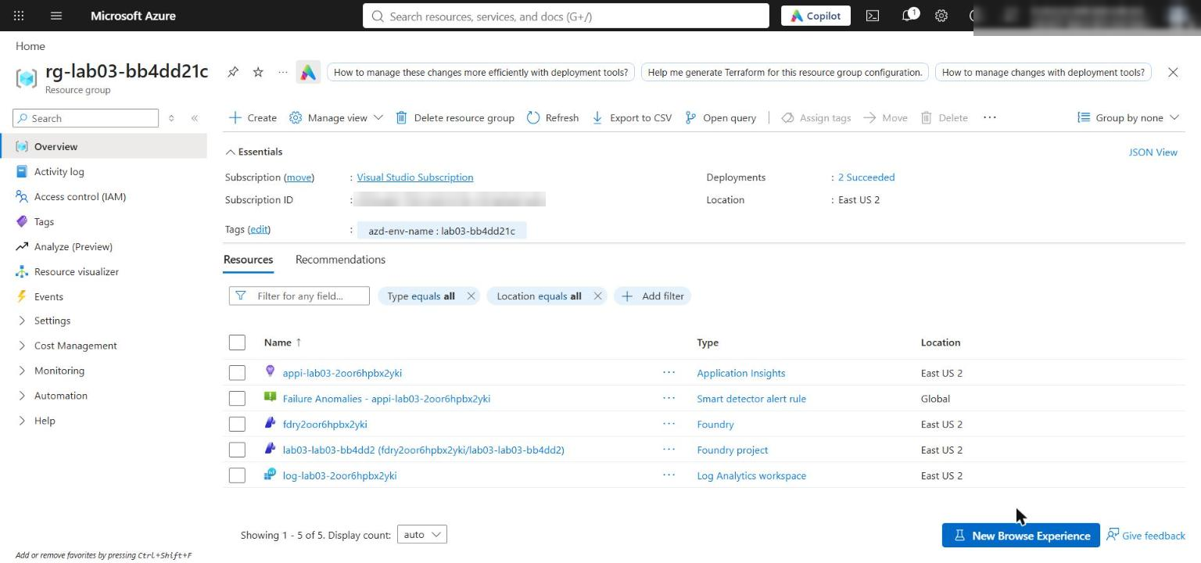
Figure 1: The lab 03 resource group with the Foundry account, project, Application Insights and Log Analytics workspace
7. Confirm the network settings of the Foundry account. Run the command below, or open the Foundry account in the portal and select Resource Management > Networking:
POWERSHELL
az cognitiveservices account list --resource-group $resourceGroupName --query "[].{name:name, publicNetworkAccess:properties.publicNetworkAccess, defaultAction:properties.networkAcls.defaultAction}" -o table

Expected result: publicNetworkAccess is Enabled and defaultAction is Allow. The template allows public access so your local app can reach the project endpoint; Microsoft Entra authentication and RBAC are still required. Production environments should use selected networks or private endpoints.
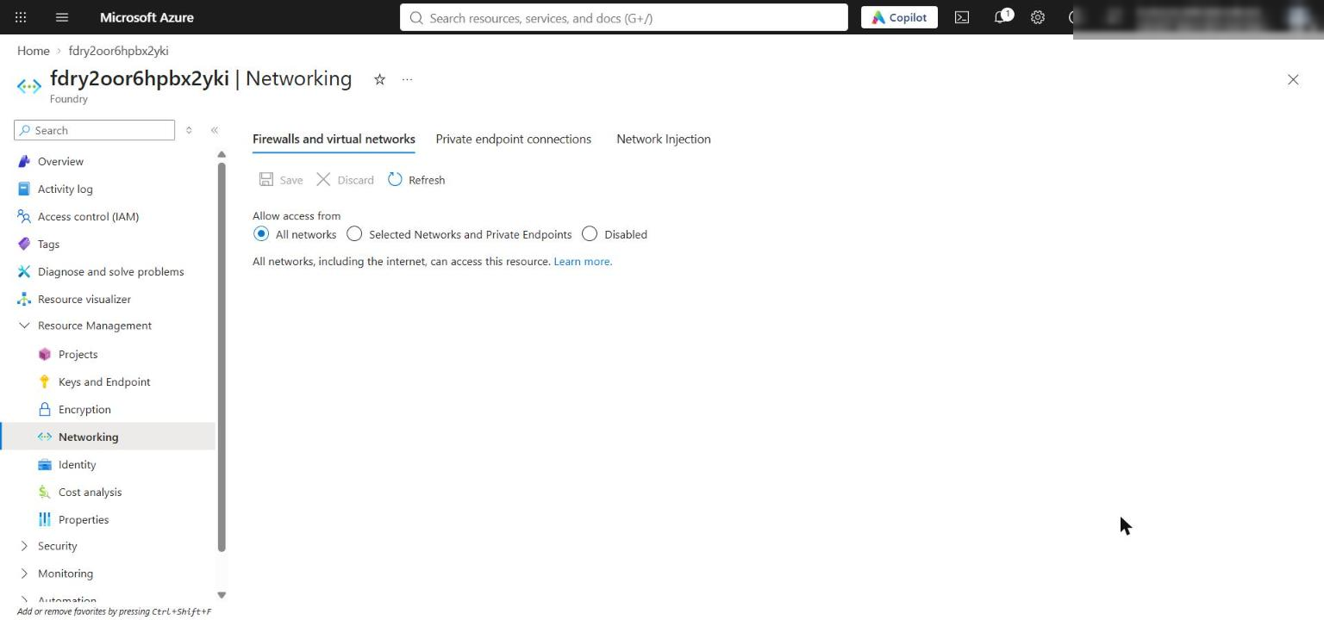
Figure 2: Foundry account Networking page showing public access from all networks
8. Confirm the model deployment:
POWERSHELL
$account = az cognitiveservices account list --resource-group $resourceGroupName --query "[0].name" -o tsv
az cognitiveservices account deployment list --resource-group $resourceGroupName --name $account --query "[].{name:name, model:properties.model.name, version:properties.model.version, sku:sku.name, state:properties.provisioningState}" -o table

Expected result: gpt-5.4-mini, version 2026-03-17, SKU GlobalStandard, state Succeeded.
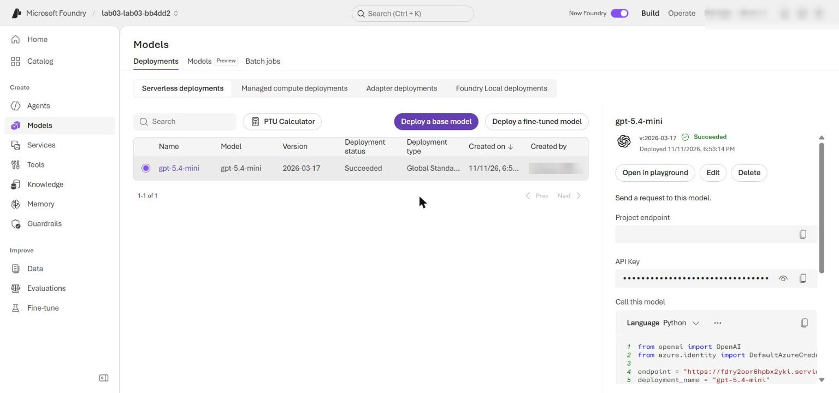
Figure 3: The gpt-5.4-mini model deployment in the Foundry project

Task 4: Implement the solution
Each placeholder in src/main.py is a # LAB PLACEHOLDER n comment followed by a raise NotImplementedError(...) line. Keep the comment, replace only the raise NotImplementedError(...) line with the code given, and keep the 4-space indentation of the function body (every line below is already indented for pasting directly under the comment).
Placeholder 1: validate the model-generated task DAG
1. Open src/main.py and find this in validate_plan:
PYTHON
# LAB PLACEHOLDER 1: Replace this line with the Task 1 sample.
raise NotImplementedError("Complete validate_plan in Task 1")

2. Replace the raise NotImplementedError("Complete validate_plan in Task 1") line with:
PYTHON
tasks = plan.get("tasks")
if not isinstance(tasks, list) or not 1 <= len(tasks) <= 6:
raise ValueError("Plan must contain between 1 and 6 tasks")

task_ids = [task.get("id") for task in tasks]
if any(not isinstance(task_id, str) or not task_id for task_id in task_ids):
raise ValueError("Every task requires a nonempty string ID")
if len(task_ids) != len(set(task_ids)):
raise ValueError("Task IDs must be unique")

known_ids = set(task_ids)
for task in tasks:
if task.get("agent") not in registry:
raise ValueError(f"Unknown agent for task {task['id']}")
dependencies = task.get("depends_on", [])
if not isinstance(dependencies, list):
raise ValueError(f"depends_on must be a list for task {task['id']}")
if task["id"] in dependencies or not set(dependencies) <= known_ids:
raise ValueError(f"Invalid dependency for task {task['id']}")

remaining = {
task["id"]: set(task.get("depends_on", []))
for task in tasks
}
resolved: set[str] = set()
while remaining:
ready = {
task_id
for task_id, dependencies in remaining.items()
if dependencies <= resolved
}
if not ready:
raise ValueError("Plan dependencies contain a cycle")
resolved.update(ready)
remaining = {
task_id: dependencies
for task_id, dependencies in remaining.items()
if task_id not in ready
}

synthesis_tasks = [
task for task in tasks if task["agent"] == "thesis-synthesis"
]
if len(synthesis_tasks) != 1:
raise ValueError("The plan must contain exactly one thesis-synthesis task")
synthesis = synthesis_tasks[0]
non_synthesis_dependency_ids = {
dependency
for task in tasks
if task["id"] != synthesis["id"]
for dependency in task.get("depends_on", [])
}
terminal_evidence_ids = {
task["id"]
for task in tasks
if task["id"] not in non_synthesis_dependency_ids and task["id"] != synthesis["id"]
}
if set(synthesis.get("depends_on", [])) != terminal_evidence_ids:
raise ValueError(
"The thesis-synthesis task must depend on every terminal evidence task"
)
if any(synthesis["id"] in task.get("depends_on", []) for task in tasks):
raise ValueError("No task can depend on the thesis-synthesis task")

The application validates the proposed graph before any specialist is called: 1-6 tasks, unique IDs, known agents only, valid and acyclic dependencies, and exactly one thesis-synthesis task that consumes every terminal evidence branch and has no consumers.
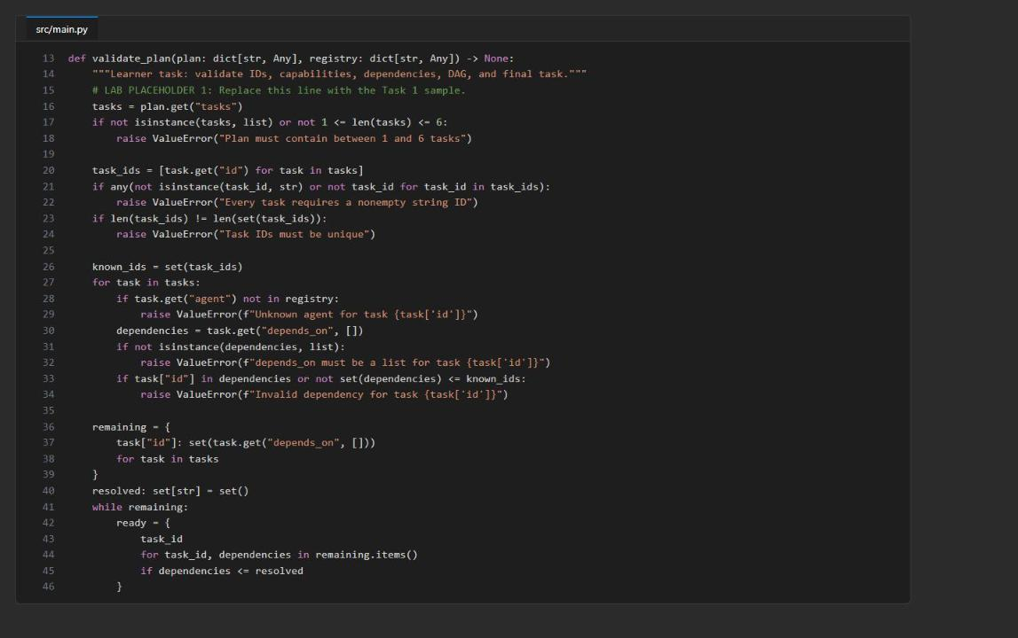
Figure 4: validate_plan after Placeholder 1 (first part: IDs, agents, dependencies, cycle check)
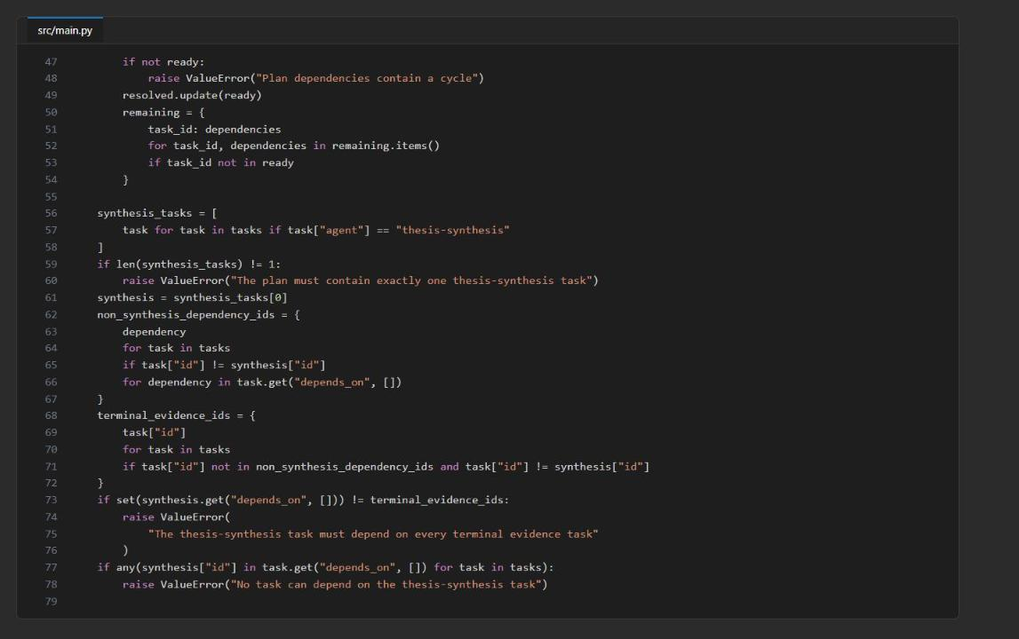
Figure 5: validate_plan after Placeholder 1 (second part: synthesis-task checks)
Placeholder 2: select dependency-ready tasks
3. Find this in ready_tasks:
PYTHON
# LAB PLACEHOLDER 2: Replace this line with the Task 2 sample.
raise NotImplementedError("Complete ready_tasks in Task 2")

4. Replace the raise NotImplementedError("Complete ready_tasks in Task 2") line with:
PYTHON
unfinished = [task for task in tasks if task["id"] not in completed]
ready = [
task
for task in unfinished
if all(
completed.get(dependency, {}).get("status") == "success"
for dependency in task.get("depends_on", [])
)
]
if unfinished and not ready:
blocked = ", ".join(task["id"] for task in unfinished)
raise RuntimeError(f"Plan deadlock: blocked tasks: {blocked}")
return ready

Only successful prerequisites unlock a task. A blocked graph raises an error instead of looping forever.
Placeholder 3: build a bounded handoff envelope
5. Find this in build_handoff:
PYTHON
# LAB PLACEHOLDER 3: Replace this line with the Task 3 sample.
raise NotImplementedError("Complete build_handoff in Task 3")

6. Replace the raise NotImplementedError("Complete build_handoff in Task 3") line with:
PYTHON
max_chars = int(os.getenv("MAX_HANDOFF_CHARS", "6000"))
dependencies = task.get("depends_on", [])
summary_limit = max(256, max_chars // max(2, len(dependencies) + 1))
dependency_context = [
{
"task_id": dependency,
"response_id": completed[dependency]["response_id"],
"summary": completed[dependency]["summary"][:summary_limit],
}
for dependency in dependencies
]
envelope = {
"task_id": task["id"],
"objective": task["objective"],
"dependency_context": dependency_context,
"source_response_ids": [
item["response_id"] for item in dependency_context
],
"expected_schema": task["expected_schema"],
"deadline_seconds": int(os.getenv("HANDOFF_DEADLINE_SECONDS", "45")),
"correlation_id": correlation_id,
}
if len(json.dumps(envelope)) > max_chars:
raise ValueError("Handoff envelope exceeds MAX_HANDOFF_CHARS")
return envelope

The envelope separates the objective from the dependency evidence, keeps the source response IDs, and caps the context size (MAX_HANDOFF_CHARS, default 6000). The correlation ID links the tasks without logging research content.
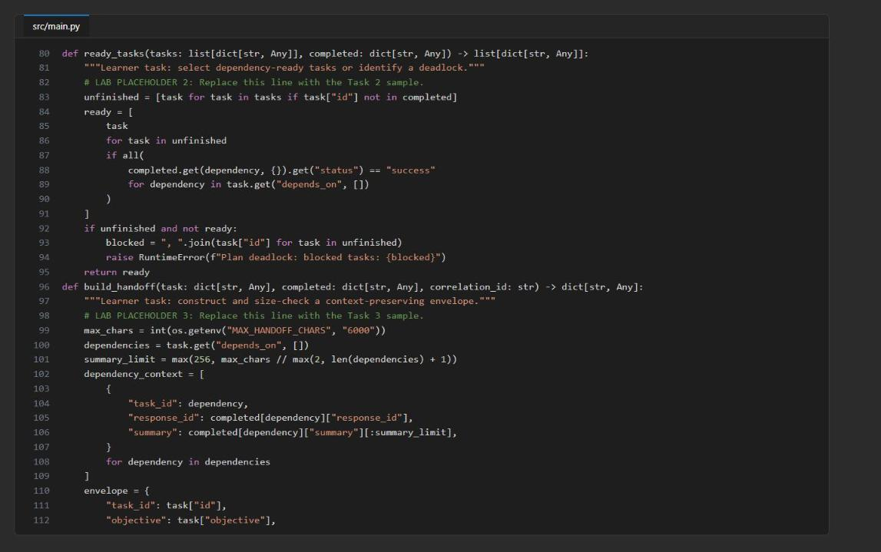
Figure 6: ready_tasks (Placeholder 2) and the start of build_handoff (Placeholder 3)
Placeholder 4: signal one evidence-driven replan
7. Find this in should_replan:
PYTHON
# LAB PLACEHOLDER 4: Replace this line with the Task 4 sample.
raise NotImplementedError("Complete should_replan in Task 4")

8. Replace the raise NotImplementedError("Complete should_replan in Task 4") line with:
PYTHON
if replan_count >= 1:
return False
if result.get("status") != "success":
return True

try:
payload = json.loads(result.get("summary", "{}"))
except json.JSONDecodeError:
return False

status = str(payload.get("status", "")).lower()
confidence = payload.get("confidence")
low_confidence = isinstance(confidence, (int, float)) and confidence < 0.5
return (
status in {"missing_evidence", "capability_unavailable"}
or bool(payload.get("missing_evidence"))
or low_confidence
)

The policy records at most one evidence-driven signal in replan_count; it does not execute a replan. A production coordinator would send the evidence back to the planner and validate a replacement for only the remaining part of the DAG.
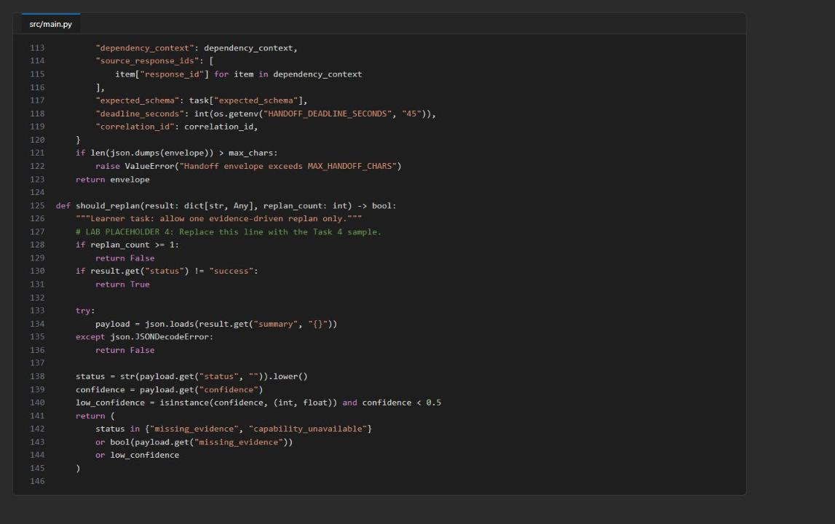
Figure 7: The end of build_handoff (Placeholder 3) and should_replan (Placeholder 4)
9. Save src/main.py (Ctrl+S).
Check the completed code
10. Run the local checks before making billable model calls:
POWERSHELL
python -m py_compile src/main.py scripts/preflight.py
python scripts/preflight.py

11. Confirm that the four LAB PLACEHOLDER markers remain and no NotImplementedError remains:
POWERSHELL
(Select-String -Path src/main.py -Pattern 'LAB PLACEHOLDER').Count
(Select-String -Path src/main.py -Pattern 'NotImplementedError').Count

Expected result: py_compile prints nothing, preflight prints four PASS lines, and the two counts are 4 and 0.
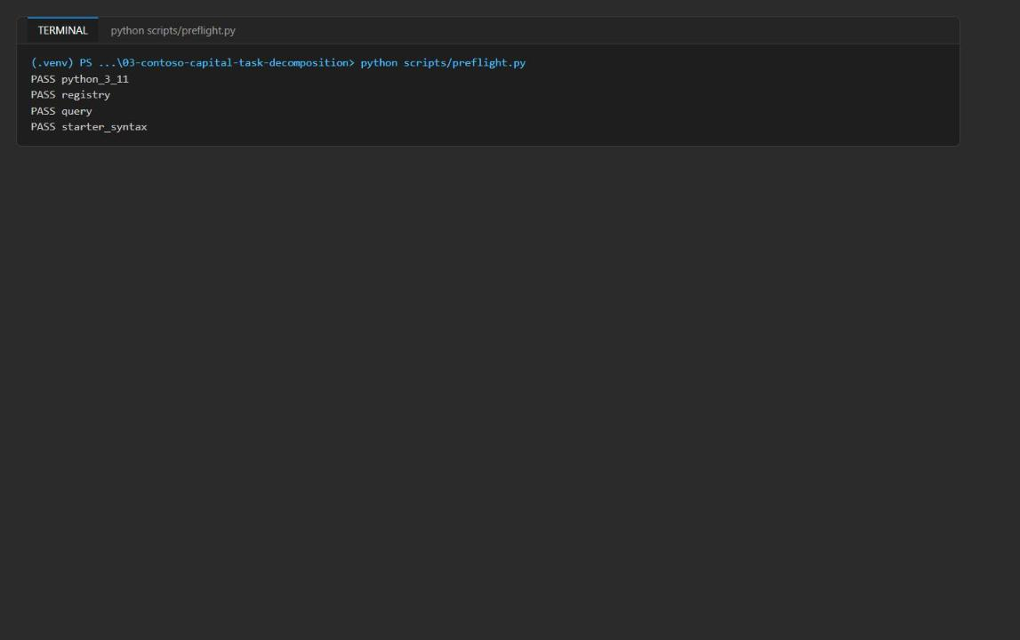
Figure 8: Preflight reports four PASS lines

Task 5: Run the solution
Run the complex query
1. Confirm that assets/research-query.json still has "complexity_hint":"complex", then run the application:
POWERSHELL
python -m src.main --input assets/research-query.json

The app creates (or adds a new version to) five prompt agents, calls research-planner once, validates the returned DAG, and then calls each specialist in dependency order. The run takes about 1-2 minutes. Authentication and HTTP log lines (INFO HTTP Request: POST ... "HTTP/1.1 200 OK") appear before the JSON result; that is expected.
Expected result: a JSON document with a 3-6 task plan whose last task is thesis-synthesis and depends on all evidence tasks, for example T1 financial-data, T2 macro-risk, T3 compliance-review, T4 thesis-synthesis [T1, T2, T3], with task_count 4, handoff_count 4 and every result status success.
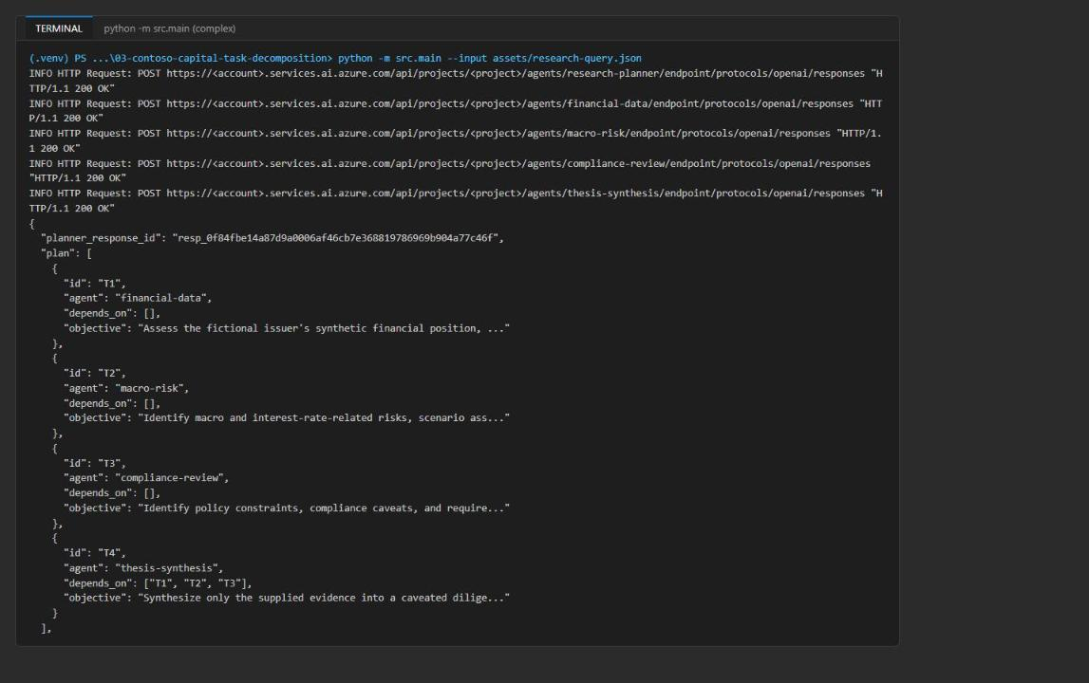
Figure 9: Complex run: one call per agent and the validated four-task plan
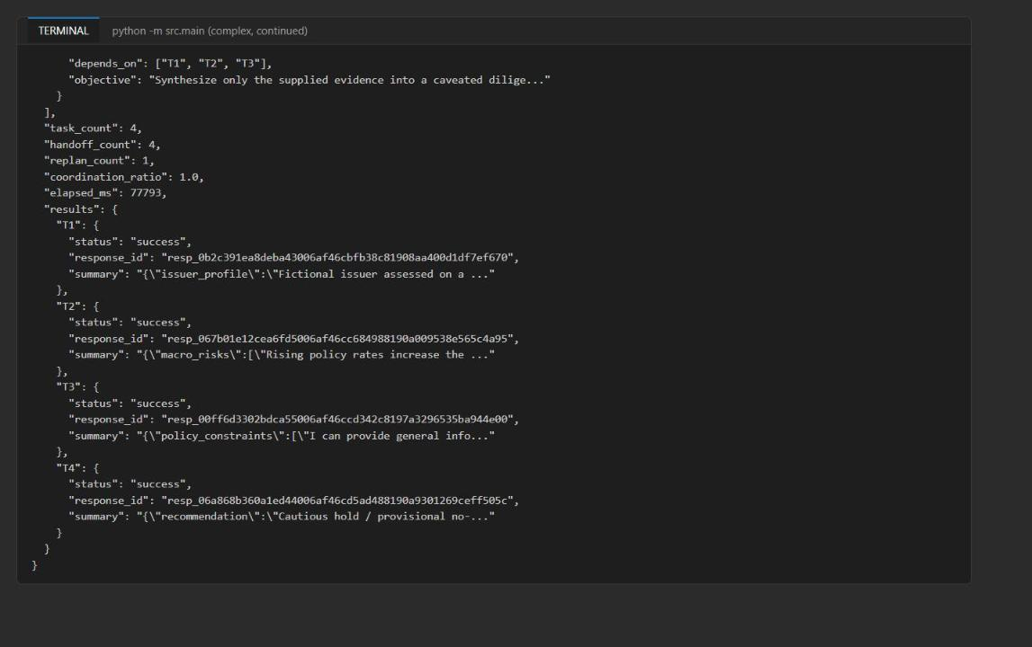
Figure 10: Complex run: metrics and per-task results with live response IDs
Run the simple query
2. Open assets/research-query.json, change "complexity_hint":"complex" to "complexity_hint":"simple", and save the file. Alternatively, run:
POWERSHELL
$q = 'assets/research-query.json'
(Get-Content $q -Raw) -replace '"complexity_hint"\s*:\s*"\w+"', '"complexity_hint":"simple"' | Set-Content $q -NoNewline -Encoding utf8
Select-String -Path $q -Pattern 'complexity_hint":"\w+"' | ForEach-Object { $_.Matches.Value }

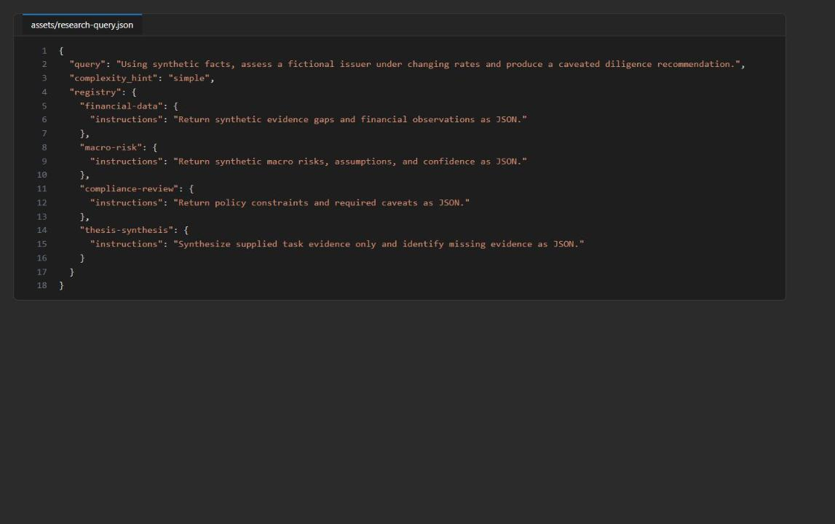
Figure 11: research-query.json with complexity_hint set to simple
3. Run the application again:
POWERSHELL
python -m src.main --input assets/research-query.json

Expected result: the planner reduces the plan depth to exactly two tasks (one evidence task, typically financial-data, and thesis-synthesis depending on it), task_count 2, handoff_count 2, and the run finishes in about 20-25 seconds instead of about 75 seconds.
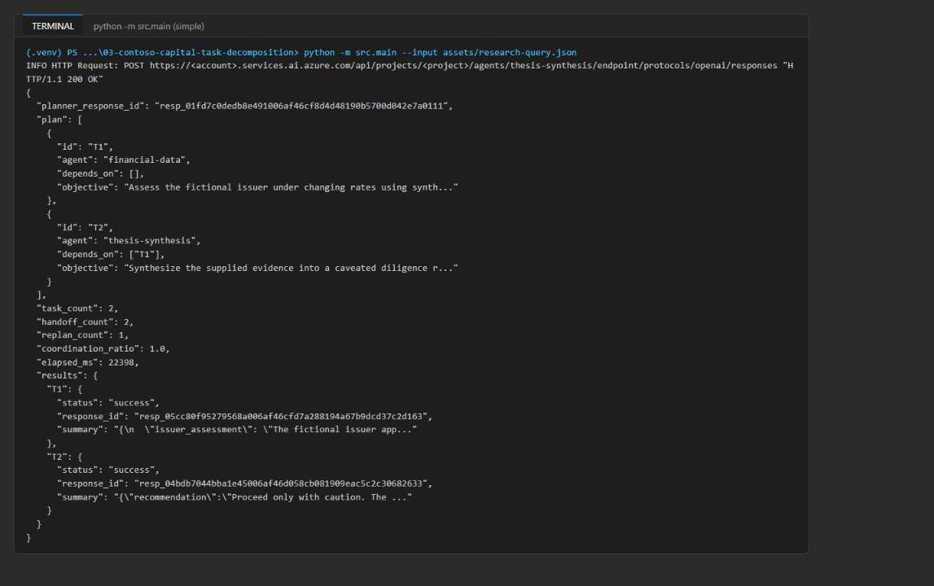
Figure 12: Simple run: a two-task plan with the final synthesis task preserved
Understand the output
Field | What it reflects
planner_response_id | The live structured plan returned by the planner agent
plan | The validated task IDs, owners, objectives, schemas and dependencies used for dispatch
task_count | Validated plan depth, bounded to 1-6 tasks
handoff_count | Number of specialist envelopes created
replan_count | 0 or 1 evidence-driven signal for an outer replanning coordinator
coordination_ratio | Handoffs divided by completed tasks; compare with quality and latency, not as a score
elapsed_ms | End-to-end wall-clock time for planner, validation, specialists and synthesis
results | Per-task status, live response ID and visible structured summary

Note: replan_count is 1 in both runs. The query is synthetic, so the specialists report missing_evidence; the single-signal budget fires once and is then capped. That is the expected behavior.

Task 6: Validate the implementation
Capture both runs in one artifact
1. Capture the complex and the simple run in artifacts-lab03.txt. This block sets the hint, runs each case and appends the output:
POWERSHELL
python -m py_compile src/main.py scripts/preflight.py
$q = 'assets/research-query.json'
"===== COMPLEX RUN (complexity_hint=complex) =====" | Out-File artifacts-lab03.txt -Encoding utf8
(Get-Content $q -Raw) -replace '"complexity_hint"\s*:\s*"\w+"', '"complexity_hint":"complex"' | Set-Content $q -NoNewline -Encoding utf8
python -m src.main --input $q *>> artifacts-lab03.txt
"===== SIMPLE RUN (complexity_hint=simple) =====" | Out-File artifacts-lab03.txt -Append -Encoding utf8
(Get-Content $q -Raw) -replace '"complexity_hint"\s*:\s*"\w+"', '"complexity_hint":"simple"' | Set-Content $q -NoNewline -Encoding utf8
python -m src.main --input $q *>> artifacts-lab03.txt
Select-String artifacts-lab03.txt -Pattern 'planner_response_id|task_count|handoff_count|replan_count|coordination_ratio'

Expected result: two sets of metrics: the complex run with task_count 3-6 and the simple run with task_count 2.
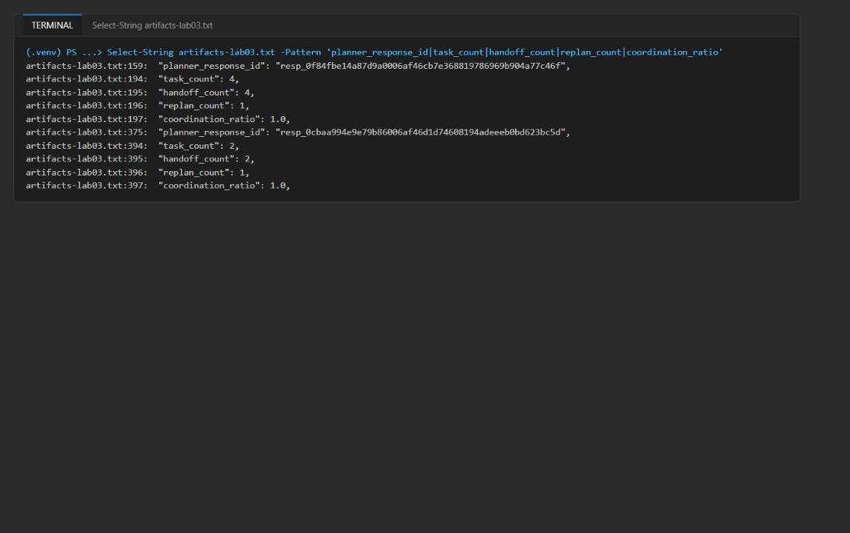
Figure 13: Select-String shows the planner response IDs and metrics for both runs
2. Open artifacts-lab03.txt and check the acceptance criteria:
Criterion | How to check
Every dependency refers to an earlier completed task | In results, each task appears after the tasks in its depends_on; thesis-synthesis is the last entry
Every specialist exists in the registry | Every agent in plan is one of financial-data, macro-risk, compliance-review, thesis-synthesis (otherwise validate_plan would have raised)
All task results have live Foundry response IDs | Every results.<id>.response_id starts with resp_
One simple and one complex plan | Simple run: 2 tasks (1 evidence + synthesis). Complex run: 3-6 tasks

Note: Offline DAG checks alone do not satisfy this lab. The response IDs must come from live Foundry calls.

Validate the agents in Foundry
3. Open the Foundry portal and select the project named in FOUNDRY_PROJECT_ENDPOINT (lab03-lab03-<suffix>).
4. Select Agents. Confirm that research-planner, financial-data, macro-risk, compliance-review and thesis-synthesis are listed.
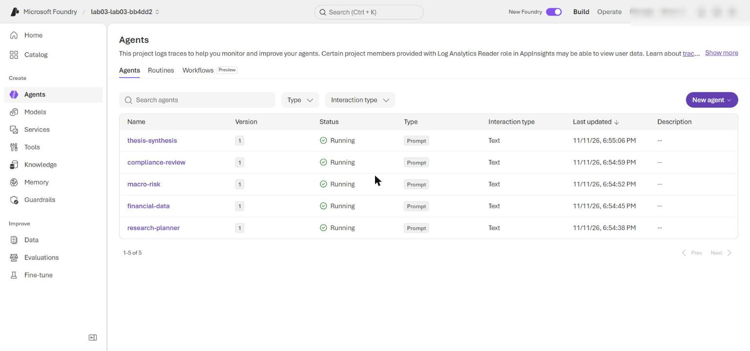
Figure 14: The Agents page lists the planner and the four specialists
5. Open research-planner and confirm its current version, model gpt-5.4-mini and the instructions that contain the registry. Version numbers increase each time you run the app.
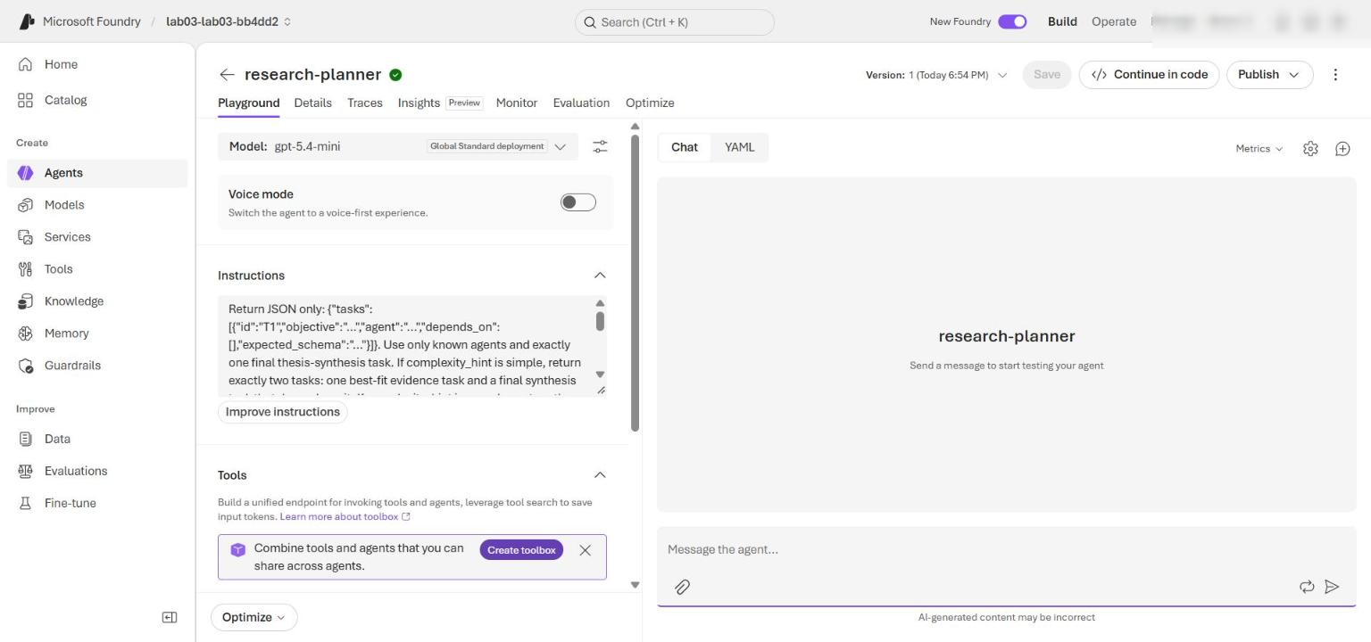
Figure 15: research-planner agent version and instructions
You can also list the agents from the command line:
POWERSHELL
$endpoint = (Select-String -Path .env -Pattern '^FOUNDRY_PROJECT_ENDPOINT=').Line.Split('=',2)[1].Trim('"')
$token = az account get-access-token --resource https://ai.azure.com --query accessToken -o tsv
(Invoke-RestMethod -Uri "$endpoint/agents?api-version=v1" -Headers @{ Authorization = "Bearer $token" }).data | Select-Object -ExpandProperty name

Validate the response traces
6. In the Foundry portal, select Agents, open research-planner, and select its Traces tab (each agent has its own Traces tab); set the time range to include your runs. Trace ingestion can take several minutes.
7. Search for the complex run's planner_response_id. Open the trace and confirm the agent name research-planner, the version, a successful response operation and the timestamp.
8. Search for each response_id in the complex run's results. Confirm that thesis-synthesis starts only after the financial-data, macro-risk and compliance-review traces have completed.
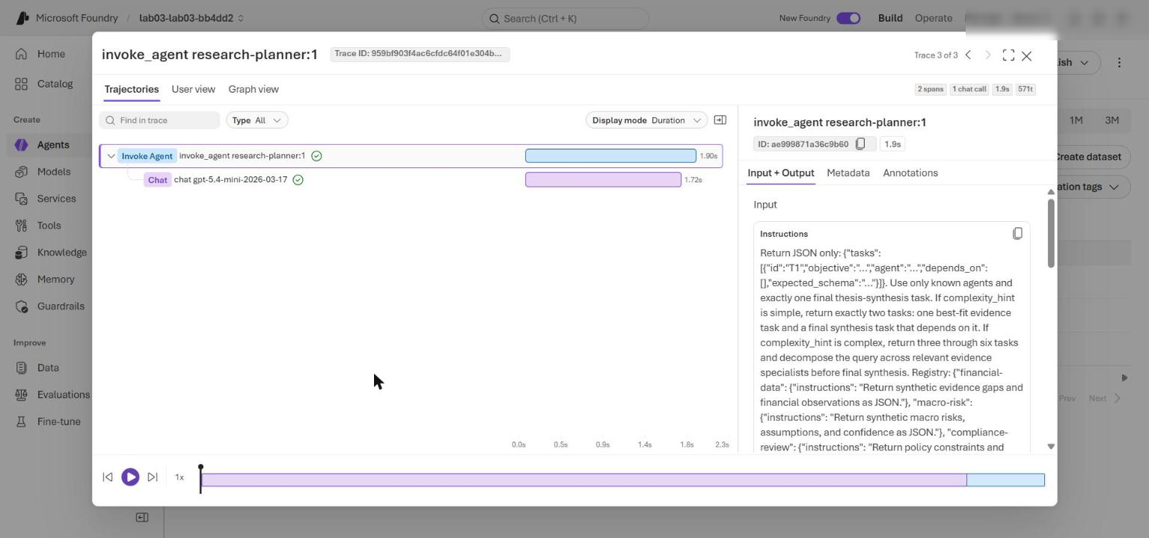
Figure 16: The complex-run research-planner trace (invoke_agent research-planner:1) opened from the agent's Traces tab
9. Repeat the search for the simple run and compare: the simple run has 2 specialist traces, the complex run has 4.
10. Optionally, query the same spans in Application Insights. In the Azure portal open appi-lab03-<suffix> > Monitoring > Logs, and run:
KQL
dependencies
| where timestamp > ago(1d)
| where name startswith "invoke_agent"
| project timestamp, end_time = timestamp + duration * 1ms, name, success,
response_id = tostring(customDimensions["gen_ai.response.id"])
| order by timestamp asc

Expected result: one invoke_agent research-planner:<version> span per run, followed by one span per specialist task, all with success = True. Each specialist that consumes a dependency starts after the prerequisite spans end.
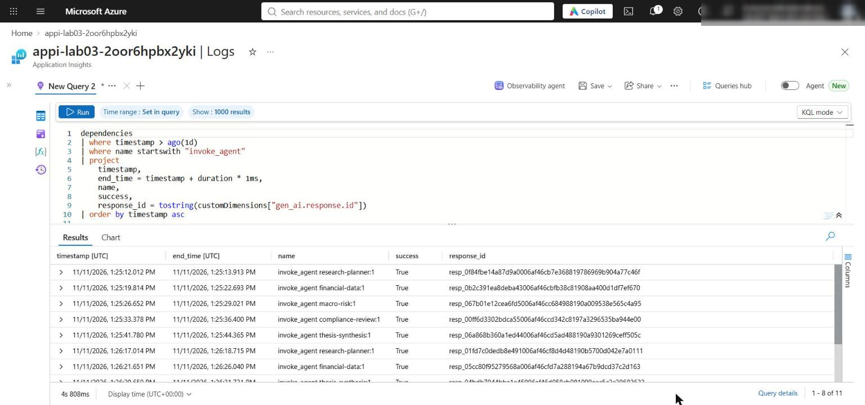
Figure 17: Application Insights Logs query of the invoke_agent spans
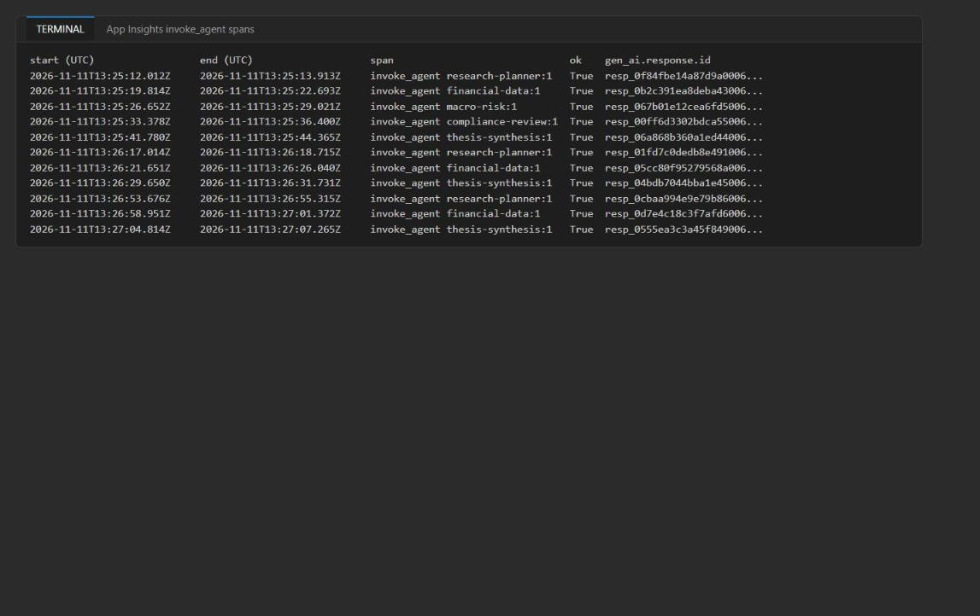
Figure 18: Span timeline: complex run (planner + 4 specialists), then two simple runs (planner + 2 specialists)

Optional challenge: Compare two decompositions
Create a coarse-grained and a fine-grained DAG for the same query, select one against explicit constraints, and then shrink the handoff limit until an envelope is rejected. The script below runs offline (no model calls). It reuses the lab's own validate_plan, ready_tasks and build_handoff, and uses the real specialist summaries from the complex run in artifacts-lab03.txt as realistic artifact sizes.
1. In the lab folder, create optional_challenge.py with this content:
PYTHON
"""Optional challenge: compare a coarse and a fine-grained DAG for the same synthetic query.

Offline only (no model calls). Uses the lab's own validate_plan / ready_tasks / build_handoff,
with real specialist summaries captured in artifacts-lab03.txt (complex run) as dependency artifacts.
Run: python optional_challenge.py > challenge-output.txt
"""
from __future__ import annotations
import json, os
from pathlib import Path
from src.main import validate_plan, ready_tasks, build_handoff

ROOT = Path(__file__).resolve().parent
data = json.loads((ROOT / "assets/research-query.json").read_text(encoding="utf-8"))
registry = data["registry"]

# Real summaries from the complex live run (used as realistic artifact sizes).
text = (ROOT / "artifacts-lab03.txt").read_text(encoding="utf-8").split("===== SIMPLE RUN")[0]
live, _ = json.JSONDecoder().raw_decode(text[text.index("\n{\n") + 1:])
live_summaries = [v["summary"] for v in live["results"].values()]

S = '{"findings":["string"],"confidence":0.0,"missing_evidence":["string"]}'
coarse = {"tasks": [
{"id": "E1", "agent": "financial-data", "objective": "Collect financial, rate-sensitivity and caveat evidence for the issuer.", "depends_on": [], "expected_schema": S},
{"id": "S1", "agent": "thesis-synthesis", "objective": "Synthesize a caveated diligence recommendation.", "depends_on": ["E1"], "expected_schema": S},
]}
fine = {"tasks": [
{"id": "F1", "agent": "financial-data", "objective": "Leverage, coverage and liquidity observations.", "depends_on": [], "expected_schema": S},
{"id": "M1", "agent": "macro-risk", "objective": "Rate scenarios and transmission channels.", "depends_on": [], "expected_schema": S},
{"id": "F2", "agent": "financial-data", "objective": "Stress coverage under M1 scenarios.", "depends_on": ["F1", "M1"], "expected_schema": S},
{"id": "C1", "agent": "compliance-review", "objective": "Required caveats and diligence boundaries.", "depends_on": [], "expected_schema": S},
{"id": "C2", "agent": "compliance-review", "objective": "Check stressed findings against policy caveats.", "depends_on": ["F2", "C1"], "expected_schema": S},
{"id": "S1", "agent": "thesis-synthesis", "objective": "Synthesize a caveated diligence recommendation.", "depends_on": ["C2"], "expected_schema": S},
]}

def simulate(name: str, plan: dict, max_chars: int) -> dict:
os.environ["MAX_HANDOFF_CHARS"] = str(max_chars)
validate_plan(plan, registry)
completed: dict = {}; envelopes = []; waves = 0; i = 0
while len(completed) < len(plan["tasks"]):
batch = ready_tasks(plan["tasks"], completed); waves += 1
for task in batch:
env = build_handoff(task, completed, "challenge-corr-id")
envelopes.append(len(json.dumps(env)))
completed[task["id"]] = {"status": "success", "response_id": f"sim_{task['id']}",
"summary": live_summaries[i % len(live_summaries)]}
i += 1
return {"plan": name, "tasks": len(plan["tasks"]), "handoffs": len(envelopes),
"sequential_waves": waves, "max_envelope_chars": max(envelopes),
"total_handoff_chars": sum(envelopes)}

print("== Valid DAG comparison (MAX_HANDOFF_CHARS=6000) ==")
results = [simulate("coarse", coarse, 6000), simulate("fine", fine, 6000)]
for r in results: print(json.dumps(r))
for name, plan in (("coarse", coarse), ("fine", fine)):
print(name, [(t["id"], t["agent"], t["depends_on"]) for t in plan["tasks"]])

print("\n== Selection (constraints: latency <= 4 sequential waves, envelope <= 6000 chars, >= 3 specialists for a complex query) ==")
for r, plan in zip(results, (coarse, fine)):
agents = {t["agent"] for t in plan["tasks"]} - {"thesis-synthesis"}
ok = r["sequential_waves"] <= 4 and r["max_envelope_chars"] <= 6000 and len(agents) >= 3
print(f"{r['plan']}: waves={r['sequential_waves']} specialists={len(agents)} max_env={r['max_envelope_chars']} -> {'meets' if ok else 'fails'} constraints")
print("Selected: fine-grained plan. It is the only one meeting the quality constraint (financial, macro and compliance"
" evidence all reach synthesis) within the 4-wave latency and 6000-char envelope budgets; the coarse plan is cheaper"
" (2 handoffs, ~3.7k handoff chars vs 6 / ~12.7k) but drops macro and compliance evidence. Preserved artifacts:"
" every envelope carries source_response_ids for its dependencies; S1 depends on C2, the single terminal evidence branch.")

print("\n== Failure investigation: shrink MAX_HANDOFF_CHARS until an envelope is rejected (fine plan) ==")
for limit in (6000, 4000, 3000, 2000, 1500, 1200, 1000, 800):
try:
r = simulate("fine", fine, limit); print(f"limit={limit}: OK max_envelope={r['max_envelope_chars']}")
except ValueError as exc:
print(f"limit={limit}: REJECTED -> {exc}")
print("Classification: dispatch validation caught it; root cause is decomposition granularity"
" (a fan-in task C2/F2 carries several dependency summaries, each floored at 256 chars plus"
" objective/schema/IDs overhead), not a single oversized artifact.")
break

Note: The script reads the complex run from artifacts-lab03.txt (the part before the ===== SIMPLE RUN line), so run Task 6 step 1 first.

2. Run it and save the output:
POWERSHELL
python optional_challenge.py | Tee-Object -FilePath challenge-output.txt

Expected result: both DAGs pass validate_plan; the coarse plan (2 tasks, 2 waves) fails the "at least 3 specialists" quality constraint, the fine plan (6 tasks, 4 waves, largest envelope about 4.3k characters) meets all constraints and is selected; with the fine plan, envelopes still pass at a 1500-character limit and are rejected at 1200 with Handoff envelope exceeds MAX_HANDOFF_CHARS. The rejection is caught by dispatch validation; the root cause is decomposition granularity (fan-in tasks carry several dependency summaries).
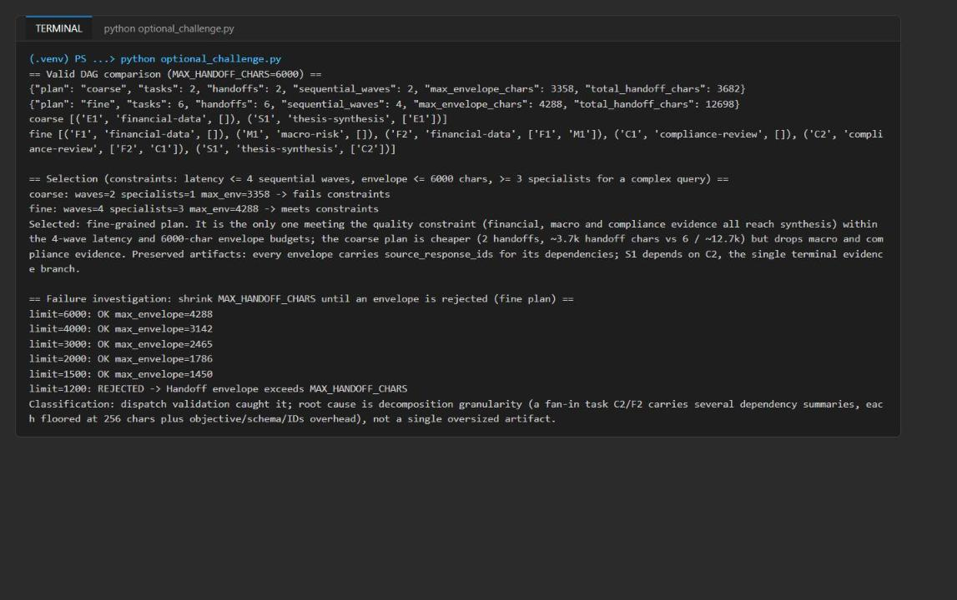
Figure 19: Optional challenge output: DAG comparison, selection and the envelope-size failure investigation

Task 7: Review the design
Answer the review questions in the Review questions section at the end of this guide.

Task 8: Clean up
Restore the input file (optional)
1. If you want to rerun the lab later with the default input, set the hint back to complex:
POWERSHELL
$q = 'assets/research-query.json'
(Get-Content $q -Raw) -replace '"complexity_hint"\s*:\s*"\w+"', '"complexity_hint":"complex"' | Set-Content $q -NoNewline -Encoding utf8

Remove the Azure resources (optional, recommended)
2. Delete the resource group (use the name from .env if you opened a new terminal):
POWERSHELL
$resourceGroupName = (Select-String -Path .env -Pattern '^AZURE_RESOURCE_GROUP=').Line.Split('=',2)[1].Trim('"')
az group delete --name $resourceGroupName --yes --no-wait

3. After the deletion completes (a few minutes), purge the soft-deleted Foundry account so its name and quota are released:
POWERSHELL
az cognitiveservices account list-deleted --query "[].{name:name, location:location}" -o table
az cognitiveservices account purge --name <foundry-account-name> --resource-group $resourceGroupName --location eastus2

4. Confirm the resource group is gone:
POWERSHELL
az group exists --name $resourceGroupName

Expected result: false.
Remove local files and deactivate the environment
5. Remove generated files and deactivate the virtual environment in every terminal that shows (.venv):
POWERSHELL
Remove-Item .env, artifacts-lab03.txt, challenge-output.txt -ErrorAction SilentlyContinue
deactivate

Validate
Acceptance criterion | How to check (CLI) | How to check (portal)
Preflight: four PASS, four LAB PLACEHOLDER markers, no NotImplementedError | python scripts/preflight.py; Select-String counts 4 and 0 (Task 4) | n/a
.env has the five required values | Get-Content .env | Deployment outputs on the resource group Deployments page
Foundry account allows public network access (lab only) | az cognitiveservices account list ... shows Enabled / Allow | Foundry account > Networking
Complex plan has 3-6 tasks and synthesis last | Select-String artifacts-lab03.txt -Pattern task_count | n/a
Simple plan has exactly 2 tasks | Same, second task_count is 2 | n/a
Every dependency precedes its consumer; all agents in the registry | Read plan and results in artifacts-lab03.txt | n/a
All results have live resp_ response IDs | Select-String artifacts-lab03.txt -Pattern 'response_id' | Search each ID in Traces
research-planner and four specialists exist | REST agents list (Task 6) | Foundry portal Agents
Planner trace has name, version, success and timestamp | KQL query (Task 6) | Foundry portal Traces
Dependent specialists start after prerequisites end; simple run has fewer specialist traces | KQL timestamp / end_time columns | Foundry portal Traces timeline

Troubleshooting
Symptom | Cause | Fix
401 / 403 PermissionDenied when creating agents or calling responses | Data-plane roles missing or not yet applied (the Bicep template does not assign them) | Run Task 3 step 2 to grant Azure AI User, Cognitive Services OpenAI User and Azure AI Developer; wait 1-5 minutes and run again
DefaultAzureCredential failed to retrieve a token | Not signed in to the Azure CLI, or wrong tenant | Run az login (add --tenant <tenant-id> if needed) and az account set --subscription <subscription-id>
Deployment fails with InsufficientQuota or model/version not available | No gpt-5.4-mini GlobalStandard quota in the region | Choose another region with quota, delete the failed resource group, and rerun Task 3 with the new $azureRegion
KeyError: 'FOUNDRY_PROJECT_ENDPOINT' | .env missing or written in the wrong folder | Run Task 3 step 3 from the lab folder; confirm Get-Content .env shows the endpoint
ValueError: The thesis-synthesis task must depend on every terminal evidence task (or another validate_plan error) | The model returned a plan that breaks an invariant | This is the validator working as designed. Rerun the command; the planner usually returns a valid plan
json.decoder.JSONDecodeError right after the planner call | The planner returned non-JSON text | Rerun the command
IndentationError after pasting | Snippet pasted with the wrong indentation | Every line of the replacement code must start with at least 4 spaces (function body level), exactly as shown in Task 4
replan_count is 1 in every run | Expected: specialists report missing_evidence on the synthetic query; the budget caps the signal at one | No action needed
Simple run still returns 3+ tasks | complexity_hint is still complex | Check the file shows "complexity_hint":"simple" and that you saved it
No traces in Foundry or Application Insights | Ingestion delay | Wait 5-10 minutes and widen the time range
Rerun after the lab shows only 2 tasks | The lab leaves assets/research-query.json at simple | Restore complex (Task 8 step 1)

Review questions
1. Which plan invariants must never be delegated to a model?
Everything that validate_plan and the dispatcher enforce in code: a bounded task count (1-6), unique non-empty IDs, only registry-known agents, dependencies that exist and are not self-references, an acyclic graph, exactly one thesis-synthesis task that depends on every terminal evidence branch with nothing depending on it, dispatch only after every prerequisite succeeds, a deadlock error instead of an endless loop, a size cap on each handoff envelope, and a replan budget of one. The model proposes a plan; code decides whether it is admissible.
2. When is a fixed chain cheaper and safer?
When the query shape is known and stable, such as a simple lookup or a fixed "one evidence source, then synthesis" path. A fixed chain skips the planner call (about 1.7-1.9 seconds and one extra response per run in this lab), has no plan-validation failure mode, and produces the same trace shape every time, which simplifies auditing. Dynamic decomposition pays off only when queries vary enough that a fixed chain would over-process simple work or miss dependencies in complex work.
3. What context can be summarized without breaking downstream evidence?
Narrative reasoning, restated assumptions and verbose observations can be truncated to the per-dependency summary_limit. Keep verbatim: the task_id, the response_id / source_response_ids that trace each claim to a live response, the objective and expected_schema, the correlation ID, and explicit missing_evidence and confidence fields. Truncating a JSON summary can cut off trailing missing_evidence keys, so specialists should put gaps and confidence first.
4. Which signal justifies the single replan budget?
An evidence-driven signal from a completed specialist: a non-success status, a structured status of missing_evidence or capability_unavailable, a non-empty missing_evidence field, or a numeric confidence below 0.5. Style or length does not justify a replan. A replan should cover only the remaining DAG and must pass validate_plan again. In this lab both runs raised the signal once (replan_count: 1), showing the budget caps it instead of letting it loop.

Clean up
This step is optional but recommended to stop charges. If you did not already do it in Task 8, delete the resource group and purge the Foundry account:
POWERSHELL
az group delete --name rg-lab03-<suffix> --yes --no-wait
az cognitiveservices account purge --name <foundry-account-name> --resource-group rg-lab03-<suffix> --location eastus2

Then run deactivate in every terminal that shows (.venv).

