Lab 08: Build persistent shared memory for Foundry agents

Overview
Scenario. Northwind Health runs several agents (scheduling, care navigation, medication support) that must share reviewed, patient-scoped preferences. A Memory Coordinator supplies bounded, patient-scoped evidence from a durable store, with patient isolation, read-your-writes consistency, retention, and auditable deletion.
What you'll build. You implement a custom memory layer in Azure Cosmos DB for NoSQL (vector search, partition per patient, TTL, separate audit container) and connect it to a Microsoft Agent Framework agent that you run locally and then deploy as a Microsoft Foundry Hosted Agent. The agent calls a read-only recall_patient_memory tool, builds a bounded context, and answers with cited memory IDs. Memory writes, consolidation, and pruning stay as explicit administrative CLI commands.
Duration. About 60-75 minutes (45 minutes of lab work plus provisioning and hosted-agent build time).
Important: The Cosmos DB serverless account, both Foundry model deployments, and Hosted Agent compute are billable. Use only the synthetic data in the lab and complete the Clean up section when you finish.

Architecture
Component | Role in the lab
agent.py | Hosted Agent (Microsoft Agent Framework) with the read-only recall_patient_memory tool
src/memory_store.py | Patient-scoped upsert, vector recall (VectorDistance), audit, guarded consolidation
src/context_budget.py | Bounded, delimited model context (token budget)
src/consistency.py | Read-your-writes check with explicit session-token transfer
src/retention.py | Retention policy, partition-scoped deletes, audit of deletions
Cosmos DB clinical-memory-db / patient-memories | Durable memory: partition key /patientId, 1,536-dim cosine vector policy, quantizedFlat index, default TTL 30 days
Cosmos DB clinical-memory-db / memory-audit | Content-free audit events (separate container)
Foundry account + project | gpt-5.4-mini chat deployment, text-embedding-3-small embedding deployment, Hosted Agent northwind-health-memory-coordinator
Hosted agent instance identity | Entra identity the deployed agent runs as; needs its own model and Cosmos data-plane roles

Prerequisites
Install these tools:
- Python 3.13
- Azure CLI (2.80 or later)
- Azure Developer CLI (azd) 1.27.1 or later, used only to run and deploy the Hosted Agent
- Git
- Visual Studio Code with the Python, Bicep, and Foundry Toolkit extensions
Azure permissions: you need to create a resource group, Cosmos DB account, Foundry account and project, model deployments, a Hosted Agent, and role assignments. Owner (or Contributor plus User Access Administrator) on the subscription or resource group is sufficient. Vector search and model availability vary by region; this guide uses eastus2.

Task 1: Prepare the lab
1. Clone the lab repository (skip if you already have it):
POWERSHELL
git clone https://github.com/MicrosoftLearning/mslearn-ai-multi-agents.git

2. Open the cloned mslearn-ai-multi-agents folder in Visual Studio Code, then open a terminal (Terminal > New Terminal, PowerShell).
3. Change to the lab folder and check the tools and your subscription:
POWERSHELL
cd Allfiles\08-northwind-health-multi-agent-memory
az version
azd version
python --version

4. Sign in to Azure with both CLIs and select your subscription:
POWERSHELL
az login
az account set --subscription "<your-subscription-id>"
az account show --output table
azd auth login

5. Install (or update) the azd AI agents extension, which provides the azd ai agent commands:
POWERSHELL
azd extension install azure.ai.agents
azd extension upgrade azure.ai.agents

Expected result: python --version prints 3.13.x, azd version is 1.27.1 or later, and az account show lists the subscription you want to use.
6. Review the architecture boundaries before you edit code:
Boundary | Component
Hosted conversation and read-only recall tool | agent.py
Durable patient-scoped memory | src/memory_store.py and the patient-memories container
Bounded model context | src/context_budget.py
Session consistency transfer | src/consistency.py
Retention and deletion | src/retention.py
Durable audit evidence | memory-audit container
Azure resources and synthetic input | infra/main.bicep and assets/memories.json

Cosmos DB, not the conversation history, is the durable memory authority, and memory and audit records live in separate containers. Use DefaultAzureCredential only: no account keys, connection strings, real patient data, or shared memory partitions.
Note: Do not replace Cosmos DB operations with an in-memory list or a local vector calculation. The lab validates real service behavior (vector index, RU charge, partitions, TTL, consistency).

Task 2: Build the virtual environment
1. Create the virtual environment and install the requirements, then activate it:
POWERSHELL
./scripts/setup.ps1
. ./.venv/Scripts/Activate.ps1

Note: On macOS/Linux run bash scripts/setup.sh and then source .venv/bin/activate.

2. Open assets/memories.json and review the records. All patient IDs and observations are synthetic (synthetic-patient-100 and synthetic-patient-200). There are no stored vectors: embeddings are generated at ingestion time.
Expected result: the prompt starts with (.venv).

Task 3: Deploy the Azure resources
You provision with the Azure CLI (not azd provision). The template infra/main.bicep takes three parameters: location, environmentName, and principalId (your user object ID, which receives Cosmos DB data-plane and model roles). It creates the Cosmos DB serverless account with vector search, the database and both containers, the Foundry AIServices account and project, and the gpt-5.4-mini and text-embedding-3-small deployments.
1. Choose a region where Cosmos DB vector search, Microsoft Foundry, gpt-5.4-mini (GlobalStandard, 10K TPM) and text-embedding-3-small (GlobalStandard, 20K TPM) are available with quota. The example uses eastus2.
2. Run the following block from the lab folder. It creates a unique resource group, deploys the Bicep template, grants your user data-plane access, and writes .env from the deployment outputs:
POWERSHELL
$azureRegion = 'eastus2'
$suffix = (New-Guid).Guid.Substring(0, 8)
$resourceGroupName = "rg-lab08-$suffix"
$envName = "lab08-$suffix"
$me = az ad signed-in-user show --query id -o tsv
az group create --name $resourceGroupName --location $azureRegion --output none
az bicep build --file infra/main.bicep
az deployment group create --resource-group $resourceGroupName --name lab08-main `
--template-file infra/main.bicep `
--parameters location=$azureRegion environmentName=$envName principalId=$me `
--output none
# Grant yourself data-plane access (Foundry agents + model calls)
$rgId = az group show --name $resourceGroupName --query id -o tsv
foreach ($role in 'Azure AI User','Cognitive Services OpenAI User','Azure AI Developer') {
az role assignment create --assignee-object-id $me --assignee-principal-type User --role $role --scope $rgId --output none
}
# Write .env from the deployment outputs
$outputs = az deployment group show --resource-group $resourceGroupName --name lab08-main --query properties.outputs -o json | ConvertFrom-Json
$lines = @("AZURE_RESOURCE_GROUP=`"$resourceGroupName`"", "AZURE_LOCATION=`"$azureRegion`"", "AZURE_ENV_NAME=`"$envName`"",
"AZURE_SUBSCRIPTION_ID=`"$(az account show --query id -o tsv)`"", "AZURE_PRINCIPAL_ID=`"$me`"", "AZURE_PRINCIPAL_TYPE=`"User`"",
"AGENT_PATIENT_ID=`"synthetic-patient-100`"")
$outputs.PSObject.Properties | ForEach-Object { $lines += "$($_.Name.ToUpper())=`"$($_.Value.value)`"" }
$lines | Out-File .env -Encoding utf8
Get-Content .env

Expected result: the deployment finishes in about 5-10 minutes and .env lists AZURE_COSMOS_ENDPOINT, AZURE_COSMOS_DATABASE_NAME=clinical-memory-db, AZURE_COSMOS_MEMORY_CONTAINER=patient-memories, AZURE_COSMOS_AUDIT_CONTAINER=memory-audit, FOUNDRY_PROJECT_ENDPOINT, FOUNDRY_PROJECT_ID, FOUNDRY_ACCOUNT_NAME, FOUNDRY_MODEL_NAME=gpt-5.4-mini, AZURE_OPENAI_ENDPOINT and AZURE_OPENAI_EMBEDDING_DEPLOYMENT=text-embedding-3-small. AZURE_OPENAI_ENDPOINT points to the Foundry AIServices account (https://aif...openai.azure.com/), not to a separate kind: OpenAI account. There are no keys or connection strings in the file.
Note: If the deployment fails, read the first error with az deployment group show -g $resourceGroupName -n lab08-main --query properties.error. The common causes are regional availability of Cosmos DB vector search or a model, GlobalStandard quota, and missing permission to create role assignments. Fix the cause (for example, change $azureRegion and use a new resource group) and run the block again.

3. Allow 1-5 minutes for the RBAC role assignments to propagate before you run code against Cosmos DB or the models.
4. In the Azure portal, open your resource group rg-lab08-<suffix> and confirm it contains the Cosmos DB account (cos...) and the Foundry account (aif...) with its project.
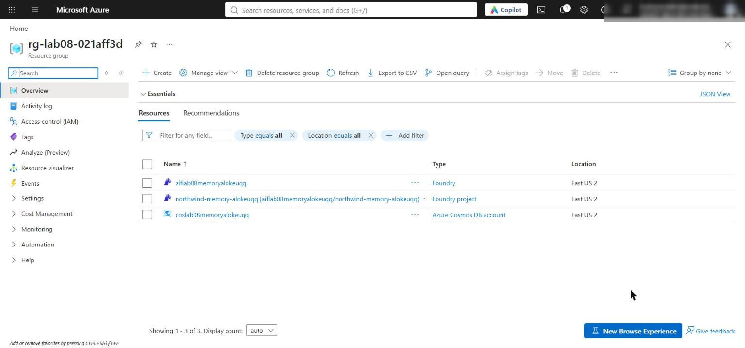
Figure 1: The lab 08 resource group with the Cosmos DB account and the Foundry account and project
5. Open the Foundry account, select Model deployments (or open the project in the Foundry portal and select Models + endpoints), and confirm that gpt-5.4-mini and text-embedding-3-small both show Succeeded.
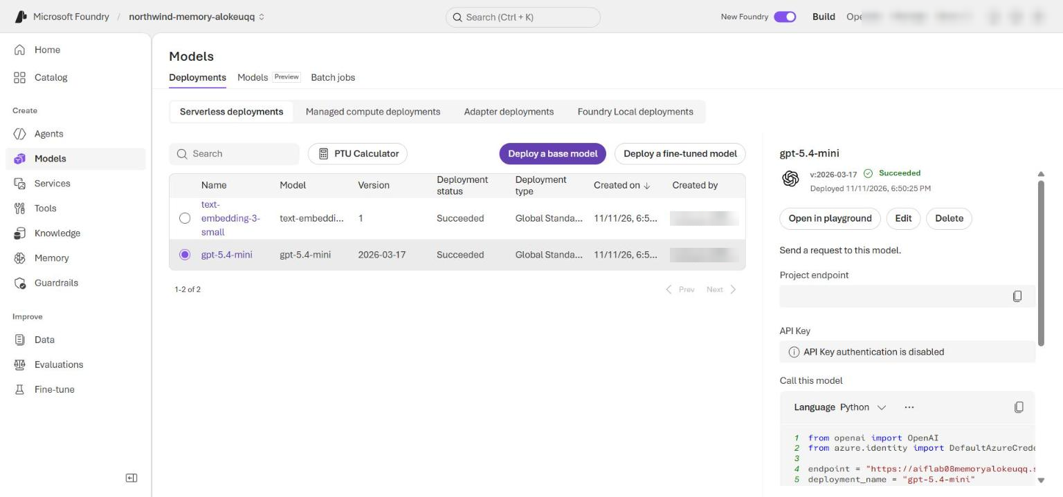
Figure 2: Both model deployments in the Foundry project
6. Open the Cosmos DB account and select Data Explorer. Expand clinical-memory-db and confirm the patient-memories and memory-audit containers exist.
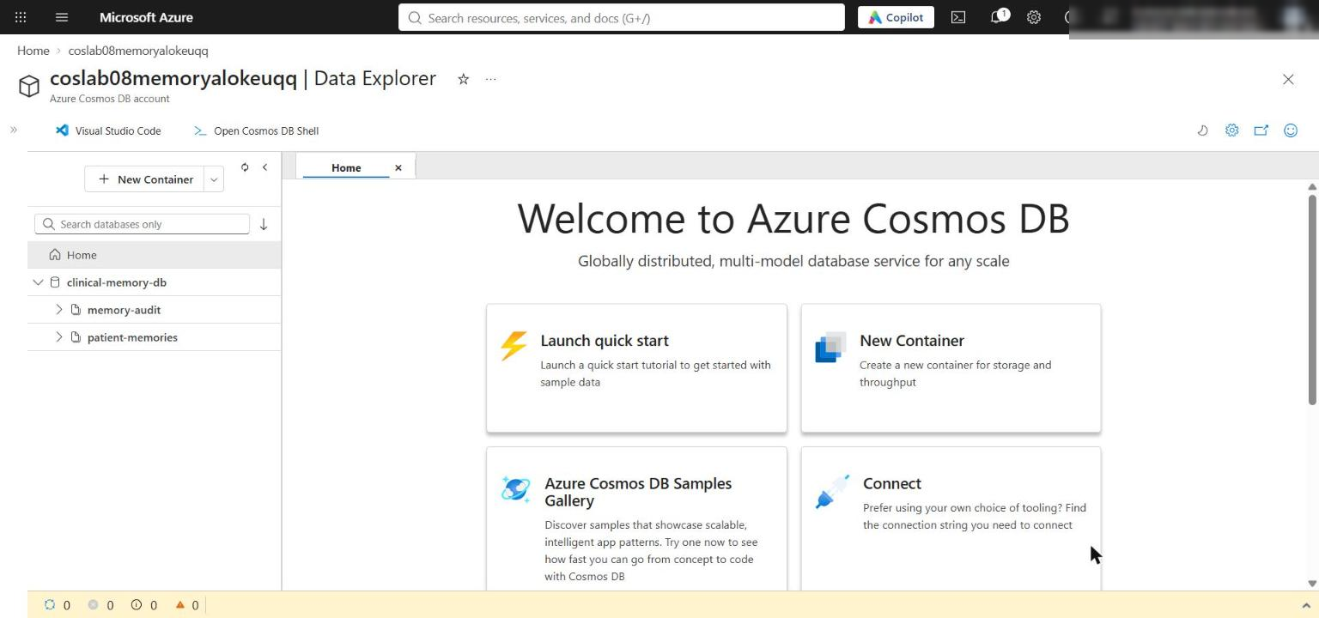
Figure 3: The clinical-memory-db database with the patient-memories and memory-audit containers
7. Create an azd environment for the Hosted Agent and load the values from .env into it. azd is used only for azd ai agent run/invoke and azd deploy in Task 5; do not run azd provision.
POWERSHELL
azd env new lab08-memory-dev --subscription (az account show --query id -o tsv) --location $azureRegion
Get-Content .env | ForEach-Object {
if ($_ -match '^\s*([A-Z0-9_]+)\s*=\s*"?(.*?)"?\s*$') { azd env set $Matches[1] $Matches[2] }
}
azd env get-values

Expected result: azd env get-values shows the same values as .env, including AZURE_SUBSCRIPTION_ID, AZURE_LOCATION, AZURE_RESOURCE_GROUP, AZURE_AI_PROJECT_ID and FOUNDRY_PROJECT_ENDPOINT.
Note: Run this in PowerShell. In Git Bash, azd env set rewrites values that start with /subscriptions/... into Windows paths such as C:/Program Files/Git/subscriptions/.... If you must use Git Bash, prefix the command with MSYS_NO_PATHCONV=1.

Task 4: Implement the solution
There are six placeholders. For each one, find the exact # LAB PLACEHOLDER comment, keep the comment, and replace only the raise NotImplementedError(...) line beneath it.
Note: How to paste with the right indentation: select the whole raise NotImplementedError(...) line including its leading spaces and delete it, paste the snippet on that empty line, then select the pasted lines and press Tab the number of times given in each step, so the first pasted line lines up with the # LAB PLACEHOLDER comment. Python uses 4-space indentation (VS Code inserts 4 spaces per Tab). Placeholders 1-3 are inside class methods (body at 8 spaces: press Tab twice); placeholders 4-6 are inside module functions (body at 4 spaces: press Tab once).

The PatientMemoryStore constructor already creates one reusable async CosmosClient with DefaultAzureCredential and session consistency. Keep using that client.

Placeholder 1: Persist an embedded memory
1. Open src/memory_store.py and find # LAB PLACEHOLDER 1: Replace this line with the Task 1 sample. in upsert_memory.
2. Replace the line raise NotImplementedError("Complete upsert_memory in Task 1") with the following code, then press Tab twice:
PYTHON
patient_id = str(memory["patientId"])
self._authorize(patient_id)
item = {
**memory,
"embedding": self._embeddings.embed(str(memory["content"])),
}
response = await self._memories.upsert_item(item)
headers = response.get_response_headers()
return {
"id": response["id"],
"patientId": response["patientId"],
"request_charge": float(headers.get("x-ms-request-charge", 0)),
"session_token": headers.get("x-ms-session-token"),
}

Authorization happens before any embedding call or I/O. The result returns the RU charge and session token but never the memory content. Items without a ttl inherit the container default of 2,592,000 seconds (30 days); a positive ttl overrides it, and ttl: -1 disables expiry for that item.
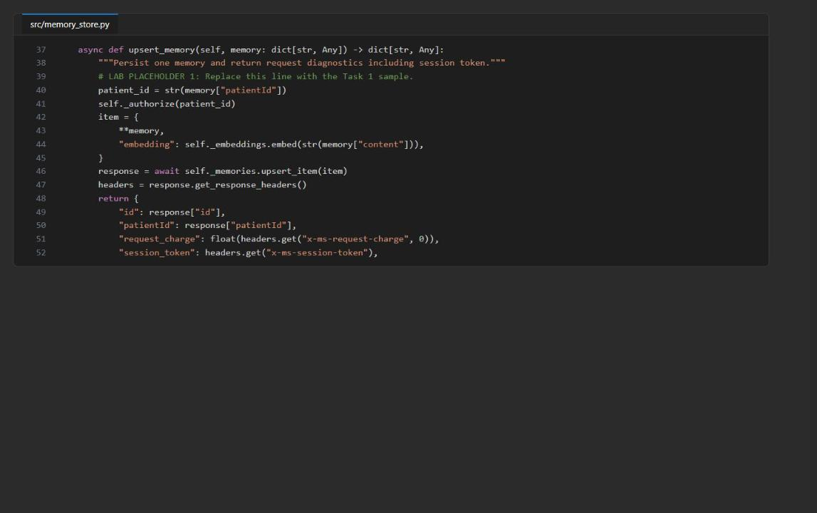
Figure 4: upsert_memory after placeholder 1

Placeholder 2: Run partition-scoped vector recall
1. In src/memory_store.py, find # LAB PLACEHOLDER 2: Replace this line with the Task 2 sample. in vector_recall.
2. Replace the line raise NotImplementedError("Complete vector_recall in Task 2") with the following code, then press Tab twice:
PYTHON
self._authorize(patient_id)
if isinstance(top_k, bool) or not isinstance(top_k, int) or not 1 <= top_k <= 20:
raise ValueError("top_k must be an integer from 1 through 20")
embedding = self._embeddings.embed(query_text)
query = f"""
SELECT TOP {top_k}
c.id, c.patientId, c.content, c.importance, c.memoryType,
c.critical, c.timestamp, c.ttl,
VectorDistance(c.embedding, @embedding) AS vector_distance
FROM c
WHERE c.patientId = @patientId
ORDER BY VectorDistance(c.embedding, @embedding)
"""
response_headers: dict[str, str] = {}
iterator = self._memories.query_items(
query=query,
parameters=[
{"name": "@patientId", "value": patient_id},
{"name": "@embedding", "value": embedding},
],
partition_key=patient_id,
response_hook=lambda headers, _: response_headers.update(headers),
)
results = [item async for item in iterator]
request_charge = float(response_headers.get("x-ms-request-charge", 0))
for item in results:
item["request_charge"] = request_charge
return results

Only the validated integer is interpolated into TOP; the patient ID and the embedding stay as query parameters, and partition_key restricts the query to one patient partition. The quantizedFlat index needs at least 1,000 vectors before performance conclusions are meaningful; the six starter records validate behavior only.
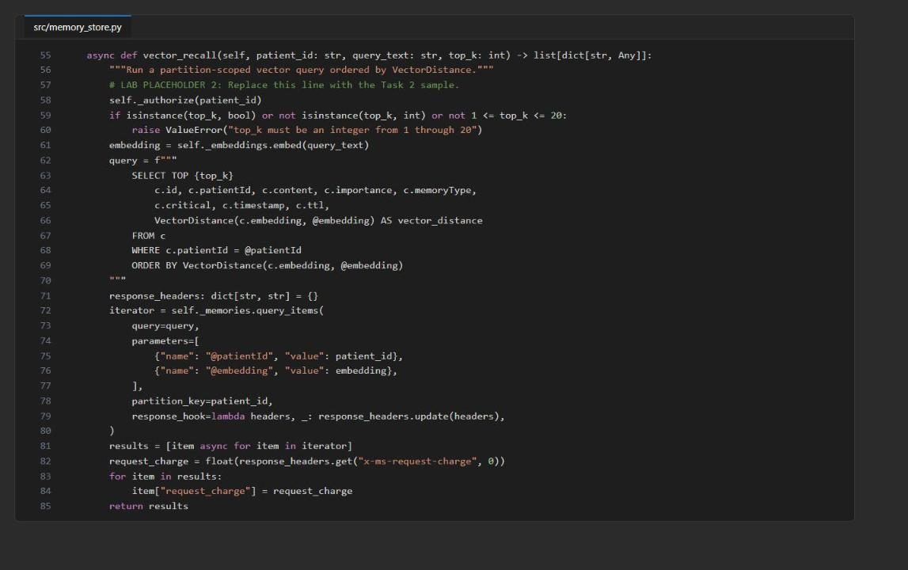
Figure 5: vector_recall after placeholder 2

Placeholder 3: Write content-free audit evidence
1. In src/memory_store.py, find # LAB PLACEHOLDER 3: Replace this line with the Task 3 sample. in write_audit.
2. Replace the line raise NotImplementedError("Complete write_audit in Task 3") with the following code, then press Tab twice:
PYTHON
self._authorize(patient_id)
await self._audit.upsert_item(
{
"id": event_id or str(uuid4()),
"patientId": patient_id,
"operation": operation,
"memoryIds": sorted(set(memory_ids)),
"reason": reason,
"timestamp": event_timestamp or datetime.now(UTC).isoformat(),
}
)

The audit event names the operation and affected IDs but deliberately excludes memory content and embeddings.
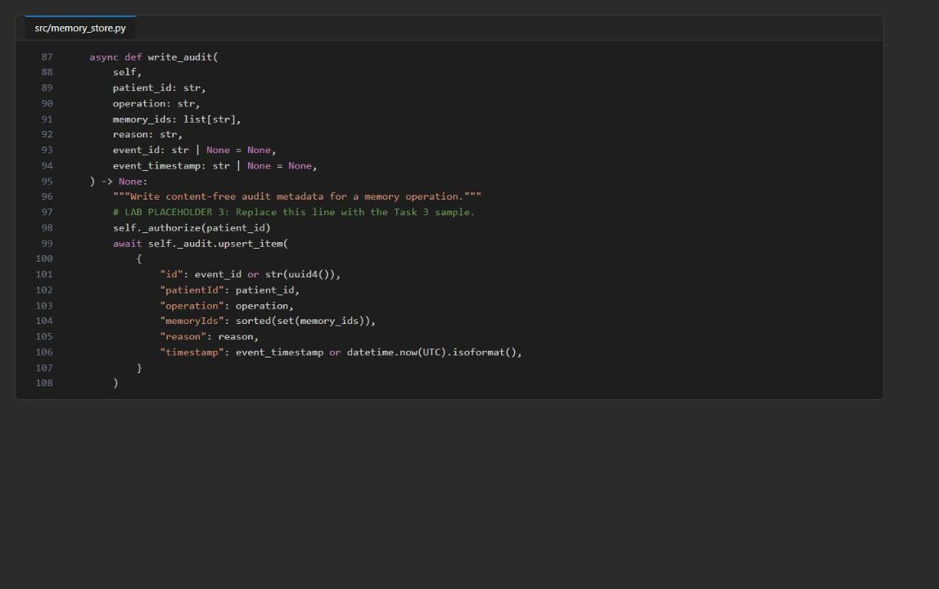
Figure 6: write_audit after placeholder 3

Placeholder 4: Prove read-your-writes consistency
1. Open src/consistency.py and find # LAB PLACEHOLDER 4: Replace this line with the Task 4 sample. in validate_read_your_writes.
2. Replace the line raise NotImplementedError(...) with the following code, then press Tab once:
PYTHON
diagnostics = await store.upsert_memory(memory)
session_token = diagnostics.get("session_token")
if not session_token:
raise RuntimeError("The write response did not include a session token")
item = await store._memories.read_item(
item=memory["id"],
partition_key=memory["patientId"],
session_token=session_token,
)
return {
"write_id": diagnostics["id"],
"read_id": item["id"],
"patientId": item["patientId"],
"session_token_transferred": True,
"request_charge": diagnostics["request_charge"],
}

The point read uses the same partition key and the session token from the write, which gives an explicit read-your-writes guarantee.
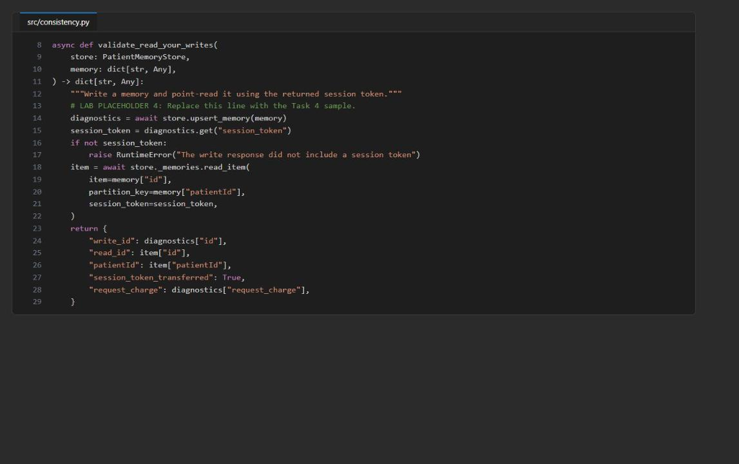
Figure 7: validate_read_your_writes after placeholder 4

Placeholder 5: Build bounded memory context
1. Open src/context_budget.py and find # LAB PLACEHOLDER 5: Replace this line with the Task 5 sample. in select_context.
2. Replace the line raise NotImplementedError(...) with the following code, then press Tab once:
PYTHON
if token_budget < 1:
raise ValueError("token_budget must be positive")
recent_count = max(1, (len(memories) * 3 + 9) // 10) if memories else 0
recent = sorted(memories, key=lambda item: str(item["timestamp"]), reverse=True)[:recent_count]
ranked = sorted(
memories,
key=lambda item: (
float(item.get("importance", 0)) * 0.5
+ (1.0 / (1.0 + float(item.get("vector_distance", 1)))) * 0.5
),
reverse=True,
)
ordered = recent + [item for item in ranked if item not in recent]
selected: list[dict[str, Any]] = []
blocks: list[str] = []
used = estimate_tokens("<patient_memory>\n</patient_memory>")
for item in ordered:
block = f"<memory id=\"{item['id']}\">{item['content']}</memory>"
cost = estimate_tokens(block)
if used + cost <= token_budget:
selected.append(item)
blocks.append(block)
used += cost
return {
"selected_ids": [item["id"] for item in selected],
"token_count": used,
"context": "<patient_memory>\n" + "\n".join(blocks) + "\n</patient_memory>",
}

The most recent 30% of records are reserved first; the rest are ranked by importance and vector score. The <patient_memory> delimiters separate stored memory from instructions.
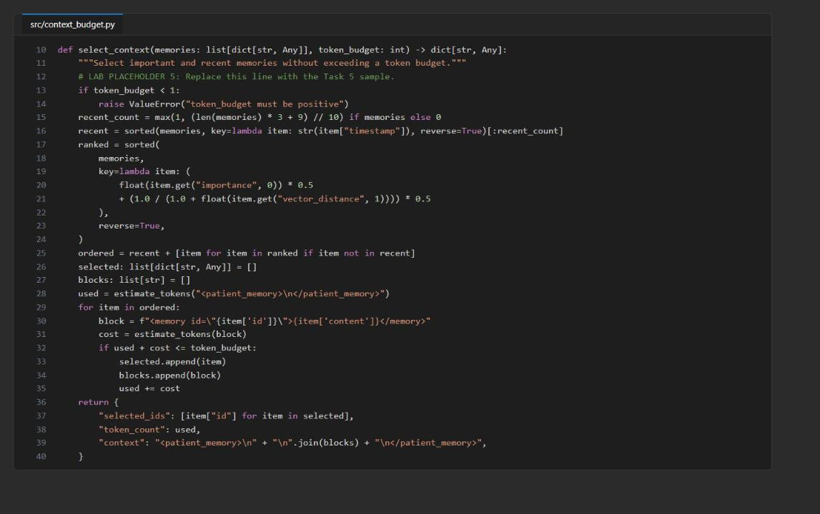
Figure 8: select_context after placeholder 5

Placeholder 6: Apply retention and audit deletion
1. Open src/retention.py and find # LAB PLACEHOLDER 6: Replace this line with the Task 6 sample. in prune_memories.
2. Replace the line raise NotImplementedError(...) with the following code, then press Tab once:
PYTHON
store._authorize(patient_id)
eligible_ids = sorted(
str(memory["id"])
for memory in memories
if memory.get("patientId") == patient_id
and not bool(memory.get("critical"))
and int(memory.get("ttl", -1)) > 0
and datetime.fromisoformat(
str(memory["timestamp"]).replace("Z", "+00:00")
) + timedelta(seconds=int(memory["ttl"])) <= datetime.now(UTC)
and float(memory.get("importance", 0)) <= 4.0
)
if dry_run:
return {"status": "dry_run", "eligible_ids": eligible_ids, "deleted_count": 0}
for memory_id in eligible_ids:
await store._memories.delete_item(item=memory_id, partition_key=patient_id)
if eligible_ids:
await store.write_audit(
patient_id,
"retention_prune",
eligible_ids,
"expired noncritical memory with finite TTL and importance at or below 4.0",
)
return {
"status": "applied",
"eligible_ids": eligible_ids,
"deleted_count": len(eligible_ids),
}

Dry run and apply use the same rule: a record is eligible only if it is not critical, has a finite TTL, its timestamp plus TTL is in the past, and its importance is 4.0 or lower. Each delete is partition-scoped and is audited.
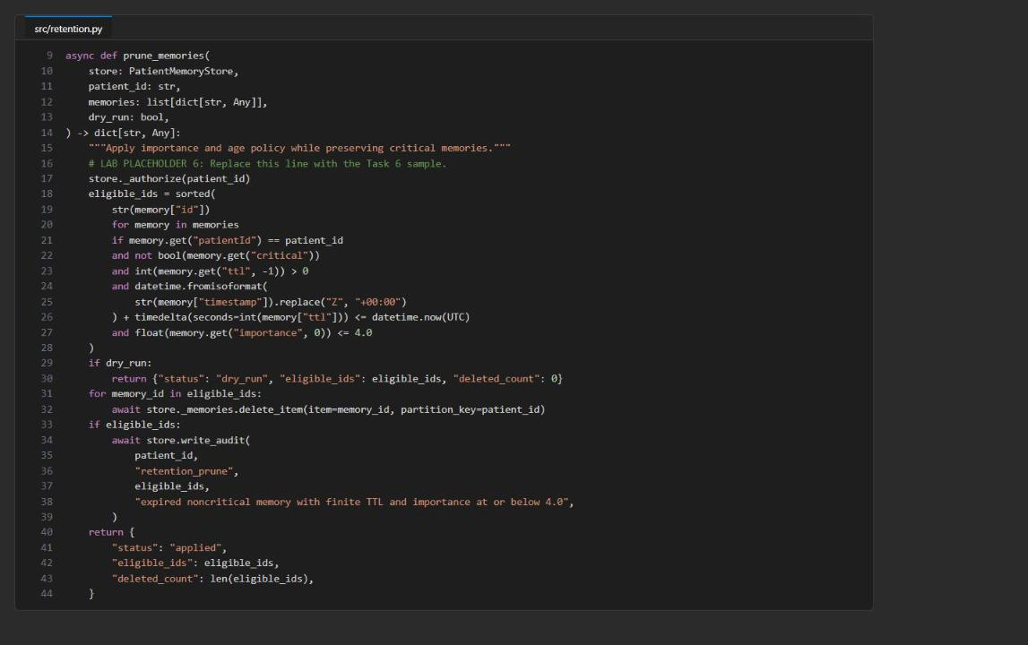
Figure 9: prune_memories after placeholder 6

Review guarded consolidation (no code change)
1. In src/memory_store.py, read consolidate_episodic_memories. It point-reads every source in the patient partition, derives the TTL from the sources, and sends the semantic-memory create plus an ETag-conditional patch of every source in one Cosmos DB transactional batch (same patientId partition), so lineage changes commit all-or-nothing. The deterministic semantic ID (semantic-<sha256>) and audit ID make retries idempotent.

Check the completed code
1. Save all files and run preflight:
POWERSHELL
python scripts/preflight.py

Expected result: three ... configured: True lines and Preflight passed. Live service values may remain unset until provisioning. If you see an IndentationError or Preflight failed, fix the indentation of the reported file.

Task 5: Run the solution

Run the memory operations
1. Load the synthetic memories and capture the write diagnostics:
POWERSHELL
python -m src.main ingest --file assets/memories.json

Expected result: five entries (mem-100-1 to mem-100-5), each with patientId: synthetic-patient-100, a request_charge of about 25 RU, and a session_token. No memory content is printed. mem-200-1 is skipped on purpose because the store is bound to synthetic-patient-100.
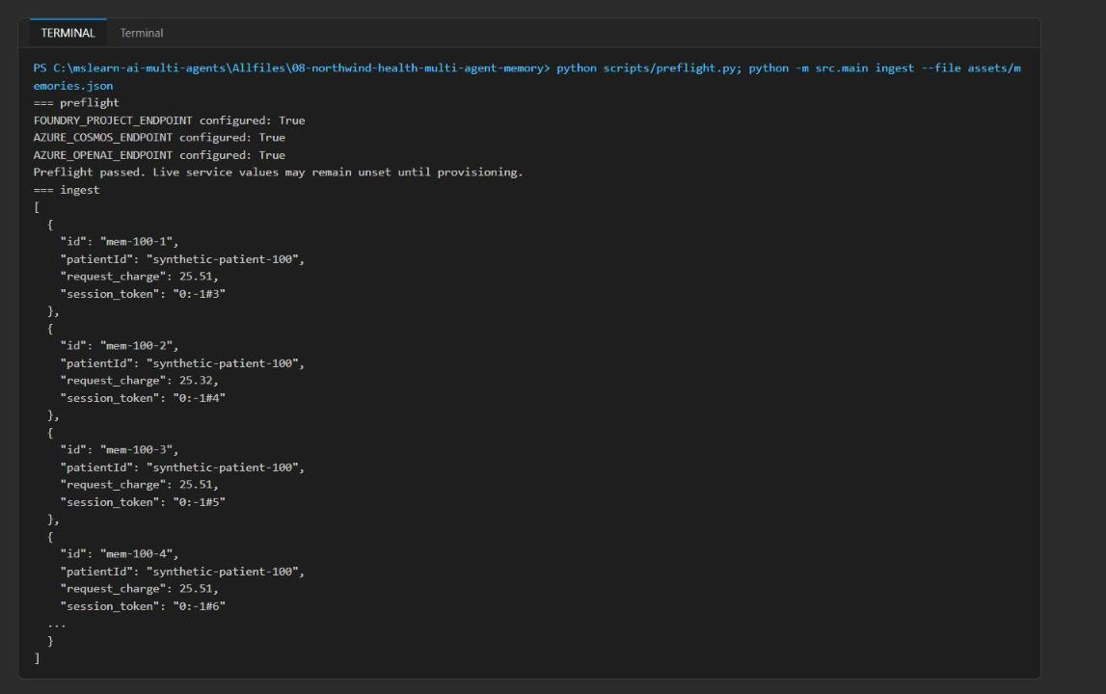
Figure 10: Preflight and ingest output
2. Recall memory for one patient and build the bounded context:
POWERSHELL
python -m src.main recall --patient-id synthetic-patient-100 --query "medication tolerance and appointment preferences" --top 5 --budget 500

Expected result: retrieved_memories contains five records, all for synthetic-patient-100, each with the same query request_charge (about 3.3 RU). bounded_context lists the selected IDs, a token_count of 500 or less (about 132), and a <patient_memory> block.
Note: The values in vector_distance appear in descending numeric order (for example 0.452, 0.435, 0.398, 0.373, 0.315). The container uses distanceFunction: cosine, and for cosine Cosmos DB VectorDistance returns a similarity score, so ORDER BY VectorDistance returns the most similar record first. The ordering is correct; the field name and the official lab text ("ascending") are misleading.

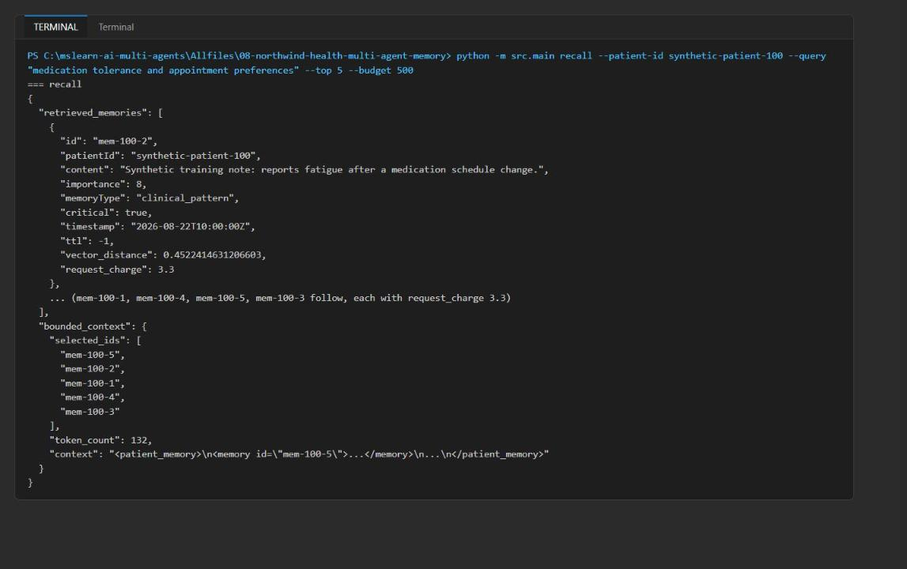
Figure 11: Partition-scoped vector recall and bounded context
3. Validate read-your-writes consistency:
POWERSHELL
python -m src.main consistency --patient-id synthetic-patient-100

4. Run a dry-run prune before allowing any deletion:
POWERSHELL
python -m src.main prune --patient-id synthetic-patient-100 --dry-run

Expected result: consistency shows the same write_id and read_id, session_token_transferred: true and the write RU charge. The dry run shows status: dry_run, eligible_ids mem-100-3, mem-100-4, mem-100-5, and deleted_count: 0. The critical record mem-100-2 (ttl -1) and the high-importance mem-100-1 are not eligible.
5. Consolidate the repeated episodic evidence into one reviewed semantic pattern. Run the dry run first, check that it lists the three sources, then apply it. (These are reminder preferences only; never infer a clinical pattern from them.)
POWERSHELL
python -m src.main consolidate --patient-id synthetic-patient-100 --source-id mem-100-3 --source-id mem-100-4 --source-id mem-100-5 --summary "Repeatedly requests written reminders before synthetic follow-ups." --reviewer-id reviewer-07 --dry-run

POWERSHELL
python -m src.main consolidate --patient-id synthetic-patient-100 --source-id mem-100-3 --source-id mem-100-4 --source-id mem-100-5 --summary "Repeatedly requests written reminders before synthetic follow-ups." --reviewer-id reviewer-07

Expected result: the dry run returns status: dry_run, a semantic_memory with sourceMemoryIds for the three sources, reviewerId: reviewer-07 and source_count: 3. The applied run returns status: consolidated, one semantic_memory_id (semantic-...), the three source_memory_ids, and write_diagnostics with transactional_batch: true and operation_count: 4.
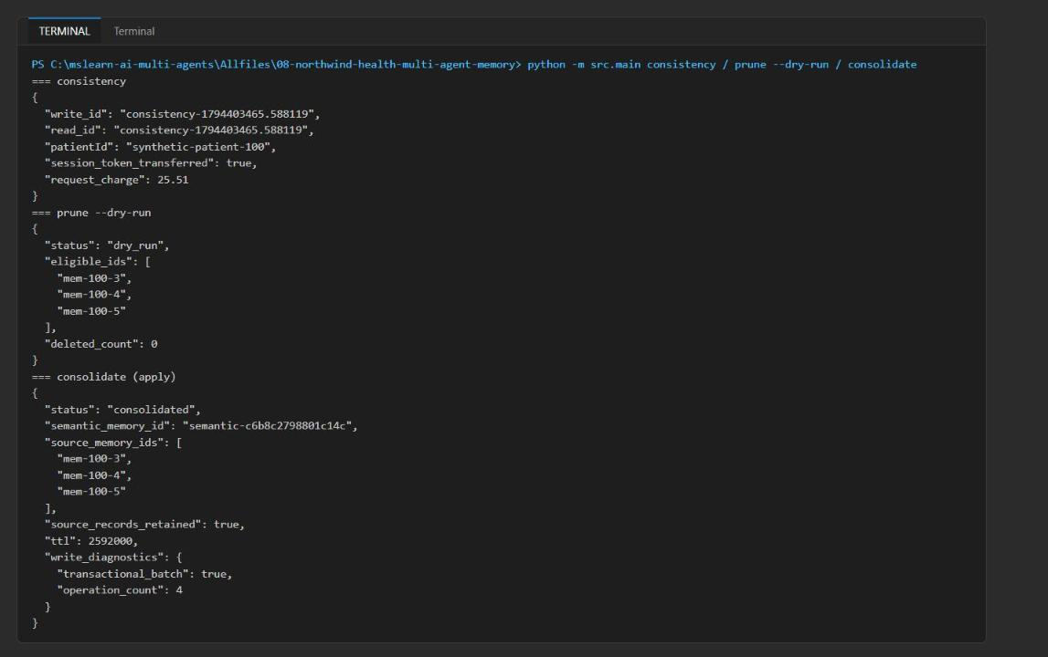
Figure 12: Consistency, prune dry run, and applied consolidation

Run the Memory Coordinator locally
1. Open a second terminal in the lab folder, activate the virtual environment, and start the local Responses server. Keep this terminal running:
POWERSHELL
cd Allfiles\08-northwind-health-multi-agent-memory
. ./.venv/Scripts/Activate.ps1
azd ai agent run memory-coordinator --no-client --start-command "python agent.py"

Expected result: the log shows Running on http://0.0.0.0:8088 (CTRL + C to quit).
Note: The --start-command "python agent.py" option is needed because some versions of the azure.ai.agents extension (for example 1.0.0-beta.23) cannot find the entry point from codeConfiguration.entryPoint in azure.yaml. If your version starts the server without it, you can omit it.

2. In the first terminal, invoke the local agent:
POWERSHELL
azd ai agent invoke memory-coordinator --local --new-session "What reminder and appointment preferences should the care team consider? Cite the supporting memory IDs."

Expected result: the answer lists written reminders, morning appointments, and written summaries, cites memory IDs such as semantic-..., mem-100-5, mem-100-4, mem-100-3 and mem-100-1, and says what the store does not contain. The server terminal logs Function recall_patient_memory succeeded. AGENT_PATIENT_ID binds the tool to synthetic-patient-100; the model cannot choose a patient ID.
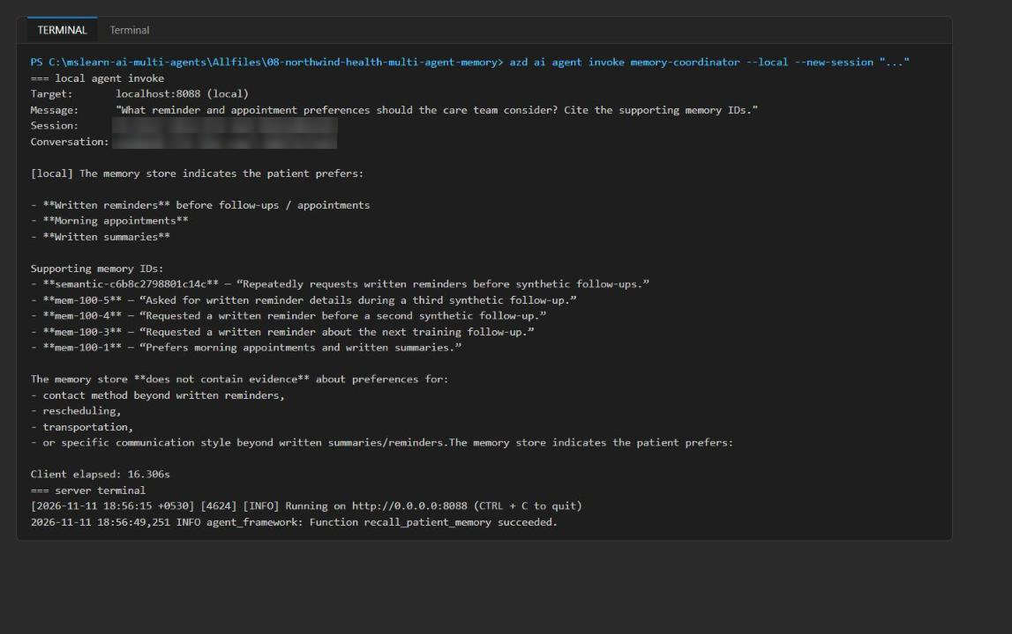
Figure 13: Local agent answer grounded in recalled memory IDs
3. Press Ctrl+C in the server terminal to stop the local agent.

Deploy the Hosted Agent
1. Deploy the same tested code to Foundry. azd packages the source, uploads it, and Foundry builds and starts the hosted agent northwind-health-memory-coordinator (about 2-3 minutes):
POWERSHELL
azd deploy memory-coordinator

Expected result: memory-coordinator: Done, an agent endpoint URL ending in /agents/northwind-health-memory-coordinator/endpoint/protocols/openai/responses?api-version=v1, and SUCCESS: Your application was deployed to Azure.

Grant the hosted agent identity access to the model and Cosmos DB
The deployed agent does not run as the project managed identity that the Bicep template grants roles to. Foundry creates a dedicated instance identity (a Microsoft Entra service principal) for each hosted agent at deploy time. Without its own roles, the first remote invoke fails with 401 and the agent answers that "the memory lookup failed". Grant the roles now.
1. Get the agent's instance identity principal ID:
POWERSHELL
azd ai agent show memory-coordinator

Expected result: the output includes Instance Identity Principal ID <agent-identity-principal-id> and Status active.
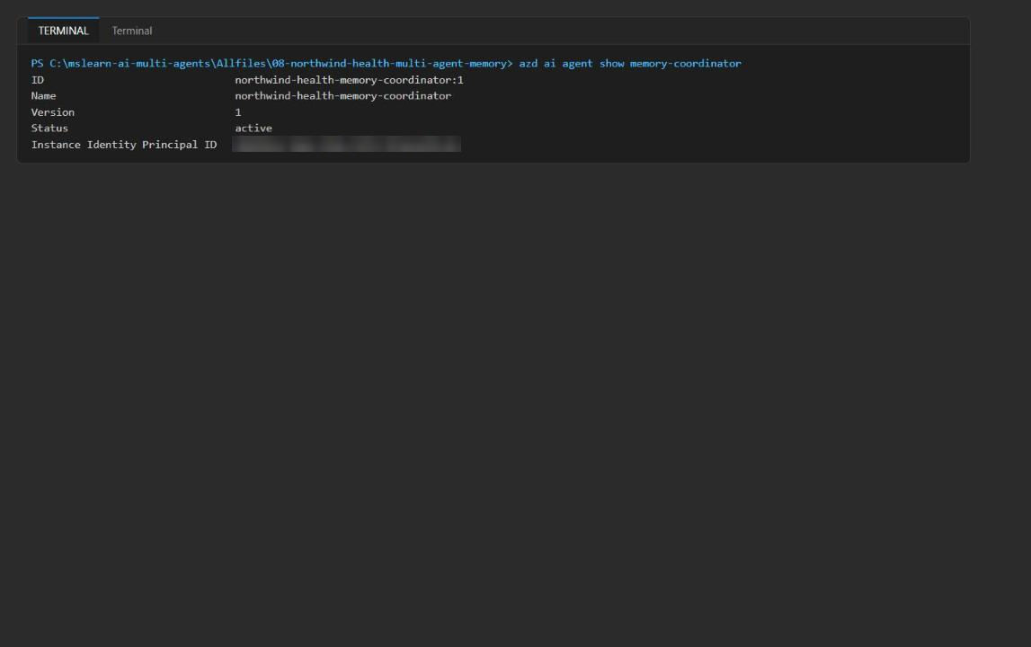
Figure 14: The hosted agent and its instance identity principal ID
2. Store the ID in a variable. You can copy it from the previous output, or read it with the REST API:
POWERSHELL
$projectEndpoint = (Get-Content .env | Select-String '^FOUNDRY_PROJECT_ENDPOINT=').ToString().Split('=',2)[1].Trim('"')
$agentPrincipalId = az rest --method get `
--url "$projectEndpoint/agents/northwind-health-memory-coordinator?api-version=v1" `
--resource "https://ai.azure.com" `
--query "instance_identity.principal_id" -o tsv
$agentPrincipalId

Note: You can also find it in the Foundry portal: open the project, select Build > Agents (or Agents), select northwind-health-memory-coordinator, and open Identity.

3. Grant the agent identity Cognitive Services OpenAI User on the Foundry account (it calls the embedding deployment through AZURE_OPENAI_ENDPOINT):
POWERSHELL
$foundryAccount = az cognitiveservices account list -g $resourceGroupName --query "[0].name" -o tsv
$foundryId = az cognitiveservices account show -g $resourceGroupName -n $foundryAccount --query id -o tsv
az role assignment create --assignee-object-id $agentPrincipalId --assignee-principal-type ServicePrincipal `
--role "Cognitive Services OpenAI User" --scope $foundryId --output none

4. Grant the agent identity the Cosmos DB Built-in Data Contributor data-plane role (role definition 00000000-0000-0000-0000-000000000002) on the Cosmos DB account:
POWERSHELL
$cosmosAccount = az cosmosdb list -g $resourceGroupName --query "[0].name" -o tsv
az cosmosdb sql role assignment create --account-name $cosmosAccount --resource-group $resourceGroupName `
--role-definition-id 00000000-0000-0000-0000-000000000002 `
--principal-id $agentPrincipalId --scope "/" --output none
az cosmosdb sql role assignment list --account-name $cosmosAccount --resource-group $resourceGroupName `
--query "[].{principal:principalId, role:roleDefinitionId}" -o table

Note: If you opened a new terminal since Task 3, set $resourceGroupName = '<your-resource-group>' first. Wait 1-5 minutes for the role assignments to propagate.

Expected result: the Cosmos role assignment list includes the agent principal ID alongside your user and the project identity. In the Azure portal, the Foundry account's Access control (IAM) > Role assignments shows the agent identity with Cognitive Services OpenAI User.
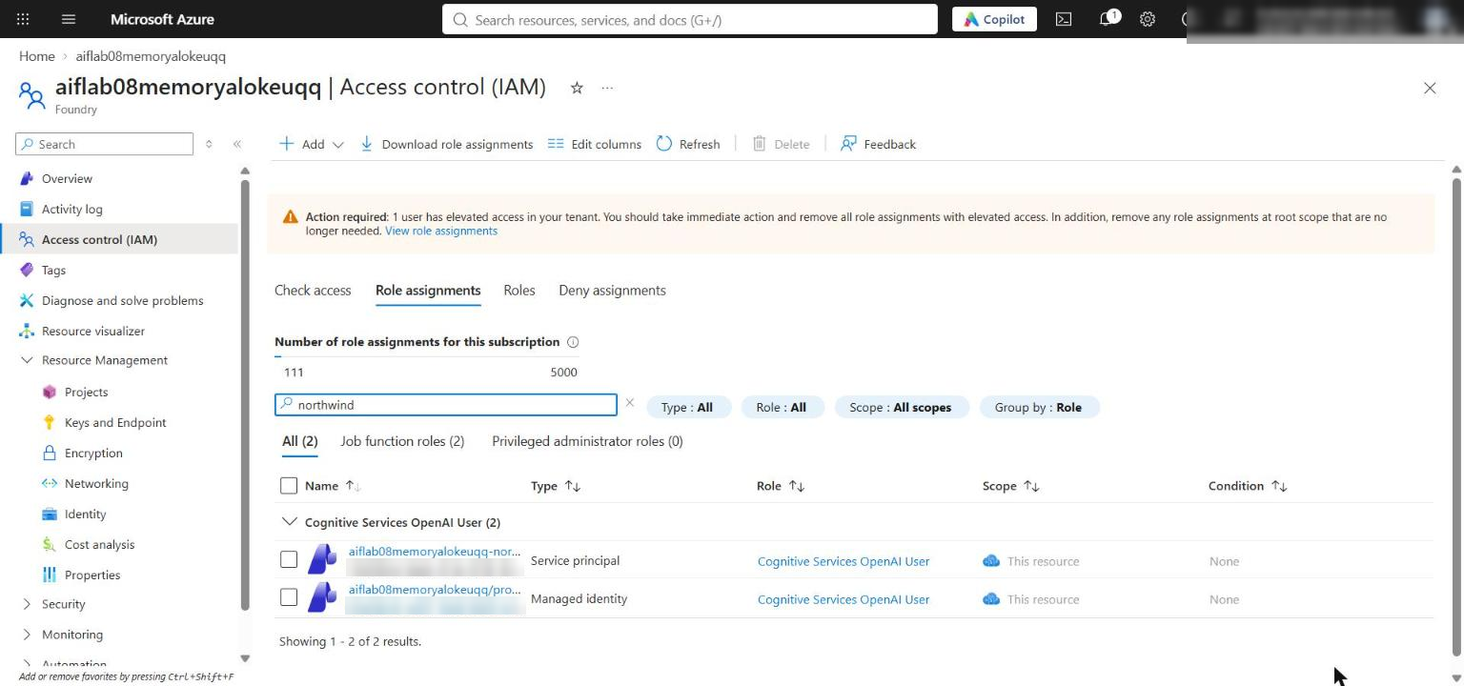
Figure 15: The hosted agent identity holds Cognitive Services OpenAI User on the Foundry account

Invoke the Hosted Agent
1. Invoke the deployed agent:
POWERSHELL
azd ai agent invoke memory-coordinator --new-session "What reminder and appointment preferences should the care team consider? Cite the supporting memory IDs."

Expected result: the (remote) agent answers with the reminder and appointment preferences and cites supporting memory IDs, limited to the bounded context. Foundry hosts the Responses endpoint and the model call; patient memory stays in Cosmos DB. Optionally run azd ai agent monitor memory-coordinator to see Function recall_patient_memory succeeded. and embeddings ... 200 OK in the hosted log.
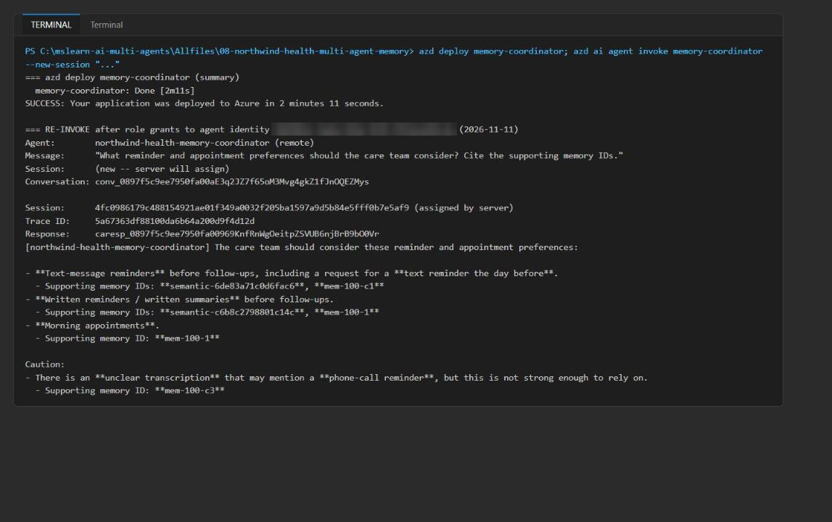
Figure 16: Deployed hosted agent answer after the role grants

Task 6: Validate the implementation

Review evidence from the commands you already ran
1. Use the Task 5 output to confirm:
- ingest reports each ID, patientId, RU charge and a session token, without content.
- recall returns only synthetic-patient-100 records, each with the same query request_charge, ordered most-similar first, and bounded_context.token_count is 500 or less.
- consistency shows matching write_id and read_id, session_token_transferred: true, and the write RU charge.
- prune --dry-run shows status: dry_run, deleted_count: 0, and the eligible IDs, and preserves the critical record.
- Consolidation dry run shows three sources and no writes; the applied run shows status: consolidated, one semantic ID, the three retained sources, and transactional-batch diagnostics.
- Both the local and the deployed agent call recall_patient_memory, cite memory IDs, and stay within the bounded context.

Inspect the persisted records in the portals
1. In the Foundry portal, open the lab project, confirm both deployments exist, then open Agents and confirm northwind-health-memory-coordinator has an active deployed version.
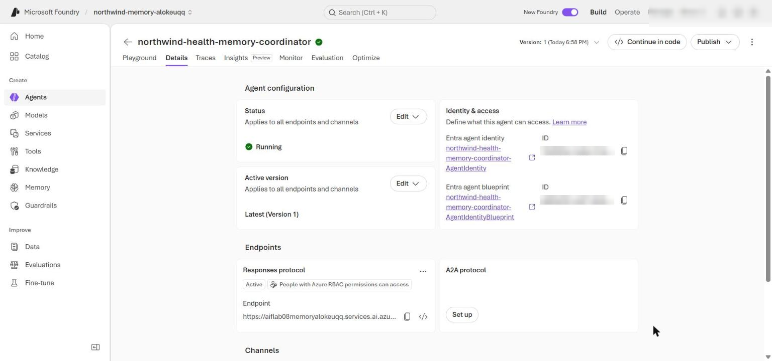
Figure 17: The deployed Memory Coordinator in the Foundry portal
2. In the Azure portal, open the Cosmos DB account and select Data Explorer > clinical-memory-db > patient-memories > Items.
3. Open mem-100-1 and confirm it has patientId, schemaVersion, memoryType, importance, timestamp, ttl, and an embedding array (1,536 numbers, as required by the container's vector embedding policy).
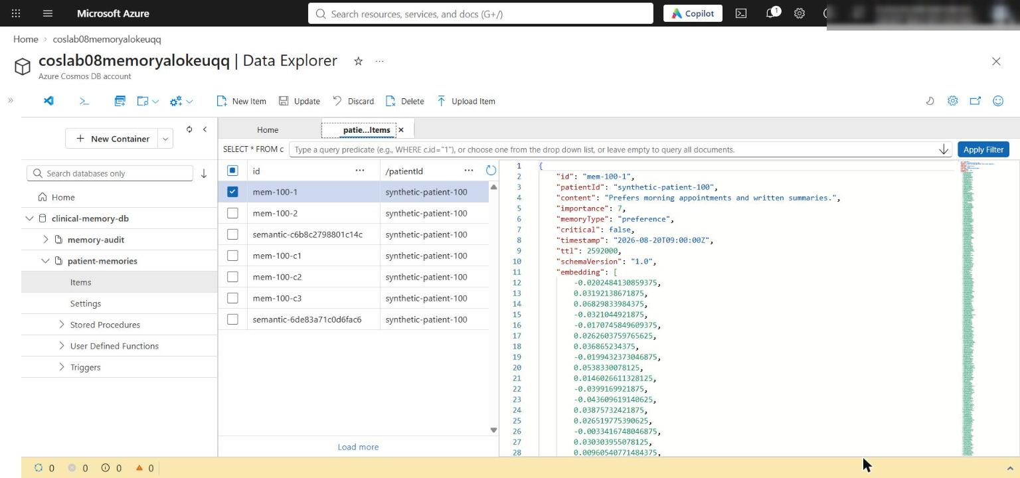
Figure 18: A persisted memory item with its schema fields and embedding array
4. Open mem-100-3, mem-100-4 and mem-100-5 and confirm all three still exist and contain the same consolidatedInto semantic ID.
5. Open the semantic-... document and confirm memoryType is semantic_pattern, sourceMemoryIds contains the three source IDs, and reviewerId is reviewer-07.
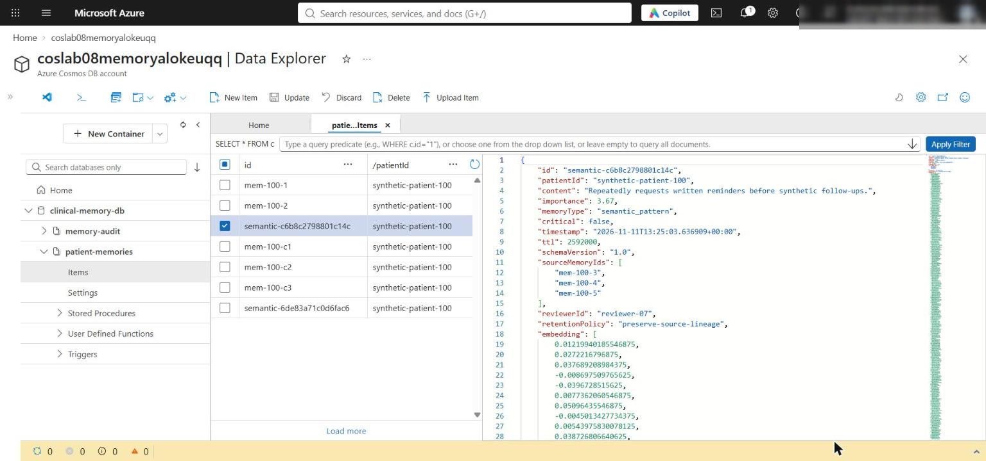
Figure 19: The consolidated semantic_pattern document with its source lineage
These checks validate persistence and lineage; the terminal output remains the evidence for vector ordering, RU charge, context budgeting, and session-token transfer.

Complete the remaining live checks
1. Rerun the applied consolidation before pruning to prove retries are idempotent:
POWERSHELL
python -m src.main consolidate --patient-id synthetic-patient-100 --source-id mem-100-3 --source-id mem-100-4 --source-id mem-100-5 --summary "Repeatedly requests written reminders before synthetic follow-ups." --reviewer-id reviewer-07

Expected result: status: already_consolidated with the same semantic ID and source IDs. No duplicate semantic memory is created.
2. Apply the retention policy. This deletes the eligible noncritical, finite-TTL records, so run it only after steps 5-7:
POWERSHELL
python -m src.main prune --patient-id synthetic-patient-100

Expected result: status: applied, eligible_ids mem-100-3, mem-100-4, mem-100-5, and deleted_count: 3.
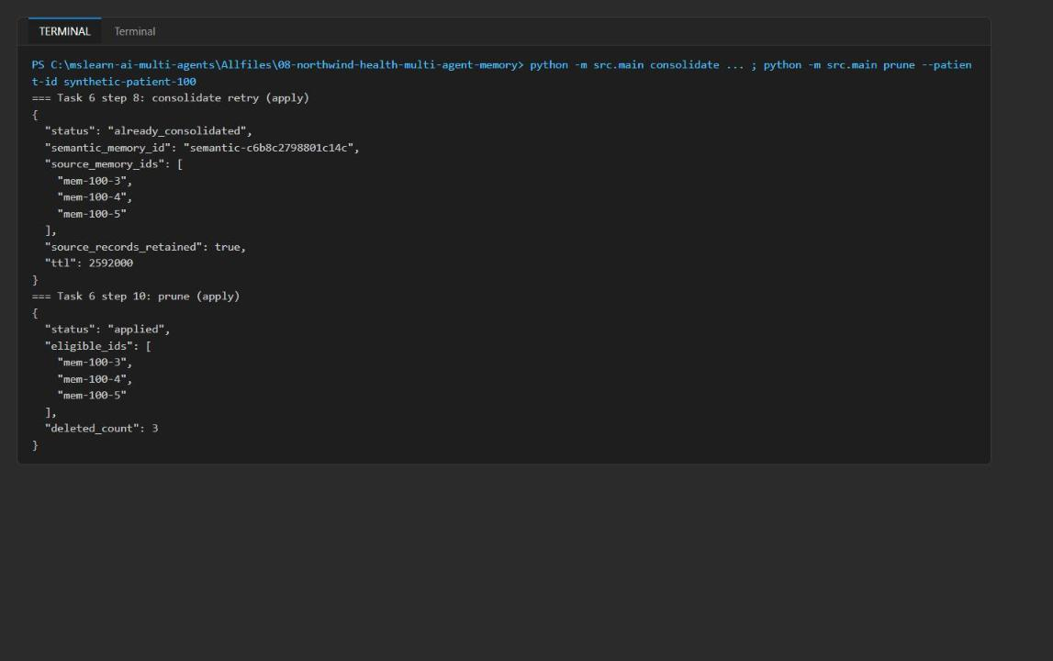
Figure 20: Idempotent consolidation retry and applied prune
3. In Data Explorer, select clinical-memory-db > memory-audit > Items. Open the event whose operation is retention_prune and confirm it contains patientId, operation, memoryIds, reason and timestamp, but no memory content and no embedding. You also see the audit-semantic-... consolidation event.
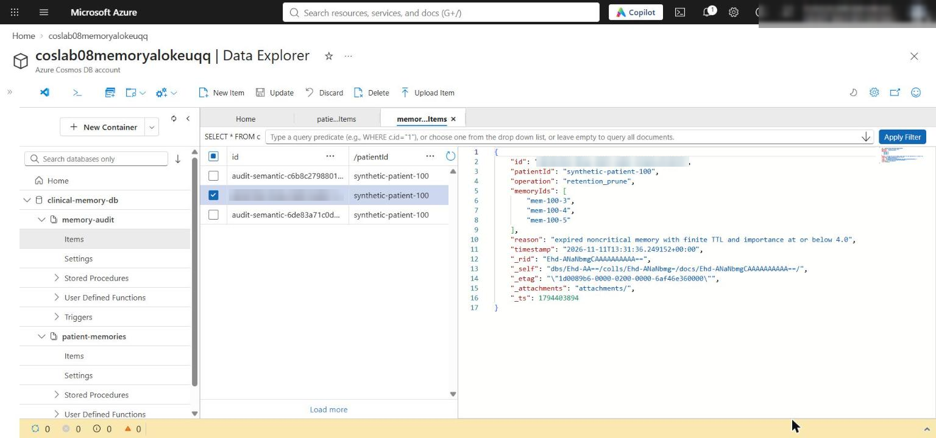
Figure 21: Content-free retention_prune audit event
4. Review _authorize in src/memory_store.py. It raises PermissionError when the requested patient differs from the patient bound to the store, and it is the first statement in upsert, recall, audit, and consolidate (and in prune through store._authorize), so it runs before any embedding or Cosmos DB I/O.
Acceptance criteria
Criterion | How to check
Ingest reports ID, patientId, RU and session token, no content | ingest output (Task 5 step 1)
Recall returns only the bound patient, same query RU per record | recall output; every patientId is synthetic-patient-100
Recall ordered by VectorDistance (most similar first) | vector_distance values decrease (cosine similarity)
bounded_context.token_count is 500 or less | recall output
Read-your-writes: write_id equals read_id, token transferred | consistency output
Prune dry run: dry_run, deleted_count 0, critical preserved | prune --dry-run output
Consolidation applied in one transactional batch | status: consolidated, transactional_batch: true, operation_count: 4
Retry is idempotent | status: already_consolidated, same semantic ID
Prune apply deletes eligible records | status: applied, deleted_count: 3
Audit is content-free | Data Explorer > memory-audit > retention_prune item
Persisted schema and 1,536-dim embedding | Data Explorer > patient-memories > mem-100-1
Semantic lineage | Data Explorer > semantic-... item: sourceMemoryIds, reviewerId
Deployments exist and agent version is active | Foundry portal, or az cognitiveservices account deployment list -g <rg> -n <foundry-account> -o table and azd ai agent show memory-coordinator
Local and hosted agent grounded with cited IDs | azd ai agent invoke output (local and remote)
_authorize before any I/O | Code review of src/memory_store.py

Optional challenge: Gate memory consolidation
Add a synthetic confidence field and consolidate only evidence at or above a documented threshold (0.8 in this solution). Low-confidence evidence stays in source history but is not consolidated; the semantic record stores the threshold, the rejected IDs, and the reviewer.
1. Create assets/challenge-memories.json with this content:
JSON
[
{"id":"mem-100-c1","patientId":"synthetic-patient-100","content":"Asked for a text-message reminder the day before a synthetic follow-up.","importance":4.0,"memoryType":"episodic","critical":false,"timestamp":"2026-10-01T12:00:00Z","ttl":2592000,"schemaVersion":"1.0","confidence":0.92},
{"id":"mem-100-c2","patientId":"synthetic-patient-100","content":"Confirmed a text-message reminder works best before synthetic follow-ups.","importance":4.0,"memoryType":"episodic","critical":false,"timestamp":"2026-10-08T12:00:00Z","ttl":2592000,"schemaVersion":"1.0","confidence":0.85},
{"id":"mem-100-c3","patientId":"synthetic-patient-100","content":"Unclear transcription that may mention a phone-call reminder.","importance":2.0,"memoryType":"episodic","critical":false,"timestamp":"2026-10-15T12:00:00Z","ttl":2592000,"schemaVersion":"1.0","confidence":0.40}
]

2. In src/main.py, in _parser(), find the line consolidate.add_argument("--dry-run", action="store_true") and add this line directly below it (same indentation, 4 spaces):
PYTHON
consolidate.add_argument("--min-confidence", type=float, default=None)

3. In src/main.py, in _run(), find the call to store.consolidate_episodic_memories(...) and add args.min_confidence, as the last argument, directly below args.dry_run, (same indentation):
PYTHON
args.min_confidence,

4. In src/memory_store.py, change the consolidate_episodic_memories signature by adding a new last parameter below dry_run: bool, (8-space indentation, same as dry_run):
PYTHON
min_confidence: float | None = None,

5. In the same method, select the block that starts with digest = hashlib.sha256(...) and ends with raise ValueError("Every consolidation source must be episodic") (the digest, semantic ID, source reads, and episodic check), and replace it with the following code. After pasting, press Tab twice so it lines up with self._authorize(patient_id):
PYTHON
sources = [
await self._memories.read_item(item=memory_id, partition_key=patient_id)
for memory_id in unique_ids
]
if any(source.get("memoryType") != "episodic" for source in sources):
raise ValueError("Every consolidation source must be episodic")
# Optional challenge: confidence gate. Sources below the documented threshold stay
# untouched in source history and are excluded from the consolidated pattern.
rejected_ids: list[str] = []
if min_confidence is not None:
if not 0.0 <= min_confidence <= 1.0:
raise ValueError("min_confidence must be between 0.0 and 1.0")
rejected_ids = [
str(source["id"])
for source in sources
if float(source.get("confidence", 0.0)) < min_confidence
]
sources = [source for source in sources if str(source["id"]) not in rejected_ids]
unique_ids = [str(source["id"]) for source in sources]
if len(unique_ids) < 2:
raise ValueError("Fewer than two sources meet the confidence threshold")
digest = hashlib.sha256(f"{patient_id}:{':'.join(unique_ids)}".encode()).hexdigest()[:16]
semantic_id = f"semantic-{digest}"

6. Still in the method, find the line "retentionPolicy": "preserve-source-lineage", and the closing } of the semantic = {...} dictionary. Directly below that closing } (and above if dry_run:), add the following code (8-space indentation, press Tab twice after pasting):
PYTHON
if min_confidence is not None:
semantic["confidenceThreshold"] = min_confidence
semantic["rejectedSourceIds"] = rejected_ids

7. In both returned dictionaries that contain "status": "already_consolidated" and "status": "consolidated", add this entry directly below the "source_memory_ids": unique_ids, line (same indentation):
PYTHON
"rejected_source_ids": rejected_ids,

8. Run preflight, ingest the challenge records, then consolidate with the threshold (dry run, apply, and repeat for idempotency):
POWERSHELL
python scripts/preflight.py
python -m src.main ingest --file assets/challenge-memories.json
python -m src.main consolidate --patient-id synthetic-patient-100 --source-id mem-100-c1 --source-id mem-100-c2 --source-id mem-100-c3 --summary "Prefers text-message reminders before synthetic follow-ups." --reviewer-id reviewer-07 --min-confidence 0.8 --dry-run
python -m src.main consolidate --patient-id synthetic-patient-100 --source-id mem-100-c1 --source-id mem-100-c2 --source-id mem-100-c3 --summary "Prefers text-message reminders before synthetic follow-ups." --reviewer-id reviewer-07 --min-confidence 0.8
python -m src.main consolidate --patient-id synthetic-patient-100 --source-id mem-100-c1 --source-id mem-100-c2 --source-id mem-100-c3 --summary "Prefers text-message reminders before synthetic follow-ups." --reviewer-id reviewer-07 --min-confidence 0.8

Expected result: mem-100-c1 (0.92) and mem-100-c2 (0.85) are consolidated (operation_count: 3) and mem-100-c3 (0.40) appears in rejected_source_ids; it keeps no consolidatedInto. The semantic record stores confidenceThreshold: 0.8, rejectedSourceIds and reviewerId. The repeated run returns already_consolidated with the same ID, because the semantic ID is derived deterministically from the accepted source IDs.
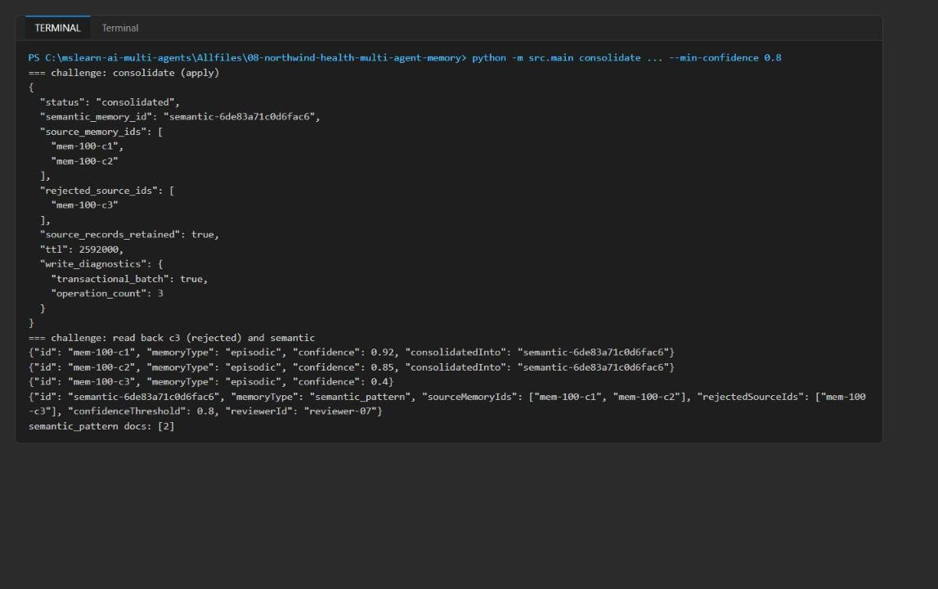
Figure 22: Confidence-gated consolidation and its idempotent retry

Troubleshooting
Symptom | Cause and fix
Remote azd ai agent invoke answers "the memory lookup failed"; hosted log shows 401 | The hosted agent runs as its own instance identity, not the project managed identity that Bicep grants roles to. Do Task 5 steps 10-13 (Cognitive Services OpenAI User on the Foundry account and Cosmos DB Built-in Data Contributor), wait a few minutes, and invoke again with --new-session.
azd ai agent run cannot find the entry point | Start it with --start-command "python agent.py".
ARM IDs in the azd environment look like C:/Program Files/Git/subscriptions/... | azd env set was run in Git Bash. Re-run Task 3 step 7 in PowerShell, or prefix with MSYS_NO_PATHCONV=1.
recall shows vector_distance descending, not ascending | Expected: with the cosine distance function VectorDistance returns similarity, and ORDER BY returns the most similar first.
ingest writes only five records | Expected: mem-200-1 belongs to another patient and is skipped because the store is bound to synthetic-patient-100.
Forbidden / 403 from Cosmos DB or 401 from the model when running locally | RBAC is still propagating (wait 1-5 minutes), or you are signed in to a different tenant or subscription (az account show).
IndentationError in preflight | A placeholder snippet is not aligned with its # LAB PLACEHOLDER comment. Select the snippet and use Tab or Shift+Tab.
Deployment fails with quota or InvalidResourceLocation | Choose another region with Cosmos DB vector search and GlobalStandard quota for both models, and use a new resource group.
already_consolidated is not returned on retry | You pruned before retrying; run the retry (Task 6 step 7) before the prune.

Review questions
1. Which memory fields should be immutable after creation? id, patientId (also the partition key), content, memoryType, timestamp, schemaVersion, embedding (must match content), and lineage fields such as sourceMemoryIds and reviewerId. Only lifecycle metadata such as consolidatedInto, supersededBy, ttl and status flags should change; corrections are new records.
2. How should a contradiction supersede an older memory without destroying audit history? Write a new memory with supersedes: <oldId> and a reason, and in the same partition-scoped transactional batch patch the old record with supersededBy under an ETag condition. Write a content-free audit event naming both IDs. Recall excludes superseded records by default; the old record is kept or expires through retention.
3. When is explicit session-token transfer required instead of client-local token management? When the read happens on a different CosmosClient or process than the write: another agent, another hosted replica, another worker, or after a restart. The SDK tracks session tokens only inside one client, so other readers need the token from the write response.
4. What would a right-to-deletion verification query need to prove? That SELECT VALUE COUNT(1) FROM c WHERE c.patientId=@p returns 0 in patient-memories (including derived semantic records and embeddings); that no other partition or container references the patient's content; that the audit container holds a content-free deletion event with IDs, actor, reason and timestamp; and that the check ran with a post-delete session token (or strong consistency) so a stale replica cannot hide leftovers.

Clean up (optional)
1. Delete the resource group, which removes the Cosmos DB account, the Foundry account and project, the model deployments, and the Hosted Agent:
POWERSHELL
az group delete --name $resourceGroupName --yes --no-wait

2. Purge the soft-deleted Foundry account so its name and quota are released (after the group deletion completes):
POWERSHELL
az cognitiveservices account list-deleted --query "[].{name:name, location:location}" -o table
az cognitiveservices account purge --name <foundry-account-name> --resource-group $resourceGroupName --location $azureRegion

3. Remove the local azd environment and the .env file:
POWERSHELL
Remove-Item -Recurse -Force .azure\lab08-memory-dev
Remove-Item .env

4. Run deactivate in every terminal that shows (.venv):
POWERSHELL
deactivate

