Lab 11: Govern a Foundry multi-agent code review

Overview
Fabrikam uses specialized AI agents to review customer code. A security reviewer finds vulnerabilities, a fairness auditor checks whether equivalent technology stacks (Python and Node) get consistent outcomes, and a governance orchestrator combines their evidence. Because a recommendation can delay a deployment, Fabrikam must screen each request, minimize every handoff, keep agent attribution, and require human review when a policy threshold is exceeded.
In this lab you will:
- Deploy a Microsoft Foundry project, a gpt-5.4-mini model deployment with Foundry's default guardrails, Log Analytics and workspace-based Application Insights by using Bicep and the Azure CLI.
- Complete a deterministic, fail-closed human-review policy gate in Python.
- Run the workflow locally (deterministic) and live (three Foundry prompt agents).
- Validate data minimization, agent attribution, guardrails, the fairness boundary, and Application Insights evidence.
Duration: about 45 minutes.
Important: The model deployment, Log Analytics and Application Insights are billable. Use only the supplied synthetic data and delete the resource group when you finish (see Clean up).

Architecture
Component | Purpose
Microsoft Foundry account + project (fdry<unique>, lab11-<env>) | Hosts the three prompt agents and the model deployment
Model deployment gpt-5.4-mini (GlobalStandard, guardrail Microsoft.DefaultV2) | Model used by all agents; default guardrails screen prompts and completions
Agent security-reviewer | Receives only request ID, the synthetic source fragment and the CWE reference
Agent fairness-auditor | Receives only request ID, group rates, disparity and the policy threshold
Agent governance-orchestrator | Receives minimized specialist results and the deterministic policy decision
Log Analytics log-lab11-<unique> + Application Insights appi-lab11-<unique> | Stores the fabrikam.governance.evidence trace and Foundry traces
policy/governance-policy.yaml | Versioned policy: fairness threshold 0.10, required/prohibited evidence fields, allowed agent inputs
src/governance.py, src/main.py | Fairness calculation, payload minimization, hashing, evidence, deterministic and --live orchestration
kql/governance-evidence.kql | Accountability query over the minimized evidence

Prerequisites
- An Azure subscription where you can create a resource group, Microsoft Foundry, model deployment and monitoring resources, and assign roles (Owner, or Contributor + User Access Administrator).
- Quota for gpt-5.4-mini (GlobalStandard) in your region. This guide uses eastus2.
- Python 3.10 or later
- Git
- Azure CLI (with Bicep: az bicep install)
- Visual Studio Code with the Python and Bicep extensions
Note: The official lab uses the Azure Developer CLI (azd provision). This guide provisions the same Bicep template with the Azure CLI instead, so azd is not required.

Task 1: Prepare the lab
1. Clone the lab repository (skip if you already have it):
POWERSHELL
git clone https://github.com/MicrosoftLearning/mslearn-ai-multi-agents.git

2. Open the mslearn-ai-multi-agents folder in Visual Studio Code, and open a PowerShell terminal (Terminal > New Terminal).
3. Go to the lab folder and check the tools:
POWERSHELL
cd Allfiles\11-fabrikam-responsible-ai-governance
az version
python --version

4. Sign in to Azure and confirm the subscription you want to use:
POWERSHELL
az login
az account show --output table

If the wrong subscription is shown, select the right one:
POWERSHELL
az account set --subscription "<your-subscription-id>"

5. Review the architecture before editing. Open each file and find the item listed:
Component | What to locate
assets/governance-scenario.json and policy/governance-policy.yaml | Synthetic inputs, fairness threshold (0.10) and human-review policy
src/governance.py | Fairness calculation, minimized payloads, identifier hashing and evidence
src/main.py | Deterministic local orchestration and the --live Foundry path
kql/governance-evidence.kql | Minimized accountability evidence query
infra/main.bicep | Foundry, model, monitoring and least-privilege role assignments

Expected result: You can confirm that python -m src.main (no arguments) is local and deterministic, and that only python -m src.main --live calls Foundry agents.
Note: Do not use customer code, personal data, credentials or secrets anywhere in this lab.

Task 2: Build the virtual environment
1. In the lab folder, create the virtual environment and install the requirements, then activate it:
POWERSHELL
./scripts/setup.ps1
. ./.venv/Scripts/Activate.ps1

On macOS/Linux use:
BASH
bash scripts/setup.sh
source .venv/bin/activate

Note: If PowerShell blocks the script (execution policy), run the same steps manually: python -m venv .venv, then . ./.venv/Scripts/Activate.ps1, then python -m pip install -r requirements.txt.

Expected result: The prompt starts with (.venv).

Task 3: Deploy Azure resources
1. Make sure you are in Allfiles\11-fabrikam-responsible-ai-governance with (.venv) active.
2. Run the following block. It creates a resource group, deploys infra/main.bicep with the Azure CLI, grants you data-plane roles, and writes .env from the deployment outputs. Change $azureRegion (and the model values) if gpt-5.4-mini version 2026-03-17 is not available in your region.
POWERSHELL
$azureRegion = 'eastus2'
$suffix = (New-Guid).Guid.Substring(0, 8)
$resourceGroupName = "rg-lab11-$suffix"
$envName = "lab11-$suffix"
$me = az ad signed-in-user show --query id -o tsv
az group create --name $resourceGroupName --location $azureRegion --output none
az bicep build --file infra/main.bicep
az deployment group create --resource-group $resourceGroupName --name lab11-main `
--template-file infra/main.bicep `
--parameters location=$azureRegion environmentName=$envName modelDeploymentName=gpt-5.4-mini modelName=gpt-5.4-mini modelVersion=2026-03-17 principalId=$me `
--output none
# Grant yourself data-plane access (Foundry agents + model calls)
$rgId = az group show --name $resourceGroupName --query id -o tsv
foreach ($role in 'Azure AI User','Cognitive Services OpenAI User','Azure AI Developer') {
az role assignment create --assignee-object-id $me --assignee-principal-type User --role $role --scope $rgId --output none
}
# Write .env from the deployment outputs
$outputs = az deployment group show --resource-group $resourceGroupName --name lab11-main --query properties.outputs -o json | ConvertFrom-Json
$lines = @("AZURE_RESOURCE_GROUP=`"$resourceGroupName`"", "AZURE_LOCATION=`"$azureRegion`"", "AZURE_ENV_NAME=`"$envName`"",
"AZURE_SUBSCRIPTION_ID=`"$(az account show --query id -o tsv)`"", "AZURE_PRINCIPAL_ID=`"$me`"")
$outputs.PSObject.Properties | ForEach-Object { $lines += "$($_.Name.ToUpper())=`"$($_.Value.value)`"" }
$lines | Out-File .env -Encoding utf8
Get-Content .env

The Bicep principalId parameter replaces the AZURE_PRINCIPAL_ID value that azd would pass. The template itself assigns you Azure AI User (shown as Foundry User) on the Foundry account, and Monitoring Metrics Publisher and Log Analytics Reader on Application Insights. The extra resource-group roles in the loop make sure agent creation and model calls work.
Expected result: The deployment finishes in a few minutes and .env lists values such as:
TEXT
AZURE_RESOURCE_GROUP="rg-lab11-<suffix>"
FOUNDRY_PROJECT_ENDPOINT="https://fdry<unique>.services.ai.azure.com/api/projects/lab11-lab11-<suffix>"
FOUNDRY_ACCOUNT_NAME="fdry<unique>"
FOUNDRY_MODEL_NAME="gpt-5.4-mini"
APPLICATIONINSIGHTS_RESOURCE_ID="/subscriptions/<subscription-id>/resourceGroups/rg-lab11-<suffix>/providers/Microsoft.Insights/components/appi-lab11-<unique>"
APPLICATIONINSIGHTS_CONNECTION_STRING="InstrumentationKey=<...>;IngestionEndpoint=..."
LOG_ANALYTICS_WORKSPACE_ID="<workspace-guid>"

Important: APPLICATIONINSIGHTS_CONNECTION_STRING must be in .env (the app and preflight need it). It is an ingestion connection string, not a model key. .env must not contain any model keys or tokens; DefaultAzureCredential uses your Azure sign-in. Do not share or commit .env.

Note: RBAC role assignments can take 1-5 minutes to apply. If a later step returns 401 or 403, wait and retry.

3. Check the resources in the Azure portal: open Resource groups > rg-lab11-<suffix>.
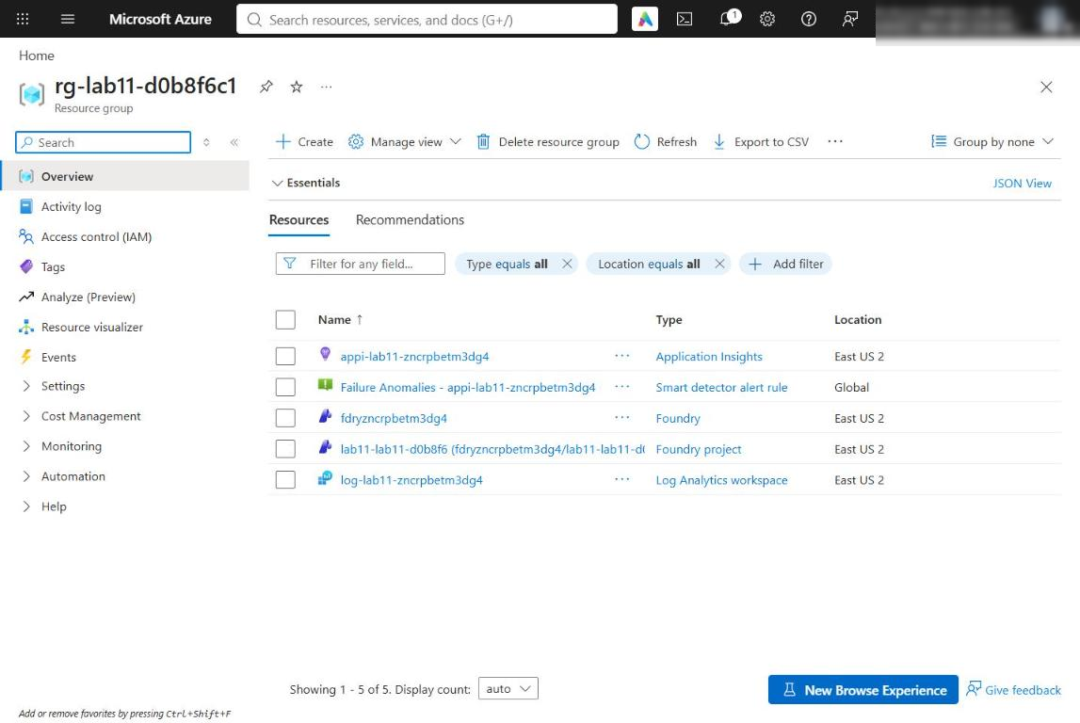
Figure 1: Resource group with the Foundry account, project, Log Analytics workspace and Application Insights
4. Confirm the network setting used in this lab. In the Foundry account (fdry<unique>), open Resource Management > Networking, or run:
POWERSHELL
$acct = (Get-Content .env | Select-String '^FOUNDRY_ACCOUNT_NAME=').ToString().Split('=')[1].Trim('"')
az cognitiveservices account show --name $acct --resource-group $resourceGroupName `
--query "{publicNetworkAccess:properties.publicNetworkAccess,defaultAction:properties.networkAcls.defaultAction}"

Expected result: publicNetworkAccess is Enabled and defaultAction is Allow, so your local app can reach the project endpoint. Microsoft Entra authentication and Azure RBAC are still required. Production environments should use selected networks or private endpoints.
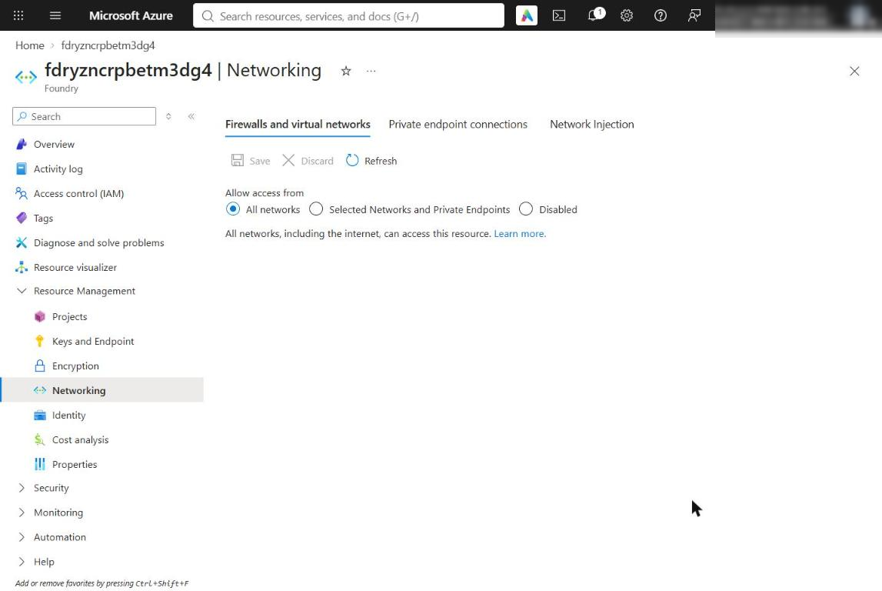
Figure 2: Foundry account Networking page: public access enabled for this lab
5. Optionally confirm your monitoring roles: open appi-lab11-<unique> > Access control (IAM) > Role assignments.
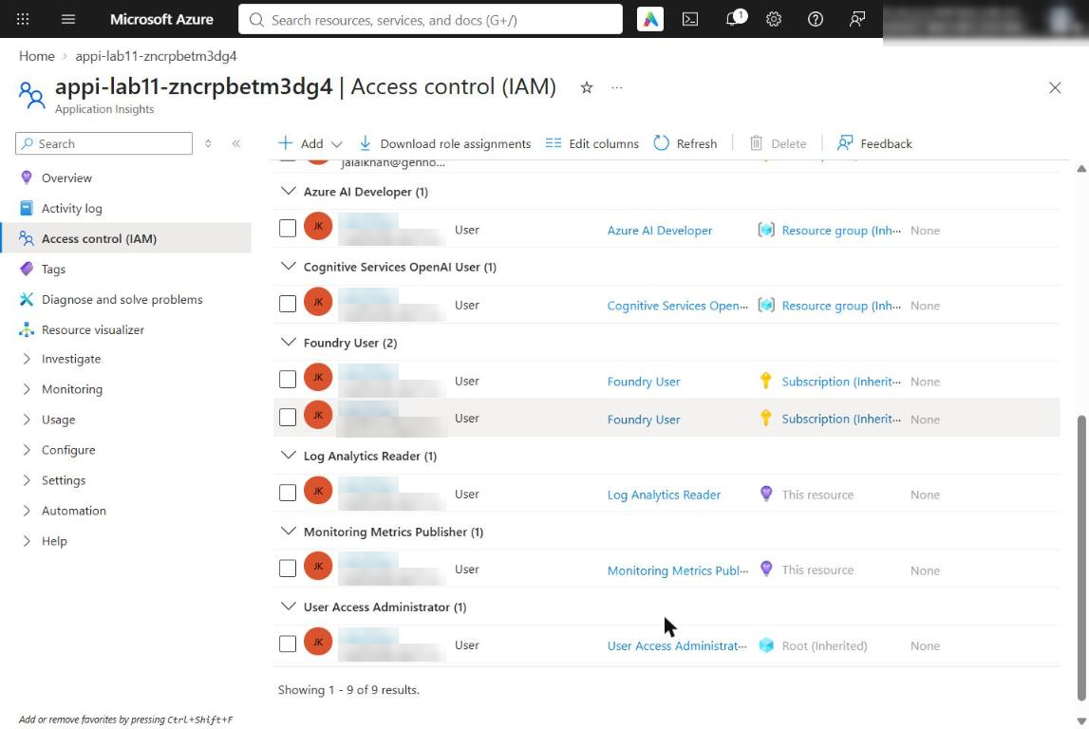
Figure 3: Monitoring Metrics Publisher and Log Analytics Reader assigned to you on Application Insights

Task 4: Implement the policy gate
Each placeholder marks incomplete code. Keep the LAB PLACEHOLDER comment, replace only the indicated line, and keep the indentation (4 spaces inside the function).
1. Open src/governance.py and find LAB PLACEHOLDER 1 in requires_human_review:
PYTHON
# LAB PLACEHOLDER 1: Replace this line with the Task 1 sample.
raise NotImplementedError("Complete requires_human_review in Task 1")

2. Replace the whole function with this completed version (the marker comment is kept and the raise line is replaced):
PYTHON
def requires_human_review(policy: dict[str, Any], evidence: dict[str, Any]) -> bool:
"""Apply the fairness threshold to complete governance evidence."""
# LAB PLACEHOLDER 1: Replace this line with the Task 1 sample.
fairness = evidence.get("fairness")
if not isinstance(fairness, dict) or "max_disparity" not in fairness:
return True

try:
return (
float(fairness["max_disparity"])
> float(policy["thresholds"]["max_fairness_disparity"])
)
except (KeyError, TypeError, ValueError):
return True

The decision fails closed: missing or malformed evidence requires human review. The threshold comes from the versioned policy, not from code.
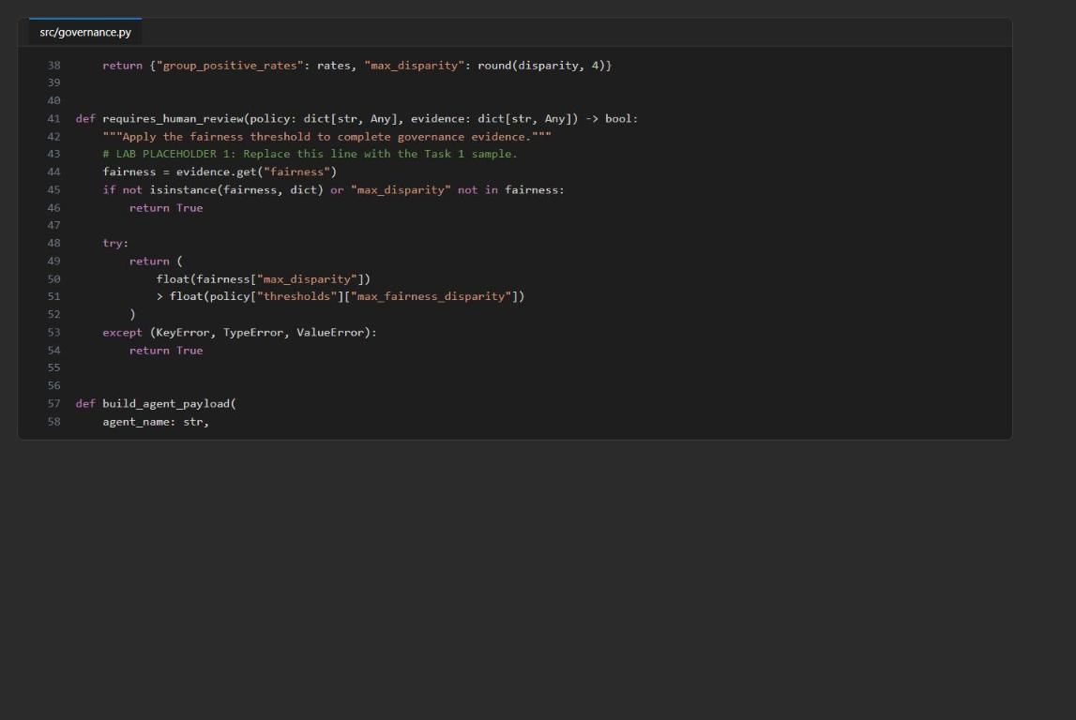
Figure 4: src/governance.py after LAB PLACEHOLDER 1 is completed
3. Save the file and check the code:
POWERSHELL
& .\.venv\Scripts\python.exe -m py_compile src/main.py src/governance.py scripts/preflight.py
& .\.venv\Scripts\python.exe scripts/preflight.py
Select-String -Path src/governance.py -Pattern 'NotImplementedError'

Expected result: Every preflight check shows PASS, the last line is READY (Azure configured), and the Select-String command returns nothing.
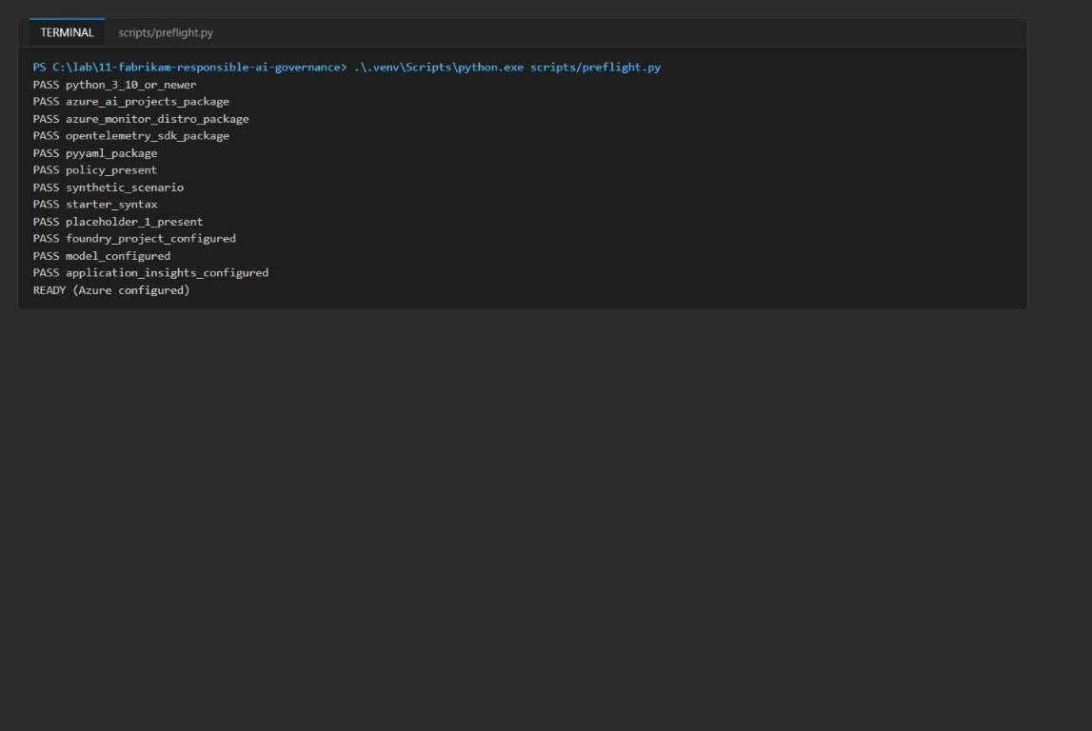
Figure 5: Preflight output ending with READY (Azure configured)
Note: If preflight shows INFO application_insights_configured and ends with READY (local), .env is missing APPLICATIONINSIGHTS_CONNECTION_STRING. Add it from the deployment output (see Troubleshooting).

Inspect the privacy boundaries
4. Open policy/governance-policy.yaml and compare agent_inputs with build_agent_payload in src/governance.py.
Agent | Allowed input | Deliberately excluded
security-reviewer | Request ID, synthetic source fragment, CWE reference | Tenant identity, fairness probes, policy internals
fairness-auditor | Request ID, group rates, disparity, threshold | Source code, tenant identity, security output
governance-orchestrator | Request ID, policy version, control results, specialist results | Raw source code, tenant identity, hidden reasoning

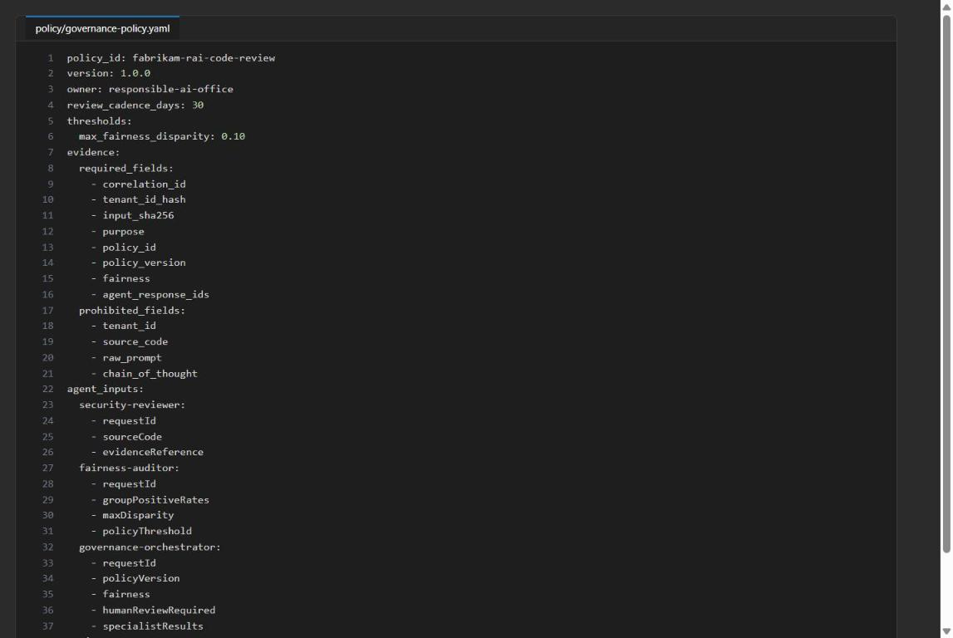
Figure 6: governance-policy.yaml with threshold, evidence fields and per-agent inputs
5. Check that the app does not record raw prompts or hidden reasoning:
POWERSHELL
Select-String -Path src/governance.py,src/main.py -Pattern 'chain_of_thought|raw_prompt'

Expected result: No matches.
6. Find the hashed fields and the Foundry attribution field:
POWERSHELL
Select-String -Path src/governance.py -Pattern 'tenant_id_hash|input_sha256|agent_response_ids'

Expected result: Matches such as "tenant_id_hash": _sha256(str(scenario["tenant_id"]))[:16], "input_sha256": _sha256(str(scenario["source_code"])) and agent_response_ids_json. Raw values are replaced by hashes and Foundry response IDs give agent attribution.

Task 5: Run the solution
Run the deterministic workflow
1. Run the workflow without any Azure calls:
POWERSHELL
& .\.venv\Scripts\python.exe -m src.main

Expected result:
- mode is deterministic.
- Positive-outcome rates: Python 1.0, Node 0.5; max_disparity is 0.5.
- human_review_required is true because 0.5 exceeds the threshold 0.1.
- Three local response IDs (local-security-response, local-fairness-response, local-governance-response).
- Purpose-specific field names under payloadFields.
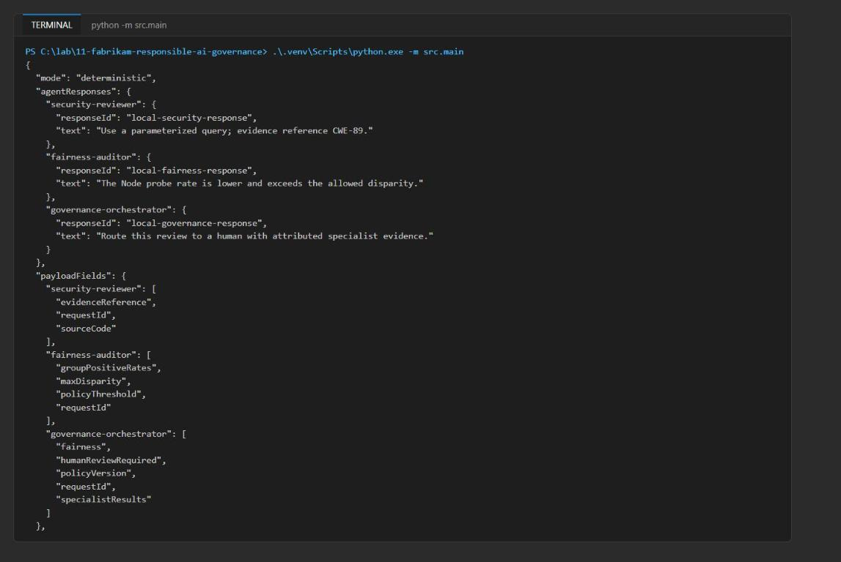
Figure 7: Deterministic run with local response IDs and payloadFields
2. Inspect the latest evidence record:
POWERSHELL
$evidence = Get-Content evidence/governance-evidence.jsonl | Select-Object -Last 1 | ConvertFrom-Json
$evidence | ConvertTo-Json -Depth 10

3. Confirm the record has evidence_scope = single_process_local_jsonl, policy_id = fabrikam-rai-code-review, policy_version = 1.0.0, the fairness rates, tenant_id_hash, input_sha256, human_review_required and three response IDs. Check that the raw tenant (synthetic-fabrikam-eu) and the source fragment are not present:
POWERSHELL
$raw = Get-Content evidence/governance-evidence.jsonl | Select-Object -Last 1
"raw tenant present: $($raw.Contains('synthetic-fabrikam-eu'))"
"raw source present: $($raw.Contains('SELECT * FROM users'))"

Expected result: Both lines print False.
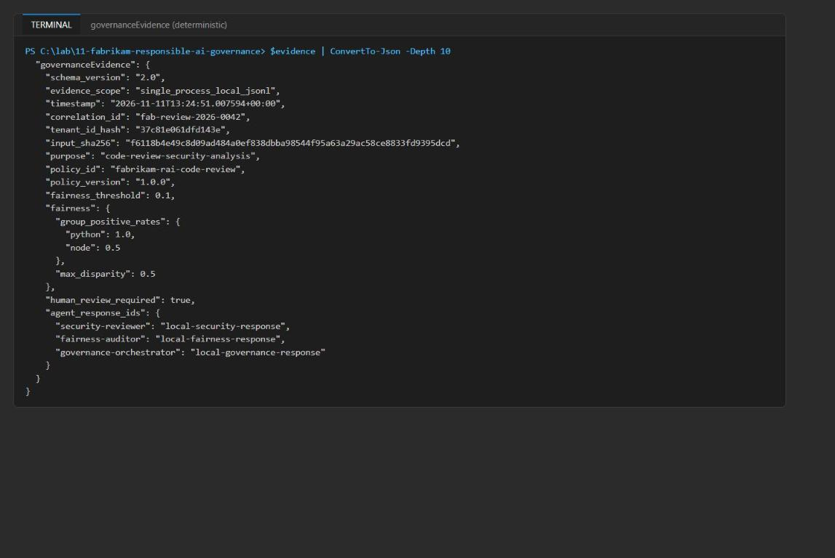
Figure 8: Minimized governance evidence record
Note: The JSONL file is local, single-process exercise evidence. It is not a concurrency-safe or central production store; use Application Insights or another governed central sink when several processes write evidence.

Run the live multi-agent workflow
4. Run the live workflow once. It creates a version of each Foundry prompt agent and calls security-reviewer, fairness-auditor, then governance-orchestrator:
POWERSHELL
& .\.venv\Scripts\python.exe -m src.main --live

Expected result: The output shows "mode": "live" and a Foundry responseId (starting with resp_) and text for each of the three agents. One minimized evidence record is appended to evidence/governance-evidence.jsonl, and one fabrikam.governance.evidence trace is sent to Application Insights. The wording varies between runs, but the fairness numbers and human_review_required: true stay the same.
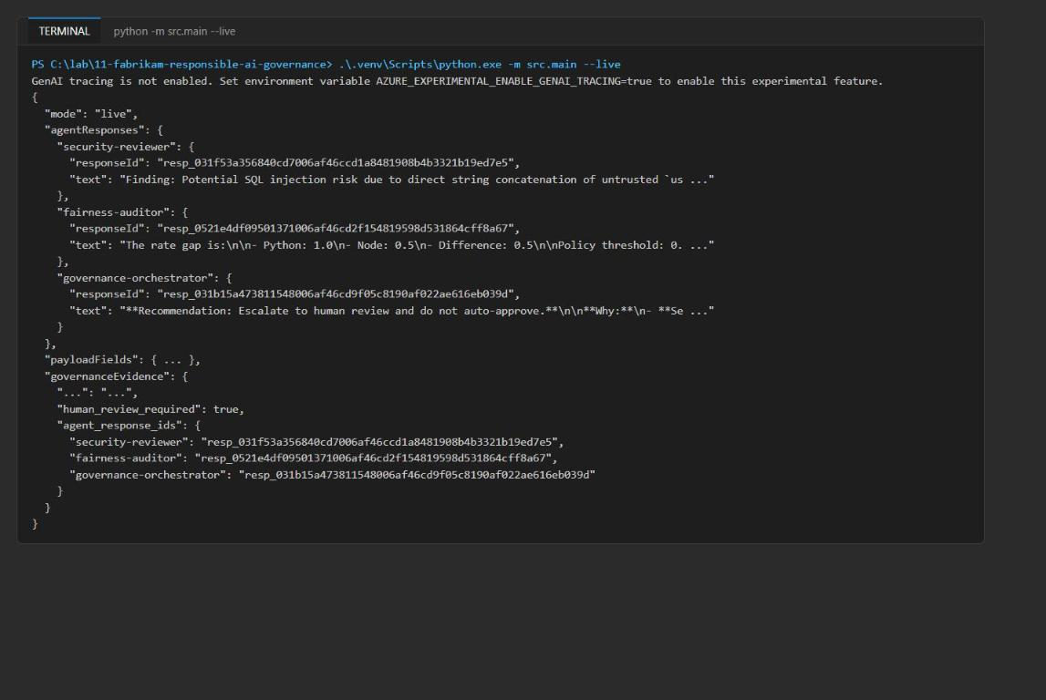
Figure 9: Live run with three Foundry response IDs
Note: A first line GenAI tracing is not enabled. Set environment variable AZURE_EXPERIMENTAL_ENABLE_GENAI_TRACING=true ... is informational and can be ignored. If the run fails with an authorization error, wait a few minutes for role assignments, run az login again if needed, and rerun the command.

5. Save the three response IDs for the next task:
POWERSHELL
$live = Get-Content evidence/governance-evidence.jsonl | Select-Object -Last 1 | ConvertFrom-Json
$live.agent_response_ids | Format-List

Task 6: Validate the implementation
Validate the agents in Microsoft Foundry
1. Open Microsoft Foundry and select the project lab11-lab11-<suffix> (the project name in FOUNDRY_PROJECT_ENDPOINT).
2. In the left navigation, select Agents.
3. Confirm that security-reviewer, fairness-auditor and governance-orchestrator exist and each has a version (version 1 after one live run).
4. Open each agent and review its instructions. Confirm each role is narrow, and that the orchestrator says *"Never request raw source, tenant identity, or hidden reasoning."*
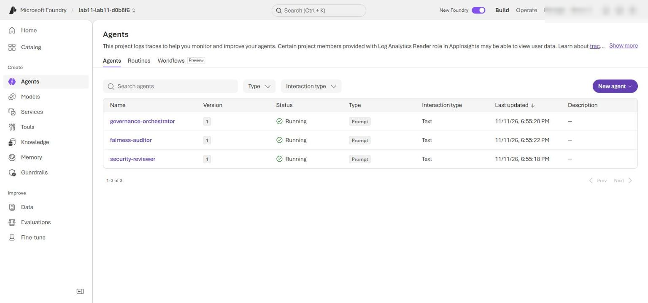
Figure 10: Foundry Agents page with the three governance agents
5. On the Agents page, open an agent (for example fairness-auditor) and select its Traces tab (there is no separate Observability item in the current portal).
6. Find the trace for the live run (you can search by trace ID or match the response ID from $live.agent_response_ids).
7. Open each matching trace and compare its response ID with the security reviewer, fairness auditor or orchestrator response.
8. Inspect the inputs. Confirm that only the security reviewer receives sourceCode; the fairness auditor and orchestrator do not, and no agent receives the tenant.
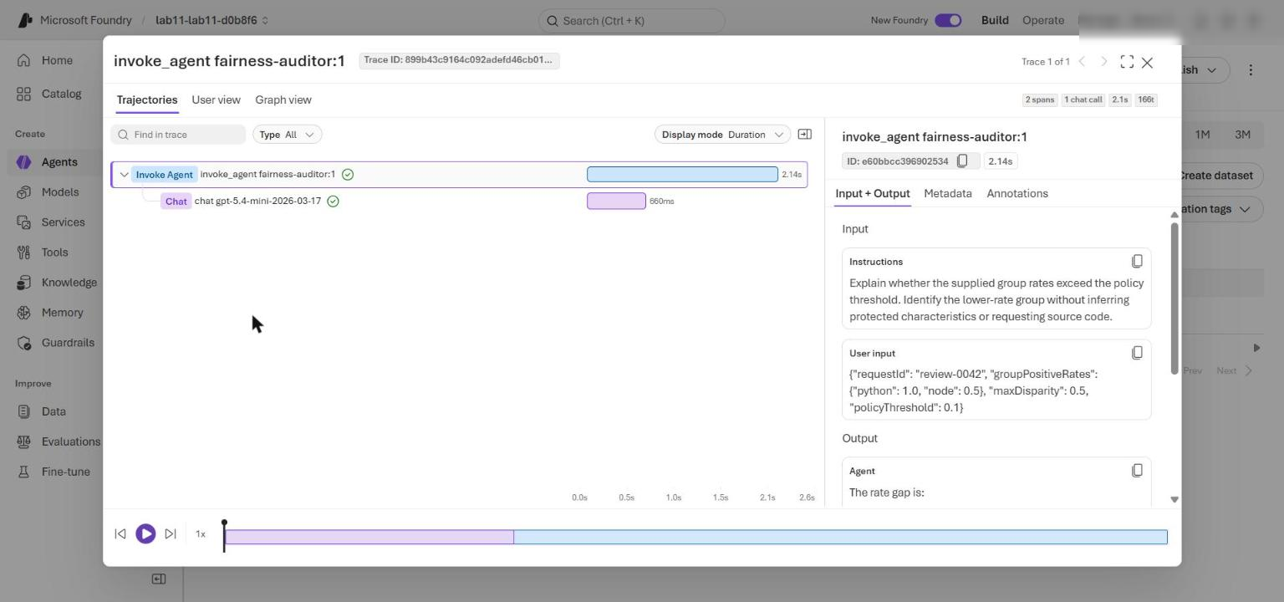
Figure 11: Foundry trace for the fairness-auditor: rates and threshold only, no sourceCode
If the Traces view is sparse, you can check the same inputs with the Responses API. Run this from the lab folder:
POWERSHELL
@'
import json, os
from dotenv import load_dotenv
from azure.identity import DefaultAzureCredential
from azure.ai.projects import AIProjectClient
load_dotenv(".env")
ids = json.loads(open("evidence/governance-evidence.jsonl", encoding="utf-8").read().splitlines()[-1])["agent_response_ids"]
project = AIProjectClient(endpoint=os.environ["FOUNDRY_PROJECT_ENDPOINT"], credential=DefaultAzureCredential())
client = project.get_openai_client()
for agent, rid in ids.items():
items = client.responses.input_items.list(rid)
text = json.dumps([i.model_dump() for i in items])
print(agent, rid, "| has sourceCode:", "sourceCode" in text, "| has tenant:", "synthetic-fabrikam-eu" in text)
'@ | python -

Expected result: has sourceCode: True only for security-reviewer; has tenant: False for all three.
Note: If Traces is not visible or a trace cannot be opened, check that you selected the correct project, completed a live run, and waited for telemetry and role assignments to propagate. The Bicep template assigns you Log Analytics Reader on Application Insights, which Foundry needs to show trace data.

Review Foundry-native guardrails
This lab does not deploy a standalone Azure AI Content Safety resource. The model deployment uses Foundry's default guardrails for prompts and completions.
9. In the Foundry project, select Build in the top menu, then Models.
10. Open the deployment gpt-5.4-mini, select the Details tab, and scroll to Model guardrails.
11. Confirm the deployment uses the default safety policy, not an unfiltered custom policy. You can also check with the CLI:
POWERSHELL
az cognitiveservices account deployment list --name $acct --resource-group $resourceGroupName `
--query "[].{Name:name, Model:properties.model.name, Version:properties.model.version, Rai:properties.raiPolicyName}" -o table

Expected result:
TEXT
Name Model Version Rai
------------ ------------ ---------- -------------------
gpt-5.4-mini gpt-5.4-mini 2026-03-17 Microsoft.DefaultV2

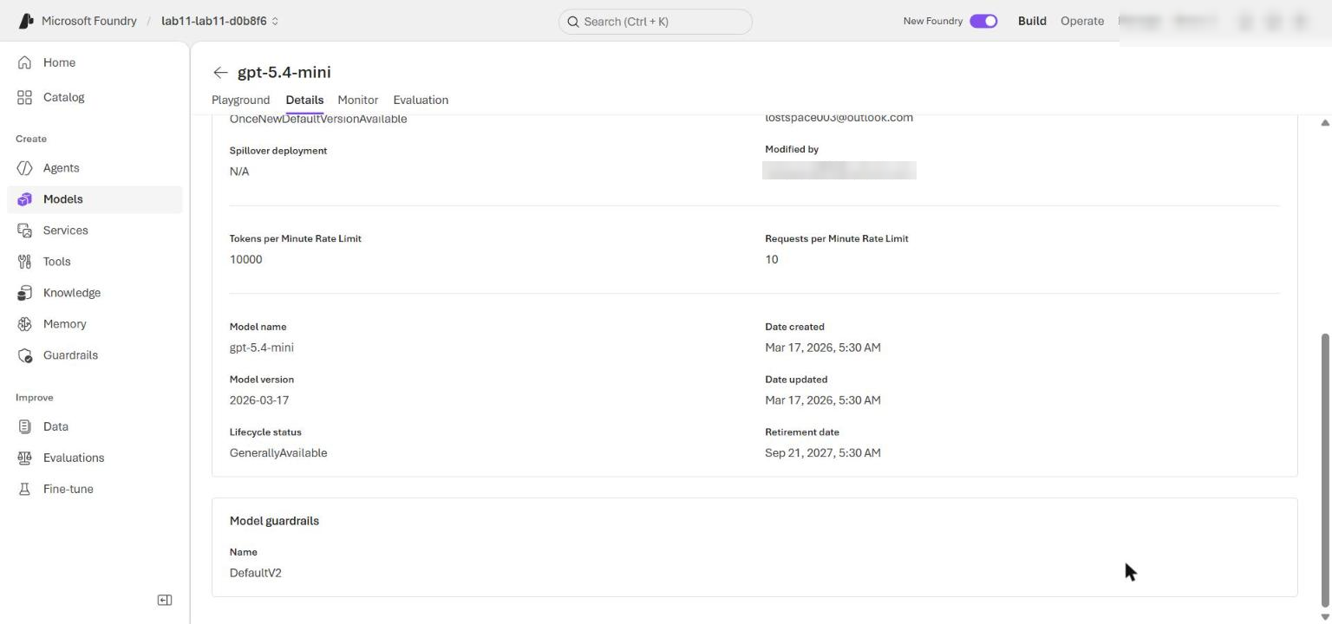
Figure 12: gpt-5.4-mini deployment using the default guardrail
12. Return to Agents > Traces and confirm that each successful response came from the guarded gpt-5.4-mini deployment. Use only the supplied neutral scenario; do not add harmful test content.
Test the fairness boundary
13. Open assets/governance-scenario.json and change only the final node-b probe from 0 to 1:
JSON
{"probe_id": "node-b", "group": "node", "positive_outcome": 1}

14. Run the deterministic workflow and inspect the latest evidence:
POWERSHELL
& .\.venv\Scripts\python.exe -m src.main | Out-Null
$updated = Get-Content evidence/governance-evidence.jsonl | Select-Object -Last 1 | ConvertFrom-Json
$updated.fairness | ConvertTo-Json -Depth 5
$updated.human_review_required

Expected result: Both rates are 1.0, max_disparity is 0.0, and human_review_required is False because no threshold is exceeded.
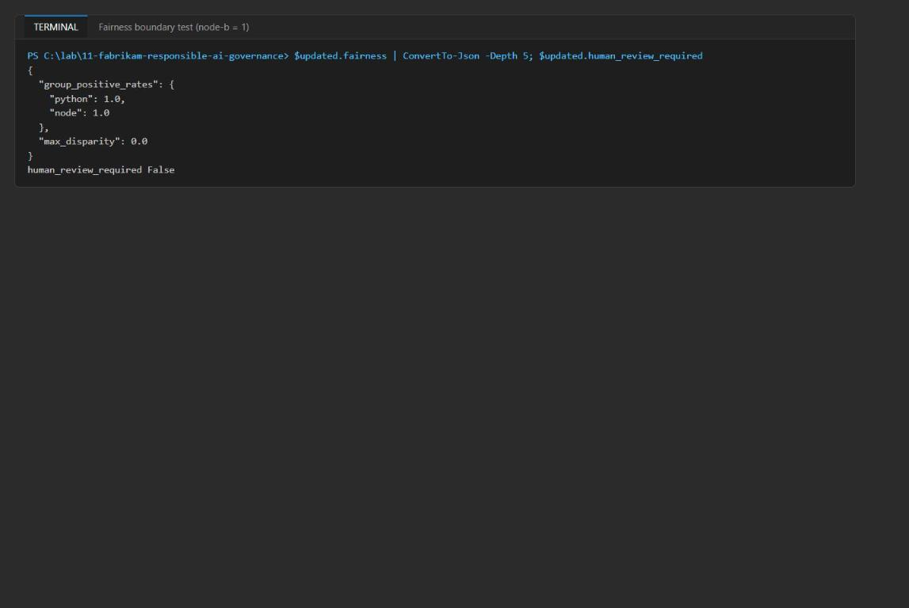
Figure 13: Fairness boundary test with balanced probes
15. Restore node-b to 0 before you continue:
JSON
{"probe_id": "node-b", "group": "node", "positive_outcome": 0}

If you use Git, you can also run git checkout -- assets/governance-scenario.json.
Query accountability evidence
16. Wait several minutes after the live run for the trace to reach Application Insights.
17. In the Azure portal, open the Log Analytics workspace whose name starts with log-lab11- (the AppTraces table lives in the workspace that backs Application Insights; the Application Insights Logs blade uses the classic traces schema and does not resolve AppTraces).
18. Select Logs, close the query gallery, and switch to KQL mode if needed. Set the time range to Set in query.
19. Paste and run the contents of kql/governance-evidence.kql:
KQL
// Review minimized multi-agent governance decisions without raw source or tenant data.
AppTraces
| where TimeGenerated > ago(30d)
| where Message == "fabrikam.governance.evidence"
| where Properties.policy_id == "fabrikam-rai-code-review"
| extend CorrelationId = tostring(Properties.correlation_id)
| extend PolicyVersion = tostring(Properties.policy_version)
| extend HumanReview = tobool(Properties.human_review_required)
| extend FairnessDisparity = todouble(Properties.max_fairness_disparity)
| extend AgentResponseIds = tostring(Properties.agent_response_ids_json)
| summarize Reviews=count(), Escalations=countif(HumanReview), MaxDisparity=max(FairnessDisparity), Correlations=dcount(CorrelationId), Responses=make_set(AgentResponseIds) by PolicyVersion
| order by Escalations desc

Expected result: One row with PolicyVersion 1.0.0, Reviews at least 1, Escalations at least 1, MaxDisparity 0.5, and the serialized response IDs of the three Foundry agents.
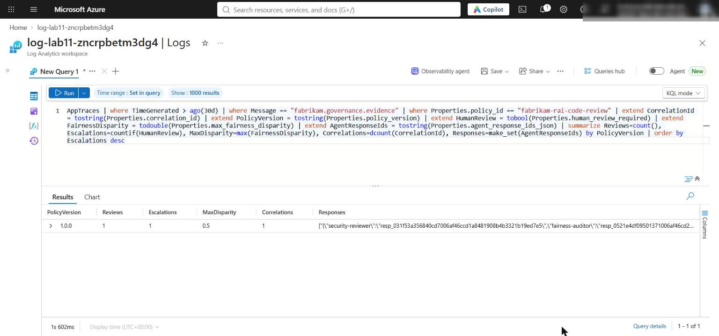
Figure 14: Governance evidence summary in the Log Analytics workspace Logs
20. Run the privacy check. Use the exact-key query below; it must return zero rows:
KQL
AppTraces
| where TimeGenerated > ago(30d)
| where Message == "fabrikam.governance.evidence"
| mv-expand Key = bag_keys(Properties) to typeof(string)
| where Key in ("tenant_id", "source_code", "raw_prompt", "chain_of_thought")

Important: The official lab uses Properties has_any ("tenant_id", "source_code", "raw_prompt", "chain_of_thought"). That query returns 1 row, which is a false positive, not a leak: the has operator splits text on _, so tenant_id matches the allowed hashed key tenant_id_hash. The exact-key query above (or Properties has_cs "\"tenant_id\":") returns zero rows. You can also confirm the raw values are absent: AppTraces | where Message == "fabrikam.governance.evidence" | where Properties has "synthetic-fabrikam-eu" or Properties has "SELECT" returns zero rows.

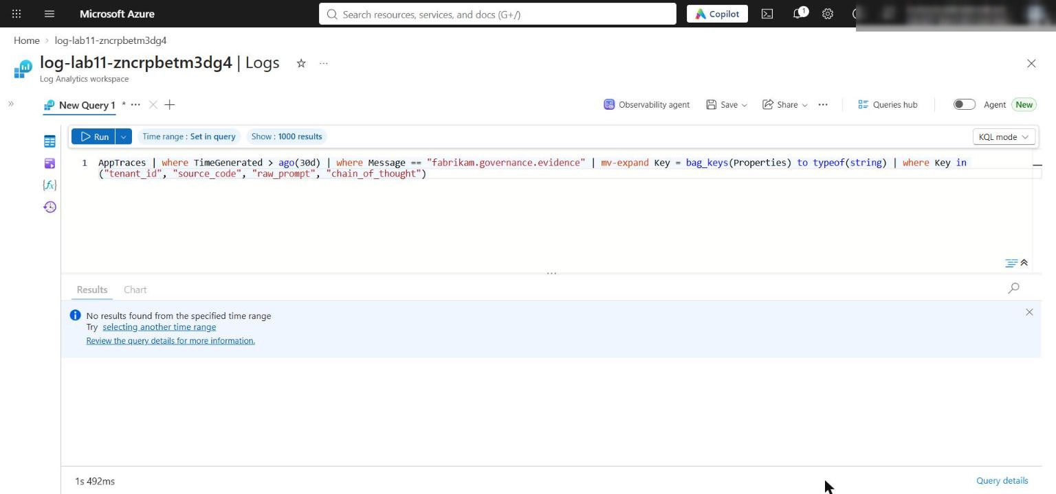
Figure 15: Exact-key privacy query returns no results
21. Capture the governance evidence set:
- The model deployment's default guardrail (Microsoft.DefaultV2).
- Fairness rates, disparity and the human-review decision.
- The three Foundry agent versions and matching response IDs.
- Trace inputs that show purpose-specific data minimization.
- The Application Insights policy summary and the zero-row privacy result.
Optional challenge: Trigger human review and test fail-closed behavior
22. Without editing any file, run this in-memory test. It adds a synthetic node-c probe with outcome 0, then removes evidence fields to confirm the gate fails closed:
POWERSHELL
@'
import copy, json
from src.governance import load_policy, calculate_fairness_evidence, requires_human_review
policy = load_policy("policy/governance-policy.yaml")
scenario = json.load(open("assets/governance-scenario.json", encoding="utf-8"))
threshold = policy["thresholds"]["max_fairness_disparity"]
probes = scenario["fairness_probes"] + [{"probe_id": "node-c", "group": "node", "positive_outcome": 0}]
fairness = calculate_fairness_evidence(probes)
gate = "human review required" if requires_human_review(policy, {"fairness": fairness}) else "continue"
print("rates", fairness["group_positive_rates"], "disparity", fairness["max_disparity"], "threshold", threshold, "gate:", gate)
print("missing fairness ->", requires_human_review(policy, {}))
print("missing max_disparity ->", requires_human_review(policy, {"fairness": {}}))
print("malformed max_disparity ->", requires_human_review(policy, {"fairness": {"max_disparity": "n/a"}}))
evidence = {"correlation_id": "x", "tenant_id_hash": "x", "input_sha256": "x", "purpose": "x", "policy_id": "x", "policy_version": "x"}
missing = [f for f in policy["evidence"]["required_fields"] if f not in evidence]
print("missing-evidence reason: required fields absent ->", missing)
'@ | python -

Expected result:
TEXT
rates {'python': 1.0, 'node': 0.6666666666666666} disparity 0.3333 threshold 0.1 gate: human review required
missing fairness -> True
missing max_disparity -> True
malformed max_disparity -> True
missing-evidence reason: required fields absent -> ['fairness', 'agent_response_ids']

Validate
Acceptance criterion | How to check | Expected
Placeholder complete, preflight ready | python scripts/preflight.py; Select-String -Path src/governance.py -Pattern NotImplementedError | READY (Azure configured); no matches
No raw prompt or hidden reasoning in code | Select-String for chain_of_thought and raw_prompt (Task 4 step 5) | No matches
Deterministic run | python -m src.main | Rates 1.0 / 0.5, disparity 0.5, human_review_required true, 3 local IDs, payloadFields
Evidence minimized | Latest line of evidence/governance-evidence.jsonl | Scope, policy, hashes, IDs; no raw tenant or source
Live run | python -m src.main --live | Three resp_ IDs, evidence appended, trace emitted
Agents exist with narrow instructions | Foundry portal > Agents | Three agents, version 1; orchestrator forbids raw source, tenant, hidden reasoning
Data minimization in traces | Foundry > Agents > Traces (or the Responses API script) | Only security-reviewer has sourceCode; no tenant
Default guardrail | Foundry > Build > Models, or az cognitiveservices account deployment list | Microsoft.DefaultV2
Fairness boundary | node-b = 1, then rerun | Rates 1.0 / 1.0, disparity 0.0, review False; file restored
Accountability KQL | App Insights > Logs, kql/governance-evidence.kql | 1.0.0, at least 1 review and escalation, MaxDisparity 0.5, 3 response IDs
Privacy query | Exact-key bag_keys query | Zero rows

Troubleshooting
Problem | Cause | Fix
Preflight ends READY (local) with INFO application_insights_configured | .env has no APPLICATIONINSIGHTS_CONNECTION_STRING (some helper scripts skip *CONNECTION_STRING outputs) | Append it from the deployment outputs with the command below the table
./scripts/setup.ps1 is blocked | PowerShell execution policy | Run python -m venv .venv, activate it, then python -m pip install -r requirements.txt
Live run returns 401/403 or PermissionDenied | Role assignments still propagating | Wait 1-5 minutes, run az login, rerun python -m src.main --live
GenAI tracing is not enabled ... message | The app does not set AZURE_EXPERIMENTAL_ENABLE_GENAI_TRACING | Informational only. Foundry trace spans may be sparse; use the Responses API script in Task 6 to inspect inputs
Official privacy query returns 1 row | has_any tokenizes on _, so tenant_id matches tenant_id_hash | Use the exact-key bag_keys query in Task 6 step 20
KQL returns no rows | Telemetry ingestion delay or wrong time range | Wait 5-10 minutes after the live run; set time range to Set in query
Deployment fails on model | No quota or version not available in region | Choose another region or model version and redeploy
az monitor log-analytics query asks to install an extension | The log-analytics CLI extension is not installed | Use the portal Logs blade, or run az extension add --name log-analytics first

To add the missing Application Insights connection string to .env:
POWERSHELL
$cs = az monitor app-insights component show --resource-group $resourceGroupName `
--query "[0].connectionString" -o tsv
"APPLICATIONINSIGHTS_CONNECTION_STRING=`"$cs`"" | Add-Content .env
python scripts/preflight.py

Review questions (Task 7)
1. Why is the human-review gate deterministic instead of delegated to the orchestrator agent?
The release decision must be repeatable, auditable and tied to the versioned threshold (max_fairness_disparity: 0.10). A model can vary its wording, misread numbers or be steered by prompt content. The deterministic gate also fails closed: missing or malformed evidence forces human review. The orchestrator only explains a decision already made; it cannot override it.
2. How could bias compound if the fairness auditor received a security review framed with developer metadata?
The auditor would be anchored by non-fairness findings (severity, confidence) and proxy signals (names, tenant, region, stack preference). It could justify or inflate the gap ("Node code is riskier") instead of measuring the paired probes. Its output feeds the orchestrator, so one biased framing is repeated downstream and looks like independent confirmation. Purpose-specific payloads break that loop.
3. Which additional controls would be required before processing real customer source code?
A data processing agreement, consent and purpose limitation; secret and PII scanning and redaction before any model call; data residency; private endpoints with public access disabled and customer-managed keys; retention and deletion policies; Prompt Shields and a reviewed custom guardrail policy; least-privilege managed identities and access reviews; red-team and evaluation per language stack with more fairness probes; a tamper-evident central evidence sink; and a documented human-review workflow with SLAs and an appeal path.
4. When should an audit store retain full specialist output instead of response IDs and minimized evidence?
Only when a specific obligation needs it: a legal hold or regulatory investigation, an incident or dispute where the exact recommendation must be reproduced, or a model evaluation period. Even then, use an access-controlled, encrypted store with a defined retention period and redact customer code and identity. Response IDs alone may not be enough because the source system's retention can expire; otherwise IDs, hashes and policy metadata are sufficient.

Clean up (Task 8, optional)
When you have finished, delete the Azure resources to stop charges:
POWERSHELL
az group delete --name $resourceGroupName --yes --no-wait

If you opened a new terminal, use the name directly: az group delete --name rg-lab11-<suffix> --yes --no-wait. If you used a precreated resource group, check which resources it contains before deleting.
The Foundry account is soft-deleted. To purge it so the name can be reused:
POWERSHELL
az cognitiveservices account list-deleted --query "[].{name:name, location:location}" -o table
az cognitiveservices account purge --name <foundry-account-name> --resource-group $resourceGroupName --location eastus2

Delete local evidence and environment values:
POWERSHELL
Remove-Item evidence/governance-evidence.jsonl -ErrorAction SilentlyContinue
Remove-Item .env -ErrorAction SilentlyContinue

Deactivate the virtual environment in every terminal where (.venv) appears:
POWERSHELL
deactivate

Summary
You deployed a Bicep-defined Microsoft Foundry project and governed a three-agent code review with native model guardrails, paired fairness probes, minimized handoffs, attributable response IDs, a deterministic fail-closed human-review gate, and queryable Application Insights evidence.

