Lab 13: Trace multi-agent workflows with OpenTelemetry
Scenario: Adventure Works runs a customer intelligence platform. A router agent hands each request to a recommendation agent, which calls an inventory agent. These agents run across service boundaries. Operators need one trace waterfall for the whole chain, decision logs that respect privacy, latency and token evidence, and alerts that name the responsible agent before customers notice a failure.
What you build: You instrument a synthetic three-agent chain with real OpenTelemetry spans. You propagate W3C traceparent context explicitly from agent to agent, emit structured logs that are correlated to the spans, and evaluate three policy decisions (latency, token anomaly and chain error rate). You then export everything to Application Insights with Microsoft Entra authentication (no keys), query it with KQL, and watch an Azure Monitor scheduled-query alert fire and then resolve.
Duration: about 45 minutes, plus 10-15 minutes waiting for alert evaluation.
Note: Cost warning. Log Analytics and Application Insights ingestion is billable, and so are scheduled-query alert rules. The lab sends only a few kilobytes of synthetic telemetry, but delete the resource group when you finish (see Clean up). If you leave the exporter configured, every run keeps ingesting data.

Architecture
Component | Resource / file | Purpose
Agent chain | src/main.py, src/telemetry.py | Runs router -> recommendation -> inventory. Creates one span per agent and injects and extracts W3C context at every handoff
Synthetic scenario | assets/trace-scenario.json | Agent versions, latency, token counts, expected tokens and the error flag. Contains no customer data
Telemetry policy | config/telemetry-policy.yaml | Sampling ratios, prohibited fields and alert thresholds (latency 60 ms, error rate 0.05, token sigma 3.0)
Log Analytics workspace | log-aw-otel-<suffix> | Stores the AppTraces and AppDependencies tables
Application Insights | appi-aw-otel-<suffix> | Workspace-based, with local (key) auth disabled. Ingestion requires an Entra token with Monitoring Metrics Publisher
User-assigned identity | id-aw-telemetry-<suffix> | Holds Monitoring Metrics Publisher for deployed execution
Action group | ag-aw-agent-anomaly-<suffix> | Email receiver with the common alert schema
Scheduled-query rule | alert-aw-agent-policy-anomaly-<suffix> | Severity 2. Runs kql/anomaly-alert.kql every 5 minutes and auto-resolves after 5 healthy minutes
KQL | kql/trace-waterfall.kql, kql/agent-health.kql, kql/anomaly-alert.kql | Waterfall for one trace, per-agent health, and the alert query

Prerequisites
- Python 3.10 or later. The lab was validated with Python 3.13.
- Azure CLI 2.60 or later, with Bicep (az bicep install). This guide provisions with the Azure CLI, so the Azure Developer CLI (azd) is not required.
- PowerShell 7. The helper commands write UTF-8 files without a BOM, which Windows PowerShell 5.1 does not do.
- Visual Studio Code with the Python extension, and Git.
- An Azure subscription where you are Owner, or Contributor plus User Access Administrator, on the resource group. The Bicep template creates a role assignment for the telemetry identity, and you assign Monitoring Metrics Publisher to yourself.
- An email address you can read, which receives the alert notification.
Sign in and select your subscription:
POWERSHELL
az login
az account set --subscription "<your-subscription-id>"
az account show --output table

Note: Use only the included synthetic scenario. Never put prompts, personal identifiers, payment data or credentials into logs or span attributes.

Task 1: Prepare the lab
1. Clone the lab repository (skip this step if you already have it), then open the folder in Visual Studio Code.
POWERSHELL
git clone https://github.com/MicrosoftLearning/mslearn-ai-multi-agents.git
cd mslearn-ai-multi-agents
code .

2. In the VS Code terminal (Terminal > New Terminal, PowerShell), change to the lab folder and check the tools:
POWERSHELL
cd Allfiles\13-adventure-works-distributed-observability
az version --output table
python --version
az bicep version
az account show --output table

3. Architecture checkpoint. Open these files and review them: src/telemetry.py, config/telemetry-policy.yaml, assets/trace-scenario.json, kql/anomaly-alert.kql and infra/main.bicep. Note these points:
- sampling.lab_export_ratio is 1.0, so one learner run produces a complete waterfall. production_head_ratio: 0.05 exists only for design discussion.
- execute_agent extracts the incoming carrier before start_as_current_span. This makes each agent a child of the previous one.
- kql/anomaly-alert.kql reads the emitted decisions (anomaly_types, token_anomaly, error_rate_anomaly), not raw thresholds.
Expected result: You can explain how traceparent flows router -> recommendation -> inventory, and why the alert does not repeat thresholds.

Task 2: Build the virtual environment
1. Create the virtual environment and install the requirements (OpenTelemetry SDK 1.43, Azure Monitor OpenTelemetry distro, azure-identity, python-dotenv, PyYAML):
POWERSHELL
./scripts/setup.ps1
. ./.venv/Scripts/Activate.ps1

Note: On macOS or Linux, run bash scripts/setup.sh and then source .venv/bin/activate.

2. Open config/telemetry-policy.yaml and review privacy.prohibited_fields and the alerts block.
3. Confirm that none of the prohibited fields appear in the synthetic scenario. Each count must be 0:
POWERSHELL
foreach ($field in 'raw_customer_id','email','payment_card','raw_prompt','chain_of_thought') {
$count = (Select-String -Path assets/trace-scenario.json -Pattern $field -SimpleMatch).Count
"{0,-18} {1}" -f $field, $count
}

Expected result: The prompt starts with (.venv), and all five fields show 0.

Task 3: Deploy Azure resources
The official lab uses azd provision. This guide deploys the same infra/main.bicep with the Azure CLI. This makes every parameter explicit and avoids the ${ALERT_EMAIL} substitution in infra/main.parameters.json. The template takes only two parameters, location and alertEmail. The lab was validated in eastus2.
1. Make sure you are in the lab folder with (.venv) active. Replace <your-alert-email> with an inbox you can read, then run the whole block:
POWERSHELL
$azureRegion = 'eastus2'
$alertEmail = '<your-alert-email>'
$suffix = (New-Guid).Guid.Substring(0, 8)
$resourceGroupName = "rg-lab13-$suffix"
$envName = "lab13-$suffix"
az group create --name $resourceGroupName --location $azureRegion --output none
az bicep build --file infra/main.bicep
az deployment group create --resource-group $resourceGroupName --name lab13-main `
--template-file infra/main.bicep `
--parameters location=$azureRegion alertEmail=$alertEmail `
--output none
# Write .env from the deployment outputs (includes APPLICATIONINSIGHTS_CONNECTION_STRING)
$outputs = az deployment group show --resource-group $resourceGroupName --name lab13-main --query properties.outputs -o json | ConvertFrom-Json
$lines = @("AZURE_RESOURCE_GROUP=`"$resourceGroupName`"", "AZURE_LOCATION=`"$azureRegion`"", "AZURE_ENV_NAME=`"$envName`"",
"AZURE_SUBSCRIPTION_ID=`"$(az account show --query id -o tsv)`"", "ALERT_EMAIL=`"$alertEmail`"")
$outputs.PSObject.Properties | ForEach-Object { $lines += "$($_.Name.ToUpper())=`"$($_.Value.value)`"" }
$lines | Out-File .env -Encoding utf8
Get-Content .env | ForEach-Object { $_ -replace 'InstrumentationKey=[^;]+', 'InstrumentationKey=<hidden>' }

Expected result: The deployment finishes in 1-3 minutes. .env contains APPLICATIONINSIGHTS_CONNECTION_STRING, APPLICATIONINSIGHTS_RESOURCE_ID, LOG_ANALYTICS_WORKSPACE_ID, TELEMETRY_IDENTITY_CLIENT_ID, TELEMETRY_IDENTITY_PRINCIPAL_ID, ANOMALY_ALERT_RULE_ID and ANOMALY_ACTION_GROUP_ID.
Note: The scheduled-query rule deploys with skipQueryValidation: true and a typed, empty fallback table. A new workspace has no AppTraces table until the first telemetry arrives, so query validation would otherwise fail. The fallback returns no rows, and Azure evaluates the real AppTraces signals after ingestion starts.

2. Confirm that .env holds no key or token. The connection string contains only the ingestion endpoint and an instrumentation key. That key is not a credential here because the template sets DisableLocalAuth=true, so every ingestion call needs an Entra token. Verify the setting:
POWERSHELL
az resource show --ids (Select-String -Path .env -Pattern '^APPLICATIONINSIGHTS_RESOURCE_ID="(.*)"').Matches[0].Groups[1].Value `
--query "{name:name, disableLocalAuth:properties.DisableLocalAuth, workspace:properties.WorkspaceResourceId}" -o json

Note: If you deployed with azd or another helper and .env has no APPLICATIONINSIGHTS_CONNECTION_STRING line, some helpers skip keys that end in CONNECTION_STRING. Add the line yourself: $cs = az resource show --ids <APPLICATIONINSIGHTS_RESOURCE_ID> --query properties.ConnectionString -o tsv; Add-Content .env "APPLICATIONINSIGHTS_CONNECTION_STRING="$cs"".

3. The Bicep template grants Monitoring Metrics Publisher to the user-assigned identity, which is used for deployed execution. When you run locally, DefaultAzureCredential falls back to your Azure CLI sign-in. Give your signed-in user the same role on the Application Insights resource:
POWERSHELL
$me = az ad signed-in-user show --query id -o tsv
$appiId = (Select-String -Path .env -Pattern '^APPLICATIONINSIGHTS_RESOURCE_ID="(.*)"').Matches[0].Groups[1].Value
az role assignment create --assignee-object-id $me --assignee-principal-type User `
--role "Monitoring Metrics Publisher" --scope $appiId --output none
az role assignment list --assignee $me --scope $appiId --query "[].roleDefinitionName" -o tsv

Note: RBAC propagation takes time. In the validated run, this role took about 6 minutes to apply. Until it does, exports return HTTP 403. The exporter retries and keeps failed batches in offline storage, so that telemetry is delivered later. Do not enable local (key) ingestion as a workaround.

4. Load the .env values into the current PowerShell session. Later steps use $env:... variables:
POWERSHELL
Get-Content .env | ForEach-Object {
if ($_ -match '^\s*([A-Z0-9_]+)="?(.*?)"?\s*$') { Set-Item -Path "env:$($Matches[1])" -Value $Matches[2] }
}
$env:AZURE_RESOURCE_GROUP

5. Check the email inbox for the "You've been added to an Azure Monitor action group" message from Azure. This confirms that the receiver is active.
6. In the Azure portal, open the resource group and confirm the five resources: the Log Analytics workspace, Application Insights, the managed identity, the action group and the scheduled-query rule.
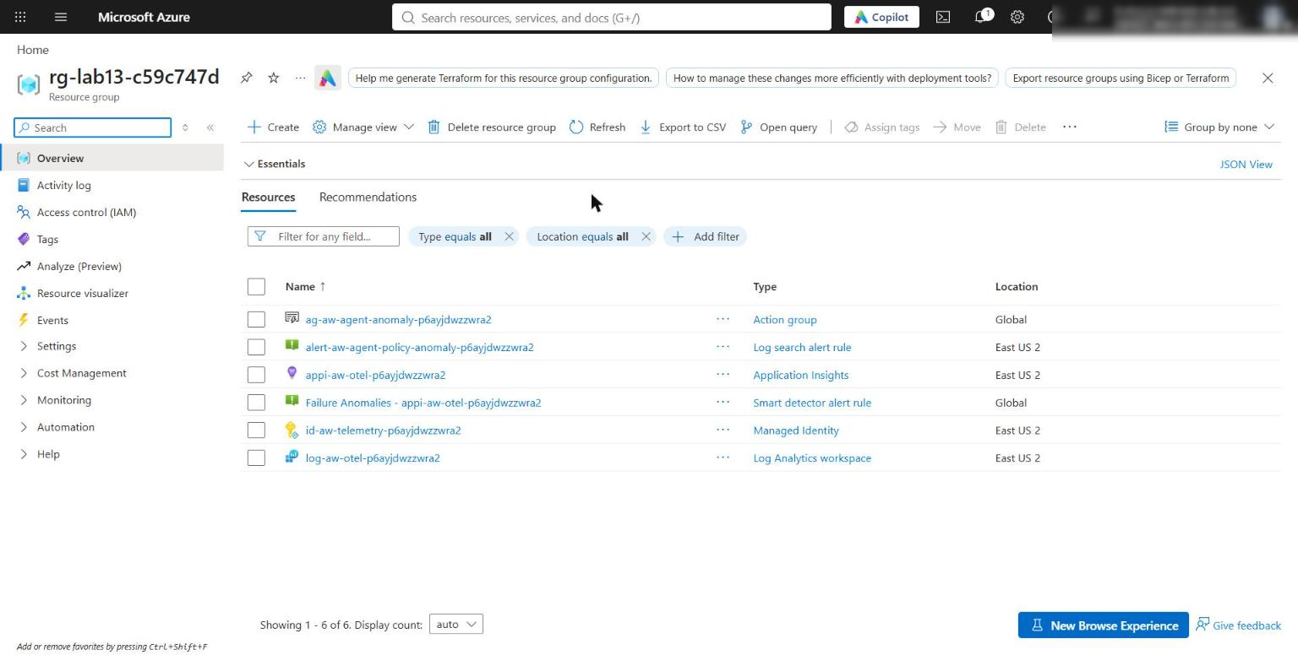
Figure 1: Lab 13 resource group with the workspace, Application Insights, identity, action group and alert rule
7. Open the Application Insights resource, select Access control (IAM) > Role assignments, and confirm that both your user and id-aw-telemetry-<suffix> have Monitoring Metrics Publisher.
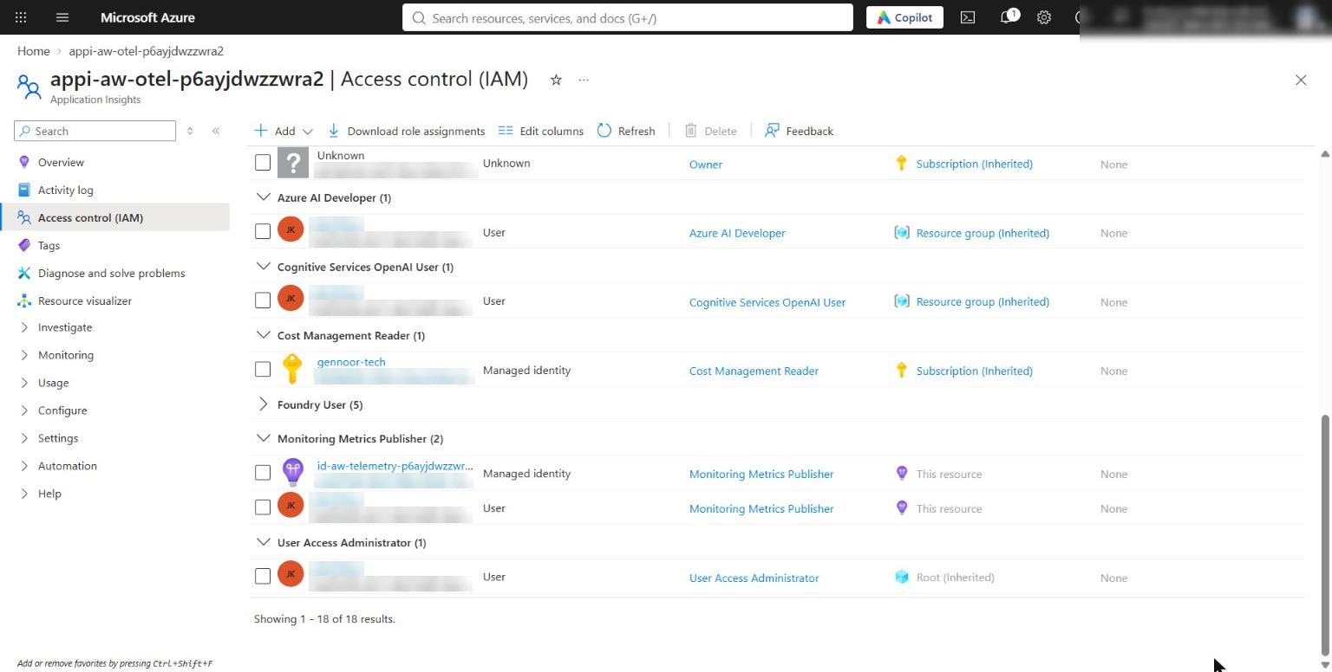
Figure 2: Monitoring Metrics Publisher assigned to your user and the telemetry identity

Task 4: Implement the solution
The starter contains one placeholder. Keep the # LAB PLACEHOLDER 1 comment and replace only the raise NotImplementedError(...) line.
1. Open src/telemetry.py and find LAB PLACEHOLDER 1 in build_next_carrier:
PYTHON
def build_next_carrier() -> dict[str, str]:
"""Inject the active W3C context into an outgoing carrier."""
# LAB PLACEHOLDER 1: Replace this line with the Task 1 sample.
raise NotImplementedError("Complete build_next_carrier in Task 1")

2. Replace the whole function with this code (4-space indentation):
PYTHON
def build_next_carrier() -> dict[str, str]:
"""Inject the active W3C context into an outgoing carrier."""
# LAB PLACEHOLDER 1: Replace this line with the Task 1 sample.
carrier: dict[str, str] = {}
propagator.inject(carrier)
return carrier

The TraceContextTextMapPropagator writes the active span context into the carrier as traceparent (00-<32-hex trace id>-<16-hex span id>-01). The next execute_agent call runs propagator.extract(incoming_carrier) and passes the result to start_as_current_span(..., context=parent_context). This makes the next agent a child span in the same trace.
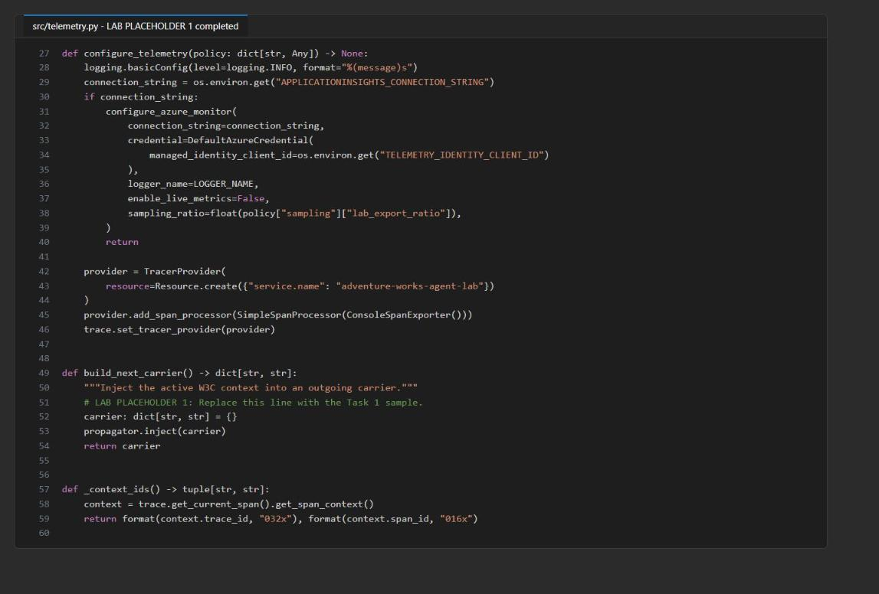
Figure 3: build_next_carrier after LAB PLACEHOLDER 1 is completed
3. Review the structured decision telemetry. Read _structured_log and execute_agent. Both the span attributes and the log record include gen_ai.operation.name, gen_ai.agent.name, gen_ai.agent.id, gen_ai.provider.name, gen_ai.conversation.id, gen_ai.usage.input_tokens and gen_ai.usage.output_tokens. Failed spans and logs also include error.type.
4. Find the domain attributes kept next to the semantic ones: agent.version, latency_ms, anomaly_types, token_anomaly, status and session_id_hash (a SHA-256 hash, truncated to 16 characters). Do not add raw request text or model reasoning.
5. Identify the three policy decisions:
- Latency: latency_ms > latency_threshold_ms. This is a strict greater-than comparison, so 60 ms is not anomalous.
- Token anomaly: input + output > expected_tokens + token_anomaly_sigma * token_stddev. For recommendation, 516 > 350 + 3 x 50 = 500.
- Chain error rate: computed in run_chain after all agents complete, as errors / agents, then compared with error_rate_threshold.
6. Compile the code, run preflight, and confirm that no NotImplementedError remains:
POWERSHELL
python -m py_compile src/main.py src/telemetry.py scripts/preflight.py
python scripts/preflight.py
Select-String -Path src/telemetry.py -Pattern 'NotImplementedError'

Expected result: Preflight prints PASS for every check (azure_monitor_configured can show INFO if .env is not written yet) and ends with READY (local). Select-String returns nothing.
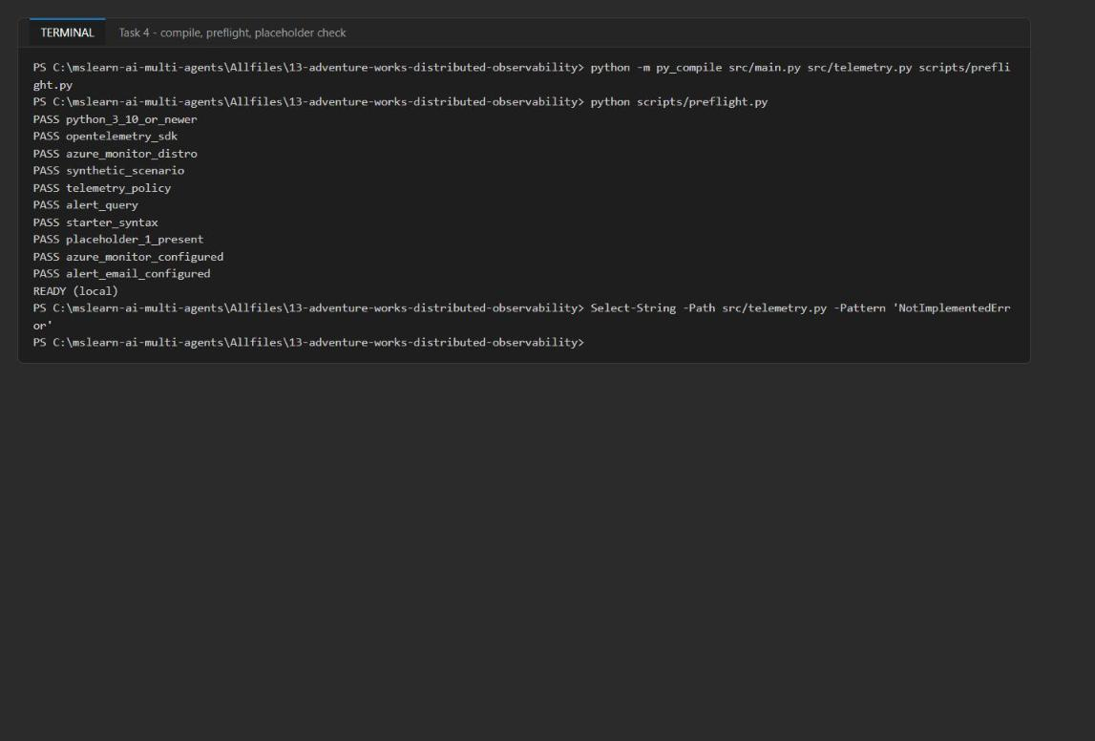
Figure 4: py_compile, preflight READY (local), and no NotImplementedError matches

Task 5: Run the solution
First run without Azure export, so spans print to the console. Then run with export enabled.
1. Define two helper functions. They switch Azure export off and on by commenting out the connection string in .env and removing it from the session. main.py loads .env with load_dotenv. PowerShell cannot hold an empty environment variable, so commenting out the line is the reliable way to leave the value blank.
POWERSHELL
function Disable-AzureExport {
(Get-Content .env) -replace '^APPLICATIONINSIGHTS_CONNECTION_STRING=', '#APPLICATIONINSIGHTS_CONNECTION_STRING=' | Set-Content .env
Remove-Item Env:APPLICATIONINSIGHTS_CONNECTION_STRING -ErrorAction SilentlyContinue
}
function Enable-AzureExport {
(Get-Content .env) -replace '^#APPLICATIONINSIGHTS_CONNECTION_STRING=', 'APPLICATIONINSIGHTS_CONNECTION_STRING=' | Set-Content .env
}

2. Leave the connection string blank, then run the chain in console mode:
POWERSHELL
Disable-AzureExport
python -m src.main --output evidence/console-run.json

3. Inspect the console span JSON. Each agent prints adventureworks.agent.observation followed by its span.
- All three spans have the same 32-character trace_id and different span_id values.
- agent.router has "parent_id": null. The recommendation span's parent_id is the router's span_id, and the inventory span's parent_id is the recommendation span's span_id.
- agent.recommendation has a latency.anomaly event (threshold_ms: 60, because 85 > 60) and a token.anomaly event (threshold_tokens: 500.0, observed_tokens: 516).
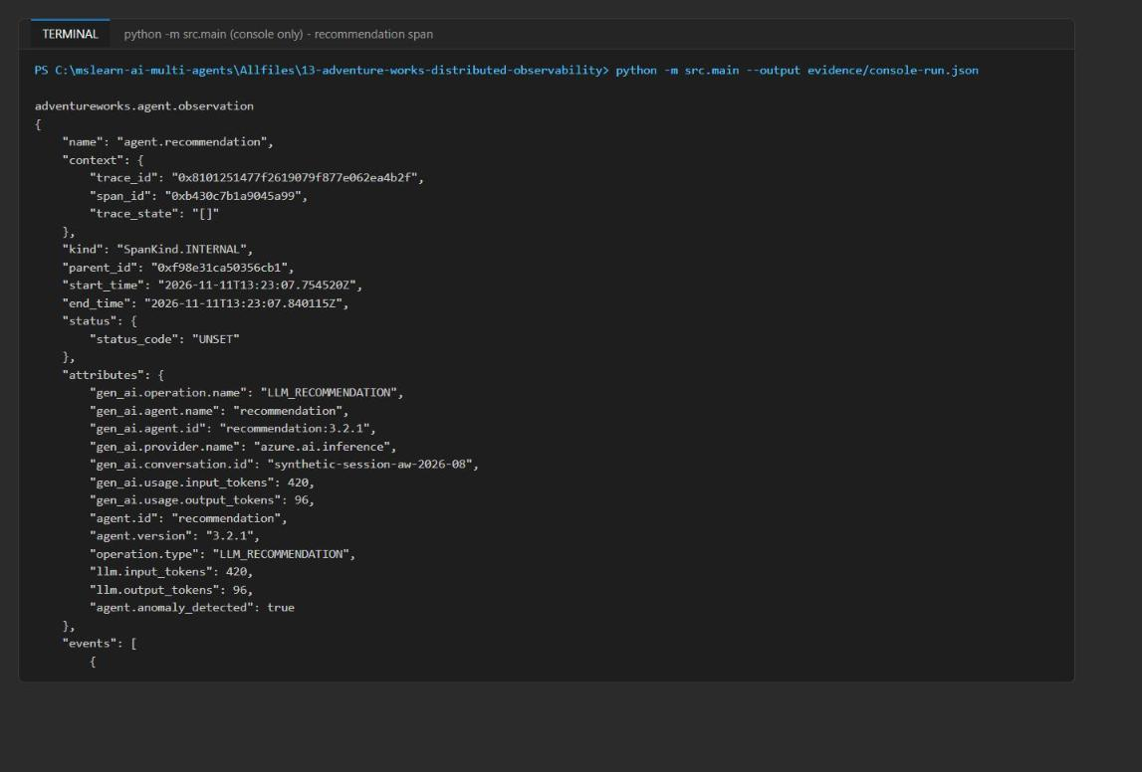
Figure 5: Console span for the recommendation agent with its parent_id and both anomaly events
4. Scroll to the end of the output. The inventory span has status_code: ERROR and error.type: SyntheticAgentError. The summary reports a chain error rate of 1/3, which is above 0.05.
JSON
{
"correlation_complete": true,
"trace_id": "<32-hex-trace-id>",
"span_count": 3,
"anomalies": ["recommendation", "inventory"],
"error_rate": 0.3333333333333333,
"error_rate_anomaly": true
}

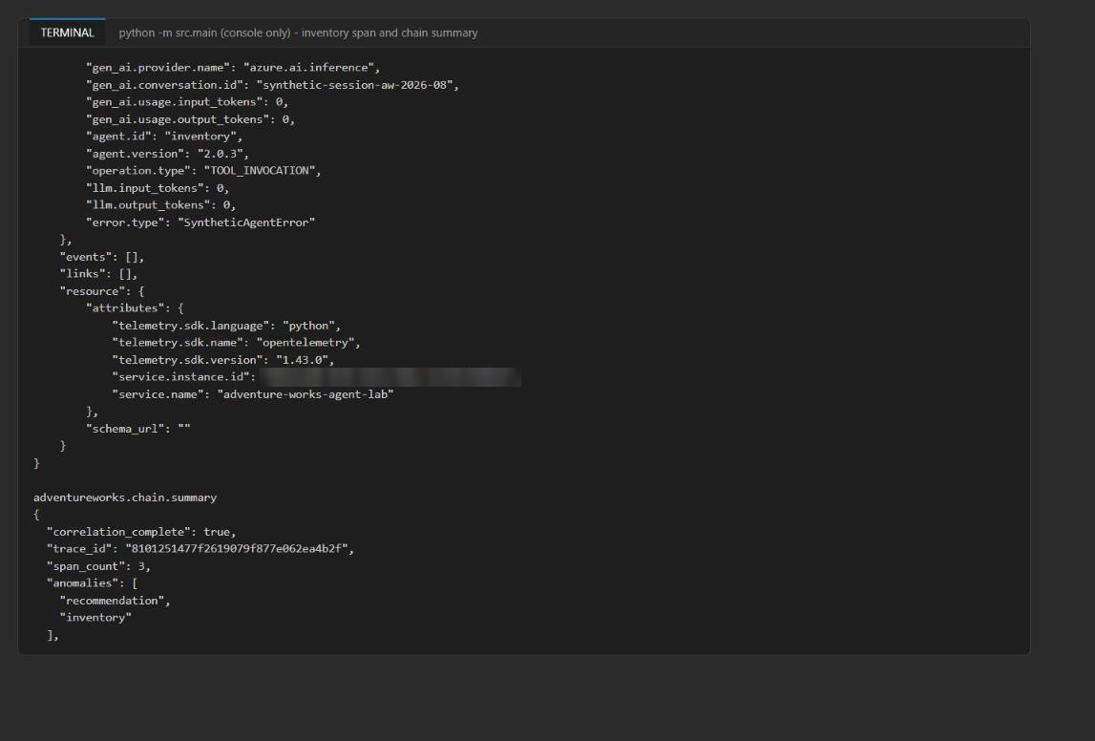
Figure 6: Inventory error span and the chain summary
5. Restore the Azure Monitor connection string and run the default scenario again. This run writes evidence/trace-evidence.json and exports spans and logs with your Entra token:
POWERSHELL
Enable-AzureExport
python -m src.main

Expected result: You see the Azure SDK HTTP log lines (Request URL: 'https://<region>.in.applicationinsights.azure.com//v2.1/track') followed by Transmission succeeded: Item received: N. Items accepted: N. The JSON summary is printed last. This log output is normal, because the root logger runs at INFO level.
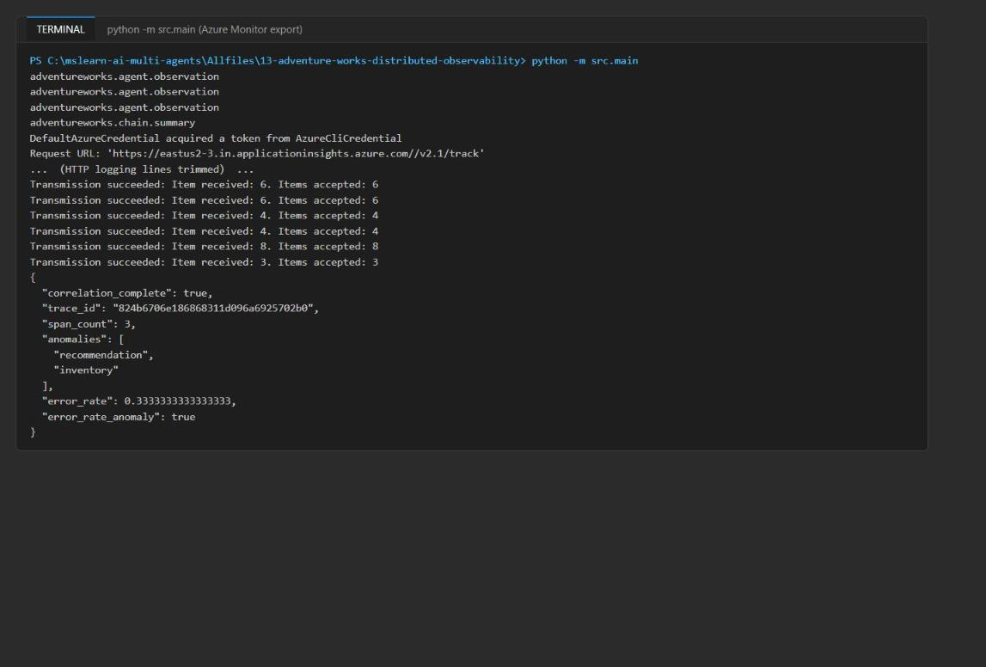
Figure 7: Azure export run - transmissions accepted and the summary with the trace ID
6. Record the printed trace ID. You need it in Task 6:
POWERSHELL
$traceId = (Get-Content evidence/trace-evidence.json -Raw | ConvertFrom-Json).trace_id
$traceId

Note: If you see Response status: 403 or Transmission failed instead, the Monitoring Metrics Publisher role has not propagated yet (Task 3, step 3). Wait a few minutes and run again. Batches that already failed are retried from offline storage.

Understand the output
Field | Meaning
correlation_complete: true | All three agent records share one trace ID
span_count: 3 | The number of agent semantic spans, not every SDK or exporter span
anomalies | The agents whose status is not success (recommendation is anomaly, inventory is error)
error_rate | The observed chain error fraction, 1/3
error_rate_anomaly | The policy comparison error_rate > error_rate_threshold

Task 6: Validate the implementation
Allow 2-5 minutes for ingestion after the Azure run before you query.

Built-in Agents view and transaction waterfall
1. In the Azure portal, open the Application Insights resource appi-aw-otel-<suffix>. In the left menu, under Investigate, select Agents (Preview). Use this built-in baseline to inspect per-agent requests, latency, token usage and errors. Select an agent to see its details. For more information, see Monitor AI agents with Application Insights.
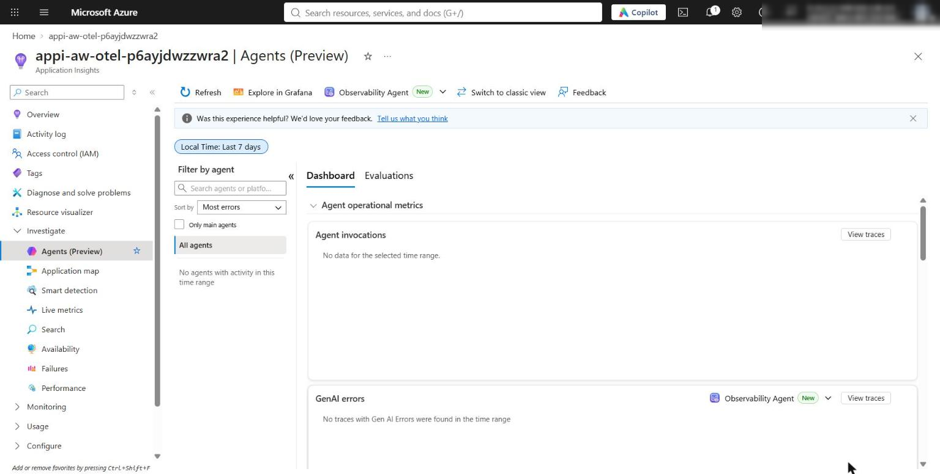
Figure 8: Application Insights Agents (Preview) view (Last 7 days). In this environment it reports "No agents with activity" because the synthetic spans are not Foundry/GenAI agent invocations; use Search and Logs below for the per-agent data
2. Select Search (Transaction search), set the time range to Last 30 minutes, and paste your trace ID into the search box. Open the agent.router dependency to display the end-to-end transaction details.
3. Confirm that the waterfall shows agent.router > agent.recommendation > agent.inventory under one operation, that inventory is marked as failed, and that the correlated trace (log) rows are attached to each span.
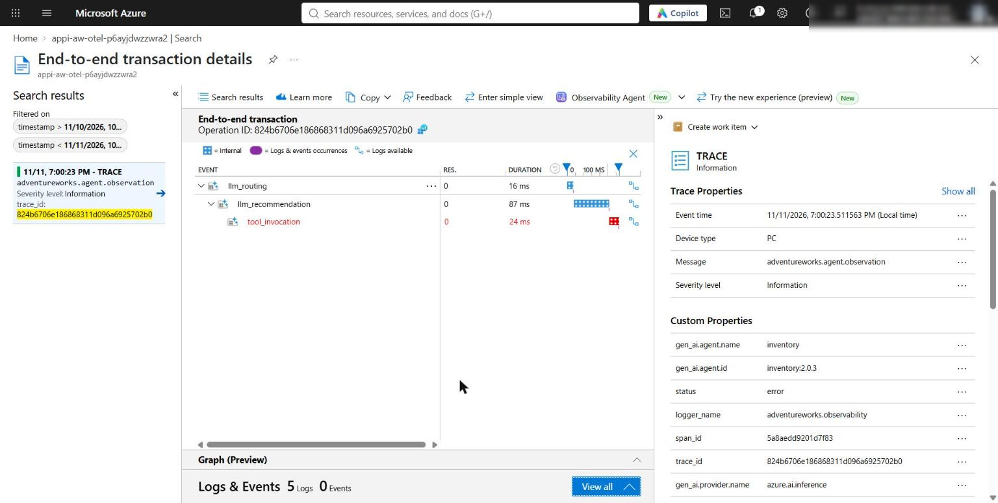
Figure 9: End-to-end transaction waterfall (timeline view) - llm_routing > llm_recommendation > tool_invocation (inventory, failed) under one operation

Query the trace waterfall and agent health with KQL
1. In the portal, open the Log Analytics workspace log-aw-otel-<suffix> and select Logs (switch to KQL mode). Paste the contents of kql/trace-waterfall.kql, replace <paste-trace-id> with your trace ID, and select Run.
Expected result: You see 3 AppDependencies rows (router -> recommendation -> inventory, each ParentId equal to the previous Id, with inventory Success = False) and the correlated AppTraces rows. These include two span-event rows for the latency and token anomalies, and one observation log per agent with ErrorType = SyntheticAgentError on inventory.
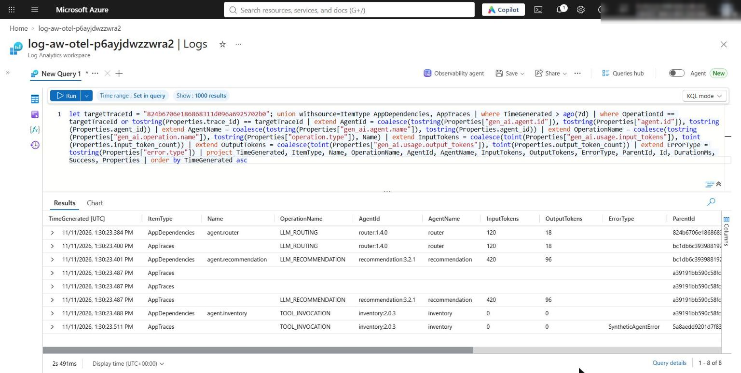
Figure 10: trace-waterfall.kql in Log Analytics for the recorded trace ID
2. You can also run the same queries from the terminal through the Log Analytics query API. Define this helper once:
POWERSHELL
function Invoke-LabKql([string]$Query) {
$bodyFile = New-TemporaryFile
@{ query = $Query; timespan = 'P1D' } | ConvertTo-Json -Compress | Out-File $bodyFile -Encoding utf8
$r = az rest --method post --url "https://api.loganalytics.io/v1/workspaces/$($env:LOG_ANALYTICS_WORKSPACE_ID)/query" `
--resource "https://api.loganalytics.io" --body "@$bodyFile" | ConvertFrom-Json
Remove-Item $bodyFile
$t = $r.tables[0]
foreach ($row in $t.rows) {
$o = [ordered]@{}
for ($i = 0; $i -lt $t.columns.Count; $i++) { $o[$t.columns[$i].name] = $row[$i] }
[pscustomobject]$o
}
}

3. Run the waterfall query for your trace ID:
POWERSHELL
$q = (Get-Content kql/trace-waterfall.kql -Raw) -replace '<paste-trace-id>', $traceId
Invoke-LabKql $q | Format-Table TimeGenerated, ItemType, Name, AgentId, ErrorType, ParentId, Id, DurationMs, Success

4. Run kql/agent-health.kql, either in the portal Logs pane or from the terminal:
POWERSHELL
Invoke-LabKql (Get-Content kql/agent-health.kql -Raw) |
Format-Table AgentId, Requests, P95LatencyMs, Anomalies, TokenAnomalies, InputTokens, OutputTokens, AnomalyRate

Expected result: recommendation:3.2.1 has the highest P95 latency (85 ms) and TokenAnomalies equal to Requests. inventory:2.0.3 has Anomalies equal to Requests (error status). router:1.4.0 has 0 anomalies. These custom queries extend the built-in Agents view with domain policy. They do not replace it.
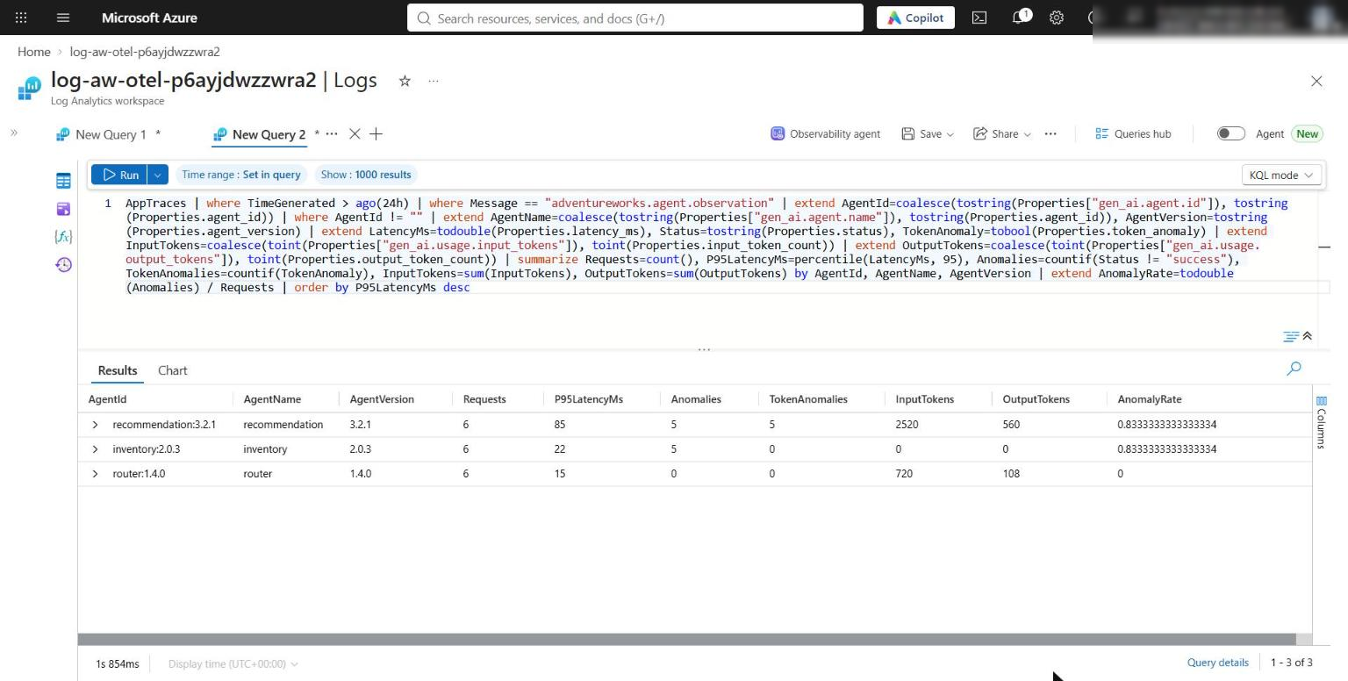
Figure 11: agent-health.kql - recommendation has the highest P95 and token anomalies, inventory is in error
5. Query the emitted policy decisions. This is the data the alert reads:
KQL
AppTraces
| where TimeGenerated > ago(1h)
| where Message in ("adventureworks.agent.observation", "adventureworks.chain.summary")
| project TimeGenerated, OperationId, Message, AgentId=tostring(Properties.agent_id), Status=tostring(Properties.status), AnomalyTypes=tostring(Properties.anomaly_types), TokenAnomaly=tostring(Properties.token_anomaly), ErrorRate=tostring(Properties.error_rate), ErrorRateAnomaly=tostring(Properties.error_rate_anomaly)
| order by TimeGenerated asc

Expected result: Observation rows show router success, recommendation anomaly with latency,token, and inventory error. Each run has a chain.summary row with ErrorRate 0.333 and ErrorRateAnomaly True.

Validate each policy setting independently
The official lab edits the asset and the YAML in place, then restores them. Instead, these steps write copies to evidence/variants/ and pass them with --scenario and --policy. The shipped files never change, so you have nothing to restore. Run the variants in console mode so they do not trigger the alert.
1. Turn off export, then create the scenario and policy variants:
POWERSHELL
Disable-AzureExport
New-Item -ItemType Directory -Force evidence/variants | Out-Null
function New-ScenarioVariant([string]$Name, [scriptblock]$Change) {
$s = Get-Content assets/trace-scenario.json -Raw | ConvertFrom-Json
& $Change $s
$s | ConvertTo-Json -Depth 10 | Out-File "evidence/variants/$Name.json" -Encoding utf8
}
New-ScenarioVariant 'boundary-60ms-80tok' { param($s) $s.agents[1].latency_ms = 60; $s.agents[1].output_tokens = 80 }
New-ScenarioVariant 'boundary-60ms-96tok' { param($s) $s.agents[1].latency_ms = 60; $s.agents[1].output_tokens = 96 }
New-ScenarioVariant 'no-errors' { param($s) foreach ($a in $s.agents) { $a.error = $false } }
New-ScenarioVariant 'no-anomaly' { param($s) $s.agents[1].latency_ms = 60; $s.agents[1].output_tokens = 80; foreach ($a in $s.agents) { $a.error = $false } }
$yaml = Get-Content config/telemetry-policy.yaml -Raw
$yaml -replace 'latency_threshold_ms: 60', 'latency_threshold_ms: 100' | Set-Content evidence/variants/latency-100.yaml
$yaml -replace 'error_rate_threshold: 0.05', 'error_rate_threshold: 0.5' | Set-Content evidence/variants/errrate-0.5.yaml
$yaml -replace 'token_anomaly_sigma: 3.0', 'token_anomaly_sigma: 4.0' | Set-Content evidence/variants/sigma-4.yaml

2. Run every variant and print a one-line decision summary for each:
POWERSHELL
function Show-Decisions([string]$Path) {
$r = Get-Content $Path -Raw | ConvertFrom-Json
($r.records | ForEach-Object { "($($_.agent_id), $($_.status), '$($_.anomaly_types)')" }) -join ' ' | Write-Host -NoNewline
Write-Host " err_rate_anom=$($r.error_rate_anomaly)"
}
foreach ($v in 'boundary-60ms-80tok','boundary-60ms-96tok','no-errors','no-anomaly') {
python -m src.main --scenario "evidence/variants/$v.json" --output "evidence/variants/out-$v.json" *> $null
Write-Host "=== $v"; Show-Decisions "evidence/variants/out-$v.json"
}
foreach ($v in 'latency-100','errrate-0.5','sigma-4') {
python -m src.main --policy "evidence/variants/$v.yaml" --output "evidence/variants/out-$v.json" *> $null
Write-Host "=== $v"; Show-Decisions "evidence/variants/out-$v.json"
}

Expected result:
Variant | What it proves | Expected decision
boundary-60ms-80tok | 60 ms and 500 tokens are exactly at the boundary (greater-than) | recommendation success
boundary-60ms-96tok | Restoring 96 output tokens (516 > 500) brings back the token anomaly only | recommendation anomaly, token
no-errors | Every error is false | err_rate_anom=False
latency-100 | YAML latency threshold 100 | recommendation token only (latency gone)
errrate-0.5 | YAML error-rate threshold 0.5 | err_rate_anom=False
sigma-4 | YAML sigma 4 gives a threshold of 550 | recommendation latency only (token gone)
no-anomaly | Healthy chain, used later for auto-mitigation | all success, err_rate_anom=False

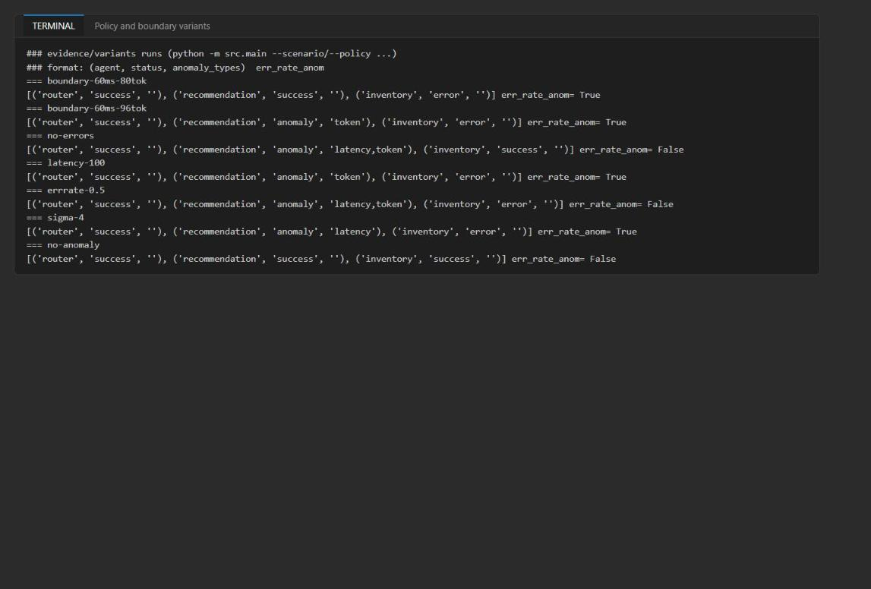
Figure 12: Boundary and YAML variants change runtime decisions without any KQL edit

Inspect the alert rule and action group
1. Check the action group. az monitor action-group show is built into the Azure CLI:
POWERSHELL
az monitor action-group show --ids $env:ANOMALY_ACTION_GROUP_ID `
--query "{enabled:enabled, receivers:emailReceivers[].emailAddress, commonSchema:emailReceivers[].useCommonAlertSchema, status:emailReceivers[].status}" -o json

2. Check the scheduled-query rule. The official az monitor scheduled-query show command needs the scheduled-query CLI extension. The generic resource command below works without any extension:
POWERSHELL
az resource show --ids $env:ANOMALY_ALERT_RULE_ID --api-version 2023-12-01 `
--query "{enabled:properties.enabled, severity:properties.severity, frequency:properties.evaluationFrequency, window:properties.windowSize, scopes:properties.scopes, actions:properties.actions.actionGroups, resolve:properties.resolveConfiguration, skipQueryValidation:properties.skipQueryValidation}" -o json

Expected result: The action group is enabled with your email, useCommonAlertSchema: true and status Enabled. The rule is enabled, severity 2, with frequency and window PT5M. It is scoped to the log-aw-otel-<suffix> workspace, linked to the action group, and auto-resolves.
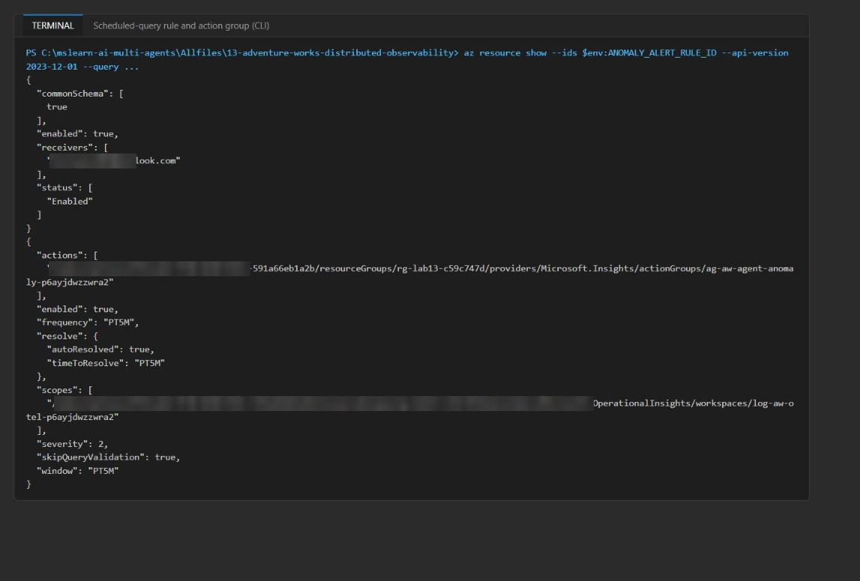
Figure 13: Rule and action-group configuration from the CLI
3. In the portal, open the alert rule alert-aw-agent-policy-anomaly-<suffix>. Confirm the scope (the workspace that stores the Application Insights telemetry), the condition (the query from kql/anomaly-alert.kql) and the action group.
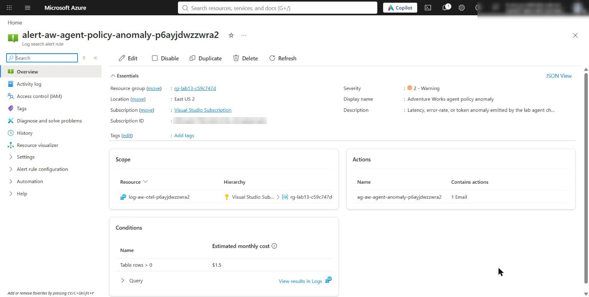
Figure 14: Scheduled-query rule - scope, condition and action group

Fire and resolve the alert
1. Run the default scenario with Azure export turned on. Run it twice, about a minute apart, so that at least one run falls inside a 5-minute evaluation window:
POWERSHELL
Enable-AzureExport
python -m src.main

2. Wait about 5-10 minutes (ingestion plus the next 5-minute evaluation). Then list the alerts for the rule:
POWERSHELL
$rule = [uri]::EscapeDataString($env:ANOMALY_ALERT_RULE_ID)
az rest --method get --url "https://management.azure.com/subscriptions/$($env:AZURE_SUBSCRIPTION_ID)/providers/Microsoft.AlertsManagement/alerts?api-version=2019-05-05-preview&alertRule=$rule&timeRange=1d" `
--query "value[].{name:name, severity:properties.essentials.severity, condition:properties.essentials.monitorCondition, started:properties.essentials.startDateTime, resolved:properties.essentials.monitorConditionResolvedDateTime, target:properties.essentials.targetResourceName}" -o table

Expected result: A Sev2 alert named Adventure Works agent policy anomaly shows monitorCondition Fired. Its target is the log-aw-otel-<suffix> workspace.
3. In the portal, open Monitor > Alerts, filter Alert rule = alert-aw-agent-policy-anomaly-<suffix>, and open the alert. Its History tab shows that the action group ag-aw-agent-anomaly-<suffix> was executed. In your inbox, confirm that the notification email uses the common alert schema (sections such as *Essentials* and *Alert context*, a severity, the monitor condition and the affected resource).
4. Now run the healthy scenario with export turned on, so that the next evaluation windows contain no anomaly signals:
POWERSHELL
python -m src.main --scenario evidence/variants/no-anomaly.json --output evidence/no-anomaly-azure.json

Expected result: The summary shows "anomalies": [], "error_rate": 0.0 and "error_rate_anomaly": false.
5. Wait about 5-10 minutes for the configured 5-minute healthy period, then run the alert listing from step 15 again. The alert's monitorCondition changes to Resolved (auto-mitigated), and you receive a "Resolved" email.
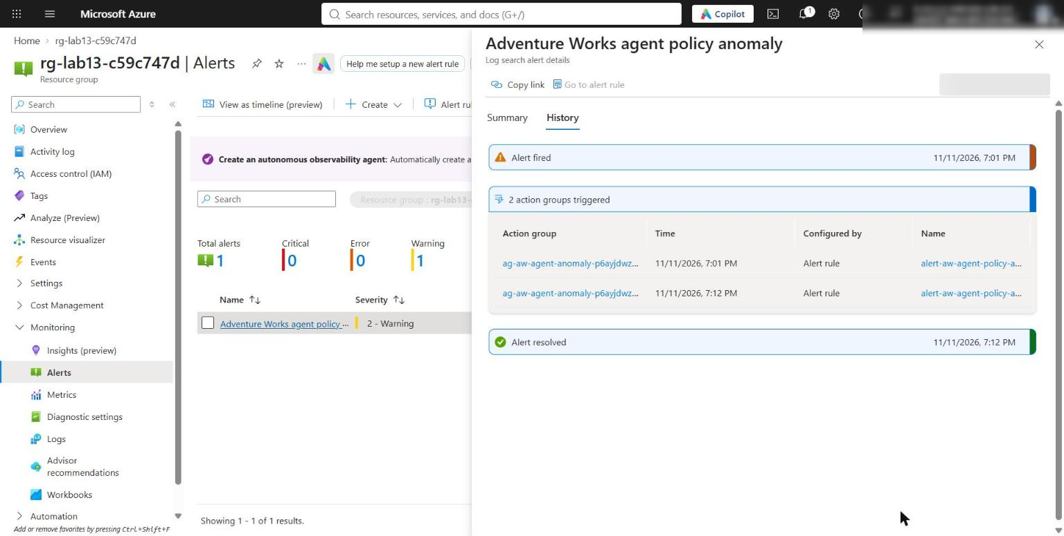
Figure 15: Azure Monitor Alerts - the Sev2 policy anomaly alert, fired and then resolved
6. Keep these items as live evidence: the Agents view baseline, the waterfall, the correlated property rows, the three policy decisions, the rule and action-group linkage, the fired alert, the notification email and the resolved state.

Optional challenge: Add a cross-agent attribute
Goal: Add a synthetic request.classification value that travels with the trace (as W3C baggage, next to traceparent). Each agent sets it as a span attribute and a log field. The value can be selected in KQL without exposing request content.
1. In src/telemetry.py, replace the OpenTelemetry import line from opentelemetry import trace with these three lines:
PYTHON
from opentelemetry import baggage, trace
from opentelemetry import context as otel_context
from opentelemetry.baggage.propagation import W3CBaggagePropagator

2. Below the line propagator = TraceContextTextMapPropagator(), add:
PYTHON
# Optional challenge: synthetic request classification travels as W3C baggage.
baggage_propagator = W3CBaggagePropagator()
CLASSIFICATION_KEY = "request.classification"

3. Replace build_next_carrier so that it injects the baggage too:
PYTHON
def build_next_carrier() -> dict[str, str]:
"""Inject the active W3C context into an outgoing carrier."""
# LAB PLACEHOLDER 1: Replace this line with the Task 1 sample.
carrier: dict[str, str] = {}
propagator.inject(carrier)
baggage_propagator.inject(carrier) # Optional challenge
return carrier

4. In _structured_log, add a classification parameter and write it to the log record. Replace the signature and the lines just before if status == "error": as shown below. The middle of the record dictionary does not change.
PYTHON
def _structured_log(
agent: dict[str, Any],
session_id: str,
status: str,
anomaly_types: list[str],
classification: object = None,
) -> dict[str, Any]:

PYTHON
if classification:
record[CLASSIFICATION_KEY] = str(classification)
if status == "error":
record["error.type"] = "SyntheticAgentError"
logger.info("adventureworks.agent.observation", extra=record)
return record

5. In execute_agent, make these three edits.
a. Replace the first line parent_context = propagator.extract(incoming_carrier) with:
PYTHON
parent_context = propagator.extract(incoming_carrier)
parent_context = baggage_propagator.extract(incoming_carrier, context=parent_context)
classification = baggage.get_baggage(CLASSIFICATION_KEY, parent_context)

b. After span.set_attribute("llm.output_tokens", agent["output_tokens"]), add:
PYTHON
if classification:
span.set_attribute(CLASSIFICATION_KEY, str(classification))

c. Replace the last two lines of the with block (record = _structured_log(...) and return record, build_next_carrier()) with:
PYTHON
record = _structured_log(agent, session_id, status, anomaly_types, classification)
if classification:
# Optional challenge: keep the baggage active (with this span) for the next hop.
token = otel_context.attach(baggage.set_baggage(CLASSIFICATION_KEY, classification))
try:
return record, build_next_carrier()
finally:
otel_context.detach(token)
return record, build_next_carrier()

Note: You must re-attach the baggage. start_as_current_span(context=parent_context) makes only the span current, not the extracted baggage. Without the attach call, build_next_carrier injects no baggage, and only the router span gets the attribute.

6. In run_chain, directly after carrier: dict[str, str] = {}, seed the first carrier with the classification. You can override the value with an optional request_classification key in the scenario:
PYTHON
classification = scenario.get("request_classification", "synthetic.product_recommendation")
baggage_propagator.inject(carrier, context=baggage.set_baggage(CLASSIFICATION_KEY, str(classification)))

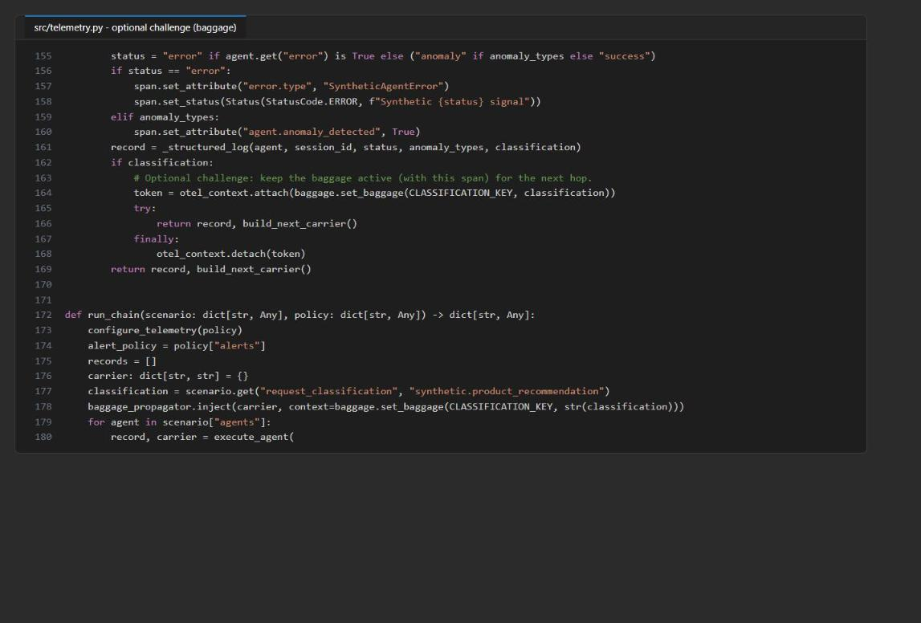
Figure 16: execute_agent tail and run_chain with the baggage re-attach and seed
7. Compile the code and run in console mode. Then run with export turned on:
POWERSHELL
python -m py_compile src/telemetry.py
Disable-AzureExport
python -m src.main --output evidence/challenge-console.json
Enable-AzureExport
python -m src.main --output evidence/challenge-azure.json

Expected output: "request.classification": "synthetic.product_recommendation" appears on all three spans in one trace.
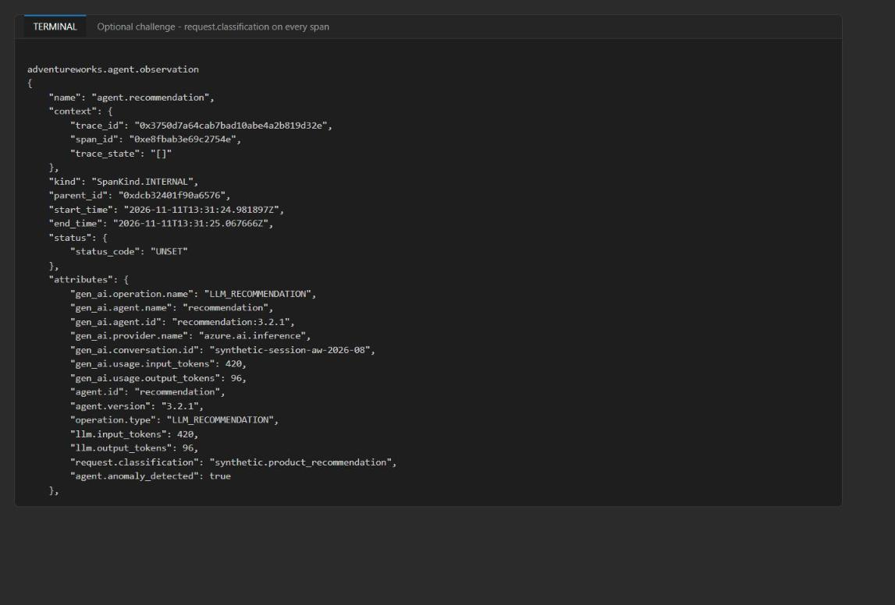
Figure 17: request.classification carried on the recommendation span (same trace as the router)
8. After ingestion, select the attribute in KQL:
KQL
AppDependencies
| where TimeGenerated > ago(1h)
| where isnotempty(Properties["request.classification"])
| project TimeGenerated, Name, Id, ParentId, OperationId, Classification=tostring(Properties["request.classification"])
| order by TimeGenerated asc

Failure investigation: Break context propagation at one handoff and find the first span that leaves the original trace. You don't need to edit the lab file. This scratch script (piped to Python, never saved in src/) drops the carrier only at the recommendation -> inventory handoff:
POWERSHELL
$brokenHandoff = @'
import json, yaml
from src import telemetry
original = telemetry.execute_agent
def broken(agent, session_id, carrier, policy):
if agent["name"] == "inventory":
carrier = {} # simulate a missing inject at this boundary
return original(agent, session_id, carrier, policy)
telemetry.execute_agent = broken
scenario = json.load(open("assets/trace-scenario.json", encoding="utf-8"))
policy = yaml.safe_load(open("config/telemetry-policy.yaml", encoding="utf-8"))
result = telemetry.run_chain(scenario, policy)
for r in result["records"]:
print(r["agent_id"], r["trace_id"], r["span_id"])
print("correlation_complete:", result["correlation_complete"])
'@
Disable-AzureExport
$brokenHandoff | python - 2>$null | Select-String -Pattern '^(router|recommendation|inventory) |correlation_complete'
Enable-AzureExport

Expected result: Router and recommendation share one trace ID. Inventory is the first span with a new trace ID (a new root), and correlation_complete is False.
Note: Run the block from the lab folder. python - reads the script from standard input and puts the current folder on sys.path, so from src import telemetry resolves.

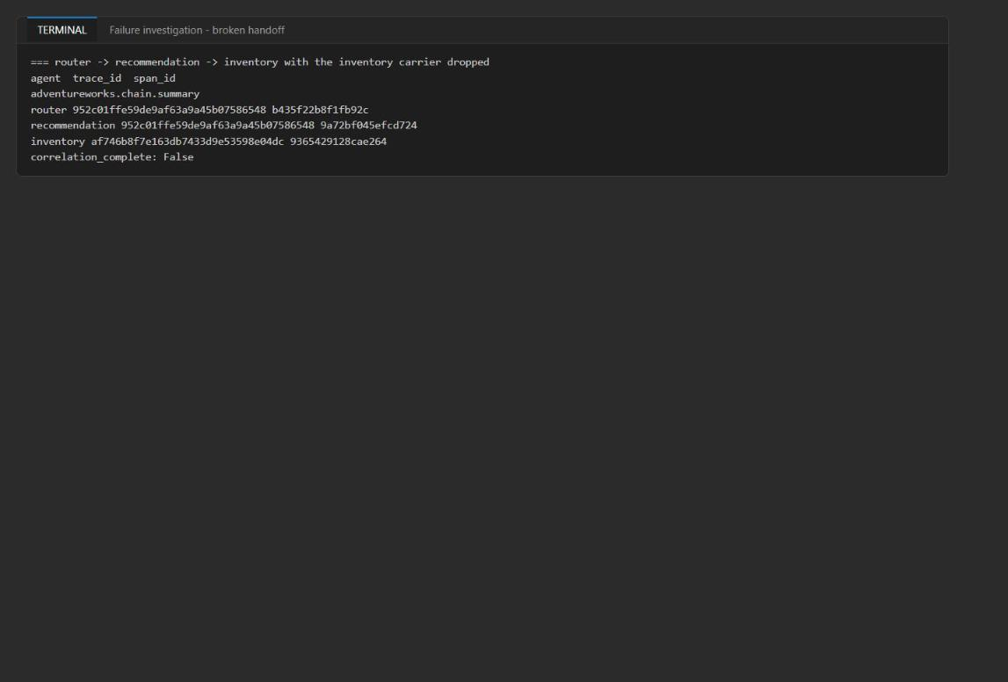
Figure 18: Broken handoff - inventory starts a new trace

Validate
# | Acceptance criterion | How to check (CLI) | How to check (portal)
1 | Three spans share one 32-character trace ID and form a parent-child chain | Console run (Task 5, step 3): parent_id chain router -> recommendation -> inventory | Transaction search waterfall
2 | Recommendation has latency (85 > 60) and token (516 > 500) anomalies, and the chain error rate is 1/3 | Summary JSON and evidence/trace-evidence.json | Span events in the transaction details
3 | Export uses Entra auth (local auth disabled) and the waterfall is under one operation | Transmission succeeded lines. DisableLocalAuth=true | trace-waterfall.kql returns 3 AppDependencies plus the AppTraces rows
4 | agent-health shows recommendation with the highest P95 and token anomalies, and inventory in error | Invoke-LabKql (Get-Content kql/agent-health.kql -Raw) | Logs
5 | 60 ms / 80 tokens is not anomalous (strict greater-than) | Variant boundary-60ms-80tok | -
6 | 96 tokens brings back the token anomaly, and latency stays clean at 60 ms | Variant boundary-60ms-96tok | -
7 | With every error false, error_rate_anomaly is false | Variant no-errors | -
8 | YAML threshold changes alter decisions with no KQL edit | Variants latency-100, errrate-0.5, sigma-4 | -
9 | Action group is enabled, uses the email receiver and the common alert schema | az monitor action-group show | Action group > Notifications
10 | Rule is enabled, Sev2, PT5M, linked to the action group and scoped to the workspace | az resource show --api-version 2023-12-01 | Alert rule overview
11 | A Sev2 alert fires, linked to the workspace and the action group | az rest ... AlertsManagement/alerts | Monitor > Alerts > History
12 | A no-anomaly run leads to auto-mitigation | Same listing shows Resolved | Alert monitor condition = Resolved
13 | Notification email uses the common alert schema | - | Your inbox

Troubleshooting
Symptom | Cause | Fix
Response status: 403 / Transmission failed on the first Azure runs | Monitoring Metrics Publisher has not propagated yet. In the validated run it took about 6 minutes | Wait and run again. Failed batches are retried from the exporter's offline storage. Do not enable local-key ingestion
.env has no APPLICATIONINSIGHTS_CONNECTION_STRING | Some helpers (and azd setups) skip keys that end in CONNECTION_STRING | Add it with az resource show --ids <APPLICATIONINSIGHTS_RESOURCE_ID> --query properties.ConnectionString -o tsv (Task 3, step 2 note)
az monitor scheduled-query show fails with "not a valid command" / prompts for an extension | The scheduled-query extension is not installed | Use az resource show --ids $env:ANOMALY_ALERT_RULE_ID --api-version 2023-12-01 (Task 6, step 12), or run az extension add --name scheduled-query
az monitor log-analytics query is not available | The log-analytics extension is not installed | Use the Invoke-LabKql helper (Log Analytics query REST API through az rest), or the portal Logs pane
Console run still exports to Azure | The connection string is still in the session or .env | Run Disable-AzureExport. Setting $env:APPLICATIONINSIGHTS_CONNECTION_STRING = '' removes the variable in PowerShell, so load_dotenv reloads it from .env
json.decoder.JSONDecodeError: Unexpected UTF-8 BOM on a variant | The file was written by Windows PowerShell 5.1 (-Encoding utf8 adds a BOM) | Use PowerShell 7 (pwsh)
Alert rule deployment fails with "Failed to resolve table AppTraces" | Query validation on a new workspace | The template already sets skipQueryValidation: true with an empty fallback. Redeploy the unmodified main.bicep
trace-waterfall.kql returns no rows | Ingestion delay, or the placeholder was not replaced | Wait 2-5 minutes. Check that <paste-trace-id> was replaced with the 32-hex trace ID
Alert does not fire | No anomaly signal fell inside the 5-minute window, or ingestion lagged | Run the default scenario again and wait up to 10 minutes
No email | The action group email is wrong or went to spam | Check az monitor action-group show and your spam folder
Deployment fails on the role assignment | You lack Microsoft.Authorization/roleAssignments/write | Ask for Owner or User Access Administrator on the resource group

Review questions
What breaks when context injection is omitted at one boundary? The next agent extracts an empty carrier and starts a new root span with a new trace ID. The waterfall splits into two transactions at that hop, correlation_complete becomes false, OperationId-based KQL returns only part of the chain, and an alert on a downstream agent can no longer be attributed to the upstream request.
Which structured fields are useful without exposing customer content? These fields are useful:
- Trace and span IDs.
- gen_ai.agent.name and gen_ai.agent.id, agent.version, gen_ai.operation.name and the provider name.
- Token counts, latency, status and error.type.
- Anomaly flags and types, the policy ID and version, and error-rate values.
- A hashed session ID.
Raw prompts, model reasoning, customer IDs, emails and payment data are excluded (prohibited_fields).
Why would errors and slow traces require collector-side tail sampling rather than head sampling? Head sampling decides at the root span, before latency or errors are known, so a 5% ratio discards about 95% of the rare failing or slow traces. A tail-sampling collector buffers whole traces and keeps them based on their outcome (error status, duration or an anomaly attribute), while it samples healthy traffic down.
How would you correlate simultaneous anomalies into one incident? Group signals by trace or operation ID first (one chain = one incident), then by agent ID, version and time window. Use one scheduled-query rule for all three signals, alert processing rules or smart grouping, or dedup keys built from the trace ID plus the agent. The earliest failing span is the probable root cause.
Why does the alert consume emitted policy decisions instead of repeating thresholds in KQL? The policy YAML is the single source of truth. Thresholds change in one place and are versioned (policy_id and policy_version appear in the logs), and the rule stays valid without a redeploy. Thresholds duplicated in KQL drift from the runtime decision. The variants in Task 6 showed decisions changing with no KQL edit.

Clean up (optional)
Note: Leaving telemetry export configured keeps ingestion charges running. Delete the resources when you finish.

1. Delete the resource group:
POWERSHELL
az group delete --name $env:AZURE_RESOURCE_GROUP --yes --no-wait

2. Confirm the deletion after a few minutes (the command returns false):
POWERSHELL
az group exists --name $env:AZURE_RESOURCE_GROUP

3. Remove the local .env and the evidence, which contains trace IDs and resource IDs:
POWERSHELL
Remove-Item .env, evidence -Recurse -Force

4. Deactivate the virtual environment in every terminal where (.venv) appears, and confirm that (.venv) is gone before you change to another lab folder:
POWERSHELL
deactivate

