Reflect on your teaching experience to date, make a note of the aspects you would like to improve about your teaching and your students learning (after completing this course you can revisit this question and propose solutions and teaching strategies that you can employ to enhance students learning) **(Guide <800 words)**

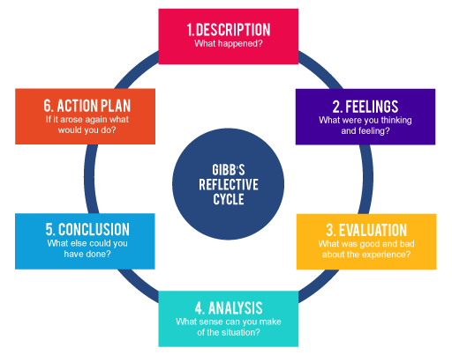

|  |  |
| --- | --- |
| **Gibbs Reflective Cycle** | **Use these questions to guide your reflection**  (**Guide <800 words; 100 – 150 words per section**) |
| Describe | Describe a critical incident or a significant event in your teaching practice? Something that happened that you were not happy with and would like to change  Describe the context and outline the roles played by you and others |
| Feel | What were you thinking and feeling? How have these feelings changed since? |
| Evaluate | What was good and bad about the experience? What problems did you have? How did it impact on you? How do you feel it impacted on the students learning? |
| Analyse | What sense can you make of the situation? What challenged you? Did you talk to others about it, did they have the similar issues, what feedback/advice did they give you? What other resources did you use or could you use to help you with similar incidents in the future? |
| Conclude | What did you learn about yourself? What did you learn about your students? What did you learn about teaching and learning? What else could you have done? |
| Plan | If it arose again, what would you do and why? What would you do differently the next time? What will you do to overcome any problems/issues you identified? |

Add your reflection here: