Watch the two videos taken from 'Mona Lisa's Smile' and using the lens of 'Blooms taxonomy' identify and discuss which levels in the cognitive domain each video sample is targeting. Discuss also how these levels are reflected in your own practice. **(Guide < 600 words; 100 – 150 words per section)**

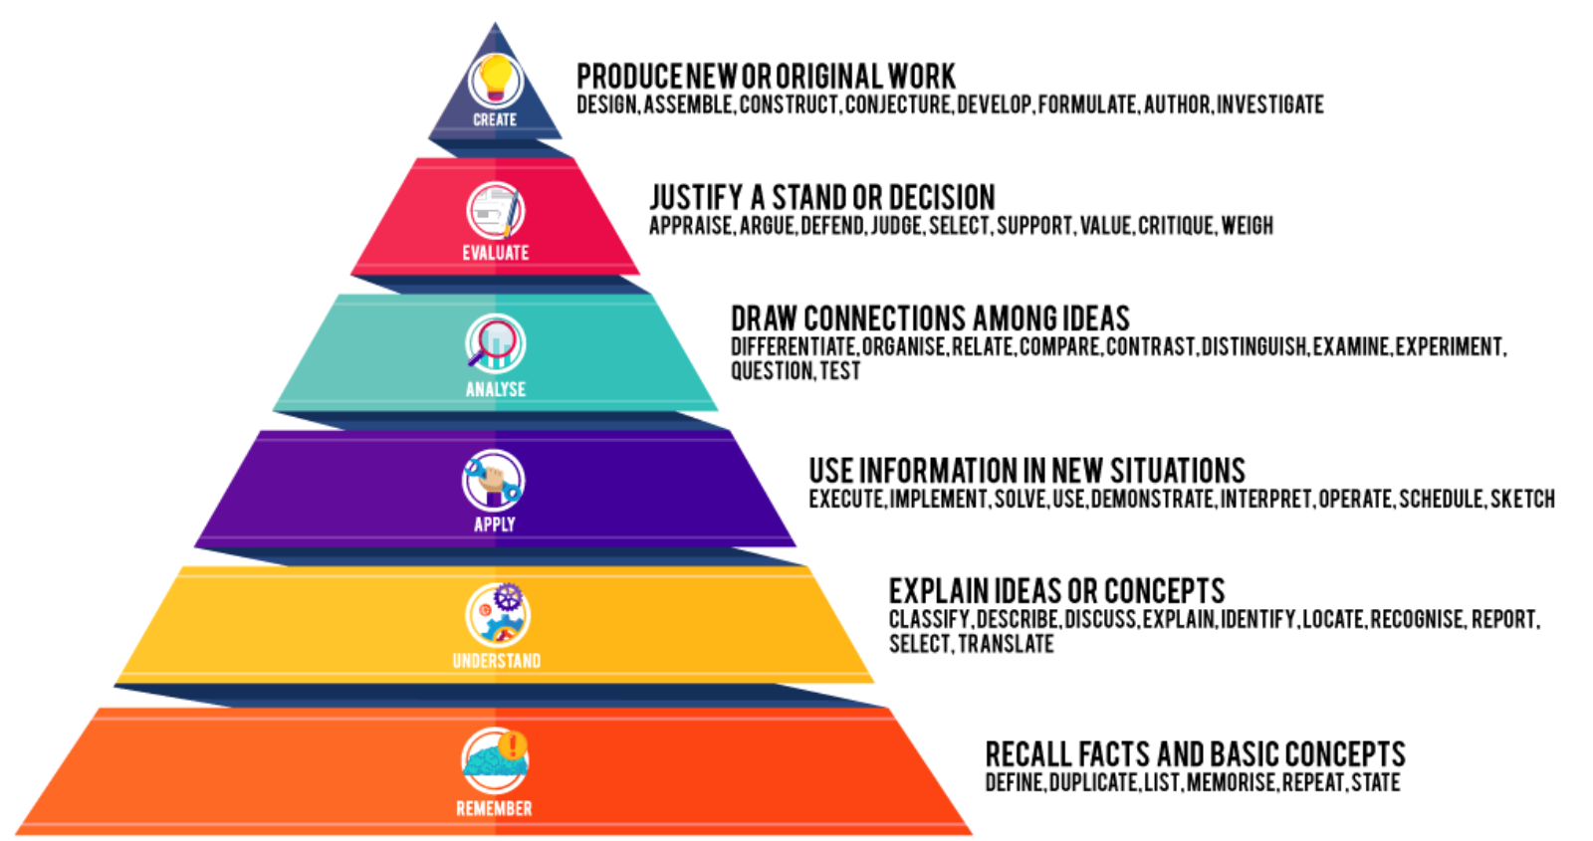

|  |  |
| --- | --- |
| **Video 1** | **Your own teaching** |
| Watch **Video 1** on ‘Mona Lisa’s Smile’  Describe what the teacher did  Describe what the students did  What level(s) in the cognitive domain are being targeted?  Outline why you believe these levels in Blooms Taxonomy are being targeted? | Think about a lecture that you felt did not go so well for you, where your felt your students did not learn.  Describe what you did  Describe what your students did  What level(s) in the cognitive domain were you targeting with this approach/teaching strategy?  Outline why you believe these levels in Blooms Taxonomy were targeted in this session?  With reference to the levels in Blooms Taxonomy, briefly outline what you could do to improve this session. |
| **Video 2** | **Your own teaching – Please complete this component post your active learning intervention** |
| Watch **Video 2** on ‘Mona Lisa’s Smile’  Describe what the teacher did  Describe what the students did  What level(s) in the cognitive domain are being targeted?  Outline why you believe these levels in Blooms Taxonomy are being targeted? | Think about a lecture that you felt went well for you, where your felt your students really learned.  Describe what you did  Describe what your students did  What level(s) in the cognitive domain were you targeting with this approach/teaching strategy?  Outline why you believe these levels in Blooms Taxonomy were targeted in this session?  On reflection and with reference to the levels in Blooms Taxonomy, briefly outline what you could do to improve this session. |

Add your reflections here: