**1.**

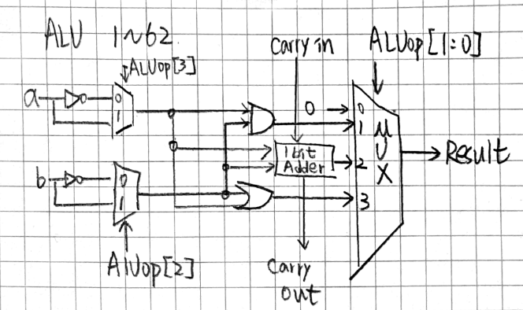

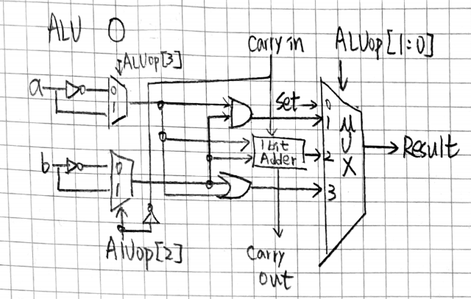

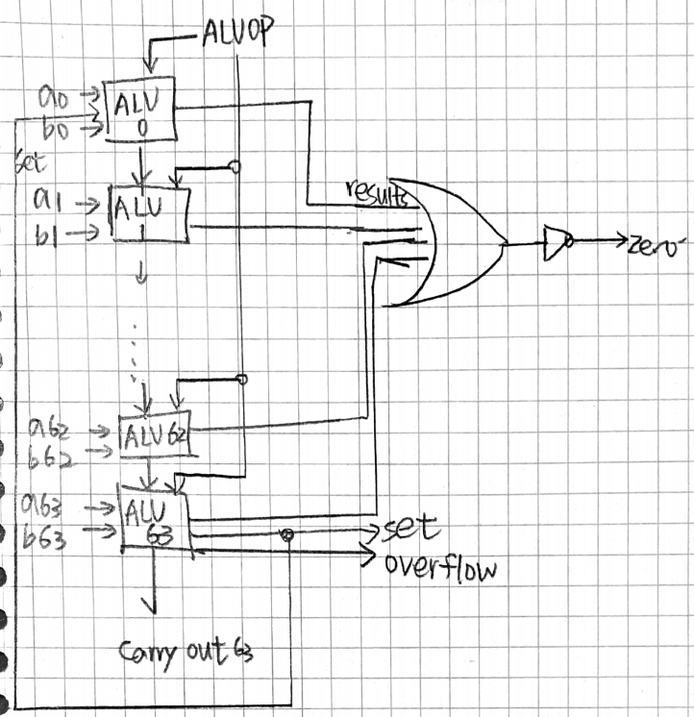

**2.(abcd)**

**3.(a)**

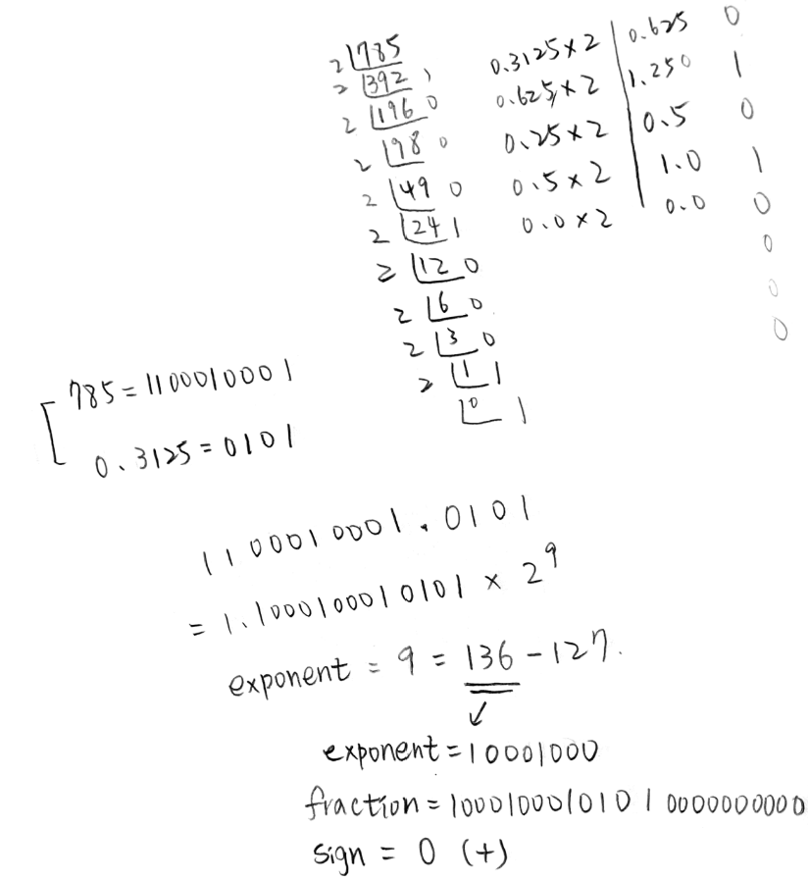

X = 0 10001000 10001000101010000000000

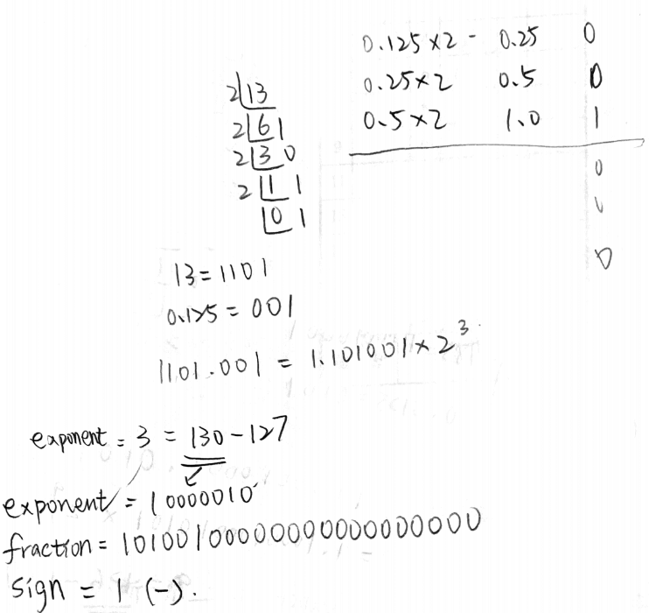

Y = 1 10000010 10100100000000000000000

**3.(b)**

STEP1 X=1.1000100010101 x 2^9

STEP2 Y=-1.101001 x 2^3 = -0.000001101001 x 2^9 (負)

STEP3 X+Y = 1.1000001000011 x 2^9 = 0 10001000 10000010000110000000000 =-772.1875

**3.(c)**

STEP1 (1.1000100010101 x 1.101001) x 2^(9+3)

STEP2 10.10000100001101 x 2^(12)

STEP3 -1.010000100001101 x 2^(13) (put the sign)

= 1 10001100 01000010000110011101000

**4.(a)**

Convert W into 32 bit binary : 1111 1111 1000 1110 0000 1110 0001 0011

2補數為: 0000 0000 0111 0001 1111 0001 1110 1101 = 7467501

加上負號 = ANS = -7467501

**4.(b)**

Convert W into 32 bit binary : 1111 1111 1000 1110 0000 1110 0001 0011

|  |  |  |
| --- | --- | --- |
| Sign(1Bit) | Exponent(8 bits) Bias = 127 = 2^7-1 | Fraction 23 bits |

Sign = 1

Exponent = 1111 1111

Fraction = 0000 1110 0000 1110 0001 0011

They are called Not a Number (NaN) à (Exponent = 111…1), (Fraction ≠ 000…0)

NaN

**4.(c)**

Convert W into 32 bit binary : 1111 1111 1000 1110 0000 1110 0001 0011

Last 7 codes are opcode = 001 0011

[14:12] = funct3 = 000

Rd = 1110 0

Rs1 = 1110 0

Imm = 1111 1111 1000

So the corresponding assembly instruction is addi rd, rs1, imm = addi x28, x28, -8

**5.(a)**

0(sign) 00001(exponent) 0000000000(fraction)

1.0 x 2^(-14) is smallest positive normalized number = a0

**5.(b)**

0(sign) 00000(exponent) 1111111111(fraction)

=0.1111111111 x 2^(-14)

= 1.111111111 x 2^(-15) = largest positive denormalized number = a1

0(sign) 00000(exponent) 1111111110(fraction)

0.111111111 x 2^(-14)

=1.11111111 x 2^(-15) = second largest positive denormalized number = a2

**5.(c)**

A0-a1= 0.0000000001 x 2^(-14)

A1-a2 = 0.000000001 x 2^(-15)

A0-a1 = a1-a2 so the minimize difference between denormalized numbers are same as the difference between normalized numbers.

**5.(d)**

1(sign) 01111(exponent) 0110100111(fraction)

=-1.0110100111 x 2^(0) = -1.4130859375

**5.(e)**

所以可能1.0011110101 = 1.2392578125 和1.24差 0.0007421

或 1.0011110110 = 1.240234375 和 1.24 差 0.000234

因為0.000234<0.0007421 所以 U = 1.240234375 (1.0011110110)