Turing Machine Simulator

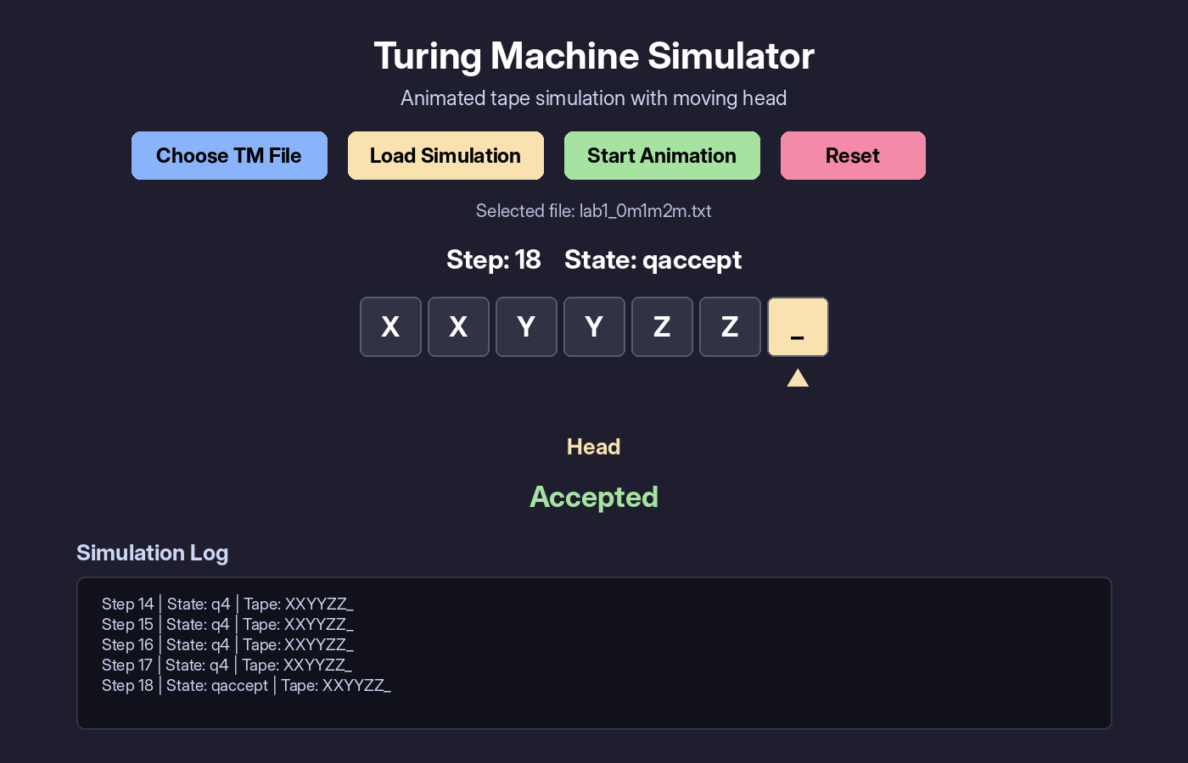
Final accepted simulation screen.

Course | Theory of Computing
Project | Turing Machine Simulator
Programming Language | Python 3
GUI Toolkit | Tkinter
Team Members | 1. Lotfe eissah ID: 231001631  2. Hamza ahmed ID: 231002474  3.Yassin Amr ID: 231000873  4. Jana Amr ID: 231002013

1. Project Overview
The Turing Machine Simulator is a desktop application that loads a machine definition from a text file and simulates how the machine processes a test string on its tape. The program displays the tape as cells, highlights the current head position, and updates the current state at every simulation step.
The main goal of the project is to make Turing Machine execution easier to understand. Instead of reading a transition table only, the user can visually follow the movement of the head, the symbols written on the tape, and the final accept or reject result.

2. Main Features
- Reads the complete Turing Machine definition from a .txt file.
- Supports states, input alphabet, tape alphabet, blank symbol, start state, accept state, reject state, and transition rules.
- Displays the tape using a clean graphical interface.
- Animates the tape head step by step during simulation.
- Shows the current step number, current state, tape content, and final result.
- Works without external libraries. Tkinter is included with Python.

3. Program Interface
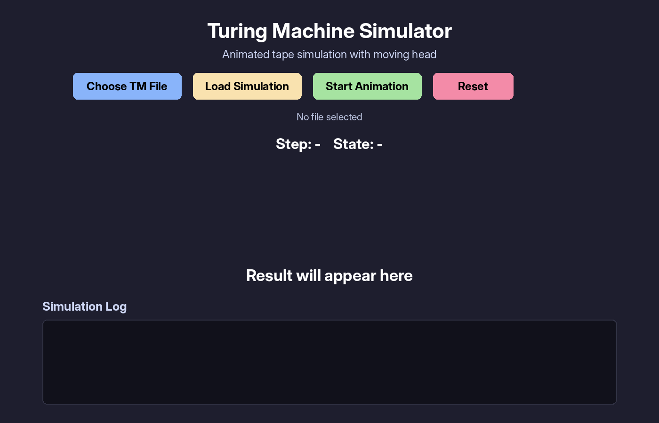
Figure 1. Main screen before loading a Turing Machine file.
The interface contains four main buttons: Choose TM File, Load Simulation, Start Animation, and Reset. After selecting an input file, the simulator loads all transition rules and prepares the simulation steps.
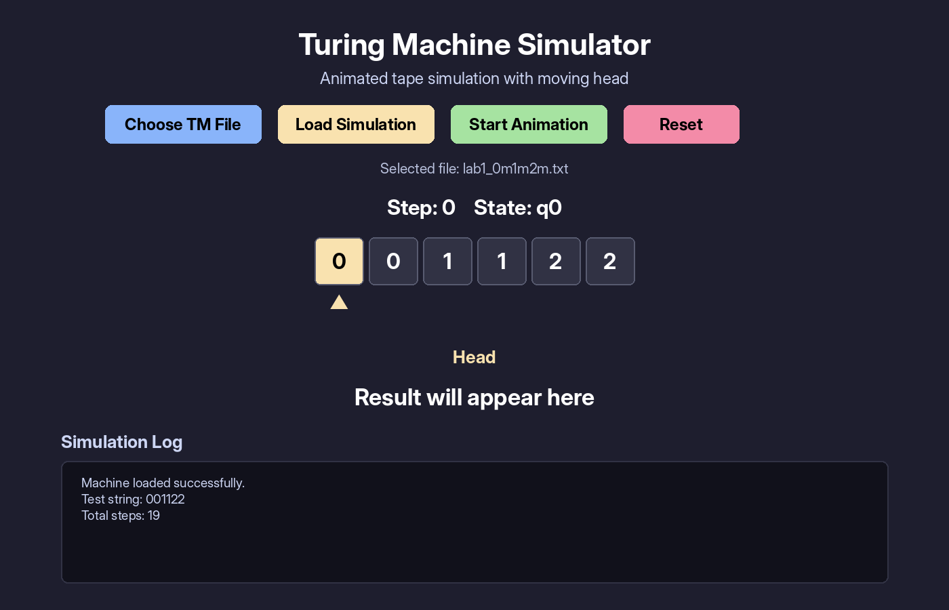
Figure 2. The selected file is loaded and the first tape configuration is displayed.

4. Input File Format
The simulator uses a simple text-based format. Machine components are written first, followed by the keyword transitions:. Each transition must contain five values: current state, read symbol, next state, write symbol, and movement direction.
states: q0 q1 q2 q3 q4 qaccept qreject
input_alphabet: 0 1 2
tape_alphabet: 0 1 2 X Y Z _
blank: _
start: q0
accept: qaccept
reject: qreject
test_string: 001122
transitions:
q0 0 q1 X R
q0 Y q4 Y R
q4 _ qaccept _ S
Field | Description
states | All states used by the machine.
input_alphabet | Symbols allowed in the input string.
tape_alphabet | All symbols that may appear on the tape.
blank | Blank symbol used for empty tape cells.
start | Initial state of the machine.
accept / reject | Final decision states.
test_string | String that will be simulated.
transitions | Transition function rules.

5. Transition Rule Format
Every transition rule follows this format:
current_state read_symbol next_state write_symbol direction
The direction value can be R for right, L for left, or S for stay. For example, the rule below means: if the machine is in q0 and reads 0, it writes X, moves right, and changes to q1.
q0 0 q1 X R

6. Simulation Mechanism
Internally, the tape is stored as a dynamic list of symbols. The head position is stored as an integer index. The transition function is stored in a dictionary, where each key is made from the current state and the current tape symbol. This allows the program to find the correct transition efficiently at each step.
- Load the Turing Machine description from the selected input file.
- Validate that the test string uses only symbols from the input alphabet.
- Initialize the tape and place the head at the first symbol.
- Read the current state and the symbol under the head.
- Search for a matching transition rule.
- Write the new symbol, update the current state, and move the head.
- Display the new configuration in the GUI.
- Stop when the machine reaches qaccept, qreject, or when no valid transition exists.
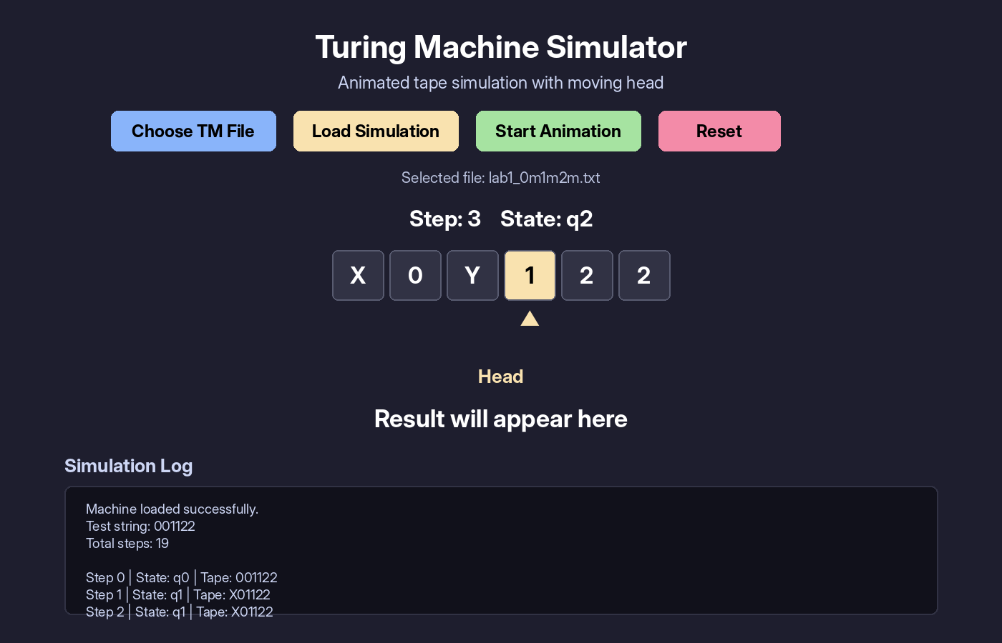
Figure 3. Simulation in progress. The highlighted cell shows the current head position.

7. Output Format
The output is displayed in two ways. First, the tape cells show the live configuration of the machine. Second, the simulation log records each step using a compact text format.
Step 0 | State: q0 | Tape: 001122
Step 1 | State: q1 | Tape: X01122
Step 2 | State: q1 | Tape: X01122
Step 3 | State: q2 | Tape: X0Y122
...
Step 18 | State: qaccept | Tape: XXYYZZ_

Figure 4. Accepted result after the simulation finishes.
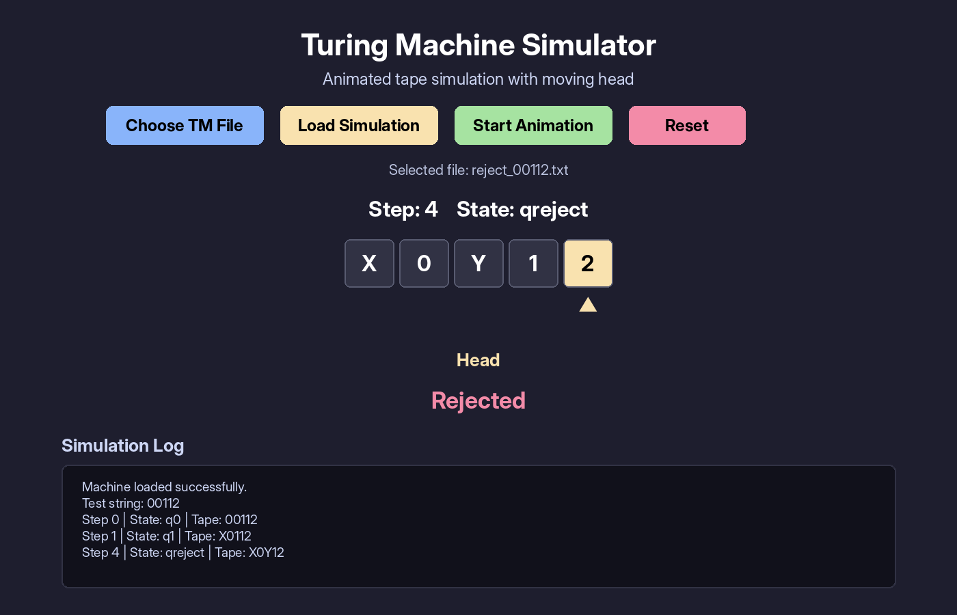
Figure 5. Rejected result for an invalid pattern.

8. Test Machines Used
The following examples are used for testing the simulator. They cover languages discussed in the Turing Machine tutorial and demonstrate both simple and multi-symbol tape processing.
File Name | Language | Test String | Expected Result
example1_anbn.txt | { a^n b^n | n > 0 } | aabb | Accepted
example2_anbm_n_less_m.txt | { a^n b^m | 0 < n < m } | aabbb | Accepted
lab1_0m1m2m.txt | { 0^m 1^m 2^m | m > 0 } | 001122 | Accepted
lab2_ambncmdn.txt | { a^m b^n c^m d^n | m,n > 0 } | aabccd | Accepted
reject_00112.txt | Invalid 0^m1^m2^m pattern | 00112 | Rejected

9. Sample Input Files

9.1 Language { a^n b^n | n > 0 }
states: q0 q1 q2 q3 qaccept qreject
input_alphabet: a b
tape_alphabet: a b X Y _
blank: _
start: q0
accept: qaccept
reject: qreject
test_string: aabb
transitions:
q0 a q1 X R
q0 Y q3 Y R
q0 b qreject b S
q0 _ qreject _ S
q1 a q1 a R
q1 Y q1 Y R
q1 b q2 Y L
q1 _ qreject _ S
q2 a q2 a L
q2 Y q2 Y L
q2 X q0 X R
q3 Y q3 Y R
q3 _ qaccept _ S
q3 a qreject a S
q3 b qreject b S

9.2 Language { 0^m 1^m 2^m | m > 0 }
states: q0 q1 q2 q3 q4 qaccept qreject
input_alphabet: 0 1 2
tape_alphabet: 0 1 2 X Y Z _
blank: _
start: q0
accept: qaccept
reject: qreject
test_string: 001122
transitions:
q0 0 q1 X R
q0 X q0 X R
q0 Y q4 Y R
q0 1 qreject 1 S
q0 2 qreject 2 S
q0 _ qreject _ S
q1 0 q1 0 R
q1 Y q1 Y R
q1 1 q2 Y R
q1 2 qreject 2 S
q1 Z qreject Z S
q1 _ qreject _ S
q2 1 q2 1 R
q2 Z q2 Z R
q2 2 q3 Z L
q2 0 qreject 0 S
q2 _ qreject _ S
q3 0 q3 0 L
q3 1 q3 1 L
q3 2 q3 2 L
q3 Y q3 Y L
q3 Z q3 Z L
q3 X q0 X R
q4 Y q4 Y R
q4 Z q4 Z R
q4 _ qaccept _ S
q4 0 qreject 0 S
q4 1 qreject 1 S
q4 2 qreject 2 S

