2II66 Assignment 1 – Robbert Jongeling

## 1: Is there a control-flow of the process discoverable in terms of a Petri net with a fitness of 1.0?

Using the ILP Miner in the setup of Figure 1 applied to the provided file APM_First_Assignment.xes, we have discovered a Petri net with a fitness of 1.0.

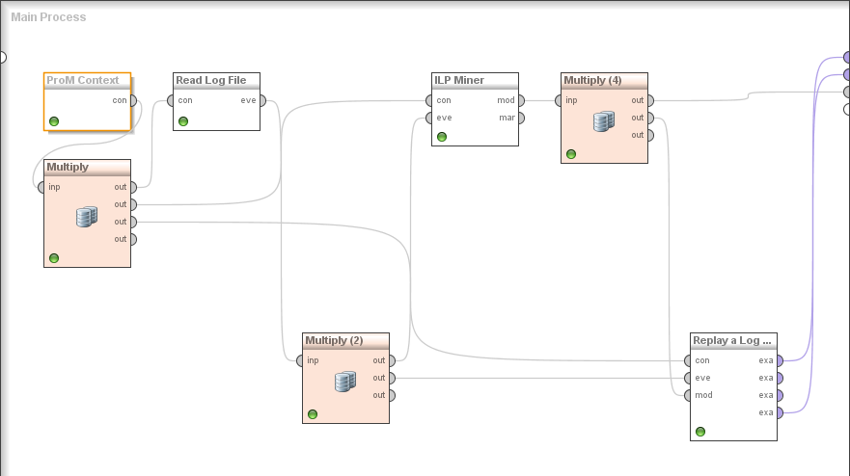

Figure : Setup for discovering a Petri net. Read Log File type: buffered, settings of ILP Miner: *EmptyAfterCompletion*, settings of Replay A Log for Conformance analysis: Max Explored States (in hunderds): 200, Create no final marking and do not calculate precision/generalization.

This Data View of ExampleSet (Replyay a Log on Petri Net for Conformance Analysis) is shown in Table 1. There do not exist “Unreliable Alignments.” The resulting Petri net is show in

Table : Data view of generated Petri net

|  |  |
| --- | --- |
| Trace Fitness | 1 |
| Move-Log Fitness | 1 |
| Move-Model Fitness | 1 |
| Raw Fitness Cost | 0 |
| Num. States | 25 |
| Queued states | 78.898 |
| Generalization | 0 |
| Precision | 0 |



Figure : Resulting Petri net with fitness 1.0

## 2: Discover information about the organizational perspective of the process

### Discovering networks

The setup used to discover the various types of networks is shown in Figure 3.

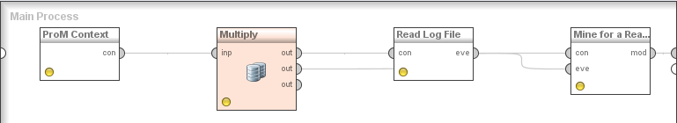

Figure : Setup for discovering networks, from the provided input file APM_First_Assignment.xes. The last operator is altered to discover the various types of networks discussed.

### Similar-Task Social Network

The similar-task network discovered is shown in Figure 4

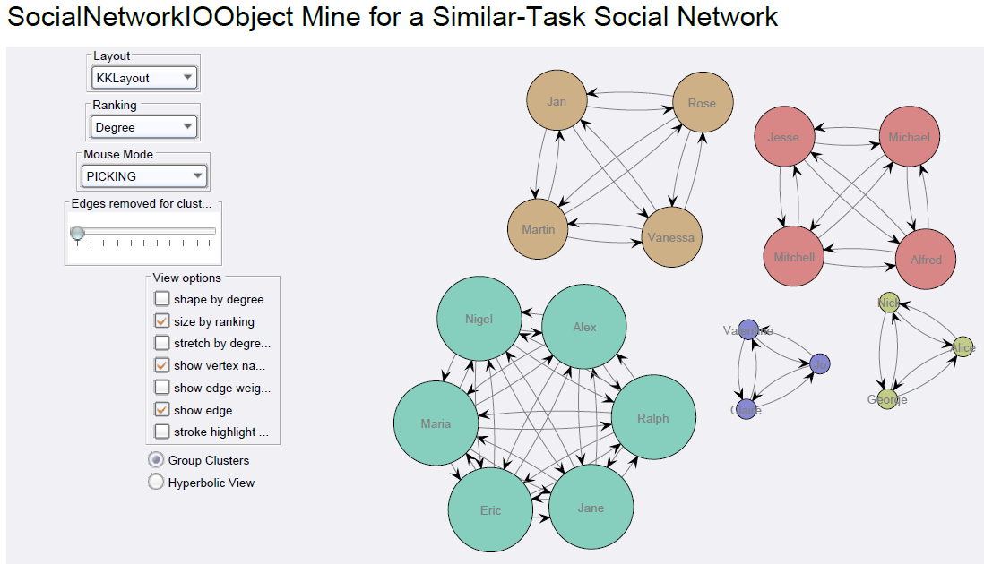

Figure : Similar-Task social network

We see that there are five identifiable clusters of employees performing similar tasks. These may correspond to departments within the organization. Larger departments have larger nodes because they have more edges between nodes.

### Handover-of-work social network

The handover-of-work social network is shown in Figure 5. The size of the nodes corresponds to the number of outgoing and incoming edges. That is, for each person the number of people he has handed over work to and the number of people who have handed off work to him. We see that George, Alice and Nick participate the least in the handing over of work. Interestingly, those three form a department according to the similar-task social network. So this department does not handle much work from other departments. This may be because they do specialized work or because they do very basic work that others have no interest in doing (a doctor will probably not clean the hospitals toilets).

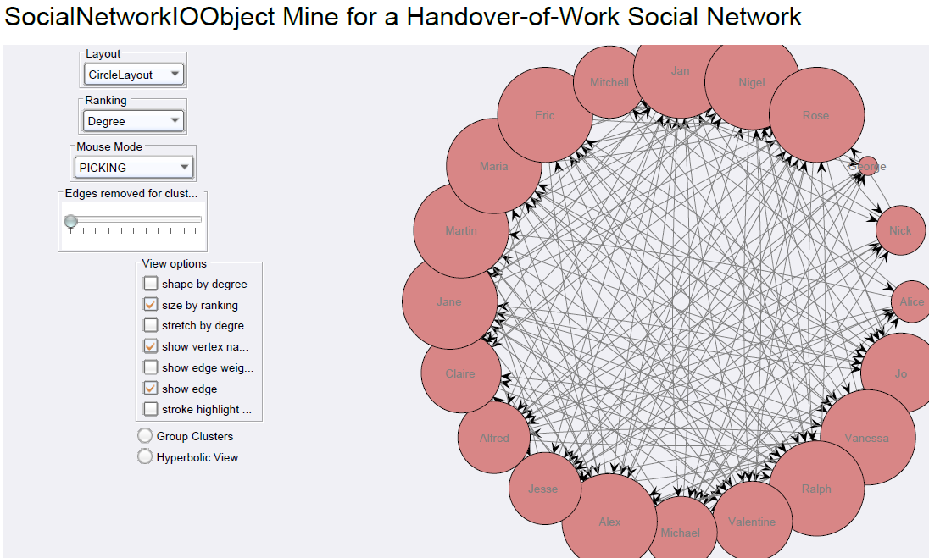

Figure : Handover-of-work social network

### Subcontracting social network

The discovered subcontracting social network is shown in Figure 6. We see three clusters of subcontracting people. Interestingly, one of those contains just George. In the blue cluster, on the right, we see that Valentine, Claire and Jo are subcontracted a lot. These also form a cluster in the similar-task network.

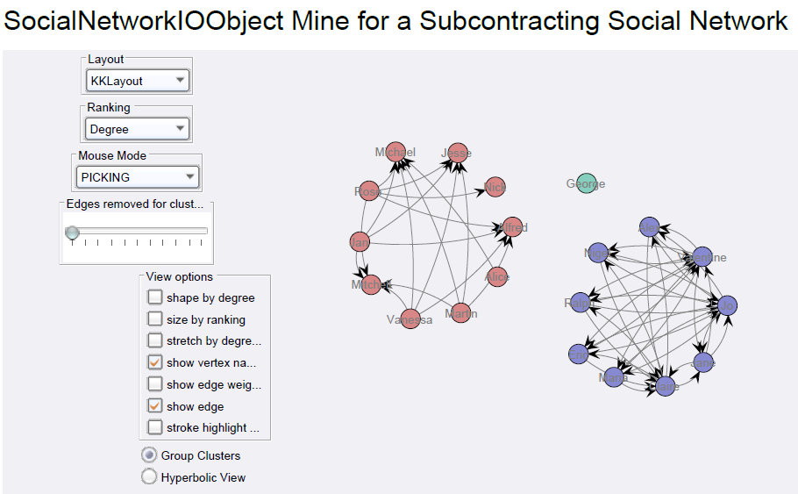

Figure : Subcontracting social network

### Working-together social network

We show the discovered working-together social network in Figure 7. The size of the nodes again corresponds to the number of relations. So in this case, to the number of people with whom a person works together. The six smallest nodes correspond to the two clusters of three people previously mentioned. Also indicating that their work is specialized or undesired.

### Reassignment social network

We show the discovered reassignment network in Figure 8. The network has no relations indicating that no employees have been reassigned. Also indicating there is no hierarchy in practise.

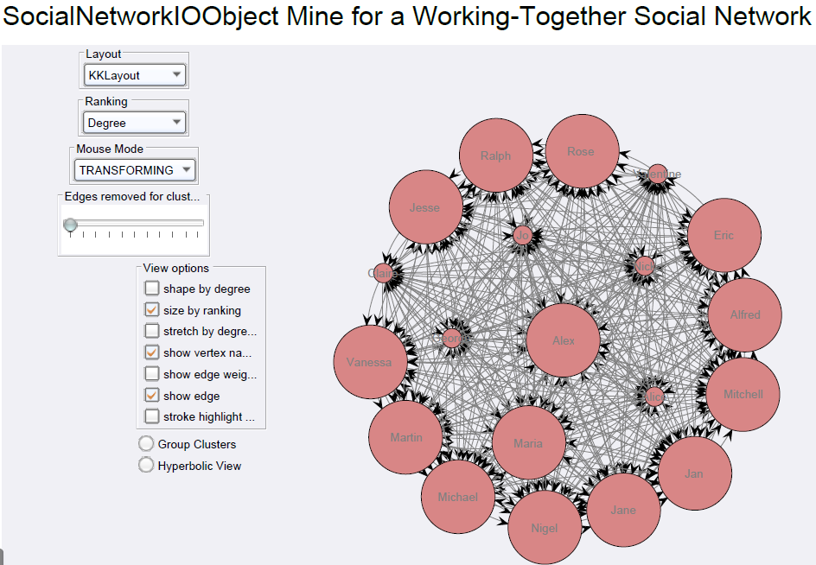

Figure : Working-together social network

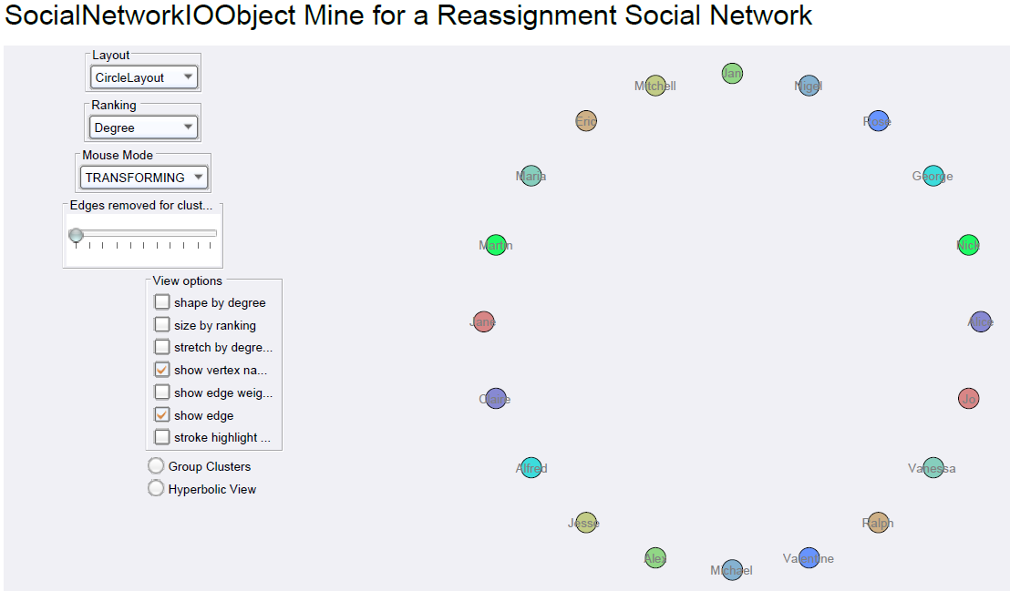

Figure : Reassignment social network

3: Which bottlenecks within the process cause the biggest amount of delay within the entire process?

The setup we used to find the time bottlenecks of the process is shown in Figure 9.

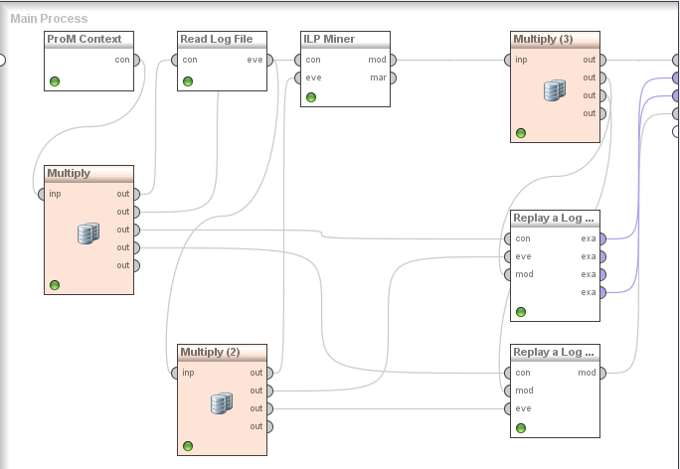

Figure : Setup of experiment 3, determining time bottlenecks

When we color transitions on the average waiting time, the following two regions in the process draw our attention:

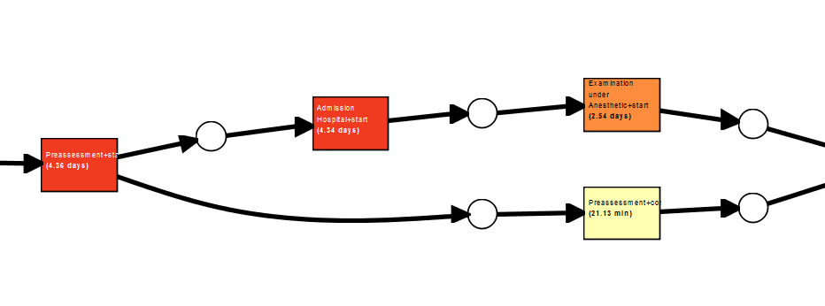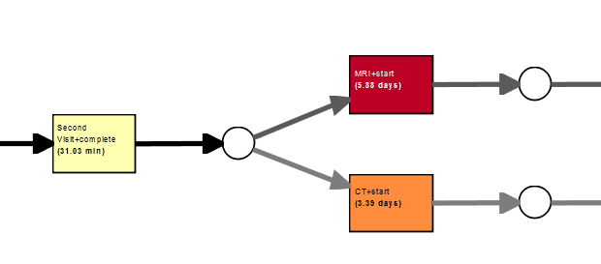

These are the transition with the highest average waiting time. This in itself is not necessarily a problem, for example if a transition if rarely taken or the continuation of the process does not rely on the completion of the task. Therefore, we examine the same regions when we color the transitions on number of times taken. It results in the following images:

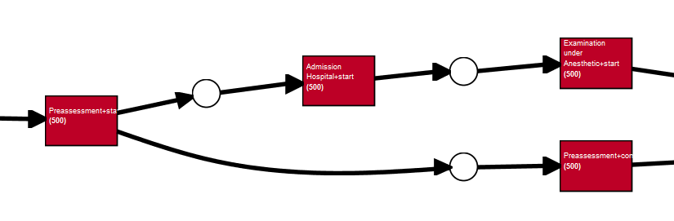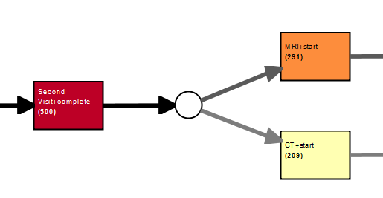

Here we see that the MRI-scan, by far the transition with the longest waiting time, is taken in about 3/5 of the cases. The waiting time for the MRI machine may be explained by the cost of these machines. Therefore the hospital probably owns one and a lot of people need to use it.

The other processes need to be taken in every instance of the process and thus are more of a bottleneck. The Pre-assessment task for example, takes 4.36 days on average and is taken in all cases. To speed up the process, only taking care of the waiting time there is not enough, as one of its succeeding tasks, “Admission hospital + start’’, has an average waiting time of 4.34 days and is also taken in all instances of the process.

## 4: Identify the first decision point within the process. For this decision point, by which criterion is a certain path taken?

The setup used to identify decision points is shown in Figure 10.

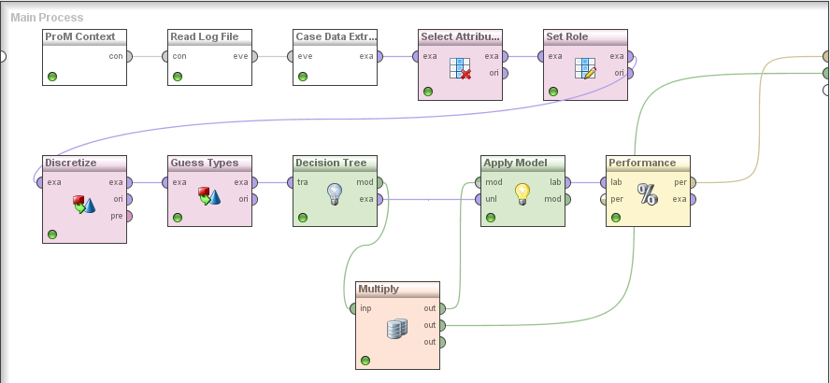

Figure : Setup for identifying decision points

By placing a breakpoint after Read Log File, we obtained a table with all activities and their data elements. The first decision point looks to be the first visit. After which either the ECG activity or the Echography activity is performed. We select the following attributes:

* E:ECG.nrInstances
* E:data.First Visit.age
* E:data.First Visit.asa
* E:data.First Visit.urgent

In set Role, we select E:ECG.nrInstances as the label. We discretize on E:ECG.nrInstances and use the other selected attributes in guess types. The generated decision tree is shown in Figure 11. The decision is apparently based on both the asa-number as on the age of the patient.

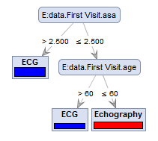

Figure : decision tree on APM_First_Assignment.xes

## 5: For each of the above questions can you mention any improvement opportunity?

From the discovered Petri net, no improvements can be identified. Improvements can only be seen when we have more data such the average waiting time per transition.

The organizational perspective has shown us that George does not subcontract any other employees nor is he subcontracted by others. We also see that he does not hand of much work nor does he get much work handed to him. Now it may be the case that George is a specialist and nobody can help him with his work. The other possibility is that he is not very productive.

The greatest bottleneck in the process is the admission to the hospital. First the preassessment and then the actual admission have the two of the three longest waiting times in the process. From the read log data, we have seen that George is mainly occupied with doing preassessments, together with Alice and Nick. We recommend to increase this department with an extra employee to speed up the process. We also see that Mitchell, Michael, Jesse and Alfred do the hospital admissions. They can also use some extra help.

There are no improvements to be identified from the first decision point and the knowledge on which data attributes this choice is based. As there is such a clear distinction between ECG and Echography made, we can assume that this knowledge is already being utilized.