Assessment Project: CB FSD – Backend and Database Development  
Author: Rogelio Lotho

**Goal**: To build a Gym Membership application to handle and manage the data detail recordings of the participants and batches.

**Feature:** Design Server side Controller Structure with Servlets implementing Database connections to perform CRUD operation.

**Tech Stack**: Java, Servlets, JSP, Maven, JDBC, HTML, MySQL, Git and GitHub

1. Create a Dynamic Web Project in Eclipses and configure it to Maven project
   1. Dynamic Web Project

* 1. Configure to Maven Project

* 1. Maven POM  
     Graphical user interface, text, application, email

     Description automatically generated

1. Create Java Classes
   1. Create Participant class  
      Graphical user interface, text, application

      Description automatically generated  
      2.1.a. Generate Constructor and toString()  
      Table

      Description automatically generated  
      2.1.b Generated  
      Graphical user interface, text, application, email

      Description automatically generated
   2. Create Batch class  
      Graphical user interface, text, email

      Description automatically generated

2.2.a. Batch Constructors

1. Create Servlets in the Project  
   Text, letter

   Description automatically generated

3.1. Create a Servlet for Participant  
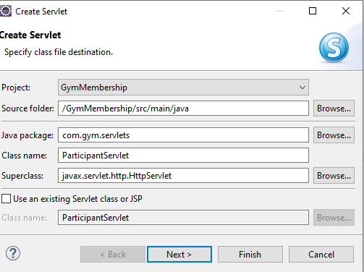

3.1.a. Create Participant mapping  
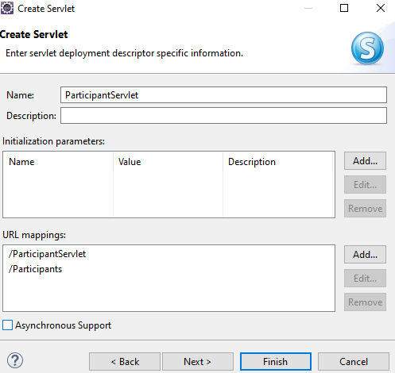

3.1.b. Select Implementation and methods  
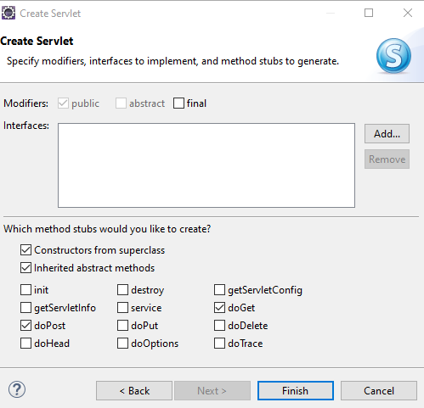  
3.1.c. Generate Code  
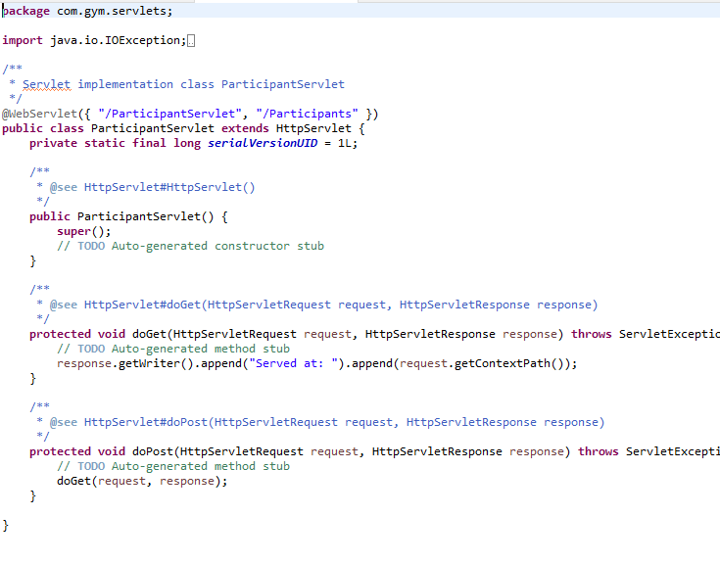

3.2. Create Servlet for Batch

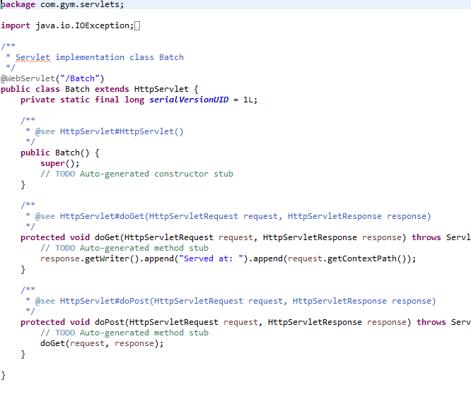

1. Create HTML Pages
   1. Create a Welcome Page with Navigation Menu  
      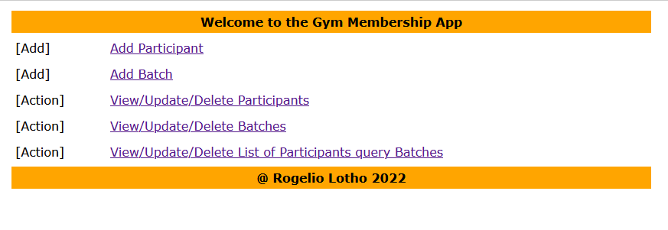
   2. Create a HTML page to Add Batch  
      Graphical user interface, text, application

      Description automatically generated
   3. Create a HTML page to Add Participant  
      Graphical user interface, application

      Description automatically generated
   4. Create a HTML page to Update Batch  
      Graphical user interface, application

      Description automatically generated
   5. Create a HTML page to Update Participant  
      Graphical user interface, application

      Description automatically generated
2. Perform CRUD Operations in JDBCCreate Database and Table in MySQL  
   5.1.a Mysql Database  
   Text

   Description automatically generated

5.1.b Mysql Participant and Batch table

* 1. Configure JDBC Dependencies for MySQL  
     Graphical user interface, text

     Description automatically generated
  2. Implement a DAO Design Pattern  
     Text

     Description automatically generated
  3. Create a Repository Class which uses DAO to perform DB Interactions  
     Graphical user interface, text, application

     Description automatically generated
  4. In Participant Servlet implement CRUD Operations using doGet, doPost, doDelete and doPut Http Methods  
     Text

     Description automatically generated with medium confidence  
     Graphical user interface, text, application

     Description automatically generated  
     Graphical user interface, text

     Description automatically generated  
     Text

     Description automatically generated

[UpdateParticipantServlet]

* 1. In Batch Servlet implement CRUD Operations using doGet, doPost, doDelete and doPut Http Methods  
     5.5.a Batch doPost  
     Graphical user interface, text, application

     Description automatically generated

5.5.b Run Batch doPost

1. Create JSP Pages in the Project
   1. Create a JSP Page to view the list of Participants with delete option  
      Graphical user interface

      Description automatically generated with medium confidence

[UpdateParticipant JSP]

[UpdateBatch Servlet]  
[UpdateParticipant Servlet]

[DeleteParticipant Servlet]

* 1. Text

     Description automatically generated  
     Graphical user interface, application, Word

     Description automatically generated  
     Graphical user interface, text

     Description automatically generated
  2. Create a JSP page to view the list of Batches with delete option  
     Table

     Description automatically generated
  3. Create a JSP Page to view the lists of Particpants in a Batch using query parameter

1. Build and Run the Project on Apache Tomcat webserver

1. Validate the working of project  
   Text

   Description automatically generated
2. Package the project as a Jar file using maven Package Goal

