# Water Quality Report Card

## Segment Summaries

### COLCLC01_A

*Reach Description:*

Colorado River from Paradise Creek to below the confluence with Rifle Creek

*Designated Uses:*

Summary

Regulatory status

Parameters of interest

*NA*

*Total_Phosphorus*

*Chloride*

*Arsenic*

Data quality and representativeness

*Table X: Sampling locations for COLCLC01_A.*

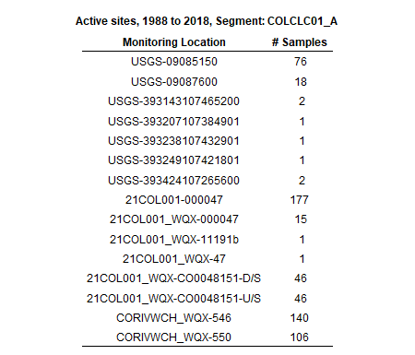

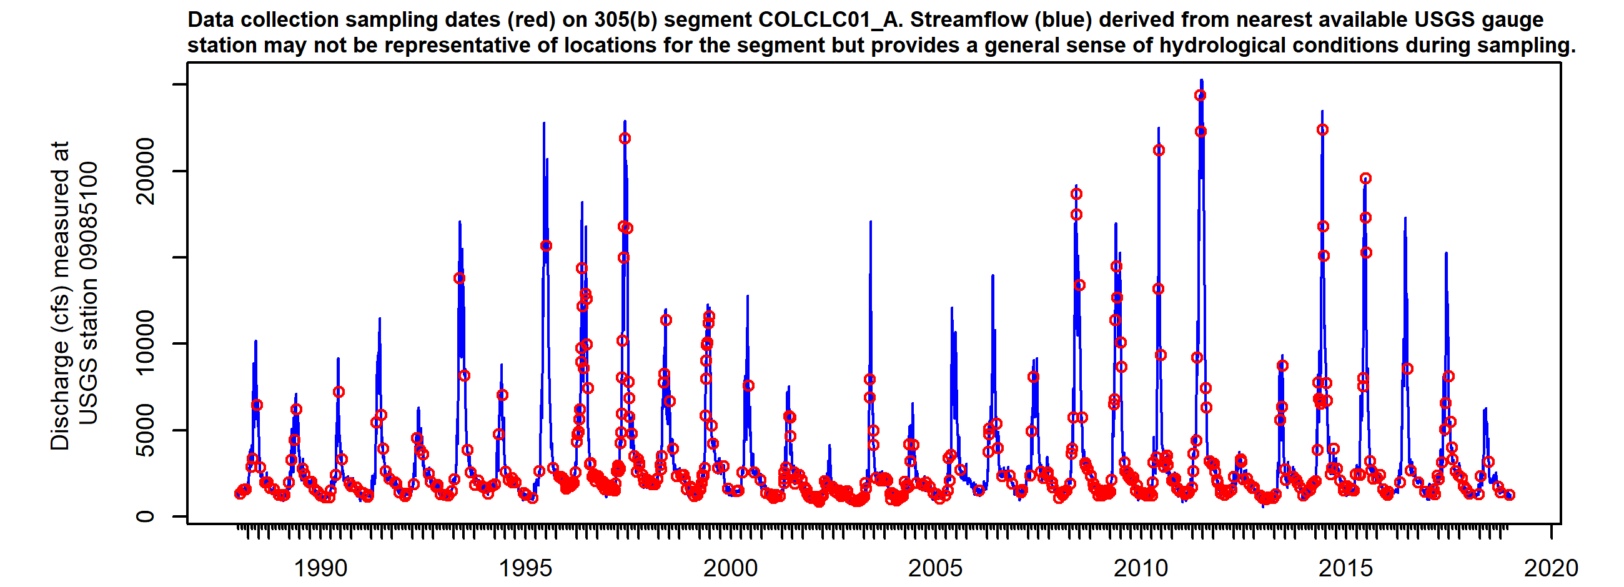

*Figure X. Sampling dates hydrograph, COLCLC01_A. Observed streamflow (blue line) derived from nearest available USGS gauges may not be directly representative for the segment but provides general sense of hydrological conditions present during sampling.*

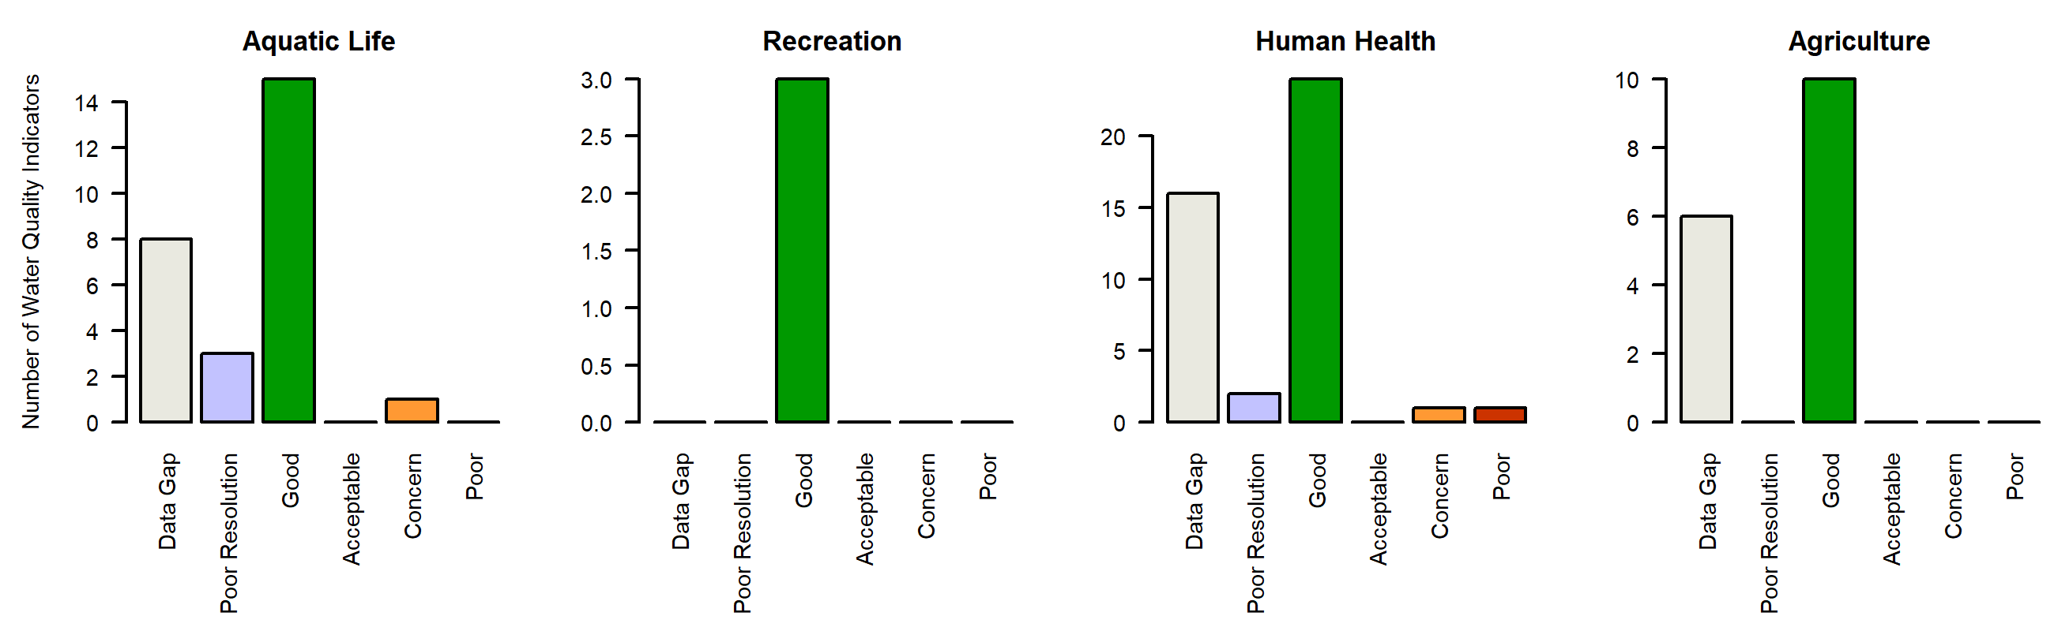

*Figure X. Water quality Indicators summary, COLCLC01_A. Graphs summarize the count of individual parameter ratings in each Report Card assessment class (Good, Acceptable, Concern, Poor, Low Resolution, Data Gap).*

### COLCLC01_B

*Reach Description:*

Colorado River from Roaring Fork to Paradise Creek

*Designated Uses:*

Summary

Regulatory status

Parameters of interest

*Total_Phosphorus*

*Manganese*

*Arsenic*

Data quality and representativeness

*Table X: Sampling locations for COLCLC01_B.*

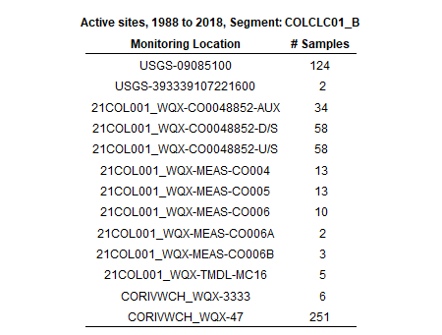

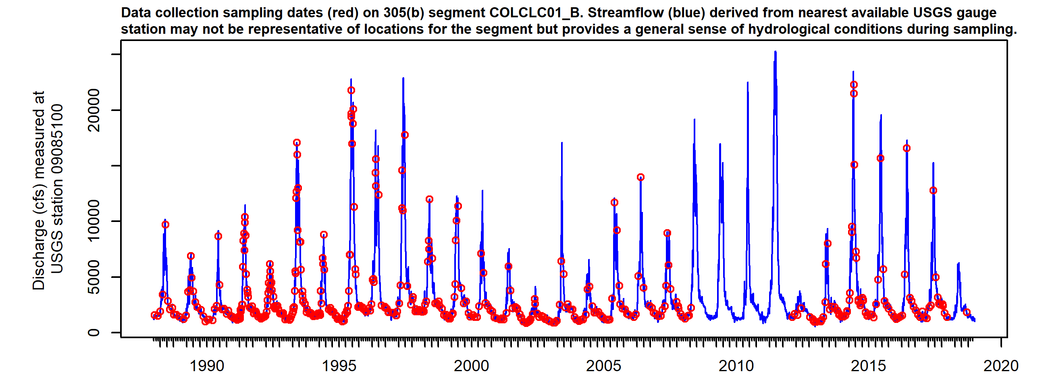

*Figure X. Sampling dates hydrograph, COLCLC01_B. Observed streamflow (blue line) derived from nearest available USGS gauges may not be directly representative for the segment but provides general sense of hydrological conditions present during sampling.*

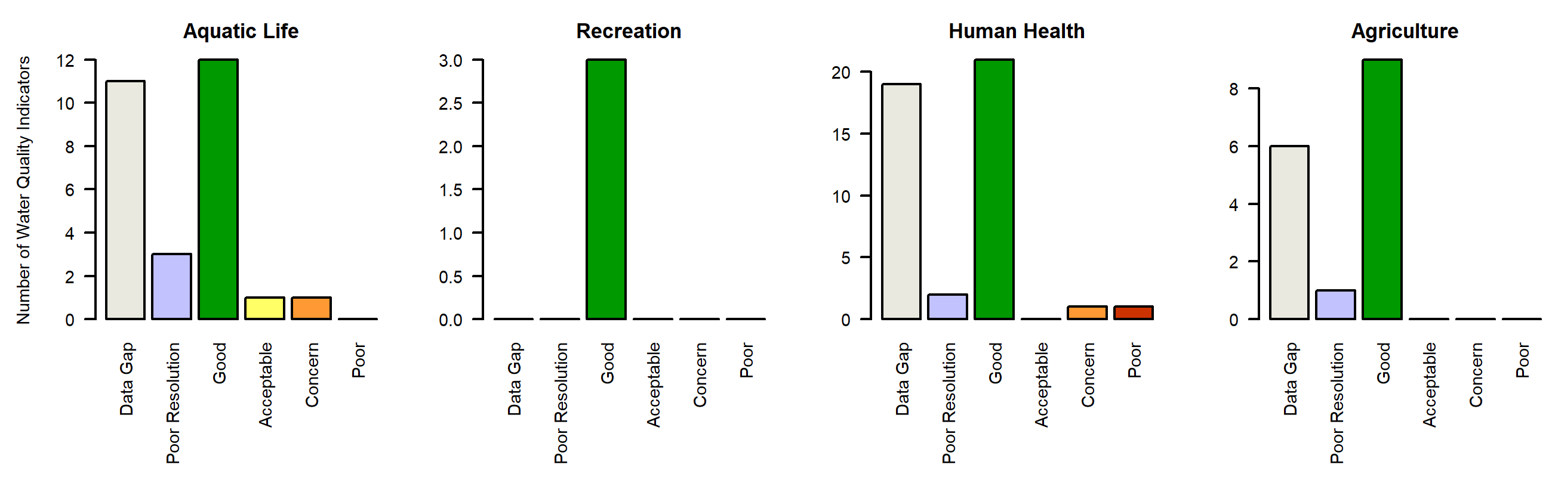

*Figure X. Water quality Indicators summary, COLCLC01_B. Graphs summarize the count of individual parameter ratings in each Report Card assessment class (Good, Acceptable, Concern, Poor, Low Resolution, Data Gap).*

### COLCLC02a_A

*Reach Description:*

Mainstem of the Colorado River from immediately below the confluence with Rifle Creek to immediately above the confluence of Rapid Creek.

*Designated Uses:*

Summary

Regulatory status

Parameters of interest

*NA*

*Iron*

*Chloride*

*Lead*

*Sulfate*

*NA*

*NA*

*NA*

*NA*

*NA*

*NA*

*NA*

*NA*

*NA*

Data quality and representativeness

*Table X: Sampling locations for COLCLC02a_A.*

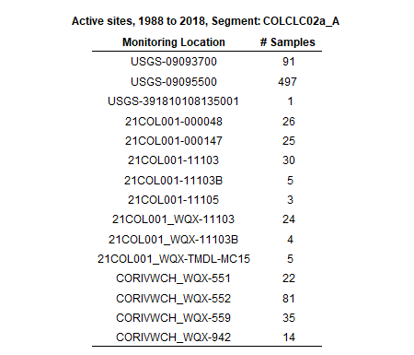

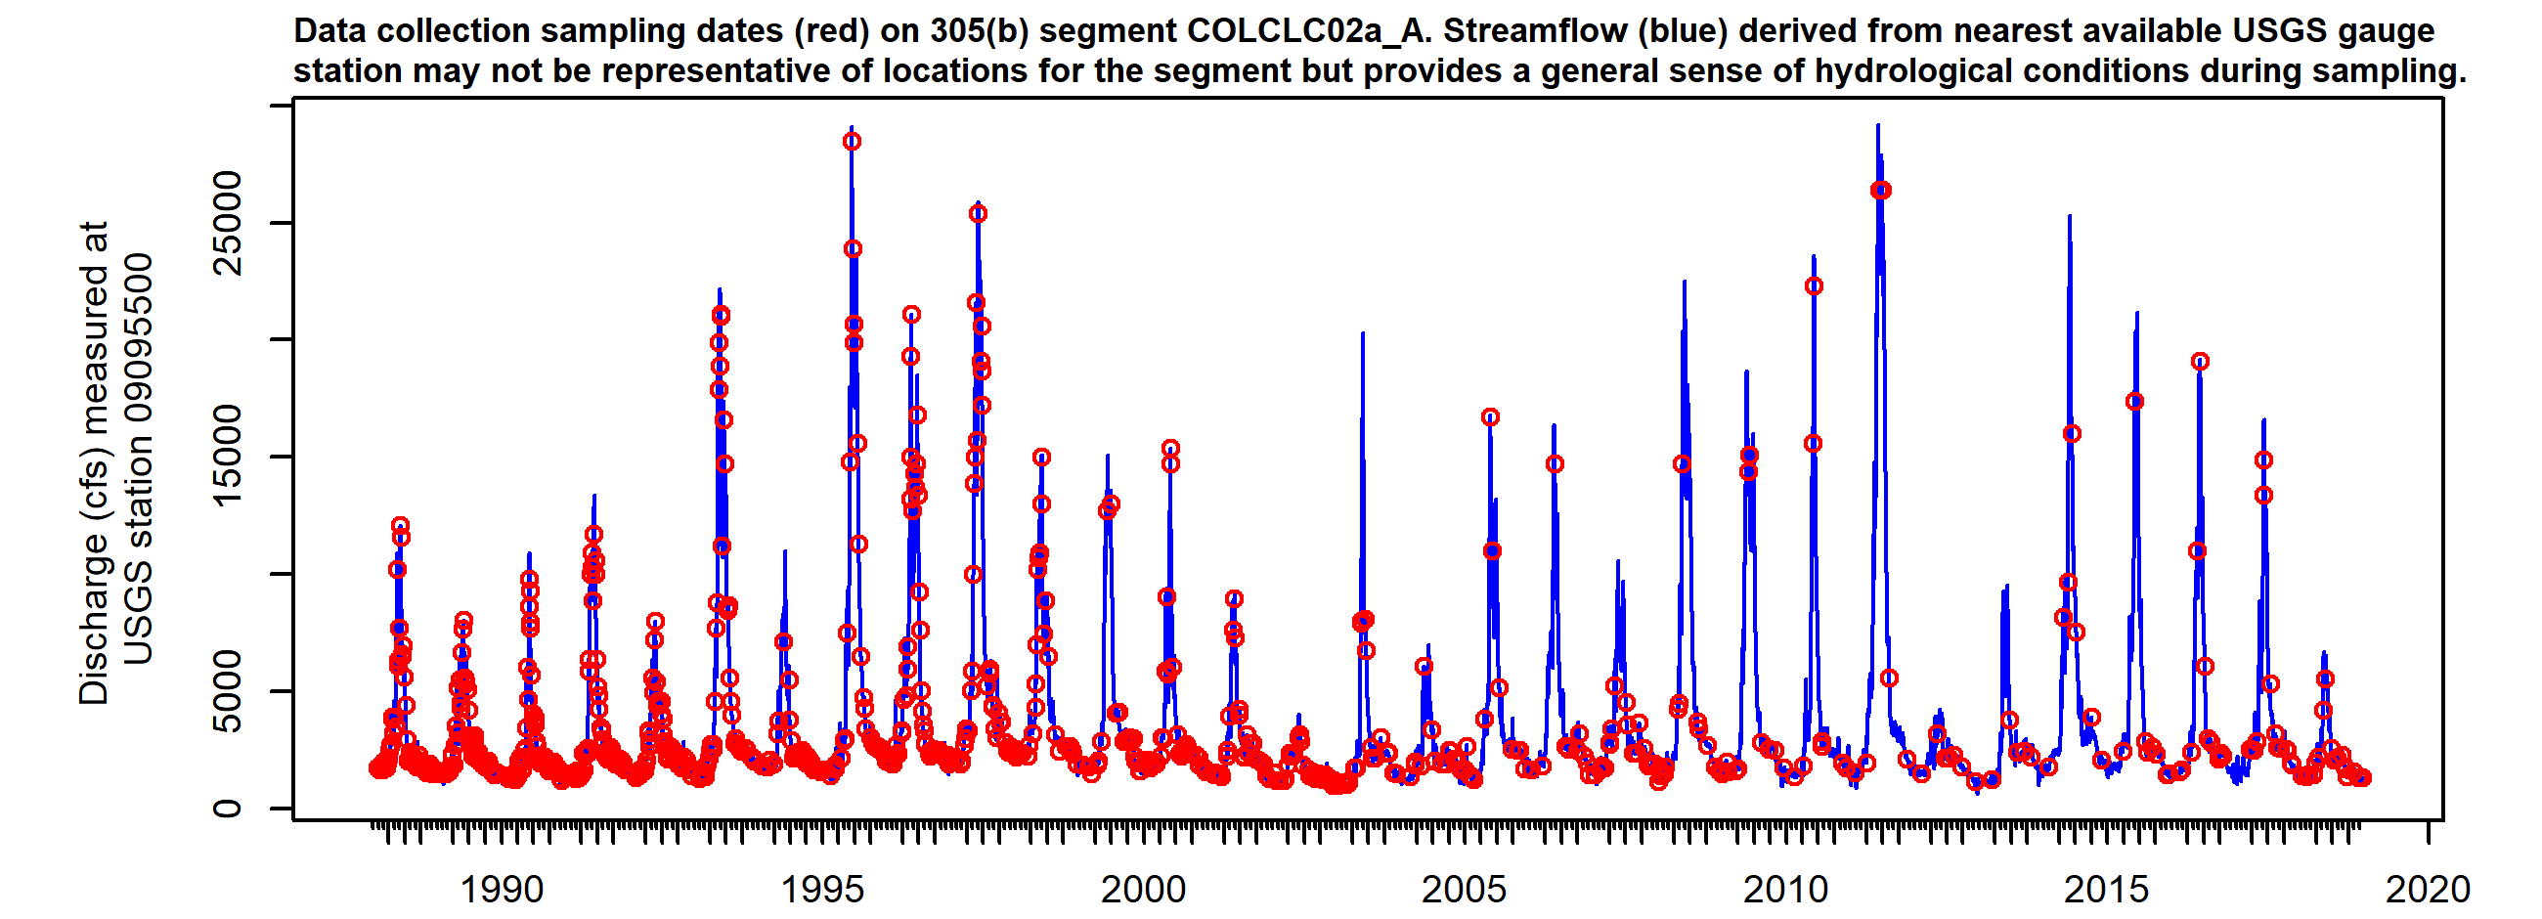

*Figure X. Sampling dates hydrograph, COLCLC02a_A. Observed streamflow (blue line) derived from nearest available USGS gauges may not be directly representative for the segment but provides general sense of hydrological conditions present during sampling.*

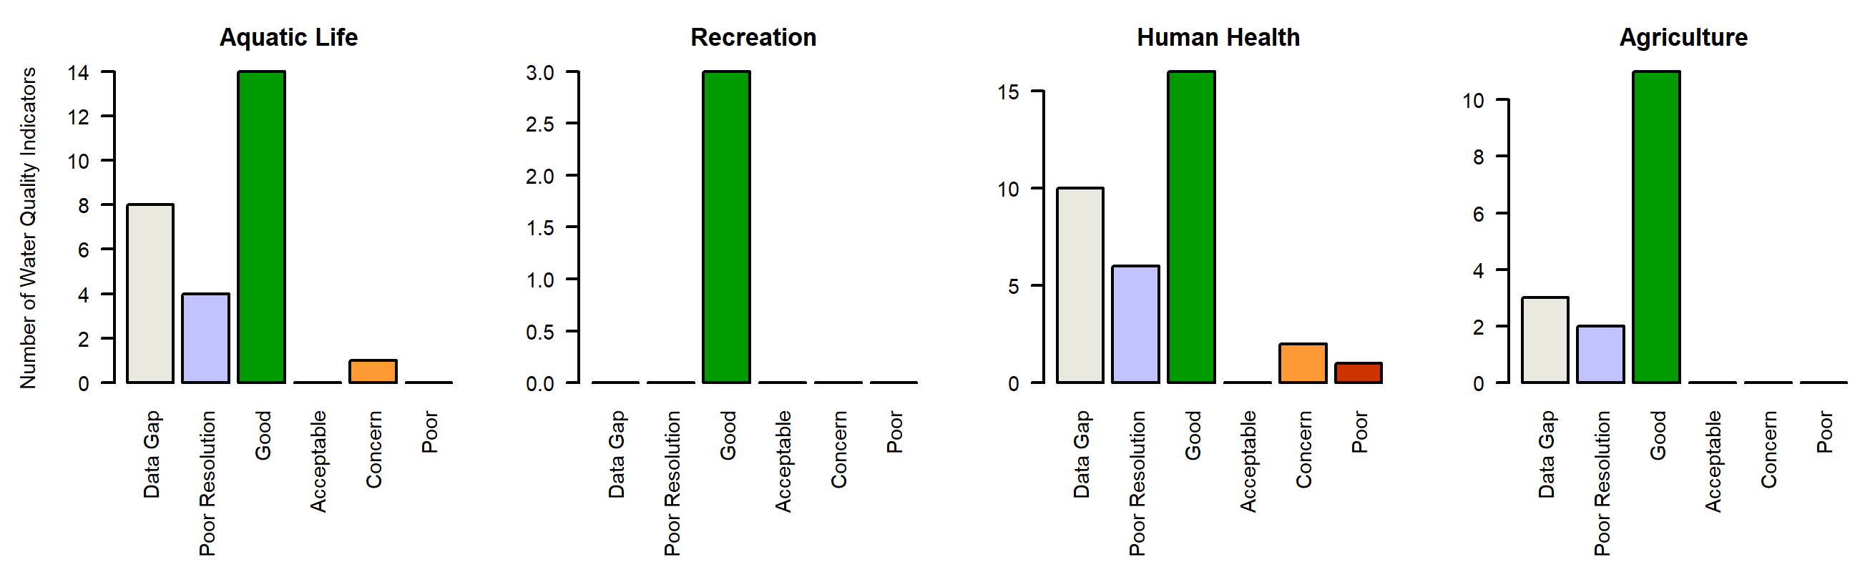

*Figure X. Water quality Indicators summary, COLCLC02a_A. Graphs summarize the count of individual parameter ratings in each Report Card assessment class (Good, Acceptable, Concern, Poor, Low Resolution, Data Gap).*

### COLCLC04a_A

*Reach Description:*

Tributaries to Colorado River, Roaring Fork to Parachute Creek, except for Mamm Creek and Alkali Creek

*Designated Uses:*

Summary

Regulatory status

Parameters of interest

*Arsenic*

*Sulfate*

*Arsenic*

*Arsenic*

Data quality and representativeness

*Table X: Sampling locations for COLCLC04a_A.*

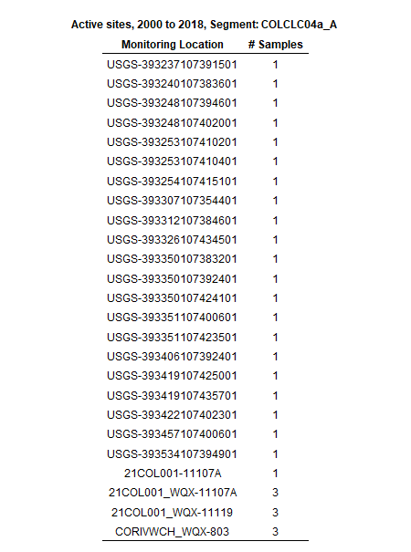

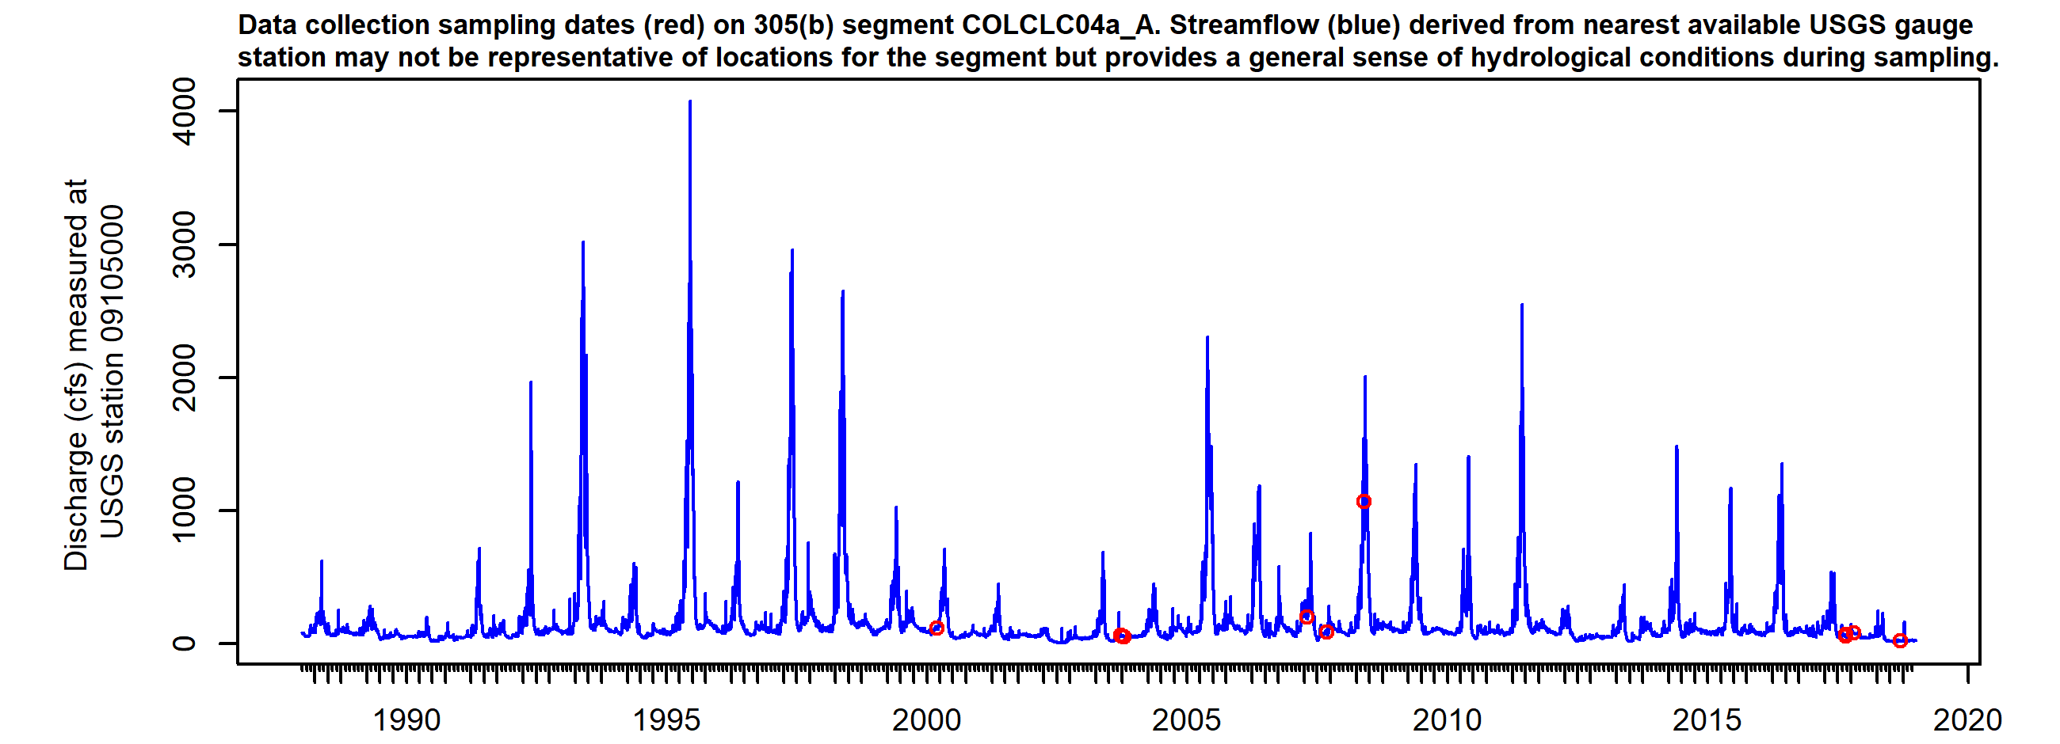

*Figure X. Sampling dates hydrograph, COLCLC04a_A. Observed streamflow (blue line) derived from nearest available USGS gauges may not be directly representative for the segment but provides general sense of hydrological conditions present during sampling.*

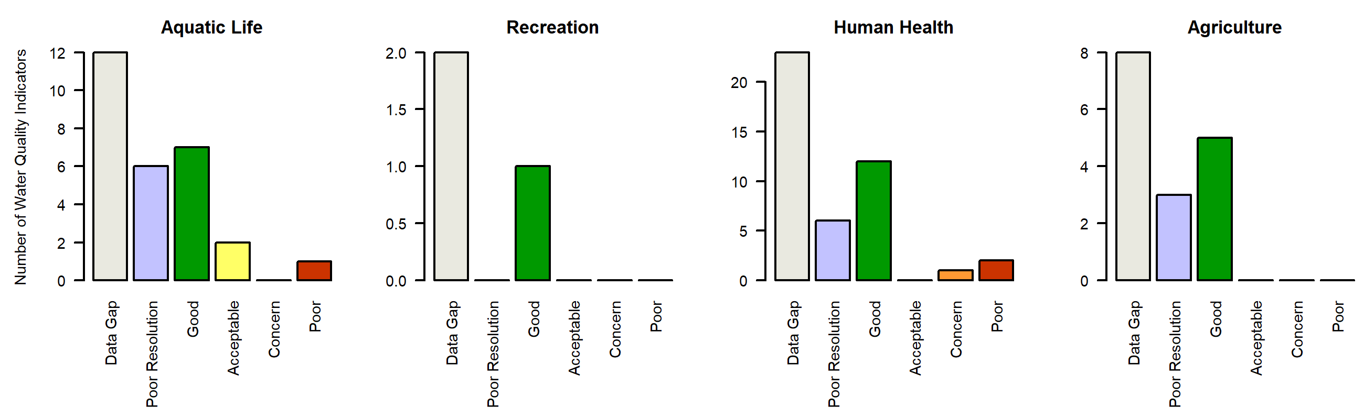

*Figure X. Water quality Indicators summary, COLCLC04a_A. Graphs summarize the count of individual parameter ratings in each Report Card assessment class (Good, Acceptable, Concern, Poor, Low Resolution, Data Gap).*

### COLCLC04a_B

*Reach Description:*

Mamm Creek

*Designated Uses:*

Summary

Regulatory status

Parameters of interest

*Total_Nitrogen*

*Selenium*

*Manganese*

*Sulfate*

*Arsenic*

*Arsenic*

Data quality and representativeness

*Table X: Sampling locations for COLCLC04a_B.*

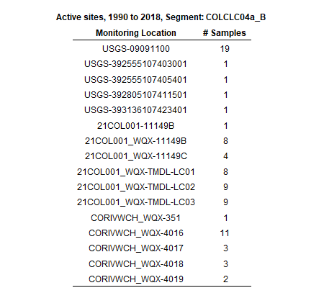

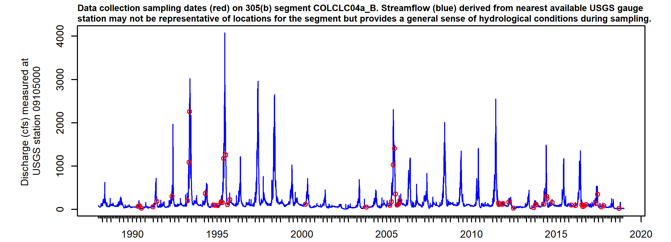

*Figure X. Sampling dates hydrograph, COLCLC04a_B. Observed streamflow (blue line) derived from nearest available USGS gauges may not be directly representative for the segment but provides general sense of hydrological conditions present during sampling.*

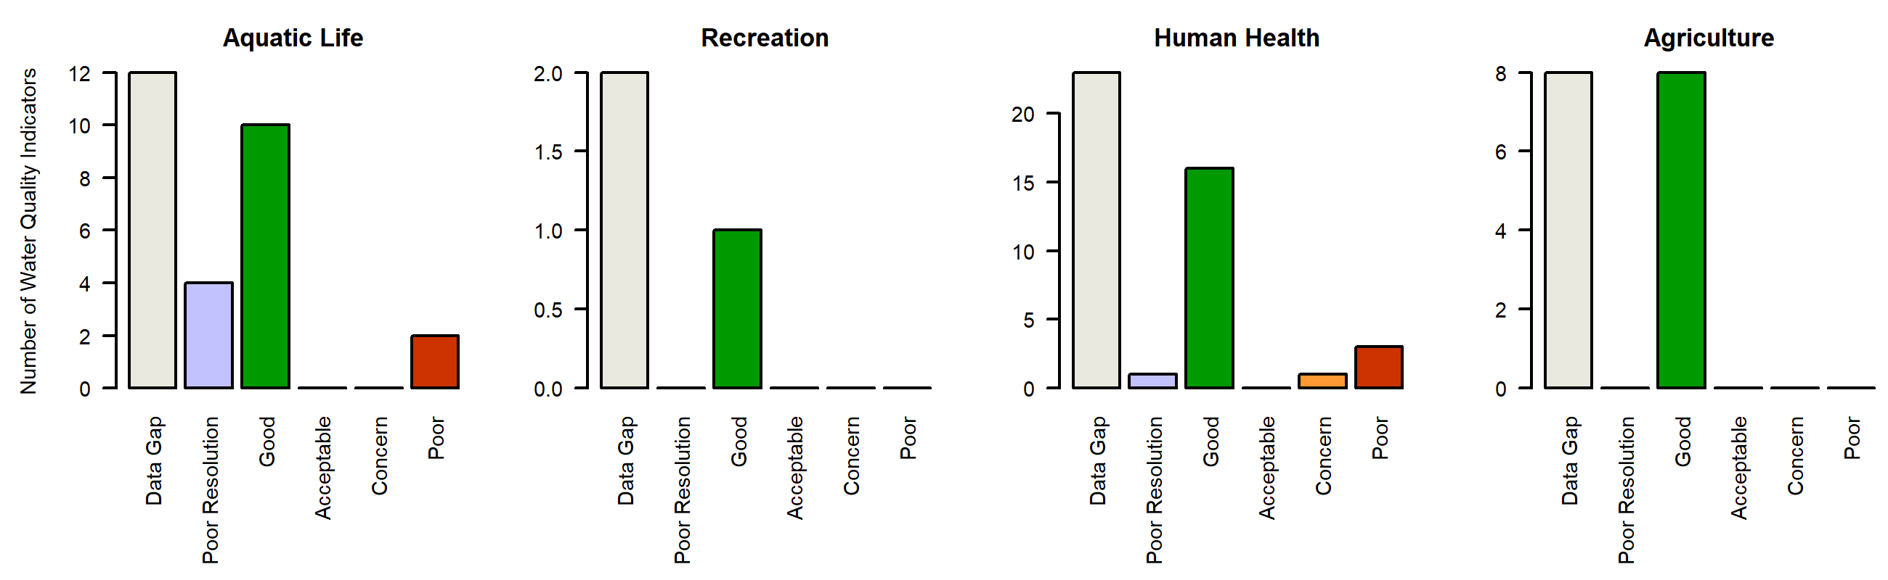

*Figure X. Water quality Indicators summary, COLCLC04a_B. Graphs summarize the count of individual parameter ratings in each Report Card assessment class (Good, Acceptable, Concern, Poor, Low Resolution, Data Gap).*

### COLCLC04a_C

*Reach Description:*

Alkali Creek

*Designated Uses:*

Summary

Regulatory status

Parameters of interest

*NA*

*Selenium*

Data quality and representativeness

*Table X: Sampling locations for COLCLC04a_C.*

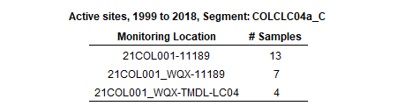

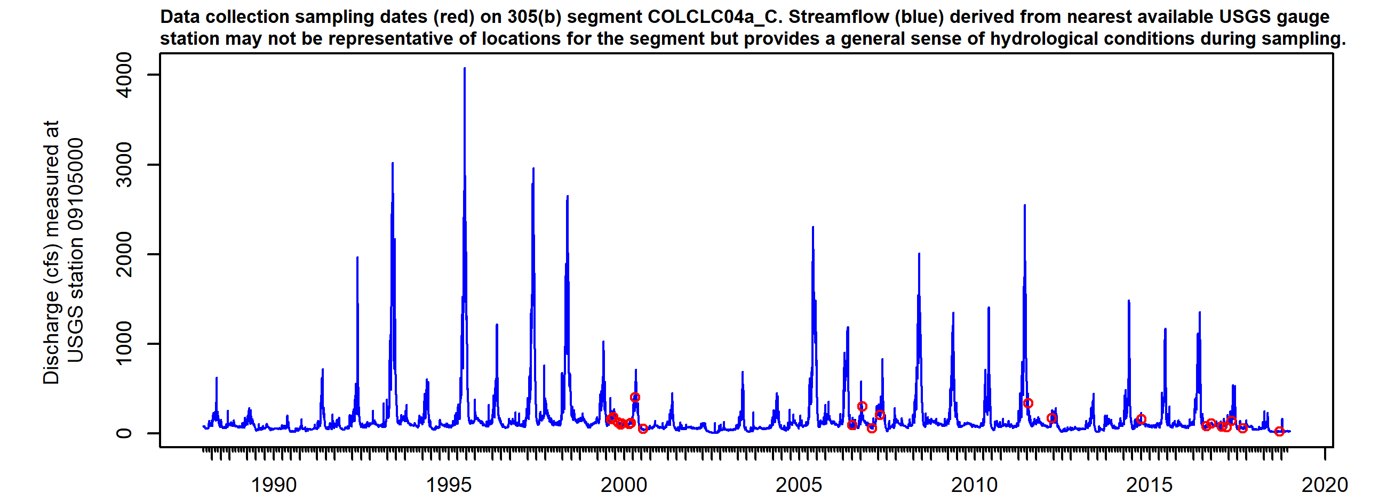

*Figure X. Sampling dates hydrograph, COLCLC04a_C. Observed streamflow (blue line) derived from nearest available USGS gauges may not be directly representative for the segment but provides general sense of hydrological conditions present during sampling.*

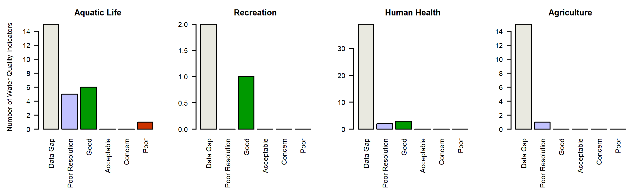

*Figure X. Water quality Indicators summary, COLCLC04a_C. Graphs summarize the count of individual parameter ratings in each Report Card assessment class (Good, Acceptable, Concern, Poor, Low Resolution, Data Gap).*

### COLCLC04a_D

*Reach Description:*

South Canyon Creek sections above hot springs

*Designated Uses:*

Summary

Regulatory status

Parameters of interest

*Arsenic*

*Selenium*

*Arsenic*

Data quality and representativeness

*Table X: Sampling locations for COLCLC04a_D.*

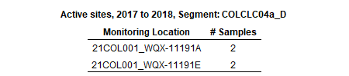

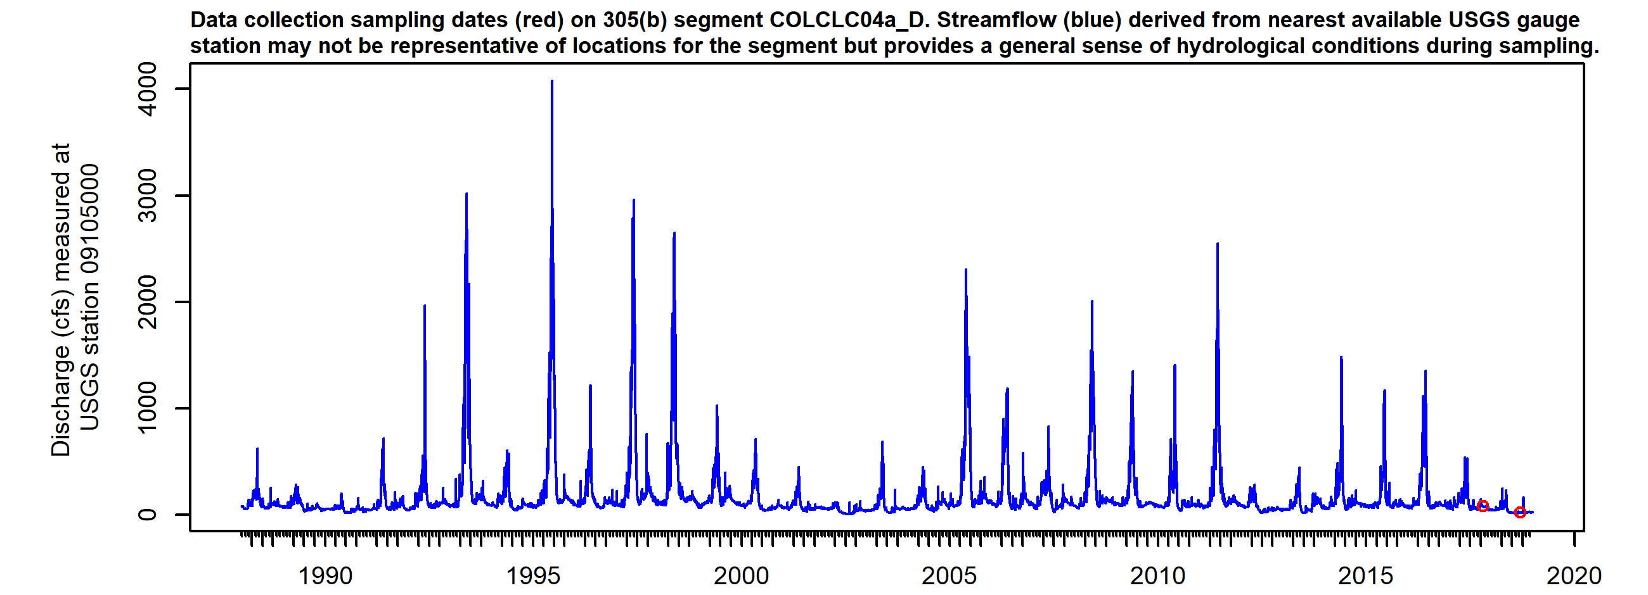

*Figure X. Sampling dates hydrograph, COLCLC04a_D. Observed streamflow (blue line) derived from nearest available USGS gauges may not be directly representative for the segment but provides general sense of hydrological conditions present during sampling.*

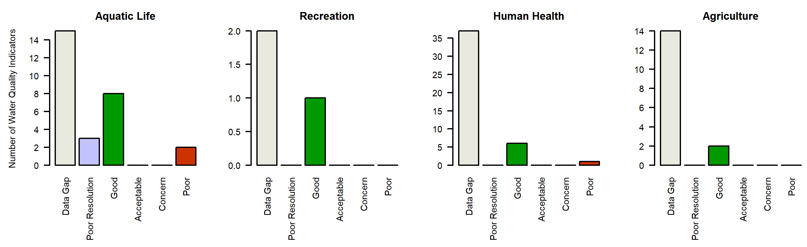

*Figure X. Water quality Indicators summary, COLCLC04a_D. Graphs summarize the count of individual parameter ratings in each Report Card assessment class (Good, Acceptable, Concern, Poor, Low Resolution, Data Gap).*

### COLCLC04c_A

*Reach Description:*

South Canyon Creek from South Canyon Hot Springs to Colorado River

*Designated Uses:*

Summary

Regulatory status

Parameters of interest

*NA*

*Aluminum*

*Iron*

*Selenium*

*Manganese*

*NA*

*NA*

*NA*

*NA*

*NA*

*NA*

*NA*

Data quality and representativeness

*Table X: Sampling locations for COLCLC04c_A.*

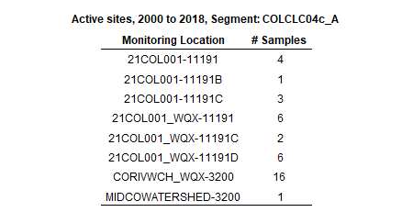

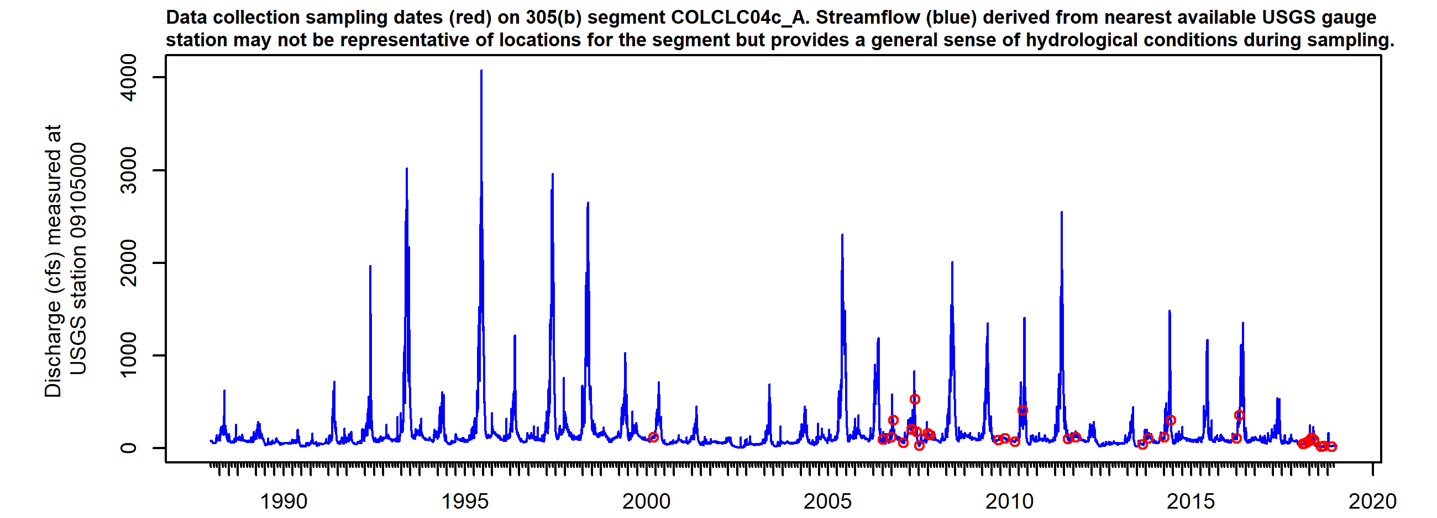

*Figure X. Sampling dates hydrograph, COLCLC04c_A. Observed streamflow (blue line) derived from nearest available USGS gauges may not be directly representative for the segment but provides general sense of hydrological conditions present during sampling.*

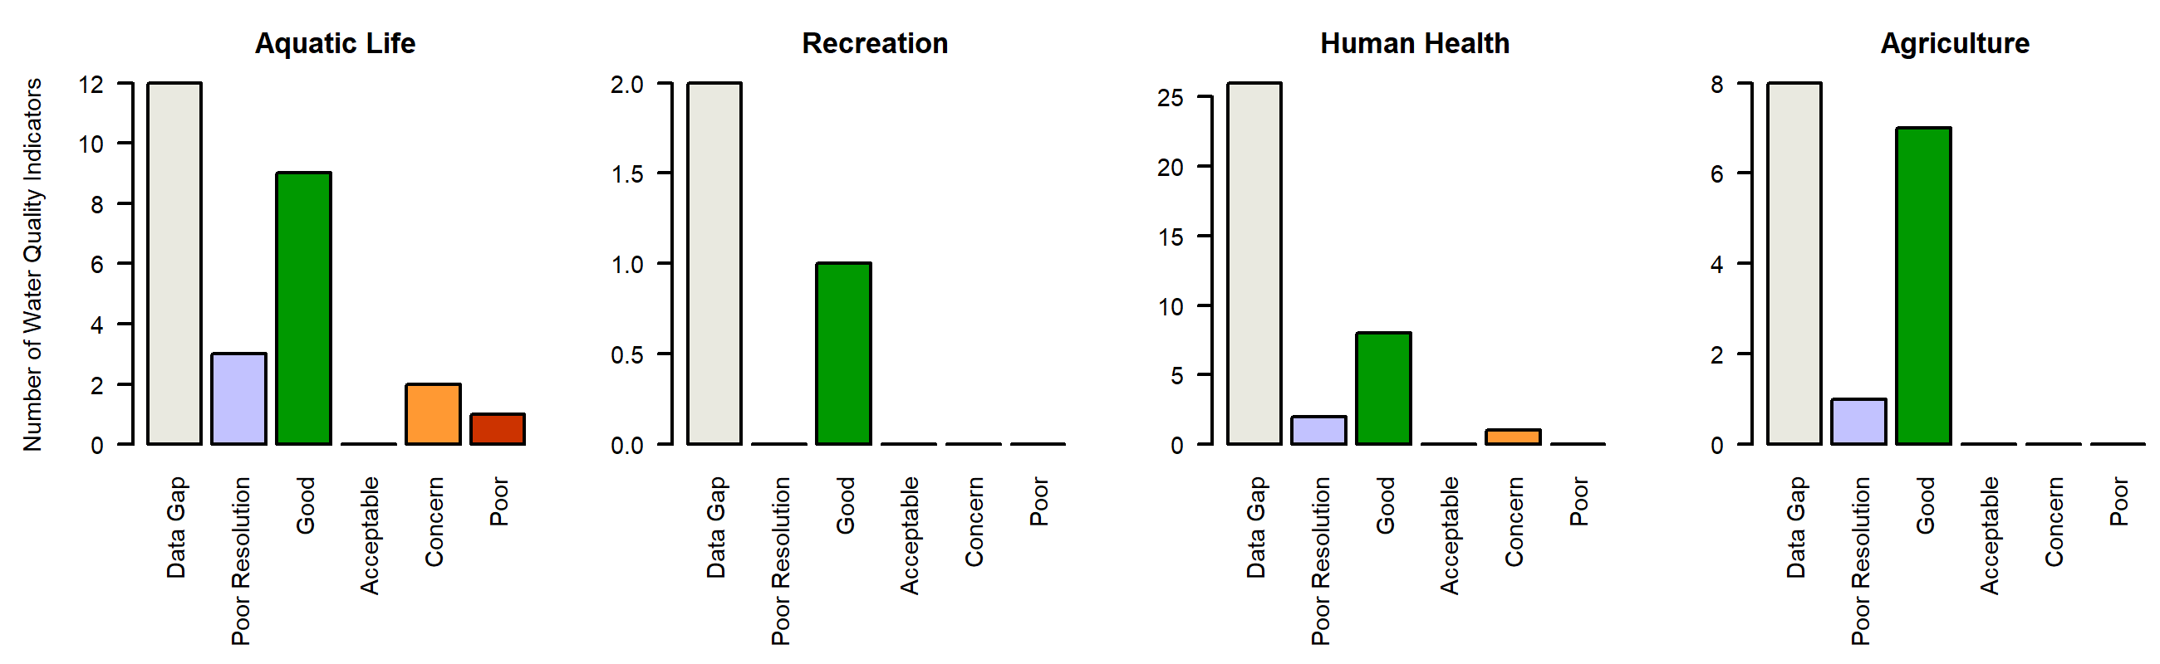

*Figure X. Water quality Indicators summary, COLCLC04c_A. Graphs summarize the count of individual parameter ratings in each Report Card assessment class (Good, Acceptable, Concern, Poor, Low Resolution, Data Gap).*

### COLCLC04d_A

*Reach Description:*

The mainstem of Dry Hollow Creek, including all tributaries and wetlands, from the source to the confluence with the Colorado River.

*Designated Uses:*

Summary

Regulatory status

Parameters of interest

*Selenium*

*Sulfate*

Data quality and representativeness

*Table X: Sampling locations for COLCLC04d_A.*

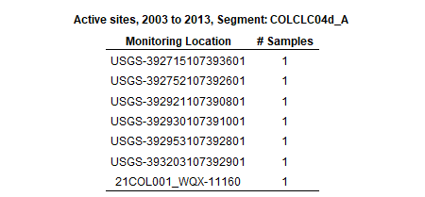

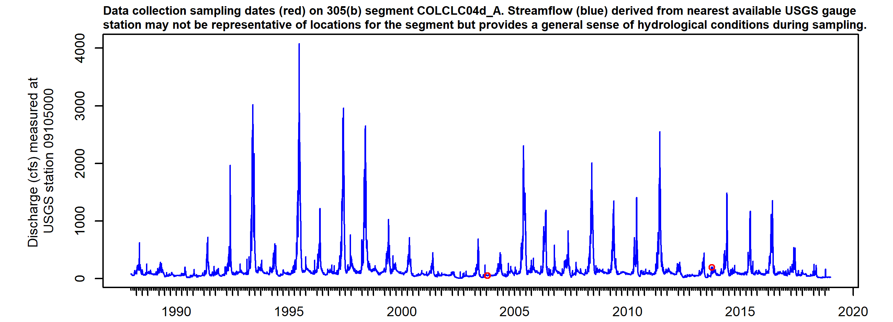

*Figure X. Sampling dates hydrograph, COLCLC04d_A. Observed streamflow (blue line) derived from nearest available USGS gauges may not be directly representative for the segment but provides general sense of hydrological conditions present during sampling.*

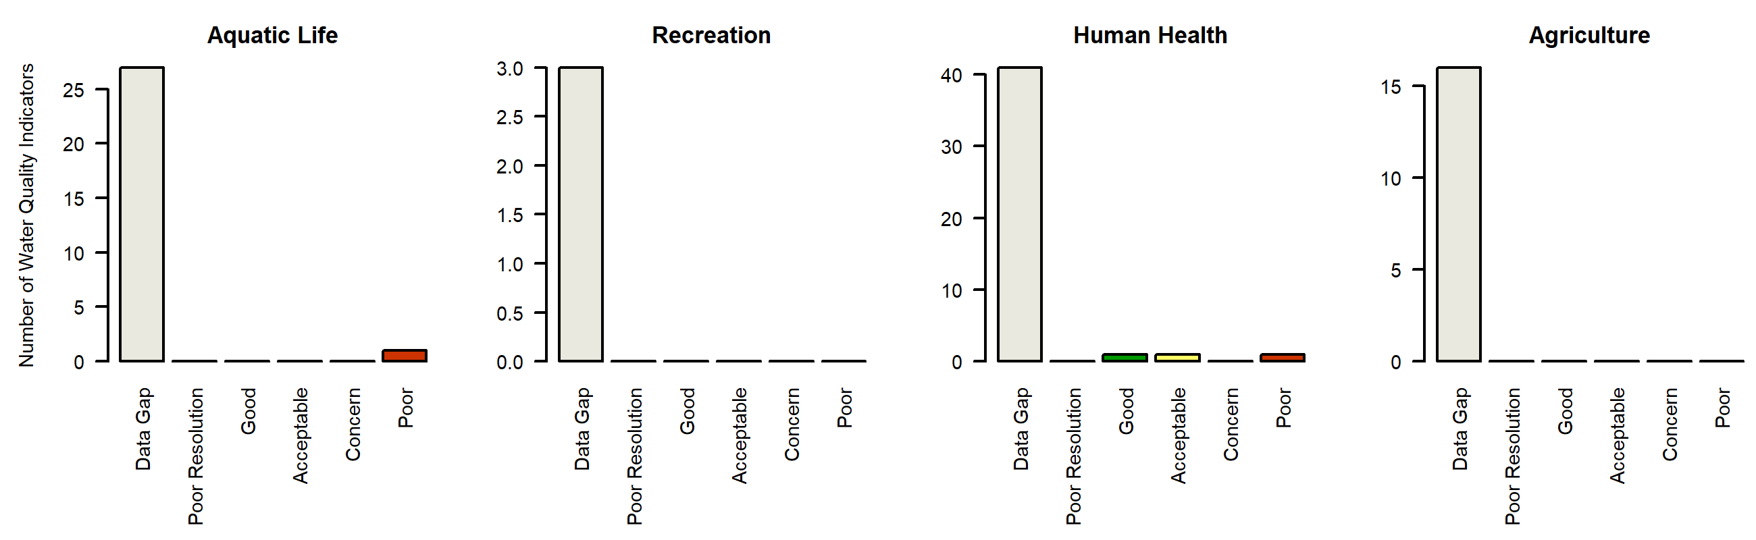

*Figure X. Water quality Indicators summary, COLCLC04d_A. Graphs summarize the count of individual parameter ratings in each Report Card assessment class (Good, Acceptable, Concern, Poor, Low Resolution, Data Gap).*

### COLCLC04e_A

*Reach Description:*

Mainstem of Dry Creek including all tributaries and wetlands from the source to immediately above the Last Chance Ditch.

*Designated Uses:*

Summary

Regulatory status

Parameters of interest

*pH*

*Total_Nitrogen*

*Total_Phosphorus*

*Arsenic*

*Copper*

*Iron*

*pH*

*NA*

*NA*

*NA*

*NA*

*NA*

*NA*

Data quality and representativeness

*Table X: Sampling locations for COLCLC04e_A.*

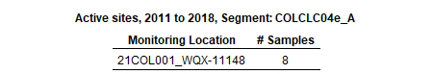

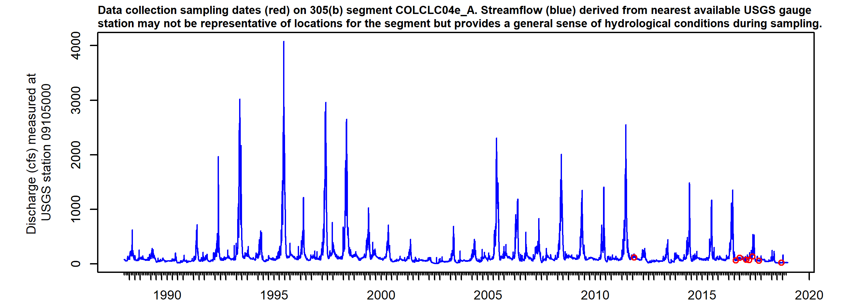

*Figure X. Sampling dates hydrograph, COLCLC04e_A. Observed streamflow (blue line) derived from nearest available USGS gauges may not be directly representative for the segment but provides general sense of hydrological conditions present during sampling.*

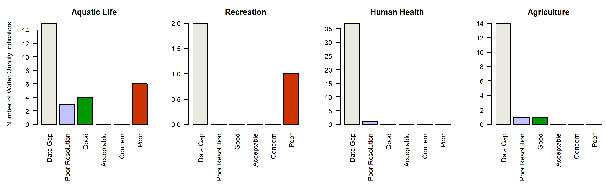

*Figure X. Water quality Indicators summary, COLCLC04e_A. Graphs summarize the count of individual parameter ratings in each Report Card assessment class (Good, Acceptable, Concern, Poor, Low Resolution, Data Gap).*

### COLCLC05_A

*Reach Description:*

All tributaries to the Colorado River, including wetlands, which are within the boundaries of White River National Forest, except for the specific listing in Segments 9a and 9c.

*Designated Uses:*

Summary

Regulatory status

Parameters of interest

*NA*

Data quality and representativeness

*Table X: Sampling locations for COLCLC05_A.*

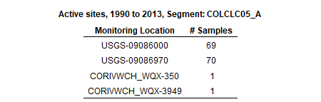

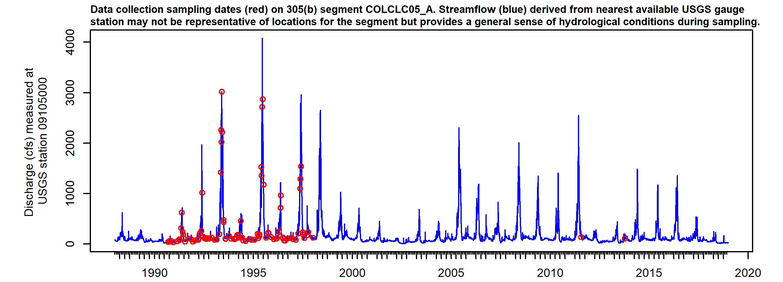

*Figure X. Sampling dates hydrograph, COLCLC05_A. Observed streamflow (blue line) derived from nearest available USGS gauges may not be directly representative for the segment but provides general sense of hydrological conditions present during sampling.*

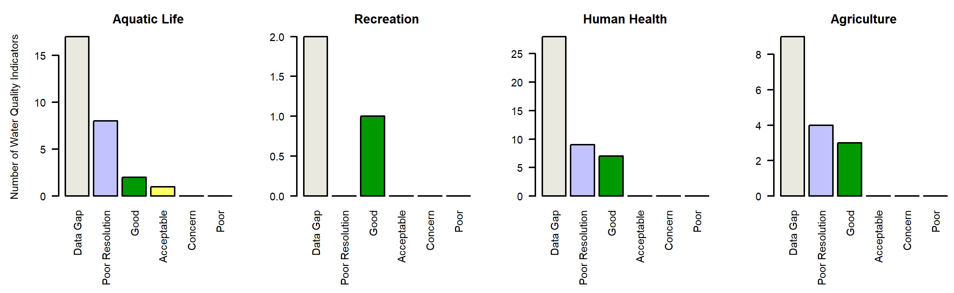

*Figure X. Water quality Indicators summary, COLCLC05_A. Graphs summarize the count of individual parameter ratings in each Report Card assessment class (Good, Acceptable, Concern, Poor, Low Resolution, Data Gap).*

### COLCLC06_A

*Reach Description:*

Mainstem of Oasis Creek including all tributaries and wetlands from the boundary of White River National Forest to the confluence with the Colorado River.

*Designated Uses:*

Summary

Regulatory status

Parameters of interest

*NA*

*Silver*

Data quality and representativeness

*Table X: Sampling locations for COLCLC06_A.*

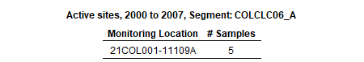

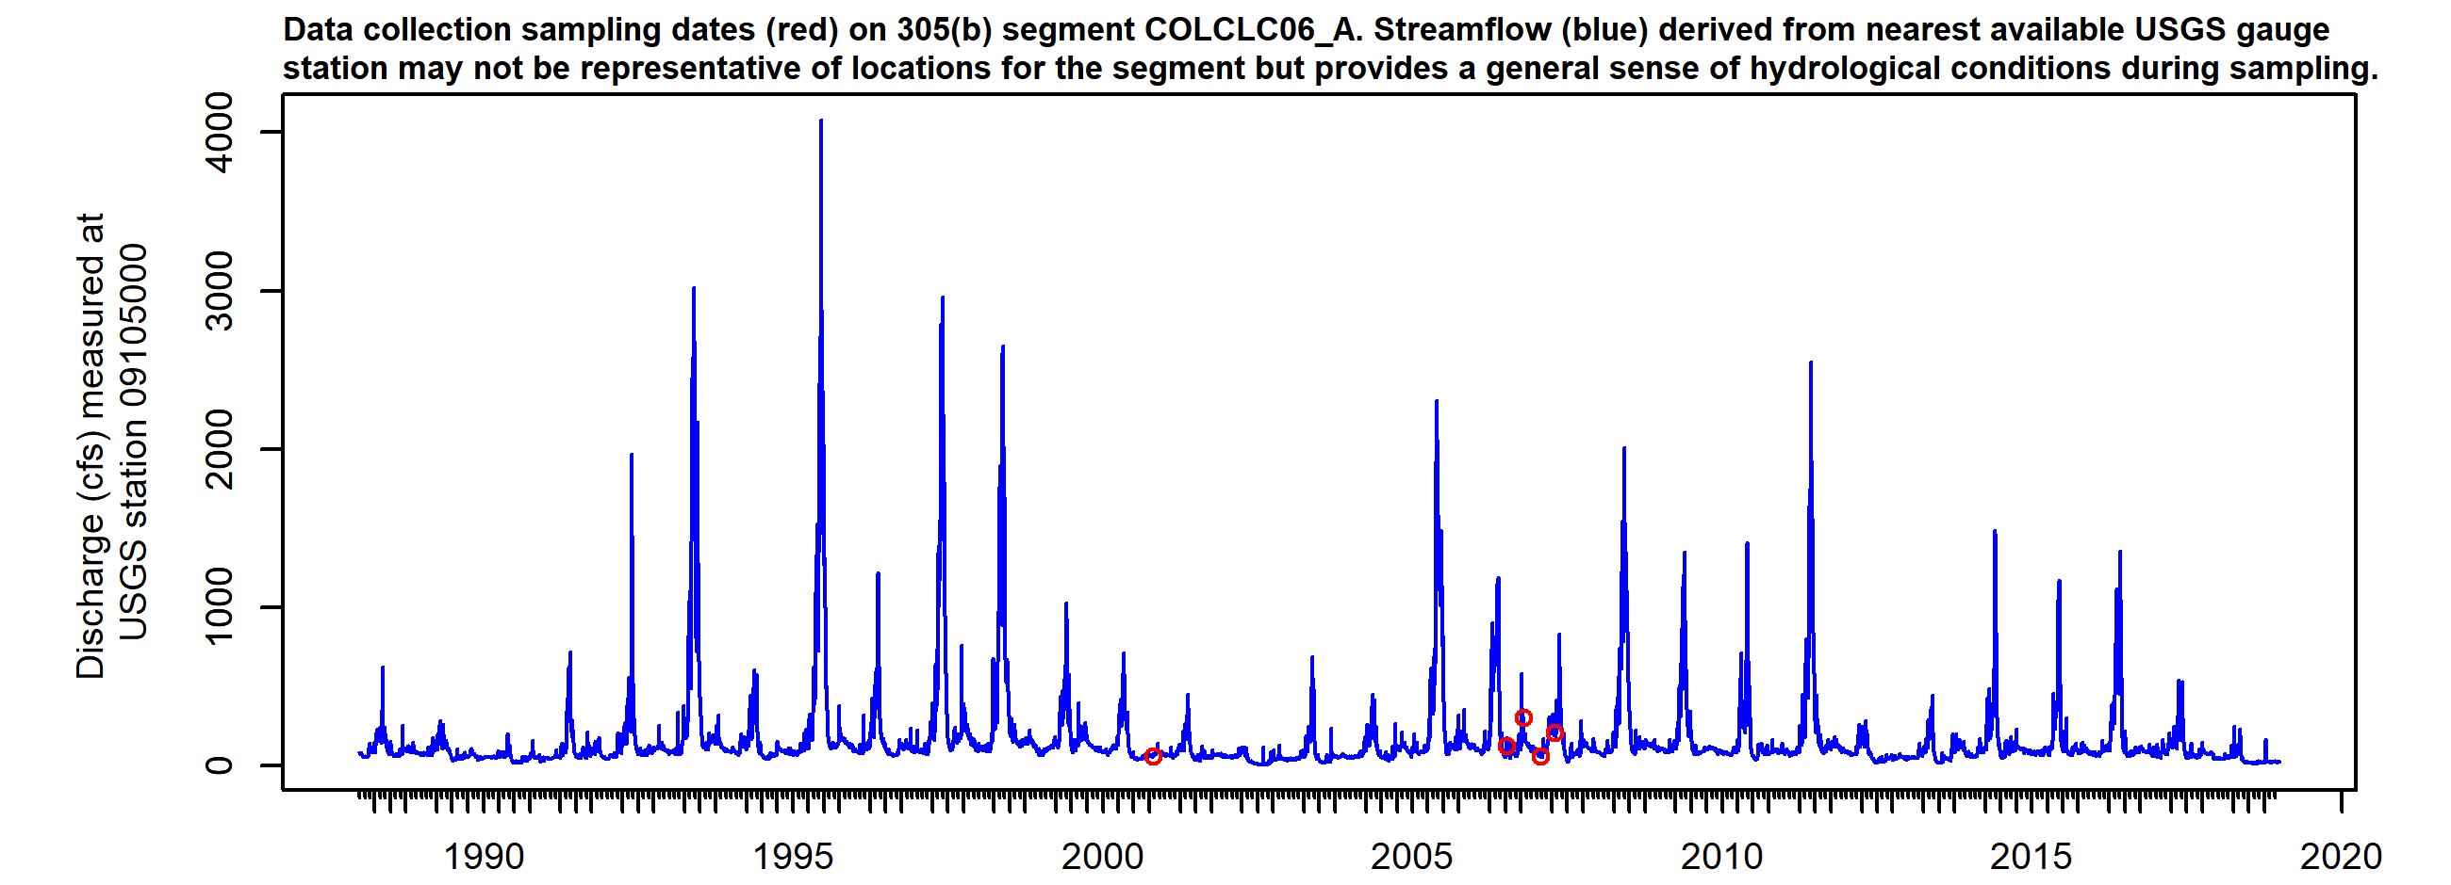

*Figure X. Sampling dates hydrograph, COLCLC06_A. Observed streamflow (blue line) derived from nearest available USGS gauges may not be directly representative for the segment but provides general sense of hydrological conditions present during sampling.*

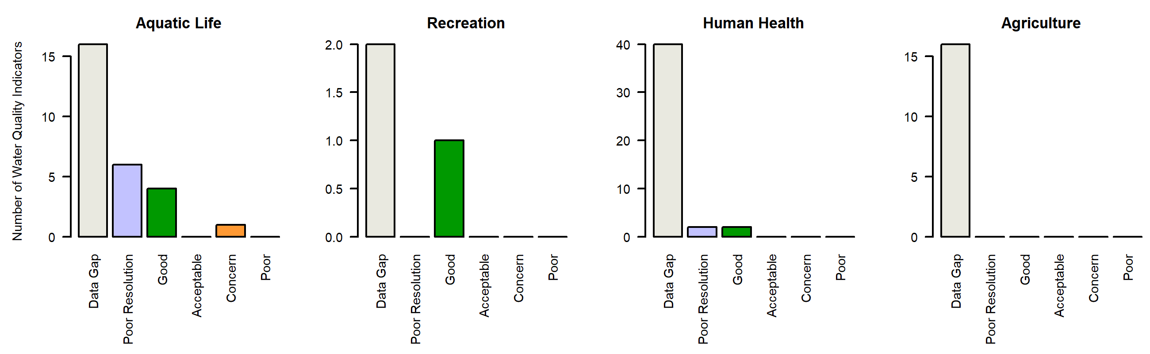

*Figure X. Water quality Indicators summary, COLCLC06_A. Graphs summarize the count of individual parameter ratings in each Report Card assessment class (Good, Acceptable, Concern, Poor, Low Resolution, Data Gap).*

### COLCLC07a_A

*Reach Description:*

Mainstem of Mitchell, Canyon, Elk, Garfield, Beaver, and Cache Creeks, including all tributaries and wetlands, from the boundary of the White River National Forest to their confluences with the Colorado River. Battlement Creek from the most downstream bo

*Designated Uses:*

Summary

Regulatory status

Parameters of interest

*NA*

*Selenium*

*Lead*

*Selenium*

*Zinc*

*Arsenic*

Data quality and representativeness

*Table X: Sampling locations for COLCLC07a_A.*

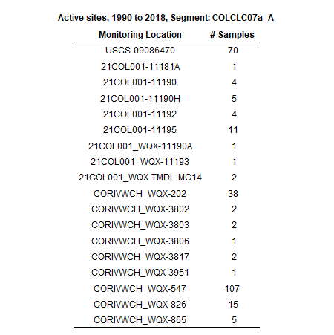

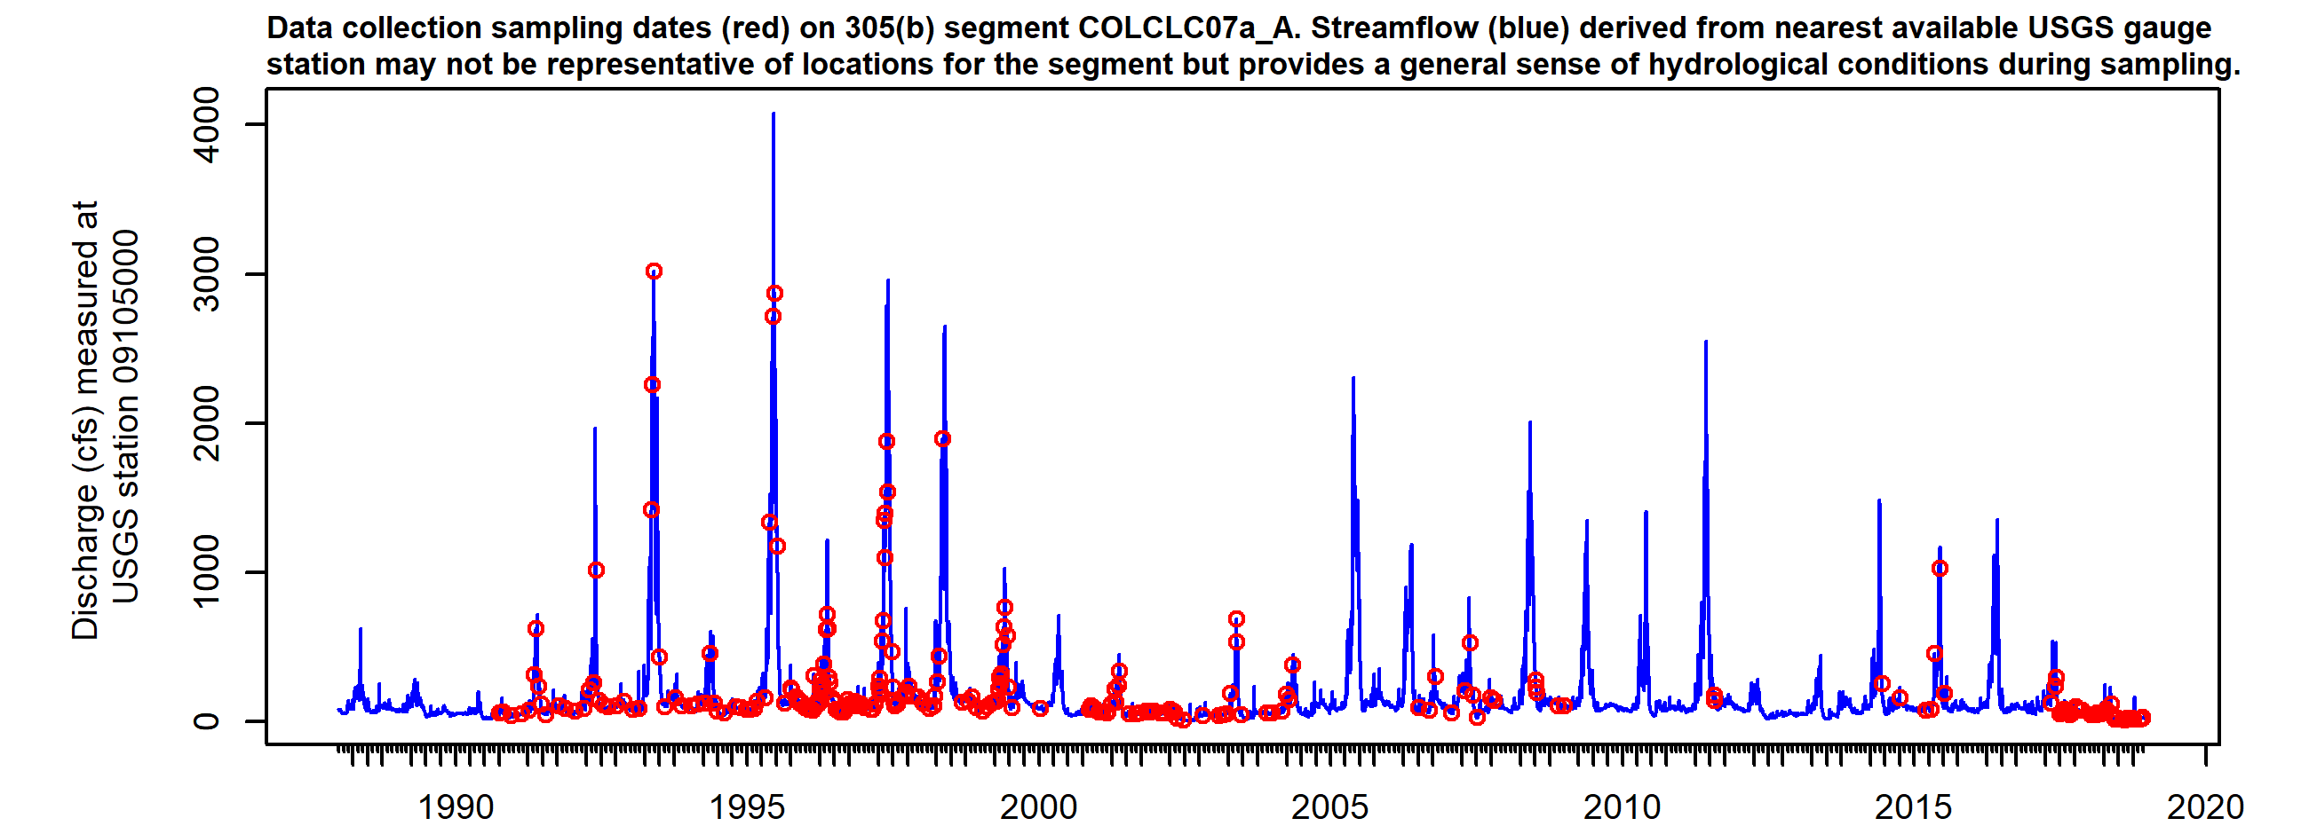

*Figure X. Sampling dates hydrograph, COLCLC07a_A. Observed streamflow (blue line) derived from nearest available USGS gauges may not be directly representative for the segment but provides general sense of hydrological conditions present during sampling.*

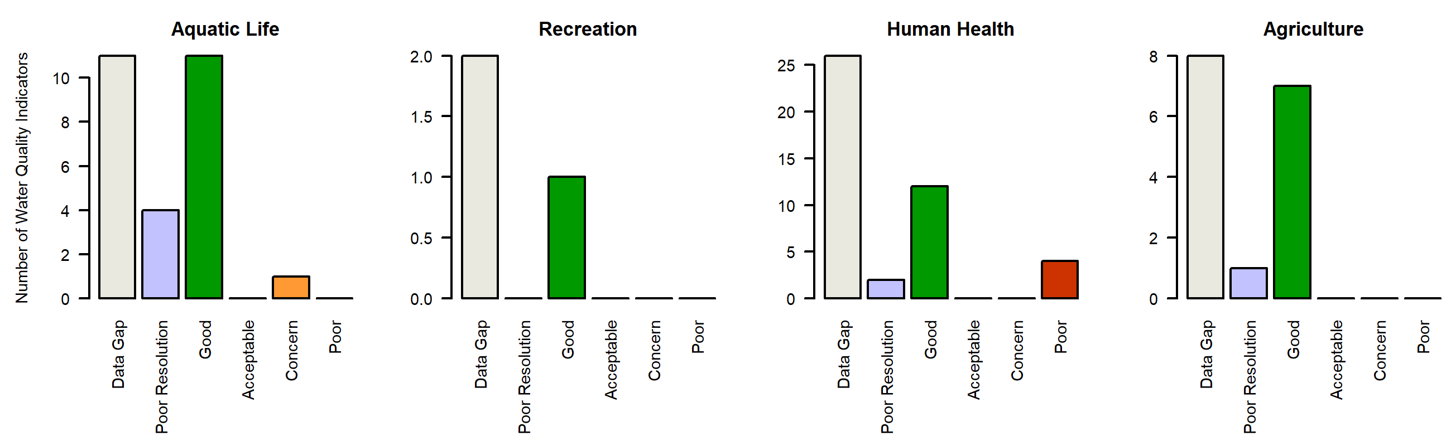

*Figure X. Water quality Indicators summary, COLCLC07a_A. Graphs summarize the count of individual parameter ratings in each Report Card assessment class (Good, Acceptable, Concern, Poor, Low Resolution, Data Gap).*

### COLCLC07b_A

*Reach Description:*

Mainstem of Divide Creek, including all tributaries and wetlands, from the boundary of the White River National Forest to the confluence with the Colorado River.

*Designated Uses:*

Summary

Regulatory status

Parameters of interest

*NA*

*Total_Phosphorus*

*Aluminum*

*Selenium*

*Manganese*

*Arsenic*

Data quality and representativeness

*Table X: Sampling locations for COLCLC07b_A.*

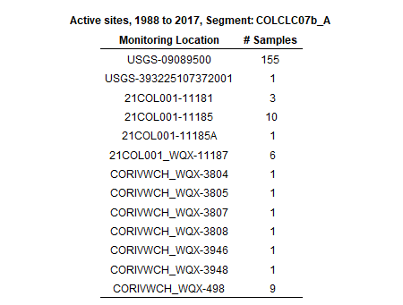

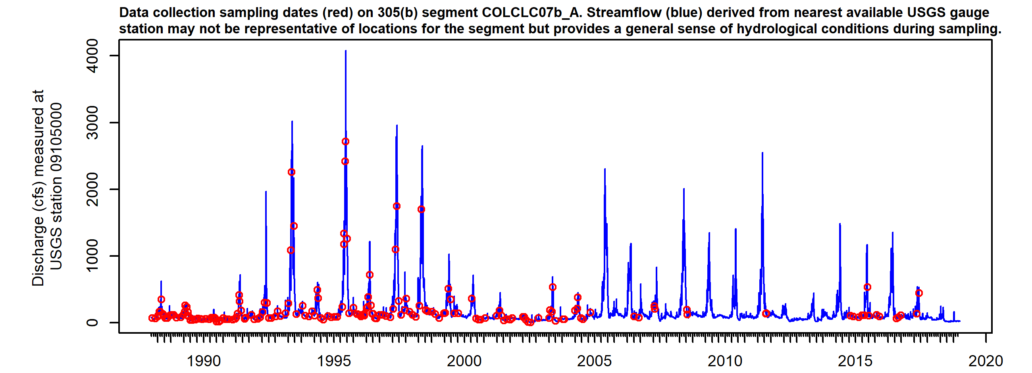

*Figure X. Sampling dates hydrograph, COLCLC07b_A. Observed streamflow (blue line) derived from nearest available USGS gauges may not be directly representative for the segment but provides general sense of hydrological conditions present during sampling.*

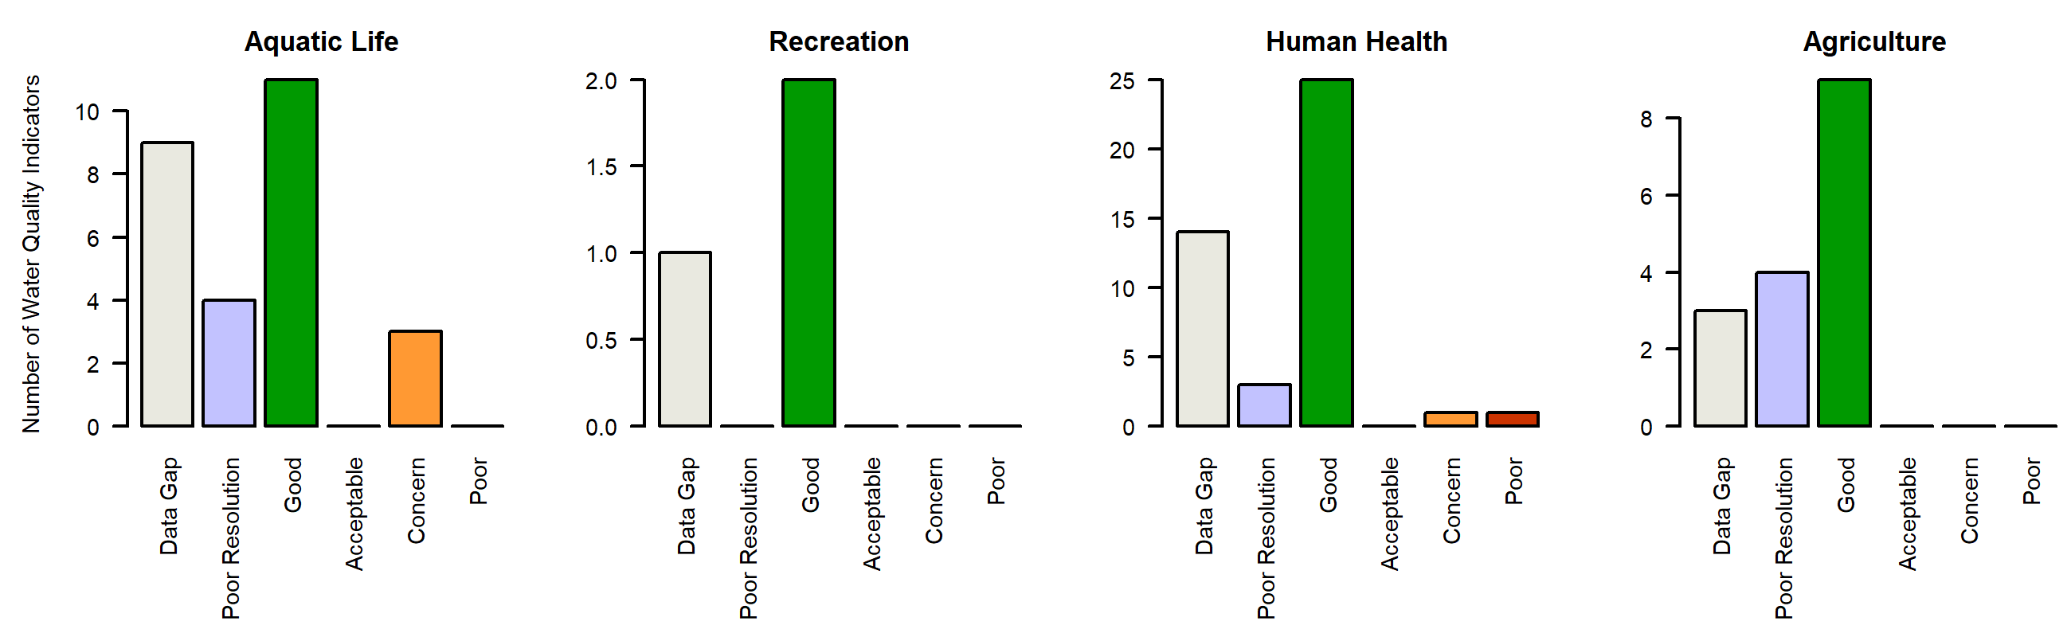

*Figure X. Water quality Indicators summary, COLCLC07b_A. Graphs summarize the count of individual parameter ratings in each Report Card assessment class (Good, Acceptable, Concern, Poor, Low Resolution, Data Gap).*

### COLCLC08_A

*Reach Description:*

Mainstem of Northwater and Trapper Creeks, including all tributaries and wetlands, from their sources to the confluence with the East Middle Fork of Parachute Creek. East Middle Fork of Parachute Creek, including all tributaries and wetlands, from the so

*Designated Uses:*

Summary

Regulatory status

Parameters of interest

*Arsenic*

*Arsenic*

*Arsenic*

Data quality and representativeness

*Table X: Sampling locations for COLCLC08_A.*

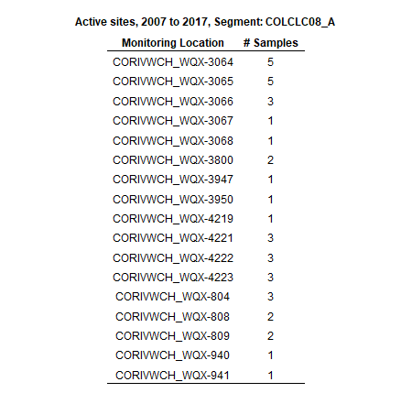

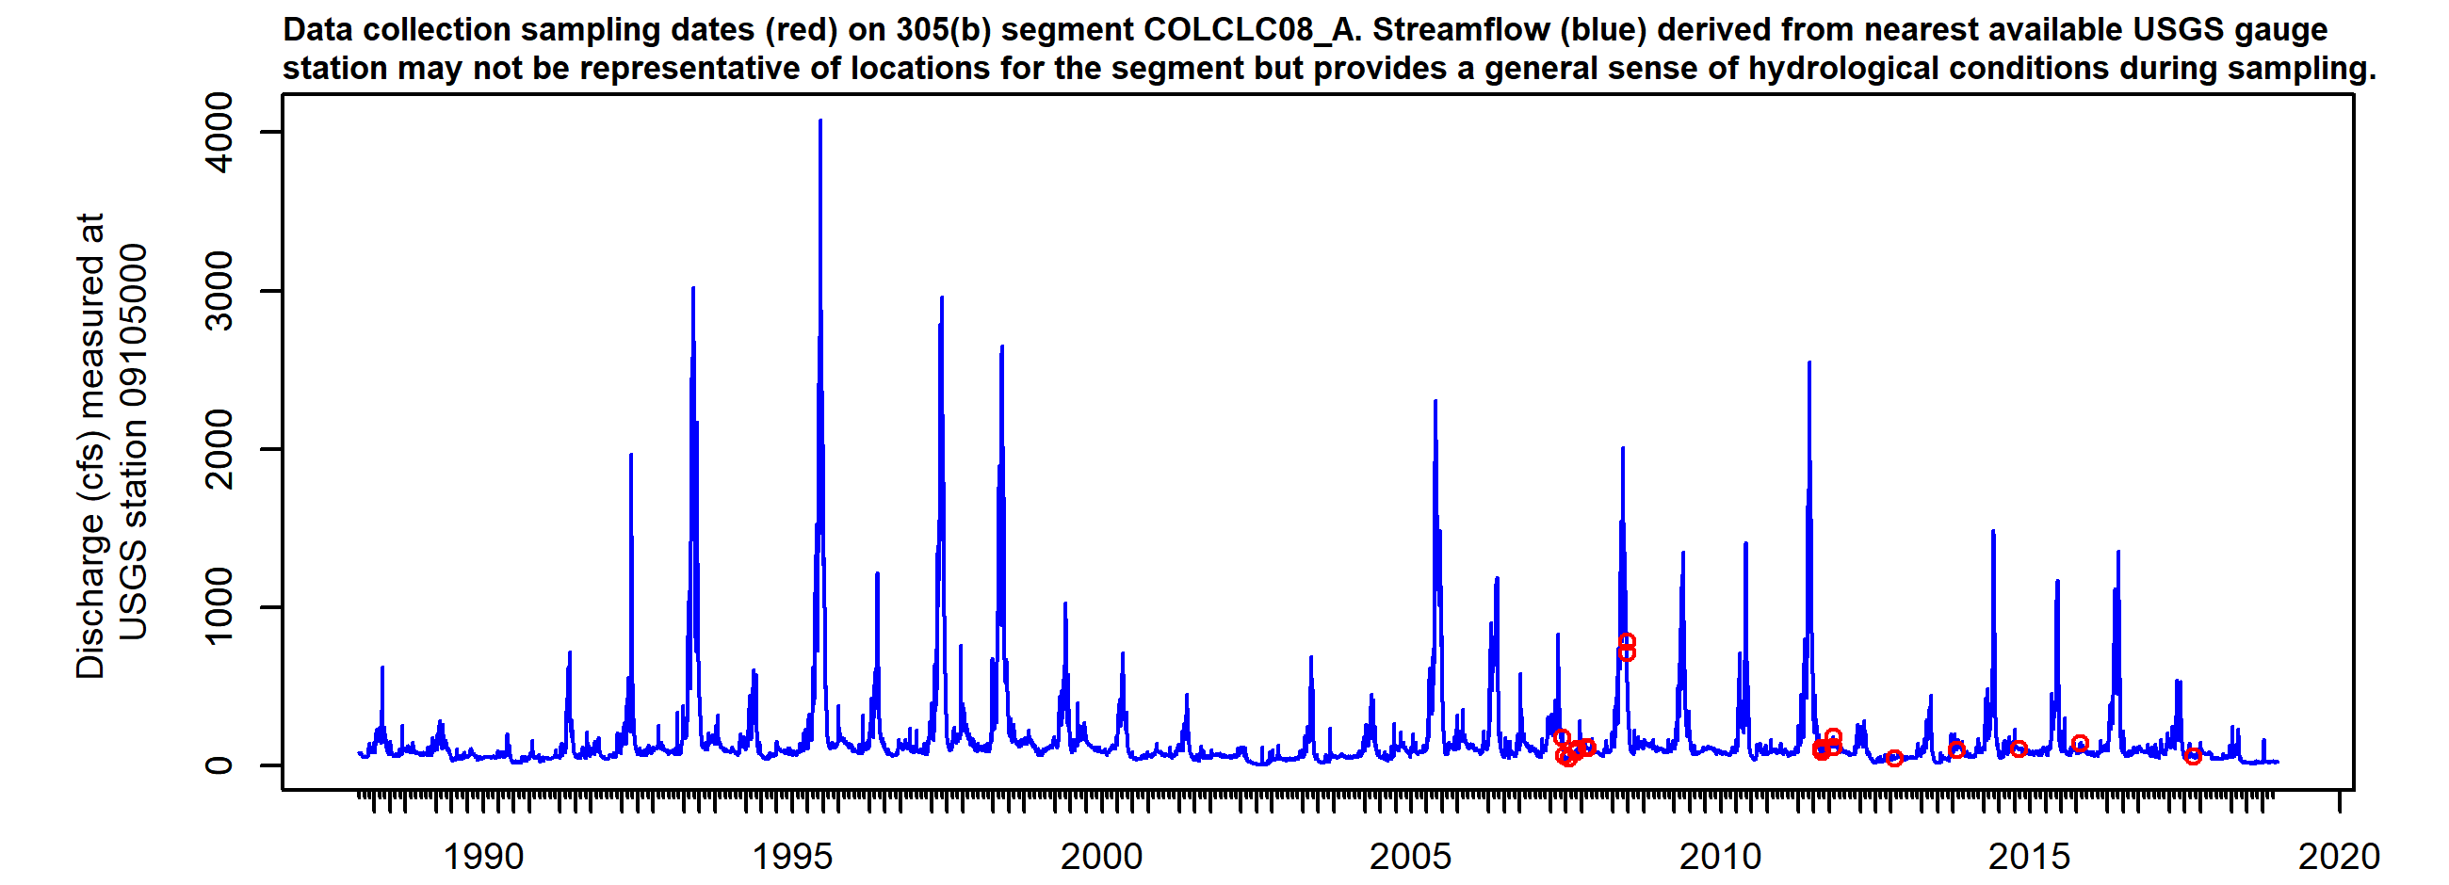

*Figure X. Sampling dates hydrograph, COLCLC08_A. Observed streamflow (blue line) derived from nearest available USGS gauges may not be directly representative for the segment but provides general sense of hydrological conditions present during sampling.*

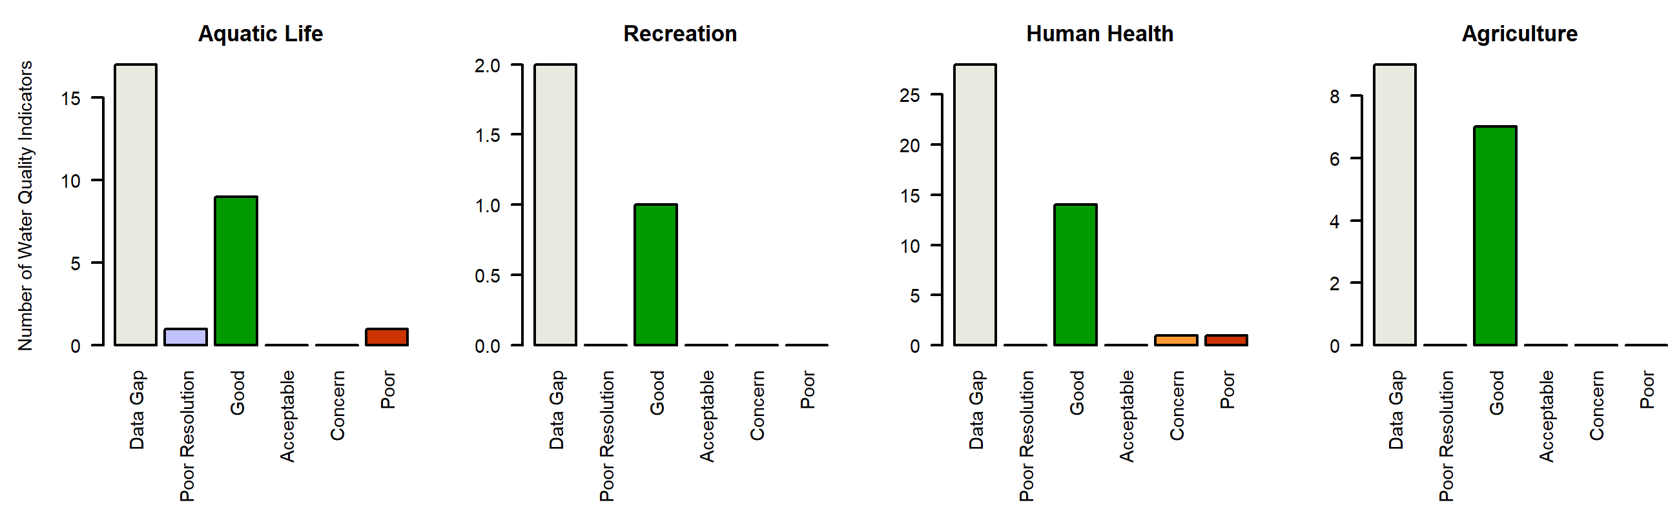

*Figure X. Water quality Indicators summary, COLCLC08_A. Graphs summarize the count of individual parameter ratings in each Report Card assessment class (Good, Acceptable, Concern, Poor, Low Resolution, Data Gap).*

### COLCLC09a_A

*Reach Description:*

Middle Rifle Creek, including all tributaries and wetlands, from its source to the confluence with West Rifle Creek. East Rifle Creek, including all tributaries and wetlands, from the source to the boundary of the White River National Forest.

*Designated Uses:*

Summary

Regulatory status

Parameters of interest

*NA*

*NA*

*NA*

*NA*

*NA*

*NA*

*NA*

*NA*

*NA*

*NA*

*NA*

*NA*

*NA*

*NA*

Data quality and representativeness

*Table X: Sampling locations for COLCLC09a_A.*

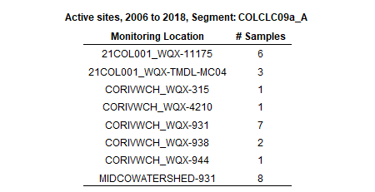

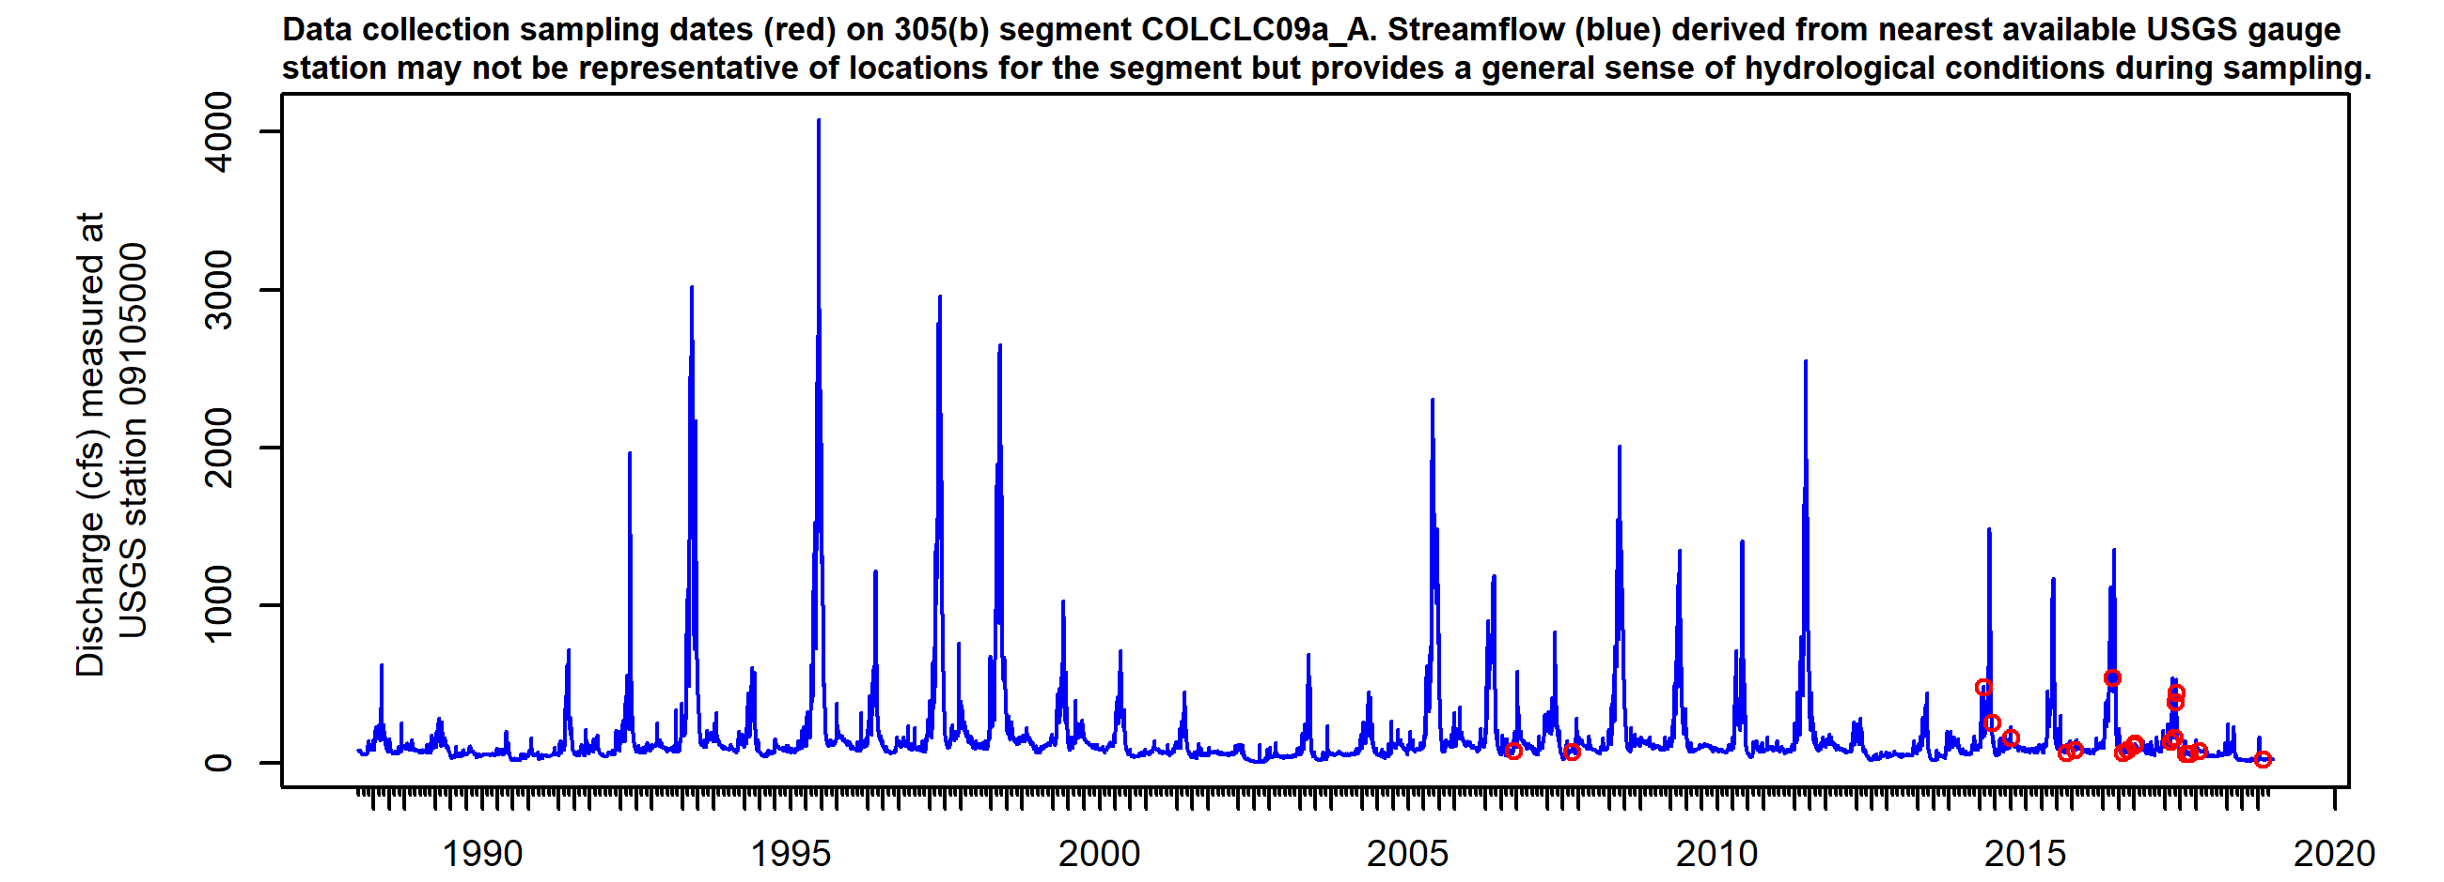

*Figure X. Sampling dates hydrograph, COLCLC09a_A. Observed streamflow (blue line) derived from nearest available USGS gauges may not be directly representative for the segment but provides general sense of hydrological conditions present during sampling.*

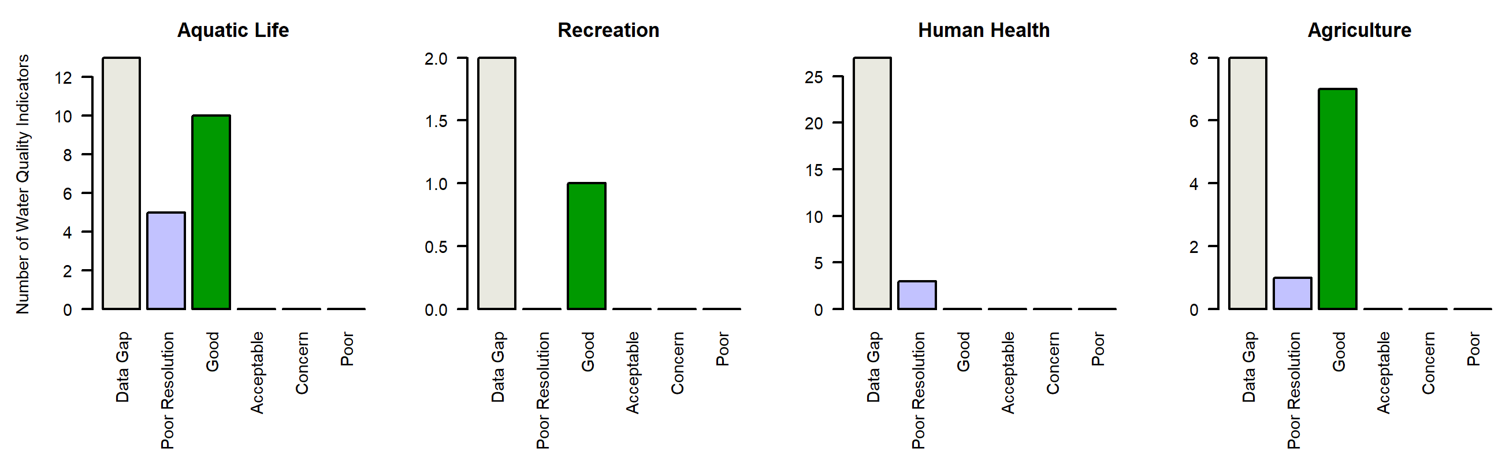

*Figure X. Water quality Indicators summary, COLCLC09a_A. Graphs summarize the count of individual parameter ratings in each Report Card assessment class (Good, Acceptable, Concern, Poor, Low Resolution, Data Gap).*

### COLCLC09c_A

*Reach Description:*

Battlement Creek, including all tributaries and wetlands, from the source to the most downstream boundary of BLM lands.

*Designated Uses:*

Summary

Regulatory status

Parameters of interest

*Lead*

Data quality and representativeness

*Table X: Sampling locations for COLCLC09c_A.*

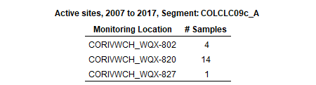

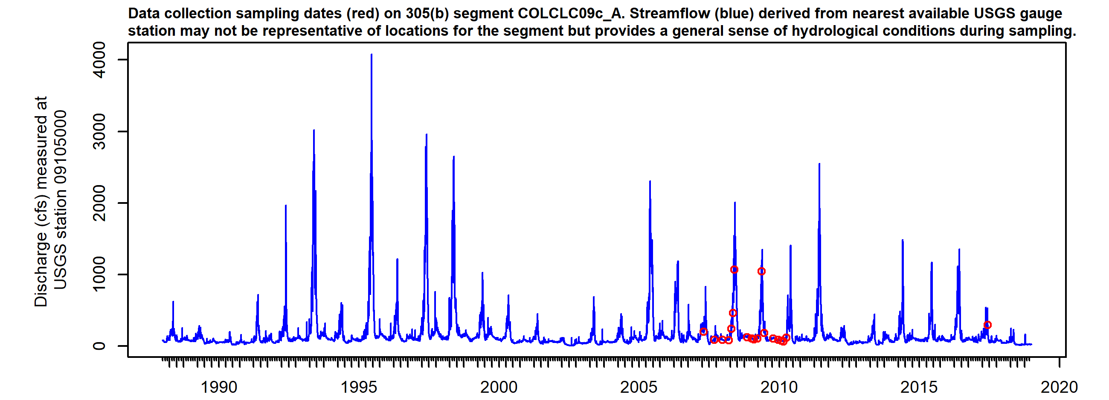

*Figure X. Sampling dates hydrograph, COLCLC09c_A. Observed streamflow (blue line) derived from nearest available USGS gauges may not be directly representative for the segment but provides general sense of hydrological conditions present during sampling.*

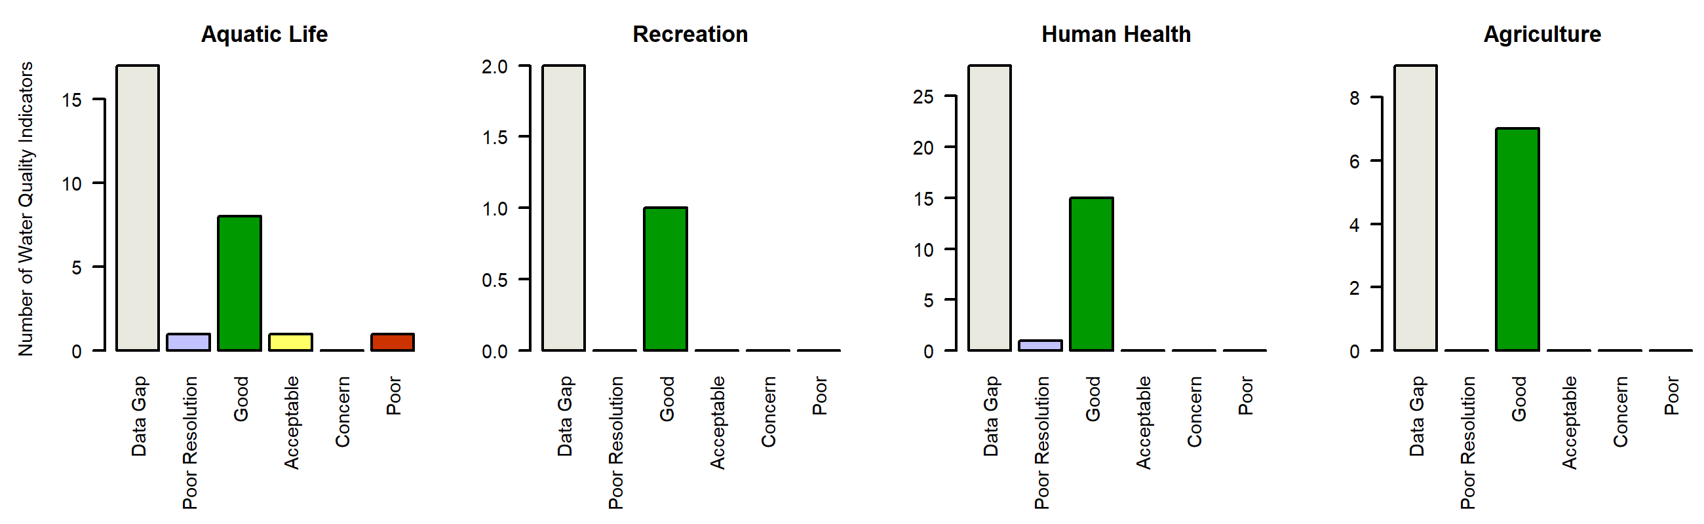

*Figure X. Water quality Indicators summary, COLCLC09c_A. Graphs summarize the count of individual parameter ratings in each Report Card assessment class (Good, Acceptable, Concern, Poor, Low Resolution, Data Gap).*

### COLCLC10_A

*Reach Description:*

East Rifle Creek from the White River NF boundary to Rifle Gap Reservoir. Rifle Creek from Rifle Gap Reservoir to the Colorado River

*Designated Uses:*

Summary

Regulatory status

Parameters of interest

*NA*

*Total_Phosphorus*

*Aluminum*

*Iron*

*Selenium*

*Cadmium*

*Lead*

*Manganese*

*Zinc*

*Arsenic*

*Manganese*

Data quality and representativeness

*Table X: Sampling locations for COLCLC10_A.*

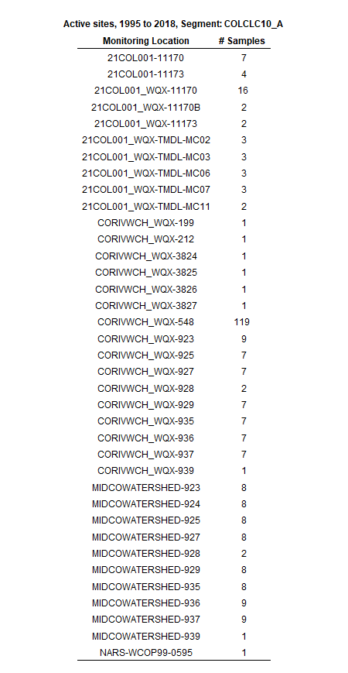

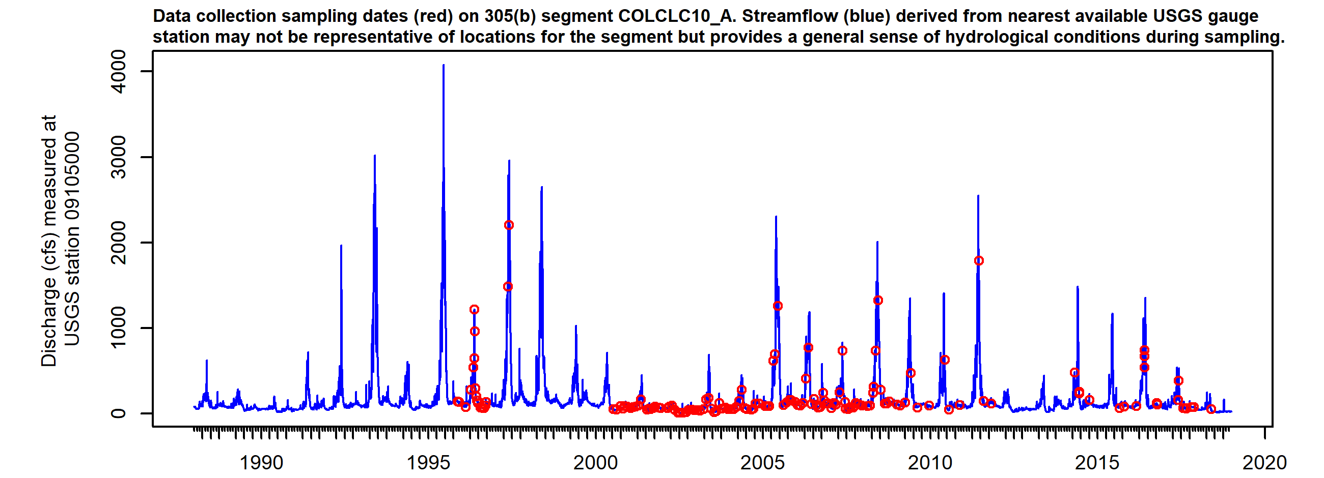

*Figure X. Sampling dates hydrograph, COLCLC10_A. Observed streamflow (blue line) derived from nearest available USGS gauges may not be directly representative for the segment but provides general sense of hydrological conditions present during sampling.*

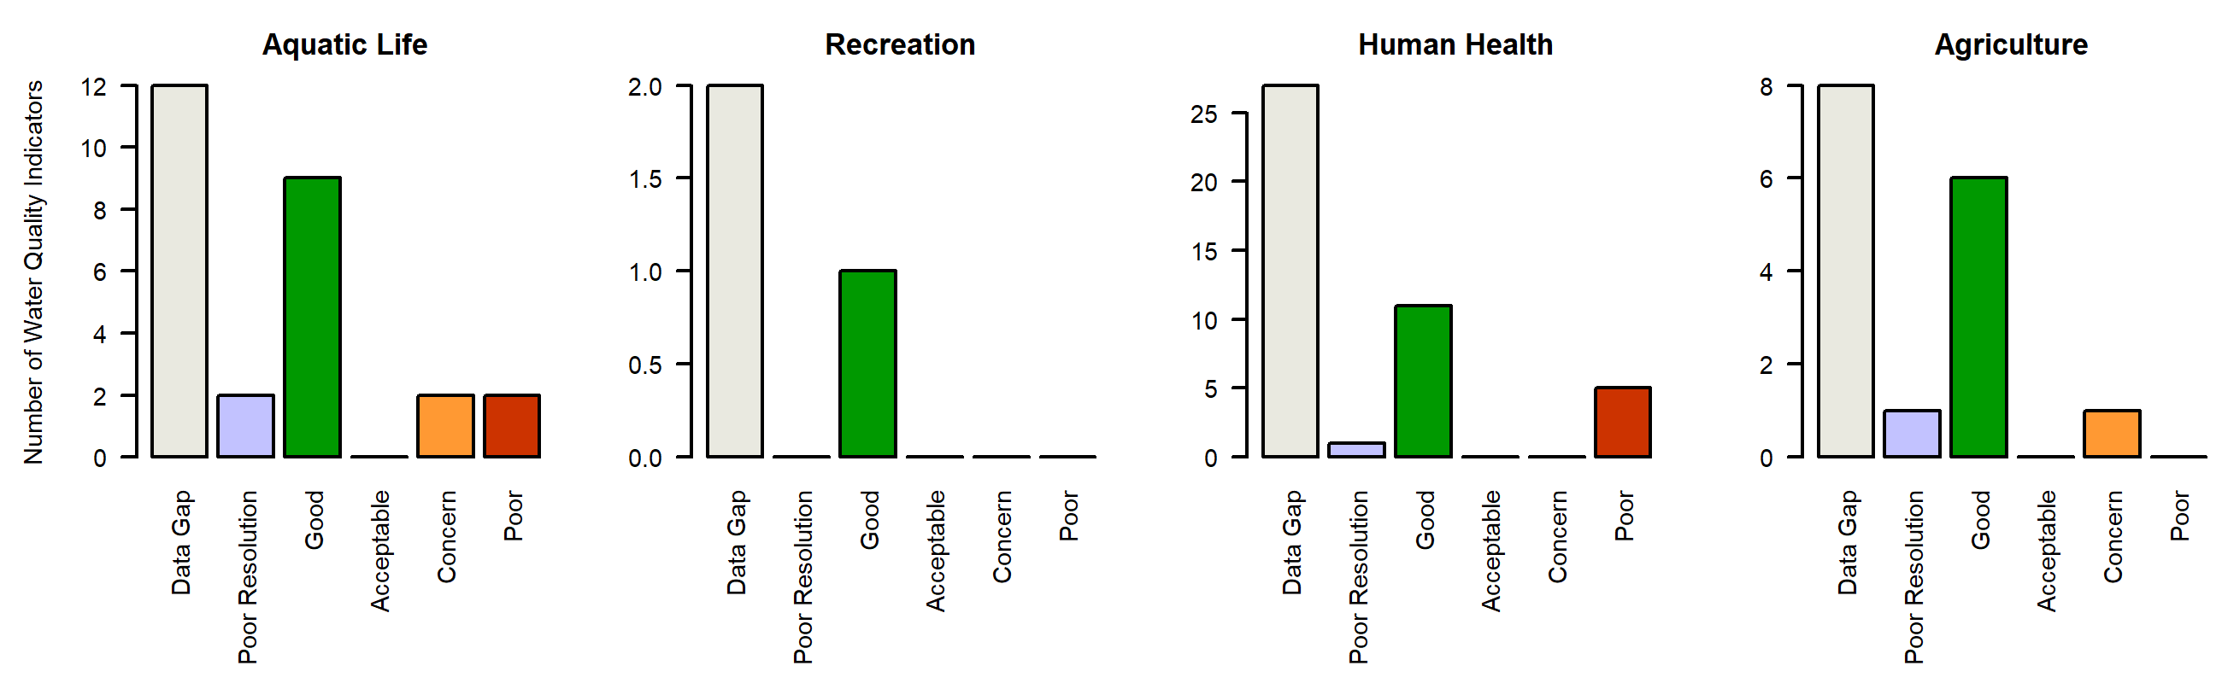

*Figure X. Water quality Indicators summary, COLCLC10_A. Graphs summarize the count of individual parameter ratings in each Report Card assessment class (Good, Acceptable, Concern, Poor, Low Resolution, Data Gap).*

### COLCLC10_B

*Reach Description:*

West Rifle Creek and tributaries

*Designated Uses:*

Summary

Regulatory status

Parameters of interest

*NA*

*Iron*

*Manganese*

*Arsenic*

Data quality and representativeness

*Table X: Sampling locations for COLCLC10_B.*

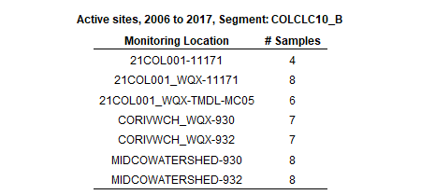

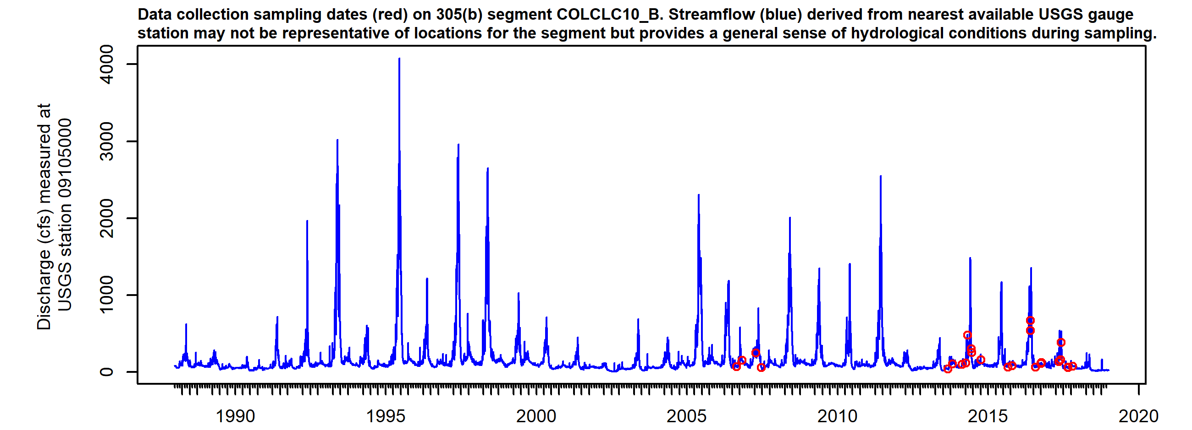

*Figure X. Sampling dates hydrograph, COLCLC10_B. Observed streamflow (blue line) derived from nearest available USGS gauges may not be directly representative for the segment but provides general sense of hydrological conditions present during sampling.*

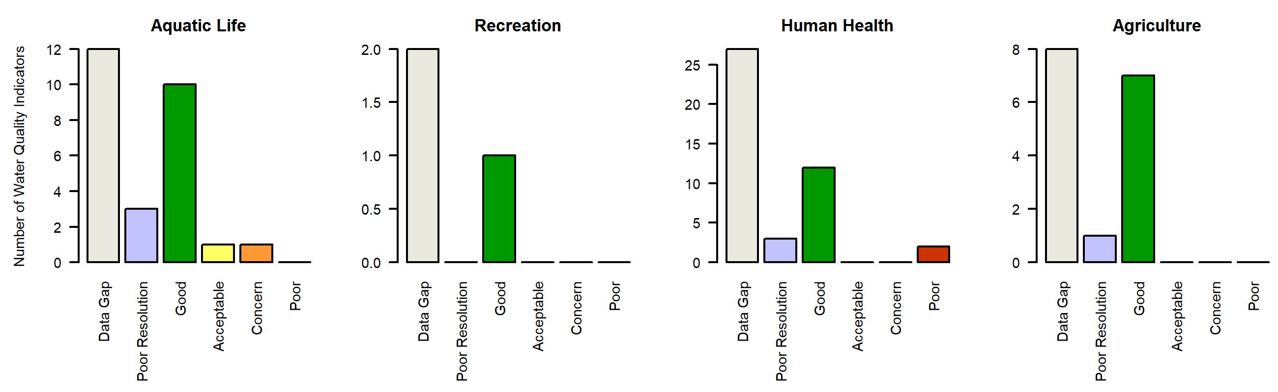

*Figure X. Water quality Indicators summary, COLCLC10_B. Graphs summarize the count of individual parameter ratings in each Report Card assessment class (Good, Acceptable, Concern, Poor, Low Resolution, Data Gap).*

### COLCLC11a_A

*Reach Description:*

Mainstem of the West Fork of Parachute Creek, including all tributaries, from its source to West Fork Falls. Mainstem of East Fork of Parachute Creek, including all tributaries and wetlands, from a point immediately below the mouth of First Anvil Creek t

*Designated Uses:*

Summary

Regulatory status

Parameters of interest

*Selenium*

*Arsenic*

*Arsenic*

Data quality and representativeness

*Table X: Sampling locations for COLCLC11a_A.*

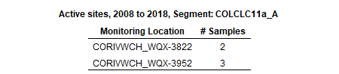

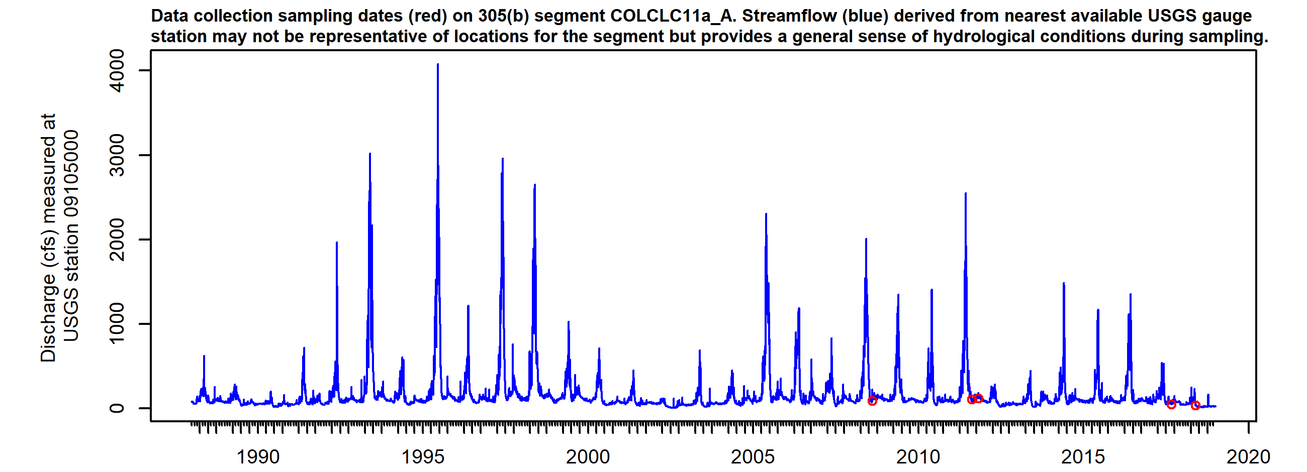

*Figure X. Sampling dates hydrograph, COLCLC11a_A. Observed streamflow (blue line) derived from nearest available USGS gauges may not be directly representative for the segment but provides general sense of hydrological conditions present during sampling.*

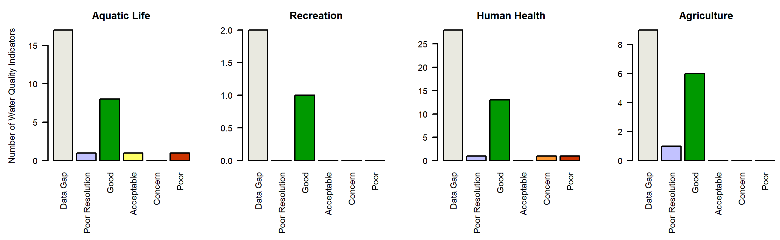

*Figure X. Water quality Indicators summary, COLCLC11a_A. Graphs summarize the count of individual parameter ratings in each Report Card assessment class (Good, Acceptable, Concern, Poor, Low Resolution, Data Gap).*

### COLCLC11b_A

*Reach Description:*

Mainstem of the West Fork of Parachute Creek from West Fork Falls to the confluence with Parachute Creek; mainstem of the Middle Fork of Parachute Creek, including all tributaries, from the source to the confluence with East Middle Fork of Parachute Cree

*Designated Uses:*

Summary

Regulatory status

Parameters of interest

*NA*

*NA*

*NA*

*NA*

*NA*

*NA*

*NA*

*NA*

*NA*

*NA*

*NA*

*NA*

*NA*

*NA*

Data quality and representativeness

*Table X: Sampling locations for COLCLC11b_A.*

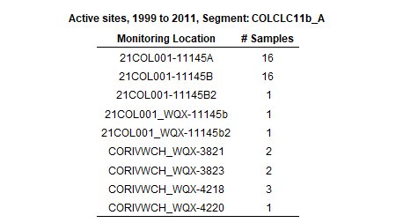

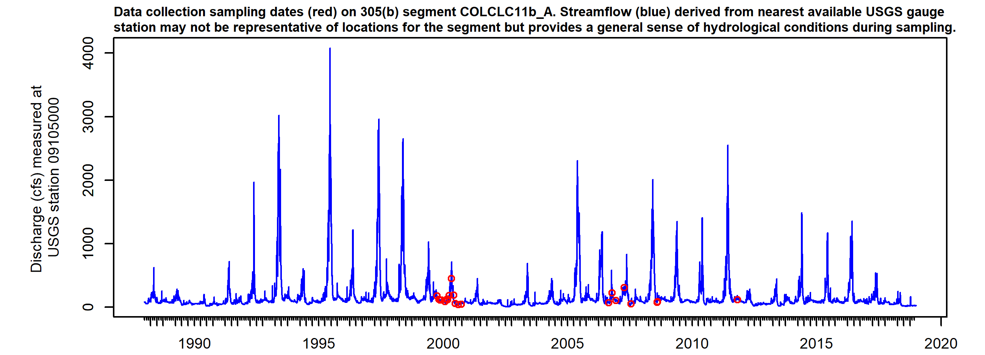

*Figure X. Sampling dates hydrograph, COLCLC11b_A. Observed streamflow (blue line) derived from nearest available USGS gauges may not be directly representative for the segment but provides general sense of hydrological conditions present during sampling.*

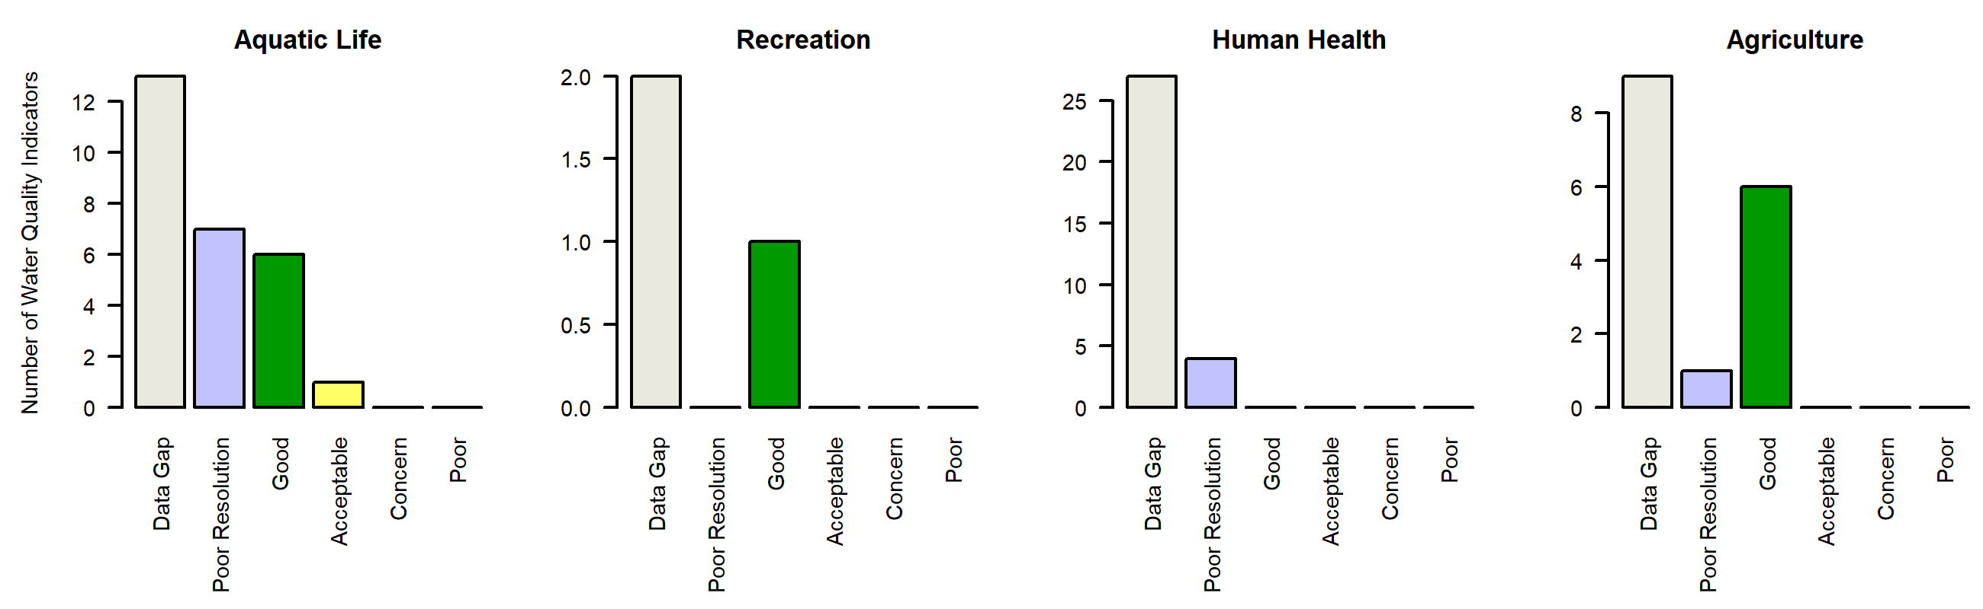

*Figure X. Water quality Indicators summary, COLCLC11b_A. Graphs summarize the count of individual parameter ratings in each Report Card assessment class (Good, Acceptable, Concern, Poor, Low Resolution, Data Gap).*

### COLCLC11e_A

*Reach Description:*

That portion of the mainstem of the East Fork of Parachute Creek, including all tributaries and wetlands, within Sections 27, 28, and 29, T5S, R95W.

*Designated Uses:*

Summary

Regulatory status

Parameters of interest

*pH*

*NA*

*pH*

*NA*

Data quality and representativeness

*Table X: Sampling locations for COLCLC11e_A.*

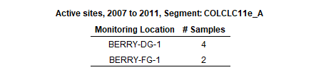

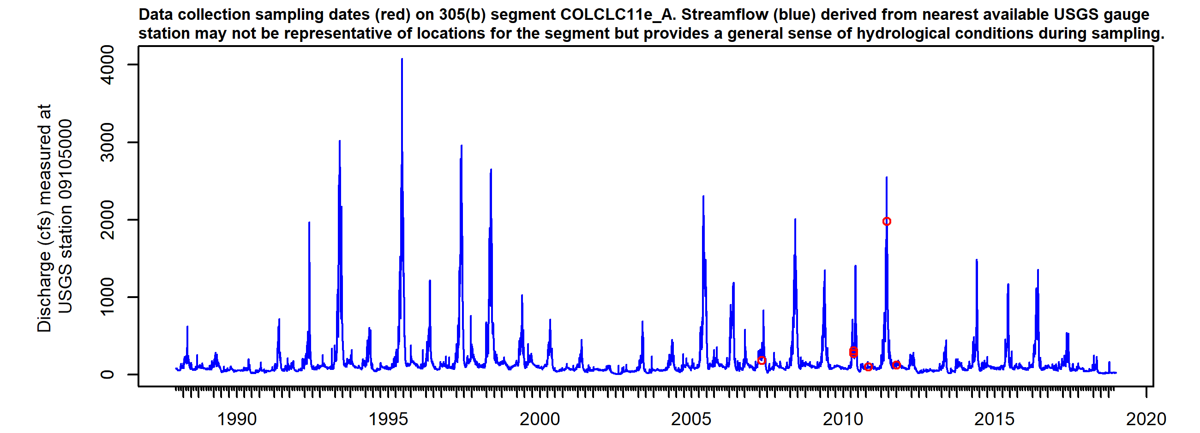

*Figure X. Sampling dates hydrograph, COLCLC11e_A. Observed streamflow (blue line) derived from nearest available USGS gauges may not be directly representative for the segment but provides general sense of hydrological conditions present during sampling.*

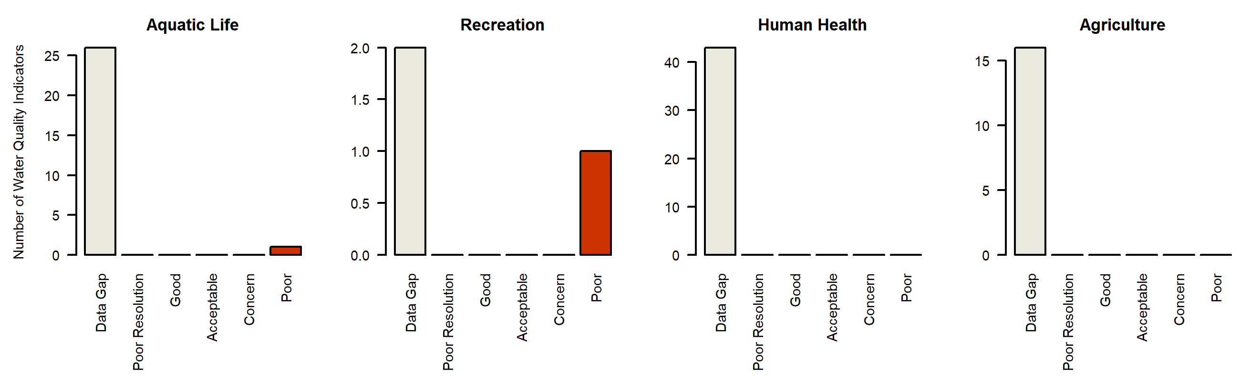

*Figure X. Water quality Indicators summary, COLCLC11e_A. Graphs summarize the count of individual parameter ratings in each Report Card assessment class (Good, Acceptable, Concern, Poor, Low Resolution, Data Gap).*

### COLCLC11f_A

*Reach Description:*

Mainstem of the East Fork of Parachute Creek from the west boundary line of S29, T5S, R95W to the confluence with Middle Fork of Parachute Creek.

*Designated Uses:*

Summary

Regulatory status

Parameters of interest

*NA*

*Selenium*

Data quality and representativeness

*Table X: Sampling locations for COLCLC11f_A.*

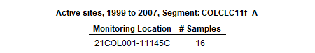

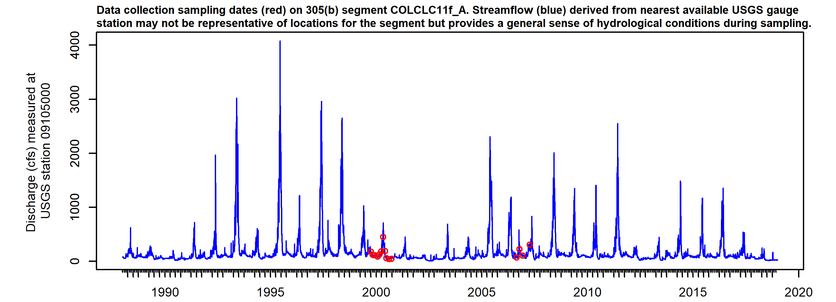

*Figure X. Sampling dates hydrograph, COLCLC11f_A. Observed streamflow (blue line) derived from nearest available USGS gauges may not be directly representative for the segment but provides general sense of hydrological conditions present during sampling.*

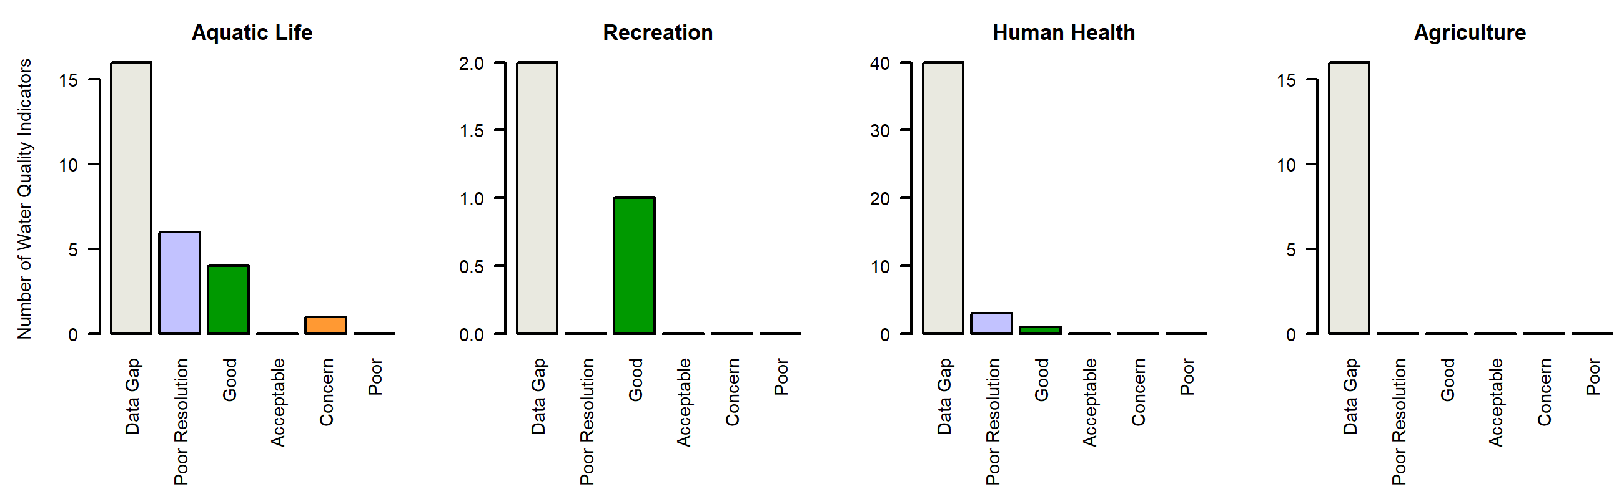

*Figure X. Water quality Indicators summary, COLCLC11f_A. Graphs summarize the count of individual parameter ratings in each Report Card assessment class (Good, Acceptable, Concern, Poor, Low Resolution, Data Gap).*

### COLCLC11g_A

*Reach Description:*

All tributaries to East Fork Parachute Creek on the south side of the East Fork Parachute Creek from a point immediately below First Anvil Creek to the confluence with Parachute Creek; all tributaries to Parachute Creek on the east side of Parachute Cree

*Designated Uses:*

Summary

Regulatory status

Parameters of interest

*NA*

*Arsenic*

*NA*

*NA*

*NA*

*NA*

*NA*

*NA*

*NA*

*NA*

*NA*

*NA*

*NA*

*NA*

*NA*

*NA*

*NA*

*NA*

Data quality and representativeness

*Table X: Sampling locations for COLCLC11g_A.*

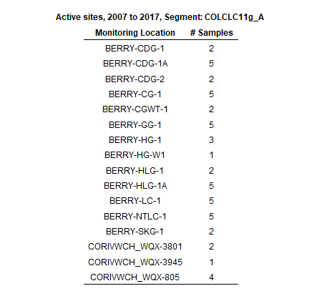

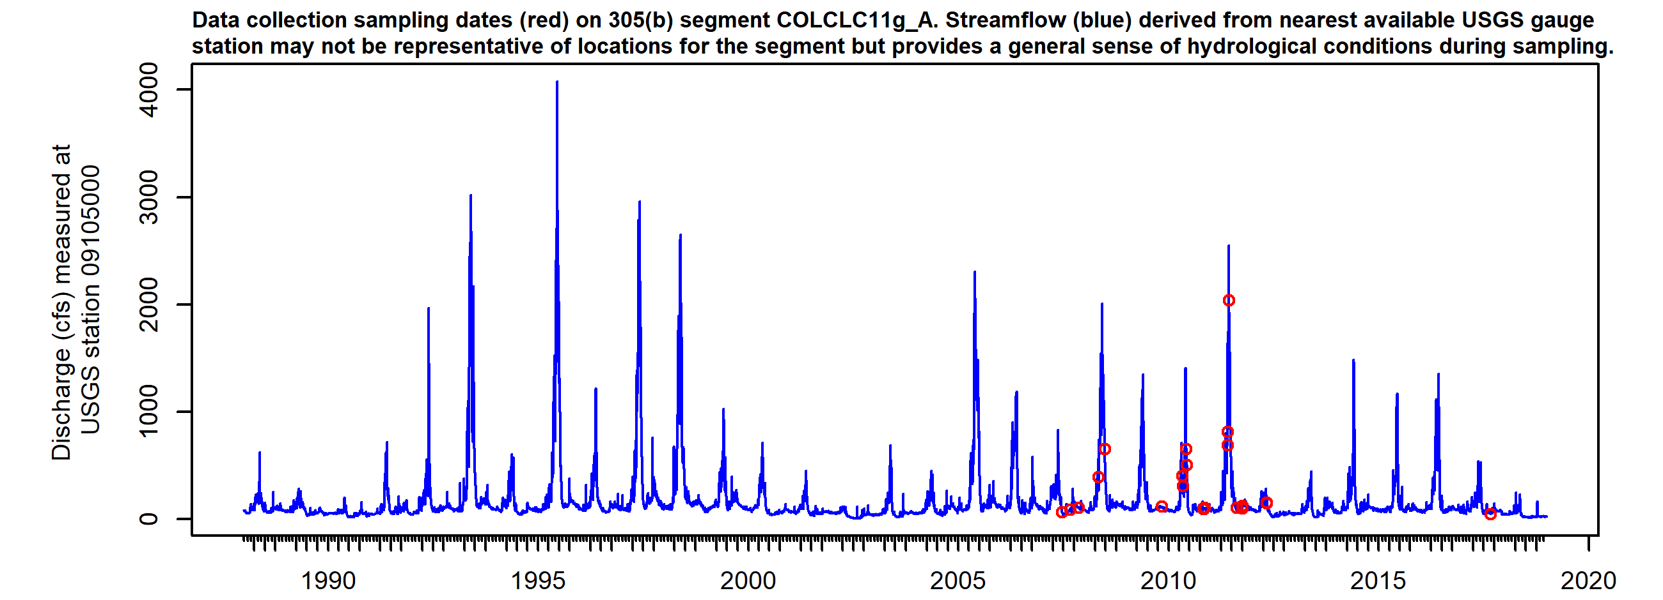

*Figure X. Sampling dates hydrograph, COLCLC11g_A. Observed streamflow (blue line) derived from nearest available USGS gauges may not be directly representative for the segment but provides general sense of hydrological conditions present during sampling.*

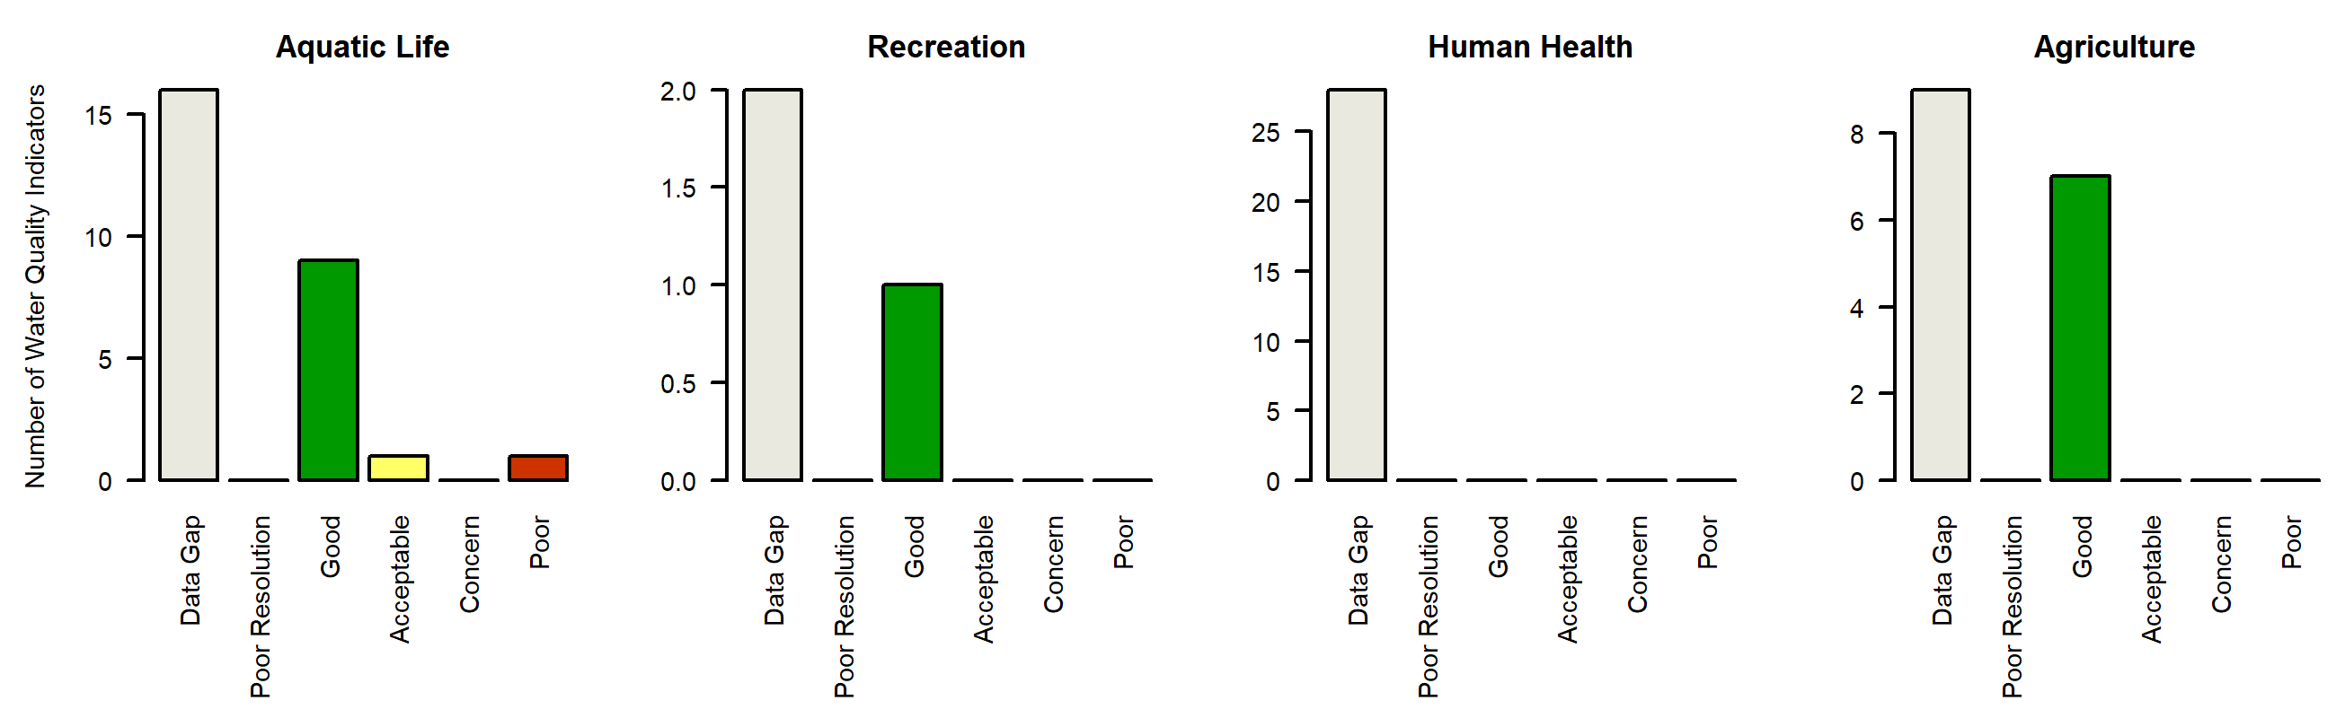

*Figure X. Water quality Indicators summary, COLCLC11g_A. Graphs summarize the count of individual parameter ratings in each Report Card assessment class (Good, Acceptable, Concern, Poor, Low Resolution, Data Gap).*

### COLCLC11h_A

*Reach Description:*

Mainstem of Parachute Creek, including all tributaries and wetlands, from the confluence of the West and East Forks to the confluence with the Colorado River except for specific listings in segment 11g.

*Designated Uses:*

Summary

Regulatory status

Parameters of interest

*NA*

*Selenium*

*Arsenic*

*Zinc*

*Arsenic*

Data quality and representativeness

*Table X: Sampling locations for COLCLC11h_A.*

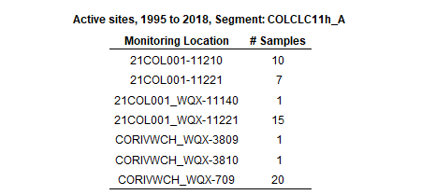

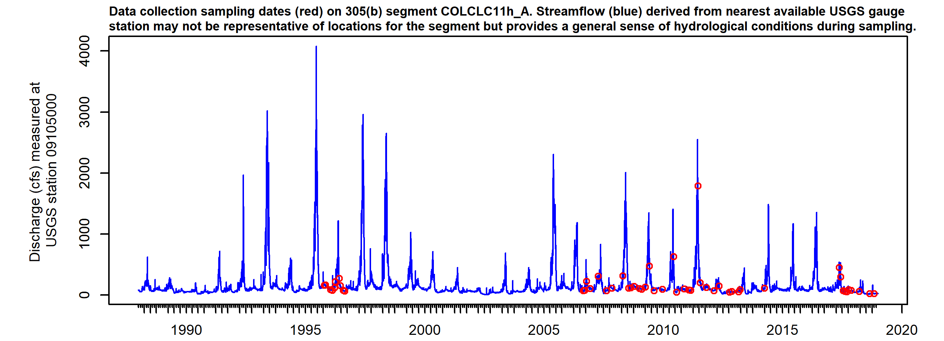

*Figure X. Sampling dates hydrograph, COLCLC11h_A. Observed streamflow (blue line) derived from nearest available USGS gauges may not be directly representative for the segment but provides general sense of hydrological conditions present during sampling.*

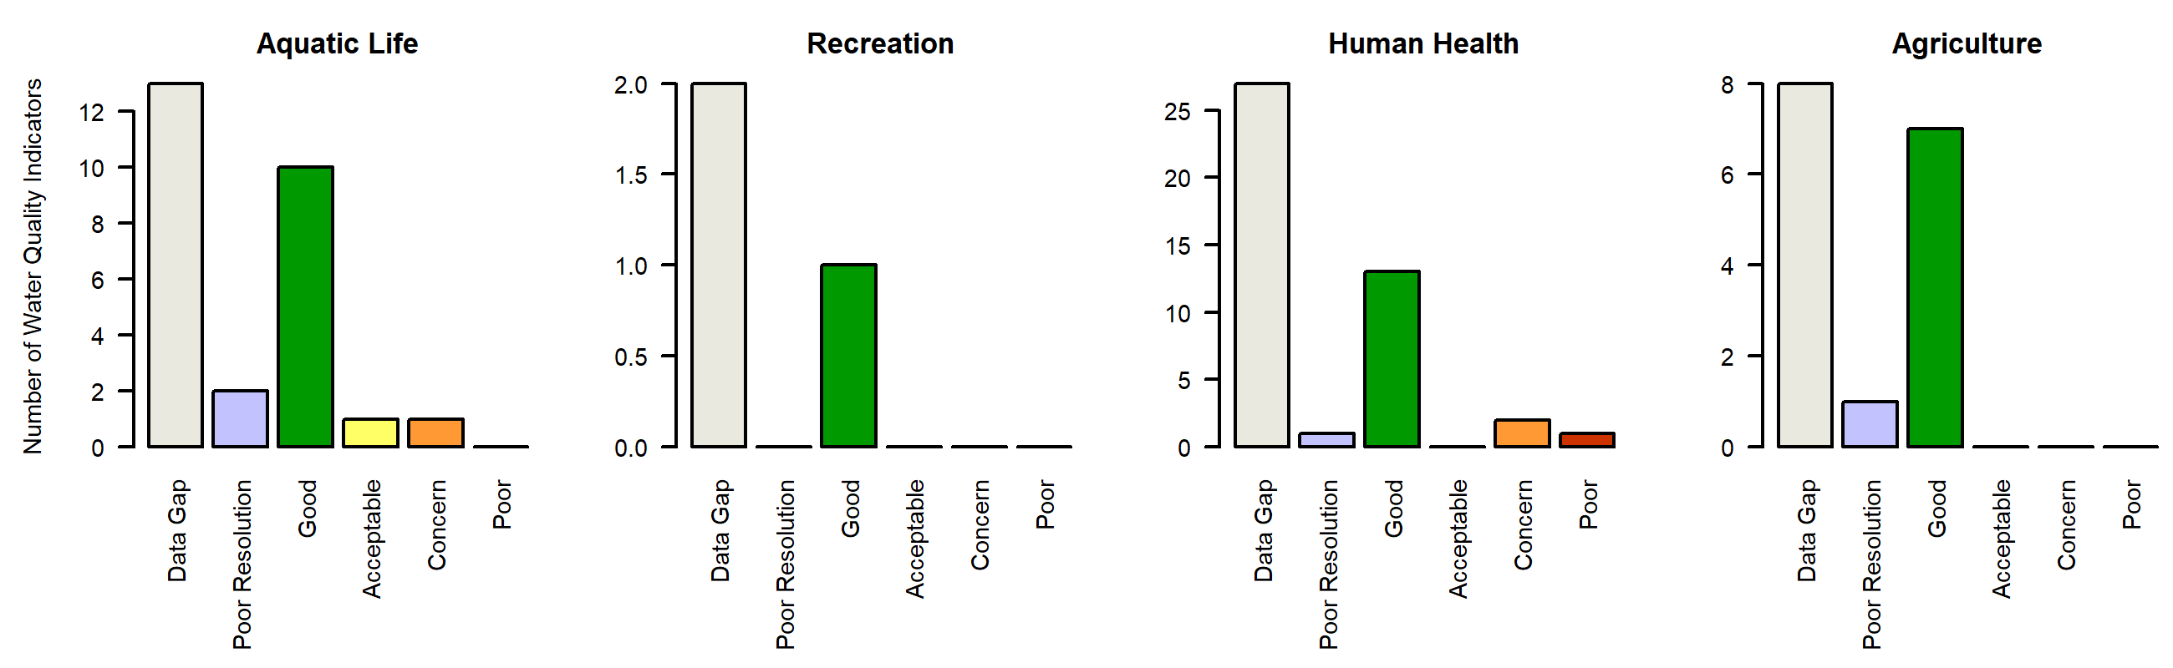

*Figure X. Water quality Indicators summary, COLCLC11h_A. Graphs summarize the count of individual parameter ratings in each Report Card assessment class (Good, Acceptable, Concern, Poor, Low Resolution, Data Gap).*

### COLCLC12b_A

*Reach Description:*

All tributaries and wetlands to the Colorado River from a point immediately below the confluence of Parachute Creek to a point immediately below the confluence with Roan Creek, except for the specific listings in segments 14a, 14b and 14c.

*Designated Uses:*

Summary

Regulatory status

Parameters of interest

*NA*

Data quality and representativeness

*Table X: Sampling locations for COLCLC12b_A.*

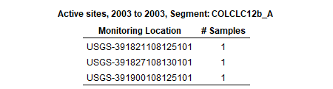

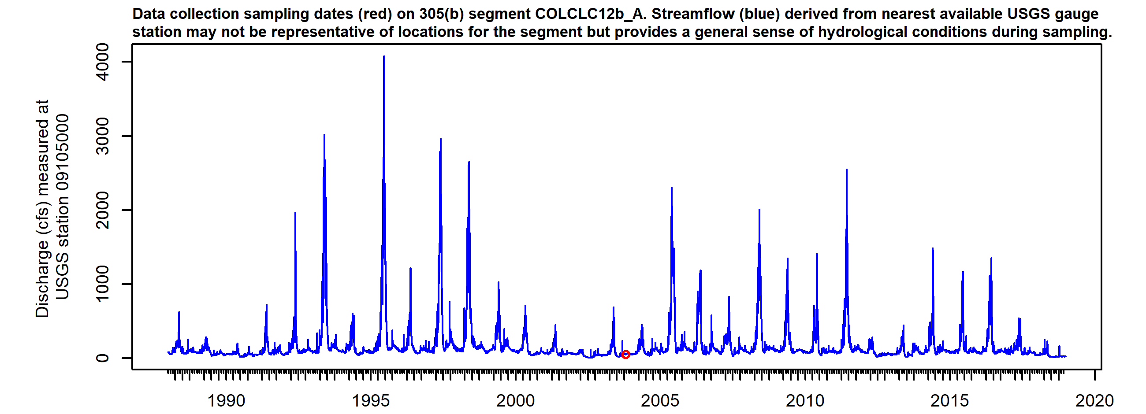

*Figure X. Sampling dates hydrograph, COLCLC12b_A. Observed streamflow (blue line) derived from nearest available USGS gauges may not be directly representative for the segment but provides general sense of hydrological conditions present during sampling.*

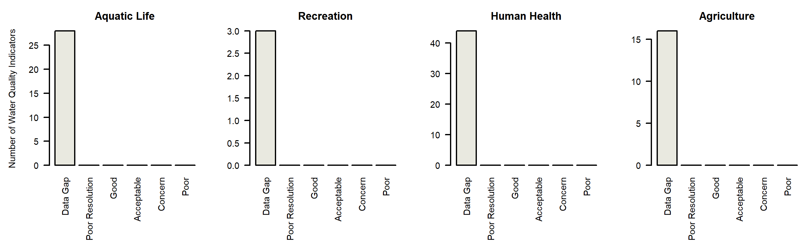

*Figure X. Water quality Indicators summary, COLCLC12b_A. Graphs summarize the count of individual parameter ratings in each Report Card assessment class (Good, Acceptable, Concern, Poor, Low Resolution, Data Gap).*

### COLCLC13a_A

*Reach Description:*

Tributaries to the Colorado River from below the confluence of Roan Creek to Colorado/Utah border except for Sulphur Gulch and tributaries

*Designated Uses:*

Summary

Regulatory status

Parameters of interest

*NA*

Data quality and representativeness

*Table X: Sampling locations for COLCLC13a_A.*

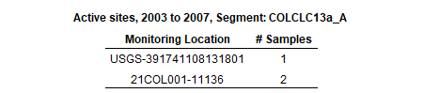

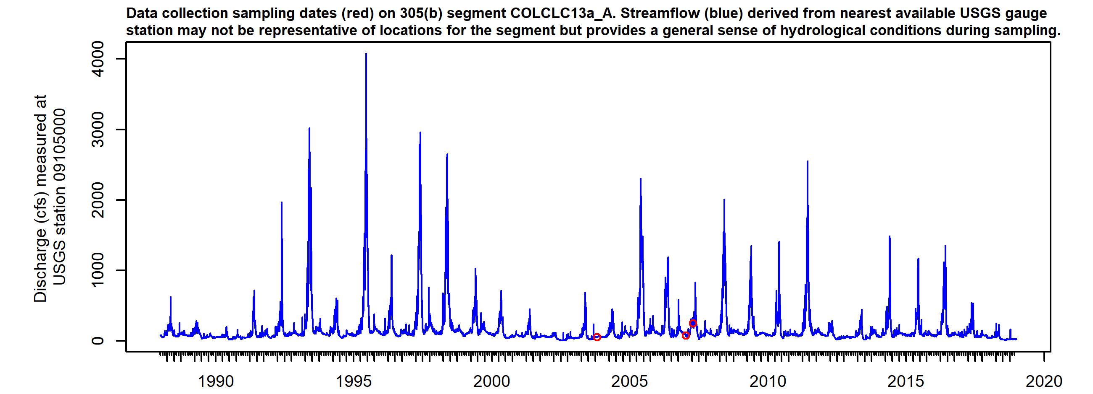

*Figure X. Sampling dates hydrograph, COLCLC13a_A. Observed streamflow (blue line) derived from nearest available USGS gauges may not be directly representative for the segment but provides general sense of hydrological conditions present during sampling.*



*Figure X. Water quality Indicators summary, COLCLC13a_A. Graphs summarize the count of individual parameter ratings in each Report Card assessment class (Good, Acceptable, Concern, Poor, Low Resolution, Data Gap).*

### COLCLC13a_B

*Reach Description:*

Sulphur Gulch and tributaries

*Designated Uses:*

Summary

Regulatory status

Parameters of interest

*NA*

*Selenium*

*NA*

*NA*

*NA*

*NA*

*NA*

*NA*

Data quality and representativeness

*Table X: Sampling locations for COLCLC13a_B.*

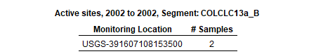

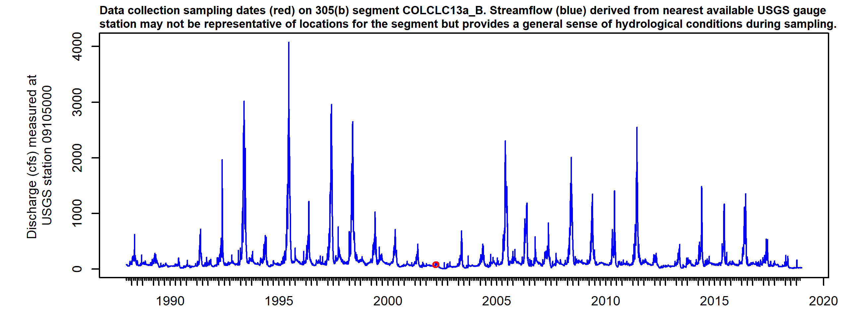

*Figure X. Sampling dates hydrograph, COLCLC13a_B. Observed streamflow (blue line) derived from nearest available USGS gauges may not be directly representative for the segment but provides general sense of hydrological conditions present during sampling.*

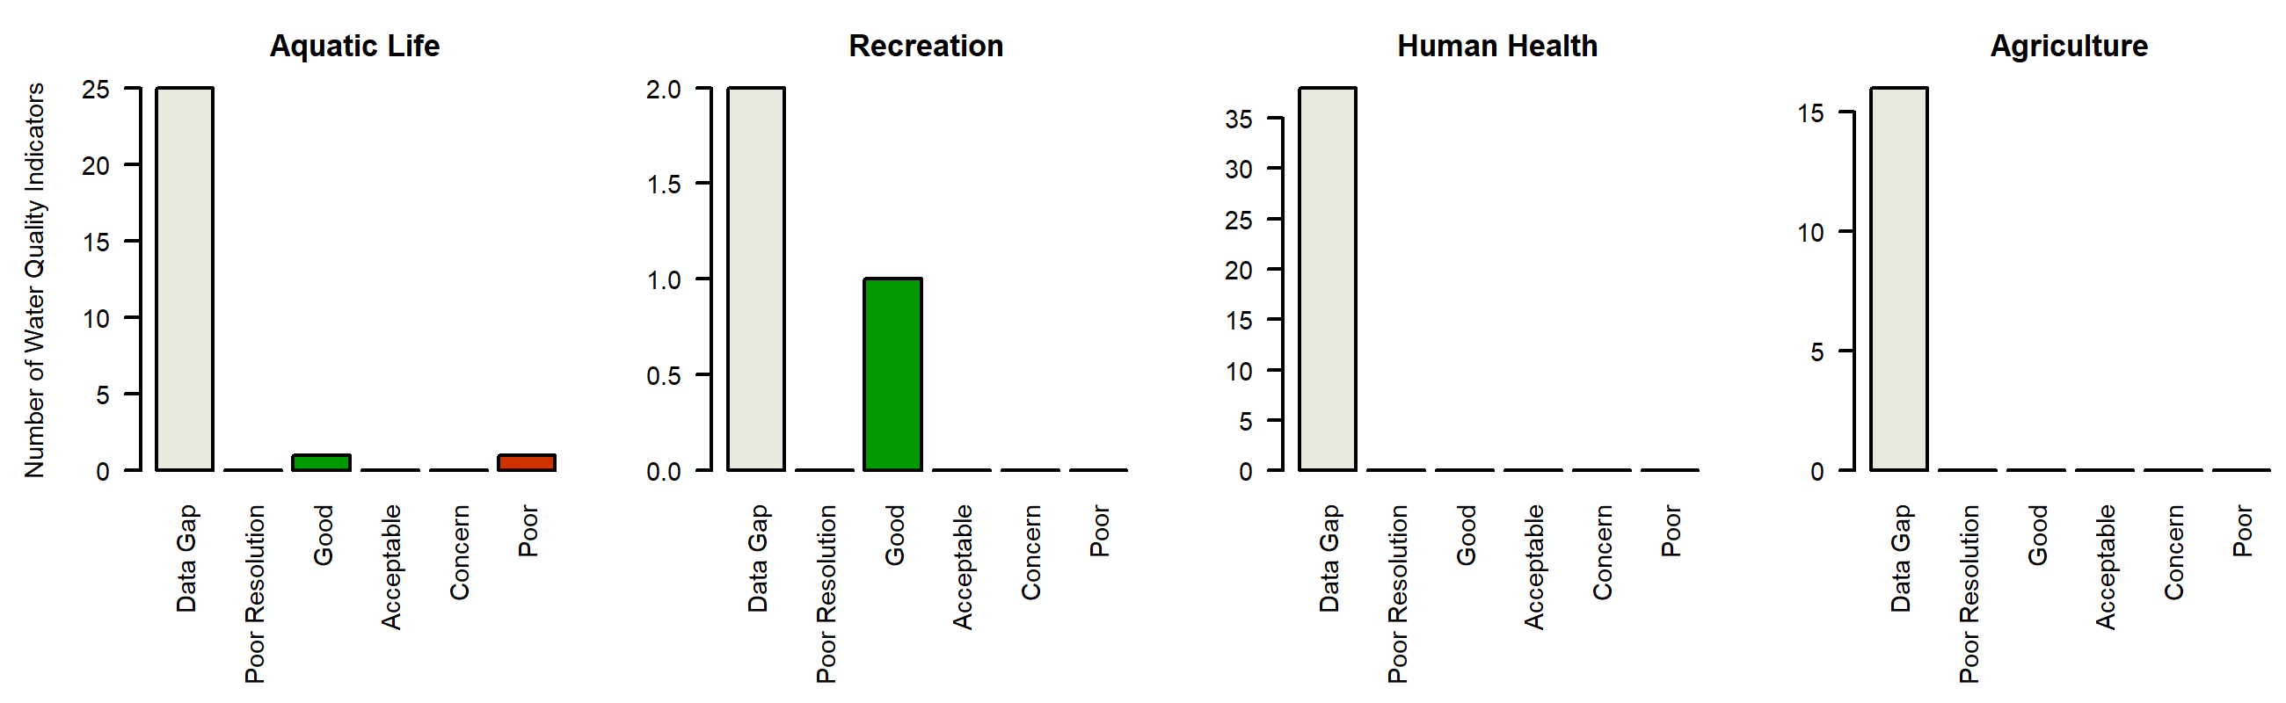

*Figure X. Water quality Indicators summary, COLCLC13a_B. Graphs summarize the count of individual parameter ratings in each Report Card assessment class (Good, Acceptable, Concern, Poor, Low Resolution, Data Gap).*

### COLCLC14a_A

*Reach Description:*

Mainstem of Roan Creek including all wetlands and tributaries, from its source to a point immediately above the confluence with Clear Creek, except for the specific listing in segment 14b. Clear Creek, including all tributaries and wetlands, from the sou

*Designated Uses:*

Summary

Regulatory status

Parameters of interest

*NA*

*Selenium*

Data quality and representativeness

*Table X: Sampling locations for COLCLC14a_A.*

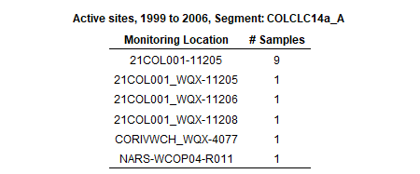

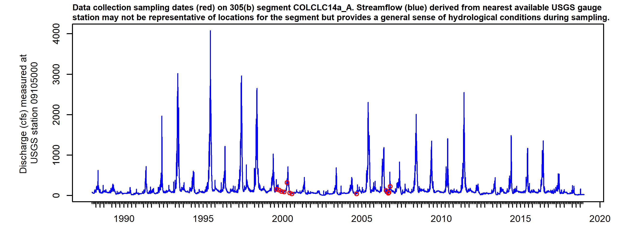

*Figure X. Sampling dates hydrograph, COLCLC14a_A. Observed streamflow (blue line) derived from nearest available USGS gauges may not be directly representative for the segment but provides general sense of hydrological conditions present during sampling.*

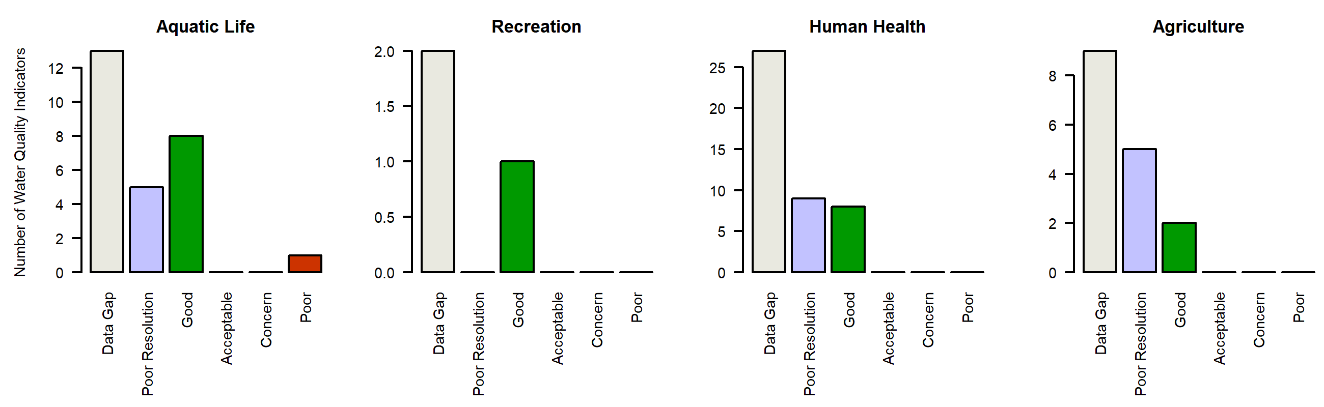

*Figure X. Water quality Indicators summary, COLCLC14a_A. Graphs summarize the count of individual parameter ratings in each Report Card assessment class (Good, Acceptable, Concern, Poor, Low Resolution, Data Gap).*

### COLCLC14b_A

*Reach Description:*

Clear Creek, including all tributaries and wetlands, from a point immediately below the confluence with Tom Creek to the confluence with Roan Creek. Roan Creek, including all tributaries and wetlands, from a point immediately above the confluence with Cl

*Designated Uses:*

Summary

Regulatory status

Parameters of interest

*NA*

Data quality and representativeness

*Table X: Sampling locations for COLCLC14b_A.*

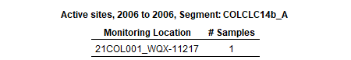

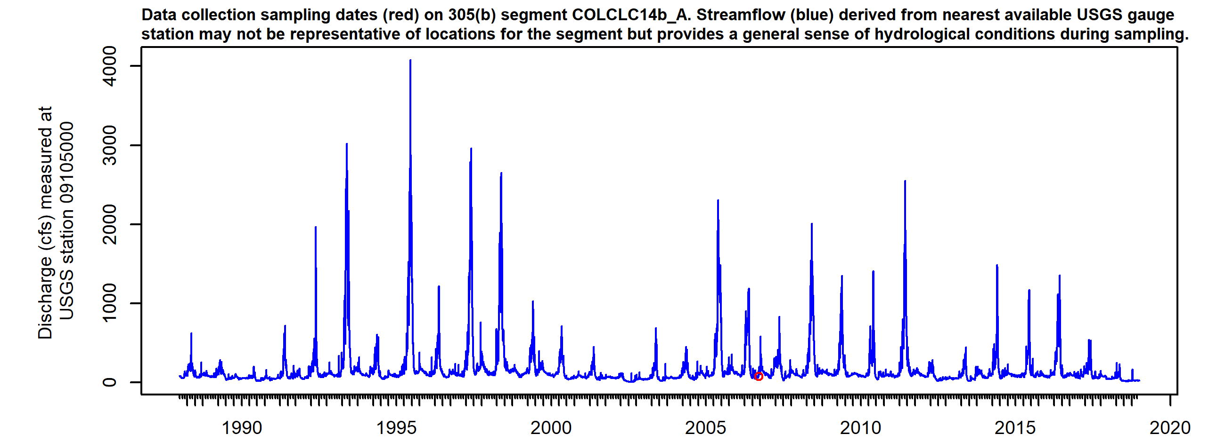

*Figure X. Sampling dates hydrograph, COLCLC14b_A. Observed streamflow (blue line) derived from nearest available USGS gauges may not be directly representative for the segment but provides general sense of hydrological conditions present during sampling.*

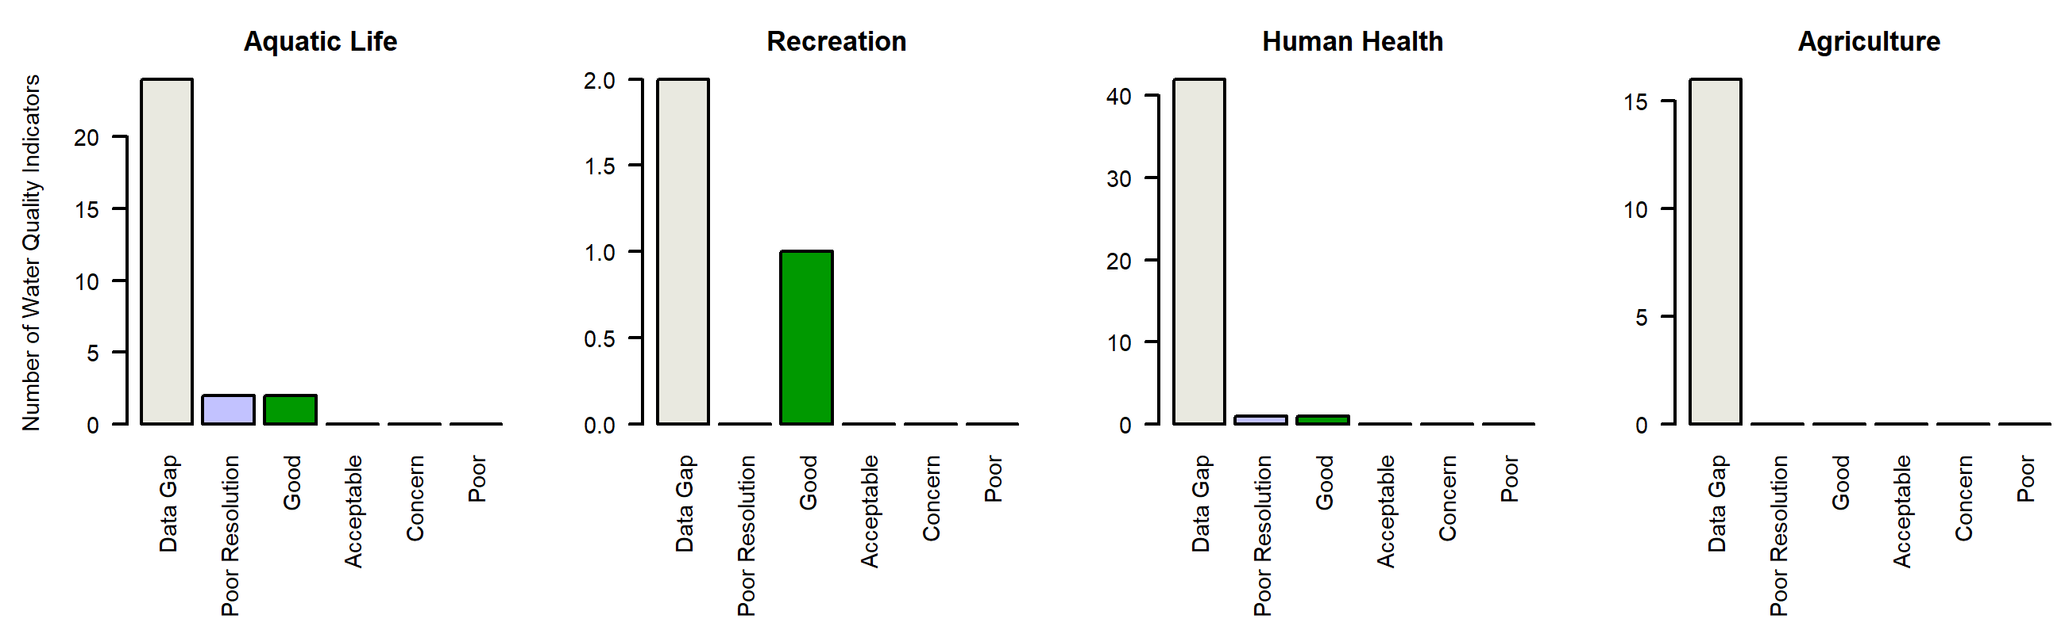

*Figure X. Water quality Indicators summary, COLCLC14b_A. Graphs summarize the count of individual parameter ratings in each Report Card assessment class (Good, Acceptable, Concern, Poor, Low Resolution, Data Gap).*

### COLCLC14c_B

*Reach Description:*

North, South and mainstem of Dry Fork including tributaries

*Designated Uses:*

Summary

Regulatory status

Parameters of interest

*Total_Phosphorus*

*Arsenic*

*Iron*

*Selenium*

*Manganese*

*Sulfate*

*Arsenic*

Data quality and representativeness

*Table X: Sampling locations for COLCLC14c_B.*

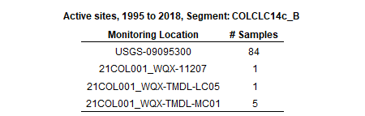

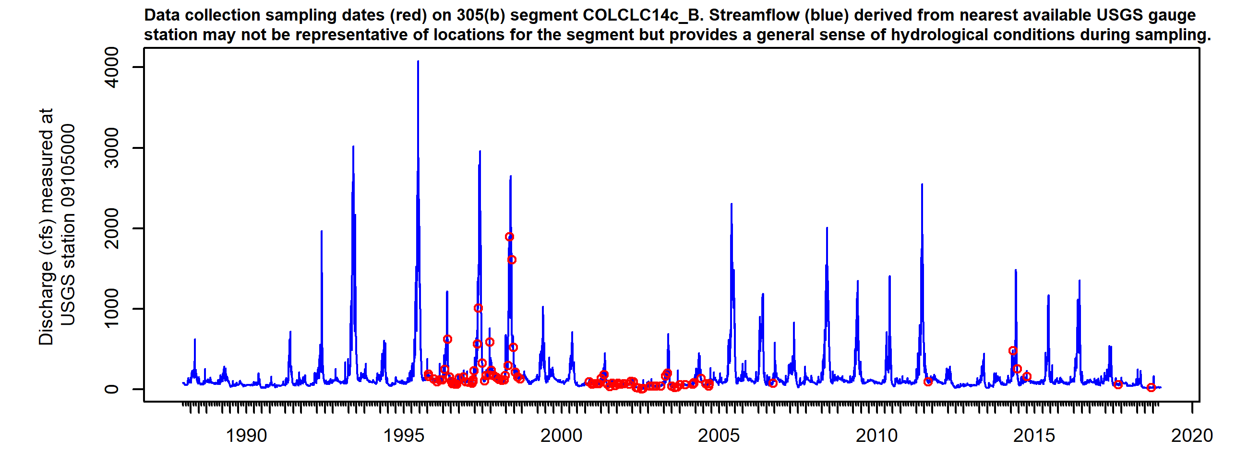

*Figure X. Sampling dates hydrograph, COLCLC14c_B. Observed streamflow (blue line) derived from nearest available USGS gauges may not be directly representative for the segment but provides general sense of hydrological conditions present during sampling.*

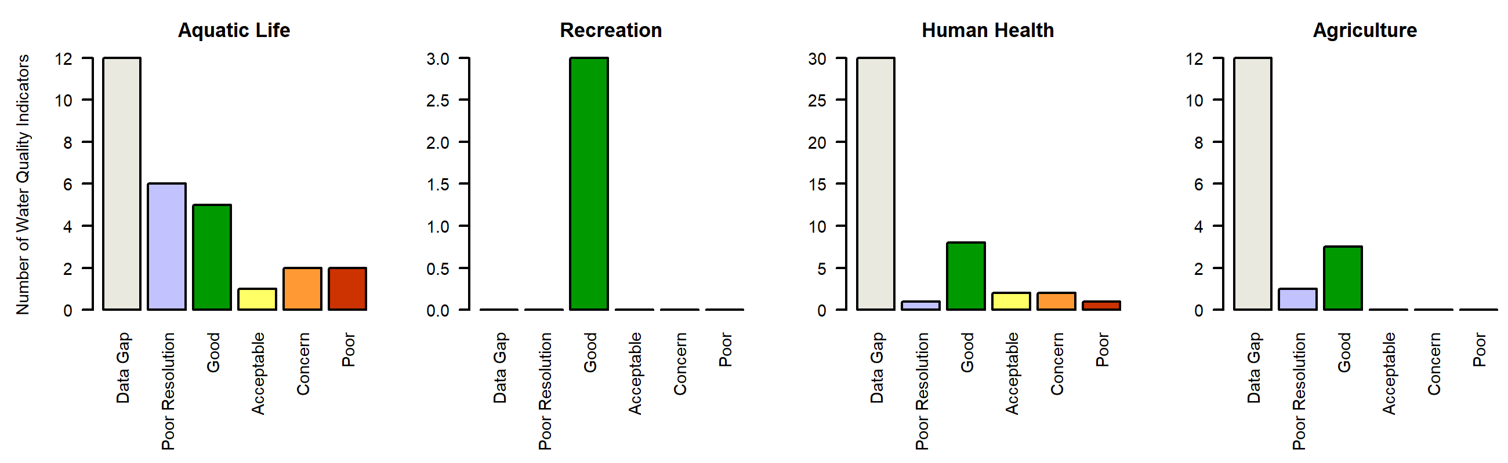

*Figure X. Water quality Indicators summary, COLCLC14c_B. Graphs summarize the count of individual parameter ratings in each Report Card assessment class (Good, Acceptable, Concern, Poor, Low Resolution, Data Gap).*

### COLCLC14c_C

*Reach Description:*

Roan Creek and tributaries including Conn Cr, Logan Wash, Bloat Gulch and Gibler Gulch

*Designated Uses:*

Summary

Regulatory status

Parameters of interest

*NA*

*Arsenic*

*Iron*

*Manganese*

*Arsenic*

*Arsenic*

Data quality and representativeness

*Table X: Sampling locations for COLCLC14c_C.*

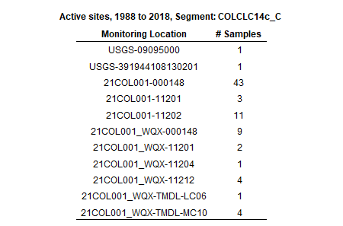

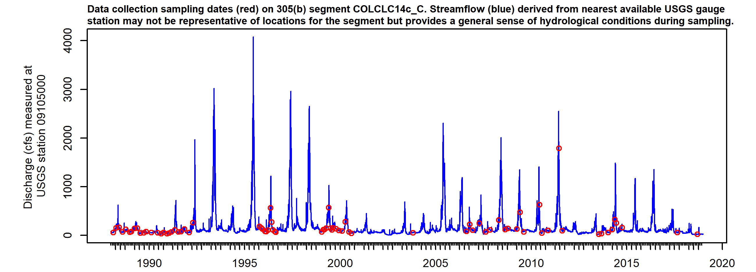

*Figure X. Sampling dates hydrograph, COLCLC14c_C. Observed streamflow (blue line) derived from nearest available USGS gauges may not be directly representative for the segment but provides general sense of hydrological conditions present during sampling.*

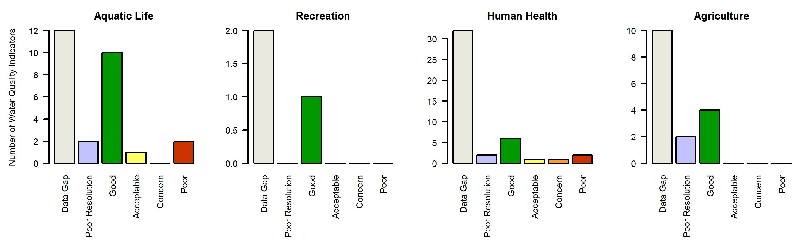

*Figure X. Water quality Indicators summary, COLCLC14c_C. Graphs summarize the count of individual parameter ratings in each Report Card assessment class (Good, Acceptable, Concern, Poor, Low Resolution, Data Gap).*