Name_____Ryan Rapier________ Mark _____________________/50

## Brief introduction __/3

My feature is Enemy AI and design. I design each enemy and program the AI for them as well.

## Use case diagram with scenario __14

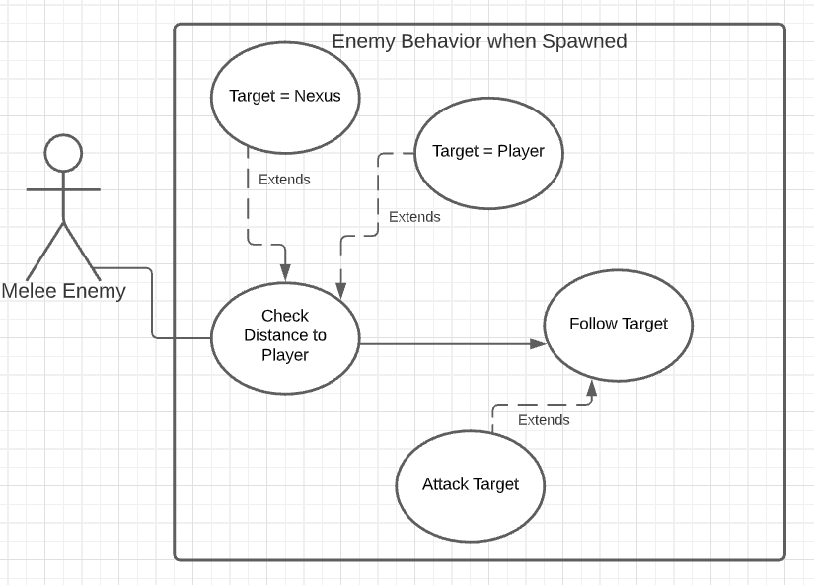

### Scenarios

**Name:** Enemy behavior after spawning in

**Summary:** The melee enemy first checks its distance from the player then chooses its target based on that and follows the target.

**Actors:** Melee Enemy

**Preconditions:** The player is in a room where enemies are supposed to spawn

**Basic sequence:**

**Step 1:** The enemy checks distance between itself and the player

**Step 2:** The enemy follows its target.

**Exceptions:**

**Step 1:** If player is close enough to the enemy then the player is the target

**Step 1:** If player is too far away, the nexus is the target of the enemy

**Step 2:** If the target gets within a certain range of the enemy, the enemy switches from  
 following to attacking the target

**Post conditions:** The enemy has spawned in and is following either the nexus or the player

Priority: 1

ID: RR1

## Data Flow diagram(s) from Level 0 to process description for your feature _______14

### Diagram 0

### Process Descriptions

Follow Target:

IF target is greater than 0.5 units away

Move towards target

ELSE

Attack target

## Acceptance Tests ________9

**Melee Enemy Boundary Test**

Goal is to make a melee enemy that checks if a player that walks towards the player if the player is within a certain range from the enemy, otherwise it will walk towards the nexus.

Lets say the range is 7 or less units of distance.

We can set up the player at three different distances to make sure the feature is working.

|  |  |
| --- | --- |
| Distance | Desired Outcome |
| 6.9 | Enemy walks towards player |
| 7 | Enemy walks towards player |
| 7.1 | Enemy walks towards nexus |

## Timeline _________/10

### Work items

|  |  |  |
| --- | --- | --- |
| Task | Duration (hours) | Predecessor Task(s) |
| 1. Design Enemies | 6 | - |
| 2. Code Enemy AI | 21 | 1 |
| 3. Enemy Animations | 9 | 2 |
| 4. Testing enemy AI | 3 | 2 |
| 5. Integration | 5 | 3,4 |

### Pert diagram

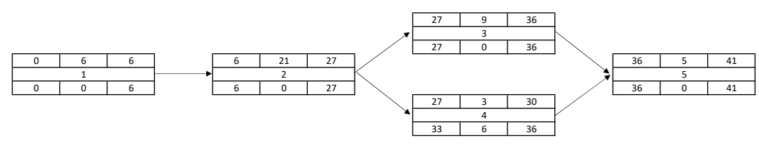

### Gantt timeline

|  |  |  |  |  |  |  |  |  |  |  |  |  |  |  |  |  |  |  |  |  |  |
| --- | --- | --- | --- | --- | --- | --- | --- | --- | --- | --- | --- | --- | --- | --- | --- | --- | --- | --- | --- | --- | --- |
| 1 |  |  |  |  |  |  |  |  |  |  |  |  |  |  |  |  |  |  |  |  |  |
| 2 |  |  |  | 1 |  |  |  |  |  |  |  |  |  |  |  |  |  |  |  |  |  |
| 3 |  |  |  |  |  |  |  |  |  |  |  |  |  |  | 2 |  |  |  |  |  |  |
| 4 |  |  |  |  |  |  |  |  |  |  |  |  |  |  | 2 |  |  |  |  |  |  |
| 5 |  |  |  |  |  |  |  |  |  |  |  |  |  |  |  |  |  |  | 3,4 |  |  |
|  | 2 | 4 | 6 | 8 | 10 | 12 | 14 | 16 | 18 | 20 | 22 | 24 | 26 | 28 | 30 | 32 | 34 | 36 | 38 | 40 | 42 |