Name: Garrett Wells Mark _____________________/50

## Brief introduction __/3

In the implementation of this game my responsibility is to create the menus and implement user interface features. My features include the main menu, pause menu, and HUD. They will interface and get game state data from other subsystems that are being made by my teammates.

## Use case diagram with scenario __14

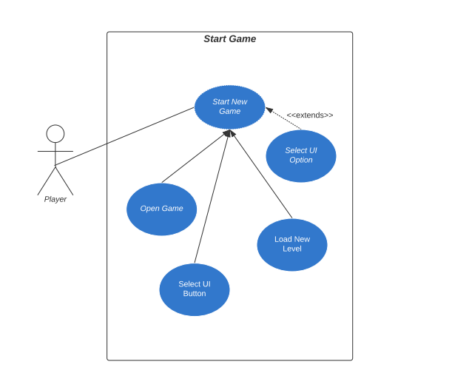

### Scenario

**Name:** Start New Game

**Summary:** The player opens and starts new game.

**Actors:** Player

**Preconditions:** Game application is installed on system.

**Basic sequence:**

**Step 1:** Player opens the game.

**Step 2:** User selects start new game UI option.

**Step 3:** Button calls the start game function from Menu Manager script.

**Step 4:** Load new level from game data.

**Exceptions:**

**Step 2:** User selects UI button other than new game.

**Post conditions:** New game is loaded and running.

**Priority:** 1

**ID:** GW2

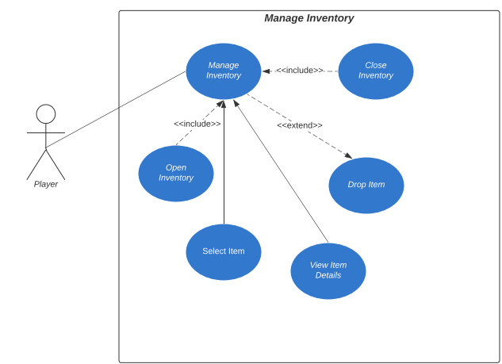

### Scenario

**Name:** Manage Inventory

**Summary:** The player opens inventory from the HUD and removes an item from the inventory.

**Actors:** Player

**Preconditions:** Game application is installed on system and game is running.

**Basic sequence:**

**Step 1:** Press tab to toggle the inventory UI.

**Step 2:** Select item by mousing over the item in the inventory display.

**Step 3:** Retrieve item data from inventory data structure.

**Step 4:** Set the description details in inspector panel.

**Step 5:** Player views item details in inspector panel.

**Step 6:** Close inventory UI by pressing tab again.

**Exceptions:**

**Step 2:** Inventory is empty. Close inventory by pressing tab.

**Step 5:** Player presses ‘q’ to drop item from the inventory.

**Post conditions:** Inventory is closed again.

**Priority:** 2

**ID:** GW6

## Data Flow diagram(s) from Level 0 to process description for your feature _______14

### Data Flow Diagrams

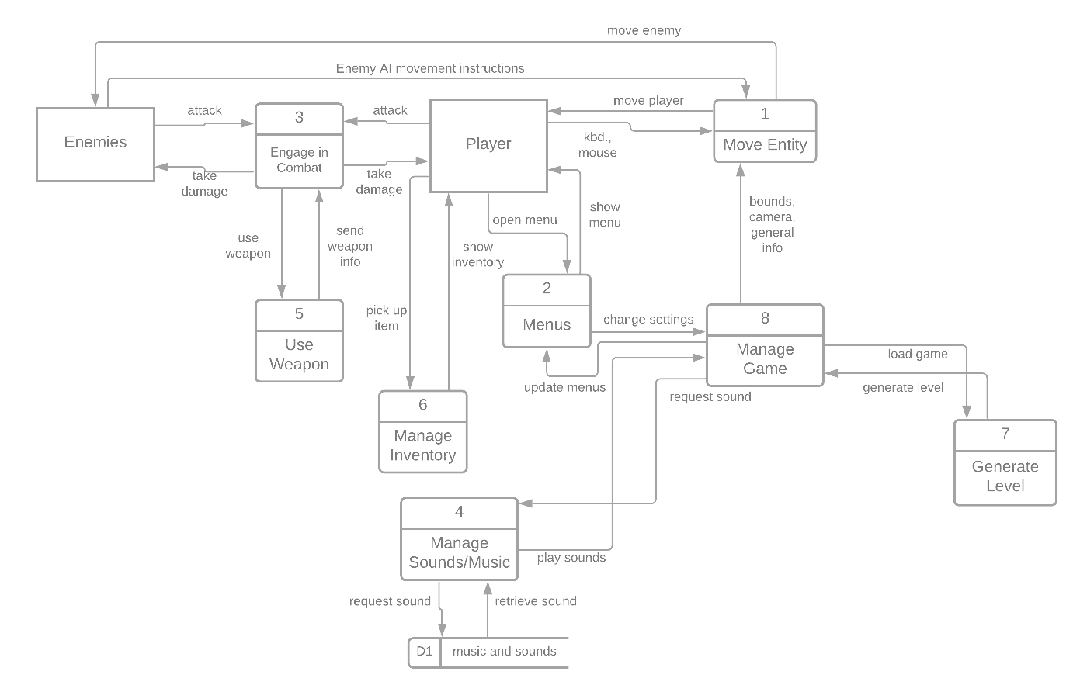



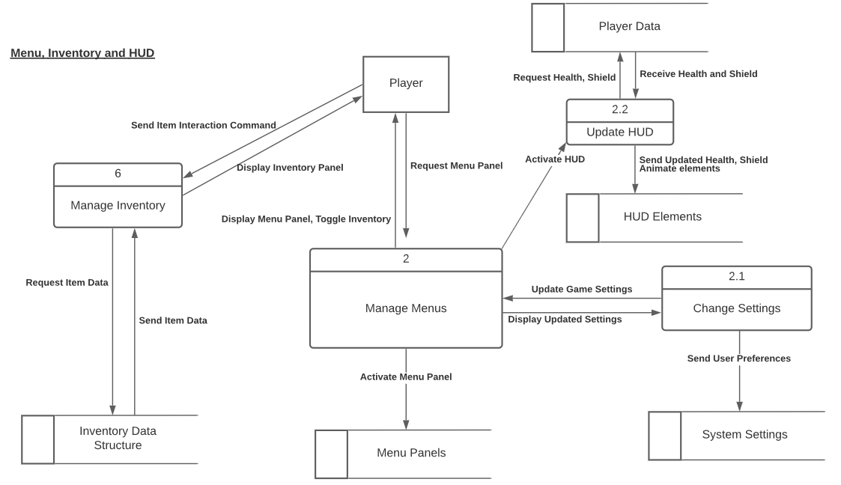

### Process Descriptions

**Manage Menus:**

WHILE player is playing main game:

Activate HUD

IF requested pause menu:

Pause game

Activate menu

END IF

END WHILE

IF requested settings menu:

Activate the settings menu

Deactivate all other menus

Call Change Settings

ELSE IF requested other menu:

Activate other menu

Deactivate all other menus

ELSE IF requested pause menu:

Pause game

Activate menu

END IF

**Manage Inventory:**

IF player presses ‘tab’ and inventory not open:

Open Inventory

IF player selects item:

Request item data

Display item information

ELSE IF player presses ‘tab’ and inventory open:

Clear item information

Close Inventory

END IF

## Acceptance Tests ________9

**Manage Inventory**

***TEST 1:*** Add 0 items to weapon slots, attempt to remove one item from each slot. Print results to output file. Repeat 1000 times.

The output file will have the following characteristics:

* Items Added: 0
* Items Removed: 1
* Current List of Item Names in Inventory

***TEST 2:*** Add 1 item to inventory, attempt to remove one item. Print results to output file. Repeat 1000 times

Output file should contain:

* Items Added: 1
* Items Removed: 1
* Current List of Item Names in Inventory

**Manage Menus**

***TEST 1:*** Enable and disable each menu 500 times. Print final state to output file.

Output file should contain:

* Final state of each menu: disabled

## Timeline _________/10

### Work items

|  |  |  |
| --- | --- | --- |
| Task | Duration (hrs) | Predecessor Task(s) |
| 1. Create Game Menus | 6 | - |
| 2. Program Game Menus | 12 | 1 |
| 3. Layout Inventory and HUD | 24 | - |
| 4. Program Inventory | 12 | 3 |
| 5. Integrate with other Systems | 6 | 2, 4 |
| 6. Testing | 3 | 5 |

### Pert diagram

### Gantt timeline

|  |  |  |  |  |  |  |  |  |  |  |  |  |  |  |  |  |  |  |  |  |  |  |  |  |
| --- | --- | --- | --- | --- | --- | --- | --- | --- | --- | --- | --- | --- | --- | --- | --- | --- | --- | --- | --- | --- | --- | --- | --- | --- |
| 1 |  |  |  |  |  |  |  |  |  |  |  |  |  |  |  |  |  |  |  |  |  |  |  |  |
| 2 |  |  | 1 |  |  |  |  |  |  |  |  |  |  |  |  |  |  |  |  |  |  |  |  |  |
| 3 |  |  | 1 |  |  |  |  |  |  |  |  |  |  |  |  |  |  |  |  |  |  |  |  |  |
| 4 |  |  |  |  |  |  |  |  |  |  | 3 |  |  |  |  |  |  |  |  |  |  |  |  |  |
| 5 |  |  |  |  |  |  |  |  |  |  |  |  |  |  | 2,4 |  |  |  |  |  |  |  |  |  |
| 6 |  |  |  |  |  |  |  |  |  |  |  |  |  |  |  |  | 5 |  |  |  |  |  |  |  |