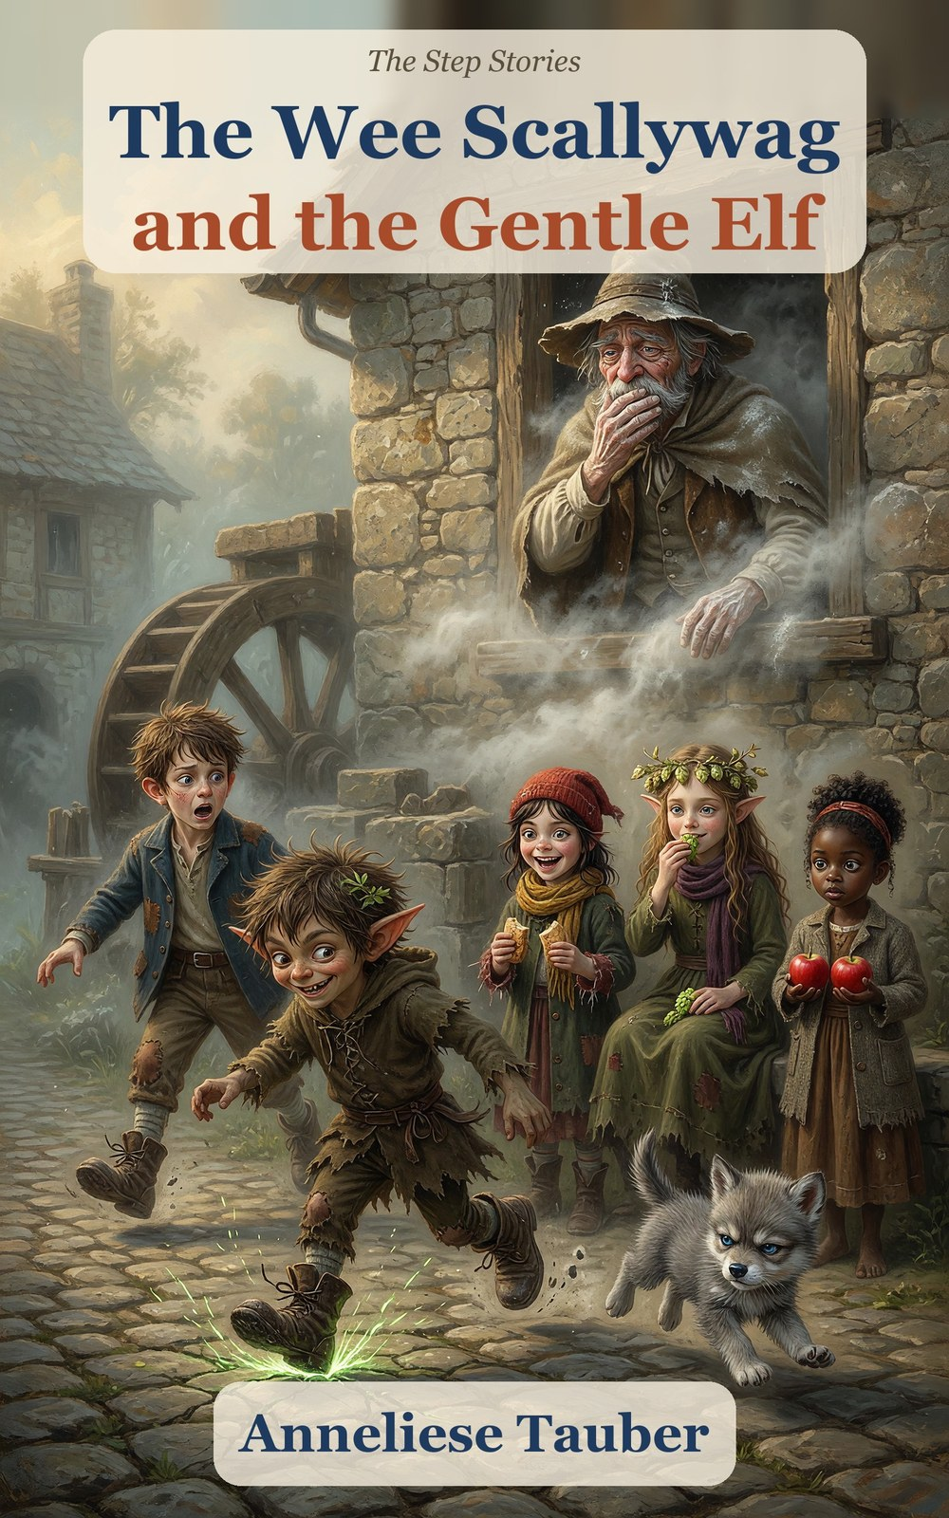

The Wee Scallywag
and the Gentle Elf
Book 1 of The Step Stories
Anneliese Tauber

Contents
Meet the Characters
Chapter 1. The Stuck Wheel
Chapter 2. The Lord of the Riverbank
Chapter 3. The Ghost in the Wall
Chapter 4. The Toad of the Ford
Chapter 5. The Pike and the Torn Tag
Chapter 6. The Howl and the Moon
Chapter 7. The Hot Night
Chapter 8. The Girl with the Apples
Chapter 9. The Quick Way and the True Way
Chapter 10. The True Name
Chapter 11. Sunday
Hopsi’s True Things
For Parents and Teachers
About the Author
Also by Anneliese Tauber

Meet the Characters
Hal (Halbert) Millersen
8. The miller’s son. Brown, tousled hair, chalk on his fingers, a slate under his arm. Dry and steady. Says “Acceptable” when things are bad.
Titch Mitchel
8. Dark brown hair under a red knitted cap. Quick, practical, always has a crust. Tears bread into even pieces.
Scally, the wee scallywag
A little devil: short sharp pointed ears, messy hair with a leaf in it, a grin like a lit match. Makes bargains and runs up walls. His true name is the puzzle of the book.
Hopsi (Elfie Didlhop)
9. An elf: long swept-back ears, long wavy light-brown hair, a needle and a bowl of hops. Only says what is true.
Tabitha Smoke
8. Curly black hair in a bun. Warm and watchful. Asks the one question nobody else thought of.
Gucci
A baby wolf with a grumpy face and a very big appetite for crusts.
Old Miller Millersen
A ghost, with a flour-sack cloak and a dusty hat. Polite, lonely, and Hal’s great-great-grandfather.
The Soft Voice
A tall thin stranger with sweets, a smile too wide and a quicker way. Never take it.
Ages 5–9. Little ones can follow the whole story from the pictures alone.

Chapter 1. The Stuck Wheel
The wheel at Miller’s Mill had stopped on Monday. By Thursday the whole village was out of flour.
Hal Millersen sat on the mill step with an empty sack across his knees. He was eight years old, with brown hair that never lay flat and chalk on his fingers. His slate leaned against the wall beside him. His boots, the only good thing he owned, stood neatly on the step. The air smelled of old flour and wet stone. Somewhere inside the wall, the wheel pit dripped.
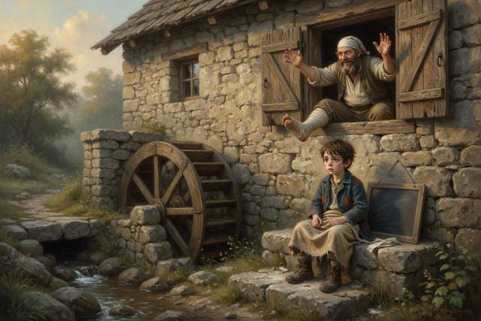
His father, the miller, had climbed down into the pit on Monday to see what was wrong, and had come back up with a broken leg and no idea. He lay in bed upstairs with the leg on a pillow and a great many opinions. His mother had gone to the village to borrow flour, and had left Hal in charge of the step. “Keep the door shut,” she had said. “Keep your boots on. And don’t make bargains with anyone. If a stranger says I sent them, ask for the word. The word is marmalade. Nobody who really comes from me will forget it.”
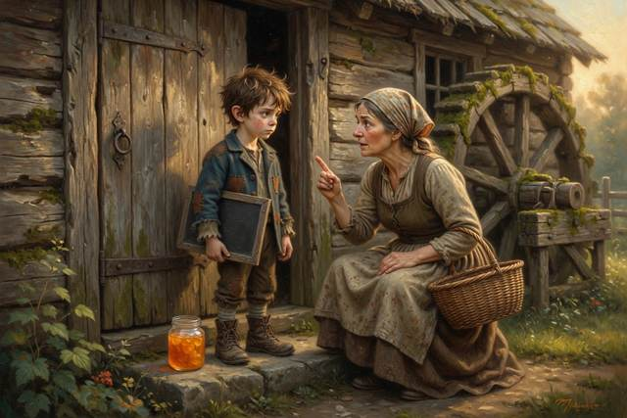
On Sunday the king would hold a feast, and the king’s men wanted twelve sacks of flour by dawn. Nobody could grind twelve sacks with a wheel that would not turn.
“Acceptable,” said Hal, to nobody. It was what he said when things were bad.
Something dropped out of the wheel and landed on its feet.
It was a boy of about his own age, with black spiky hair and a grin like a lit match. His ears were pointed, his knees were muddy, and under one arm he carried a pair of big boots with a tag tied to the laces. He put these down on the step very carefully, the way you put down something that might go off.
“Mind those,” he said. “They’re my spare. Don’t put your feet in them. They go places.”
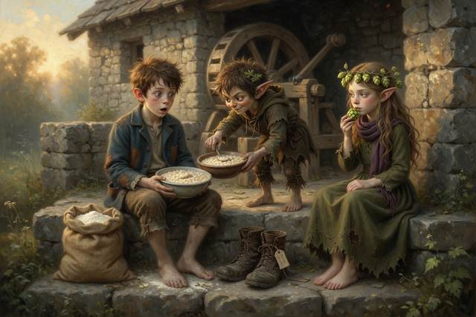
Then he looked at Hal’s boots. His own were worn to the leather.
“Those,” he said, “look made for someone my size.”
He pulled them on. They fitted. Hal, who was too surprised to be cross, found he was holding a bowl of porridge. The stranger took it, ate it, and handed back the empty bowl, all in one motion.
“I’m the wee scallywag,” he announced. “I make bargains. This one’s old and fair. Three days of making you look like a gentleman. Or you guess my true name before the third day closes, and I give the boots back. Or you don’t, and the boots stay mine, and one small thing besides.”
“What small thing?”
“Small,” said the scallywag. He glanced at the worn step the way you look at a lit window when you are standing out in the rain.
Hal thought. He had no flour, no wheel, no boots and no better idea. “Agreed,” he said.
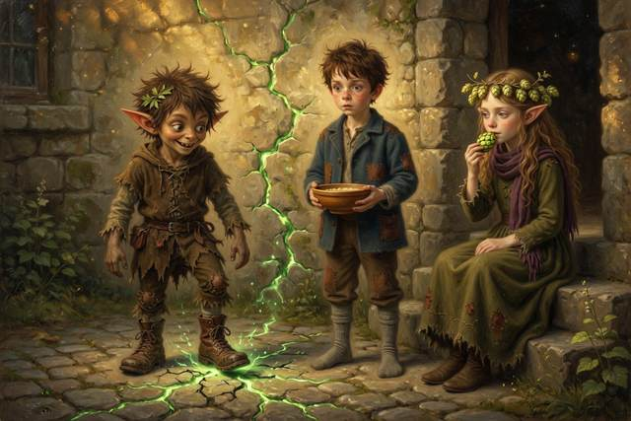
The scallywag stamped once. The ground answered. A crack of green light ran across the yard, up the mill wall and over the roof, and the scallywag ran up it like a squirrel up a tree and was gone.
“That,” said Hal, “was not in the bargain.”
“It was in the small print,” said a voice from the step.
A girl was sitting two steps down. She was nine, with pointed ears, long wavy light-brown hair and a wreath of hops. She had a needle in one hand and a bowl of hops in the other. She smelled of green bread and cut grass. She ate one hop.
“I am Hopsi,” she said. “Elfie Didlhop, if you must. I only say what is true, so I say little.”
“How long have you been there?”
“Since the porridge,” said Hopsi.
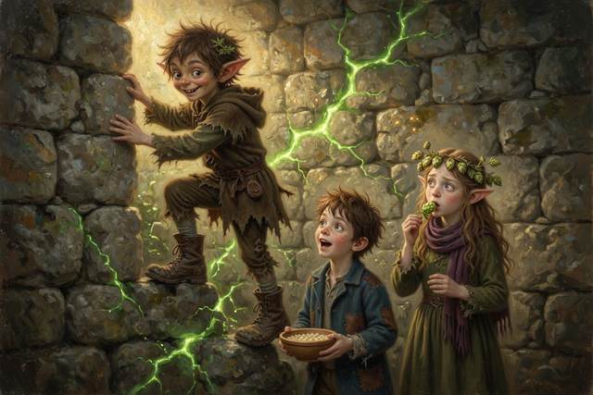
Behind them, in the empty yard, the spare boots took one step on their own, and stopped.
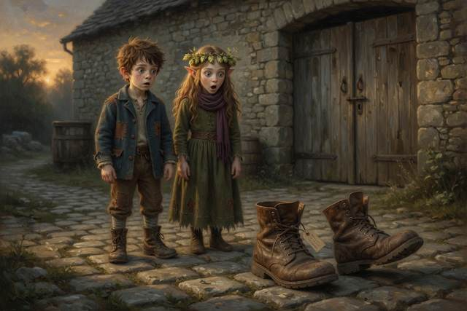
↑ Contents

Chapter 2. The Lord of the Riverbank
Next morning two messengers in blue and purple coats came down the road with feathers in their hats and their noses in the air.
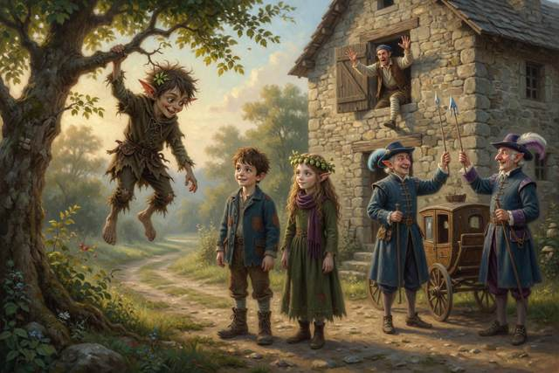
The scallywag dropped from a tree.
“The Lord of the Riverbank,” he announced, “approaches.”
He stood Hal on a fallen log across the stream. It was the sort of log that looks as if it has opinions. The scallywag jumped on the high end. The log tipped, Hal rose slowly through the air, and the messengers saw a young lord rise above the water and come down on the bank, quite undamaged.
They bowed. The scallywag bowed deeper.
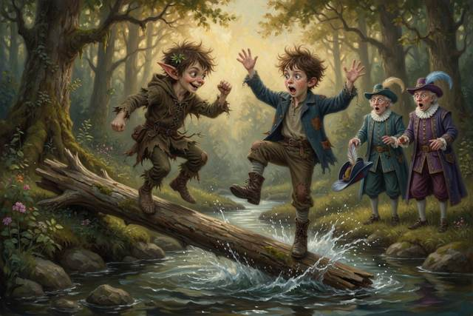
“Twelve sacks,” said the first messenger, with a sniff. “By dawn on Sunday, or the king buys from the next valley.”
“The wheel,” said Hal. “It’s stuck.”
“A lord,” said the second messenger, “has people to see to that.”
An upstairs window banged open. A bandaged leg came out of it first, then the miller. “Twelve sacks!” he called. “Hal, tell them yes!”
“I have, Father,” said Hal.
“Tell them again!”
“The log,” said Hal quietly to Hopsi. “How did it throw me so high? He is no bigger than I am.”
“A lever,” said Hopsi. “Try it. Do not take my word.”
Hal took out his slate. “It will be easier to lift with the short end,” he said. “It’s nearer the stone.” He wrote that down. It was his guess.
Titch’s guess, from the bank, was the opposite. Hal laid the log across a stone and set a second, heavy stone on the short end. He pushed the short end down with his hand. Nothing. He pushed the long end down with two fingers. The heavy stone rose a finger’s width.
Hal looked at his slate. He rubbed out the guess and wrote beside it: WRONG. LONG END IS EASIER.
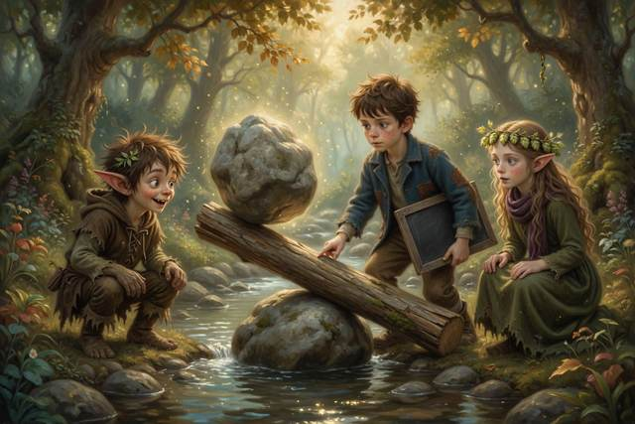
“Acceptable,” said Hal, which for him was a cheer.
“A lever multiplies your push,” said Hopsi. “The long end goes a long way down, and the short end goes a little way up, but with great strength.”
That was when the sky turned the colour of a bruise.
The wind came first. It took the messengers’ feathers and then the messengers’ dignity. Rain arrived all at once, sideways, with hail in it the size of peas. The messengers’ carriage went into the mud up to the axle and stuck.
A small girl with dark brown hair under a red knitted cap came sprinting out of the rain with a crust in each hand. She was eight. She put both crusts in her mouth, took hold of the carriage wheel with both hands, and said around the bread, “Log.”
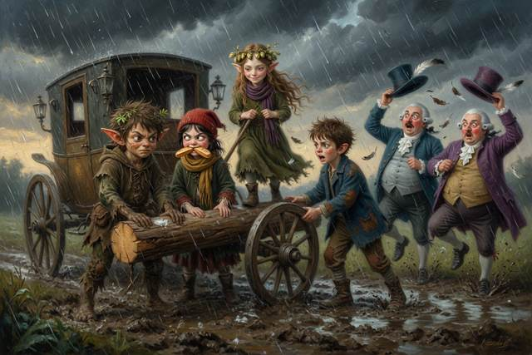
They slid the log under the wheel. Hopsi stood on the end of it. The scallywag jumped on her side. The carriage came free with a noise like a very large cork, and the messengers went off down the road without a word of thanks.
Ten minutes later the sun came out, and the whole valley steamed. A rainbow stood across the mill like an arch.
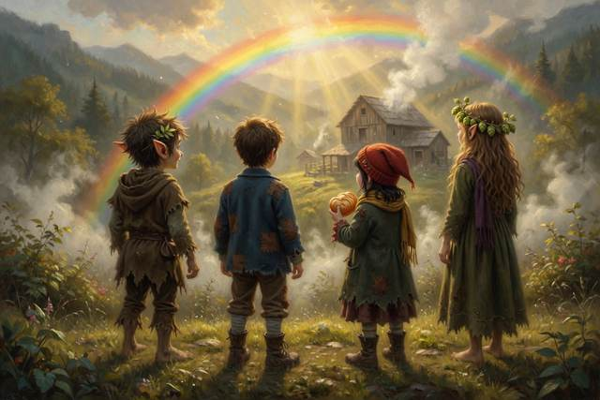
“Sunlight coming apart inside raindrops,” said Hopsi. “You must have the sun behind you.”
“Titch,” said the girl with the cap, with her mouth full. “That’s me. I do hems and crusts. Who’s the boot boy?”
“Hal,” said Hal.
“Not him,” said Titch, pointing at the scallywag. “Him. He took your boots.”
“Oh,” said Hal. “Yes.”
The scallywag looked at his feet.
“What do I call him?” said Titch.
“Scally,” said Hal. “It is short for scallywag.”
“It will do,” said Scally, “until you guess the other one.”
That evening Hal tried the wheel. He pushed, pulled, and poked a pole down the pit. Nothing moved. On the wall behind him Scally watched with his arms folded, very quietly, which was not like him. And when Hal turned, there was a clink from somewhere behind the wall, and Scally’s face went white.
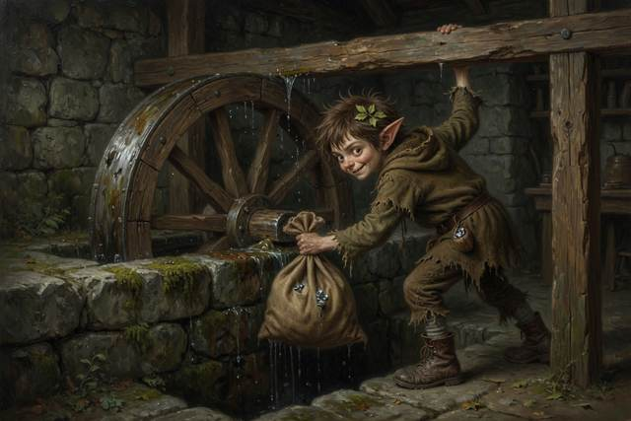
↑ Contents

Chapter 3. The Ghost in the Wall
That night the wheel creaked, though the stream was low.
Hal followed the sound across the yard. The moon was up. The wheel was turning, slowly, a hand’s breadth, back and forth, with nobody pushing. On top of it sat a ghost.
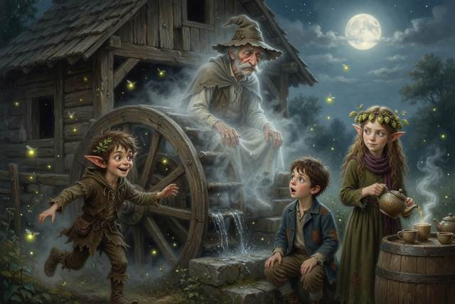
It was a thin, pale, see-through old man in a flour-sack cloak and a dusty hat, with whiskers like two grey brushes. It smelled of cold flour and old stone. It looked at Hal for a long moment.
“Boo,” said the ghost, rather flatly.
Hal sat down on the step. “Acceptable,” he said.
Scally came out of the dark at a run, shrieked with delight, and chased the ghost twice round the mill. The ghost, which had not been chased in two hundred years, found it rather liked it. It went straight through the stone wall and came out the other side with its hat on backwards.
“Ghost trap!” shouted Scally. He came back with a jam jar, and the ghost, who was feeling obliging, shrank and sat down in it quite politely. Scally slammed the lid.
“Boo,” said the ghost, through the glass, in a flat voice.
“I think,” said Titch, “it is too small a ghost to be dangerous.”
Scally opened the lid. The ghost climbed out, grew back to its size, brushed its cloak and took its hat.
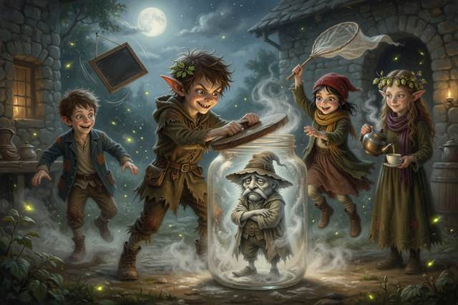
“How did you do that?” said Hal. “Go through the wall?”
Hopsi had arrived with a pot of hop tea and four cups. She set the hot pot down with its handle turned in toward the wall, away from small hands, and she did not let anyone near it. She poured one for the ghost, who held it in both hands and looked at it sadly. It could not drink. But nobody had put a cup in its hand for a very long time.
“Real walls,” said Hopsi, “are not quite as solid as they look, if you are very, very small. Roll a marble at a hill and it rolls back. But the smallest marbles in the world, much smaller than a speck of flour, sometimes turn up on the far side with the hill still standing. That is called tunnelling. It does not happen to boys. It does not happen to ghosts. A ghost is magic. Tunnelling is only very small.”
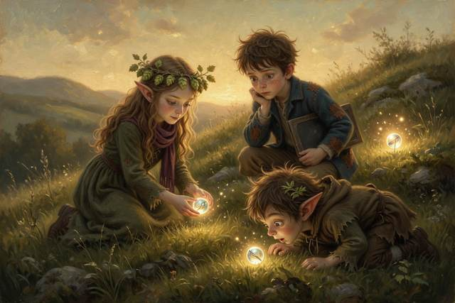
“The sun does it,” said the ghost, unexpectedly. “So I am told. That is part of why it shines.”
“That is true,” said Hopsi. “Even I did not know that you knew.”
“I do not go into the wall,” said the ghost. “I go through it into the Mirror Mill.”
“The what?” said Hal.
“The mill that stands behind this one,” said the ghost, “like the mill you see in the pond. Everything in it is the wrong way round. The wheel turns backwards. The stream runs uphill. The writing is back to front. I go there when the wheel stops here. It is a comfort to see a wheel turn, even the wrong way.”
“Who are you?” said Hal.
“Old Miller Millersen,” said the ghost. “Your great-great-grandfather. You are Halbert, are you not? You have my chin. The wheel was mine. I lost my way on the bog two hundred years ago, and I have been the ghost of this mill ever since. On Monday the wheel stopped. I went to look for the reason.”
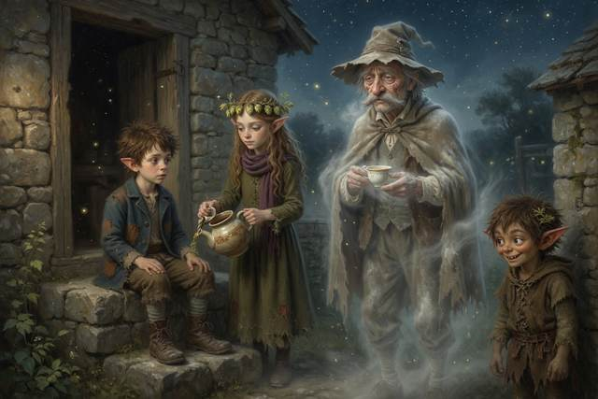
“What is the reason?”
“A bag,” said the ghost. “Behind the sluice wall at the bottom of the pit. The wall is two feet thick. I can go through it, but I cannot open the gate on this side, and I cannot lift the bag. A bag is a thing you have to be able to hold. Your father went down the ladder, and saw nothing, because the bag lies behind the wall where no ladder reaches. He fell off the bottom rung.”
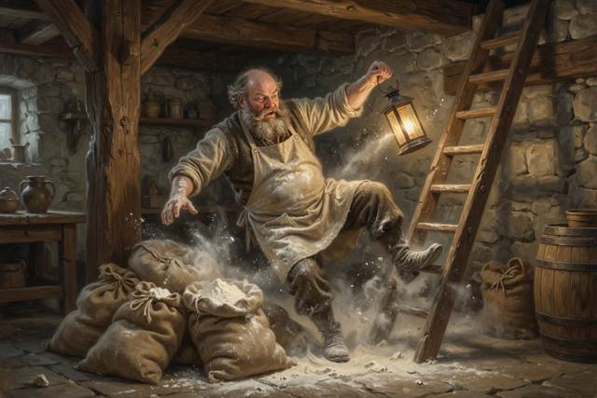
Scally looked at his boots.
“A soft voice sent me out on to the bog two hundred years ago,” said the ghost. “It offered sweets and a quicker way home. It was the shortest way. It was not the quickest. I have been looking for the other one ever since.”
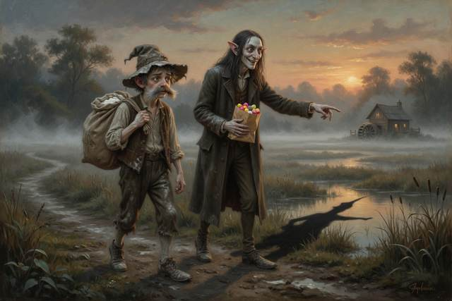
Hopsi’s hand stopped on the needle. “A soft voice?”
“Boiled sweets,” said the ghost. “A smile too wide. A bag that clinked.”
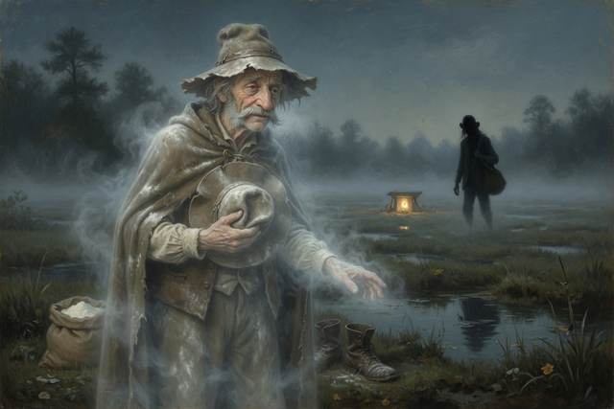
Scally stood up. “I’m going to bed.”
“You are going nowhere near that wall,” said Hopsi, without looking up.
He went in anyway. In the morning there was a smear of mud on the back wall of the mill, and Scally was asleep on the step with his boots on. Hopsi saw it. She could not lie, and she did not say.
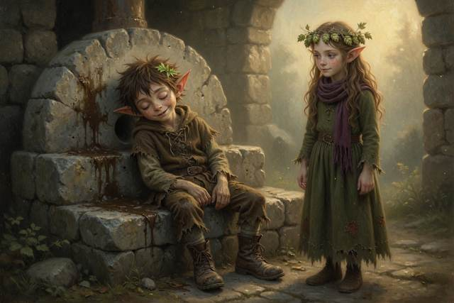
Down by the bog, in the thin early light, a long shadow lay across the grass with nobody standing in it. A line of footprints led toward the mill, and stopped.
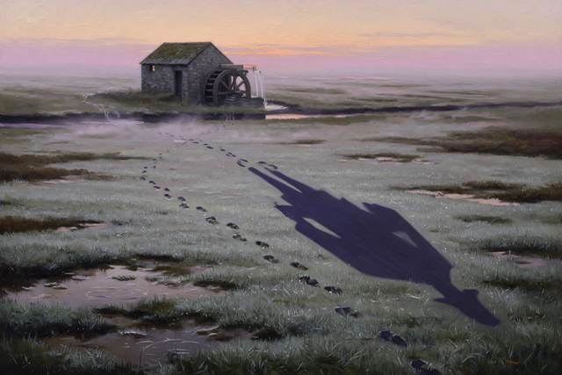
↑ Contents

Chapter 4. The Toad of the Ford
On the second day they walked down to the village for bread, because the mill had none. Before they left, Hal wrote on his slate and hung it on the door where his mother would see it: GONE TO THE VILLAGE FOR BREAD, WITH FRIENDS. BACK BY NOON. HAL. It was her rule, and he had never once broken it.
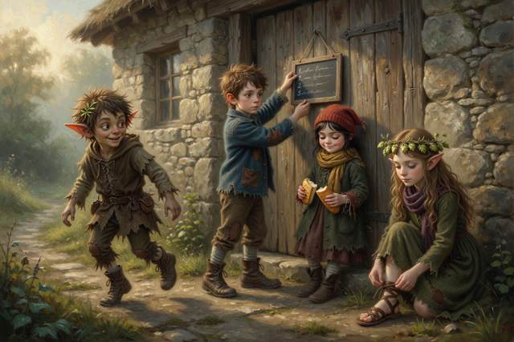
Titch had picked up a handful of pretty purple bells from beside the path. “Drop those,” said Hopsi, quite quickly for her. “Foxglove. Pretty, and poison. Never taste, and never pick for tasting, what you cannot name. Wash your hands.” Titch dropped them as though they were hot. Tabitha, who knew about plants from her gran, nodded.
Hopsi led the way into the wood. Under the oak a hundred seedlings grew from the same two parents. No two were alike. One was taller. One leaned toward the shade. One had a petal the colour of the moon. Hopsi pulled a leaf, wrote on it with her needle and gave it to Hal:
Little ones take after their own,
yet none are ever quite the same.
“Think of a recipe,” said Hopsi. “A seed gets half its recipe cards from each parent, shuffled. Every time a card is copied, a letter may slip. So the loaf comes out a little different.”
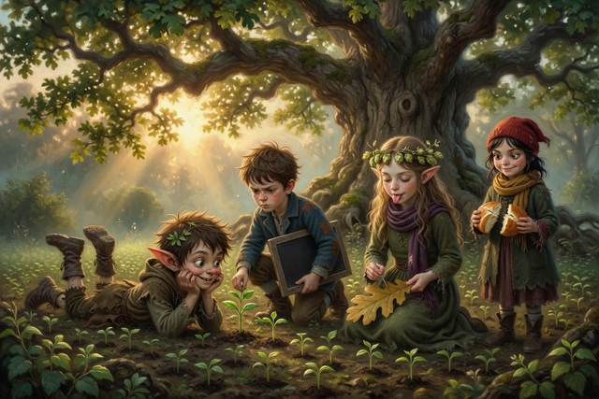
“My ears are my mum’s ears,” said Scally, who had come along without being asked. “Her mum’s. Her mum’s mum’s.”
“Copied faithfully,” said Hopsi.
“And some of the new loaves are better,” said Titch, who was practical about bread.
The ford had a toad in it.
It was the largest toad in the county. It sat on a flat stone in the middle of the water with its eyes half shut and its throat going in and out. It smelled of pond mud. It wore a moustache of pondweed.
“Toll,” said the toad, in a voice as slow as a barrel rolling. “Something good to eat. Or something clever to say. Or a boot.”
Scally, who was wearing a very good pair of boots, put one foot behind the other. Then he had an idea. He picked up a round brown stone, rolled it in moss, and held it out.
“A fly,” he said. “Best in the valley.”
The toad looked at it for some time.
Its tongue came out like a fishing line, took Scally’s left boot clean off his foot, and swallowed it. Scally fell over. The toad burped, softly, and a small grasshopper flew out.
The grasshopper landed on Hopsi’s hand. A great many more arrived behind it, a green cloud rising off the long grass along the ford with a noise like a hundred tiny watches. They did not seem angry. They were simply many, and all of them wanted the hops in Hopsi’s bowl.
“Run!” shouted Scally, hopping on one boot.
They ran. The grasshoppers came after them, bright and flickering. The toad bounded behind from stone to stone like a bad-tempered boulder. Hal slipped and went under the water. Titch, who had come up behind him, threw out her cloth as a net. She caught Hal, three grasshoppers and a small silver fish that was not hers.
They got out on the far bank, wet and out of breath, and looked back. The grasshoppers had settled again. On the long green grass, they were green. On the dry bank beside the ford, where the grass was yellow, they were brown.
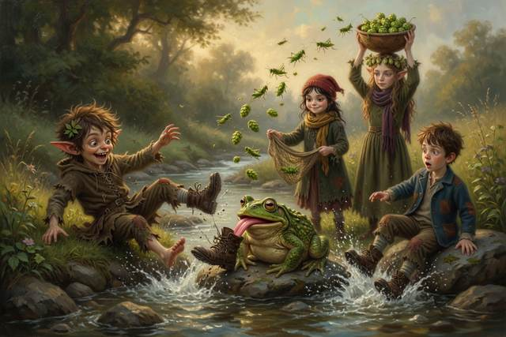
“Why?” said Hal.
“Guess first,” said Hopsi.
Hal guessed that the grasshoppers chose where to sit by colour. “Count,” said Hopsi. Titch took the green grass and Hal the dry bank. GREEN GRASS: 14 GREEN, 2 BROWN. DRY BANK: 11 BROWN, 1 GREEN. “They did not choose,” said Hal slowly. “The ones in the wrong place are the ones that got eaten.”
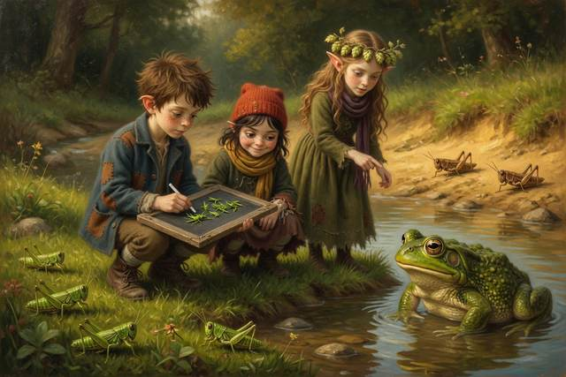
“Toads eat the ones they can see,” said Hopsi. “So the ones that match their grass leave the most young.”
“That’s not fair on the toad,” said Titch.
“It is fair,” said the toad, from behind them. It had followed, and was sitting in the shallows. “I eat the ones I see.”
Titch looked at the crust in her left hand. She had saved it since breakfast. She did not like to waste a crumb. “Here,” she said. She tore it in two, evenly, and held out half.
The toad took it with great care, with its tongue, and chewed for a long time. Then it gave back Scally’s boot, damp, and said, in a lower voice, so only Hal heard:
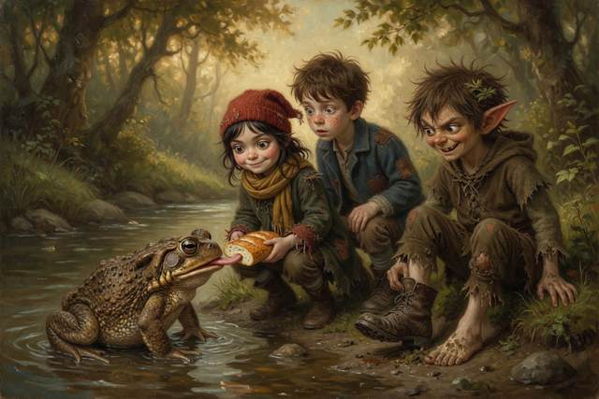
“The soft voice goes by the shortest road. Remember it. And do not let the boy walk in the other boots.”
They reached the village lane at last, hungry and wet. Scally ran straight out across it without looking. A cart came round the bend with a snort and a clatter, and Tabitha grabbed him by the hood and yanked him back so hard that they both sat down. “Stop. Look. Listen,” she said, with her heart going like a drum. “Then cross.” A woman stood by a covered cart at the corner with a basket on her arm. She had a bonnet, an apron, a round kind face, and a warm voice, and in her arms was a tiny, wriggling puppy.
“Oh, you poor wet things,” she said. “I have sweet buns in the basket, and I have a puppy for every one of you in my cart, just round the corner. It is a surprise. Come along quickly, and do not tell your mothers, or it will spoil it. Your mother sent me, Hal.”
Hal’s mouth went dry. He had a puppy-shaped hole in his heart, and a bun-shaped hole in his stomach. But he also had a sentence in his head, in his mother’s voice.
“What is the word?” said Hal.
“The word?” said the woman, and for half a breath her smile slid sideways. “Oh, it has gone clean out of my head, dear.”
“No,” said Tabitha. She held up one hand, flat, like a wall. She had learned this from her gran, and she said it loud. “No. We do not go with people who say keep it secret. Grown-ups who need help ask other grown-ups. They do not ask children.”
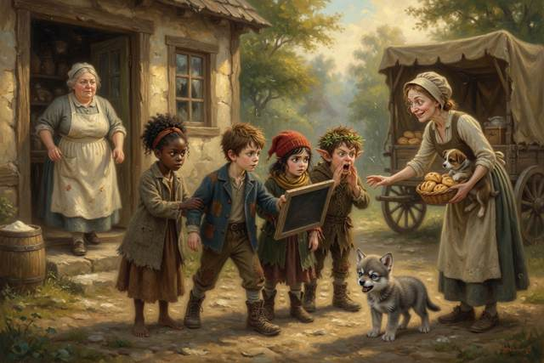
“Go!” said Titch, and tugged Hal’s sleeve.
“Yell!” shouted Scally, with his hands cupped round his mouth, in the loudest voice any of them had ever heard. “HELP! WE DON’T KNOW THIS LADY! HELP!”
“Tell,” said Hal. They ran straight to the baker’s door, where Mrs Crumb stood floury in the doorway with her arms crossed. “Mrs Crumb! A woman wants us to go with her and not tell our mothers!”
Mrs Crumb looked down the lane. The woman was already climbing onto her cart. The cart rattled away over the hill, and nobody ever found out whose puppy it was. Mrs Crumb said something very sharp under her breath, and gave everyone a bun, and walked them all the way back to the mill.
“Was she wicked?” said Titch, to Hopsi, on the road.
“I do not know,” said Hopsi. “I cannot tell wickedness by looking. A kind face can be a trick, and a rough face can be a friend. I know she asked us to keep a secret from the people who love us. That is the sign. That is enough.”
↑ Contents

Chapter 5. The Pike and the Torn Tag
By afternoon they were hungry enough to eat grasshoppers. Hopsi would not allow it.
At the mill pond a shadow slid beneath the surface, long as a canoe. It was a pike, old and enormous, with a head like a hatchet.
A small grey shape came padding down the bank. It was a wolf pup, thin and sleepy, with a darker saddle and one ear that flopped. It had been living in Scally’s spare boots by the door, and nobody had noticed until it woke up and followed them. It pressed its wet nose to the water. Hopsi did not grab it. She crouched, held out her hand flat, and let it sniff her first, because a strange animal, even a small one, bites when it is frightened, and you never reach for one that does not know you.
“Gucci,” said Titch. It was the first thing that came into her head.
“Why Gucci?” said Hal.
“Look at its face,” said Titch.
The pup looked at them both with the expression of a very small, very grumpy duchess, which settled the matter.
Under the willow, a little way off, a ripple broke. The pike seemed to be lying just under the surface, a hand’s breadth from the pup’s nose. Gucci lunged for it. Its jaws closed on water, and its whole body went in with a splash.
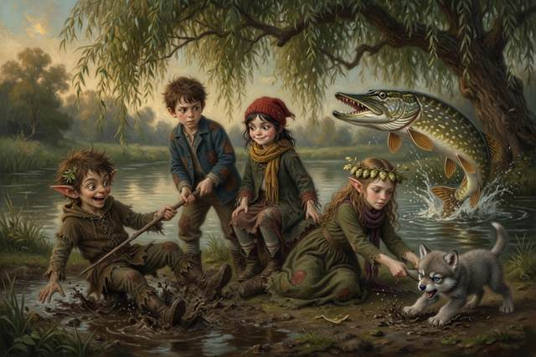
“It’s deeper,” said Hopsi. She had not stepped into the pond. She had lain flat on the bank while Titch held her ankles, and reached, and hauled it out by the scruff. “Reach or throw,” she said. “Never go in after a friend. Water is deeper and colder than it looks, and two in the water is worse than one.” “A fish is always deeper than it looks.”
“A stick stays straight,” said Hal, who had been thinking. “Everyone knows that.” He pushed a straight stick into the pond. Under the water it bent. He pulled it out, and it was straight. He did this four times, and wrote on his slate: I WAS WRONG. IT LOOKS BENT IN WATER, EVERY TIME.
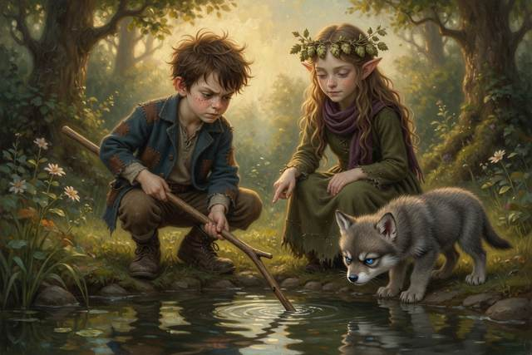
“The stick did not change,” said Hopsi. “Light slows down when it goes from air into water, and so it bends.”
“Why would slowing make it bend?” said Hal.
“Push a barrow off the path onto soft grass at a slant,” said Hopsi. “One wheel reaches the grass first and slows down. The other wheel is still fast. So the barrow swings. Light does the same. When light has a choice of ways, it takes the one that gets there soonest. Not the shortest. The quickest.”
“Same thing,” said Scally.
“Prove it,” said Titch. “Race you to the willow.”
Scally went straight across the shallow puddle by the bank, because it looked like the shortest way. Titch went round by the firm path, which was longer. She reached the willow first, with dry boots and a whole crust. Scally arrived with a boot full of mud and half a crust, and said nothing at all about beams choosing anyone.
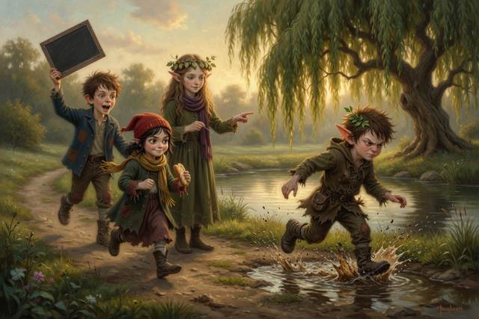
“Longer,” said Titch, “and sooner.”
They caught the pike at dusk. Titch threw her cloth over its head, and Hal and Hopsi hauled on one side and Gucci on the other, and the biggest fish in the pond came onto the bank in a spray of silver and landed on Scally. They roasted it on a fire he lit with a stamp of his foot, with hop tea, warm bread from the village, and an apple Hopsi found. The sparks went up. The wheel creaked. The ghost watched from the roof with its hat on straight and its cup in its hands. When the pike was gone, nobody put the fire out. “It will go out by itself,” said Scally, and everybody was too full to argue.
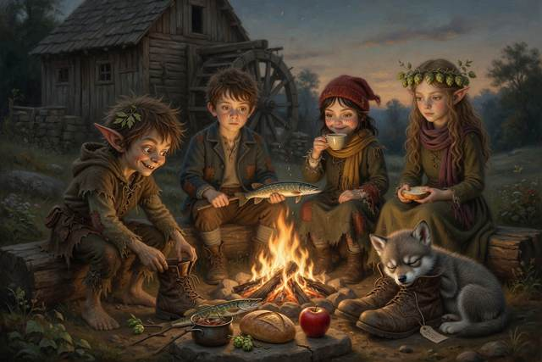
While they ate, Gucci went to sleep in the spare boot by the door. Before it did, it chewed at the tag tied to the laces. When Hal picked up the boot to stop it, he saw that the front said only SPARE PAIR. But the back of the tag had writing on it too. Before Hal could read a letter, Scally snatched the boot out of his hand.
“Mine,” he said, rather too loudly. His ears had gone red. He went and sat on the roof.
The boots twitched in Scally’s hands as he climbed. Hal saw. He wrote nothing on his slate. He did not know how.
↑ Contents

Chapter 6. The Howl and the Moon
That night the moon came up fat and white over the willows. Gucci climbed onto the top step, lifted his small narrow head, and howled.
It was a thin, wavering howl, like a kettle that had not made up its mind. Scally howled back, badly, from the roof. Titch howled in a different key. The ghost said “Ooo,” politely. Hal, who had never howled in his life, found that he rather liked it.
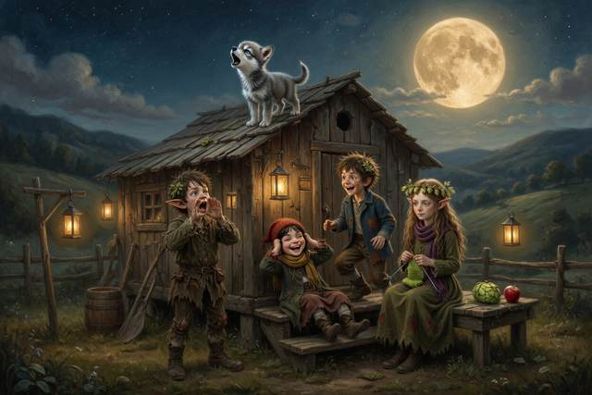
When they ran out of breath, Titch lay back on the step and looked up.
“It’s round tonight,” she said. “Last Friday it was a half. Where did the other half come from?”
“Guess,” said Hopsi.
“Somebody put it there,” said Titch.
“Make a model,” said Hopsi.
Hal borrowed the ghost’s lantern and hung it on a post at the far end of the yard. It was the Sun. He took the apple Hopsi had found. It was the Moon. He held it out at arm’s length and slowly turned on the spot, because Hal was the Earth.
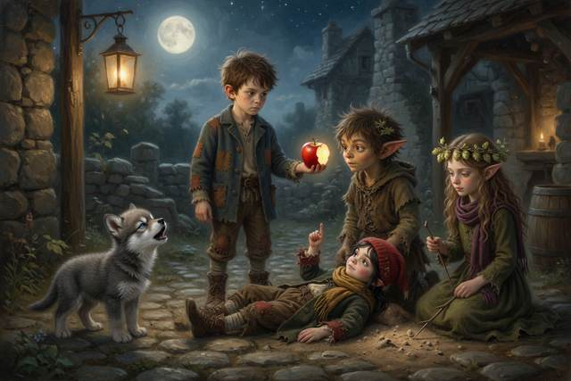
With the lantern behind him, the whole face of the apple shone. “Full,” said Titch.
He turned a quarter. Half the apple was bright and half was dark. “Half moon,” said Titch.
He turned again, and only a thin curl of the apple caught the light. “A fingernail.”
He turned until the apple was between him and the lantern. The bright side faced away. “New moon,” said Hopsi. “You cannot see it at all.”
“The Moon makes no light of its own,” said Hopsi. “The Sun always lights half of it. As it travels round the Earth, we see more of the bright half, then less. A full round, about once a month. Nobody put anything there. And it has nothing to do with the Earth’s shadow.”
“Does Gucci howl at it?” said Titch.
“I do not know,” said Hopsi. “Wolves howl to call each other. The Moon is only where they happen to be looking.”
Hal looked at the rectangular eggs, far off in the long grass behind the mill, silver in the moonlight. They sat in a neat row, square as boxes. “And those?” he said. “Why have they got corners?”
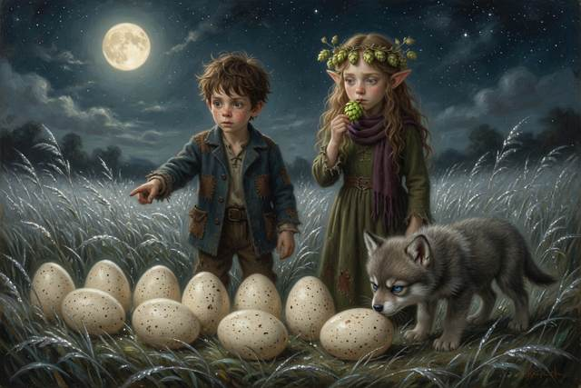
Hopsi opened her mouth. She shut it. She ate a hop.
“I do not know,” said Hopsi.
Everyone looked at her. It was the first time any of them had heard her say it.
“It is true,” said Hopsi. “That counts.”
Gucci, who had been looking at the Moon, sneezed, and fell asleep on Hal’s foot.
Far down the road, in the dark, someone was walking toward the mill with a bag of apples. Nobody saw. And up on the roof, Scally had stopped sitting, and was standing very still, looking at the boots in his hands. They were pointing, very slightly, at the road.
↑ Contents

Chapter 7. The Hot Night
Hal climbed up on the roof at midnight, though he had been told not to.
“What’s on the back of the tag?” he said.
“Nothing.”
“You said that very fast,” said Hal.
“It’s mine,” said Scally. His voice shook. “Everything is mine, or nothing is. You don’t understand. You have a mill and a step and a mother with a basket. I have a pair of boots that walk where somebody else wants.” He jumped down off the roof into the yard, right beside the supper bonfire, which nobody had put out. It lay in the dark, a low heap of red ash, ticking and glowing. He stamped.
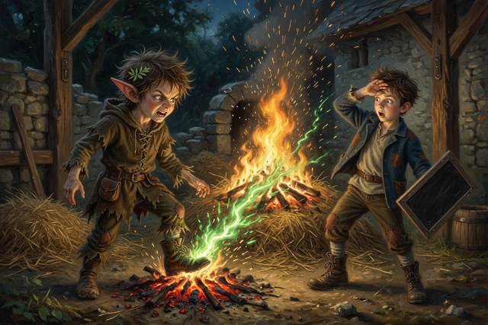
The ground answered. The green light jumped out of his foot and into the embers, and the embers woke. The ash roared up into a tall, yellow, crackling bonfire, taller than Scally, and flung a fountain of sparks across the yard, over the wall, and into the heap of dry straw by the granary door.
There was a small, bright, interested sound, like a cat clearing its throat.
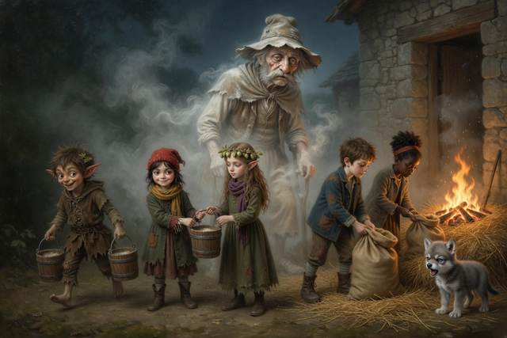
Then the straw was on fire too.
Scally stared. For once in his life he did not have a clever thing to say. Orange light climbed the stone wall. Heat touched Hal’s face like a slap, and the whole yard turned red.
“Fire!” screamed Titch.
“Father!” yelled Hal. “FATHER! FIRE!”
That was the first thing, and it was the right thing: shout first, and shout loud. Upstairs the bed creaked, there was a bellow of dismay, and a bandaged leg hit a floorboard.
“Water!” said Scally. “Fetch the stream!”
“Wait,” said Hal.
It was the hardest thing he had ever said. He stood in the red light with his hands shaking and his slate against his chest, and he made himself think. “Fire needs three things,” he said. “Hopsi said so.”
“Fuel to burn,” said Hopsi, quite calmly. “Heat to start it. And air to feed it. Take away any one of the three and it goes out.”
“Fuel,” said Hal. “It’s only a heap of straw. The wall is stone.” He saw it then. The granary door was stone-framed and shut. It was only the straw, and the straw was small.
“Air!” said a voice from the gate. A girl with curly hair in a bun stood there, red-faced from running, with a bag of apples in one hand. She had seen the glow from the village. “Wet sacks!” she said. “My gran says smother it. Wet the sacks and lay them on top. No air.”
“Sacks,” said Hal. “The empty ones, in the shed. Wet them. Lay them on from the side. Nobody goes close.”
They made a chain from the stream. Hopsi and Titch passed the buckets. The girl with the apples, whose name was Tabitha, and Hal soaked the sacks and laid them on the flames with long poles, and kept their faces turned away. Scally, who had started it, ran to the stream with a bucket in each hand so fast the water barely spilled. Gucci barked for the whole village. The ghost went through the wall to see whether the granary was burning, came back, and said “Boo” in a relieved voice, which meant no.
When the miller reached the yard, hopping on his crutch in his nightshirt, the fire was a black, wet heap, steaming in the dark.
“It was a small fire,” said Hal.
“It was a fire,” said the miller, quite gently, and he looked at his son for a long moment. “You shouted. You got me. You did not go close. That is exactly what I would have asked you to do. And now I want you all to listen. Fire is not a game, and it is not a lesson for a child. Next time, shout, get out and let a grown-up do the rest. Do you hear me?”
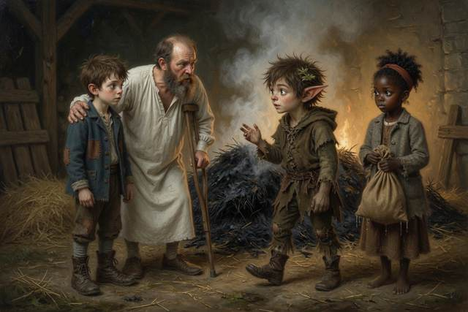
“Yes, Father,” said Hal.
“Who lit it?” said the miller.
Nobody spoke. Scally stood very straight, with soot on his face and his ears burning.
“I woke it,” he said. “I lit the supper fire, and then I stamped on it.”
“And who left a fire burning and went to bed?” said the miller.
There was a long, shuffling silence. “All of us,” said Hal.
“A fire is not out,” said Hopsi, “until you can hold your hand over the ashes and feel no warmth at all. Drown it. Stir it. Drown it again.”
The miller looked at him. He looked at the black heap. He looked at the granary, whose door was scorched and whose grain was safe and dry.
“Then you will scrub that wall in the morning,” said the miller, “and you will drown that bonfire properly, and you will not stamp in my yard again. And you may sleep on the sacks by the stove. Fire taught you something. Do not forget what.”
Scally nodded. He did not say anything clever.
Hal could not sleep. He lay on the sacks with Gucci on his foot and looked at the black ceiling, and he asked Hopsi, who was sitting up with her needle, the question he was afraid of.
“What if we had been too slow?”
“I will tell you what I know,” said Hopsi. “Not to frighten you. So that you remember.”
She told him. A fire does not stay the size it starts. A straw fire the size of a hat can fill a room in a few minutes, because the heat dries whatever is next to it, and then that catches too. The sparks from the bonfire had been flying toward the granary roof. A thatched roof burns like a haystack. If the wind had turned, the granary would have gone, with all the village’s grain for the winter, and then the sparks would have found the mill, and the house, with Hal’s father upstairs in bed with a broken leg who could not run.
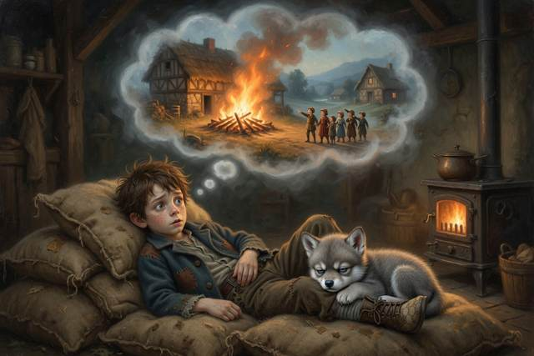
“And the smoke is worse than the flames,” said Hopsi. “Smoke is hot, and it is poisonous, and it makes people sleepy and muddled, so they cannot find the door. Most people who are hurt in a fire are hurt by the smoke. That is why you get out first. You do not go back for a toy, or a boot, or a cat. You shout, you get out, you stay out, and you stay low where the air is clearer, and a grown-up with the right tools goes in.”
“There was a mill at Hollin Brook,” said Hopsi. “It burned down when your father was a boy. The family got out. The mill did not, nor the barn, nor the winter flour. They slept in a neighbour’s barn until the spring. It is true.”
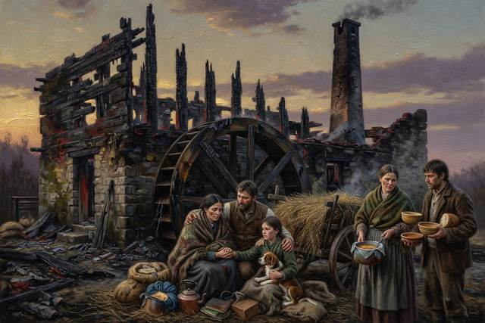
Hal lay awake for a long time after that, listening to the stove tick, and when he did sleep he dreamed that he and Gucci and a small brown bird were running down a dark road with a bucket, and that every single person he knew was standing safely outside.
Afterwards he sat apart in the dark with his knees up. Hal went and sat by him, and did not say anything either. After a while Scally said “Sorry” to his own knees, very quietly, and Hal said “Acceptable,” and that was that.
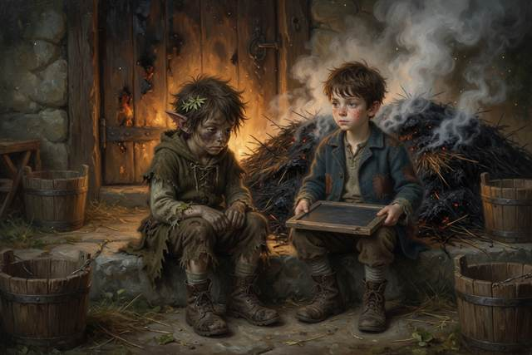
“There is one more thing about this mill,” said Hopsi, later, softly, to Hal. “A heap of flour is very hard to set alight. But a cloud of flour dust in the air can burn all at once. That is why millers never carry a naked flame. It has burned down mills. Grown-ups know how to be careful with it. You must never try it.”
“Why are you telling me?” said Hal.
“Because it is true,” said Hopsi, “and tomorrow somebody is going to need to remember it.”
↑ Contents

Chapter 8. The Girl with the Apples
On the third day Tabitha was still on the step.
She was eight, with dark brown skin, a grey coat, and a laugh she saved for the right moment. She had run down from the next village when she saw the glow, and had been too tired to go home. She had slept on a pile of sacks beside Gucci, who had decided she would do.
She watched.
She had set a crust down beside her to free both hands for her apple. Gucci took it. He ate it in two gulps, looked up at her with his grumpy face, and did not look sorry. Tabitha did not take it back. “He chose,” she said, and broke her apple in half and shared it with him instead.
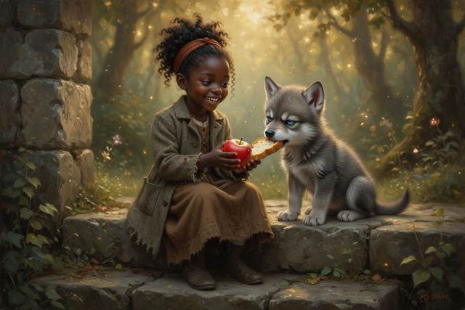
Later, while Hal paced and Titch counted crusts, Hopsi went down to the stream. She came back with a small bunch of white daisies and blue harebells, tied up with a blade of grass, and she held it out to Tabitha without a word.
Tabitha looked at it. “What is it for?”
Hopsi thought. It was difficult for her. Anyone else would have said “welcome”, or “I hope you stay.” But Hopsi only said what was true, and she did not yet know whether Tabitha would stay, or whether the step would still be standing next week. A kind thing that might not be true was a thing Hopsi could not say. So she did what an elf does when the words are not allowed. She gave a present.
“They are all different,” said Hopsi at last. “Every one. No two petals alike, and all of them growing beside the same stream. I picked them for you. I checked every stem, and there is no foxglove in it.”
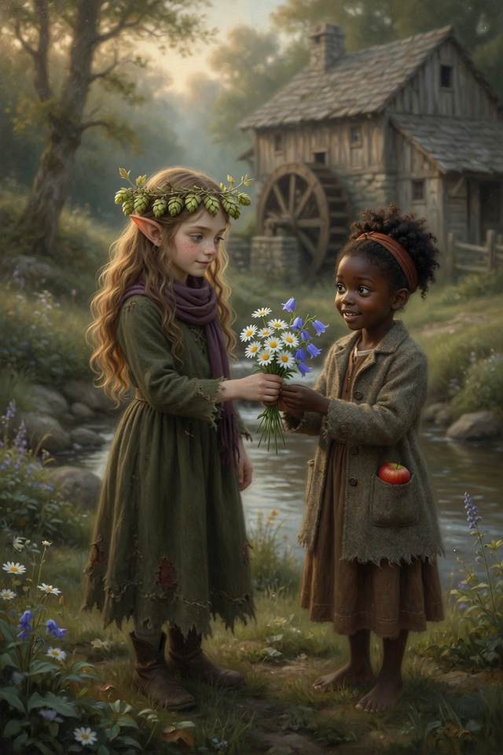
It was the nicest sentence she knew.
Tabitha laughed, the laugh she saved for the right moment, and it was the first time anyone had heard it. She tucked one daisy into her bun, and stood the rest in Hal’s empty porridge bowl on the step, where they stayed for all three days and were the first thing anyone saw.
She watched Hal pace around the wheel pit. She watched Titch tear a crust in even pieces. She watched Hopsi shut her mouth and say nothing, and she watched Scally, who stayed well away from the sluice wall and looked at it a great deal.
“Why won’t he go near the wall?” said Tabitha.
Nobody had asked that. Hal frowned.
“He keeps looking at it,” said Tabitha. “And his hands are all scraped. And there’s mud on his sleeve, here, where he leaned on the wall. Mill mud. Not the pond.”
Hopsi did not say anything. She did not lie, so she did not have to.
“My gran lives by the sea,” said Tabitha, to nobody in particular. “She says last night’s moon brings a big tide.”
“She is right,” said Hopsi. “The Moon pulls on the sea, and the sea can flow, so it piles up under the Moon. It piles up on the far side too, because the Earth is pulled a little less there. As the Earth turns, your coast goes through both piles each day. Two high tides and two low. At full and new moon the Sun joins in, and they are biggest. They are called spring tides, though they have nothing to do with spring.”

Hal wrote: FULL MOON, BIG TIDE. “Last night,” he said.
“That is why Gran said it,” said Tabitha, and ate her apple.
That afternoon the fog came.
It came up from the stream, thin and white, and in a few minutes the end of the garden was gone. The wheel stopped creaking. Gucci growled like a kettle coming to the boil. The ghost, on the roof, said “Boo,” very quietly, and then nothing.
The smell came first. Boiled sweets and cold air.
“Sweeties,” said a soft voice. “A quicker way. A shorter way.”
A tall figure stood at the end of the road. Thin, in a coat the colour of dusk. A smile too wide. A bag that clinked. Its shadow was longer than it should have been, and it lay across the grass toward them like a spill. In its hand, it carried a lantern with a real flame in it.
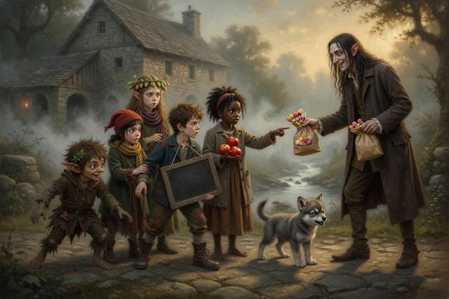
Hopsi knew the true sentence. It was: “He is not yours.” It was the one thing in the world she most wanted to say out loud. But she had learned by now what a true sentence does to a voice like that: it gives it something to answer. Every answer was a step nearer. So Hopsi pressed her lips together until they hurt, and let the stranger believe he had won, and swallowed the best sentence she had ever thought of.
“There he is,” said the voice, quite pleasantly, “my little errand imp.”
Everyone looked at Scally.
↑ Contents

Chapter 9. The Quick Way and the True Way
“I did it,” said Scally.
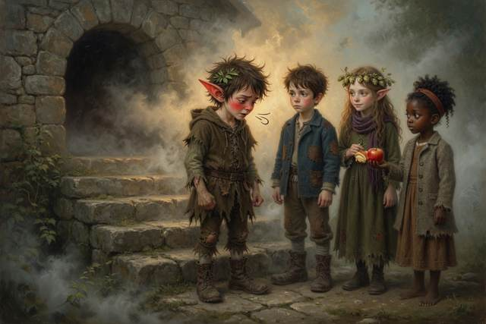
He said it in a very small voice, which was not like him. He was standing very straight, and his ears were red.
“He sent me. He said if I jammed his bag in the wheel, the mill would stop, and the family would sell, and he’d give me proper boots. Boots that went where I wanted. Mine only go where he does.” He swallowed. “Then I got here, and Hal pushed the porridge across. Just pushed it. Nobody has ever just pushed it across. So I made a bargain, to stay three days and get the bag out. And I couldn’t. I tried. I fell in the bog. And last night I burned your granary. I’m the worst errand imp that ever lived.”
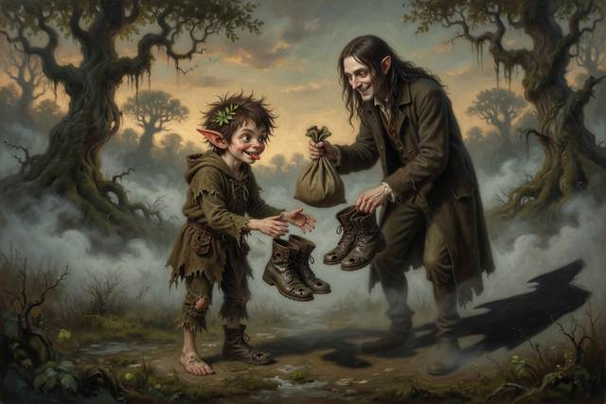
“You tell the truth when it’s funny,” said Hopsi quietly.
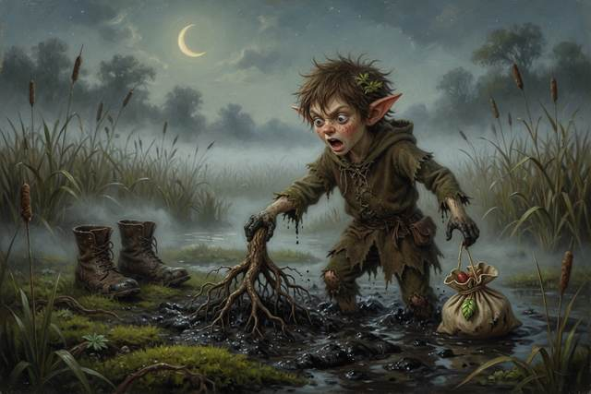
“It’s not funny.”
“No,” said Hopsi. “That is why it counts.”
The soft voice laughed, like sugar. “Pretty speech. Now give me my bag, little devil, and I’ll be on my way.”
“It’s in the pit,” said Hal.
“Then fetch it.”
“No,” said Hal.
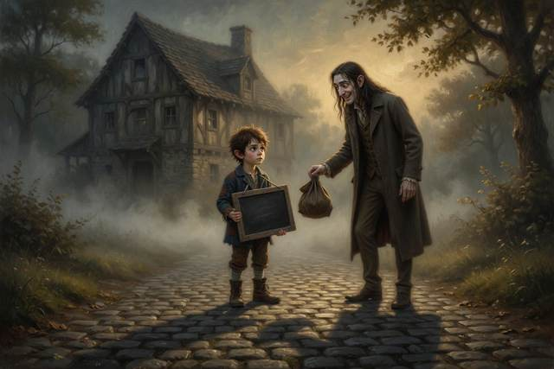
It was the bravest thing he had ever said. He said it in his flattest voice, and it came out so dry that the stranger stopped smiling.
“I’ll fetch it myself,” said the Soft Voice. It stepped onto the path.
The grass shivered. The shadow ran along the ground like spilled ink, straight across the field, toward the wheel pit.
“It’s going straight over the bog,” said Tabitha.
“It goes by the shortest road,” said Hal. He thought of the toad.
“Run!” said Titch.
They ran.
All five and Gucci, round the long way, along the path beside the stream. The fog was thick and the path was narrow. Hail began to fall. The ghost woke up and flew after them with its lantern, a cold lantern that gave light and no fire, lighting the way ahead like a small, pale star. Behind them, the stranger went in a perfectly straight line over the bog.
“We’re going the wrong way!” said Scally. “The pit’s over there! It’s shorter!”
“Shorter,” said Hopsi, “and slower.”
“How do you know?”
“The ghost knows. It is how he was lost.”
“Look,” said Tabitha. She had stopped. She was pointing.
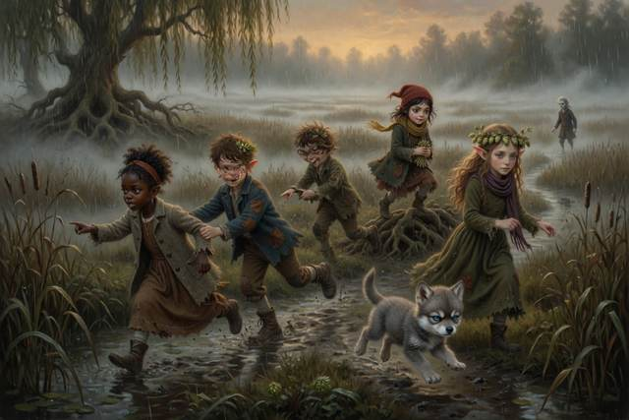
Along the path, where the ground was firm, willow roots stood in a line, and reeds stood where the water was shallow. A pale thread of firm ground ran between them.
“It’s hard here,” she said. “It’s soft there. Reeds mean wet.”
“Follow the willows,” said Hal.
They did. The path bent and doubled back and ran twice as far as the straight line, and it was firm all the way. Behind them the stranger was crossing the bog in the straightest line there ever was. Its first step sank to the ankle. Its second sank to the shin. It kept going. It had never needed another way.
At the bend the path crossed a line of three white stones. Hopsi had set them the evening before, so that the way back to the step would always be open. Scally kicked the middle stone aside as he passed, and then, on a thought, ran back and kicked it into place.
“In case,” he said.
Beyond the stones the stream ran into a stone culvert under the road, a low, black tunnel, dripping, with a smell of old moss.
“In,” said the ghost.
“In there?” said Titch.
“The wall at the mill is two feet thick,” said the ghost. “I can go through it. You cannot. But the water goes through the dark here and comes out in the Mirror Mill, if someone who belongs to both carries a light.” He held up his lantern. “I belong to both. Quickly.”
Gucci would not go in. He planted all four big paws at the mouth of the culvert, flattened his ears, and showed his small white teeth to the dark. Behind them, along the straight road, the fog was beginning to hum. “Pick him up,” said Scally. “No,” said Tabitha. She crouched down, put her hand flat on the cold stone, and waited, because she had been the new one on the step and she remembered what it felt like to be pushed. It cost them a long, held breath of time. Then Gucci sniffed her palm, sneezed, and went in first, with his tail up, as if the whole idea had been his.
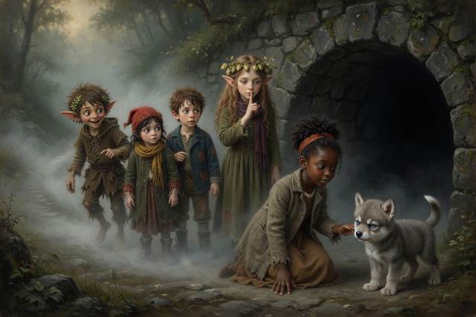
“Pairs,” said Hal. “Nobody goes anywhere in the dark alone.” Tabitha took Titch’s hand, and Hopsi took Scally’s, and Hal kept Gucci at his heel. They went in single file with the lantern in front, bent double, in the cold and the dripping and the echo. Halfway through, a single thin beam of daylight found a crack in the roof and drew a bright coin on the wall ahead. Tabitha stopped. The coin of light trembled on the wet stone, and her face, which had been watching everything so carefully, opened all at once, like a window.
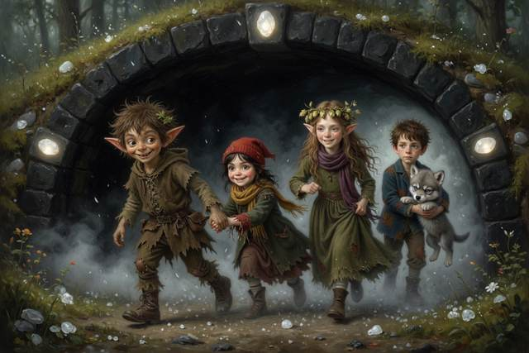
“It got through the earth,” she whispered. “Is that tunnelling?”
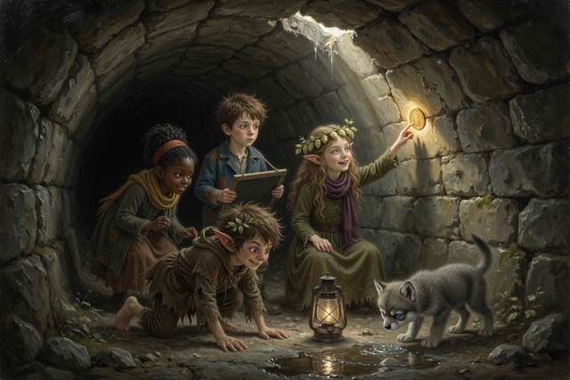
“No,” said Hopsi softly. “That is only a crack. I will not tell you it is more. Real tunnelling is a great deal smaller than a crack.”
“It was still lovely,” said Tabitha.
“Yes,” said Hopsi. “That is true too.”
Then the ghost’s lantern swung on, and the walls turned from black to grey to green.
They came out under the Mirror Mill.
It was the same mill, and it was the wrong way round. The wheel turned backwards. The stream ran gently uphill, which Titch said was unnatural, and then watched with great interest. The sign over the door said LLIM S’RELLIM. Hal looked at his hands, and the chalk was on his left. Hopsi’s needle was in her left hand, and she was looking at it with an expression that was not quite a frown.
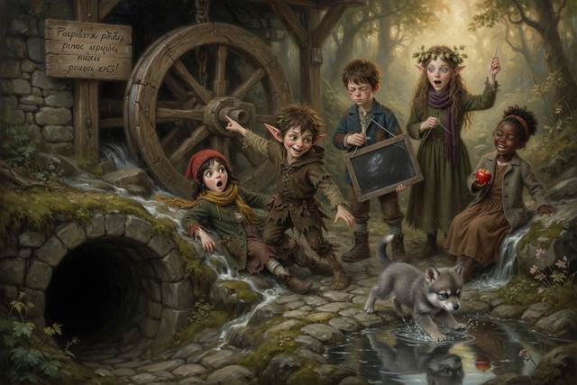
“Which mill is the real one?” said Hal.
“The one you are standing in,” said the ghost. “They are both quite sure of it.”
In front of the door stood a pair of boots with a tag. It was the spare pair, or a spare pair, or the spare pair turned inside out. The tag hung the other way round. The writing on it was whole, and it ran back to front.
KNUFERAPS
Hal looked at it. He read it from the other end.
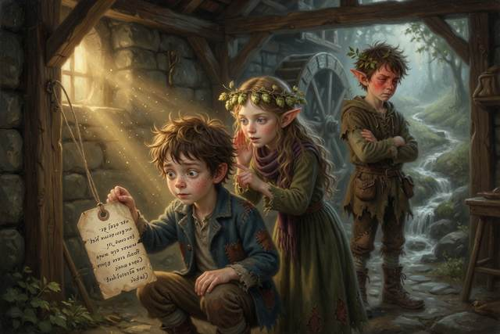
“Oh,” he said, very quietly.
“No time,” said Hopsi. “The pit.”
The sluice gate stood wide open in the Mirror Mill. The pit lay black and cold beyond it, with a lump at the bottom that clinked.
“The same bag,” said the ghost. “Pull it here and it comes loose there. That is the way of mirror mills. It is not the way of any mirror you have ever seen, and I do not know why. I only know that it works.”
Titch had already unpicked her hem. It made a very long thread. She tied one end to Scally.
“Do I have to?” said Scally.
“It’s your bag,” said Hal. “Sort of.”
Scally took a breath, ran at the gate, and jumped.
He went through it like a rat through a hedge, down into the cold black pit, and the thread went tight. For one long moment nothing happened. Then the thread jerked, and kept jerking, and somewhere in the dark below, something large and clinking began to move.
“Pull!” said Hal.
All five of them pulled. Hopsi hauled on the end of the thread. Tabitha dug her heels in. Gucci grabbed Titch’s coat. The ghost held the lantern high and said “Heave” in a flat, polite voice.
Scally came out backwards, soaked, black to the armpits, and smelling of two-hundred-year-old mud. He was holding a clinking, dripping bag the size of a flour sack.
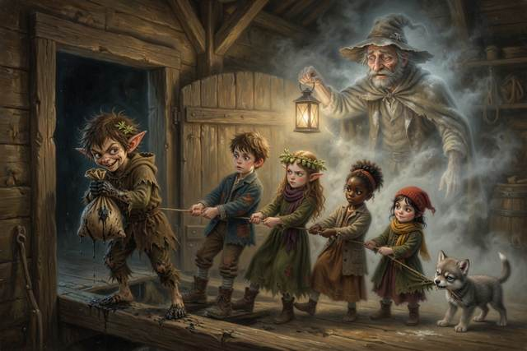
The mirror wheel gave a groan. Then it moved.
At the far end of the Mirror Mill the pond lay still and silver. In it, small and clear as a window, was the real mill, the right way round, with the real wheel groaning, and turning, once, twice, and the real water rushing over the slats.
And in the real bog, to its middle, stood the stranger.
It had stopped. Its feet were gone to the knees and its coat to the hem, and the shadow behind it, which was as long as it was proud, had lost its grip on the ground. It was holding the real bag in both hands, which had come free of the real wheel at the very moment the other came out of the pit. In its other hand, it still held the lantern with the real flame.
“Give me my bag,” it said, but not so softly now.
“Here,” said Scally. “Take it.” He leaned over the Mirror pond, and he threw the bag as hard as he could.
The bag burst.
Out came a hundred years of boiled sweets, and every one was a small grey pebble. Out came a thousand little jars with labels on, QUICK WAY, SHORT WAY, EASY WAY, and they shattered in the fog. And out came flour, a whole sack, two centuries of the mill’s stolen flour. It went up in a cloud so thick that the stranger vanished inside it, and Hal, watching in the pond, heard Hopsi’s voice in his head as if she had said it that second: a cloud of flour burns all at once.
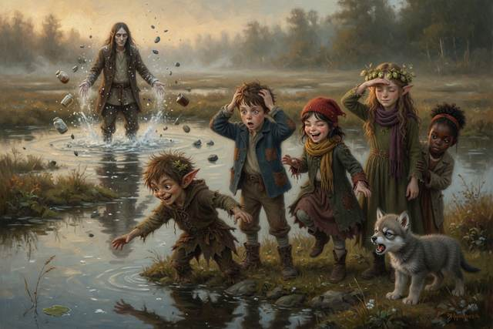
“Close your eyes!” he shouted.
There was a soft, enormous whumph.
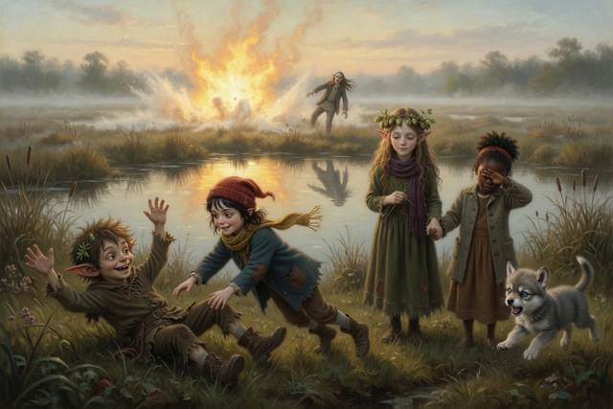
For one bright moment the whole fog turned yellow. A ball of silent flame bloomed over the bog, hot enough that the children felt it on their faces through the mirror. Then it was gone, and a rain of warm white ash fell over the field, and the stranger lay in the reeds, singed, eyebrowless and astonished, with his lantern in pieces.
“A little cloud,” said Hopsi quietly. “A big flame. That is what flour does.”
The stranger stood up. He was thinner than before, and his shadow had burned off him, and he was looking at the three white stones at the bend.
“He’s coming out of the bog,” said Tabitha.
“Run,” said Scally.
They ran back through the dark culvert, and burst out into the real fog beside the stones. The stranger was already there on the other side, and the stones lay in a straight white row across the path.
“In case,” said Scally in a whisper. He had kicked the middle stone aside and back again. Nobody had known if it mattered.
The stranger put out one long, soft foot.
The stones glowed, a thin white light like the first of a moonbeam, and the foot stopped. It stood there, with its mouth open, and the fog thinned around it.
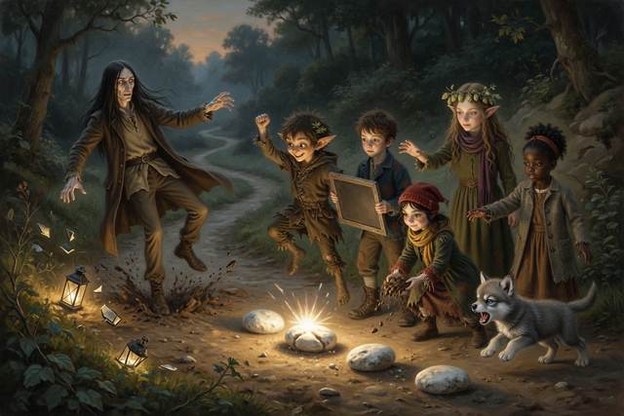
“A shortcut,” it said, in a voice like the last of a sweet, “is only…”
Nobody heard the end of the sentence. The fog went with it. The air smelled faintly of boiled sweets for about a minute, and then of rain.
Scally looked down. The spare boots by the road had gone still, and were only boots.
↑ Contents

Chapter 10. The True Name
It was past midnight when the third day closed. Everyone sat on the step, wet and exhausted. Gucci lay across Hal’s boots, which were Scally’s boots, which were somehow everybody’s.
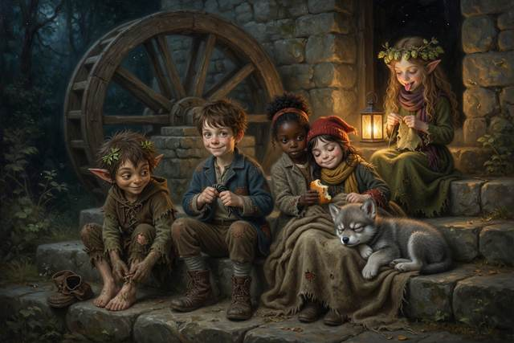
“Time,” said Scally. He was shaking, and trying to stop. “Before the third day closes. Guess my name, or the boots stay mine, and one small thing besides.”
“I know,” said Hal.
He held up his slate. On it he had written, in the dark in the mirror mill, one word backwards:
KNUFERAPS
And under it, forwards:
SPAREFUNK
“The tag in the Mirror Mill hung the other way round,” said Hal. “The back of the tag. You covered it so I wouldn’t read it. It was never about the boots. It’s your name. Somebody wrote it on the tag to make the boots yours, and you theirs.”
“It was my mother’s word for me,” said Scally. He sat down very suddenly. “He took it. He wrote it where I couldn’t rub it out. A name on a tag is a name on a leash.” He looked at his hands. “Nobody’s ever guessed.”
“Sparefunk,” said Hal.
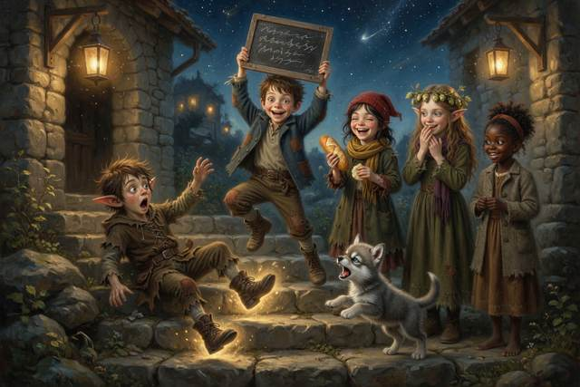
For a moment nobody breathed.
“A true name,” said Hopsi, “said by a friend, unbinds any bargain made under another. That is old magic. It is not physics.”
The boots slid off Sparefunk’s feet on their own and stood side by side on the step, empty, shining a little. Down in the road, the other pair, the spare pair, fell over, and were only boots.
“I lost,” he said. His voice cracked. “That’s the bargain. Boots go back. Then I’ll be…”
“Stay,” said Hal.
“That’s not in the bargain,” said Sparefunk.
“It’s in the small print,” said Hopsi. “A place on the step. It was always going to be the small thing.”
He looked at her. He looked at Hal. For the first time anyone could remember, he did not have a clever thing to say.
“Right,” said Sparefunk. “Well. Acceptable.”
↑ Contents

Chapter 11. Sunday
At dawn on Sunday two messengers came down the road in blue and purple coats and found the wheel turning, the mill roaring and twelve sacks of flour stacked on the step. They counted them twice. They looked for a lord. They found five children and a wolf, asleep in a heap.
“A lord,” said the first messenger, “has people to see to these things.”
“Yes,” said Titch, waking up. “We do.”
There was a thump on the stairs. Hal’s father came out on a crutch, took one look at the turning wheel, and sat down on the step so hard that Gucci squeaked. Behind him came Hal’s mother with a basket, and behind her Mrs Crumb the baker and half the village with empty sacks.
“Who did this?” said the miller.
“We did,” said Hal.
His mother counted. “Five children and a wolf,” she said. “I said no bargains.”
“It was a small bargain,” said Hal.
“That is true,” said Hopsi.
His mother opened her mouth, shut it, and laughed. “And what did it cost?”
“A place on the step,” said Hal.
Mrs Crumb was already counting sacks. “Twelve,” she said, “and every one of them grey with flour. I could kiss that wheel.”
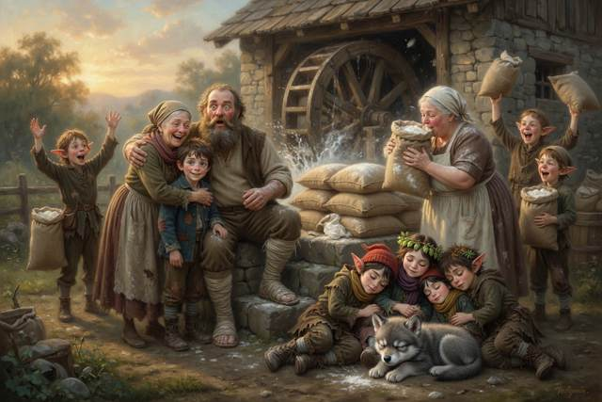
“Funny,” said the miller, squinting up at the wheel in the early sun. “For a moment I thought I saw Grandfather’s hat.”
The ghost stood on the top of the wheel in the early light. He was a little fainter than before, and a little more himself. His hat was on straight.
“It is very kind,” he said, “of the quickest way home to be so slow.”
“Where are you going?” said Hal.
“Home,” said Old Miller Millersen. “Do not worry. It is the long way round. I have walked it a great many times in my head.”
The sun rose. The light that had left it eight minutes before lay across the wheel, and across the step, and across a very old hat. Then the hat was only light, and the wheel was only turning.
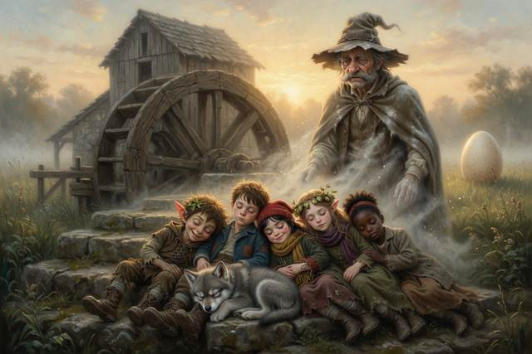
“It is true,” said Hopsi quietly. “Sunlight is eight minutes old. What we see of the Sun is news from eight minutes ago. We were all a little late, and it was enough.”
Hal looked down at Sparefunk, asleep on the step with Gucci across his foot and an apple in his hand. He had never looked more like a boy.
In the pond, very small and silver, a second mill turned the wrong way round. And a boy in the water, who was also Hal and was holding his slate in the wrong hand, looked up, and winked.
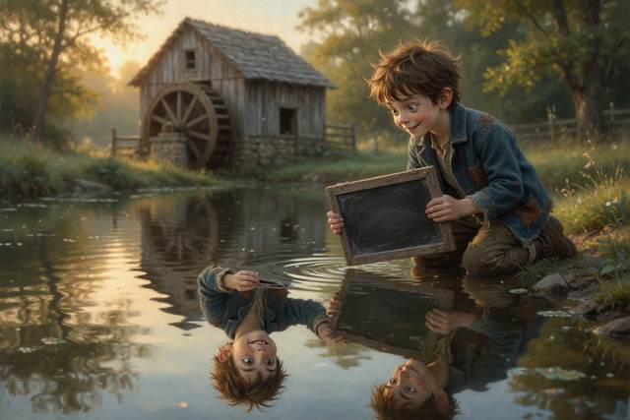
Behind the mill, in the long grass, a rectangular egg rocked once, twice, and cracked along one corner. What came out was wet, ordinary in shape, and not at all interested in rolling. It dried in the sun into a small brown bird. The other eggs kept their corners.
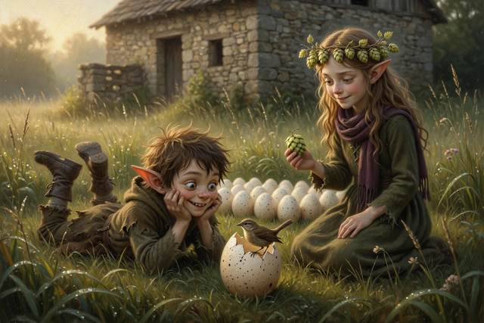
The bird was a nuisance from the first morning. It climbed onto the top of the wheel and sang four notes, exactly four, at the very moment the miller was explaining to the whole village how the wheel had stopped, so that nobody heard the end of the explanation. It would not leave the step. It stole a hop out of Hopsi’s bowl, one hop, and ate it in front of her with every sign of satisfaction. Titch said somebody ought to move it. Hal said he thought they should not. The bird sang four notes, sat down on Sparefunk’s head, and stayed there.
“It’s on me,” said Sparefunk, with great dignity, and did not shake it off.
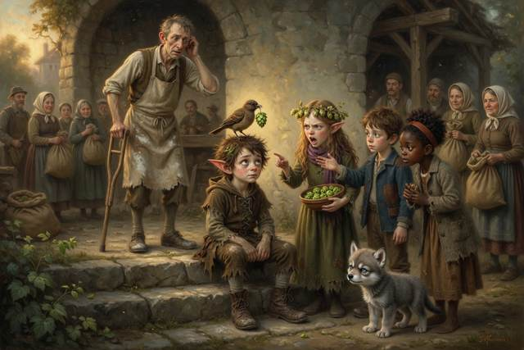
At dusk, when the village had gone home with its flour and the step was quiet, Sparefunk got up with the bird still on his head, took the spare pair of boots, and turned them so that they faced the road, where the next person to come along who needed boots would see them first. Nobody had asked him to.
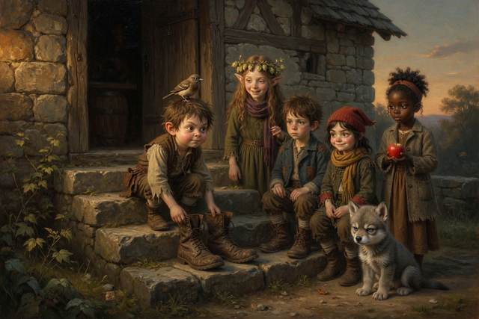
Hopsi watched him do it. She had a true sentence ready, a long and clever one, and she let it go. Instead she said the shortest true thing she had ever said out loud.
“Good,” said Hopsi.
The End
↑ Contents

Hopsi’s True Things
Everything Hopsi says in this book is true, and when she does not know, she says so. The magic is marked as magic. Here is the short list, and some things you can try.
1. Levers. A lever multiplies your push: the long end moves a long way down and the short end moves a little way up, with great strength. Guess first, then try it: rest a ruler across a pencil, put a coin on the short end and press the long end. ↩ Back to the story
2. Hail and rainbows. Hail is ice that grows in layers inside a storm cloud, tossed up and down until it is too heavy to stay up. A rainbow is sunlight coming apart inside raindrops, and you must stand with the sun behind you. Try it: spray a garden hose on a sunny day with the sun at your back. ↩ Back to the story
3. Genes are a recipe. A plant or an animal is built from a very long recipe, written in tiny letters. A baby gets half its recipe cards from each parent, shuffled, so it takes after both and is never exactly the same as either. Most of the differences between brothers and sisters come from the shuffling. When the cards are copied, a letter now and then slips, which is rare, but that is where brand-new differences begin, and sometimes that makes the loaf better. Try it: look at your family’s ears, noses and chins and see whose card you have. ↩ Back to the story
4. The best fit leaves the most young. In a place where the grass is green, green grasshoppers are harder for toads to see, so more of them grow up and have young. Over many years, the colour that fits becomes the common one. (Real grasshoppers can also change shade as they grow, so this is one reason among others, shown simply.) Try it: scatter ten green and ten brown paper dots on grass and ask a friend to grab as many as they can in ten seconds. ↩ Back to the story
5. Light bends in water. Light travels about a quarter slower in water than in air, so it changes direction at the surface, like a barrow swinging when one wheel hits the grass first. A fish is always deeper than it looks. Try it: guess whether a straight pencil stays straight in a glass of water, then look from the side. ↩ Back to the story
6. Quickest is not shortest. Light, and lifeguards, take the path that gets there soonest, which is not always the straightest. Try it: race a friend, one of you straight across a muddy lawn and the other round the firm path. ↩ Back to the story
7. Tunnelling. The very smallest things, much smaller than a speck of flour, sometimes turn up on the far side of a wall that should have stopped them, like a marble that rolls at a hill and is sometimes found beyond it. It does not happen to boys, and a crack of light in a roof is not tunnelling. It is part of the reason the sun shines. ↩ Back to the story
8. Writing in a mirror comes out reversed. A mirror swaps front and back, which turns writing the wrong way round. Try it: write your name on a card and read it in a mirror. (The Mirror Mill is magic. The reversed writing is true.) ↩ Back to the story
9. Sunlight is eight minutes old. It takes about eight minutes for sunlight to cross the space between the Sun and us, so what we see of the Sun is news from eight minutes ago. ↩ Back to the story
10. Moon phases. The Moon makes no light of its own. The Sun always lights half of it, and as the Moon travels around the Earth, about once a month, we see more or less of the lit half. The Earth’s shadow has nothing to do with it. Try it: in a dark room with a lamp across the room, hold an apple at arm’s length and turn slowly on the spot. ↩ Back to the story
11. Tides. The Moon’s pull is a little stronger on the side of the Earth nearest it, so the sea piles up in a bulge on the near side and on the far side. As the Earth turns, each coast passes through both bulges every day: two high tides and two low. When the Sun and Moon line up, at full moon and new moon, the tides are biggest. Try it: look up the tide times for a seaside town. ↩ Back to the story
12. Wolves howl to call each other. They do not howl at the moon. ↩ Back to the story
13. Fire needs three things. Fuel, heat and air. Take away any one and it goes out. A wet sack laid on a small fire smothers it. A bonfire is only out when the ashes are cold to your hand: drown it, stir it, drown it again, and never leave one burning. A heap of flour is very hard to set alight, but a cloud of flour dust can burn all at once, so never use a flame near flour dust. Smoke is more dangerous than flames: it is hot and poisonous and makes people sleepy, so get out and stay out. Do not go back for anything. Stay low where the air is clearer. (Never play with fire. If there is a fire, shout, get out, and get a grown-up. Knowing your family’s way out of the house is a good plan to make together.) ↩ Back to the story
14. Stranger safety. A stranger can be a man or a woman, old or young, and can look kind. It is not about looks. It is about what they ask. Be careful if someone asks you to keep a secret from your family, offers sweets or a puppy, says your mum sent them, or asks a child for help (grown-ups ask grown-ups). Say NO. GO. YELL. TELL: say no, go to a safe place, yell if you need to, and tell a trusted grown-up. Agree a family code word, and never go anywhere without telling someone where you are going. ↩ Back to the story
15. Plants you cannot name. Never taste berries, leaves or mushrooms unless a grown-up who knows has said it is safe. Some pretty ones, like foxglove, are poisonous. Wash your hands after touching wild plants. ↩ Back to the story
16. Safe habits, short list. Reach or throw, never go in after a friend (water is deeper and colder than it looks). Stop, look and listen before you cross a road. Turn pot handles inward and keep small hands away from hot things. Let a strange animal sniff your flat hand first, and never grab it, or ask the owner. Go in pairs in the dark, and always tell someone where you are going and when you will be back. Never taste medicines, cleaning things or wild berries unless a grown-up says so. ↩ Back to the story
17. “I do not know” is a scientist’s sentence. Hopsi says it about the square eggs. Real scientists say it every day, and then they go and find out. ↩ Back to the story
↑ Contents

For Parents and Teachers
This is a fantasy adventure to read aloud at ages 5–9. Children from about 5 can follow the whole story from the pictures alone (a “picture walk”: turn the pages and ask what is happening), and older children can read it by themselves. Every fact the elf Hopsi states is true, and every piece of magic is marked as magic. The children test things before they believe them. The book promises curiosity, new words and good scientific habits, not exam results.

The habits of a scientist in the story
“How do we know?” Hal asks it. The answer is always: look, count, test, or make a model.
Write it down. Hal’s slate is a lab notebook: the lever test, the grasshopper counts, the bent stick, the moon shapes.
Make a model. An apple and a lantern show why the moon changes shape.
Looks can fool you. A fish is deeper than it looks, a stick looks bent in water, and a mirror swaps left and right.
Say only what you know. Hopsi says only what is true, and “I don’t know” counts.
Notice what others miss. Tabitha spots the firm path from the reeds.
Guess first, then test. Sparefunk’s fake fly fails, and Hal’s first lever try takes ten fingers.

What each chapter teaches
The Stuck Wheel: a problem to solve against the clock; the idea of small print.
The Lord of the Riverbank: levers (guess, test, be wrong), a fair test, hail and rainbows.
The Ghost in the Wall: tunnelling, as a marble that sometimes turns up beyond a hill, and why the sun shines.
The Toad of the Ford: genes as a recipe, variation, counting data, why the colour that fits becomes common, poisonous plants, telling someone where you are going, and what to do when a friendly stranger asks you to go with them: No, Go, Yell, Tell.
The Pike and the Torn Tag: light bends when it slows in water, quickest is not shortest, a stick test and a puddle race.
The Howl and the Moon: why the moon changes shape, with an apple and a lantern, why wolves really howl, and a scientist’s “I do not know”.
The Hot Night: what a fire needs, how to smother a small one, why a bonfire must be put out properly, and why a grown-up must always be fetched.
The Girl with the Apples: a welcome gift when words are not allowed, careful observation, and tides: why the sea rises and falls twice a day.
The Quick Way and the True Way: reading evidence, reversed writing in a mirror, an honest answer about a crack of light, and why a cloud of flour dust burns all at once.
The True Name: reading mirror writing, and telling the truth when it is hard.
Sunday: sunlight is about eight minutes old.

Staying safe: what this book models
Strangers. The woman with the puppy and the Soft Voice are two strangers. Neither is spotted by looks. The warning signs are a request to keep a secret, offers of sweets or pets, a claim that a parent sent them, or a child being asked for help. The children say No, go to a safe place (the baker), yell, and tell. Agree a family code word, like marmalade.
Fire. Shout, get out, get a grown-up. A fire needs fuel, heat and air. Never leave a bonfire burning; drown it, stir it, drown it again. Smoke is the real danger, so stay low and stay out. Please make a family escape plan together.
Water. Reach or throw, never go in after a friend. Never go to a pond or stream without a grown-up.
Roads. Stop, look and listen before you cross.
Plants, medicines and cleaning things. Never taste berries, leaves, mushrooms, medicines or cleaning products unless a grown-up says so. Foxglove is poisonous.
Animals. Let a strange animal sniff a flat hand first, and never grab one. Ask the owner.
Hot things. Turn pot handles inward. Keep small hands away from stoves and kettles.
Telling someone. Hal writes where he is going and when he will be back. Go in pairs, and never go anywhere alone in the dark.
Screens and online. There are no screens in this story, but the Soft Voice is exactly the person who messages a child online, offering something nice and asking for a secret. The same rules apply: no, tell a grown-up, and never keep that kind of secret.

Talk about it
Why did Hal write his results down? What would have happened if he hadn’t?
Why is a fish deeper than it looks? What else looks different from how it is?
If the shortest way is the slowest, how would you plan a journey?
What shape is the moon tonight? Where will it be in a week?
Who made the fire go wrong, and how did everyone put it right? What would you do if you saw a fire?
Which part of the story is magic and which is true? How can you tell?
Who noticed something the others missed? What did they notice?

Words to grow
lever, force, hail, rainbow, inherit, variation, camouflage, bend (refraction), reflection, tunnelling, phase, tide.

A note for adults
Light travels about three-quarters as fast in water as in air, so “a quarter slower” is a child-sized number. A fish is deeper than it looks when you look into the water from above. Sunlight takes about eight minutes and twenty seconds to reach Earth. The recipe picture of genes is an analogy: real genes are made of DNA. Tunnelling is real quantum behaviour of very small particles, and it matters in how the Sun releases energy; the marble picture is only a way in. The moon’s phases come from how much of its sunlit half we can see, not from the Earth’s shadow. Tides come from the Moon’s gravity pulling more strongly on the near side of the Earth than the far side, with the Sun adding to it at full and new moon; the dough picture is a simple way in. A mirror swaps front and back, which is why writing reads the wrong way round in a mirror; the Mirror Mill itself is magic. Stranger safety is not about looks: a stranger can be a man or a woman and can seem kind. The signs are a request to keep a secret, offers of sweets or pets, a claim that a parent sent them, or a child being asked for help. Please agree a family code word, like marmalade in the story. A bonfire must be drowned, stirred and drowned again until the ashes are cold to the hand. A cloud of flour dust, unlike a heap of flour, can burn all at once; this is real, and it has burned down mills, so the flash in the story is for reading about and never for trying. These are seed ideas, meant to make children curious, not to be tested at school yet.
↑ Contents

About the Author
Anneliese Tauber grew up in Bavaria, where the old stories have mills in them and the mills have ghosts. Today she is a mother of four, and her children have taught her that the best bedtime stories answer the questions they ask, and keep the real answers true. The Step Stories are for curious children and the grown-ups who read to them.
If your child enjoyed this book, a short, kind review on Amazon helps other curious families find it. Thank you.
↑ Contents

Also by Anneliese Tauber
Bavarian Cooking Made Simple
Classic dishes from a Bavarian kitchen, written so that any cook can enjoy a taste of Bavaria.
↑ Contents
Typeface in the e-book edition: Comic Neue, © The Comic Neue Project Authors, used under the SIL Open Font License 1.1.

