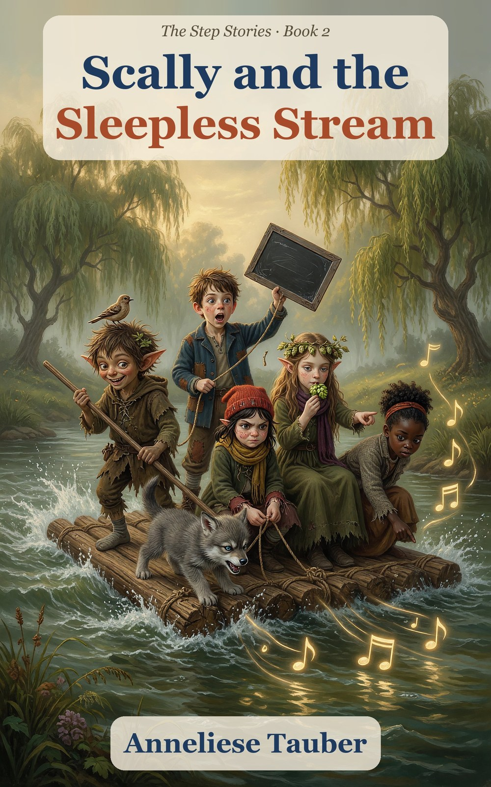

Scally and the
Sleepless Stream
Book 2 of The Step Stories
Anneliese Tauber

Contents
Meet the Characters
Chapter 1. The Hum
Chapter 2. Old Walt
Chapter 3. The Green Pool
Chapter 4. The Wandering Stream
Chapter 5. The Fire and the Voice
Chapter 6. The Count Between
Chapter 7. The Brown Water
Chapter 8. The Whirl
Chapter 9. The Long Way Round
Chapter 10. The Square Eggs
Chapter 11. Rain
Hal’s Slate: What We Found Out
For Parents and Teachers
About the Author
Also by Anneliese Tauber

Meet the Characters
Hal (Halbert) Millersen
Almost 9. The miller’s son, with a slate for his notes. Looks, counts, tests, and writes WRONG when he is.
Scally, the wee scallywag
A little devil with pointed ears and a leaf in his hair. He can never resist a scam, a lie or a shortcut. His true name is for special occasions.
Hopsi (Elfie Didlhop)
An elf with long swept-back ears. She only says what is true, and this time she has to learn to say “I think”.
Titch Mitchel
Almost 9. Red cap, quick fingers and a crust in each hand. The best knot-tier in the valley.
Tabitha Smoke
Nearly 8. Curly black hair in a bun. Watches carefully and notices what nobody else did.
Pip
6 and three-quarters. Titch’s little brother, who guards the mill step while the others are away.
Gucci
A wolf cub, now the size of a cushion, who still thinks he is the size of a boot.
Fourpence
A small brown bird who hatched from the last square egg. It sings four notes, exactly four.
Old Walt
The stream-keeper, with a stiff leg, a hat made of eel-skin and fifty years of listening to water.
Dumpling
Walt’s small round donkey, who walks as if she is paid by the hour.
Ages 5–9. Little ones can follow the whole story from the pictures alone.

Chapter 1. The Hum
On the first night of autumn, the stream began to hum.
It was not a loud hum. It was a low, wobbling sort of hum, like a kettle thinking about boiling, and it came up through the floor of the mill and into the bed and into Hal’s teeth.
Hal Millersen lay on his back and looked at the ceiling. He was almost nine, with brown hair that never lay flat, and he was wide awake. So was Gucci, who lay across his feet with his ears turned inside out. Gucci had grown since the summer. He was now the size of a cushion and still thought he was the size of a boot.
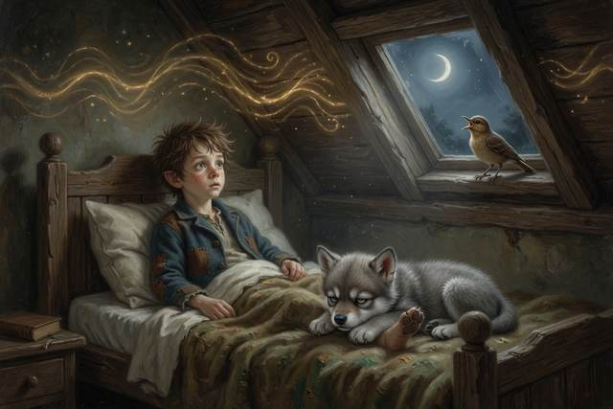
“Mmmm,” said the stream. “Mmm-mm-mmm.”
From the roof came a small, clear sound. Four notes, exactly four, and then a pause, as if somebody was waiting for the fifth.
“Fourpence,” said Hal, to the ceiling. “It is three o’clock in the morning.”
Fourpence was the little brown bird that had hatched from the last square egg at the end of the summer. It lived on the mill roof. It sang four notes whenever anybody was trying to say something important. It had never once sung a fifth.
“Mmmm,” said the stream.
“Four notes,” said the roof.
Nobody in the valley slept that night.
In the morning, the miller fell asleep in the flour hopper and came up white to the eyebrows. Mrs. Crumb the baker, who had dozed off beside her oven, sent out forty-one buns as black as boots. The village cockerel crowed at midnight, at two, and at half past three, and then gave up and sat on a wall looking offended.
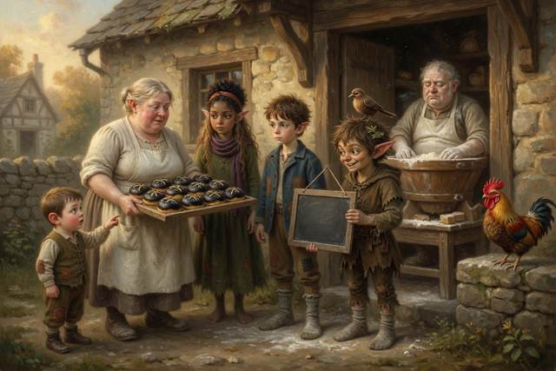
On the mill step Hal found the rest of them. Titch had her red cap over her eyes and a crust in each hand, not eating either. Tabitha Smoke, nearly eight, sat with her chin on her knees, holding one apple that she had been looking at for a long time. Hopsi sat very upright, with her needle in her fingers and a green look about her. She had pointed ears and long wavy light-brown hair and a wreath of hops. Elves are not at their best without sleep.
And Scally lay on his back across the top step, one arm over his face. He had spiky black hair, pointed ears, and a leaf in the hair. His true name was a word his mother had given him, and he had told them it, and they used it on special occasions. The rest of the time he was Scally.
“Well,” said Scally, without moving his arm. “That’s the end of the world.”
“It is a hum,” said Hopsi.
“It’s a hum that has stolen my sleep,” said Scally, “and I have a use for it.” He sat up. Under each eye there was a smear of mud-colored tiredness, but the glint was back in the middle. “Everyone in the valley is desperate. Everybody’s awake, everybody’s mad, everybody’s got a penny. Hop. Fetch me your biggest pot.”
“Why?” said Hopsi.
“Because,” said Scally, “I am about to cure the valley.”
By ten o’clock a hand-painted sign stood at the end of the mill road. It said:
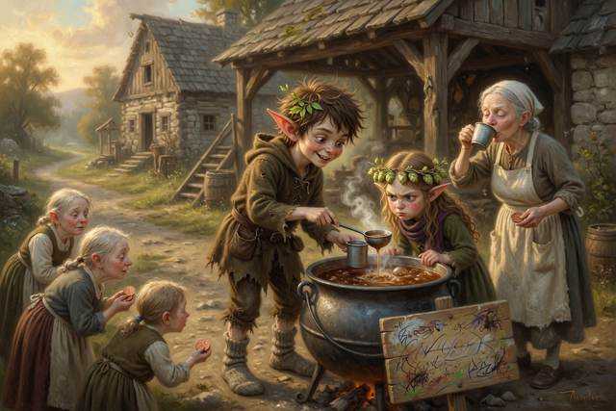
SCALLY’S SLEEPING DRAUGHT
ONE PENNY A CUP
CURES THE HUM. GUARANTEED.
The draught was stream water, a handful of hops from Hopsi’s bowl, and a pinch of mud for color. It bubbled in the pot. It smelled of a wet cabbage. Scally stood behind it with a ladle and a face of enormous honesty.
The first customer was Mrs. Crumb. She drank a cup, shut her eyes, and said she felt a bit better, which anybody would after sitting down. Then came the miller, then the butcher, then two men from the next farm, and a woman with a baby who had not slept in two nights and was well past being reasonable. A small heap of pennies grew in the tin.
Hopsi had been watching, with her lips pressed together. At last she walked up to the pot and looked into it.
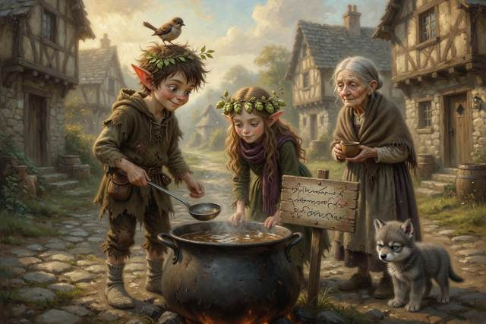
“Scally,” she said.
“Yes, Hop?”
“That is water.”
“It is,” said Scally, “a specially treated water.”
“It is stream water, with mud in it,” said Hopsi, “and it will not cure the hum.” She did not raise her voice. She never did. “Mrs. Crumb has paid a penny for a cup of mud, because she thought it was medicine.”
Scally went red from the ears inwards. “It makes them feel better.”
“It makes them feel better for the length of a sentence,” said Hopsi. “Then the hum is still there, and so is the penny that is gone. Is that cheating?”
There was a silence. In it, very faintly, the stream said, “Mmmm.”
“It might be,” said Scally, in a small voice.
“Yes,” said Hopsi, and ate a hop.
That was the whole of it. She did not say anything else. But Scally looked at the sign, and at the tin, and at Mrs. Crumb’s kind, tired, trusting face across the road, and the glint in the middle of his tiredness went out like a candle in a draught.
He scooped up the tin. He walked to every customer in turn, red to the ears, and gave back the pennies one by one, and said sorry to each. It took until noon. The woman with the baby kissed him on the cheek, which was worse than anything.
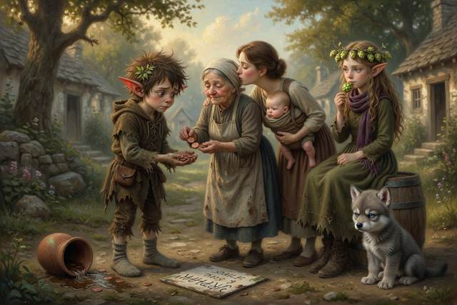
“Right,” said Scally, when it was done. “No more Draught.” He kicked the pot over, and stream water ran out across the road. “But I still want to know what that hum is.”
“So do I,” said Hopsi.
Everyone looked at her.
“I do not know what it is,” said Hopsi. “I do not know why it started, or what it wants. I do not like it.” She put her needle through her sleeve. “It is true.”
Tabitha had said nothing all morning. Now she lifted her head, the way she did when she was about to say the one thing nobody had thought of.
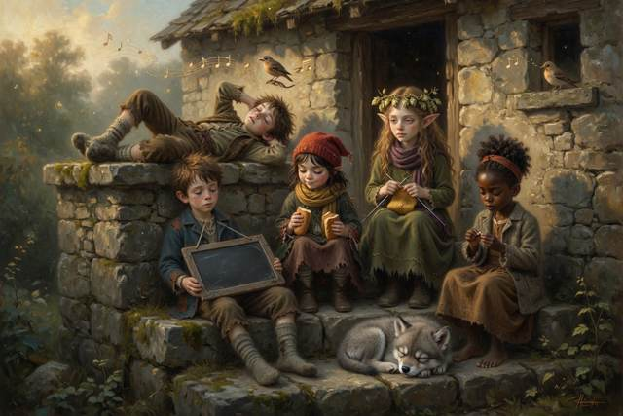
“It’s the same five sounds,” she said. “Over and over. I’ve been counting since midnight. It goes up, up, down, up, and then it stops. And then it starts again.” She looked up at the roof. “Like it’s trying to say something. And somebody’s got stuck.”
On the roof, Fourpence sang its four notes. Then it waited.
Hal went to the pond, to think. He knelt on the bank, and his reflection looked up at him, with dark rings under its eyes and its hair standing up like a hedge.
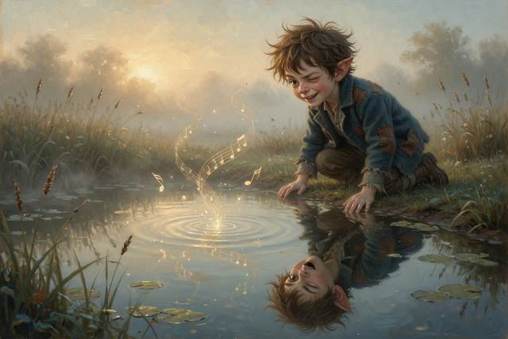
Then it winked.
It had not winked since the summer. Its mouth shaped one word, over and over, that Hal could read quite well, because it was the same word in either direction.
UP.
↑ Contents

Chapter 2. Old Walt
By afternoon the whole village was in the mill yard, and nobody could talk quietly, because everybody was tired and nobody could think.
The Mayor stood on a barrel. His name was Mr. Pomfrey, he had a chain and a waistcoat, and he was the sort of man who has never been wrong in his life and has never once checked. “Neighbors!” he said. “The stream is the trouble. It hums. It must be stopped.”
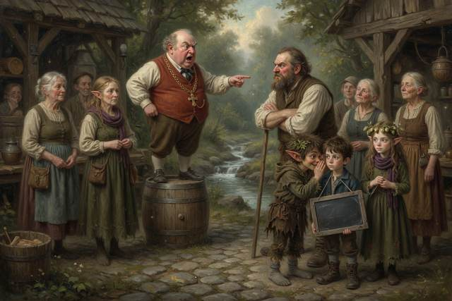
“Stopped how?” said the miller. He was leaning on a stick, since his leg was still mending.
“Sandbags,” said the Mayor. “Two hundred of them, across the water above the mill. No water, no hum.”
“No water, no wheel,” said the miller. “No flour. No bread.”
“A small price,” said the Mayor, “for a night’s sleep.”
There was a murmur of people who had not slept for two nights, thinking that two hundred sandbags did not sound too bad.
Scally, at the back of the crowd, had not spoken. He had been thinking. He tugged Hal’s sleeve and whispered. “The Mayor’s offering a reward. Ten dollars to anyone who stops the hum. If I said I could do it, and showed them a nice noise-proof box…”
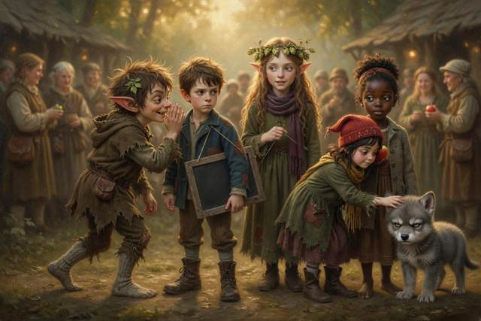
“What box?” said Hal.
“The ones in Mrs. Crumb’s shed. I’d stuff them with moss. Nobody would know until—”
“Scally.”
It was Tabitha, behind him. She had not said a word, but she had heard. She was not looking mad. She was looking at him with a sort of patient interest.
“What happens to the ten dollars,” she said, “when the hum is still there?”
Scally opened his mouth. He shut it. He looked at the Mayor on his barrel, and at the miller on his stick, and at all the tired faces.
“They’d be out ten dollars,” he said, “and the stream would still be humming. And everybody would want somebody to blame.”
“Yes,” said Tabitha.
“Right,” said Scally. “Forget the box.”
“I thought you might,” said Tabitha, and went back to counting the hum.
It was then that a gate banged, and a donkey walked into the yard.
It was a gray donkey, small and round, with ears like two dry leaves and a look of having seen everything twice. On its back sat an old man. He had a gray beard that grew in two directions, a hat made from something that had once been an eel, and a leg that stuck out stiff on one side. Over his shoulder was a long pole with a hook. He climbed down slowly, in sections, and stood leaning on the donkey.
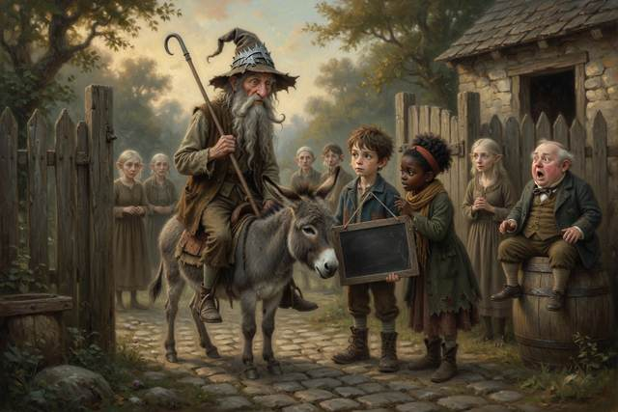
“That is Old Walt,” murmured Tabitha. “He’s the stream-keeper. He has looked after the water for fifty years. My gran says he can tell the weather by the color of a puddle.”
“Don’t block the stream,” said Old Walt.
He did not shout. He did not need to. The yard went quiet.
“You can’t stop water,” said Walt. “You can only move it, and when you move it, it goes somewhere else. Behind those sandbags, in a week, you’d have a lake. And when the lake got heavy, in a night, it would come down on this mill, and the village, all at once.” He looked at the Mayor, steadily. “I have seen a stream dammed. Once.”
The Mayor went pink. “Then what, Walter, do you propose?”
“You don’t shout at it,” said Old Walt. “You ask where it’s going.” He took a stick from his belt and dropped it in the water. It bobbed away, turning, past the wheel and out of sight. “Everything falls down. A stone falls down. An apple falls down. And water falls too, but slowly, sideways. A stream is only water on the way to the lowest place it can find. That is all it ever wants. This one is humming because something has got in its way, up at the top. I’ve known it for fifty years and it has never hummed. I’m going to go and look.”
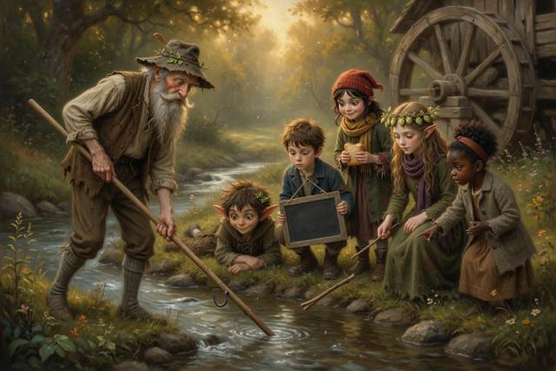
“Up the stream?” said the miller. “That’s two days. Over the Wandering, past the Falls, to the bog.”
“Two days up, and one back,” said Walt. “If my knee holds. And a donkey, and a pair of strong arms.” He looked round the yard. His eyes stopped on the children, one by one, as if he was weighing them, the way you weigh an apple. “Children notice things,” he said. “Grown-ups talk. I would take them.”
There was a short, loud argument. Hal’s mother said no, Mrs. Crumb said certainly not, and the Mayor said he forbade it. Old Walt waited until they were done and then said one thing.
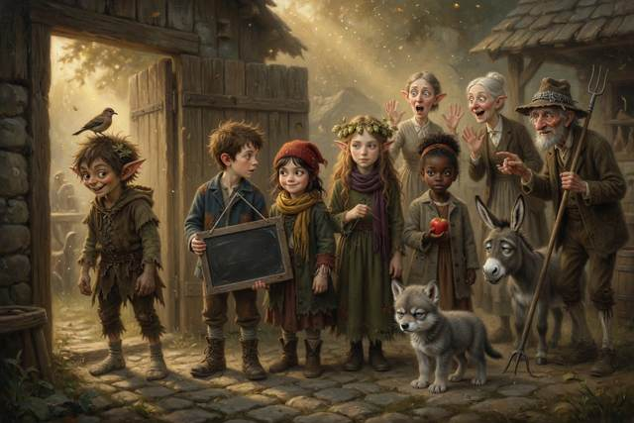
“I’ll be responsible.”
That was all. But everybody in the yard knew what Walt’s word weighed, and it was a good deal.
Hal’s mother crouched in front of him and took his face in her hands. She was warm and weathered, with a kerchief on her hair, and she smelled of bread. “I want four things,” she said. “Tell someone where you go. Go in pairs. Be back by dark on the third day. And if anyone you don’t know says I sent them—”
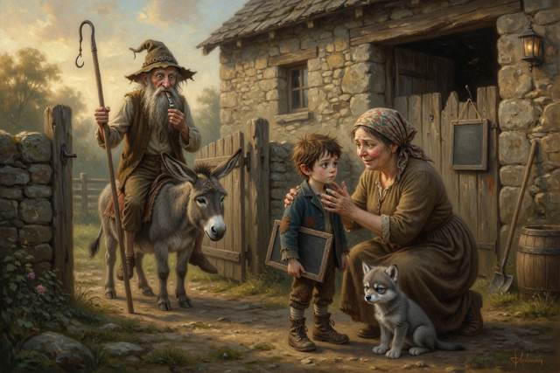
“Ask for the word,” said Hal.
“What’s the word?”
“Marmalade.”
“Good boy,” she said. “Go on.”
Hal wrote the plan on his slate, in his small neat hand. GONE UP THE STREAM WITH OLD WALT. FIVE CHILDREN, ONE WOLF, ONE DONKEY. BACK BY DARK, THIRD DAY. HAL. He hung it by its string on the mill door, where anyone could read it. It was the rule. He had never once broken it. Old Walt strolled past, tilted his head at the slate, said “Very neat,” and went on without reading a word of it.
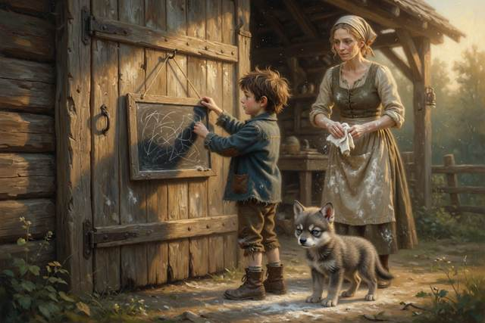
Titch’s little brother Pip, who was six and three-quarters, had planted himself in front of the donkey with his arms folded. “I am coming too,” he said.
“Six is too small for a bog,” said Titch, and crouched, and gave him her last crust and the most important job she could think of. “Guard the step. Somebody has to.”
Pip thought about it, and sat on the step, with the crust, and guarded it.
Before they left, Walt gave out his own rules, in a voice like a gate.
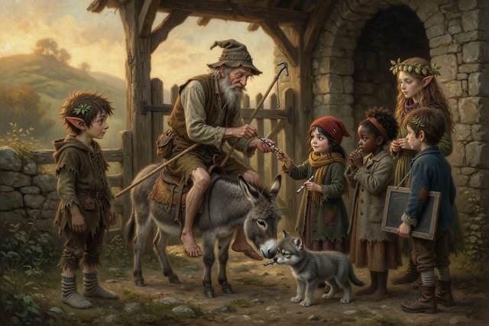
“Never go in the water alone,” he said. “If anyone falls in, you reach, or you throw. You hold out a stick, or a rope. You do not go in after them, because two in the water is worse than one. If you’re lost, stand still. Don’t wander. Blow this whistle, three blasts, and then wait. And never, ever, take a shortcut across country. Not once. Do you hear me?”
“Yes, Walt,” said everybody.
Scally said it too, but a little late, and he was looking at the hill.
↑ Contents

Chapter 3. The Green Pool
They set out at dawn.
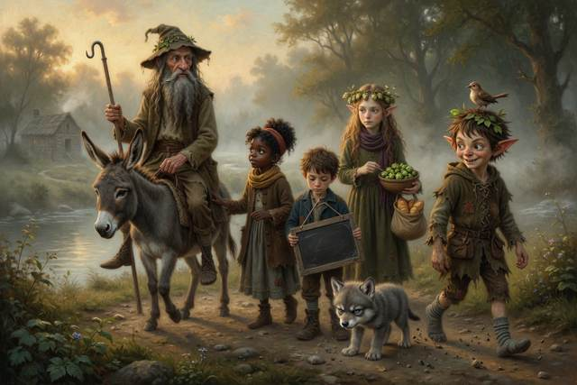
The path ran beside the water, through bracken still wet with night. Old Walt rode the donkey, whose name turned out to be Dumpling, and who walked as though she was being paid by the hour. Behind her came Gucci, nose down, and then Titch, with a bag of crusts, and Hal with his slate. Tabitha walked beside Walt with one hand on the donkey, asking him questions. Hopsi came last, with her hops. And Scally, in front, kicked pebbles.
Nobody had slept for three nights, and yet nobody fell asleep on the path, which Hopsi thought was the strangest part. Walt said the hum kept you awake the way a hand keeps a kite up, that it was no kindness, and that it would not last. All morning the stream hummed beside them, louder than in the night. Sometimes it sounded like a word and sometimes like a cat in a barrel.
At the top of the first hill the path stopped.
A bank had slipped into the stream. A wall of earth and torn roots lay across the track, and past it, where the path ought to be, there was a wide, dark, green pool, as still as glass. On the far side was the path again, going on up the hill without them.
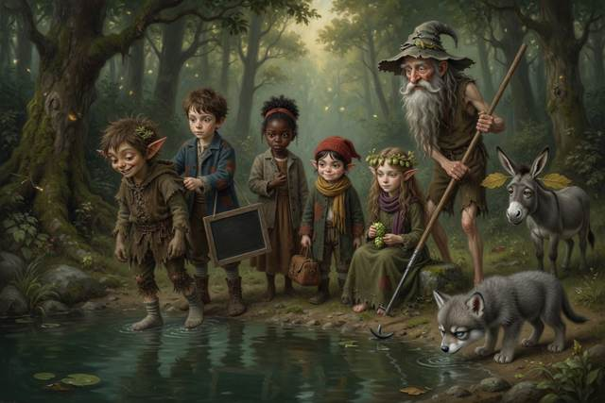
“The Green Pool,” said Walt. “Deep in the middle. Forty feet to the far bank. No bridge.”
“Wade it,” said Scally.
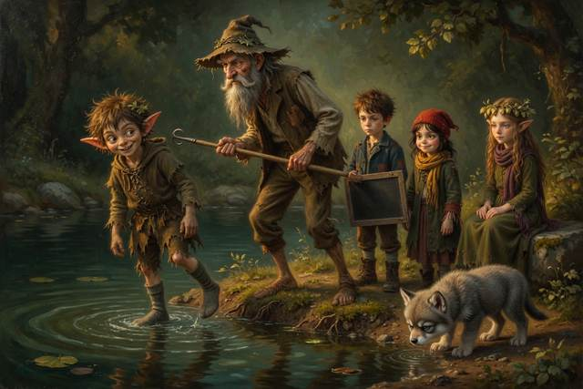
“No,” said Walt.
“It’s only water.”
“It is cold water,” said Walt, “over a deep hole, with a current underneath that you can’t see. A grown man would go in up to the chin and not come out.” He got down from Dumpling, stiff, in sections. “We build a raft.”
Hal looked at the bank. “How do we know what will float?”
Hopsi sat down on a stone. “Guess first,” she said. “Then test.”
Hal took out his slate. “A big stone sinks,” he said. “An apple floats. A log floats. A boot…” He looked at Scally’s boots. They were big and brown, and had been made for somebody older. They had once been enchanted and walked where they liked, but since the summer they had been only boots. “A boot sinks.”
“A boot floats,” said Scally, “if I say so. Bet you a crust.”
“Done,” said Hal.
“And I bet,” said Scally, “that Tabs’s apple sinks. A penny says so.” He held out his hand. “Let me carry it down to the water for you.”
“It will float,” said Tabitha, and gave it to him.
Titch had a log in each hand. She had been listening with one eyebrow up, and she had watched Scally’s hands the whole time. When he went to the water’s edge with something red in his fist and a small, thoughtful smile, she said, in her ordinary voice, “That is not Tabitha’s apple. I saw you swap it.”
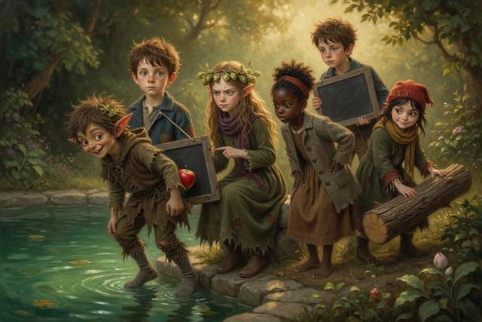
Scally stopped.
“It is a stone, painted red,” said Titch. “He swapped it behind his back.”
“It is going to sink,” said Hopsi, from her stone, “and you are going to win a penny, and it will tell nobody anything about apples.” She looked at him, gently. “If you win like that, what have you won?”
Scally looked at the red stone in his fist.
He looked for a long time. Then he opened his other hand, and there was the real apple, hidden in his sleeve. He held them both up for everybody to see.
“This one floats,” he said. “It’s got air in it. And this one was going to sink, because it’s a stone. I was going to cheat.”
“I know,” said Hopsi.
“Somebody always catches me.”
“Titch did,” said Hopsi. “I only asked what you had won. You did the rest.”
Hal found, in his surprise, that he was smiling. He pushed the apple into the pool. It bobbed straight back up. He pushed in a stone, and it dropped like a sad thought. He pushed in a log, and it floated high. He pushed in Scally’s left boot, which the owner took off without a fuss, and it sat on the water, upside down, full of air, like a small brown boat.
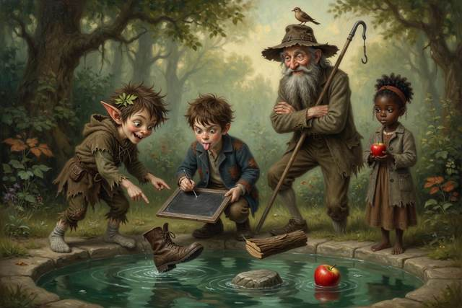
“It floats,” said Hal. “The boot floats. I was wrong.” He wrote on the slate, WRONG, in capitals.
“I thought it would sink as well,” said Hopsi. “I was wrong too. That is what a test is for.”
“A boat is only a hollow boot,” said Walt, behind them, “that has got ideas. It floats because, for its size, it is lighter than the water it pushes aside. A hollow thing full of air is light for its size. A stone is heavy for its size, so it sinks. That’s all there is to it.” He took up an axe. “Now. Logs.”
It took all morning. They cut six logs, tied them with Walt’s rope, and laid a deck of planks across the top. Titch tied the knots, and did it faster than anybody, with her tongue between her teeth. Tabitha stood at the edge and watched the water.
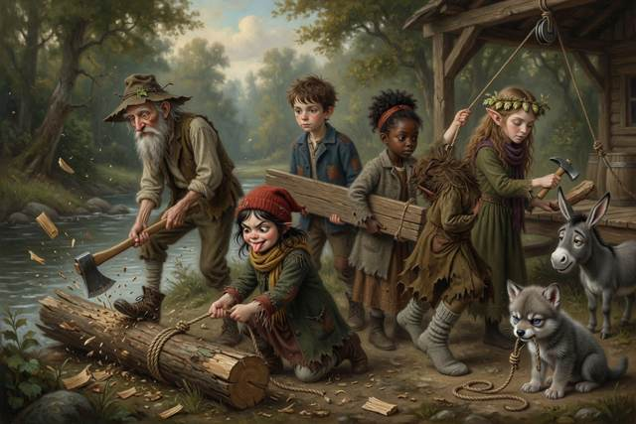
“It’s slower at the sides,” she said. “And faster in the middle. See the bubbles? They go quicker out there.”
“Good eyes,” said Walt.
“My gran taught me,” said Tabitha. “She’s a fisherman’s wife. If you want to cross, you aim high on the near bank, because the middle will carry you down.”
They launched the raft at noon. It sat on the green water like a pancake on a plate. First on was Gucci, who put one paw on the planks and fell off, and was hauled out soaked and indignant. Second was Hal, with a long pole. Third was Titch, with a rope looped over her shoulder, the other end tied to a tree. Fourth was Hopsi, with her hops held high.
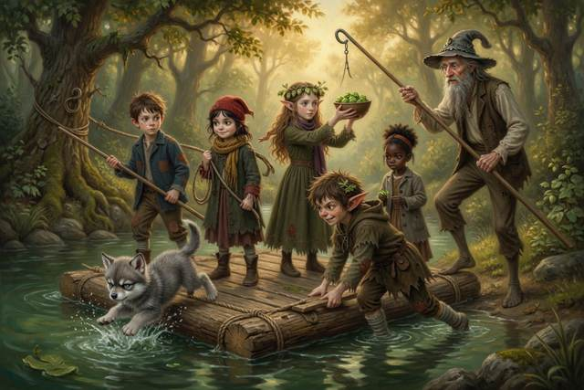
Last was Scally, because he had insisted on pushing off, and he stood on the bank with one boot on and one boot off, and shoved with all his might.
The raft slid out. The current found it at once. The middle of the pool drew it down and sideways, like a hand, and the raft began to spin.
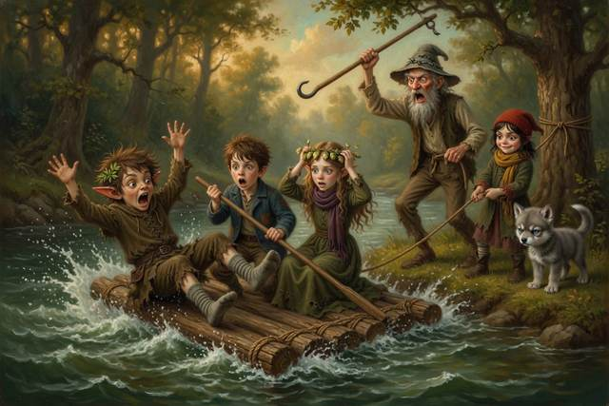
“Pole!” shouted Walt.
“It won’t reach!” shouted Hal.
“Rope!” shouted Titch, and heaved. The rope came taut, and the raft swung in a long slow arc, scraping the bank. Scally, who had stepped on at the last moment to steady it, missed his footing. He went over the side in a perfect flat splash.
For one awful second there was only a hole in the water.
“Reach or throw!” roared Walt.
Titch did not wait to be told twice. She had a rope-loop already in her hand. She threw it. It fell short. She hauled it in, wet, and threw again, and it dropped on the green water right beside a small, surfacing, spluttering, spiky head.
Scally’s hand closed on it. “Got it!” he coughed. “I’ve got — I’m — pull!”
Four of them hauled, with Gucci hanging on to the end by his teeth, and Scally came up the bank like a landed fish, in two boots’ worth of mud and weed, with one boot gone entirely. It had floated off down the stream in the sun, quite upright and rather dignified, like a small ship.
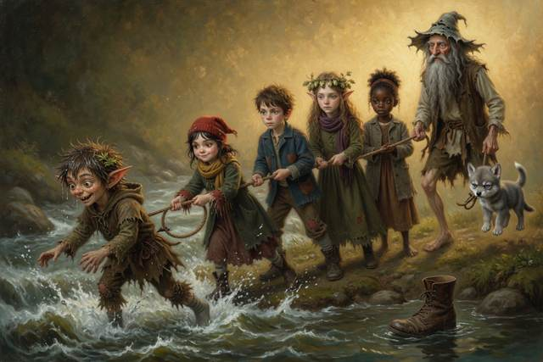
“My boot!” said Scally, sitting in the mud with his teeth chattering. “My boot’s gone to sea!”
“It floats,” said Hal. “It will be in the sea in a week.”
Scally began to laugh, and could not stop. After a minute, all of them were laughing, even Walt, even Dumpling, who gave a low hee-haw. It was the shaky laughing of people who have been frightened and found it was all right.
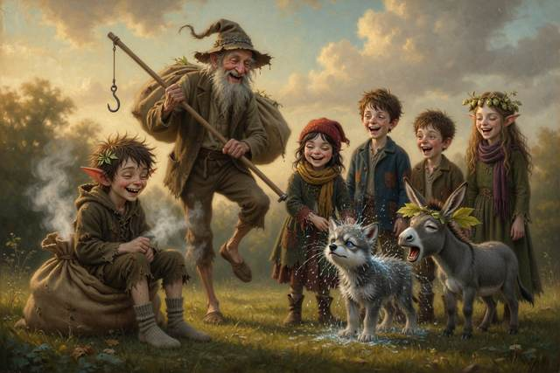
“Cold water,” said Walt, when the laughing had run out, “squeezes the chest and you gasp before you know it. A strong swimmer drowns that way. You do not go in at all, if you can reach or throw. Do you see why?”
“Yes,” said Scally, quietly. He was blue about the mouth. “Yes, Walt.”
Walt rubbed him down with a sack and put his own coat over him. They crossed on the raft, one by one, with the rope tight, and nobody tried anything clever. On the far bank, in the sun, Scally sat steaming, with his one foot in a sock.
From the hilltop above them, very clearly, came four small notes.
“A short,” said Tabitha, suddenly. She had her head on one side. “A short. Did you hear? In the hum. It’s not five sounds. It’s words.”
↑ Contents

Chapter 4. The Wandering Stream
After the Green Pool, the stream began to wander.
It had been straight for the first morning. Now, as they came up into a wide, flat valley with tall grass, it started to loop. It curled one way, and then the other, like a dropped rope, in great lazy bends, and the path beside it followed along and never seemed to get anywhere.
“It’s mad,” said Titch. “Look. It goes right, then left, then right, and it’s all the same grass.”
“It is called a meander,” said Hopsi, “and I do not know exactly why. Walt?”
Walt sat down on a rock, in sections. He had the look of a man who has been waiting for somebody to ask. “Watch the water,” he said. “At the outside of every bend it runs fast. Fast water takes the bank away, a little at a time, grain by grain. At the inside it runs slow, and slow water lets go of what it carries, sand and mud, and drops it. So the outside digs and the inside builds. The bend gets bigger, and bigger, and in a hundred years it’s a loop.” He drew it in the dust with a stick. “The stream is only a small digger, and a small dumper, working on the same bank.”
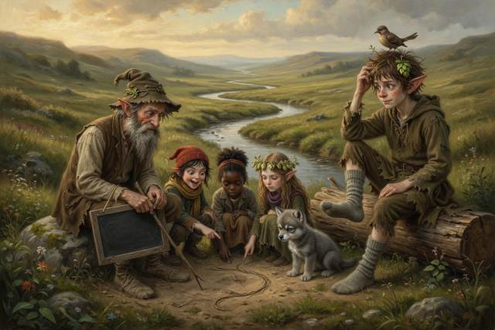
“Like a bad cook,” said Titch. “Takes the flour out of one bowl and puts it in the other.”
“Just so,” said Walt.
Hal knelt at the water. On the inside of the bend, where it was slow, the stones in the stream were fat, round, and smooth. He held one up. It was gray, as round as an egg and as smooth as soap. Then he walked back to the last bend and picked up another from the bank beside the rocks. It was sharp, with corners, like something broken.
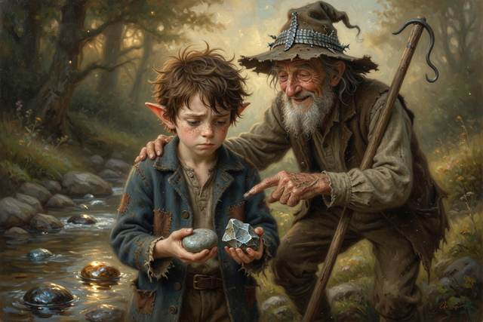
“Walt. Why are these two so different?”
Hal turned the two stones over in his hands. “I think the round one has been rolled,” he said. “Like a cookie crumb that has been in my pocket all week.”
“Ah,” said Walt, smiling slowly. “You have it already. That one’s fresh from the mountain. It’s been in the stream a week. And that one’s been in it a thousand years. The water rolls them, and rolls them, along the bottom, and every roll takes a speck off the corners. Given enough time, a stream will turn a boulder into a pebble.” He turned the round stone in his hand. “The long way makes everything smooth. That’s all it does. It takes time.”
Scally had been scratching his head. He sat, one-booted, on a log, a short way off. “It’s miles round these bends,” he said, loudly. “The whole thing is a waste. Look.” He pointed across the grass. “The next three loops come back so close to here, you could throw a stone across. Walt, I’m telling you, there’s a neck of land, just there, ten steps wide. We could cut across, and be at the top of the bend before you’ve had your lunch.”
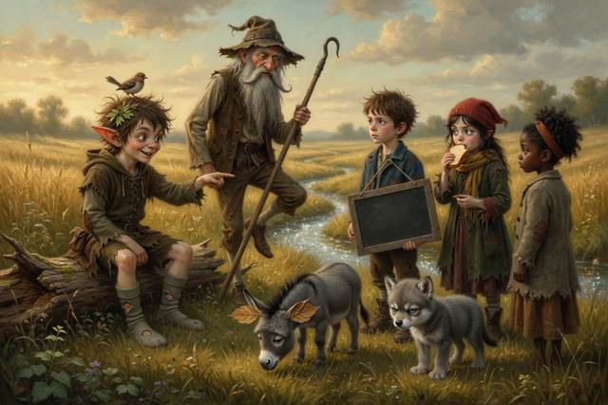
“No,” said Walt.
“It’s dry,” said Scally. “It looks dry. It looks perfectly firm.”
“It is wet clay,” said Walt, “under the grass. I know that neck. The ground looks solid and holds you for six steps, and then it lets go.”
“Right,” said Scally. “Then I’ll go and look, to see for you. I’ll tell you what’s there.”
“No,” said Walt.
But Walt had turned to look at Dumpling, who had begun to eat the grass, and when he turned back Scally had gone.
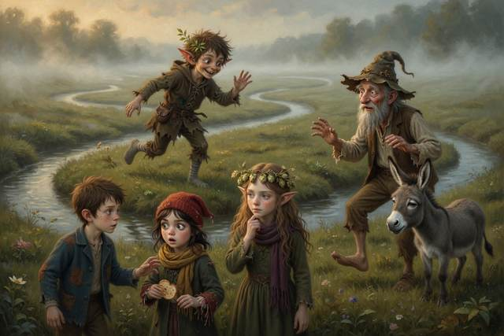
“I’m only scouting!” came a cheerful voice from far off. “I’ll shout when I find the path!”
There was a pause.
“He’s going to go across it,” said Titch.
“Of course he is,” said Hopsi.
They stood up. They followed along the firm bank, the long way round. At the second bend a mist rose off the wet ground and turned, in a few minutes, into a thick white fog.
“Walt,” called Hal.
“Stay together,” said Walt’s voice, from the white. “Stay on the bank. Don’t anyone wander.”
“Scally?” called Tabitha.
Nothing. Then, far away, thin, a voice.
“I’m fine! There’s a firm path! I told you. It’s only a bit squelchy. Come on, it’s quicker!”
“He’s lying,” said Hopsi, quietly. “It is not firm. He has been caught and he’s saying it is.”
“How do you know?”
“Because,” said Hopsi, “the first word he said was ‘fine’.”
Walt took out his whistle. He blew three blasts, long and short. They hung in the fog, and then, from the left, came a faint echo. And then, from the right, much fainter, an answering reply, three weak puffs on something small. Scally had a whistle too, a tin one he had won off a pedlar.
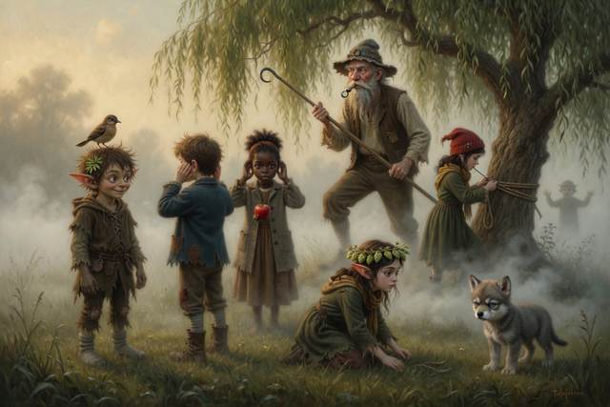
“There,” said Walt. “Left of the big willow. Slowly. Along the bank, Titch, tie that rope to the tree. Hopsi, lie flat.”
They found him in clay up to the knees, in the middle of the neck, and the other boot was gone. The soil had held him for six steps and let go on the seventh. He had stopped struggling, which was clever, because struggling sinks you. He stood perfectly still in the fog, with his arms out, green about the face.
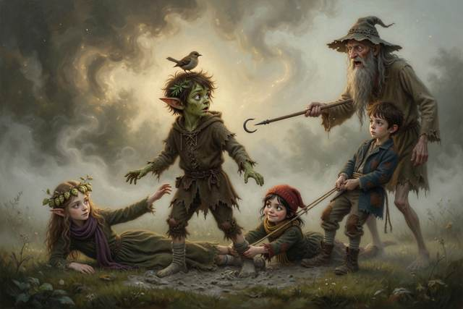
“It’s — it’s not firm,” he said, in a small voice. “It’s — Hop, I said it was firm.”
“I know,” said Hopsi. She was lying flat on her stomach, with her arms stretched out, because that spreads your weight. Titch was behind her, holding her ankles. Hal had the rope tied round his waist. “Hold the rope. Do not pull. Lean, and let us pull.”
“I lied,” said Scally. “I knew it wasn’t.”
“Yes,” said Hopsi. “Hold the rope.”
It took ten minutes. Clay does not let go easily. At last, with a noise like a giant kissing a cheek, it gave up Scally, and Scally came out of it on his stomach, covered in gray from the neck down, with no boots at all, and lay in the grass with his eyes shut.
“Both boots,” he said, after a while. “They’re both gone. That’s — Hop, that’s the last of the boots.”
“They were good boots,” said Hopsi. “I am sorry.”
Scally opened one eye. “I’m a liar,” he said, in a hoarse, flat voice. “I tell people it’s fine and it isn’t.”
“You told us it was firm,” said Hopsi, “because you did not want to be the one who was wrong. That is not the same as being a liar all the way through. It is being afraid.” She sat up. “You could say, ‘I’m stuck.’ That would have been true, and shorter.”
Nobody said anything for a long time.
Walt sat down on the grass beside him, rubbing his bad leg. “I know that neck,” he said. “I took it once, when I was your age. I was in a hurry. A voice said it would be quicker.”
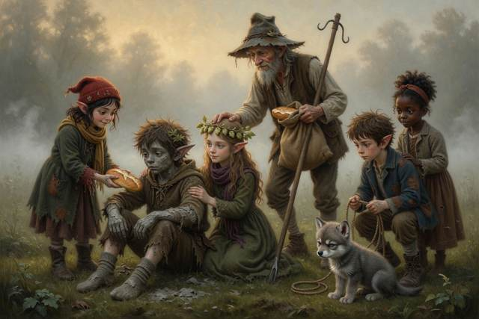
“A voice?” said Hal.
But Walt only shook his head and said, “Later.” He gave Scally the second sack, and the rest of his own bread, and for the rest of the afternoon, up the long, long bank of the Wandering Stream, the five of them walked together, the long way round, and nobody said it was a waste.
Behind them, fainter now, the stream hummed.
“A short,” it said. “A short. Cut. Is…”
↑ Contents

Chapter 5. The Fire and the Voice
They camped that night on a stony shelf above the stream, where the ground was dry and the wind came from behind.
Old Walt chose the spot, and he chose it the way he chose everything, slowly, looking at the ground first. “Never camp low,” he said. “Never camp in a dry gully, either, however kind it looks. Water comes down gullies. Up here, on the stones, we can see the stream and the stream can’t get at us.”
He built the fire himself, and he built it properly. First he cleared a circle down to the bare stone. Then he ringed it with big pebbles from the stream. Then he set a bucket of water beside it, filled to the brim.
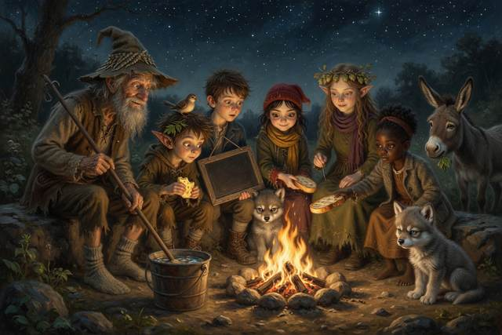
“Why the bucket?” said Titch.
“Because the fire is not in charge,” said Walt. “I am. And if it argues, there’s the answer.” He lit it with one strike. It caught, and crackled, and threw sparks up at the stars.
Hal sat very upright. He remembered the mill yard, and the heap of straw, and a green crack of light. “Fire needs three things,” he said. “Fuel, heat and air. We have given it wood. We’ve left it air. We must not let it have more than we want.”
“And in the morning?” said Walt.
“Drown it,” said Hal, “stir it, and drown it again. Until the ashes are cold to your hand.”
Walt looked at him for a moment. “Somebody taught you well.”
“A lot of people,” said Hal, “and one bonfire.”
They ate Titch’s crusts, and apples, and a hard yellow cheese, and Walt’s stew, which was mostly turnip. Gucci lay with his chin on Hal’s knee, trying to look as though he was not watching the cheese.
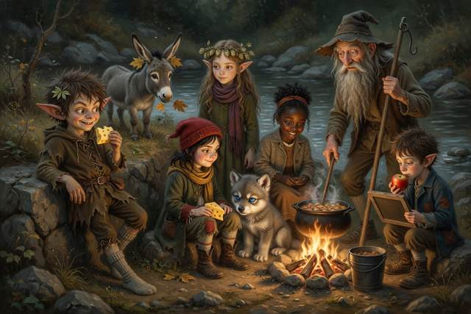
Scally had his back against a rock. His feet were wrapped in two of Walt’s spare socks, and he was not saying much. He had a large bite of cheese in one hand. And under his jacket, if anyone had looked, there was a second large bite, wrapped in a cloth, from Titch’s bag.
Nobody looked. Except Hopsi, who was sitting on the other side of the fire, with the light on her face. She did not look at the jacket. She looked at Scally’s chin.
“There is a crumb,” she said, “on your chin. It is from the cheese in Titch’s bag. She said she was counting it, because there were seven pieces and there are six of us, and one was for Gucci.” She waited. “There are now five.”
Scally went rigid. Then, slowly, he put his hand into his jacket and brought out the cloth.
“I was saving it,” he said.
“For whom?” said Hopsi.
He shut his mouth. Then he put the cloth in the middle of the fire-circle, on a flat stone, and opened it. There was a piece of cheese the size of a thumb.
“I’m hungry,” he said, quietly, to the stone. “I’m always hungry. In the mill loft, at night, it’s quiet. I wake up and I’m hungry and there’s nobody there. I took it from Titch’s bag when she wasn’t looking, and I thought, I’ll say it was mine. And then I couldn’t eat it. It’s no good if you can’t say who gave it.”
There was a silence.
“Scally,” said Titch.

“Yes.”
“If you’re hungry,” said Titch, “you say so. And I give you a crust. I always have a crust. You’ve never asked.” She picked up the cheese, broke it in half, evenly, and put one half back on the stone. “That’s yours. That’s mine. Now it’s fair.”
Scally took it. He did not say thank you. He ate it slowly, looking at the fire.
“That,” said Walt, “is the first thing I’ve seen all day that made sense.”
The stream hummed. It had grown into a long, trembling, mournful note, under the crackling, and the wind took it and carried it away, and brought it back. Gucci’s ears went flat. Fourpence, on Dumpling’s ear, sang four notes and stopped.
“Listen,” said Tabitha.
They listened. And in the dark, under the stars, they heard it. The hum was no longer a hum. It was a voice. It was thin and soft and sugary, and it came up from the water in a slow, endless loop.
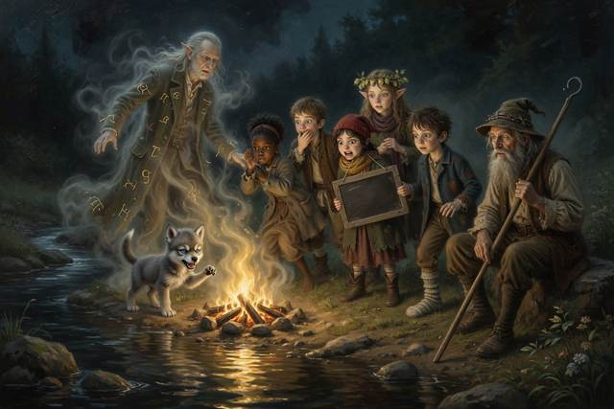
“A shortcut,” said the stream, “is only…”
It stopped. A pause, a long breath, a gurgle.
“A shortcut,” said the stream, “is only…”
Nobody moved.
Hopsi’s face had gone white as paper. Hal felt his scalp tighten. Gucci growled, low, like a kettle, at the water.
“That’s him,” whispered Titch. “That’s the soft voice. That’s the sweet-man. That’s his last—”
“It’s the end of his sentence,” said Hal. “The one he didn’t finish. When the flour came down on him. He said ‘A shortcut is only—’ and then the fog took him.”
“And the stream’s been saying it ever since,” said Tabitha. “It can’t stop. It’s stuck. Like a song that’s lost its last line.” She stared into the dark. “It’s a sleepless stream. It can’t sleep, because the sentence isn’t finished.”
Walt had not said anything. He sat, with his leg stuck out stiff, looking at the fire, and his face in the flames was very old.
“I know that voice,” he said.
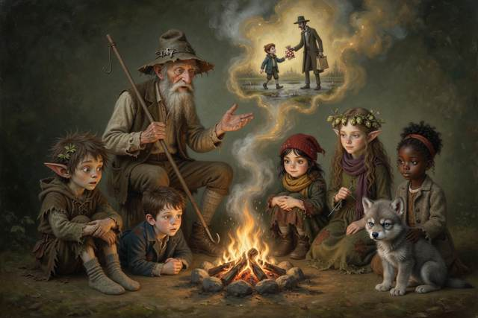
They all turned.
“I was ten,” said Walt. “I was in a hurry to get home across that neck of clay, the one you walked into today. It was a wet autumn, and the way round was an hour. And a man in a dark coat came by with a bag of candy, and a smile that was a size too big, and he said, ‘Come with me, little man. I know a quick way. A shortcut. Ten minutes, straight across.’ And I went.” He rubbed his leg. “I went six steps. The seventh, there was nothing there. I was in it to the chest. I screamed. And an old man came, a stream-keeper, who had looked after this water forty years. He pulled me out with a pole. I lost the use of my leg, and I never lost my fear of that voice. And when the old man died, they said, ‘Walt, you’ll do.’ I’ve looked after this stream ever since.” He stopped. “I never knew the end of the sentence. He said it as I went into the water. ‘A shortcut is only—’ And I never heard the rest.”
The fire cracked.
“What happens,” said Hal, slowly, “if it never ends?”
“A stream learns slowly,” said Walt. “All summer it has been taking in what was left in it. Tonight it knows the sentence by heart, and it cannot put it down. A stream that cannot sleep runs hard. It eats its banks. It drags at the bog. It pulls in the little streams on either side. By tomorrow dusk, if it goes on rising, it’ll be in the mill.” He looked up. “We have to finish the sentence. I think that is what it wants.”
“Then we say the end,” said Titch.
“I do not know the end,” said Hopsi.
She said it flatly, the way she said it when she meant it. She had her hands pressed together in her lap. “I only say what is true. I cannot make up an ending, because if I make one up, it will be a lie, and a lie will not finish it. It would only wind it tighter.” She looked at the fire. “I do not know how it ends.”
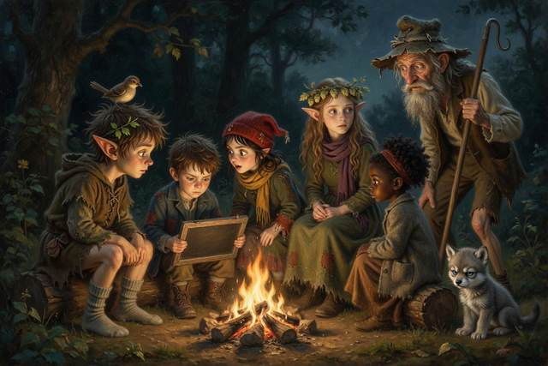
“Then who does?” said Scally.
Nobody had an answer. In the silence, Hopsi got up. She went to the edge of the shelf, where the stones lay in a heap, and she took three white ones. She set them in a row across the path, a few feet from the fire. Then she moved the middle one aside, and back again.

“In case,” she said, to nobody.
They lay down in their blankets. The stream sang on in the dark, “A shortcut is only…” and nobody slept, and nobody expected to.
Before dawn Hal crept down to the pool by the camp, to wash his face. The water was black, and still, and the stars lay in it. His reflection looked up at him, thin and yellow in the starlight. It had its mouth open. It was yawning, enormously, and trying not to.
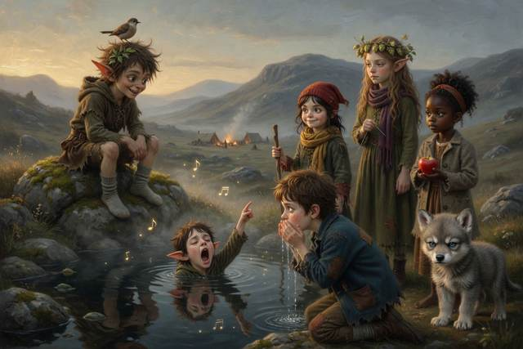
“UP,” it mouthed. And then, slowly, it pointed with its whole arm toward the hills, and the gray light, and the long climb.
↑ Contents

Chapter 6. The Count Between
In the morning they came to the Falls.
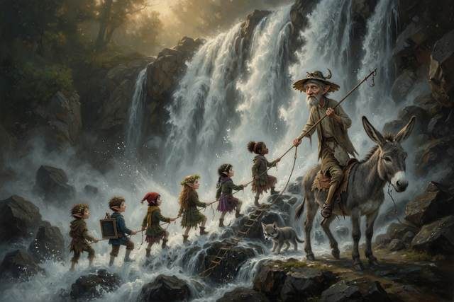
The Falls were a wall of gray water, as high as a church, coming down from a lip of black rock into a pool that boiled white. The air was full of fine wet spray, and the roar was so loud that a person could not hear himself think. Under it, the hum went on.
“The path goes up the left side,” shouted Walt. “It’s steep, and it’s wet. Nobody goes anywhere alone. Nobody leaves the path. Hold the rope!”
They had to climb, one behind the other, on a rope. Dumpling went last, in no hurry, with her ears forward. At the first ledge they stopped for breath and looked down, and the whole valley lay behind them in the morning sun, small as a toy.
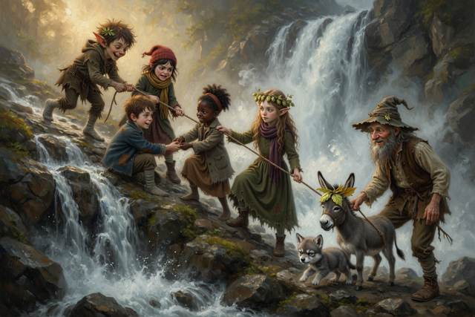
“Listen,” shouted Hal. He cupped his hands. “HELLO!”
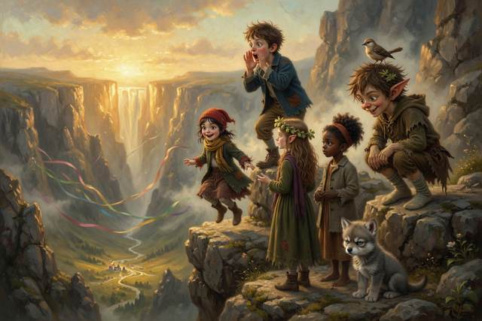
“Hello… hello… hello…” answered the cliff, from somewhere across the gorge, three times, each one smaller.
“It’s an echo!” said Titch. “It talks back!”
“It does not talk,” said Hopsi, quite loudly. “It repeats. A sound goes out, hits the rock, and bounces back. That is all. It can’t say anything you did not say.”
Scally had been listening with his head on one side, and a large smile spreading across his face. “Right,” he said. “Right. Watch.” He walked a few steps away, round a rock, out of sight. “TITCH!” he shouted. “TITCH OWES SCALLY A CRUST!”
There was a pause. Then the cliff said, in a voice that was most definitely not the cliff’s, “Titch owes Scally a crust… crust… crust.”
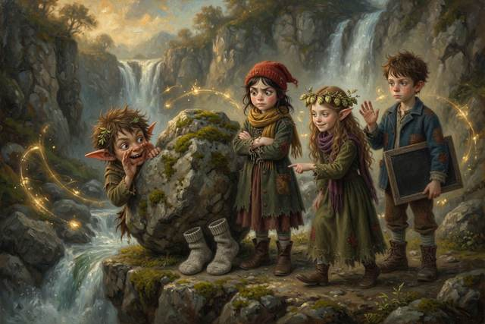
“Oh, does she,” said Titch, narrowing her eyes.
“The cliff said so,” called Scally’s voice, with enormous innocence. “It’s a magic cliff. You have to pay.”
Titch said nothing at all. She walked round a different rock, out of sight, cupped her hands and took a deep breath. “SCALLY OWES TITCH TWO CRUSTS!”
There was a pause. “Scally owes Titch two crusts… crusts… crusts,” said the cliff, in a voice that was most definitely not the cliff’s, and rather better than his.
“That’s not fair!” said Scally, coming out with a crust-shaped hole in the air where his plan had been.
“The cliff said so,” said Titch. “It’s a magic cliff. You have to pay.” She held out her hand, and after a long moment, grinning in spite of himself, he put two crusts in it.
“It was a good trick,” said Scally. “Yours was better. Mine was only a trick. Yours was funny.”
“A cliff can only say what you say,” said Hopsi to Hal, who was watching with his mouth open. “It repeats. It cannot make anything up.”
Hal had been timing the echo. “One,” he said. “Two.” He frowned. “Walt, when I shout, it takes two counts to come back. How far is the cliff?”
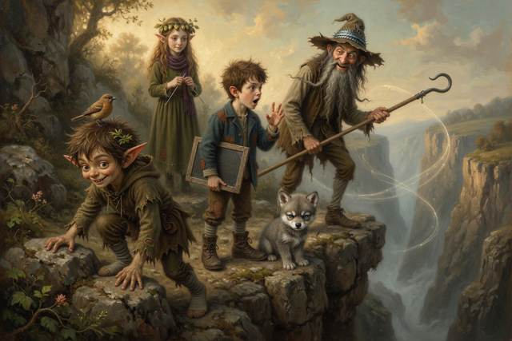
“Sound travels about a fifth of a mile in one count,” said Walt. “Two counts there and back means one count each way. So the cliff is about a fifth of a mile off, a long stone’s throw, and you could throw it twice.” He grinned in his two-ways beard. “Count the echo, and you know how far the wall is. Bats do it. So do ships in the fog.”
Hal wrote it on his slate. ECHO: COUNT TO IT. HALF OF THE COUNT IS THE WAY THERE.
It was just as he finished that the sky began to change.
It happened quickly. One minute there was a bright blue lid over the gorge. The next, a dark wall of cloud had slid over it from the west, and the first big drops fell, one by one, with a thump, on the stones.
“Weather,” said Walt, looking up. “Off the ridge. Right now.”
They got off the ledge. They reached a flat shoulder of rock above the Falls. On it stood a single huge oak, alone, tall as a house, with branches spread like arms.
“Shelter!” said Scally. “Come on! It’s dry under there!” He ran to it, under the big branches, and sat down, with his back to the trunk. “Best seat in the house. Come and sit! I got here first, so I’m in charge of the dry bit. A penny a place.”
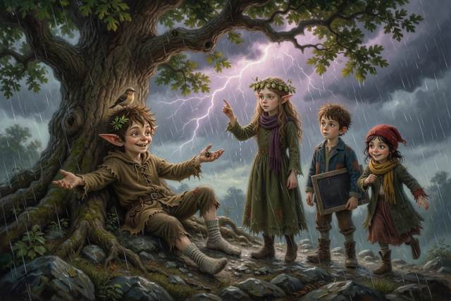
“Scally,” said Hopsi.
“Don’t,” said Scally.
“The tree is the tallest thing for a mile,” said Hopsi. She spoke gently, standing in the rain with her hair dripping. “When the sky has lightning in it, it likes tall things. Is that where you ought to be?”
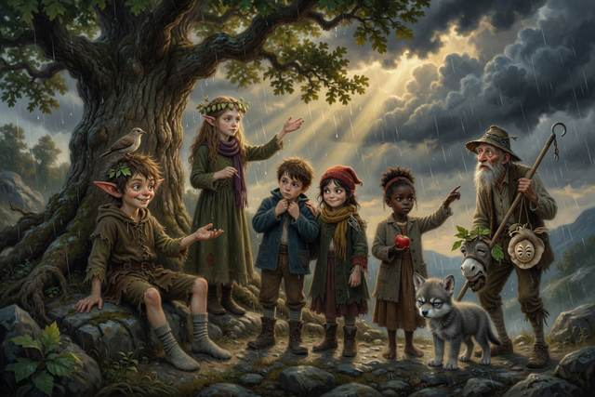
There was a flash.
It was pale violet, and lit up the whole gorge, and every one of them saw every bone in the next one’s face. A moment later, the thunder came, a long, sullen rumble.
“One,” said Titch, who had been counting. “Two. Three. Four. Five. Six.”
“Five counts is about a mile,” said Walt, grabbing Dumpling’s halter. “Six is more than a mile. It’s coming. A house is the best place in a storm, or a car, and there is neither. So we go low, and away from the tree and the water. Now. Find a dip, and crouch with your feet together. Don’t lie flat, and don’t shelter under anything tall.”
“Light comes first,” gasped Hal. “Sound comes after. That’s why you can count.”
“Yes,” said Walt. “Light is fast. Sound is slow. The count between them is how far away the storm is. Go!”
Scally went. He abandoned the dry seat without another word and scrambled out into the rain, and they all dived into a hollow of heather on the other side of the shoulder, thirty steps from the oak, and crouched in a tight bundle, wet through, in the dark, with Gucci in the middle and Dumpling’s head laid, helpless and patient, across Walt’s back.
“One,” whispered Titch. “Two.”
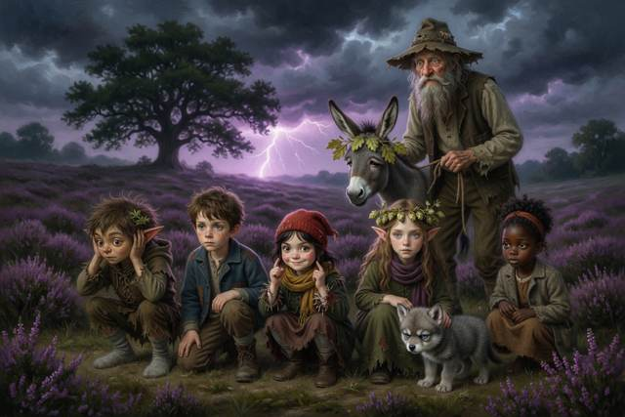
The flash came again. This time the thunder followed hard on its heels. “Two!” said Titch. “Half a mile!”
“Stay down,” said Walt.
The next came without any count at all. It was a white, tearing flash, and a clap that shook the stones in their sockets, and a smell of burnt air, and a sound like a giant tearing a sheet. They saw it hit. It struck the oak square on the crown, in a bright blue tree of fire, and the great old tree split from the top to the roots with a crack that numbed their ears. Half of it fell, slowly, right across the rock where Scally had been sitting.
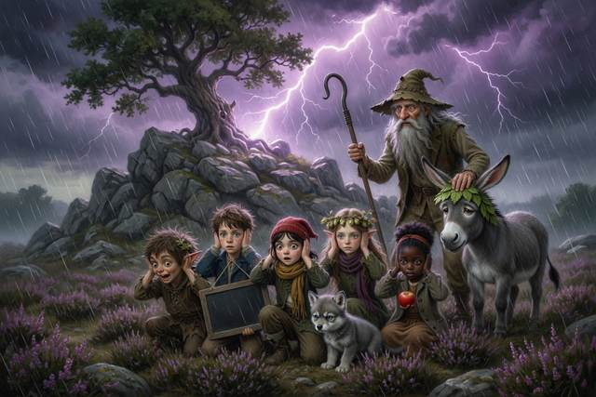
There was a long silence, full of ringing.
“Everyone all right?” said Walt, in a cracked voice. “Count heads.”
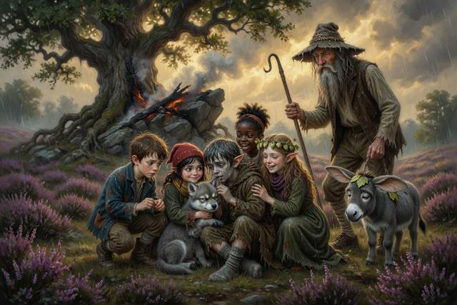
“One,” said Hal.
“Two,” said Titch. “Three. Four.”
“Five,” said Tabitha, “six, seven.” She laughed, high and shaky. “Gucci’s the seven.”
“And me,” said Scally. He was in the middle of the heap, in a ball, with his face in the heather. When he lifted it, it was gray as the ash of an old fire. “I was going to sit there.” His voice was small. “I wanted the dry seat. I was going to charge you a penny.”
“Yes,” said Hopsi. Her hand was shaking, but her voice was not. “I know.”
“Hop,” said Scally.
“Yes?”
“Thank you for asking me where I ought to be.”
“I did not tell you,” said Hopsi. “I only asked.”
↑ Contents

Chapter 7. The Brown Water
The storm went as it came, all at once.
The rain stopped. The cloud tore. The sun came out with a bang, and the whole gorge steamed like a boiled pudding. For a minute it was almost funny. Dumpling sat down in a puddle and refused to get up. Gucci shook himself all over Walt, who said it was the first bath he had had since spring. Titch wrung out Tabitha’s braid like a dishcloth, and Scally, who had a whole oak leaf stuck to his forehead, announced that he was now an official stream-keeper. Walt got stiffly to his feet and looked at the sky, and at the Falls, and then, long, at the water.
“Hal,” he said. “Come here.”
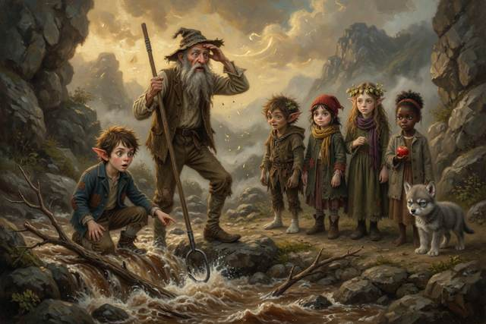
Hal came.
“What color was the stream this morning?”
“Green,” said Hal. “Clear. You could see the stones.”
“And now?”
Hal looked. The water below the Falls, where it had been green and clear that morning, had gone the color of cocoa. It was thick, and brown, and full of sticks and froth. And as he watched, a whole branch swept by, turning over and over, much faster than a person could walk.
“It’s rising,” said Hal. “Look at the stones. The bottom ones are gone.”
“It has rained,” said Walt, quietly, “for an hour, on the hills above us. The water from all those hills has to come down one way. It comes down here.” He shut his eyes. “Listen.”
At first Hal could hear nothing but the Falls. Then, under it, far away, he heard a long, deep, rolling sound, like carts on a stone bridge, or the wind in a chimney. It was coming closer.
“Flash flood,” said Walt. He opened his eyes. “UP. Everybody up the bank, now. High ground. Leave the bags. Leave everything.”
They ran.
It was the longest minute of Hal’s life. The path was steep and slick with rain. Titch went first, hauling Dumpling by the halter, with Tabitha pushing from behind. Hopsi had Gucci under one arm, which was a great deal like carrying a cushion with a motor. Hal turned and looked back.
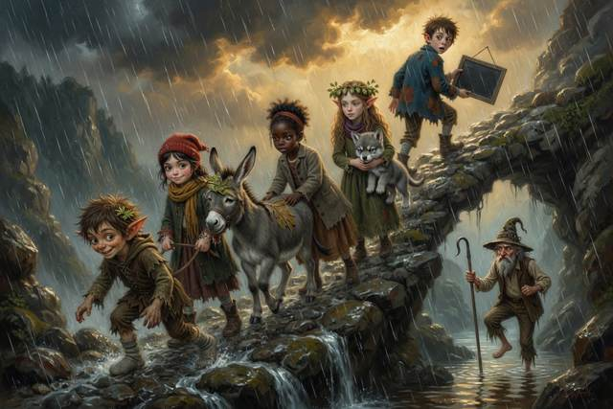
Walt was not coming.
He was on the lower path, thirty steps down, leaning on his pole, one leg stiff and useless. He was trying to climb, and every step took him a full breath. The roar behind him was growing, louder and louder, and now there was a thin brown tongue of water running over the stones at his feet.
“Walt!” shouted Hal.
“Go on!” shouted Walt. “Leave me! My knee—”
“No,” said Hal. He said it in the flat, dry voice. He pulled the rope from his shoulder. “Scally! Rope!”
Scally was already beside him. He had been the first up the bank, and he was the fastest runner of them all, but he had not gone on. He was standing with his bare, sock-wrapped feet planted and his face stiff with something that was not fear.
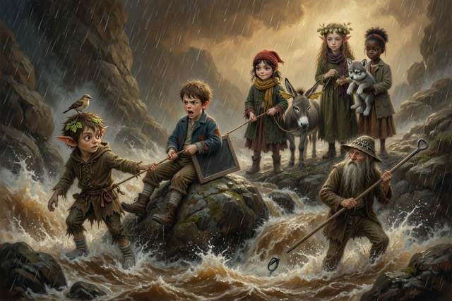
“I’m going down,” he said.
“You’re not going in the water,” said Hal.
“I’m not going in. I’m going to the edge.” He took the end of the rope and tied it round his waist with a neat, quick knot. “I’m the lightest. I’m the quickest. If he falls I’ll reach.” He looked at Hal. “It’s fine. I’m fine.”
“Scally,” said a voice, and it was Hopsi’s, on the bank above.
“Don’t,” said Scally, without turning.
“Your hands are shaking.”
He stopped. He looked at his hands. They were shaking, hard, like leaves. He held them out in front of him, and stared at them, as though they belonged to someone else.
“I’m scared,” said Scally. “I’m so scared I can’t feel my feet.”
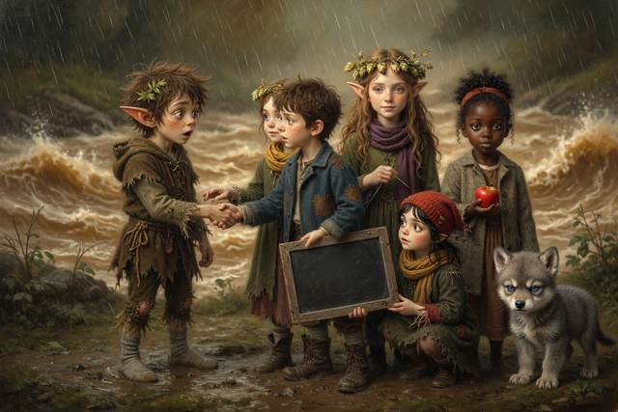
“Yes,” said Hopsi. “Now you have said it. Is it easier?”
He drew a long breath. He let it out. His hands went on shaking, but something in his shoulders eased. “A bit,” he said.
“Then say it to Hal,” said Hopsi, “and he can help you.”
Scally turned. “Hal,” he said. “I’m scared. I can’t do it alone. Will you hold the rope?”
“Yes,” said Hal. “I’ll hold the rope. Titch! Dumpling!”
The next minutes were a blur of brown water and shouting. Hal sat down hard on a boulder with the rope round his middle and dug in his heels. Scally ran down the bank to the very edge of the rising water and held out his hand.
“Walt!” he yelled. “Take it!”
Walt took it. It was not enough. The water had reached his knees now, and it pulled at him with a steady, hungry drag, like a hand. The old man swayed.
“The donkey,” said Tabitha, behind Hal. “Tie the rope to Dumpling.”
Titch had already done it. She had run the other end back round Dumpling’s chest in a double loop, and she was standing at the donkey’s head, clicking her tongue. “Walk on, girl,” she said. “Walk on.”
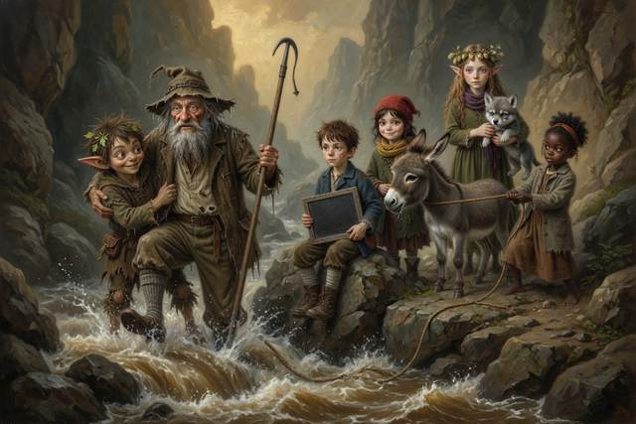
Dumpling, who had walked at the pace of an elderly clock for two days, walked on.
She walked up the path, steady, slow and strong, with her ears pricked and the rope taut behind her. And at the bottom of the rope, up to his thighs in the flood, Walt came out of the water, dragging his bad leg, with Scally’s arm round his waist and Hal’s heels dug in on the bank.
They all got up, at last, on a ledge forty feet above the stream, in a heap, gasping.
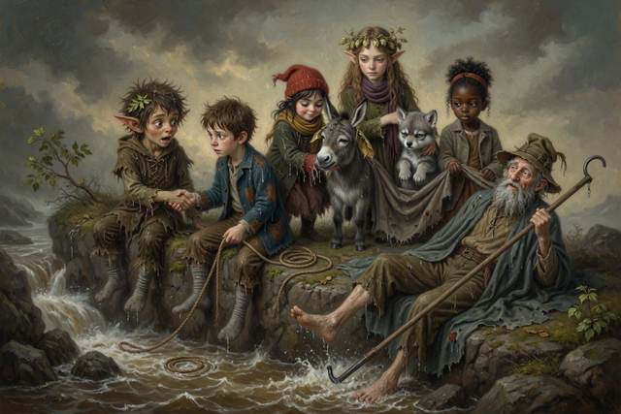
“That,” said Walt, after a while, “was foolish of me.”
“It was,” said Hopsi.
“I should have said the rule myself. A stream-keeper doesn’t stand in a gully.” He lay on his back, looking at the sky. “I stopped to look at it. Fifty years, and I stopped to look. And it was a young boy with no boots who came and got me.” He turned his head and looked at Scally. “I thank you.”
“It was Dumpling,” said Scally. He could not seem to stop his hands. “She did it.”
“She did,” said Walt, “and so did you. Next time, throw the rope and stay on the bank. But I thank you, and I mean it.”
They watched the flood. It was brown and ugly and roaring, and it swept away the lower path and the whole of the grass they had crossed that morning. And far under the thunder, in a dark gap between two notes of it, the stream said, thin and cold and calm:
“A shortcut is only…”
“We’re running out of time,” said Hal.
“Yes,” said Walt, getting up. “If it is rising now it will be down in the village by dark tomorrow. We’ve one more climb. Come on.”
↑ Contents

Chapter 8. The Whirl
They came to the bog at dusk.
It lay at the head of the valley, gray and wide, like a dish of cold porridge. Old Walt stopped them at the edge on the firm ground, and he pointed with his pole to a green path, and nobody argued with him.
“That is the only way,” he said. “Stay on the green. Look for the reeds. Reeds mean wet. Follow me, in line, and put your feet where I put mine.”
They crossed in single file, slowly. Gucci went ahead, nose down, picking his route as if he’d done it all his life. Titch walked behind with her rope looped in her hand.
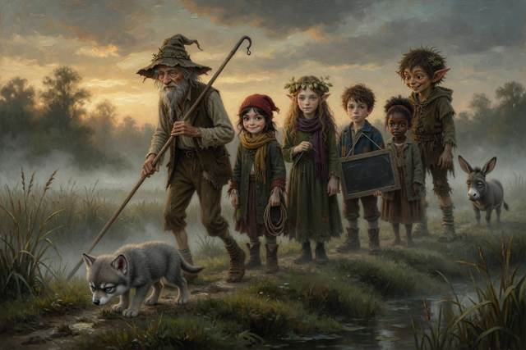
Halfway across, Dumpling stopped dead, looked at the bog, looked at Walt, and sat down. “She will not be carried,” said Walt. “She will be persuaded.” Titch offered half a crust. Scally offered to push, and was looked at. In the end it was Tabitha who hummed, very low, the five notes of the stream, and Dumpling, with a long-suffering sigh, got up and walked on as though the whole thing had been her own idea. And at last they came out on a low, flat bank above the pool.
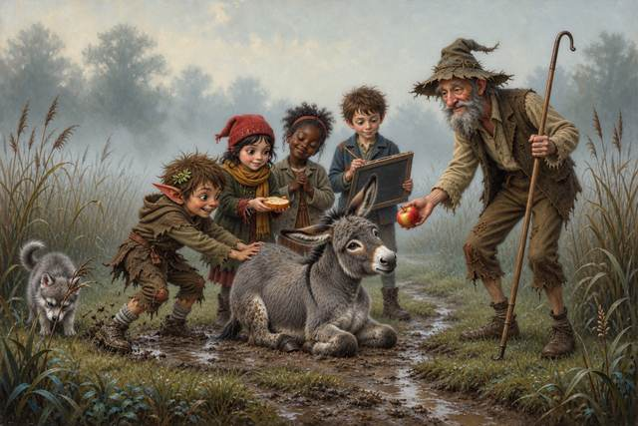
It was the Source. The stream began here, welling up from underground in the middle of a black round pool as wide as a barn. Round and round, in the middle, the water was turning.
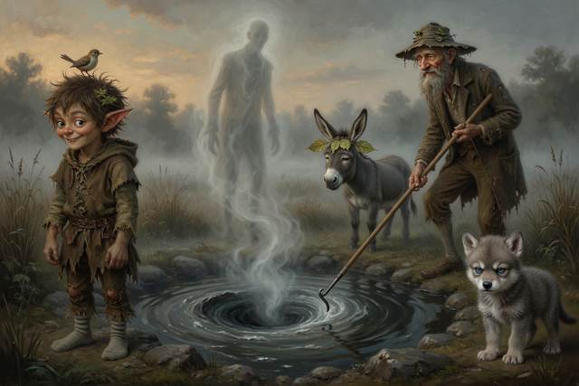
It turned slowly, in one great smooth spiral. In the center there was a deep, dark funnel, and a faint sucking noise. From the whirl rose a pale thin mist, shaped, if you did not look straight at it, like a very tall man in a long coat.
“A shortcut is only…” said the mist.
Nobody breathed.
It was a voice, but no longer a stranger’s. It was worn thin, and stuck like a needle in a groove, the voice of one sentence said ten thousand times.
“Right,” said Tabitha. She was whispering. “So it’s a whirlpool.”
“It is,” said Walt. “Whirlpools are only water going round a drain. Water wants the lowest place. When it finds a hole, it spins as it goes down. This one has been spinning ever since the stranger fell in here. He fell into a good many bogs, that man, and left a bit of himself in each. This was the last of him. It has never been allowed to stop.” He held up his pole. “Nobody goes near the edge. Nobody. It would take a grown man down like a straw. Reach or throw.”
“Then how do we finish it?” said Hal.
“We say it,” said Titch. “Don’t we? The end. We just say the end.”
“We do not know it,” said Hopsi.
“I do!” said Scally.
He stepped up to the edge of the bank. He was shaking all over, gray in the dusk, but his chin was up, and in his face was the old glint, bright and eager. “I know what a shortcut is only. I do. I’ve been thinking about it for two days. A shortcut is only a hat! Or a bucket, or a goose, or—” He took a breath, cupped his hands, and shouted to the whirl. “A SHORTCUT IS ONLY A HAT!”
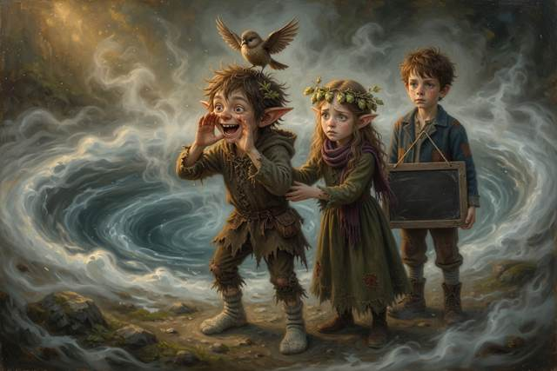
The mist swayed.
For one long second, nothing happened. The whole bog held its breath. Then the whirlpool gave a great gulp, like a swallowed laugh.
“A shortcut,” said the voice, in the water, “is only…”
And the whirl began to turn faster.
The water ran up the bank and slapped at their feet. The stream roared. Fourpence flew up from Dumpling’s ear, singing four notes, wildly, and fluttered back.
“It’s not working,” said Hal. “Scally, what did you do?”
“I made one up,” said Scally. His face had changed. “I made it up. I thought if I said something, anything, with enough nerve, it would think it was the end, and stop. I thought I could trick it.”
“Is it true?” said Hopsi.
“No.”
“Then it cannot finish it,” said Hopsi. “A lie cannot be an ending. It can only be another beginning.” She put her hand on his arm. “You do not have to be clever. You only have to be right.”
“But I don’t know what’s right!” Scally’s voice cracked. “I never know! I only know how to get round things!”
“GUCCI!” screamed Titch.
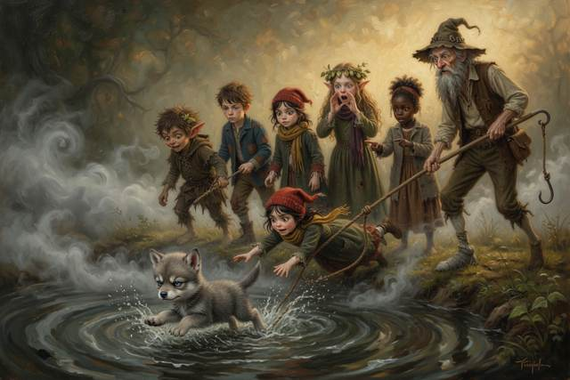
Gucci had taken a step too far. A wave had run up the bank and caught his paws and, with a startled yelp, the young wolf was dragged, sliding, spinning, toward the edge of the whirl.
Titch went after him. She did not think. She threw herself flat, the way Hopsi had taught them, and caught him by the scruff with one hand, and the water caught her by the boots. The two of them slid. Hal grabbed the rope. Tabitha grabbed Hal. Walt grabbed Dumpling.
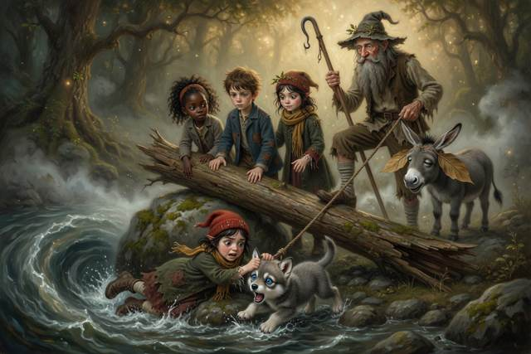
“Chain!” roared Walt. “All of you! Hold! Nobody lets go!”
They held. Titch, on her stomach, with Gucci’s scruff in her fist, was sliding inch by inch to the edge. Hal felt the rope burn through his palms.
“Lever!” shouted Tabitha, behind him. “Hal! Use the log!”
He saw it. A fallen tree lay on the bank, as thick as a man, one end across a mossy boulder. He remembered a stream and a stone and a long plank, and a push of two fingers that had lifted a weight ten fingers could not. He knotted the rope to the short end of the log, where it lay across the boulder, and threw himself on the long end. “Scally! Help me!”
Scally came running. They heaved together, and the long end went down a long way, and the short end came up a little way, with great strength. The rope came taut and rose with it, and Titch, with Gucci in her arms, shot out of the water like a cork from a bottle.
They fell in a heap on the bank.
“I’ve got him,” gasped Titch, “I’ve — oh, Gucci!”
Gucci was sodden, gray as a rat, and furious. He sneezed twice. Then he put his head in Titch’s lap and shook all over.
“You went to the very edge,” said Walt, and his voice was not quite steady. “That is the thing I told you never to do. You lay flat, you held on, and the others held you. That is the only reason this ended well. Next time, shout for the rope first, and let the rope go in, not you.”
“I know,” said Titch, small. “I did not think. He is my Gucci.”
“That is a good reason,” said Walt, “and still not an excuse. But nobody is hurt, and we all know it now.” Tabitha put her coat round Titch’s shoulders and sat there until the shaking stopped.
“A lever,” said Hal, panting. “The long end goes down a long way and the short end lifts. Told you.”
“You didn’t,” said Scally.
“I wrote it down.”
Neither of them could stop grinning. And behind them, in the whirl, the stranger’s mist sagged and swayed. It hung in the air like a coat on a nail. “A shortcut,” it said, in a thin little thread of a voice, “is only…”
Then it stopped, and waited, and nobody knew for what. ---
↑ Contents

Chapter 9. The Long Way Round
They sat on the bank in the dusk, in a ring, with their backs to the whirl, and nobody talked for a while.
Titch was wrapping Gucci in her coat. Tabitha held a canteen to Walt’s lips. Dumpling lay with her nose in Hal’s pocket, looking for the last apple. And Scally sat apart, with his arms round his knees, as quiet as a stone.
“Hal,” said Hopsi.
“Yes?”
“Your slate.”
Hal took it out. It was soggy, and the chalk had run, but he rubbed his sleeve across it and began to write, in his small neat hand. Hopsi sat down beside him and read over his shoulder, a line at a time, while the others drifted in and sat round.
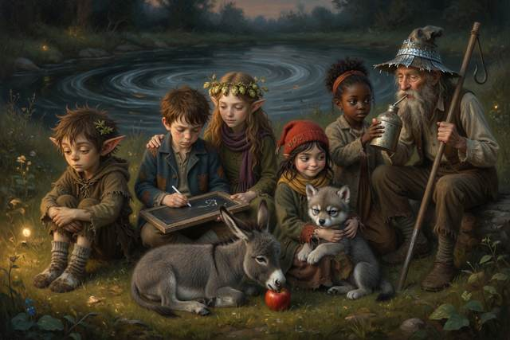
“What are you writing?” said Titch.
“The data,” said Hal. “Everything that happened. Look, count, test.” He tapped the slate. “Shortcuts we took. Number one: the clay neck. Scally went across it to save a bend. It took one hour and ten minutes to get him out. It cost two boots. It saved nothing. Number two: the high ledge in the storm, the dry seat under the oak. That saved nobody anything. It nearly cost a boy his life.” He kept writing. “Number three: Walt going to look at the stream instead of climbing. It cost us half a day, and nearly Walt.”
“Number four,” said Walt, quietly, “was me, when I was ten.”
“That’s four,” said Hal. He wrote it. “Shortcuts that worked: none. Four tries is not many, so I cannot say never. But I have looked, and I can’t find one.”
Walt had been listening with his head on one side, the way he listened to water. “Read it to me again,” he said. “The part about the neck.”
Hal read it aloud, slowly. When he had finished, Walt was quiet for a while.
“I cannot read it myself, you know,” said Walt, rather gruffly, to the grass. “Fifty years I have kept this stream in my head, every bend and bog and gully, and I never learned my letters. There was never anybody to teach me, and then there was no time.” He cleared his throat. “It is a strange thing, to hear it written down.”
“I will teach you,” said Hal.
“Slowly,” said Walt. “I am old.”
“Slowly,” said Hal, and wrote a big W in the corner of the slate, and held it up.
“And long ways?” said Tabitha.
“We went the long way round the bend,” said Hal. “We crossed the pool on a raft, with a rope. We climbed the Falls on the rope. We got through the bog on the green path, in single file. All safe.” He looked at his slate. “Every long way has got us here. And every shortcut has been the longest of all.”
“Because a shortcut is only quicker if it works,” said Tabitha.
They all stopped.
Tabitha said it again, half to herself. “If it doesn’t, you’re lost. And then it’s the slowest way of all.”
There was a long silence. The whirlpool went round in the dusk, with its mist like a coat on a nail, and as they listened, it said, in a low, uncertain voice:
“A shortcut is only…”
“Say it,” said Titch.
“I can’t,” said Tabitha. “I’m not sure.”
“I will,” said Hopsi.
They looked at her.
She was sitting very straight, on a stone, with her hands in her lap. Her face was pale, and set, and a little afraid. “I cannot say anything I do not know is true,” she said. “That is my one rule. I do not know it is true. But we have looked, and counted, and tested, and Hal has written it down. And it seems to me that it fits.” She swallowed. “So I will say it, and I will say how sure I am. I will say, ‘I think.’”
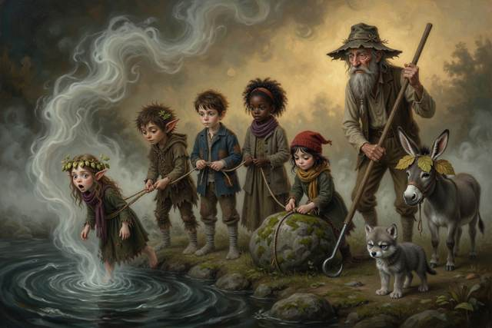
“You never say ‘I think,’” said Scally.
“No,” said Hopsi. “I have only ever said what I know. But a scientist does not only know. A scientist looks at everything, and then says, ‘This is what I think, and here is how I would find out if I am wrong.’” She stood up. “Nobody goes near the edge,” said Walt, “not alone, and not without a rope.” So Titch tied the rope round Hopsi’s middle with her best knot and passed the other end round a boulder and back. Hal and Tabitha took hold of it, and Walt drove his pole into the ground and tied Dumpling’s halter to it, and when everything was made fast, Hopsi walked to the very edge of the bank, in the cold wind off the whirl, with the rope paying out behind her, and looked up at the tall gray mist.
“I think,” said Hopsi, in a clear, small, steady voice, “that a shortcut is only quicker if it works.”
The whirl slowed.
It was not much. But the water, which had turned for fifty years without a rest, hesitated, like a wheel when someone puts a hand to it. The mist wavered. The thread of the voice stopped, in the middle of its loop.
“It is listening,” whispered Tabitha.
“There’s more,” said Hal. “Is that all of it? Is it finished?”
“No,” said Hopsi. She was shaking. “It is not finished. There is a gap. I can feel it. I only have half.”
“What’s the other half?” said Titch.
Nobody knew.
And then Scally stood up.
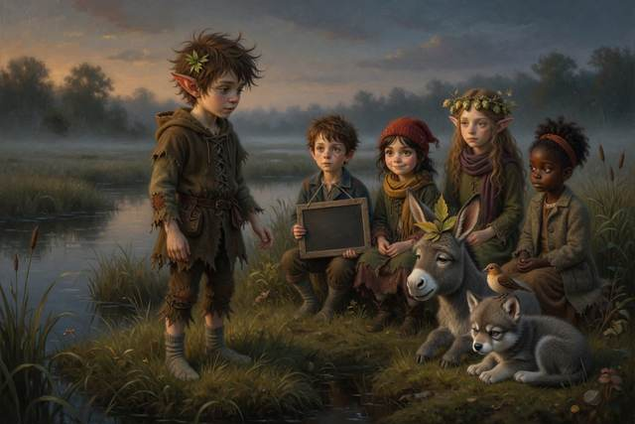
He had not spoken for a long time. He had taken his place on the rope without being asked. He stood now, in his two socks, on the bank, with the rope wound twice round his fists and the wind in his black hair. He did not look clever. He did not look sly. He looked like a boy who has been very frightened, and has just been told it is all right, and has found out that it is true.
“I think,” said Scally, “that when you can’t tell if a shortcut works, you should take the way you can check.”
He said it quietly. Then he said it again, to the water, because it seemed to want to be heard.
“A shortcut is only quicker if it works. And if you can’t tell, take the way you can check.”
For a moment there was no sound at all.
Then Fourpence, on Dumpling’s ear, opened its small brown beak.
It sang. It sang four notes, as it had sung them every night for a month. And after the fourth, it paused, and the whole bog leaned toward it. And then, for the first time in its life, the little bird sang a fifth.
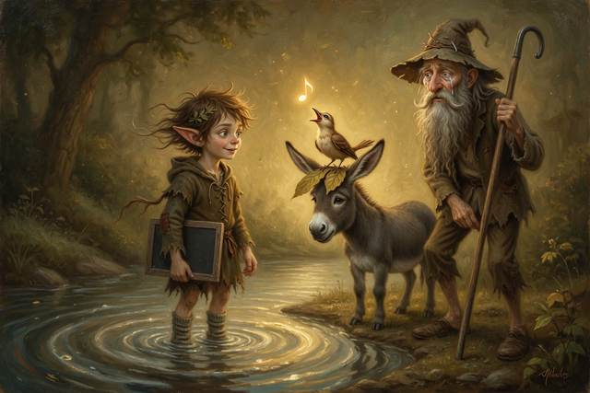
It was a small, round, clear note, like a drop of water falling into a still pool. It rose, and hung in the air, and rang, like a bell.
The whirlpool stopped.
It did not stop all at once. It slowed, and eased, like a great wheel that has been pushed for fifty years and at last allowed to rest. The funnel in the middle filled. The black water went smooth. And the stranger’s mist, which had been standing for so long, with its coat on a nail, unbuttoned itself, and thinned, and lifted away in long soft rags, into the dark.
Just before it went, they all saw, plainly, a face. It was a thin, pale face, with a smile that was no longer a size too big. It looked, for the first time, rather tired, and rather relieved. It said nothing. It only bowed, once, to Scally.
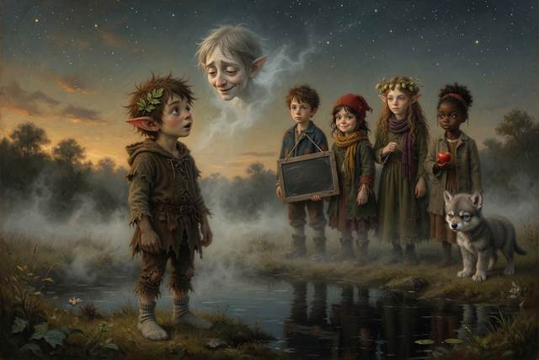
Then it was gone, and there was only the bog, and the first star.
And the stream was quiet.
It was the quietest thing any of them had ever heard, a silence like a long breath let go. Then, slowly, from the black, still water, came a different sound, so soft that at first they were not sure it was there. It was a sound of water moving, gently, over stones, like a child breathing in its sleep.
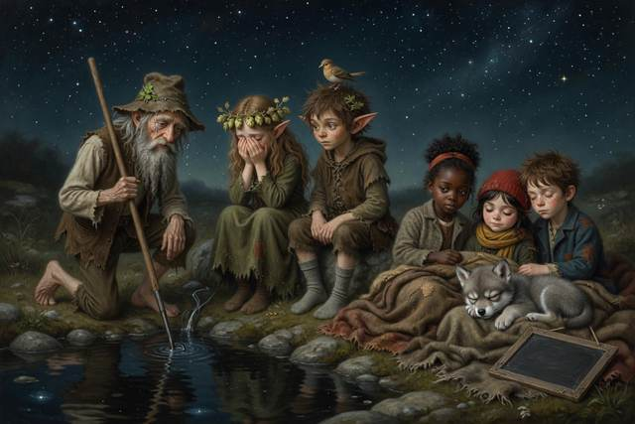
“Listen,” said Walt. He had tears running down his beard. “Do you hear it? It’s sleeping. It’s only — it’s only sleeping.”
Hopsi turned round. She came back from the edge along the rope, hand over hand, and Titch undid the knot, and she sat down on her stone and put her face in her hands. Her shoulders shook.
“Hop,” said Scally, alarmed.
“I am all right,” said Hopsi, into her fingers. “I said ‘I think’ and it was not a lie, and it was not wrong, and I am — I am extremely glad.”
“You were right,” said Hal.
“I do not know that,” said Hopsi, smiling through her fingers. “I think so.”
↑ Contents

Chapter 10. The Square Eggs
They went home the long way.
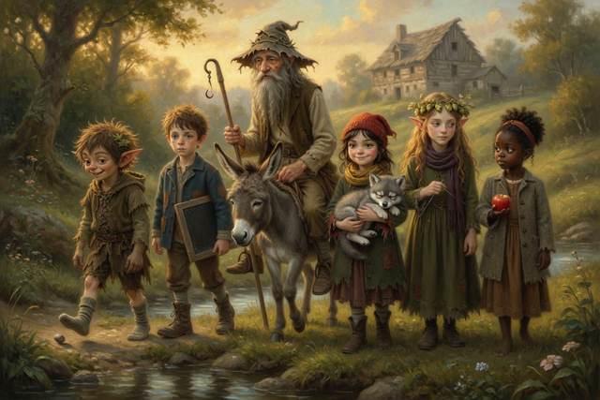
It took the whole of the next day. The stream ran beside them, low and clear and slow, humming nothing, and the grass on its banks was already green again where the flood had passed. Old Walt rode Dumpling most of the way, with his stiff leg stuck out and his eel-skin hat over his eyes, saying nothing and smiling a great deal. As the sun dropped red behind the mill, they came down through the bracken to the yard and found the whole village waiting.
They had been there since dawn. The Mayor was at the front, in his waistcoat, with his chain on crooked, and when he saw them, he took off his hat.
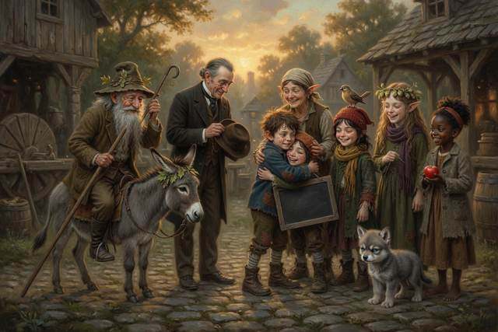
“Walter,” he said. “And children.” He seemed to be having difficulty with the next sentence. “The hum stopped last night. At a quarter to eleven. Mrs. Crumb says she woke up this morning, and for a moment she didn’t know what was wrong. And then she knew. It was the quiet.” He cleared his throat. “I said sandbags. I said it was a small price. I would like to say that I was wrong. I did not check.”
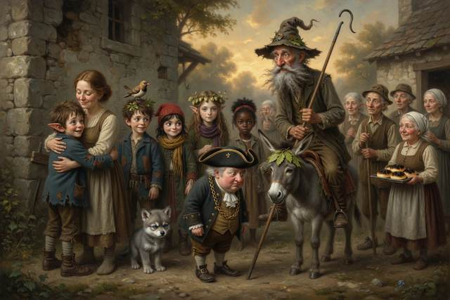
“No,” said Walt. “You did not.”
“I am sorry.”
“Say it again to the stream,” said Walt. “It’s a better listener than I am.”
Hal’s mother was at the mill door, with her kerchief in her hands. She did not say anything. She walked straight down the steps and picked Hal up off the ground, which she had not done since he was five, and held on. Over her shoulder he saw his father, leaning on his stick, with his face working, and Mrs. Crumb, with a tray of buns, quite black on the bottom, handing them out without a word.
“I’m filthy,” said Hal, into her shoulder.
“I don’t care,” said his mother.
“I wrote it on the slate. Third day, by dark.”
“I read it,” she said. “Every night.” She set him down and held his face. “And the word?”
“We didn’t need it,” said Hal. “Nobody offered us anything. Except the stream.”
Pip came out of the crowd like a cork out of a bottle and wrapped himself round Titch’s middle. “I guarded the step,” he said. “Three whole days. Nothing came.”
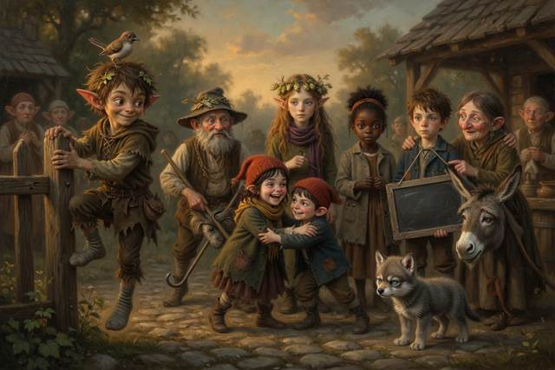
“Good,” said Titch, and found she had no crust left to give him, so she gave him a long hug instead.
“Except the Mayor,” Pip added, in a carrying voice. “He did not know the word. I made him stand on one leg until Mrs. Crumb told him.”
At the front of the crowd the Mayor went pink to the tips of his ears. “It was,” he said, with great dignity, “a good password.”
“Marmalade,” said Pip, with deep satisfaction.
That night every light in the valley went out early, and everybody slept for twelve hours.
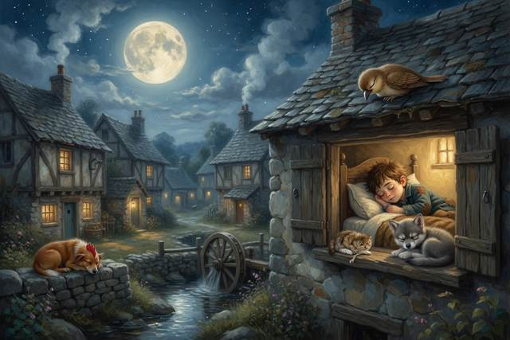
In the morning Scally sat on the mill step with a board across his knees and a pot of Mrs. Crumb’s black paint.
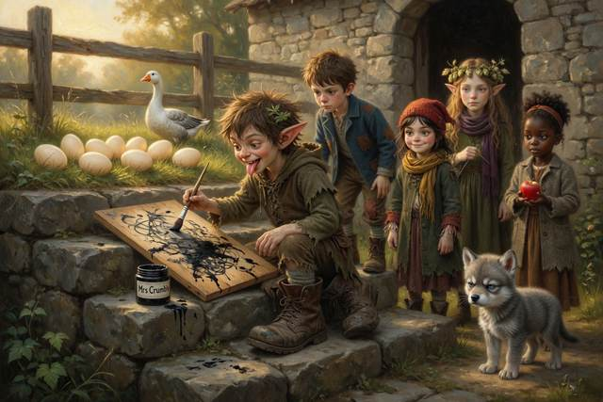
He had Walt’s boots on. They were old, heavy, brown, well-oiled, and a good deal too big, and he had been given them that morning, in the yard, in front of the village. “I’ve kept these fifty years,” Walt had said, gruffly, putting them into his hands, “for a boy I never found. They were my own, at your age. They’re no use to me. I’ve a stiff leg, and a good donkey, and I’m too old to be careful with them. You’ll look after them, I think.” And Scally, who had never in his life been given a present he did not have to explain, had said nothing at all, and gone red to the roots of his hair, and put them on.
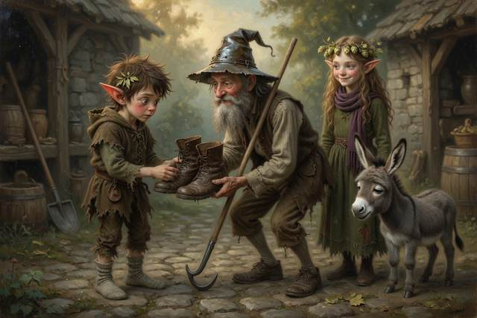
Now he was painting. The sign, as it grew, said:
RARE SQUARE EGGS
SEE THE STRANGE EGGS OF THE MILL
ONE PENNY EACH
There were nine of them, in the long grass behind the mill, where they had lain all summer. Square eggs, with sharp corners, like small cream-colored boxes. Nobody had ever been able to explain them. And Scally was crouching over the board with a brush, quite happily, with his tongue between his teeth.
He got as far as the second E in PENNY.
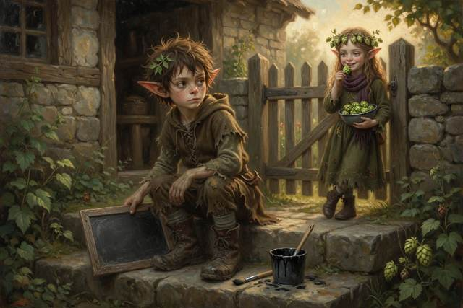
Then he stopped.
He looked at the sign. He looked at the eggs, over the fence, in the sun. They were not his, and they were not for sale. He had only found a penny in them, as he had in Mrs. Crumb’s hands, and in the Mayor’s ten dollars, and in a box of moss. He held the brush for a long moment, dripping.
Nobody was watching.
“No,” said Scally, aloud, to nobody. “That’s a cheat.”
He put the brush down. He turned the board face-down on the step. Then he sat, for a while, looking at the grass.
“Good,” said a voice from the gate.
It was Hopsi. She had a bowl of hops, and she was eating one, and she had clearly been there quite a long time.
“I didn’t say anything,” said Scally.
“I know,” said Hopsi. “You did the rest.”
They sat together on the step in the sun. And that was how they were sitting, a little while later, when one of the square eggs began to move.
It rocked once. Twice. Then it rolled, slowly, on its side, along the grass.
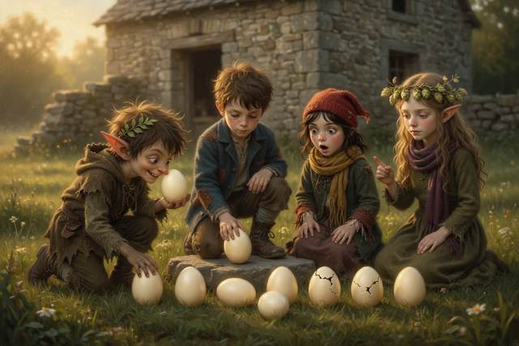
“It’s rolling,” said Scally. “Hop. It’s — it’s round.”
It was. They ran down the garden and knelt in the grass. The nine eggs lay in their row. And they were changing, as slowly as the stones in a stream. The sharp corners were wearing smooth. The flat sides were swelling, a little more with every breath. The box shapes were softening, gently, into curves, narrowing at one end, broadening at the other, as though some long invisible water was rolling each one over and over, taking a speck off every corner.
“They are taking the long way,” said Hopsi. “They were made in a hurry. They are being finished.”
“Why are real eggs that shape?” said Titch, who had come running.
“I do not know all the reasons,” said Hopsi. “One is that an egg with a narrow end does not roll in a straight line. It rolls in a circle. So if it moves, it does not roll off the edge of the nest.”
Hal put one in his palm and spun it on the step. It went round and round in a tight little ring, like a small dancer, and stayed where it was.
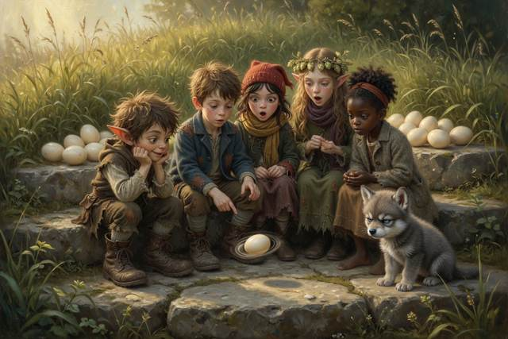
Then, one by one, they cracked. Out came nine small, damp, round-headed ducklings and, at the end, because there is always one, a large, indignant gosling, who stood up in the grass, took one look at Scally’s boots, and attached itself to them for the rest of his life.
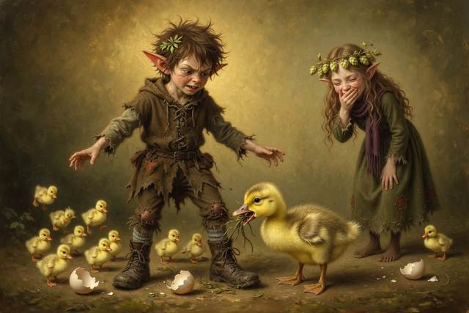
“I am not paying for that,” said Scally, to the gosling. “I did not hatch you.”
“It appears to disagree,” said Hopsi.
↑ Contents

Chapter 11. Rain
That autumn the stream slept soundly.
In the village, everybody slept soundly too, and woke each morning rather surprised. Mrs. Crumb’s buns came out golden. The cockerel crowed at dawn and at no other time. The Mayor was seen on the bank on Sundays, with a small notebook, writing down the color of the water.
On the last Sunday of October the village held a picnic on the bank for Old Walt, and it ended, as these things do, in a boat race. Every child made a boat from half a walnut shell, a matchstick mast and a leaf for a sail, and the whole valley lined up along the water to watch. Hal’s sank at once, because he had tested it with one pea too many, and he wrote WRONG on his slate and tried again with none. Titch’s went straight and fast, and Gucci jumped in after it. Pip entered a single wooden clog, and was disqualified, and was awarded a bun for effort. Scally’s boat won by a whole length, because Fourpence landed on the mast and sang.
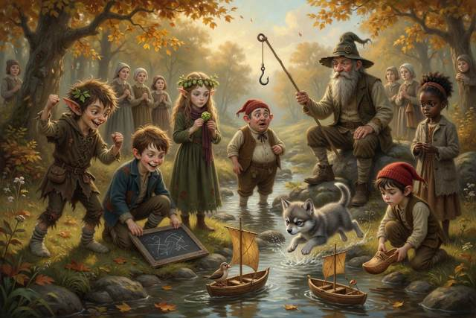
“Is that cheating?” said Scally, before anybody could say it for him.
“I do not think so,” said Hopsi, after a long think. “You did not ask the bird. It was luck. But next year we will write the rules down first.”
The Mayor, who had come to give out the prizes, stepped back to admire the winner and fell in up to the knees. Nobody dived in. Old Walt, who was sitting down, simply held out his pole without getting up. “Reach,” he said, “not throw. The water is shallow and the Mayor is near.”
Old Walt took on an apprentice. The apprentice had spiky black hair, a goose that followed him, and a pair of boots too big for him, and he asked a great many questions. Every one of them began, “How do you know?” Walt had to admit he did not know the answer to quite a number. He found that, to his surprise, he did not mind.
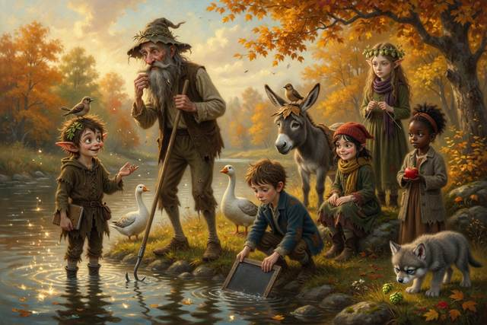
Every evening on the mill step Hal taught the stream-keeper his letters, beginning with W, and Walt, who could name every pebble in the valley, got extremely cross with the letter G.
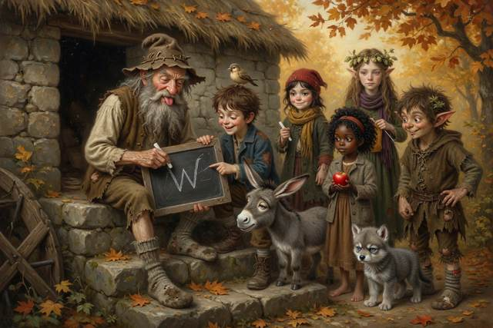
One gray afternoon at the end of October the five of them sat on the mill step, in a row, with a basket of Mrs. Crumb’s buns between them and Gucci asleep across everyone’s feet. Fourpence sat on the roof. It sang five notes, now, whenever anybody was trying to say something important, and quite often when they weren’t.
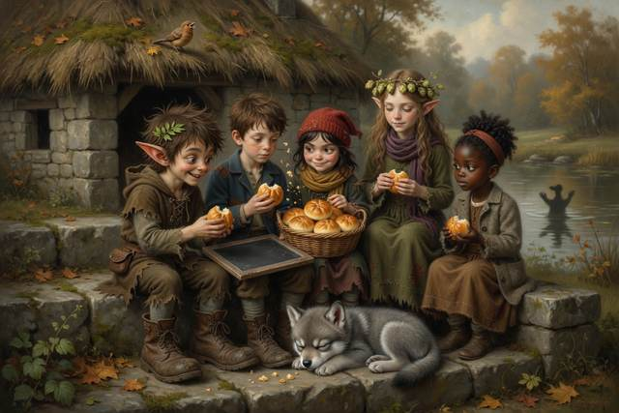
The pond lay quiet at the foot of the garden. And on the water, Hal’s reflection, as he looked over at it, was sitting on the bank with its chin on its knees. It looked, for once, entirely rested. When it saw him looking, it gave a lazy wave, and went on watching the clouds.
“It stopped saying UP,” said Hal.
Far behind his reflection, very faintly, a second mill turned the wrong way round, and a thin old man in a flour-sack cloak, with his hat on straight, touched it to the pond and was gone. Hal did not say anything. It seemed like a thing to keep.
“It’s got where it wanted to go,” said Tabitha.
“Everything has,” said Titch.
Scally was swinging his legs. He had a small, important look. “Tomorrow, I’ve got to take Walt’s lunch up to the bridge,” he said. “It’s on the other side of the cabbage field. Mrs. Crumb’s cabbage field. If I go straight across the field, it’s ten minutes. If I go round by the lane and the stile, it’s nearly an hour.”
Nobody said anything.
“It’s very firm,” said Scally. “Mrs. Crumb’s field. Nothing there but cabbages.”
Nobody said anything at all.
“Right,” said Scally, and got up. “I’m going the long way. I want to see if the willow’s still got its leaves.” He looked round, rather grumpily. “Don’t all look at me.”
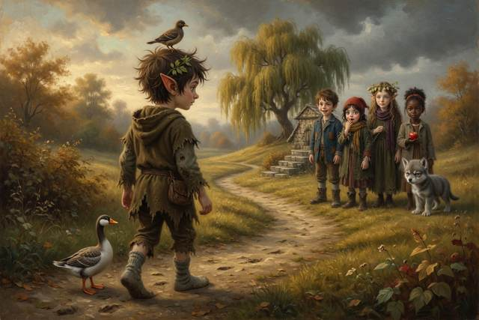
“Nobody asked you,” said Hopsi.
“I know,” said Scally. “That’s the point.”
He set off down the lane, in the big brown boots, with the goose behind him, and did not look back. The long road bent, and the willow showed gold at the end of it. And above them, slowly, the gray sky had begun to come down.
Hopsi had her head tilted back, looking at the cloud, and at the line of the hills, and at a small bird flying low over the mill roof.
She was quiet for a while. Then she said it, easily, the way a person says a thing she has been practising.
“I think,” said Hopsi, “that it is going to rain.”
“How do you know?” said Hal.
“I don’t,” said Hopsi, and ate a hop. “But I will find out.”
The first drop fell, round and heavy, on the step beside her. Then a second. Then the whole sky let go, softly, in a long gray whisper, and on the roof Fourpence sang five notes, and tucked its head under its wing.
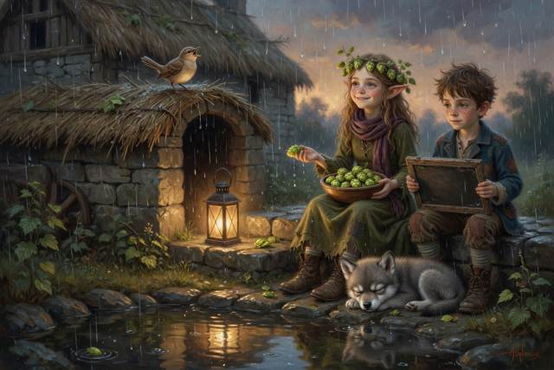
Down in the valley, beyond the mill, the stream took the rain in its stride. It had somewhere to be. It was on its way to the river, and the river to the sea, and the sea, in time, to the clouds, and the clouds, as it happens, to the hills. It had never in its life been in a hurry.
It sang one note. Then it slept.
The End
↑ Contents

Hal’s Slate: What We Found Out
Hal looked, counted and tested, and wrote it all on his slate. Here it is, with things you can try. Where Hopsi is not sure, she says, “I think.” You do not have to read them all at once: one a night is plenty. The magic is marked as magic.
1. Water runs downhill. Everything falls toward the ground, and a stream is only water on its way to the lowest place it can find. Try it: pour a little water on a tray and tilt the tray.
2. Floating and sinking. A stone sinks and an apple floats. A boat is hollow and full of air, so for its size it is lighter than the water it pushes aside, and that is why it floats. Guess first, then test: try a stone, an apple, a cork, a coin, and a small plastic cup turned upside down. (Always with a grown-up near water.)
3. Reading a stream. Water runs fastest in the middle and slowest at the edges, and fastest on the outside of a bend. To cross a stream, aim upstream of where you want to land, because the current will carry you down.
4. Why streams wander. Fast water digs the outside of a bend, and slow water drops sand and mud on the inside. So each bend gets bigger, and a straight stream turns into loops. Try it: tilt a tray of damp sand, trickle water down it, and watch it start to bend.
5. Pebbles get rounded. A stream rolls stones along its bed, and each roll wears a little off the corners. A sharp stone from the mountain becomes a round pebble after a very long time. Look at the stones on a beach and a stone from a path.
6. Echoes. A sound hits a hard wall and bounces back. The time between your shout and the echo tells you how far away the wall is. Sound travels about a third of a kilometre in a second.
7. Lightning. Light is faster than sound, so you see the flash first. Count the seconds between flash and bang: three seconds is about one kilometre, and five seconds is about one mile. If the count is short, get indoors or into a car. If you are caught outside, keep away from tall trees, open water and metal, and crouch low in a dip.
8. Flash floods. When heavy rain falls upstream, a stream can rise very quickly, turn brown and carry sticks. Never camp in a dry gully, never cross a rising stream, and go to high ground at once.
9. Whirlpools. Water spins as it drains toward a low hole, like the bath. Never go near the edge of a whirlpool. Reach or throw.
10. The shape of an egg. An egg has one narrow end, so when it moves it rolls in a circle and does not roll off the edge of the nest. That is one reason among several.
11. The water cycle. Rain falls on the hills, runs into streams and rivers, reaches the sea, rises as vapour, makes clouds, and falls again. The same water goes round and round.
12. Safe journeys. Tell someone where you are going and when you will be back. Go in pairs. Carry a whistle and blow three blasts if you are lost, then stay put. Do not take a shortcut across country.
13. Water safety. Never go in the water alone. If someone falls in, reach or throw: hold out a stick or throw a rope. Cold water takes your breath away, even from strong swimmers.
14. Fire safety. Build a fire on bare stone with a ring of pebbles and a bucket of water beside it. Put it out by drowning it, stirring it, and drowning it again, until the ashes are cold to your hand.
15. A shortcut is only quicker if it works. Hal looked at all the shortcuts on the journey and found that none had saved time. That is data, but four tries is a small sample, so a scientist says “I think” and not “always”. If you cannot tell whether a shortcut works, take the way you can check.
16. The hum is magic. No real stream hums like that, though real streams do make many sounds, from a gurgle over stones to a roar in a flood.
17. “I think” is a scientist’s sentence. It means: this is what I believe, and here is how I would find out if I am wrong.
↑ Contents

For Parents and Teachers
This is a fantasy adventure to read aloud at ages 5–9. Children from about 5 can follow the whole story from the pictures alone (a “picture walk”: turn the pages and ask what is happening), and older children can read it by themselves. Every fact the elf Hopsi states is true; where she is not sure, she says “I think”, which is what a scientist says. The magic is marked as magic.

The habits of a scientist in the story
“How do we know?” Look, count, test. Hal writes everything on his slate, and writes WRONG when he is.
Guess first, then test. What floats and what sinks? Hal guesses, then the pool tells him.
Say “I think”. Hopsi learns that a scientist does not only know. She says what she thinks and how she would find out if she is wrong.
Data beats a hunch. On his slate Hal counts every shortcut on the journey and finds that none saved any time.
Honesty. Scally tries a scam, a lie or a cheat in every chapter, and the plain truth makes him think again.

What each chapter teaches
The Hum: an honest question about a mystery, and why a trick to sell a cure does not work.
Old Walt: why water cannot be stopped, only moved, and why you ask where it is going. Family safety rules.
The Green Pool: what floats and what sinks, how a current carries a raft, and “reach or throw”.
The Wandering Stream: why streams bend, why pebbles are round, and why a shortcut across unknown ground is dangerous.
The Fire and the Voice: how to build and put out a campfire safely, and telling the truth about hunger.
The Count Between: echoes, how far a sound travels, counting between lightning and thunder, and where not to shelter in a storm.
The Brown Water: flash floods, high ground, and saying “I am scared”.
The Whirl: whirlpools, why you never go near one, and why a lie cannot be an ending.
The Long Way Round: reading evidence, and “I think”.
The Square Eggs: why an egg is shaped as it is, and not cheating when nobody is watching.
Rain: the water cycle, and choosing the long way yourself.

Staying safe: what this book models
Water. Never go in alone. Reach or throw: hold out a stick or throw a rope, and do not go in after a friend. Cold water takes your breath away. Stay away from the edge of a whirlpool and from rising streams.
Shortcuts and getting lost. Tell someone where you are going and when you will be back. Go in pairs. If you are lost, stand still, blow three blasts on a whistle and wait.
Fire. Build a campfire on bare stone with a ring of pebbles and a bucket of water. Put it out by drowning it, stirring it and drowning it again, until the ashes are cold to your hand.
Storms. Count the seconds between flash and bang. A house or a car is the safest place. If you are caught outside, stay away from tall trees, open water and metal, and crouch low in a dip. This is general advice; please check your local guidance.
Floods. Heavy rain upstream can make a stream rise fast. Never camp in a dry gully, and go to high ground at once.
Strangers. The Soft Voice from Book 1 offers a shortcut, as a stranger might. Agree a family code word, as the children do.

Talk about it
Why did Scally try a trick in every chapter? What made him stop?
Hal wrote down every shortcut and found none saved time. Do you know a time when the long way was better?
Why does Hopsi say “I think” instead of “I know”? Is that braver or weaker?
What floats and what sinks in your kitchen? Guess first, then test it with a grown-up.
What would you do if you were lost, or if a stream started to rise?

Words to grow
meander, current, pebble, echo, flash flood, whirlpool, float, evaporate, water cycle, data.

A note for adults
The science here is simplified for ages 5 to 9: a stream's bends come from faster water wearing the outside bank and slower water dropping sand on the inside; a thing floats if, for its size, it is lighter than the water it pushes aside; sound travels about a third of a kilometre per second, so a count of three between lightning and thunder is about a kilometre; whirlpools form where water drains toward a low outlet. The Mirror Mill and the humming stream are magic. Please have a teacher check the science and safety content before relying on it.
↑ Contents

About the Author
Anneliese Tauber is a mother of four. When her children were small she read them a great many fairy tales, and she noticed that the best ones answered the questions children ask, and never needed to bend the truth. The Step Stories are for curious children and the grown-ups who read to them.
If your child enjoyed this book, a short, kind review on Amazon helps other curious families find it. Thank you.
↑ Contents

Also by Anneliese Tauber
The Wee Scallywag and the Gentle Elf
The Step Stories, Book 1. Where Scally first met Hal, Hopsi and a ghost in a mill.
Book 3 of The Step Stories is coming soon.
Bavarian Cooking Made Simple
Classic dishes from a Bavarian kitchen, written so that any cook can enjoy a taste of Bavaria.
↑ Contents
Typeface in the e-book edition: Comic Neue, © The Comic Neue Project Authors, used under the SIL Open Font License 1.1.

