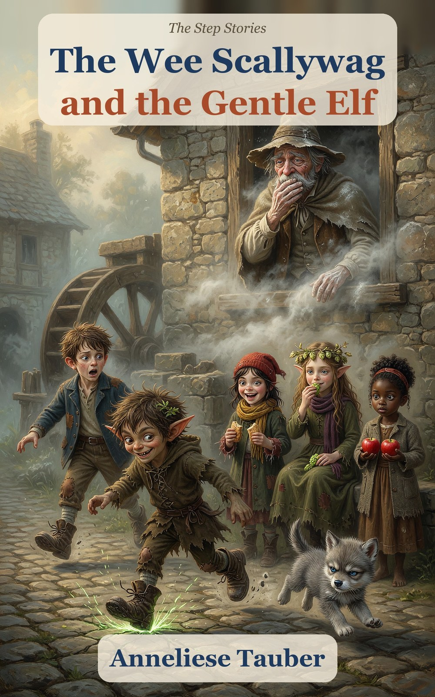

The Wee Scallywag
and the Gentle Elf
Book 1 of The Step Stories
Anneliese Tauber
For everyone who has ever called a stone a fly.

Contents
Meet the Characters
Chapter 1. The Stuck Wheel
Chapter 2. The Lord of the Riverbank
Chapter 3. The Ghost in the Wall
Chapter 4. The Toad of the Ford
Chapter 5. The Pike and the Torn Tag
Chapter 6. The Howl and the Moon
Chapter 7. The Hot Night
Chapter 8. The Girl with the Apples
Chapter 9. The Quick Way and the True Way
Chapter 10. The True Name
Chapter 11. Sunday
Next in the Series
Hopsi’s True Things
For Parents and Teachers
About the Author
Also by Anneliese Tauber

Meet the Characters
Hal (Halbert) Millersen
8. The miller’s son. Brown, tousled hair, chalk on his fingers, a slate under his arm. Dry and steady. Says “Acceptable” when things are bad.
Titch Mitchel
8. Dark brown hair under a red knitted cap. Quick, practical, always has a crust. Tears bread into even pieces.
Scally, the wee scallywag
A little devil: short sharp pointed ears, messy hair with a leaf in it, a grin like a lit match. Makes bargains and runs up walls. His true name is the puzzle of the book.
Hopsi (Elfie Didlhop)
An elf: long swept-back ears, long wavy light-brown hair, a needle and a bowl of hops. Only says what is true.
Tabitha Smoke
7. Curly black hair in a bun. Warm and watchful. Asks the one question nobody else thought of.
Pip
6. Titch’s little brother. Small, solemn and always one step behind his sister.
Gucci
A baby wolf with a grumpy face and a very big appetite for crusts.
Old Miller Millersen
A ghost, with a flour-sack cloak and a dusty hat. Polite, lonely, and Hal’s great-great-grandfather.
The Soft Voice
A tall thin stranger with candy, a smile too wide and a quicker way. Never take it.
Ages 5–9. Little ones can follow the whole story from the pictures alone.

Chapter 1. The Stuck Wheel
The wheel at Miller’s Mill had stopped on Monday. By Thursday the whole village was out of flour.
Hal Millersen sat on the mill step with an empty sack across his knees. He was eight years old, with brown hair that never lay flat and chalk on his fingers. His slate leaned against the wall beside him. His boots, the only good thing he owned, stood neatly on the step. The air smelled of old flour and wet stone. Somewhere inside the wall, the wheel pit dripped.
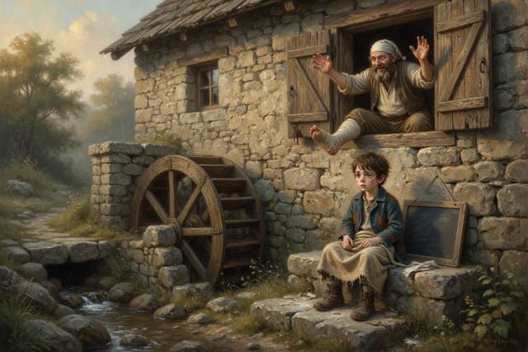
His father, the miller, had climbed down into the pit on Monday to see what was wrong, and had come back up with a broken leg and no idea. He lay in bed upstairs with the leg on a pillow and a great many opinions. His mother had gone to her sister’s, two villages over, to borrow flour, and would not be back until Sunday, and she had left Hal in charge of the step. “Keep the door shut,” she had said. “Keep your boots on. And don’t make bargains with anyone. If a stranger says I sent them, ask for the word. The word is marmalade.”
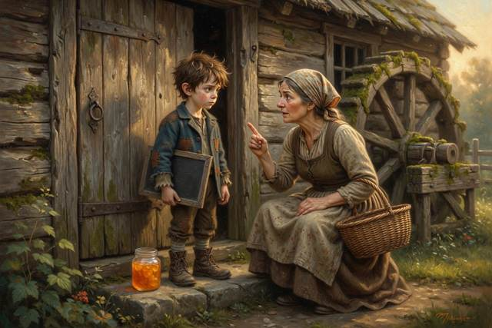
On Sunday the king would hold a feast, and the king’s men wanted twelve sacks of flour by dawn. The granary was full of grain, and nobody could grind it with a wheel that would not turn.
“Acceptable,” said Hal, to nobody. It was what he said when things were bad.
Something dropped out of the wheel and landed on its feet.
It was a boy of about his own age, with black spiky hair and a grin like a lit match. His ears were pointed, his knees were muddy, and under one arm he carried a pair of big boots with a tag tied to the laces. He put these down on the step carefully, the way you put down something that might go off.
“Mind those,” he said. “They’re my spare. Don’t put your feet in them. They go places.”
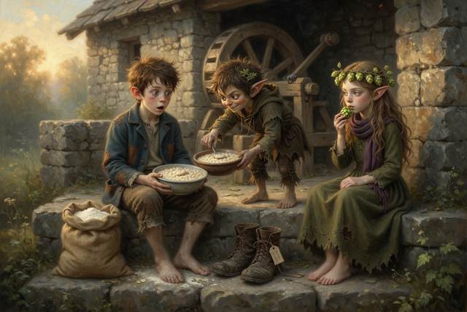
Then he looked at Hal’s boots. His own were worn to the leather.
“Those,” he said, “look made for someone my size.”
He pulled them on. They fitted. Hal, who was too surprised to be mad, found he was holding a bowl of porridge. The stranger took it, ate it, and handed back the empty bowl, all in one motion.
“I’m the wee scallywag,” he announced. (A scallywag is a rascal, in case you were wondering.) “I make bargains. This one’s old and fair. Three days of making you look like a gentleman. Or you guess my true name before the third day closes, and I give the boots back. Or you don’t, and the boots stay mine, and one small thing besides.”
“What small thing?”
“Small,” said the scallywag. He glanced at the worn step the way you look at a lit window when you are standing out in the rain.
Hal thought. He had no flour, no wheel, no boots (only his father’s old clogs from the shed) and no better idea. “Agreed,” he said.
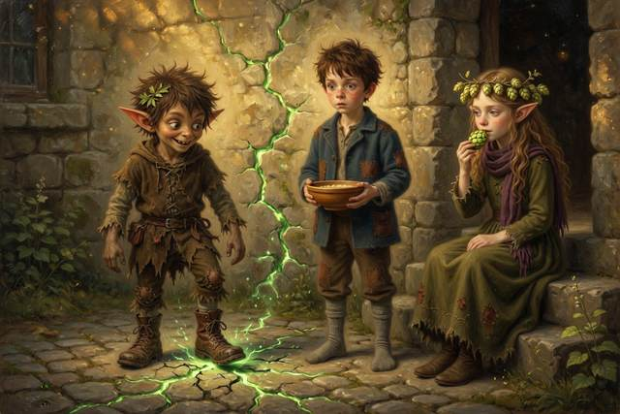
It was the first time in his life he had done something his mother had told him not to. He felt it at once, in his stomach, like a cold potato.
The scallywag stamped once. The ground answered. A crack of green light ran across the yard, up the mill wall and over the roof, and the scallywag ran up it like a squirrel up a tree and was gone.
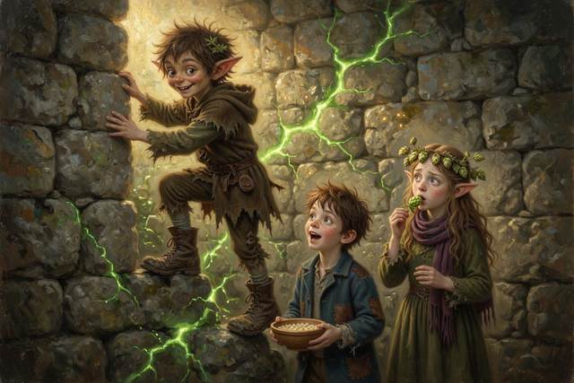
“That,” said Hal, “was not in the bargain.”
“It was in the small print,” said a voice from the step.
A girl was sitting two steps down. She had pointed ears, long wavy light-brown hair and a wreath of hops. She had a needle in one hand and a bowl of hops in the other. She smelled of green bread and cut grass. She ate one hop.
“I am Hopsi,” she said. “Elfie Didlhop, if you must. I only say what is true, so I say little.”
“How long have you been there?”
“Since the porridge,” said Hopsi.
Behind them, in the empty yard, the spare boots took one step on their own, and stopped.
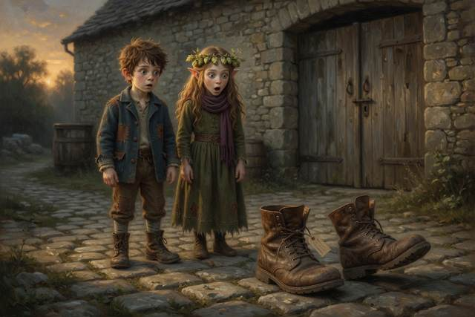
↑ Contents

Chapter 2. The Lord of the Riverbank
That afternoon two messengers in blue and purple coats came down the road with feathers in their hats and their noses in the air.
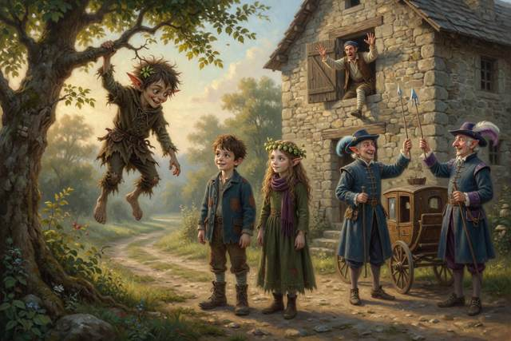
The scallywag dropped from a tree.
“The Lord of the Riverbank,” he announced, “approaches.”
He stood Hal on a fallen log across the stream. It was the sort of log that looks as if it has opinions. The scallywag jumped on the high end. The log tipped, Hal rose slowly through the air, and the messengers saw a young lord rise above the water and come down on the bank, quite undamaged.
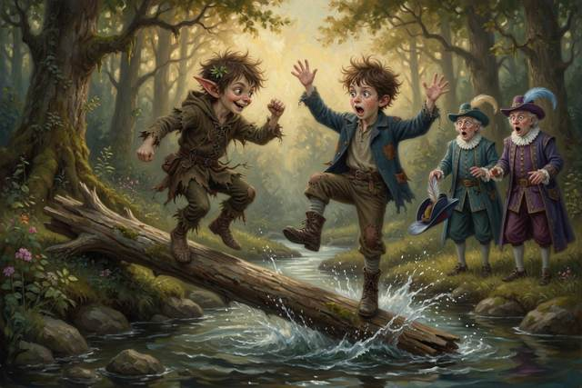
They bowed. The scallywag bowed deeper.
“Twelve sacks,” said the first messenger, with a sniff. “By dawn on Sunday, or the king buys from the next valley.”
“The wheel,” said Hal. “It’s stuck.”
“A lord,” said the second messenger, “has people to see to that.”
An upstairs window banged open. A bandaged leg came out of it first, then the miller. “Twelve sacks!” he called. “Hal, tell them yes!”
“I am telling them, Father,” said Hal.
“The log,” said Hal quietly to Hopsi. “How did it throw me so high? He is no bigger than I am.”
“A lever,” said Hopsi. “Try it. Do not take my word.”
Hal took out his slate. “It will be easier to lift with the short end,” he said. “It’s nearer the stone.” He wrote that down. It was his guess.
He laid the log across a stone and set a heavy stone on the short end. He pushed the short end down with his hand. Nothing. He pushed the long end down with two fingers. The heavy stone rose a finger’s width.
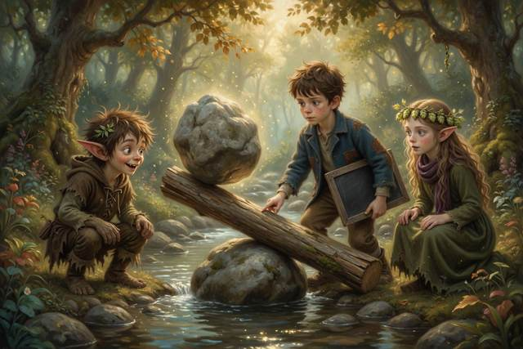
Hal rubbed out his guess and wrote beside it: WRONG. LONG END IS EASIER.
“Acceptable,” said Hal, which for him was a cheer.
“It is a seesaw!” said Titch. “My little brother sits at the very end and lifts me, and I am twice his size.”
“Yes,” said Hopsi. “A lever multiplies your push. The long end goes a long way down, and the short end goes a little way up, but with great strength. Move the stone closer to the middle and it will be easier still.”
Hal moved the stone closer to the middle and pushed with one finger. The stone rose. He wrote: CLOSER TO THE MIDDLE, EVEN EASIER.
“You told them he was a lord,” said Hopsi to the scallywag.
“It was an improvement,” said the scallywag.
“It was not true. The king’s men will come back on Sunday expecting a lord, and they will find a boy with chalk on his fingers. Who is going to be in trouble?”
The scallywag scratched his ear. “Hal,” he said, after a bit.
“Yes,” said Hopsi.
He did not say anything more about it. But he did not forget it either.
That was when the sky turned the color of a bruise.
The wind came first. It took the messengers’ feathers and then the messengers’ dignity. Rain arrived all at once, sideways. The messengers’ carriage went into the mud up to the axle and stuck.
A small girl with dark brown hair under a red knitted cap came sprinting out of the rain with a crust in each hand. She was eight. She put both crusts in her mouth, took hold of the carriage wheel with both hands, and said around the bread, “Log.”
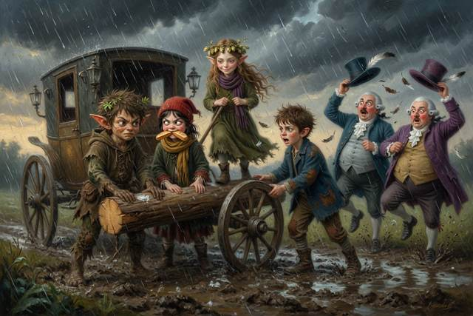
They slid the log under the wheel. Hopsi stood on the end of it. The scallywag jumped on her side. The carriage came free with a noise like a large cork, and the messengers went off down the road without a word of thanks.
Ten minutes later the sun came out, and the whole valley steamed. A rainbow stood across the mill like an arch.
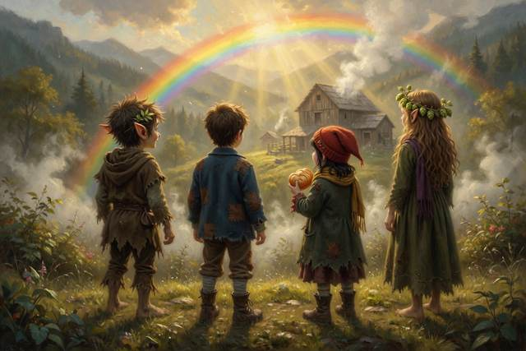
“That is sunlight coming apart,” said Hopsi, watching it. “Sunlight looks white, but it is really all the colors mixed together.”
“Like the glass on Mrs. Crumb’s chandelier,” said Titch. “It throws little rainbows on the wall.”
“Yes. A raindrop works like that glass, a little prism, and splits the colors apart. You can only see it with the sun behind you.”
“Everybody always forgets that,” said Hal, who had been looking the wrong way.
“Titch,” said the girl with the cap, with her mouth full. “That’s me. I do hems and crusts. Who’s the boot boy?”
“Hal,” said Hal.
“Not him,” said Titch, pointing at the scallywag. “Him. He took your boots.”
“Oh,” said Hal. “Yes.”
The scallywag looked at his feet.
“What do I call him?” said Titch.
“Scally,” said Hal. “It is short for scallywag.”
“It will do,” said Scally, “until you guess the other one.”
Scally decided to help. He did not say so. He hummed under his breath, a little tune with words in it: Just a little, just a bit, who will ever notice it? Then he slipped away to Mrs. Crumb’s cool shed, “borrowed” her best crock of butter, and spent the afternoon smearing it on the wheel, the rim, the step and, by accident, himself. “It will go easier,” he said, “if it is slippery.”
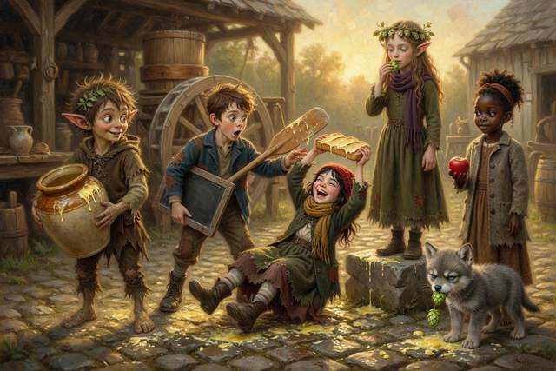
The wheel did not move. But the step, the yard and the gatepost were now as slippery as a pond in winter. Titch came out with a crust held high, sat down hard, and slid on her bottom halfway to the gate, shrieking with laughter. Hal reached for the wheel and his hand skated straight off it.
“When two things rub, they pull against each other,” said Hopsi, who had not slipped, because she had looked first. “That pull is called friction. Butter makes it smaller, so a squeaky wheel turns more easily. But this wheel is not stuck because it rubs. It is stuck because something is in the way, and butter cannot move that.”
“So butter is for squeaks,” wrote Hal, “and not for jams.”
Scally spent the rest of the afternoon scrubbing the steps with sand until they squeaked, and Mrs. Crumb’s crock went back to her shed empty, with a message in chalk on the lid: SORRY. I OWE YOU A CROCK. SCALLY. It was the first time he had ever paid for anything, and he did not like how it felt, and he did it anyway.
That evening Hal tried the wheel. He pushed, pulled, and poked a pole down the pit. Nothing moved. On the wall behind him Scally watched with his arms folded, quietly, which was not like him. And when Hal turned, there was a clink from somewhere behind the wall, and Scally’s face went white.
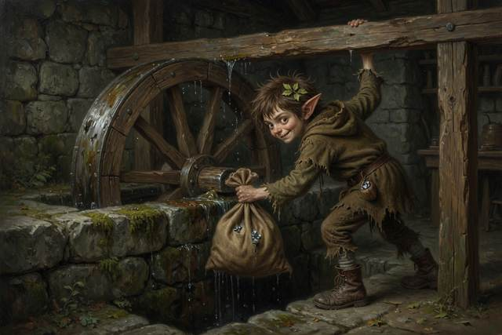
↑ Contents

Chapter 3. The Ghost in the Wall
That night the wheel creaked, though the stream was low.
Hal followed the sound across the yard. The moon was up. The wheel was turning, slowly, a hand’s breadth, back and forth, with nobody pushing. On top of it sat a ghost.
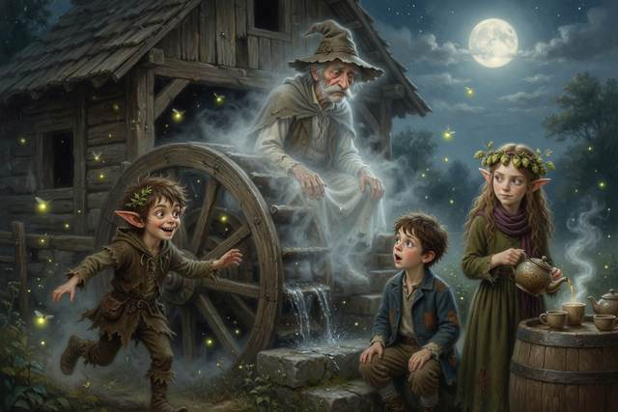
It was a thin, pale, see-through old man in a flour-sack cloak and a dusty hat, with whiskers like two gray brushes. It smelled of cold flour and old stone. It looked at Hal for a long moment.
“Boo,” said the ghost, rather flatly.
Hal sat down on the step. “Acceptable,” he said.
Scally came out of the dark at a run, with Titch, who had been invited to sleep on the sacks and had decided it was an adventure, close behind. He shrieked with delight, and chased the ghost twice around the mill. The ghost, which had not been chased in a hundred and fifty years, found it rather liked it. It went straight through the stone wall and came out the other side with its hat on backwards.
“Ghost trap!” shouted Scally. He came back with a jelly jar, and the ghost, who was feeling obliging, shrank and sat down in it quite politely. Scally slammed the lid.
“Boo,” said the ghost, through the glass, in a flat voice.
“I think,” said Titch, “it is too small a ghost to be dangerous.”
Scally opened the lid. The ghost climbed out, grew back to its size, brushed its cloak and took its hat.
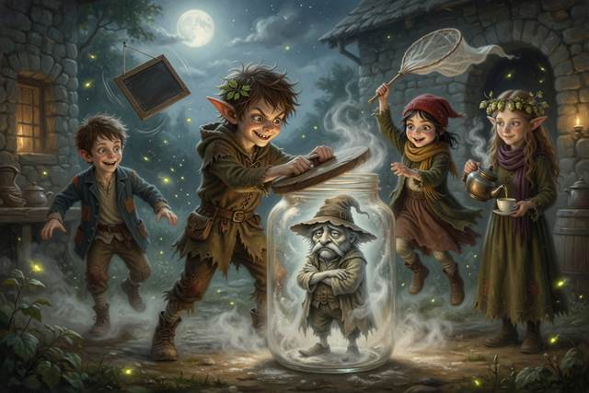
Hopsi had arrived with a pot of hop tea and four cups. She poured one for the ghost, who held it in both hands and looked at it sadly. It could not drink. But nobody had put a cup in its hand for a long time.
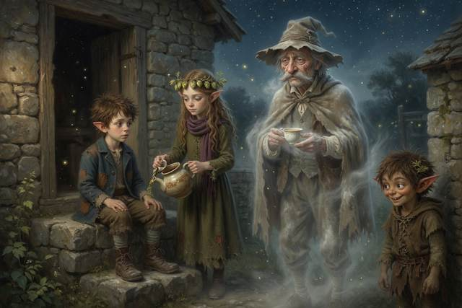
“How do you go through walls?” said Hal.
“Walls are not as solid as they look,” said Hopsi, “if you are very, small. Imagine rolling a marble at a hill. Nearly always it rolls back down. But the smallest bits in the world, much smaller than a speck of flour, sometimes turn up on the far side with the hill still standing. Nobody lifted them over. It is called tunneling. It does not happen to boys, and it does not happen to ghosts. A ghost is magic. Tunneling is just very, small. The Sun does it, deep inside, and that is part of why it shines. That is true.”
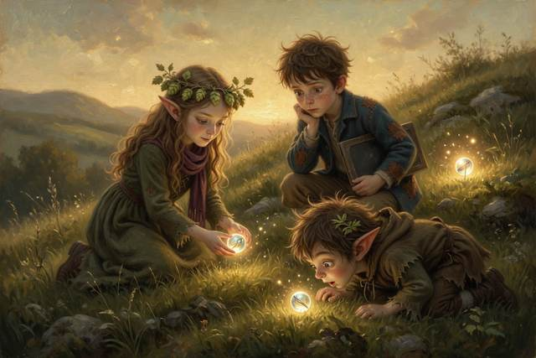
“So the marble is science, and the ghost is magic,” said Titch. “Do not mix them up.”
“I try never to,” said Hopsi. “I mark the magic when I see it.”
“A ghost does it on purpose,” said the ghost, unexpectedly. “That is the magic. I go through the wall into the Mirror Mill, the mill that stands behind this one like the mill you see in the pond. Everything in it is the wrong way around. The wheel turns backwards, the stream runs uphill, and the writing is back to front. I go there when the wheel stops here. It is a comfort to see a wheel turn, even the wrong way.”
“Who are you?” said Hal.
“Old Miller Millersen,” said the ghost. “Your great-great-great-grandfather. You are Halbert, are you not? You have my chin. The wheel was mine. A long time ago I wandered off on a foggy night, and I never found my way home. So I stayed. On Monday the wheel stopped, and I went to look for the reason.”
“What is the reason?”
“A bag,” said the ghost. “Behind the sluice wall at the bottom of the pit. I can go through the wall, because I am a ghost and that is how ghosts are. But the gate is rusted shut on this side, and I cannot lift the bag. In the Mirror Mill the gate stands open. Your father went down the ladder and saw nothing, because the bag lies where no ladder reaches, behind the wall. He fell off the bottom rung. I tried to tell him. Grown-ups hear ghosts only when they sit still, and your father has never sat still in his life.”
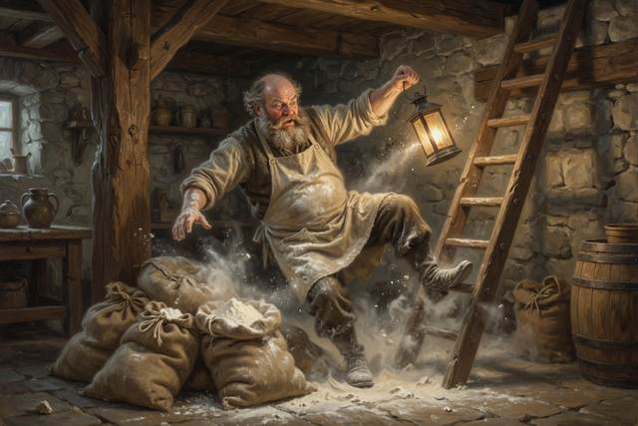
Scally looked at his boots.
“A soft voice sent me out into the fog,” said the ghost. “It offered candy and a quicker way home. It was the shortest way. It was not the quickest. I have been looking for the other one ever since.”
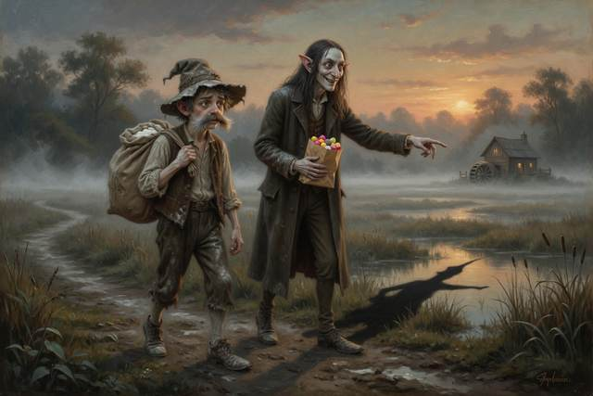
Hopsi’s hand stopped on the needle. “A soft voice?”
“Hard candies,” said the ghost. “A smile too wide. A bag that clinked.”
Scally stood up. “I’m going to bed.”
“You are going nowhere near that wall,” said Hopsi, without looking up.
He went in anyway. In the morning there was a smear of mud on the back wall of the mill, and Scally was asleep on the step with his boots on. Hopsi saw it. She could not lie, and she did not say.
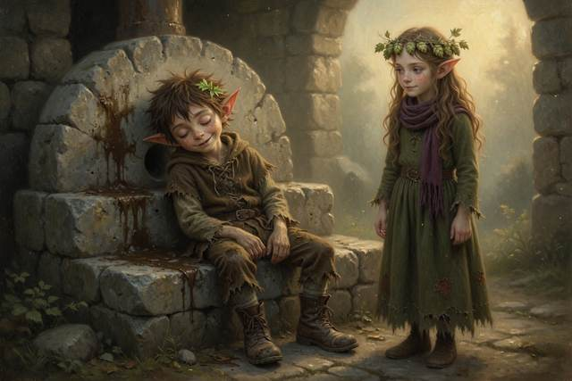
Hal climbed the stairs twice that morning to tell his father. The first time the miller was asleep with his mouth open. The second time he was shouting down at the village about the price of flour, and said, “Not now, Hal, I am busy being miserable,” and Hal went back down with the words still in his mouth. He felt the cold potato turn over. He decided to tell them on Sunday, and that was a promise he kept.
Down by the bog, in the thin early light, a long shadow lay across the grass with nobody standing in it. A line of footprints led toward the mill, and stopped.
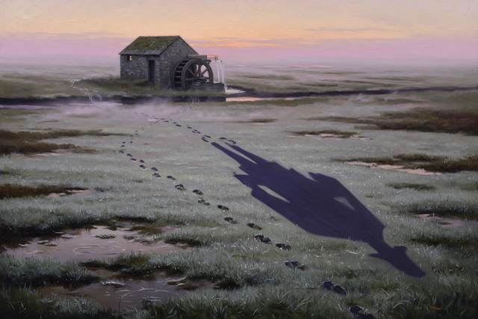
↑ Contents

Chapter 4. The Toad of the Ford
On the second day they walked down to the village for bread, because the mill had none. Before they left, Hal wrote on his slate and hung it on the door where anyone would see it: GONE TO THE VILLAGE FOR BREAD, WITH FRIENDS. BACK BY NOON. HAL. It was her rule, and he had never once broken it.
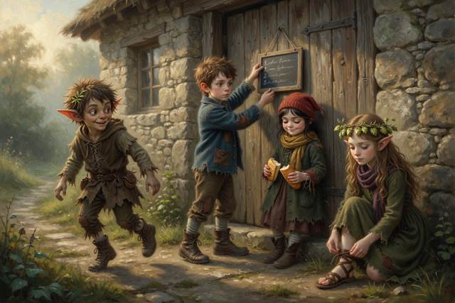
At the stile they met a girl with a sack of apples on her shoulder. She was seven, with dark brown skin, curly black hair in a bun and a gray coat, and she was walking to the village too. “Tabitha Smoke,” she said. “I take apples to the baker every Friday. Are you the ones with the elf?” She looked at Hopsi’s ears with great interest, and at Scally’s, and then she fell into step as if she had always been there. She had a laugh she saved for the right moment. She was not going to waste it yet.
Under the oak in the wood a hundred seedlings grew from the same two parents. No two were alike. One was taller. One leaned toward the shade. One had a petal the color of the moon. Hopsi pulled a leaf, wrote on it with her needle and gave it to Hal:
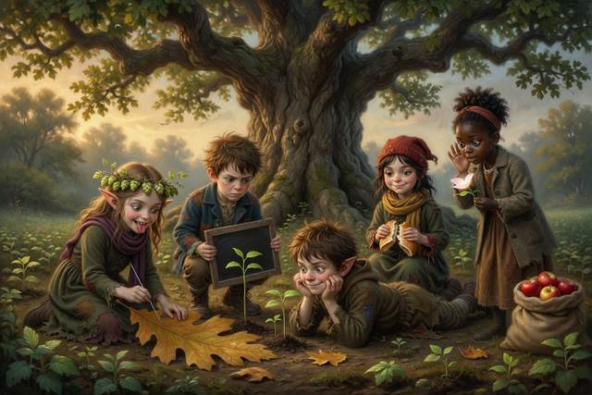
Little ones take after their own,
yet none are ever quite the same.
“Think of a recipe,” said Hopsi. “A seed is built from a long recipe, written on tiny cards. Each parent gives half the cards. The cards are shuffled, so the loaf comes out a little different, the way you might have your mother’s nose and your father’s chin. And now and then, when a card is copied, a letter slips, and something brand new turns up.”
“So I am half my mother’s crusts and half my father’s,” said Titch, “which explains a great deal.”
“My ears are my mom’s ears,” said Scally. “Her mom’s. Her mom’s mom’s.”
“Copied faithfully,” said Hopsi.
The ford had a toad in it.
It was the largest toad in the county. It sat on a flat stone in the middle of the water with its eyes half shut and its throat going in and out. It wore a mustache of pondweed.
“Toll,” said the toad, in a voice as slow as a barrel rolling. “Something good to eat. Or something clever to say. Or a boot.”
Scally, who was wearing a very good pair of boots, put one foot behind the other. Then he had an idea, and hummed, under his breath: Just a little, just a bit, who will ever notice it? He picked up a round brown stone, rolled it in moss, and held it out.
“A fly,” he said. “Best in the valley.”
The toad looked at it for some time.
Its tongue came out like a fishing line, took Scally’s left boot clean off his foot, and swallowed it. Scally fell over. The toad burped, softly, and a small grasshopper flew out.
A great many more arrived behind it, a green cloud rising off the long grass along the ford with a noise like a hundred tiny watches. They were simply many, and all of them wanted the hops in Hopsi’s bowl.
“Run!” shouted Scally, hopping on one boot.
They ran. The grasshoppers came after them, bright and flickering. The toad bounded behind from stone to stone like a bad-tempered boulder. Hal slipped and went under the water. Titch, who had come up behind him, threw out her cloth as a net, and caught Hal, three grasshoppers and a small silver fish that was not hers.
They got out on the far bank, wet and out of breath, and looked back. On the long green grass the grasshoppers were green. On the dry bank beside the ford, where the grass was yellow, they were brown.
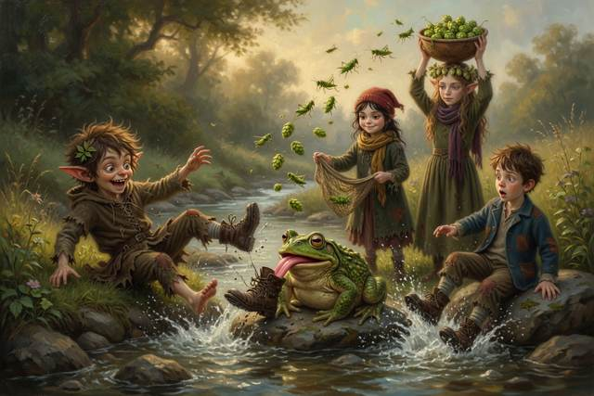
“Why?” said Hal.
“Guess first,” said Hopsi.
Hal guessed that the grasshoppers chose where to sit by color. “Count,” said Hopsi. Titch took the green grass and Hal the dry bank. GREEN GRASS: 14 GREEN, 2 BROWN. DRY BANK: 11 BROWN, 1 GREEN. “They did not choose,” said Hal slowly. “The ones in the wrong place got eaten.”
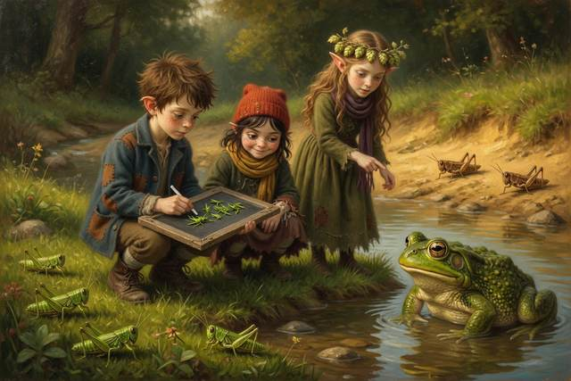
“Toads eat the ones they can see,” said Hopsi. “A green grasshopper on green grass is hard to see, so it is more likely to grow up and have young, and its young are green too. Over many years, the color that fits becomes the common one. Real grasshoppers can also change shade as they grow, so this is one reason among several.”
“It is fair,” said the toad, from the shallows. It had followed. “I eat the ones I see.”
Titch looked at the crust in her left hand. She did not like to waste a crumb. “Here,” she said. She tore it in two, evenly, and held out half.
The toad took it with great care, with its tongue, and chewed for a long time. Then it gave back Scally’s boot, damp, and said, in a lower voice, so only Hal heard:
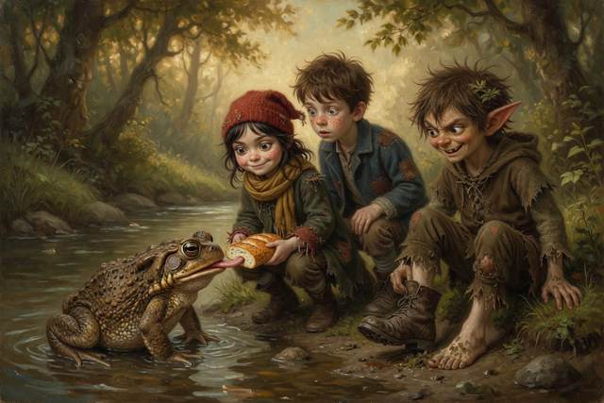
“The soft voice goes by the shortest road. Remember it.”
On the bank Hopsi picked a pebble out of the moss. “You offered him a stone,” she said to Scally, “and you called it a fly.”
“He is a toad,” said Scally. “He would not know.”
“He knew,” said Hopsi. “He kept the bargain. Can you?”
Scally scowled at the water for some time. Then he lay flat on the bank, waited, and caught a fly in his bare hand, a real one, fat and blue, and held it out on his palm. The toad ate it with great dignity. It was, everybody agreed, the first honest toll Scally had ever paid.
They reached the village lane at last, hungry and wet. Scally ran straight out across it without looking. A cart came round the bend with a snort and a clatter, and Tabitha grabbed him by the hood and yanked him back so hard that they both sat down. “Stop,” she said, with her heart going like a drum. “Look. Listen. Then cross.”
A woman stood by a covered cart at the corner with a basket on her arm. She had a bonnet, an apron, a round kind face, and a warm voice, and in her arms was a tiny, wriggling puppy.
“Oh, you poor wet things,” she said. “I have sweet buns in the basket, and a puppy for every one of you in my cart, just around the corner. It is a surprise. Come along quickly, and do not tell your mothers, or it will spoil it. Your mother sent me, Hal.”
Hal’s mouth went dry. He had a puppy-shaped hole in his heart, and a bun-shaped hole in his stomach. But he also had a sentence in his head, in his mother’s voice.
“What is the word?” said Hal.
“The word?” said the woman, and for half a breath her smile slid sideways. “Oh, it has gone clean out of my head, dear.”
“No,” said Tabitha. She held up one hand, flat, like a wall. She had learned this from her gran, and she said it loud. “No. We do not go with people who say keep it secret. Grown-ups who need help ask other grown-ups. They do not ask children.”
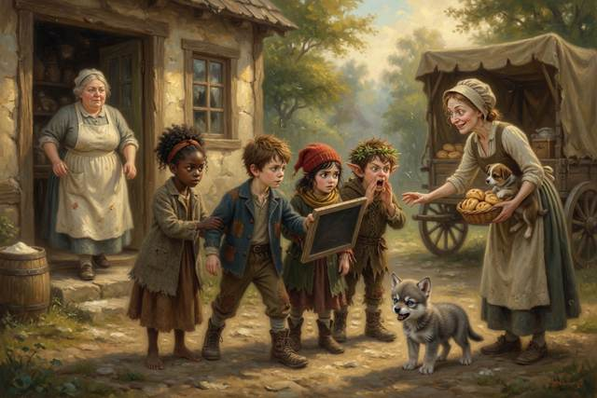
“Go!” said Titch, and tugged Hal’s sleeve.
“Yell!” shouted Scally, with his hands cupped round his mouth, in the loudest voice any of them had ever heard. “HELP! WE DON’T KNOW THIS LADY! HELP!”
“Tell,” said Hal. They ran straight to the baker’s door, where Mrs. Crumb stood floury in the doorway with her arms crossed. “Mrs. Crumb! A woman wants us to go with her and not tell our mothers!”
Mrs. Crumb looked down the lane. The woman was already climbing onto her cart. It rattled away over the hill, and nobody ever found out whose puppy it was. Mrs. Crumb gave everyone a bun, walked them all the way back to the mill, and stayed to look after the miller’s kitchen until his wife came home.
“Was she wicked?” said Titch, to Hopsi, on the road.
“I do not know,” said Hopsi. “I cannot tell wickedness by looking. A kind face can be a trick, and a rough face can be a friend. I know she asked us to keep a secret from the people who love us. That is the sign. That is enough.”
↑ Contents

Chapter 5. The Pike and the Torn Tag
By afternoon they were hungry enough to eat grasshoppers. Hopsi would not allow it.
At the mill pond a shadow slid beneath the surface, long as a canoe. It was a pike, old and enormous, with a head like a hatchet.
A small gray shape came padding down the bank. It was a wolf pup, thin and sleepy, with a darker saddle and one ear that flopped. It had been living in Scally’s spare boots by the door, and nobody had noticed until it woke up and followed them. It pressed its wet nose to the water. Hopsi did not grab it. She crouched, held out her hand flat, and let it sniff her first, because a strange animal, even a small one, bites when it is frightened.
“Gucci,” said Titch. It was the first thing that came into her head.
“Why Gucci?” said Hal.
“Look at its face,” said Titch.
The pup looked at them both with the expression of a small, very grumpy duchess, which settled the matter.
Under the willow a ripple broke. The pike seemed to be lying just under the surface, a hand’s breadth from the pup’s nose. Gucci lunged for it. Its jaws closed on water, and its whole body went in with a splash.
Hopsi did not step into the pond. She lay flat on the bank while Titch held her ankles, and reached, and hauled Gucci out by the scruff. “Reach or throw,” she said. “Never go in after a friend. Two in the water is worse than one.”
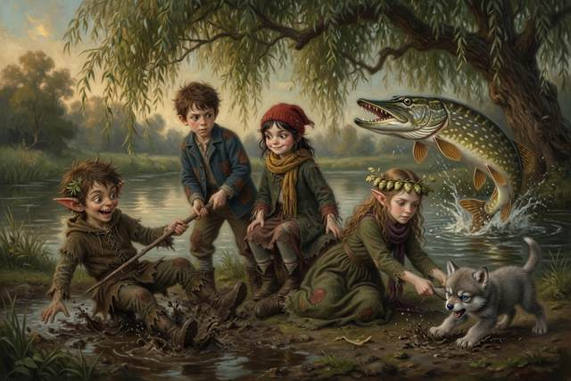
“It’s deeper than it looked,” said Hal, wet to the elbow.
“A fish is always deeper than it looks,” said Hopsi. “Light bends when it goes from air into water. Try it.”
Hal pushed a straight stick into the pond. Under the water it bent. He pulled it out, and it was straight. He did this four times, and wrote on his slate: I WAS WRONG. IT LOOKS BENT IN WATER, EVERY TIME.
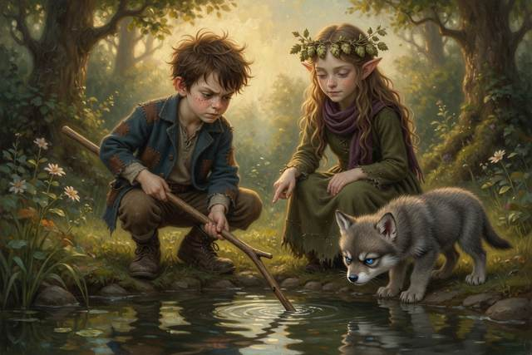
“The stick did not change,” said Hopsi. “The light took a bent road.”
“It is like a barrow,” said Titch slowly. “When Dad pushes ours off the path onto soft grass, one wheel gets there first and slows down, and the barrow swings around.”
“Just so,” said Hopsi. “Light slows down in water, so it swings too.”
“Why not go straight?” said Scally.
“Light takes the quickest road, and that is not always the shortest,” said Hopsi. “A lifeguard on the beach does not run straight at a swimmer. She runs further along the sand, because running is faster than swimming, and then swims less. A longer path, and sooner.”
“Same thing,” said Scally.
“Prove it,” said Titch. “Race you to the willow.”
Scally went straight across the shallow puddle by the bank, because it looked like the shortest way. Titch went around by the firm path, which was longer. She reached the willow first, with dry boots and a whole crust. Scally arrived with a boot full of mud and half a crust.
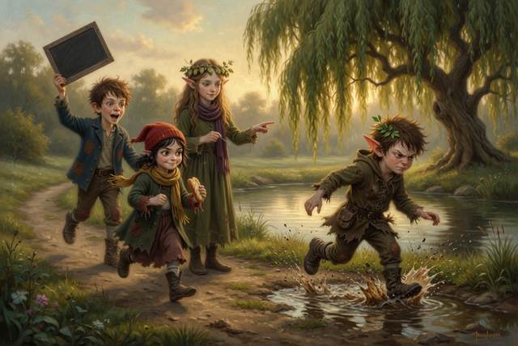
“I let you win,” said Scally.
“You are muddy to the knee,” said Hopsi.
Scally looked down at his knees. He looked at Titch’s dry boots. “She won,” he said.
“Longer,” said Titch, “and sooner.”
The pike was cleverer than any of them. It took Hal’s bait three times and gave it back each time with a look of deep disappointment, as if it had been served cold soup. At dusk Titch lost patience, threw her cloth over its head, and Hal and Hopsi hauled on one side and Gucci on the other, and the biggest fish in the pond came onto the bank in a spray of silver and landed on Scally. It looked at him. He looked at it. “I am sorry,” said Scally, to the pike, which seemed only fair. They roasted it on a fire he lit with a stamp of his foot, with hop tea, warm bread from the village, and an apple Hopsi found.
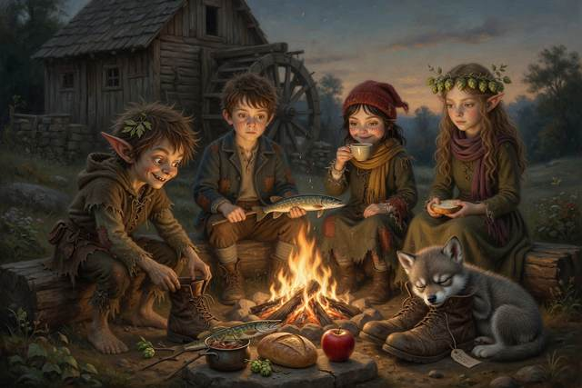
“Fire needs fuel, heat and air,” said Hopsi, when the pike was gone. “Take one away and it goes out. Somebody must put this one out.”
“I will,” said Scally. “I promise.”
Nobody noticed that he had his fingers crossed behind his back. Nobody except Hopsi, who heard him humming.
While they ate, Gucci went to sleep in the spare boot by the door. Before it did, it chewed at the tag tied to the laces. When Hal picked up the boot to stop it, he saw that the front said only SPARE PAIR. But the back of the tag had a word on it too, in smudged old ink, written the wrong way around. He could read only the first three letters: K N U.
Before he could read any more, Scally snatched the boot out of his hand.
“Mine,” he said, rather too loudly. His ears had gone red. He went and sat on the roof.
The boots twitched in Scally’s hands as he climbed. Hal saw. He wrote nothing on his slate. He did not know how.
↑ Contents

Chapter 6. The Howl and the Moon
That night the moon came up fat and white over the willows. Gucci climbed onto the top step, lifted his small narrow head, and howled.
It was a thin, wavering howl, like a kettle that had not made up its mind. Scally howled back, badly, from the roof. Titch howled in a different key. Hal, who had never howled in his life, found that he rather liked it.
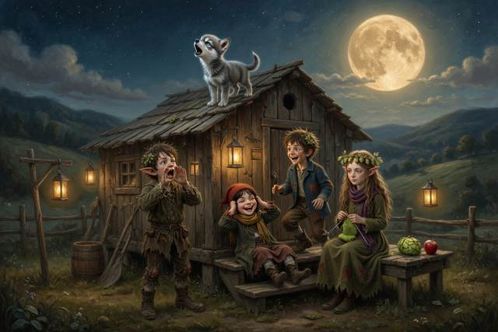
When they ran out of breath, Titch lay back on the step and looked up.
“It’s round tonight,” she said. “Last Friday it was a half. Where did the other half come from?”
“Guess,” said Hopsi.
“Somebody put it there,” said Titch.
“Make a model,” said Hopsi.
Hal borrowed the lantern and hung it on a post at the far end of the yard. It was the Sun. He took the apple Hopsi had found. It was the Moon. He held it out at arm’s length and slowly turned on the spot, because Hal was the Earth.
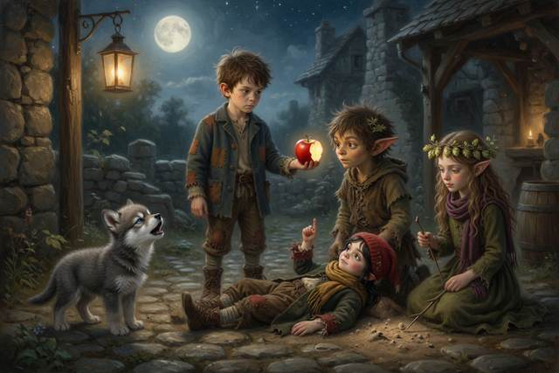
With the lantern behind him, the whole face of the apple shone. “Full,” said Titch.
He turned a quarter. Half the apple was bright and half was dark. “Half moon,” said Titch.
He turned again, and only a thin curl of the apple caught the light. “A fingernail.”
“The Moon makes no light of its own,” said Hopsi. “The Sun always lights half of it, the way the lantern lights half the apple. As the Moon goes round the Earth, about once a month, we see more of the bright half, then less, then none. Nobody put anything there. And it is not the Earth’s shadow. That is a different thing, and it happens only now and then.”
“Does Gucci howl at it?” said Titch.
“I do not know,” said Hopsi. “Wolves howl to call each other. The Moon is only where they happen to be looking.”
Hal looked at the rectangular eggs, far off in the long grass behind the mill, silver in the moonlight. They sat in a neat row, square as boxes. “And those?” he said. “Why have they got corners?”
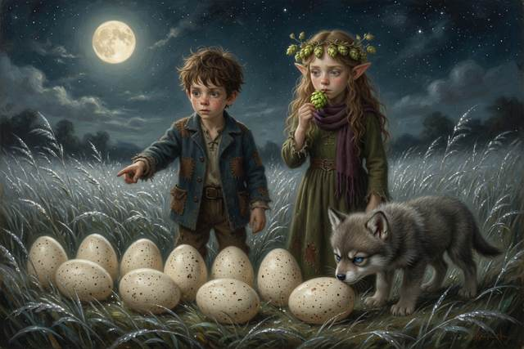
Hopsi opened her mouth. She shut it. She ate a hop.
“I do not know,” said Hopsi.
Everyone looked at her. It was the first time any of them had heard her say it.
“It is true,” said Hopsi. “That counts.”
Gucci, who had been looking at the Moon, sneezed, and fell asleep on Hal’s foot.
↑ Contents

Chapter 7. The Hot Night
Hal climbed up on the roof at midnight, though he had been told not to.
“What’s on the back of the tag?” he said.
“Nothing.”
“You said that fast,” said Hal.
“It’s mine,” said Scally. His voice shook. “Everything is mine, or nothing is. You have a mill and a step and a mother with a basket. I have a pair of boots that walk where somebody else wants.” He jumped down off the roof into the yard, right beside the supper bonfire. He had promised to put it out. He had not. It lay in the dark, a low heap of red ash, ticking and glowing. He stamped.
The ground answered. The green light jumped out of his foot and into the embers, and the embers woke. The ash roared up into a tall, yellow, crackling bonfire, and flung a fountain of sparks across the yard and into the heap of dry straw by the granary door.
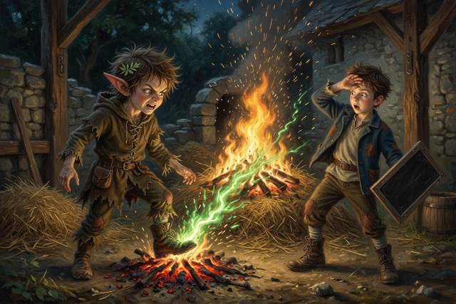
Then the straw was on fire too.
Scally stared. For once in his life he had nothing clever to say. Hal remembered what Hopsi had told them at supper: a fire needs three things. Fuel to burn. Heat to start it. And air to feed it. Take away one, and it goes out. Orange light climbed the stone wall. Heat touched Hal’s face like a slap, and the whole yard turned red.
“Fire!” screamed Titch.
“Father!” yelled Hal. “FATHER! FIRE!”
That was the first thing, and it was the right thing: shout first, and shout loud. Upstairs the bed creaked, there was a bellow, and a bandaged leg hit a floorboard.
“Everybody back!” roared the miller, from the window. “Away from it! Stay away!” He came down the stairs on his crutch faster than anyone had ever seen him move.
A girl came running out of the mill kitchen, where she had been helping Mrs. Crumb with the bread. It was Tabitha. “Wet sacks!” she said. “My gran says smother it. Wet the sacks and lay them on top. No air.”
“Good girl,” said the miller. “Sacks are in the shed. Wet them in the stream. The rest of you, a line from the stream, bucket to bucket, hand to hand. Nobody goes near the fire but me.”
They made the line. Hopsi and Titch and Hal and Tabitha passed the buckets, and Scally, who had started it, ran to the stream with a bucket in each hand so fast the water barely spilled. Gucci barked for the whole village. The miller and two neighbors laid the wet sacks on the flames with long poles, faces turned away, until the fire was a black, wet heap, steaming in the dark.
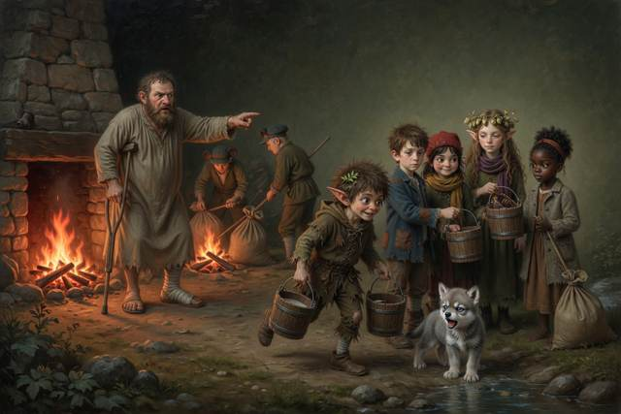
“It was a small fire,” said Hal.
“It was a fire,” said the miller, gently. “You shouted. You got me. You kept back. That is exactly right. Fire is not a game, and it is not a job for children. Next time, shout, get out and let a grown-up do the rest. Do you hear me?”
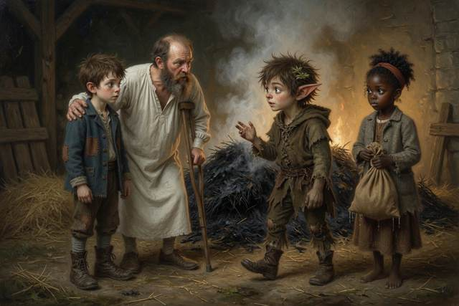
“Yes, Father,” said Hal.
“Who lit it?” said the miller.
Nobody spoke. Scally stood very straight, with soot on his face and his ears burning.
“I woke it,” he said. “I made the supper fire, and I promised to put it out, and I didn’t. And then I stamped on it. I’m sorry. I’m very sorry.”
“A fire is not out,” said Hopsi, “until you can hold your hand over the ashes and feel no warmth at all. Drown it, stir it, drown it again.”
The miller looked at him for a long time. He looked at the black heap. He looked at the granary, whose door was scorched and whose grain was safe and dry.
“Then you will scrub that wall in the morning,” said the miller, “and you will drown that bonfire properly, and you will not stamp in my yard again. And you may sleep on the sacks in the loft with the others. Do not forget what a promise is for.”
Scally nodded. He did not say anything clever.
Afterwards Hal could not sleep. He lay on the sacks with Gucci on his foot, and he asked Hopsi the question he was afraid of.
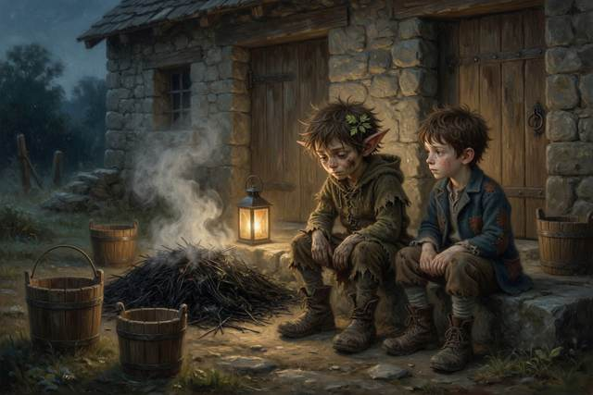
“What if we had been too slow?”
“A fire does not stay the size it starts,” said Hopsi. “The smoke is worse than the flames. That is why you shout, get out, stay out, and let a grown-up go in. You do not go back for a toy or a boot.” She put her needle through her sleeve. “Nobody was hurt. You did it right.”
Hal lay awake for a long time after that, listening to the rain tick on the roof. When he slept, he dreamed that every single person he knew was standing safely outside. It was the second night. Tomorrow at midnight the third day would close, and nobody knew the name.
↑ Contents

Chapter 8. The Girl with the Apples
On the third day Tabitha stayed on the step.
She had slept on a pile of sacks beside Gucci, who had decided she would do. She had set a crust down beside her to free both hands for her apple. Gucci took it. He ate it in two gulps, looked up at her with his grumpy face, and did not look sorry. Tabitha did not take it back. “He chose,” she said, and broke her apple in half and shared it with him instead.
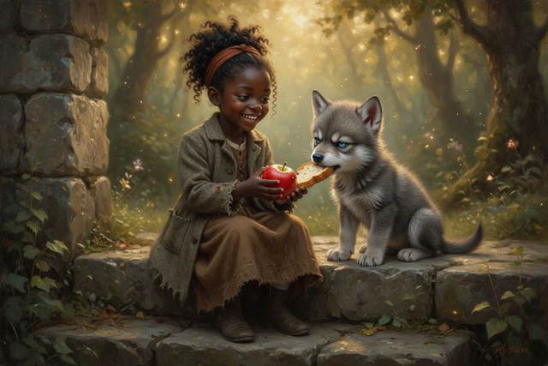
The night before had been the kind you only get once. All of them had slept in the mill loft, in a nest of old sacks, with a lantern turned low and the rain ticking on the roof, and nobody wanted to be the first to sleep. Titch told them that her little brother Pip, who was six, slept with his boots on in case of adventures, and had once been found in the morning wearing the dog. Hal read out a page of his slate where he had written “Acceptable” beside everything. Hopsi told a story, and it was very short, because it was true. “Once there was a hop. It grew. That is all, but it was a very good hop.”
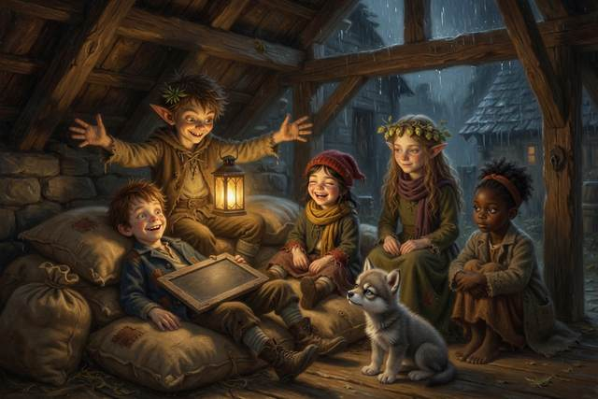
Then Scally sat up with the lantern under his chin. “I once ran so fast,” he said, “that my shadow got left behind and took three days to catch up. It arrived out of breath, and it had eaten my supper.”
“That is not true,” said Hopsi.
“Of course it is not,” said Scally. “It is a story.”
Hopsi thought about that for a while. “A lie is when you want somebody to believe it,” she said slowly. “A story is when everybody knows. I like stories. Tell it again, with the supper.”
He told it again, with a larger supper, and by the end Titch was crying with laughter, and Gucci had lifted his head to see what the noise was, and Tabitha, on her sacks, had her chin on her knees and her eyes going from face to face, as if she were memorizing them. She did not say anything. She did not laugh, not yet. But she did not go to sleep until the lantern did.
Later, while Hal paced and Titch counted crusts, Hopsi went down to the stream. She came back with a small bunch of white daisies and blue harebells, tied up with a blade of grass, and she held it out to Tabitha without a word.
Tabitha looked at it. “What is it for?”
Hopsi thought. It was difficult for her. Anyone else would have said “welcome”, or “I hope you stay.” But Hopsi only said what was true, and she did not yet know whether Tabitha would stay. A kind thing that might not be true was a thing Hopsi could not say. So she did what an elf does when the words are not allowed. She gave a present.
“They are all different,” said Hopsi at last. “Every one. I picked them for you. I checked every stem, and there is no foxglove in it. Foxglove is pretty, and poison.”
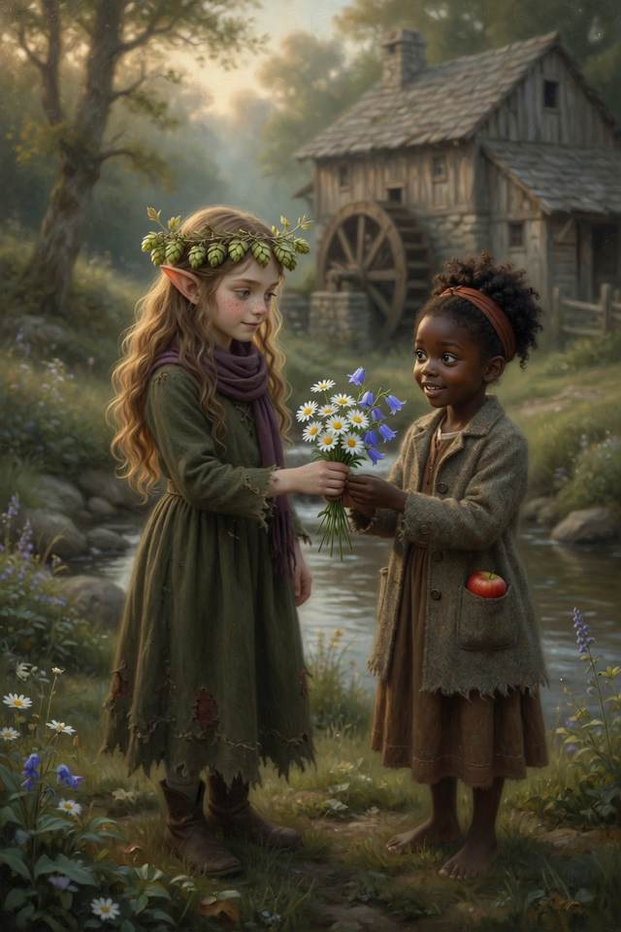
It was the nicest sentence she knew.
Tabitha laughed, the laugh she saved for the right moment, and it was the first time anyone had heard it. She tucked one daisy into her bun, and stood the rest in Hal’s empty porridge bowl on the step, where they stayed for all three days and were the first thing anyone saw.
She watched Hal pace around the wheel pit. She watched Titch tear a crust in even pieces. She watched Scally, who stayed well away from the sluice wall and looked at it a great deal.
“Why won’t he go near the wall?” said Tabitha.
Nobody had asked that. Hal frowned.
“He keeps looking at it,” said Tabitha. “And his hands are all scraped. And there’s mud on his sleeve, here, where he leaned on the wall. Mill mud. Not the pond.”
Hopsi did not say anything. She did not lie, so she did not have to.
“My gran lives by the sea,” said Tabitha, to nobody in particular. “She says last night’s moon brings a big tide.”
“Gran says the Moon pulls on the sea,” said Tabitha. “The sea piles up under it, like water in a bath when you push it to one end. And it piles up on the far side too. The Earth turns, so my gran’s beach goes through both piles every day. Two high tides, and two low.”

“She is right,” said Hopsi. “And when the Sun and the Moon pull together, at full and new moon, the tides are biggest. They are called spring tides, but that has nothing to do with spring.”
Hal wrote: FULL MOON, BIG TIDE. “Last night,” he said.
“That is why Gran said it,” said Tabitha, and ate her apple.
That afternoon the fog came.
It came up from the stream, thin and white, and in a few minutes the end of the garden was gone. The wheel stopped creaking. Gucci growled like a kettle coming to the boil.
The smell came first. Hard candies and cold air.
“Candies,” said a soft voice. “A quicker way. A shorter way.”
A tall figure stood at the end of the road. Thin, in a coat the color of dusk. A smile too wide. A bag that clinked. Its shadow was longer than it should have been, and it lay across the grass toward them like a spill.
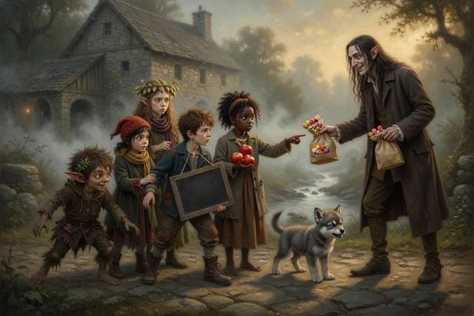
Hopsi knew the true sentence. It was: “He is not yours.” It was the one thing in the world she most wanted to say out loud. But she had learned by now what a true sentence does to a voice like that: it gives it something to answer. So Hopsi pressed her lips together until they hurt, and swallowed the best sentence she had ever thought of.
“There he is,” said the voice, quite pleasantly, “my little errand imp.”
Everyone looked at Scally.
↑ Contents

Chapter 9. The Quick Way and the True Way
“I did it,” said Scally.
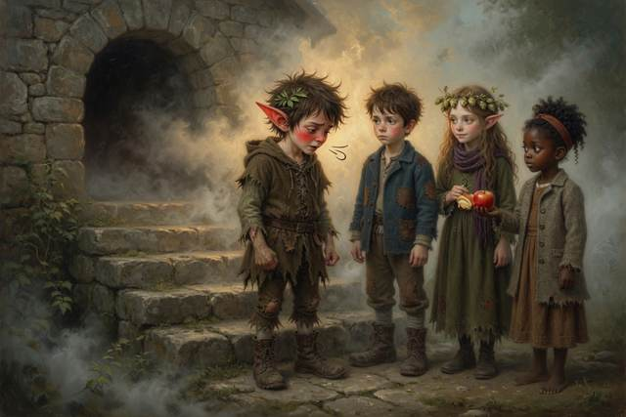
He said it in a small voice, which was not like him. He was standing very straight, and his ears were red.
“He sent me. He said if I jammed his bag in the wheel, the mill would stop, and the family would sell, and he’d give me proper boots. Boots that went where I wanted. Mine only go where he does.” He swallowed. “I jammed it on Monday, and I did not mean your father to fall. I hid. Then on Thursday I came back to see whether you were selling, and Hal pushed the porridge across. Just pushed it. Nobody has ever just pushed it across. So I made a bargain, to stay three days and get the bag out. And I couldn’t. I tried. I fell in the bog.”
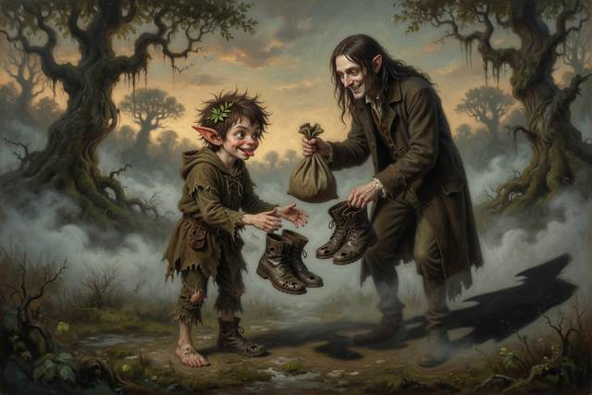
“You tell the truth when it’s funny,” said Hopsi quietly.
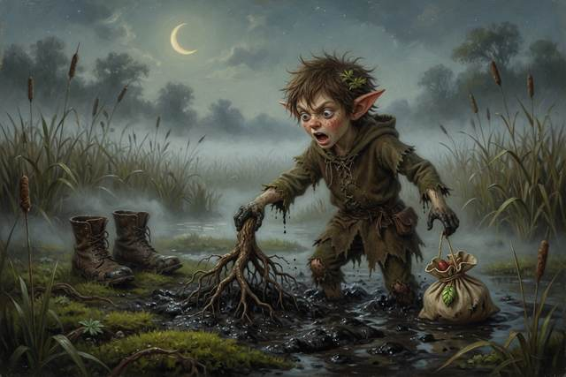
“It’s not funny.”
“No,” said Hopsi. “That is why it counts.”
The soft voice laughed, like sugar. “Pretty speech. Now give me my bag, little devil, and I’ll be on my way.”
“It’s in the pit,” said Hal.
“Then fetch it.”
“No,” said Hal.
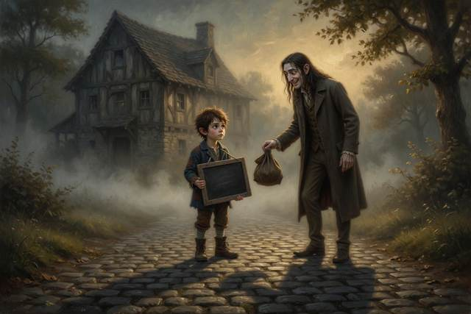
It was the bravest thing he had ever said. He said it in his flattest voice, and it came out so dry that the stranger stopped smiling.
Then it smiled again, much wider, with far too many teeth for a smile that was pretending to be kind. The grass around its feet turned white with frost. It held out a long hand to Titch. “Come, little one,” it said, sweet as syrup. “Your mother is waiting at the end of this road. I will take you.”
Titch’s feet began to move by themselves. Tabitha caught her other hand and held on. “No,” said Titch, in a small voice. Then, much louder: “NO! I WILL NOT GO WITH YOU!” She yelled it so loudly that a heron flew up out of the reeds, and the stranger flinched as if it had been slapped. A friend who tells you to keep a secret, or to come along now, is not a friend, however sweet the voice.
“I’ll fetch it myself,” said the Soft Voice. It stepped onto the path.
The grass shivered. The shadow ran along the ground like spilled ink, straight across the field, toward the wheel pit.
“It’s going straight over the bog,” said Tabitha.
“It goes by the shortest road,” said Hal. He thought of the toad.
“Run!” said Titch.
They ran.
All five and Gucci, around the long way, along the path beside the stream. The fog was thick and the path was narrow. Behind them, the stranger went in a perfectly straight line over the bog.
“We’re going the wrong way!” said Scally. “The pit’s over there! It’s shorter!”
“Shorter,” said Hopsi, “and slower.”
“How do you know?”
“The ghost knows. It is how he was lost.”
Hopsi, in front, turned onto the nearer path. “This way,” she said.
“Look,” said Tabitha. She had stopped. She was pointing.
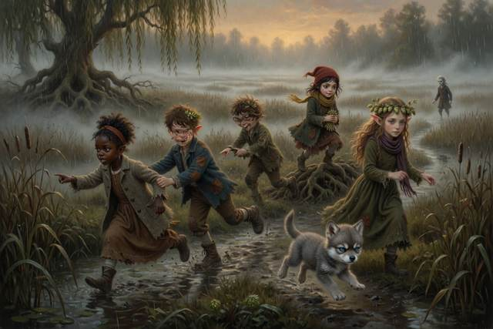
Along the path, where the ground was firm, willow roots stood in a line, and reeds stood where the water was shallow. A pale thread of firm ground ran between them.
“It’s hard here,” she said. “It’s soft there. Reeds mean wet.”
“Follow the willows,” said Hal.
“I was wrong,” said Hopsi, and turned around. “I am glad someone looked. It is not hard to say. I recommend it.”
They did. The path bent and doubled back and ran twice as far as the straight line, and it was firm all the way. Behind them the stranger was crossing the bog in the straightest line there ever was. Its first step sank to the ankle. Its second sank to the shin. It kept going. It had never needed another way.
At the bend the path crossed a line of three white stones. Hopsi had set them the evening before, so that the way back to the step would always be open. Scally kicked the middle stone aside as he passed, and then, on a thought, ran back and kicked it into place.
“In case,” he said.
Beyond the stones the stream ran into a stone culvert under the road, a low, black tunnel, dripping, with a smell of old moss.
“In,” said the ghost, who had come to meet them with a cold lantern that gave light and no fire. “The water goes through the dark here and comes out in the Mirror Mill, if someone who belongs to both carries a light. I belong to both. Quickly.”
Gucci would not go in. He planted all four big paws at the mouth of the culvert, flattened his ears, and showed his small white teeth to the dark. “Pick him up,” said Scally. “No,” said Tabitha. She crouched down, put her hand flat on the cold stone, and waited, because she had been the new one on the step and she remembered what it felt like to be pushed. It cost them a long, held breath of time. Then Gucci sniffed her palm, sneezed, and went in first, with his tail up, as if the whole idea had been his.
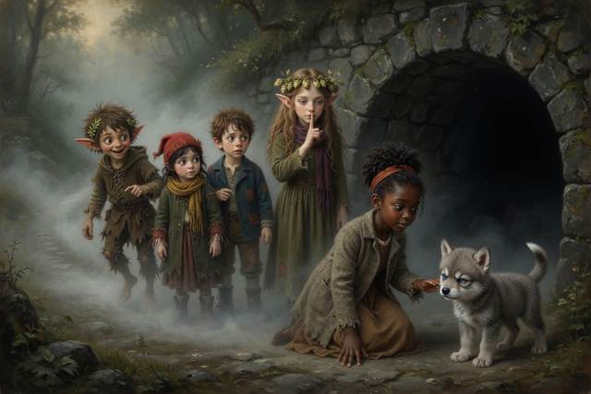
They went in single file, with the lantern in front, bent double, in the cold and the dripping and the echo. Halfway through, a single thin beam of daylight found a crack in the roof and drew a bright coin on the wall ahead. Tabitha stopped. The coin of light trembled on the wet stone, and her face, which had been watching everything so carefully, opened all at once, like a window.
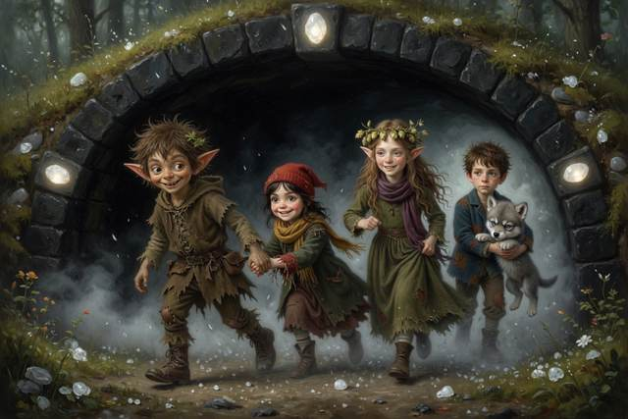
“It got through the earth,” she whispered. “Is that tunneling?”
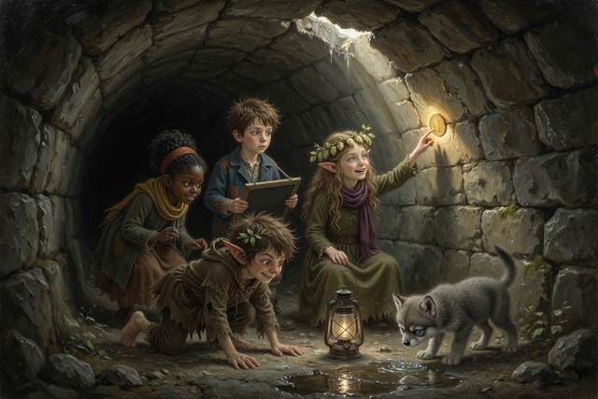
“No,” said Hopsi softly. “That is only a crack. I will not tell you it is more. Real tunneling is a great deal smaller than a crack.”
“It was still lovely,” said Tabitha.
“Yes,” said Hopsi. “That is true too.”
Then the walls turned from black to gray to green, and they came out under the Mirror Mill.
It was the same mill, and it was the wrong way around. The wheel turned backwards. Flour dust drifted up from the floor in slow gold ribbons instead of falling. The stream ran gently uphill, which Titch said was unnatural, and then watched with great interest. Hal looked at his hands, and the chalk was on his left. Hopsi’s needle was in her left hand, and she was looking at it with an expression that was not quite a frown.
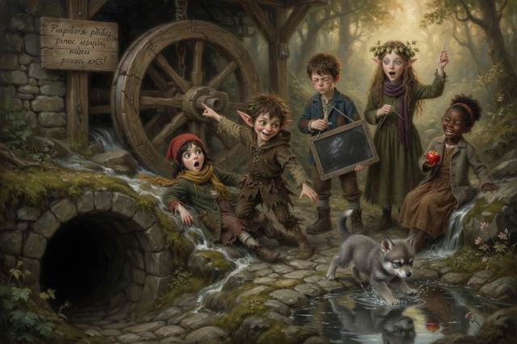
“Which mill is the real one?” said Hal.
“The one you are standing in,” said the ghost. “They are both quite sure of it.”
In front of the door stood a pair of boots with a tag. The tag was whole, and the word on it ran back to front. Hal had seen three letters of it on the other tag. He held it up to the pale light.
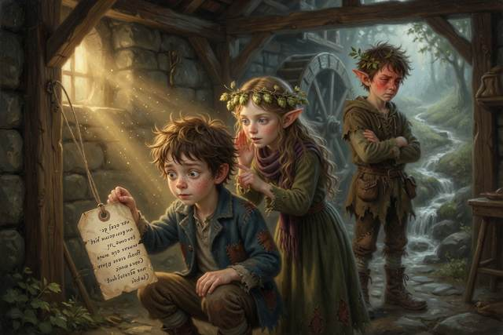
KNUFERAPS
“K N U,” said Hal. “Backwards it is S… P… A…” He stopped. “Hopsi. A mirror turns writing round. Read it from the other end.”
“Oh,” said Hopsi, quietly.
“No time,” said the ghost. “The pit.”
The sluice gate stood wide open in the Mirror Mill. The pit lay black and cold beyond it, with a lump at the bottom that clinked.
“The same bag,” said the ghost. “Pull it here and it comes loose there. That is the way of mirror mills.”
Titch had already unpicked her hem. It made a long thread. She tied one end to Scally.
“Do I have to?” said Scally.
“It’s your bag,” said Hal. “Sort of.”
Scally took a breath, ran at the gate, and jumped.
He went through it like a rat through a hedge, down into the cold black pit, and the thread went tight. For one long moment nothing happened. Then the thread jerked.
“Pull!” said Titch.
All five of them pulled. Hopsi hauled on the end of the thread. Tabitha dug her heels in. Gucci grabbed Titch’s coat. The ghost held the lantern high and said “Heave” in a flat, polite voice.
Scally came out backwards, soaked, black to the armpits, and smelling of hundred-and-fifty-year-old mud. He was holding a clinking, dripping bag the size of a flour sack.
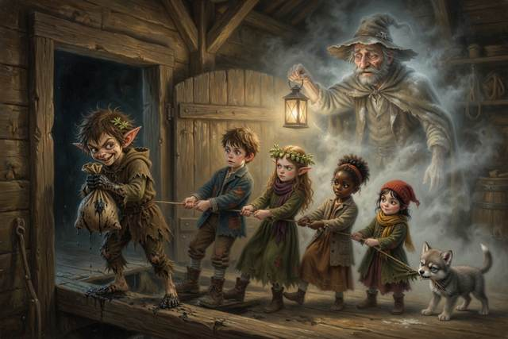
The mirror wheel gave a groan. Then it moved.
At the far end of the Mirror Mill the pond lay still and silver. In it, small and clear as a window, was the real mill, the right way round, with the real wheel groaning, and turning, once, twice, and the real water rushing over the slats. And in the real bog, to its middle, stood the stranger.
Its feet were sunk to the knees, and the shadow behind it, which was as long as it was proud, had lost its grip on the ground.
“Give me my bag,” it said, but not so softly now.
The pond went dark. The ghost’s lantern guttered and went out, and in the black the voice came up through the water, as cold as a cellar. “Boots, Sparefunk. Proper ones, that go where you like. Only give me the bag.”
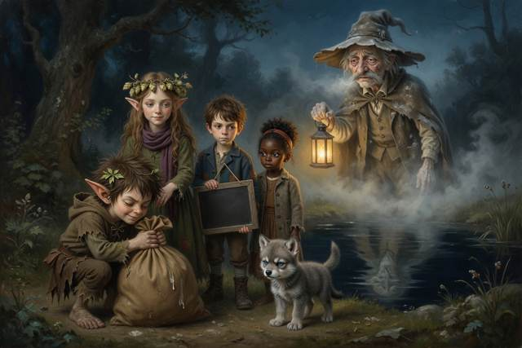
Scally’s arms tightened round it. Everyone heard the little clink of the candy inside. Nobody breathed.
“He tells you what you want,” said Hopsi, very steadily, “so that you will forget what he wants.”
Scally shut his eyes. “I want to stay,” he said, and the lantern flared back on.
“Here,” said Scally. “Take it.” He leaned over the Mirror pond, and he threw the bag as hard as he could.
The bag burst.
Out came a hundred years of hard candies, and every one was a small gray pebble. Out came a thousand little jars with labels on, QUICK WAY, SHORT WAY, EASY WAY, and they fell and smashed. And out came flour. A whole sack of it, two centuries of the mill’s stolen flour, came down over the stranger like snow.
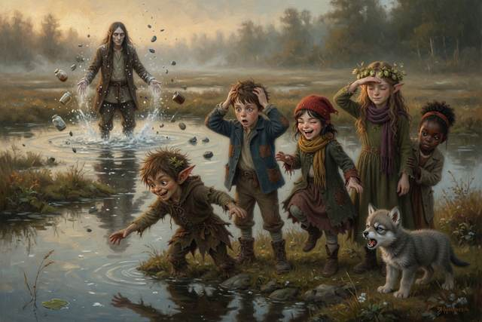
The stranger sneezed. It staggered out of the bog, white from head to foot, and came along the path toward the bend, where the three white stones lay across the road. It put out one long foot to step over them.
The stones glowed, a thin white light like the first of a moonbeam, the middle one brightest, the one Scally had put back, and the foot stopped. It could not cross. It stood there with its mouth open, and began to thin.
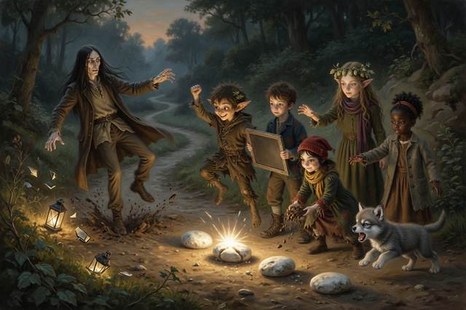
“A shortcut,” it said, in a voice like the last of a candy, “is only…”
Nobody heard the end of the sentence. The fog went with it. The air smelled faintly of hard candies for about a minute, and then of rain.
Nobody was hurt. Titch’s knees shook for a good while, and Tabitha held her hand until they stopped. “Being frightened is not the same as being wrong,” said Hopsi. “You were frightened, and you said no anyway. That is what brave is.”
Scally looked down. The spare boots by the road had gone still, and were only boots.
↑ Contents

Chapter 10. The True Name
It was past midnight when the third day closed. Everyone sat on the step, wet and exhausted. Gucci lay across Hal’s boots, which were Scally’s boots, which were somehow everybody’s.
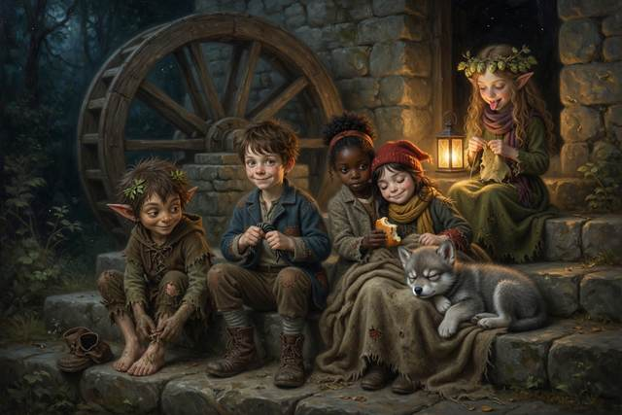
“Time,” said Scally. He was shaking, and trying to stop. “Before the third day closes. Guess my name, or the boots stay mine, and one small thing besides.”
“I know,” said Hal.
He held up his slate. On it he had written, in the dark in the mirror mill, one word backwards:
KNUFERAPS
And under it, forwards:
SPAREFUNK
“It was never about the boots,” said Hal. “It is your name. Somebody wrote it on the tag to make the boots yours, and you theirs.”
“It was my mother’s word for me,” said Scally. He sat down very suddenly. “He took it. He wrote it where I couldn’t rub it out. A name on a tag is a name on a leash.” He looked at his hands. “Nobody’s ever guessed.”
“Sparefunk,” said Hal.
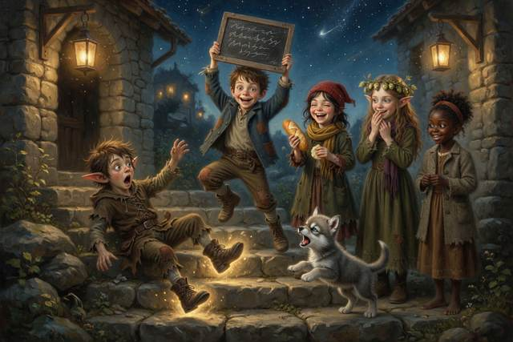
For a moment nobody breathed.
“A true name,” said Hopsi, “said by a friend, unbinds any bargain made under another. That is old magic.”
The boots slid off Sparefunk’s feet on their own and stood side by side on the step, empty, shining a little.
“I lost,” he said. His voice cracked. “That’s the bargain. Boots go back. Then I’ll be…”
“Stay,” said Hal.
“That’s not in the bargain,” said Sparefunk.
“It’s in the small print,” said Hopsi. “A place on the step. It was always going to be the small thing.”
He looked at her. He looked at Hal. For the first time anyone could remember, he did not have a clever thing to say.
“Right,” said Sparefunk. “Well. Acceptable.”
↑ Contents

Chapter 11. Sunday
At dawn on Sunday two messengers came down the road in blue and purple coats and found the wheel turning, the mill roaring and twelve sacks of flour stacked on the step. They counted them twice. They looked for a lord. They found five children and a wolf, asleep in a heap.
“A lord,” said the first messenger, “has people to see to these things.”
“Yes,” said Titch, waking up. “We do.”
Scally sat up in the heap, with straw in his hair. “He is not a lord,” he said. “I told you he was. I made it up. It was me.”
The first messenger looked at the second. “It is a great deal of flour,” said the second, “for a boy.” “And whom shall we tell the king made it?” asked the first, writing. “The wheel,” said Hal. They wrote that down, since it was the only honest answer, and it was the first time the king’s men had ever heard of a mill taking the credit. They stamped the paper, and nobody was mad at all, least of all Scally, who found that he had been dreading it for three whole days and that it was over in a breath.
There was a thump on the stairs. Hal’s father came out on a crutch, took one look at the turning wheel, and sat down on the step so hard that Gucci squeaked. Behind him came Hal’s mother, home early from her sister’s, with a basket, and behind her Mrs. Crumb the baker and half the village with empty sacks. In front of the crowd, holding Titch’s hand, was a small boy of six with a crust in each fist: her little brother Pip, who had been told to stay at home and had not.
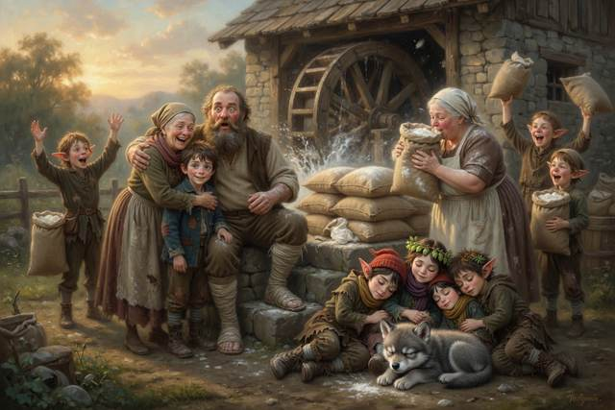
“Who did this?” said the miller.
“We did,” said Hal. He took a deep breath. “Father. Mother. I made a bargain. You told me not to. I did it anyway, because I wanted the wheel to turn, and I should have asked you first. I am sorry.”
His mother looked at him for a beat. “I said no bargains,” she said.
“I know.”
“What did it cost?”
“A place on the step,” said Hal.
His mother opened her mouth, shut it, and laughed. “Next time,” she said, “you tell me first. Even if you are sure. Especially if you are sure.”
“Yes, Mother.”
Scally stood up, very straight, with his ears red. “Sir,” he said to the miller. “It was me that jammed your wheel. I put a bag in the pit. That is why you fell. I did it because a man promised me boots. I am sorry about your leg. I am sorry about all of it.”
The whole yard was quiet. Mrs. Crumb stopped counting sacks.
The miller leaned on his crutch and looked at the boy for a long time. He was not a man who said things quickly. “A broken leg is a hard price for boots,” he said at last. “It was a wicked thing to do, and you were put up to it, and you have told me yourself, and that counts for a good deal. You will sweep this mill floor every morning until I can walk without this stick. And you will learn to grind, because I shall need an apprentice who knows what a wheel is for.” He paused. “Do you understand?”
“Yes, sir,” said Scally. His voice shook. “Thank you, sir.”
That was not the end of it. Sweeping a mill floor is a great deal harder than telling a lie, and Scally did it every morning for seven weeks, with blisters, and Mrs. Crumb gave him no buns until the floor shone.
Mrs. Crumb was already counting sacks. “Twelve,” she said, “and every one of them gray with flour. I could kiss that wheel.”
“Funny,” said the miller, squinting up at the wheel in the early sun. “For a moment I thought I saw Grandfather’s hat.”
The ghost stood on the top of the wheel in the early light. He was a little fainter than before, and a little more himself. His hat was on straight.
“It is very kind,” he said, “of the quickest way home to be so slow.”
“Where are you going?” said Hal.
“Home,” said Old Miller Millersen. “Do not worry. It is the long way round. I have walked it a great many times in my head.”
The sun rose. The light that had left it eight minutes before lay across the wheel, and across the step, and across a very old hat. Then the hat was only light, and the wheel was only turning.
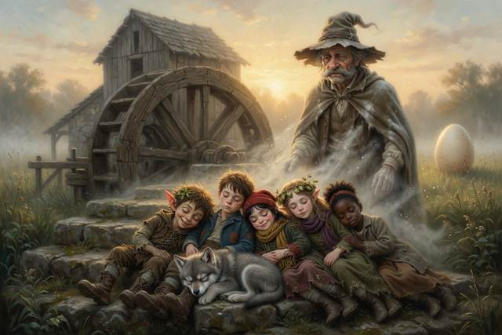
“Sunlight is eight minutes old,” said Hopsi quietly. “What we see of the Sun is news from eight minutes ago. We were all a little late, and it was enough.”
In the pond, small and silver, a second mill turned the wrong way around. And a boy in the water, who was also Hal and was holding his slate in the wrong hand, looked up, and winked.
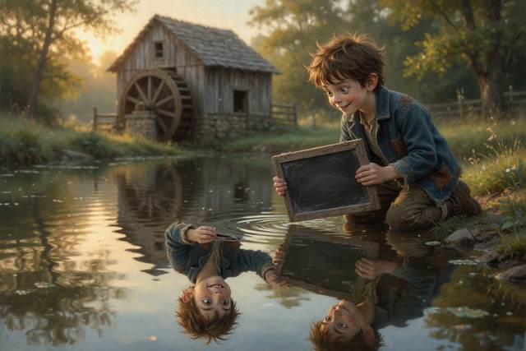
Behind the mill, in the long grass, a rectangular egg rocked once, twice, and cracked along one corner. What came out was wet, ordinary in shape, and not at all interested in rolling. It dried in the sun into a small brown bird. The other eggs kept their corners.
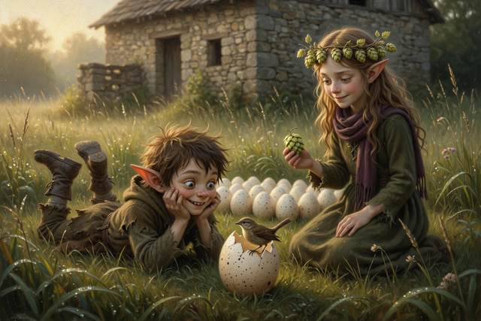
The bird was a nuisance from the first morning. It climbed onto the top of the wheel and sang four notes, exactly four, at the very moment the miller was explaining to the whole village how the wheel had stopped, so that nobody heard the end of the explanation. It would not leave the step. It stole a hop out of Hopsi’s bowl, one hop, and ate it in front of her with every sign of satisfaction. Titch said somebody ought to move it. Hal said he thought they should not. The bird sang four notes, sat down on Scally’s head, and stayed there.
“It’s on me,” said Scally, with great dignity, and did not shake it off.
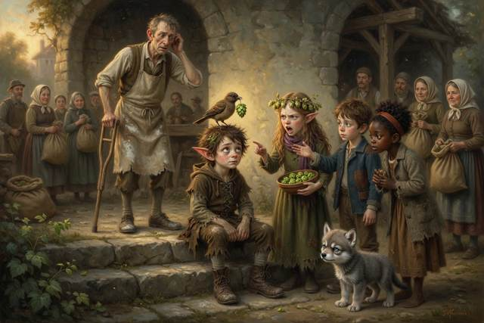
At dusk, when the village had gone home with its flour and the step was quiet, Scally got up with the bird still on his head, took the spare pair of boots, and turned them so that they faced the road, where the next person to come along who needed boots would see them first. Nobody had asked him to.
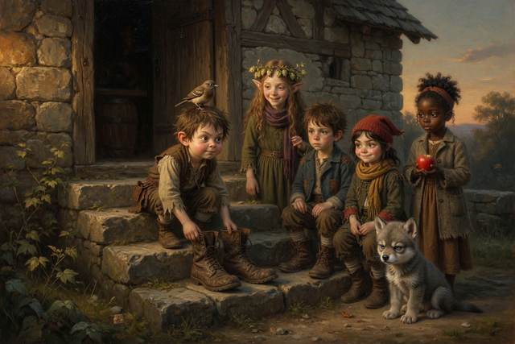
Hopsi watched him do it. She had a true sentence ready, a long and clever one, and she let it go. Instead she said the shortest true thing she had ever said out loud.
“Good,” said Hopsi.
The End
↑ Contents

Next in the Series
The Step Stories, Book 2: out now
Scally and the Sleepless Stream
The mill wheel is turning. The three white stones still keep their line. But a boy in the pond winked, a small brown bird will not leave, and the rectangular eggs in the long grass are not all hatched.
Hal, Scally, Hopsi, Titch, Tabitha and Gucci set out along the stream, on a path none of them has walked before, to find where the water goes and what else is true.
Book 2 is ready for you now. Book 3 is coming soon.
↑ Contents

Hopsi’s True Things
Everything Hopsi says in this book is true, and when she does not know, she says so. The magic is marked as magic. Here is the short list, and some things you can try. You do not have to read them all at once: one a night is plenty.
1. Levers. A lever multiplies your push, like a seesaw: the long end moves a long way down and the short end moves a little way up, with great strength. Guess first, then try it: rest a ruler across a pencil, put a coin on the short end and press the long end. ↩ Back to the story
2. Rainbows. Sunlight looks white but is really all the colors mixed. Raindrops split it apart again, like a glass prism. You must stand with the sun behind you. Try it: spray a garden hose on a sunny day with the sun at your back. ↩ Back to the story
3. Genes are a recipe. A plant or an animal is built from a very long recipe, written in tiny letters. A baby gets half its recipe cards from each parent, shuffled, so it takes after both and is never exactly the same as either. Try it: look at your family’s ears, noses and chins and see whose card you have. ↩ Back to the story
4. The best fit leaves the most young. Green grasshoppers are harder for toads to see on green grass, so more of them grow up and have young. After many generations, the color that fits is the one you mostly see. Try it: scatter ten green and ten brown paper dots on grass and ask a friend to grab as many as they can in ten seconds. ↩ Back to the story
5. Light bends in water. Light slows down in water and swings round, like a barrow going off the path onto grass. So a fish is always deeper than it looks, and a straight stick looks bent. Try it: guess whether a straight pencil stays straight in a glass of water, then look from the side. ↩ Back to the story
6. Quickest is not shortest. Light, and a lifeguard on a beach, take the quickest road, which is not always the straightest. Try it: race a friend, one straight across a muddy lawn and one round the firm path. ↩ Back to the story
7. Tunneling. The very smallest bits of the world, much smaller than a speck of flour, sometimes turn up on the far side of a wall, like a marble that rolls at a hill and is found beyond it. It does not happen to boys, and a crack of light in a roof is not tunneling. It is part of why the Sun shines. ↩ Back to the story
8. Moon phases. The Moon makes no light of its own. The Sun always lights half of it, and as the Moon goes round the Earth, about once a month, we see more or less of the lit half. The Earth’s shadow has nothing to do with it. Try it: in a dark room with a lamp across the room, hold an apple at arm’s length and turn slowly on the spot. ↩ Back to the story
9. Tides. The Moon pulls on the sea, and the sea can flow, so it piles up on the near side and the far side of the Earth. As the Earth turns, each coast passes through both piles each day: two high tides and two low. At full and new moon the Sun joins in and the tides are biggest. Try it: look up the tide times for a seaside town. ↩ Back to the story
10. Writing in a mirror comes out reversed. A mirror swaps front and back, which turns writing the wrong way round. Try it: write your name on a card and read it in a mirror. (The Mirror Mill is magic. The reversed writing is true.) ↩ Back to the story
11. Sunlight is eight minutes old. It takes about eight minutes for sunlight to cross the space between the Sun and us, so what we see of the Sun is news from eight minutes ago. ↩ Back to the story
12. Fire needs three things. Fuel, heat and air. Take away any one and it goes out. A wet sack laid on a small fire smothers it. A bonfire is only out when the ashes are cold to your hand: drown it, stir it, drown it again, and never leave one burning. (Never play with fire. If there is a fire, shout, get out, and get a grown-up.) ↩ Back to the story
13. Stranger safety. A stranger can be a man or a woman, old or young, and can look kind. It is about what they ask. Be careful if someone asks you to keep a secret from your family, offers candy or a puppy, says your mom sent them, or asks a child for help. Say NO, GO, YELL, TELL: say no, go to a safe place, yell if you need to, and tell a trusted grown-up. Agree a family code word, and always tell someone where you are going. ↩ Back to the story
14. Safe habits. Reach or throw, never go in after a friend (water is deeper and colder than it looks). Stop, look and listen before you cross a road. Never taste wild plants, berries or medicines unless a grown-up says so. Let a strange animal sniff your flat hand first, and ask the owner. ↩ Back to the story
15. “I do not know” is a scientist’s sentence. Hopsi says it about the square eggs. Real scientists say it every day, and then they go and find out. ↩ Back to the story
16. Friction. When two things rub, they pull against each other. That is why your shoes grip and why a slide gets faster when you wax it. Grease makes friction smaller, so it cures a squeak but not a jam. Try it: slide a book across a table, then across a dish towel, then across a sheet of wax paper, and see which is easiest. ↩ Back to the story
↑ Contents

For Parents and Teachers
This is a fantasy adventure to read aloud at ages 5–9. Children from about 5 can follow the whole story from the pictures alone (a “picture walk”: turn the pages and ask what is happening), and older children can read it by themselves. Every fact the elf Hopsi states is true, and every piece of magic is marked as magic. The children test things before they believe them. The book promises curiosity, new words and good scientific habits, not exam results.

The habits of a scientist in the story
“How do we know?” Hal asks it. The answer is always: look, count, test, or make a model.
Write it down. Hal’s slate is a lab notebook: the lever test, the grasshopper counts, the bent stick, the moon shapes.
Make a model. An apple and a lantern show why the moon changes shape.
Looks can fool you. A fish is deeper than it looks, a stick looks bent in water, and a mirror swaps left and right.
Say only what you know. Hopsi says only what is true, and “I don’t know” counts.
Notice what others miss. Tabitha spots the firm path from the reeds.
Guess first, then test. Hal guesses the lever wrong and writes WRONG on his slate. Scally’s fake fly fails.

What each chapter teaches
The Stuck Wheel: a problem to solve against the clock, and what it feels like to break a rule you were given.
The Lord of the Riverbank: levers, with a seesaw, a fair test, friction (butter cures a squeak, not a jam), why a trick catches up with you, and why a rainbow needs the sun behind you.
The Ghost in the Wall: tunneling, with a marble and a hill (very, very small things only), and why the sun shines.
The Toad of the Ford: genes as a recipe, variation, counting data, why the color that fits becomes common, and what to do when a friendly stranger asks you to go with them: No, Go, Yell, Tell.
The Pike and the Torn Tag: reach or throw, why light bends in water (a barrow and a lifeguard), a stick test, a puddle race, and why a promise matters.
The Howl and the Moon: why the moon changes shape, with an apple and a lantern, why wolves really howl, and a scientist’s “I do not know”.
The Hot Night: what a fire needs, shouting first, why children let grown-ups put out a fire, and why a bonfire must be put out properly.
The Girl with the Apples: welcome when the words are not allowed, careful observation, the difference between a story and a lie, and tides: how the Moon pulls the sea.
The Quick Way and the True Way: reading evidence, being brave enough to say no, a crack of light that is not tunneling, and writing that a mirror turns round.
The True Name: reading mirror writing, and telling the truth when it is hard.
Sunday: saying sorry and mending what you broke, and sunlight that is eight minutes old.

Staying safe: what this book models
Strangers. The woman with the puppy and the Soft Voice are two strangers. Neither is spotted by looks. The warning signs are a request to keep a secret, offers of candy or pets, a claim that a parent sent them, or a child being asked for help. The children say No, go to a safe place (the baker), yell, and tell. Agree a family code word, like marmalade.
Fire. Shout, get out, get a grown-up, and leave the fire-fighting to them. A fire needs fuel, heat and air. Never leave a bonfire burning; drown it, stir it, drown it again. Smoke is the real danger, so stay low and stay out. Please make a family escape plan together.
Water. Reach or throw, never go in after a friend. Never go to a pond or stream without a grown-up.
Roads. Stop, look and listen before you cross.
Plants, medicines and cleaning things. Never taste berries, leaves, mushrooms, medicines or cleaning products unless a grown-up says so. Foxglove is poisonous.
Animals. Let a strange animal sniff a flat hand first, and never grab one. Ask the owner.
Hot things. Turn pot handles inward. Keep small hands away from stoves and kettles.
Telling someone. Hal writes where he is going and when he will be back. Go in pairs, and never go anywhere alone in the dark.
Screens and online. There are no screens in this story, but the Soft Voice is exactly the person who messages a child online, offering something nice and asking for a secret. The same rules apply: no, tell a grown-up, and never keep that kind of secret.

Talk about it
Why did Hal write his results down? What would have happened if he hadn’t?
Why is a fish deeper than it looks? What else looks different from how it is?
If the shortest way is the slowest, how would you plan a journey?
What shape is the moon tonight? Where will it be in a week?
Who made the fire go wrong, and how did everyone put it right? What would you do if you saw a fire?
Which part of the story is magic and which is true? How can you tell?
Who noticed something the others missed? What did they notice?

Words to grow
lever, friction, rainbow, inherit, variation, camouflage, bend (refraction), reflection, tunneling, phase, tide.

A note for adults
Light travels about three-quarters as fast in water as in air, so “a quarter slower” is a child-sized number. A fish is deeper than it looks when you look into the water from above. Sunlight takes about eight minutes and twenty seconds to reach Earth. The recipe picture of genes is an analogy: real genes are made of DNA. Tunneling is real quantum behaviour of very small particles, and it matters in how the Sun releases energy; the marble picture is only a way in, and the story is clear that it does not happen to people or ghosts. The moon’s phases come from how much of its sunlit half we can see, not from the Earth’s shadow. Tides come from the Moon’s gravity pulling more strongly on the near side of the Earth than the far side, with the Sun adding to it at full and new moon; the bath-water picture is a simple way in. A mirror swaps front and back, which is why writing reads the wrong way round in a mirror; the Mirror Mill itself is magic. Stranger safety is not about looks: a stranger can be a man or a woman and can seem kind. The signs are a request to keep a secret, offers of candy or pets, a claim that a parent sent them, or a child being asked for help. Please agree a family code word, like marmalade in the story. In the fire scene the adults put the fire out and the children stay back; please make a family escape plan together. A bonfire must be drowned, stirred and drowned again until the ashes are cold to the hand. These are seed ideas, meant to make children curious, not to be tested at school yet.
↑ Contents

About the Author
Anneliese Tauber is a mother of four. When her children were small she read them a great many fairy tales, and she noticed that the best ones answered the questions children ask, and never needed to bend the truth. The Step Stories are for curious children and the grown-ups who read to them.
If your child enjoyed this book, a short, kind review on Amazon helps other curious families find it. Thank you.
↑ Contents

Also by Anneliese Tauber
Scally and the Sleepless Stream
The Step Stories, Book 2. Hal, Scally and Hopsi follow the stream to find where the water goes.
Bavarian Cooking Made Simple
Classic dishes from a Bavarian kitchen, written so that any cook can enjoy a taste of Bavaria.
↑ Contents
Typeface in the e-book edition: Comic Neue, © The Comic Neue Project Authors, used under the SIL Open Font License 1.1.

