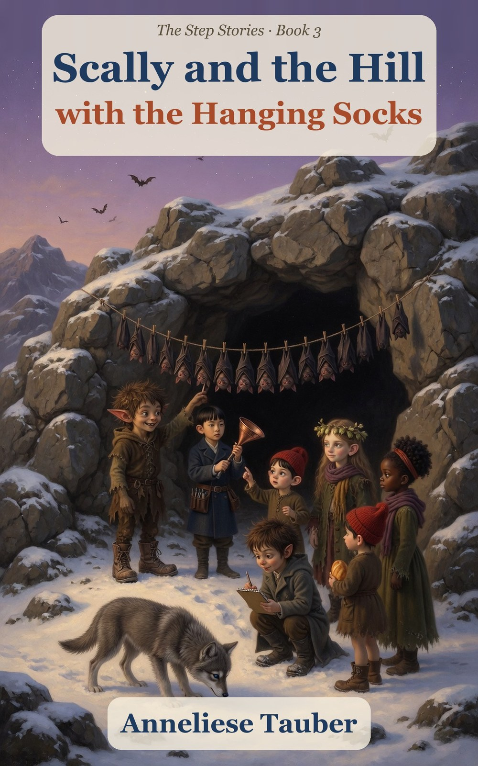

Scally and the Hill
with the Hanging Socks
Book 3 of The Step Stories
Anneliese Tauber

Contents
Meet the Characters
Chapter 1. The First Frost
Chapter 2. The Doctor’s Bag
Chapter 3. Ice on the Pond
Chapter 4. The Hill That Clicks
Chapter 5. The Mayor’s Cheese Cellar
Chapter 6. Wen’s Listener
Chapter 7. The Picture of the Baby
Chapter 8. The Sledding Day
Chapter 9. The Night of the Big Snow
Chapter 10. The Baby
Chapter 11. The First Warm Evening
Hal’s Slate: What We Found Out
For Parents and Teachers
About the Author
Also by Anneliese Tauber

Meet the Characters
Hal (Halbert) Millersen
9 and a half. The miller’s son, with a slate for his notes. Says “Acceptable” when things are bad, and is learning other words.
Scally, the wee scallywag
A little devil with pointed ears and a leaf in his hair. He hums a little tune before every trick. His true name is for special occasions.
Hopsi (Elfie Didlhop)
An elf with long swept-back ears. She only says what is true, and says so out loud when she is wrong.
Titch Mitchel
9 and a half. Red cap, quick fingers and a rope always over her shoulder.
Tabitha Smoke
8 and a half. Curly black hair in a bun. Watches carefully and knows her gran’s stories about the sea.
Wen Liang
About 9. New in the village. A careful boy who mends clocks, measures ice, and does not like the dark.
Dr. Liang
Wen’s mother, the new village doctor. Brisk, kind, funny, and never without her black bag.
Pip
7 and a half. Titch’s little brother. He is sure that anything can be tried once.
Gucci
A young wolf, now the size of an armchair, who hears things nobody else can.
Mayor Pomfrey
The village mayor, with a gold chain, a big mustache and a great love of cheese.
Mrs. Crumb
The baker. She has helped half the village into the world.
Fourpence
A small brown bird who sings five notes now.
Ages 7–10. Younger children can follow the whole story from the pictures alone.

Chapter 1. The First Frost
On the first morning of November, the world went white and crunchy, like a cookie somebody had sat on.
Hal Millersen woke to find his window furred over with feathers of ice. He scraped a hole in it with his thumbnail and looked out. The mill yard glittered. The stream, which had hummed so loudly in the autumn and slept so peacefully since, wore a thin crust of ice along its edges, like the rim of a pie. His breath made a small cloud, and he blew it at the glass to see how far it would go.
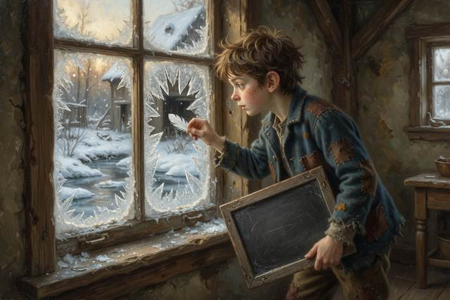
He was nine and a half now, which he felt was a very respectable age. He had a slate, a mill, a great many friends and a wolf.
The wolf had grown again. Gucci was now the size of an armchair with opinions, and he had slept across Hal’s feet all night and left them numb. He stood at the window with his nose to the glass and his ears turned toward the hills. Something over there was bothering him. Hal listened as hard as he could, and heard nothing at all.
“It is only the frost,” he told him.
Gucci did not think so. He gave a small, low, worried whine, and went on looking.
Downstairs the kitchen smelled of porridge and woodsmoke and, for the fourth morning in a row, pickled onions. Hal’s mother sat at the table with a bowl of them in front of her and a look of deep contentment. She had been tired since the harvest. She had fallen asleep twice in the bread basket. She had asked for pickled onions at breakfast, and nobody had understood it, and Hal’s father, who had a limp now instead of a crutch, had stopped saying anything in the way a sensible man does.

“Good morning,” said Hal.
“Good morning, my love,” said his mother, and ate an onion. “Somebody is coming down the road. I saw them from the window. Go and see who.”
Somebody was.
A green cart was rolling down the frozen road, pulled by a small brown pony with a fringe over its eyes. On the seat sat a woman in a long blue coat, with a black leather bag on her knee and a hat pulled down over her ears, and beside her a thin boy, about Hal’s age, with a wooden toolbox on his lap and his eyes going everywhere at once. The cart was loaded with blankets, boxes, a stove, a quilted bundle that might have been a very large clock, and what appeared to be a skeleton in a hat.
The cart stopped in the yard. The woman jumped down, quite lightly, and looked round at the mill, the wheel, the stream, the frost, and the boy with the slate.
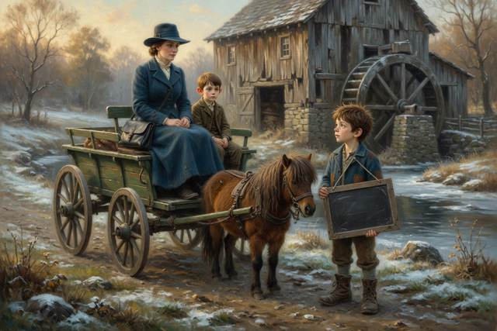
“Good morning!” she said. “I am Dr. Liang. I am the new doctor, and I have been told there is a house for me by the bridge. This is my son Wen. He will not say anything until he has looked at the whole room, and then he will say one sensible thing. I am told it runs in the family.” She nodded at the wolf, who was growling at the cart with great dignity. “Is that animal registered?”
“He is a wolf,” said Hal.
“I see,” said Dr. Liang. “Then I shall treat him with respect.” She glanced at the skeleton. “That is not a person. That is for teaching. I am afraid it is a very good listener, and it does not say much either.”
The boy, Wen, had not said anything. He had climbed down, set his toolbox on the ground, and was looking up at the gable end of the mill. High under the roof, over the loading door, there was a clock. It had a white face and black hands, and it had said ten past four since long before Hal was born. Wen looked at it the way you look at a tooth that hurts.
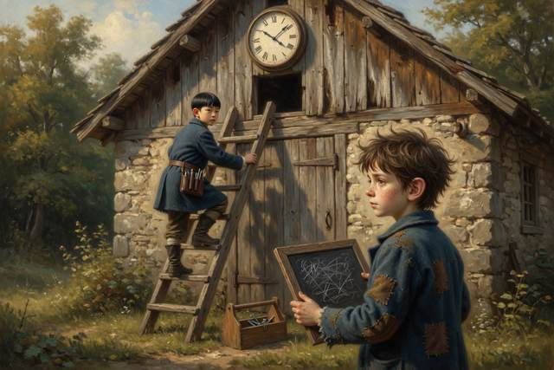
Nobody saw him go. A minute later Hal looked up and the boy was already a third of the way up the loading ladder, with the toolbox hooked on one arm and a small screwdriver between his teeth.
“Wen!” cried Dr. Liang. “You do not go up a ladder with nobody holding the bottom. We have discussed it.”
Wen came down two rungs. He did not take the screwdriver out. He looked at Hal.
“I will hold it,” said Hal. It was the rule. You do not go up a ladder with nobody at the bottom, and he had heard it a hundred times from his mother, and he put both hands on the rails and both feet on the lowest rung and held on as though the whole mill depended on it.
The boy went up.
It took a long time. A bit of old oil dripped down, and then a spring, and then a very small cog that went rolling across the yard and was fetched by Gucci. At the top Wen did something to the back of the clock with a slow, careful, patient look, as if he had all the time in the world and the clock knew it. The village came out to see. A baby cried somewhere. The miller leaned on his doorpost and said he would believe it when he heard it.
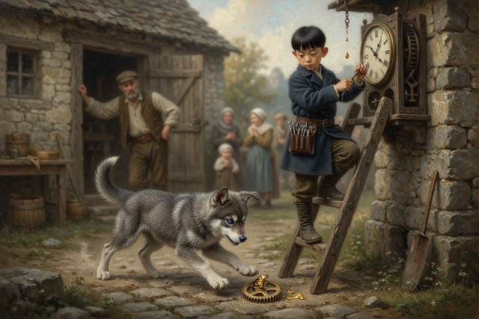
“Click,” said the clock.
It was a very small sound. Then it said “Tick,” and then “tock,” and then, with a shiver that ran through every plank of the mill, the hands began to move. They went round to a quarter to nine, and the clock took a deep breath and struck nine, with a clear round note that rang across the frost and sent a hundred starlings up from the hedge.
“It has not done that for twelve years,” said the miller.
“It was only a worn spring,” said a voice from the top of the ladder, quietly. “And some oil. And the pendulum was not hanging straight. Somebody hung it wrong a long time ago, and the clock did the best it could.”
It was the first thing Wen had said. Hal, at the bottom of the ladder, felt a small warm glow, the kind you get when somebody says something exactly right.
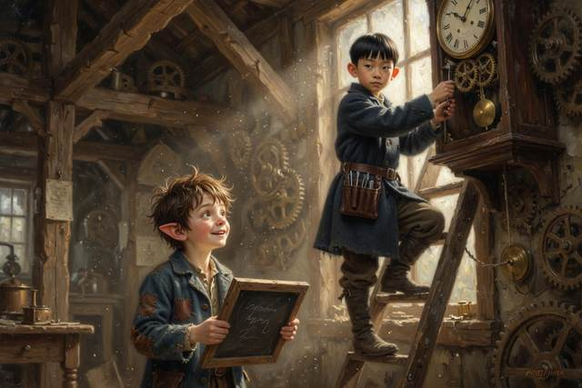
Hal’s mother had come out of the kitchen with a shawl round her shoulders. She stood with her hand on the doorframe and her face turned up to the clock, and for a moment she was smiling. Then she put her other hand flat against the wall, and swayed.
“Just a dizzy moment,” she said. “The cold.”
Dr. Liang had turned her head. She did not hurry. She walked across the yard, looked at Hal’s mother for a long, kind, level second, and said in an ordinary voice, “Sit down on the step for a minute. Breathe. I am not going to say anything at all.” And she did not. But Hal, watching, saw her eyes go to the shawl and the pickled onions on the kitchen table and back, and then, very slightly, she smiled.
Nobody explained it to him. Hal put it on the slate under THINGS I DO NOT UNDERSTAND YET, which was growing long.
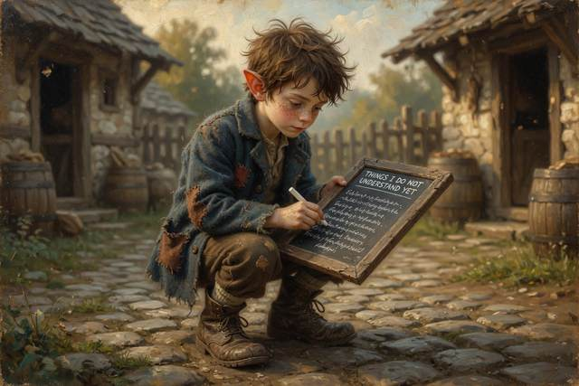
On the far side of the yard, meanwhile, somebody had put up a sign.
SCALLY’S FROST INSURANCE
ONE PENNY A HOUSE
IF THE FROST GETS YOUR CABBAGES, I PAY DOUBLE
Scally stood behind it with a tin, a ladle he had no use for, and a face of enormous honesty. He was humming under his breath, a little tune with words in it: Just a little, just a bit, who will ever notice it? He wore his big brown boots. He had a scarf round his neck that was somebody else’s. “First frost of the year,” he was telling a small crowd, in a low and worried voice. “Terrible things, frosts. They get into the cabbages. They get into the pipes. I am only trying to help.”
Titch’s mother, who was as round as a barrel and had sat down on a barrel to prove it, was already fishing for a penny. Titch and Pip stood beside her. Pip had turned seven in the summer and mentioned it to everybody. He was holding a crust in each hand and watching the tin with great concentration.
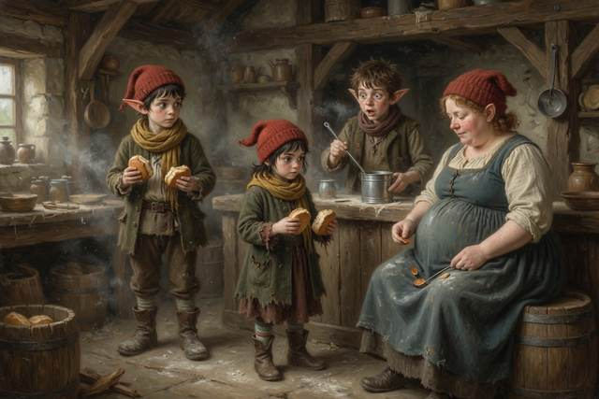
Hopsi stood a little apart, wrapped in three scarves, with a bowl of dried hops under her arm and the look of a grumpy hedgehog. Elves are not at their best below freezing. She had not said anything yet. She was watching the sign.
Tabitha had come across the yard with her hands under her arms, and was reading the sign again with her head on one side. “Double?” she said, not unkindly.
“Double,” said Scally. “That’s a promise.”
And it was at that moment that the boy from the ladder, who was standing at the edge of the crowd with his screwdriver in one hand and oil on his nose, spoke for the second time that morning.
“How many houses are there?” said Wen.
Everybody turned. Scally looked at him. He had never seen the boy before, and he did not care for the way he was looking at the tin.
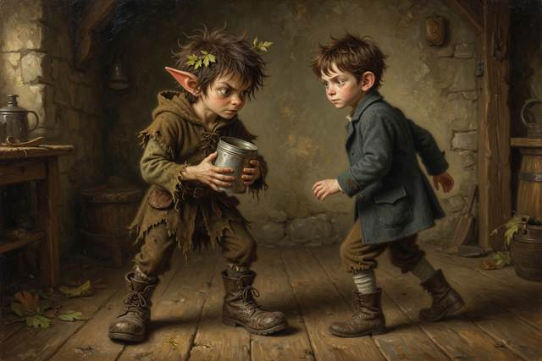
“Forty,” said Scally. “About.”
“Forty pennies,” said Wen, quietly, “if everybody pays. How many pennies have you got now?”
“Eleven.”
“If it freezes tonight,” said Wen, “it freezes everywhere. The frost does not choose. Every cabbage in the village goes, and you owe every house two pennies.” He did not raise his voice. He counted it on his fingers, slowly, one house at a time, as though somebody had asked him how many oranges were in a crate. “That is eighty. You will have forty. It will not be insurance. It will be a debt. And everybody will have lost their cabbages and their penny.”
There was a short silence. Somewhere behind the crowd, Gucci sneezed.
“It might not freeze,” said Scally.
“It will,” said Wen. “It is November.”
Hopsi had unwrapped one of her scarves to look at the sign again. She walked up to the tin and looked into it for a moment. When she spoke, it was in the quiet, even, ordinary voice that always made Scally feel as though his collar had got smaller.
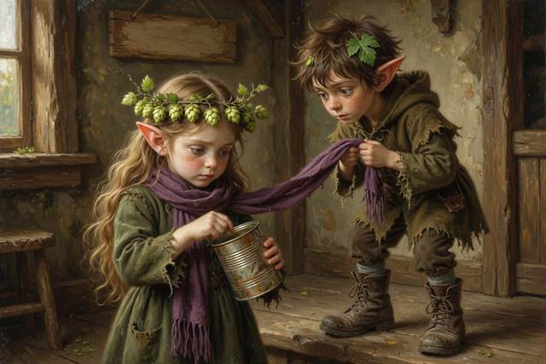
“Is that a promise you can keep?” said Hopsi.
“Well,” said Scally.
“I do not mean, do you wish to. I mean, can you.”
Scally looked at the eleven pennies. He looked at the forty houses. He looked at Titch’s mother, and at the tin, and at the boy with the oily nose, who was looking back at him without a trace of triumph, as if he had only told him the time.
“No,” said Scally.
He gave the pennies back, one at a time, to every house, with a bow, which took a long time because he had to ask whose they were. The sign went face-down in the frost. When he had finished, he sat down heavily on the nearest barrel.
“It is not fair,” he said to Hal. “He has been here ten minutes and he has already counted me. He has not even said hello.”
“Hello,” said Wen.
Scally stared at him. He stuck out a muddy hand. “I’m Scally. I am a rascal. Everybody says so.”
“I know,” said Wen, shaking it gravely. “Your friend’s mother told me to count my fingers afterward.”
“I have not got a mother like that,” said Scally, and counted them anyway. They were all there. He seemed a little disappointed.
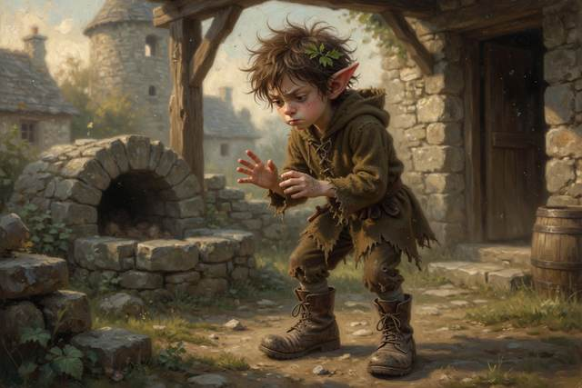
The clock above them struck the quarter, and Wen listened to it with the face of a person who has just heard a friend say his name from a long way off. Then his head turned, slowly, like a dog’s, toward the hill beyond the village, where the frozen fields ran up under a white sky to a long dark ridge of rock and heather.
“What is that clicking?” he said.
“What clicking?” said Hal.
“Very faint. Very fast. Like a tiny, tiny clock, a great many tiny clocks, a long way off.” He frowned. “It is not mine.”
Everyone listened. The wind moved in the bare hedge. A cart creaked. Nothing else.
But beside Hal, the great gray wolf had gone perfectly still. His ears were pricked, and every hair along his back stood up, and he was looking at the hill and not at anyone else at all.
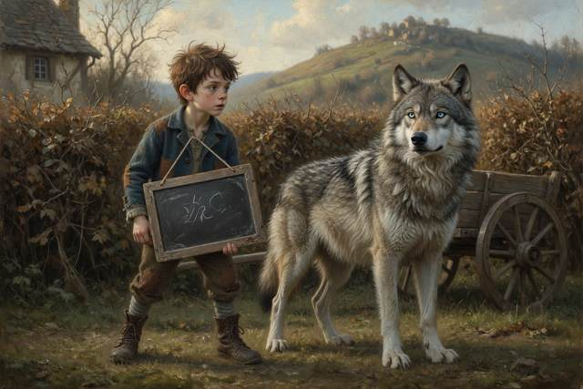
↑ Contents

Chapter 2. The Doctor’s Bag
Gucci howled at the wall all night.
He did not howl like a wolf in a story, with his nose to the moon. He howled the way a very large dog complains to a very small door: a long, low, worried grumble, with sudden sharp yaps in it. Hal lay awake with a pillow over his head. Down in the village, a hundred windows lit up and went dark again.
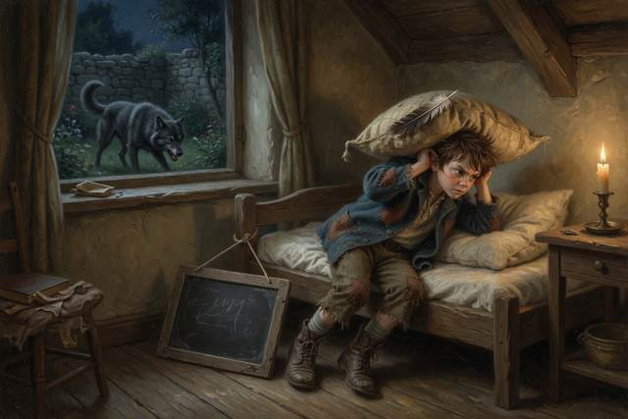
In the morning the whole valley was cranky. Mrs. Crumb had burnt nothing, which was unusual, but she had put salt in the bun dough instead of sugar, which was worse. The cockerel sat on his wall looking like a person who has been woken up for the third time. The Mayor, who was not at his best before ten, announced that wolves ought to be licensed.
“He heard something,” Hal told them, over and over. “He keeps looking at the hill.”
“Then let us ask the doctor,” said Tabitha. “Doctors know about ears.”
Dr. Liang’s house stood by the bridge, a small crooked house with a blue door and a brass plate that said DOCTOR in letters so new they squeaked. Smoke curled from the chimney. Somebody had already hung out the washing, and it hung in a long, stiff, frozen row across the garden: shirts like boards, a nightdress standing up on its own, and six socks held out sideways by the frost, like a line of little dancers.
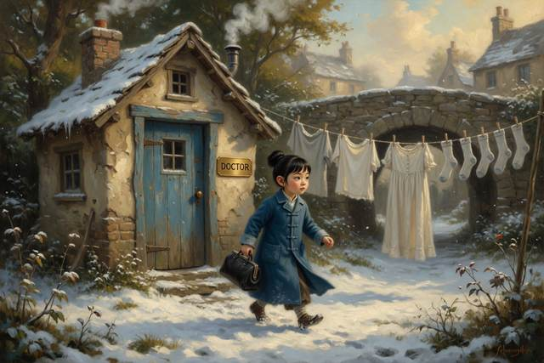
“I did that,” said Pip, with pride. “I was helping. I hung them out and they went stiff. It is a trick.”
“It is called freezing,” said a voice at the gate. It was Wen. He was standing very straight, in a coat that was a bit too big for him, holding a tin kettle in both hands, and he looked at all five children and the wolf as though he were counting them. “Water in cloth turns to ice. That is why they stand. Do not poke them; they break.”
Pip, who had been about to poke one, put his finger back in his pocket.
“We have come for the doctor,” said Hal. “It is about my wolf.”
“Is he ill?”
“No. He is just very, very worried.”
“Come in,” said Wen. “She likes worried.”
Inside, the house smelled of soap and woodsmoke and something sharp and clean that made Hal’s nose tingle. There was a big wooden table in the middle, and on it lay a long white sheet, and on the sheet sat the black leather bag. It was open. Out of it came a tangle of things Hal had never seen: a shiny silver tube with a hollow disc at one end, a small hammer with a rubber head, a lamp the size of a pencil, and a row of bottles with corks in them, in every color, like candy in a store window.
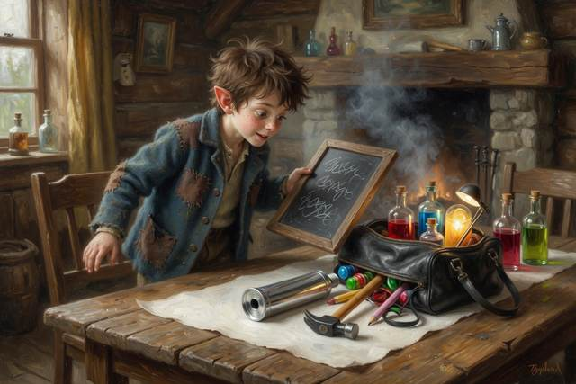
“Good morning!” said Dr. Liang, coming through from the back with a towel over her shoulder. She had her sleeves rolled up and a pencil behind her ear. “Hal Millersen, the wolf’s keeper. And all of you. I see you have brought your own patient. Good. Sit him on the floor; he is too large for the chair.”
Gucci sat. He sat with great suspicion, and did not take his eyes off the bag.
“Doctors listen,” said Dr. Liang, picking up the silver tube. “Before we do anything else, a doctor listens. Come here, Hal.” She hooked the two soft ends into her ears and put the cold round disc against his chest, under his sweater. She was quiet for a moment. Her face went still and kind. Then she took the ends out and held them to Hal’s ears instead. “Now you.”
He had never heard it before.
Thump-thump. Thump-thump. Thump-thump. It was small, and busy, and very close, and it did not stop for a single second. It had been going all his life, without once being asked, and it had never needed winding.
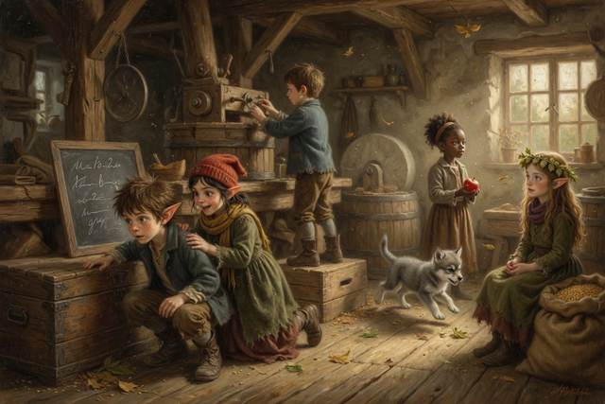
“That is me?” whispered Hal.
“That is you,” said Dr. Liang. “That is your heart, pushing blood round your body, all day and all night. Every one of you has one. The wolf has one, too.”
Every child had a turn. Titch’s went fast, like a mouse in a drum. Tabitha’s was slow and steady, as if it had nowhere to be. Pip’s galloped, and he said it was because of the excitement. Wen did not need to be asked. He pulled up his own sweater, and listened with his head on one side, and a small, secret, satisfied look, as if he were listening to a well-kept clock.
“Now the wolf,” said Dr. Liang.
Gucci had never in his life been asked to stand still for anything. He stood still. He let the cold disc go against his great gray side, with his eyes rolling toward Hal in case this was a trick, and Dr. Liang closed her own eyes and listened, and so did the five of them, in turn, with the ends in their ears. It was slow and enormous: BOOM… BOOM… BOOM… like somebody knocking, very patiently, at the other side of a hill.
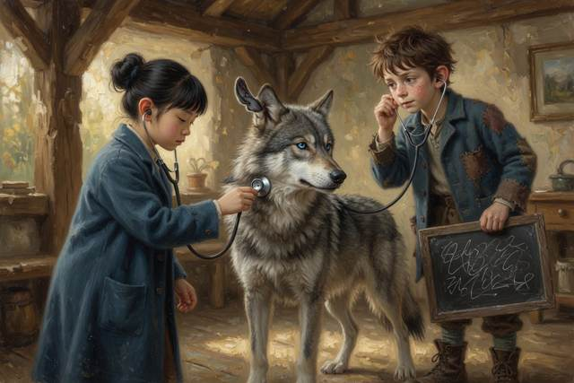
“A fine, strong heart,” said Dr. Liang. “Not a worry in it. His ears are another matter.” She lifted one of Gucci’s great ears and looked inside with the small lamp. “Perfectly clean. Perfectly healthy. And very wide awake.” She frowned. “Wolves and dogs can hear sounds much higher than we can. Sounds so high that we hear nothing at all. If he howled all night at a wall, I think he heard something that we cannot.”
“What?” said Hal.
“I do not know,” said Dr. Liang, and put the lamp away. “But I would like to.”
“I do not know either,” said Hopsi. It was the first thing she had said since the gate, and she said it in a very small, pleased voice, the way people say it when they have found somebody who will say it back.
While all this was going on, Pip had been very good. He had been so good that nobody had noticed him at all.
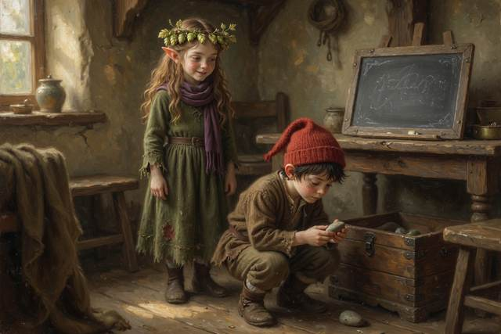
Pip was seven now, and in his experience, nothing very much happened to a person who stood perfectly still beside an open bag. So he had stood. And then he had leaned. And then, when the grown-ups were looking at the wolf, he had gone round the table, and lifted the cork out of a small pink bottle, and put his nose to it.
“It smells like strawberries,” said Pip, to the room.
Everyone turned.
“Do not drink that,” said Dr. Liang, perfectly calmly, and in a voice that made the whole room stand up straight. She crossed the floor in two steps and took the bottle out of his hand, put the cork back, and set it up on the high shelf, out of reach of anyone shorter than a door.
“It was only going to be a little bit,” said Pip. His lip had begun to wobble. “It smells like strawberries.”
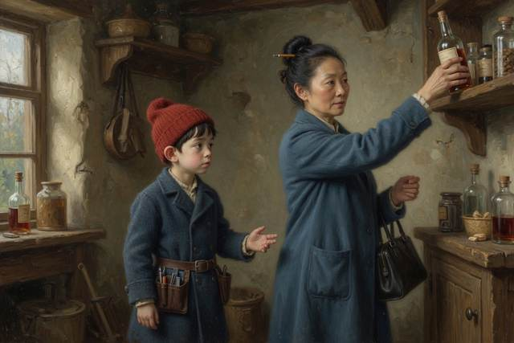
“It does,” said Dr. Liang. She knelt down in front of him, so that her face was at the same level as his, and she did not look mad, only very serious. “That is on purpose. Some medicine is made to taste of strawberries, so that sick children will take it. And that is a lovely idea, until a well child tastes it. A little of that bottle would make a small sick child better, and a great deal of it would make a small well child very ill. Medicine is not candy. Do you know the rule?”
“No,” said Pip.
“You never take any medicine, or any pill, or any pink bottle, unless a grown-up you know well gives it to you: your mother, your father, me. Not your friend. Not a bottle you found. Not a bottle that smells nice. Never.” She looked round at them all, at the children, and at the silent wolf. “That goes for all of you. A doctor’s bag is not a toy, and not a store, and not a game.”
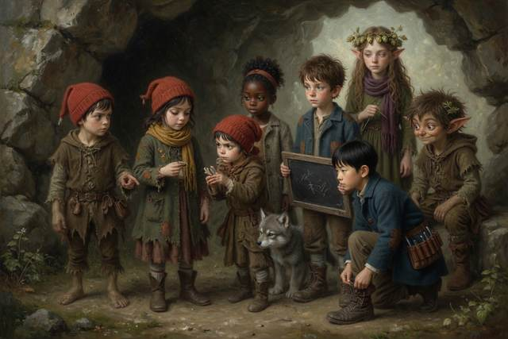
“I would not have tasted it,” said Hopsi. “I did not know what it was, so I would not have.”
“Good,” said Dr. Liang. “That is exactly the right reason.”
“I had thought,” said Hopsi, rather slowly, “that it might be rose water. I smelled it from over there.” She frowned at her own nose. “I was wrong. That is why I did not taste it.”
“A very sensible thing to be wrong about,” said Dr. Liang, with a twinkle, “and I will tell your mother so.” She stood up. “Now, who would like to see a bandage?”
That was when the milk churn happened.
It had been standing by the back door the whole time, a great, round, tin churn, as tall as Titch, with a wide mouth and a brass handle. It had come with the house. Nobody had noticed Pip go round to it. They noticed only when there was a muffled, hollow, echoing noise, like somebody shouting at the bottom of a well.
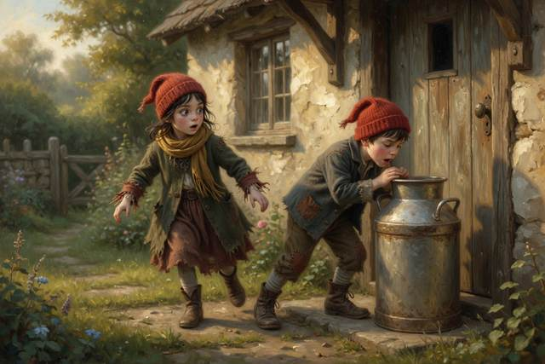
“Mmmf!” said the churn. “MMMMF! I can see all the way down!”
There was a pair of legs sticking out of the top of the churn, kicking, and nothing else.
“Pip!” said Titch, and a great many things happened at once. Titch grabbed one boot. Tabitha grabbed the other. Gucci barked at the churn. The churn said “Mmmmf!” and rocked from side to side. Hal ran for the bucket of water and was told by three people not to pour it in. Scally, who had not said a word since the door, because there was a very interesting jar of candy on the shelf and he was thinking about selling them, turned round and said, “Oh, I am good at this. Pull.”
They pulled. It did not come. The head had gone in, and the head was not coming out.
“Stop,” said Wen.
He had been standing quite still. Now he put down his kettle, and came across the floor, and knelt beside the churn, and looked at the rim. It was a narrow neck, a little too small for the ears. “If you pull,” he said, “the ears catch. Pulling makes a head bigger. I mean, it makes it feel bigger, because the ears bend. We should make the neck slippery. Is there anything slippery?”
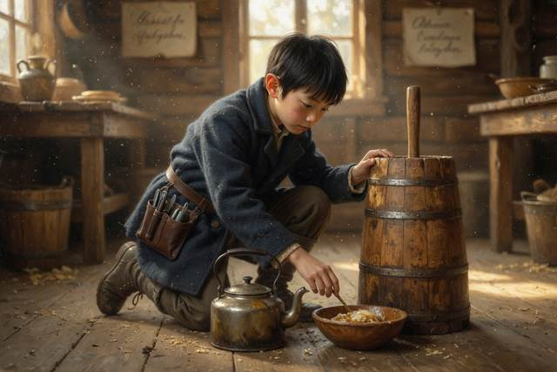
“Butter,” said Hopsi.
Hal looked at her.
“Butter is for squeaks,” said Hopsi, “and not for jams. I said so, a long time ago, about a wheel. But this is not a wheel. This is a rub: ears against tin. Butter makes it smaller. It is the same idea.”
“There is butter on the table,” said Dr. Liang, who had not moved, and was holding the churn quite steady. She had a very odd expression, like a person who is trying very hard not to laugh. “Spread it on the rim, Wen. Gently. And Pip, listen: do not pull, do not push, and when we say, tip your head to one side, like this, so one ear goes first. Do you understand?”
“Mmf,” said the churn, in a very small voice.
It took a whole pat of butter and a long, quiet minute. Wen spread it round the rim of the churn, with his tongue between his teeth. Titch and Tabitha held the churn. Hal, because it seemed right, held the top of Pip’s pants. “Now,” said Wen, and Pip tipped his head, and one red ear went through the neck, and then the other, and then, all at once, with a noise like a cork leaving a bottle, the whole of Pip came out, backwards, in a shower of buttery milk, and sat down on the floor with his hair in spikes.
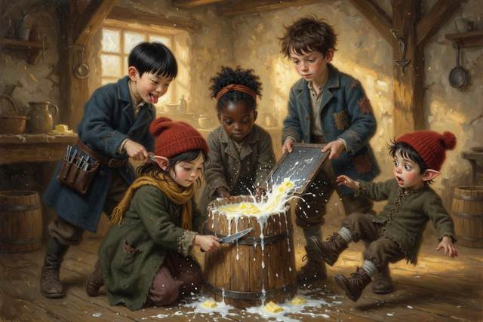
“It was very deep,” he said, in a dreamy voice. “It went all the way to the bottom. I could see.”
“What could you see?” said Hopsi.
“A bit of milk,” said Pip. “And my own nose.”
Nobody was mad. Dr. Liang sat down on a chair and laughed until she had to wipe her eyes on the towel. “I have been a doctor for fourteen years,” she gasped, “and I have never once had to rescue a person from a churn.” She got her breath back. “But that is the rule, Pip. We do not put our heads into things. Not churns, not buckets, not bags, not holes. The world will still be there if we only look at it from the outside.”
“Yes,” said Pip, very meekly, and licked the milk off his chin.
When they had cleaned up the kitchen, and washed Pip, and given him a bun, the five of them found that they were all standing in a ring round Wen, who had not been given anything.
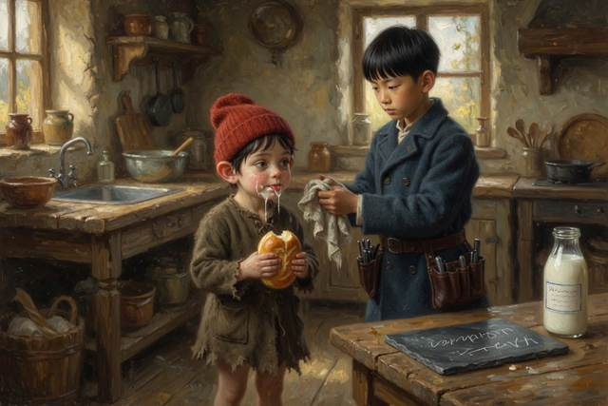
“We should have brought a present,” said Tabitha, in a low voice. “That is what Hopsi did for me.”
“I have got a present,” said Hopsi. She had unwrapped one scarf, and held out a small, tight bundle of dried hops, tied with a bit of thread. “These are for your pillow. They help a person sleep. I have checked every one, and there is nothing in them except hops. You do not have to say thank you.”
Wen looked at it very seriously, and put it in his pocket.
Hal gave him a stick of chalk. Titch gave him a crust, with a great deal of ceremony, torn in an even half, and Tabitha gave him an apple, because she always had one. Pip, who was still damp, offered him a very good stone. Gucci offered a bone, which was accepted, though not with enthusiasm.
Scally had been standing a little apart, with his hands behind his back. He had been working on something, and it had not been going well. It had been going to be a watch. It was a button, and he had been going to say that it was a watch. He had thought of the candy on the shelf. He had thought of a very small lie, a perfectly good small lie, about a gold ring he did not have.
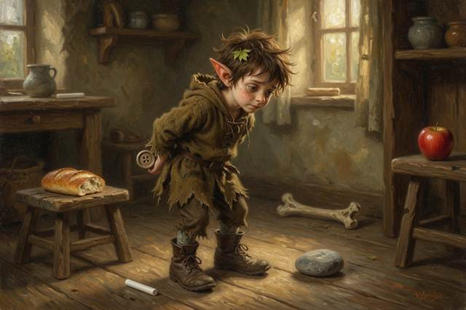
“I have not got anything,” he said at last. “Not a thing. I was going to say I had. But I have not.” He looked at his boots, and his scarf that had belonged to somebody else, and then, slowly, he sat down on the floor, took off one boot, and pulled off a sock. It was gray, and full of holes, and it smelled like a sock. He held it out.
“It is the only thing I have that is mine,” said Scally. “It has not been washed. I am sorry.”
There was a pause. Nobody laughed.
Wen took the sock. He held it up and studied the holes, one by one, as though it were a clock. Then he folded it carefully, with a slow, serious face, and put it in his breast pocket, over his heart.
“Thank you,” he said. “It is the best one. I have never been given a sock.” He turned the hops over in his other pocket, and the chalk, and the crust, and the apple, and the stone, and the bone, and looked as if he did not know what to do with his face. “I do not think I know how to say this properly. Nobody has given me so many things at once.”
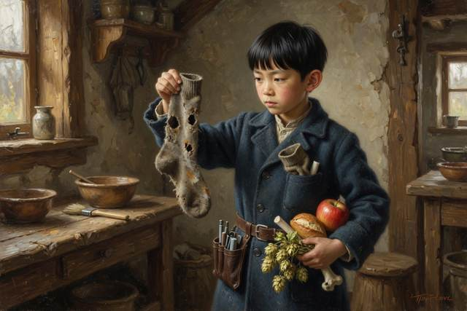
“It is only what you do,” said Titch.
“Then I shall learn it,” said Wen.
That night Gucci howled at the wall again, and Hal lay awake. But this time there was a second sound. It came through the dark, from a long way off across the frozen village, and it was so faint that he thought at first he had imagined it. It was a very small, very quick, tick-tick-tick-tick, like someone tapping on a window with a fingernail.
Over by the bridge, in a small crooked house, a boy with a gray sock in his pocket was sitting up in bed, with his head on one side, listening.
↑ Contents

Chapter 3. Ice on the Pond
By the end of the week the mill pond had frozen over, and the whole village went down to look at it.
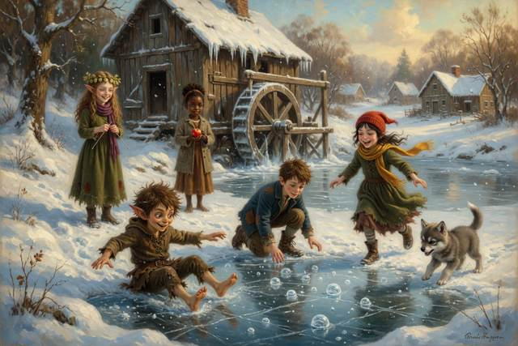
It lay at the bottom of the hill behind the mill, gray and flat and shining, like a plate somebody had forgotten to wash. A few brown leaves were stuck in it, like flies in jelly. Along the edge, where the cattails stood, the ice was white and cloudy. In the middle, where it had frozen last, it looked as clear as glass, and underneath it you could see the dark green water, and one very surprised fish.
“Skating!” said Titch, and took off running.
“Hold on,” said Wen.
Titch stopped with one boot in the air. She had gotten used to Wen in a week, which meant she had gotten used to being stopped by him. He was the kind of boy who said “Hold on” in a quiet voice, and then had a good reason.
He was kneeling on the bank, at the very edge. He had his screwdriver in one hand and a knitting needle from Dr. Liang’s kitchen in the other, and he was pushing the needle slowly down through a crack in the white ice at the edge, until it stopped. Then he pulled it out, and held it up, and measured it against his thumb.
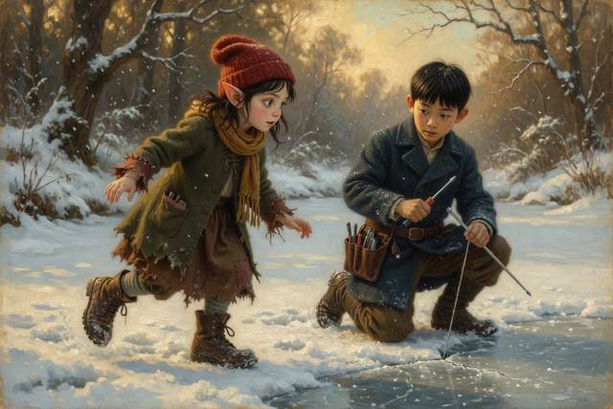
“One inch,” said Wen.
“Is that good?” said Pip.
“It is not.” Wen wiped the needle on his sleeve. “My mother says ice has to be at least four inches thick to walk on. Not three. Not almost four. Four. I measured it here, at the edge, where it is thickest. Out in the middle, where the stream runs under it, it will be thinner.”
“It looks fine,” said Pip.
“It looks fine,” said Wen, “until it doesn’t.”
Hal wrote it on his slate: ICE: 4 INCHES TO WALK. 1 INCH HERE. NO. Hopsi, who was sitting on a stump with three scarves wound round her neck and a bowl of dried hops in her lap, nodded slowly.
“White ice is strong,” she said. “That is the strong kind. It is the color of milk. I read that.”
“It is the weak kind,” said Wen, without looking up. “White ice is full of little bubbles and snow. It is about half as strong. Clear ice is the strong kind. It looks like black glass.”

“Oh,” said Hopsi. She looked at the pond for a while. “I was wrong. I am glad I said it out loud, or I would have gone on believing it.” She took a hop. “Where did you learn that?”
“From my mother,” said Wen. “She says if you are going to be wrong, be wrong where somebody can hear you.”
There was a short pause, in which everybody thought that Dr. Liang sounded like a person worth knowing.
It would have ended there, with everyone sensibly standing on the bank, and nobody going out, if it had not been for Scally.
Scally had been very quiet for a while. He had been standing at the other side of the pond, in his big brown boots, with his hands behind his back, looking at the ice the way a fox looks at a henhouse. He was humming under his breath: Just a little, just a bit, who will ever notice it? Now he came strolling round the bank. He was carrying a sign. It said:
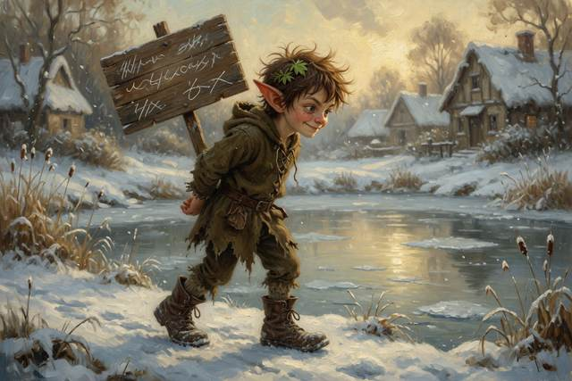
OFFICIAL ICE TESTER
ONE NICKEL, AND I TEST YOUR SPOT
SAFE OR YOUR NICKEL BACK
“I have been out there,” said Scally. “I tested it myself. Stomped all over it. Perfect. Solid as a road.” He stamped a boot on the white ice at the edge, for show. It did not crack. “Of course, I cannot test every inch for free. That is why there is a fee. A nickel a spot. You pick your spot, I test it, you skate. Who is first?”
“You did not go out there,” said Wen.
“I did.”
“There are no tracks,” said Wen. “The snow on the ice is smooth. Nobody has walked on it.”
Scally opened his mouth, and found that there was a boy at the end of it who had counted everything since the day he arrived. He shut his mouth. “It is a small pond,” he said. “Small tracks.”
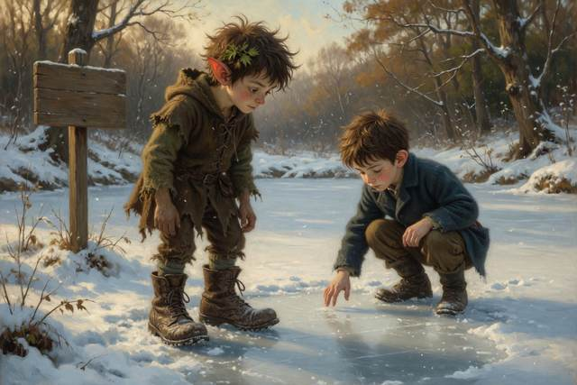
“Scally,” said Hal.
“All right. I did not go out there. I looked at it very hard.” He held up the sign. “But it looks good. It looks like a skating pond. If everybody waits for a grown-up to say it is safe, the winter will be over.”
Nobody said anything. In the end it was Hal’s mother, who had come down the hill with a basket of cocoa and cookies and Titch’s mother, leaning on her arm, as round as a barrel in a quilted coat, who said in a firm voice from up the slope, “Nobody goes on that ice today. Not one boot. I will ask Dr. Liang to look at it, and we will see.”
“Yes, Mom,” said Hal.
“Yes, Mrs. Millersen,” said everybody else.
Pip said it, too. He said it with his very best face, the face he wore when he was being good. Then he went and stood at the edge of the pond, a little apart from the others, with his hands in his pockets, whistling the way he did when he was thinking about something.
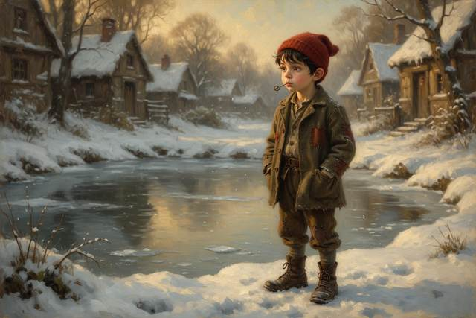
Pip was seven and a half. He had been seven and a half for a long time, and in his experience, the world had a rule that you could not do things, and a second rule hidden underneath it, which was that you could. He looked at the ice. He looked at the sign. He thought about the nickel he did not have, and the word Scally had said: Solid as a road.
“He tested it,” said Pip, to himself. “He said.”
By the time anybody looked up, Pip was already on the ice.
He did not run. He walked, quite carefully, with his arms out, like a person on a log, along a line of clear gray ice. He was ten steps out. He was twenty. He turned, and waved, and shouted, “I can walk on water!” in a very happy voice, and the whole bank of grown-ups and children and cocoa went silent at the same time.
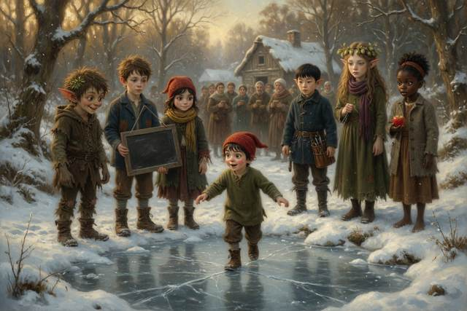
Then the ice said, “Crack.”
It was not a loud noise. It was a deep, low, groaning sound, like a floorboard in a big old house, and it ran away across the pond in a long, thin, shivering line. Pip froze. He stood absolutely still in the middle of the pond, with his arms out, and his mouth open, and his red cap crooked on his head. Under his boots, a small white star appeared in the glass, and spread, very slowly, to the size of a plate.
“Pip,” said Titch. She had gone quite white. She said it in a calm voice, a voice that Hal had not heard before, and that must have been hers for a long time. “Pip. Do not move. Do not run. Stay exactly where you are.”
“I did not do anything,” said Pip, in a very small voice.
“I know. Stay still.”
The whole bank was moving at once. Hal’s mother had dropped the cocoa. Gucci ran up and down the edge, whining, and was caught by the collar by Tabitha. Scally had gone the color of porridge, and the sign had fallen out of his hand.

“Nobody go out there,” said Wen. He was not shouting. He had put down his screwdriver and he was holding up both hands, palms out, in a sort of slow, firm, patient way. “If one person goes out, there are two people on the ice. Reach or throw. We do not go in after them. Titch, you have a rope.”
“I have a rope,” said Titch.
She had it. She had been carrying a coil of rope across her chest since the day they had pulled a boy out of a green pool, because she had said she would never be without one, and she was a girl who meant what she said. She pulled it off over her head, and shook out a loop at one end, and measured the distance with her eye the way she measured everything, quickly and exactly.
“Too far,” said Tabitha. “It will not reach.”
“It will,” said Titch, “if I throw it right.”
“Throw it low,” said Wen. “So it slides. Not up in the air. It has to land beside him, and he has to be able to grab it without moving his feet.”
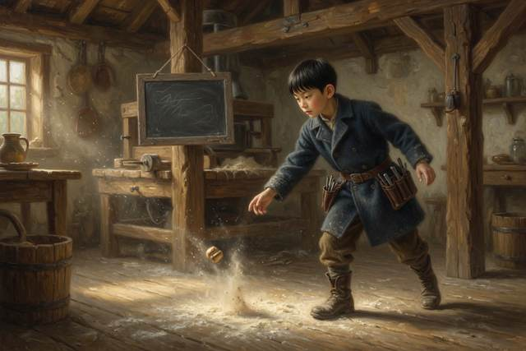
She swung. The loop went out low over the ice, slid across the glass with a long hissing noise, and stopped, a yard short.
“Again,” said Hal, in a voice he did not recognize.
Titch hauled it in, as fast as she could, and the second time she threw with her whole arm, and the loop skated over the pond like a snake. It stopped an arm’s length from Pip’s left boot.
“Lie down,” said Wen, in the same quiet voice. “Pip. This is very important. Lie down on your stomach, very slowly, with your arms and legs out, like a starfish. That spreads you out so the ice holds more.”
“I do not want to,” said Pip.
“I know,” said Wen. “Do it anyway.”
Pip lay down on the ice. He did it so slowly that it took a century. The ice groaned again, and one tiny piece of it near his hand flicked loose and slid away. He lay there, flat, with his red cap on the glass and his nose an inch from the gray ice, and his legs stuck out behind him.
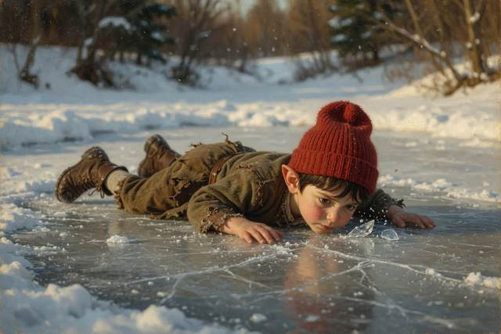
“Now take the rope,” said Wen. “Do not stand. Only reach.”
Pip reached. He put out one arm, and the rope was just there, and his fist closed on it, and a sound came out of him that was halfway between a laugh and a sob.
“Pull!” said Titch.
They all pulled. Hal and Tabitha and Titch, with Hal’s mother behind them gripping the end of the rope and Gucci tugging at the loop by his teeth, and Pip slid across the ice on his belly, like a very small sled, with his arms stretched out in front of him. Behind him, as he left, the ice cracked, and cracked again, and then at the spot where he had been standing, with a sound like somebody tearing a sheet, the whole piece of the pond sank, and a round black hole opened up, and the dark water slopped up over the edge.
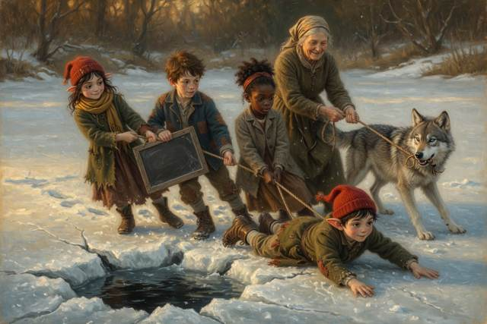
Pip slid up onto the bank, and Hal’s mother scooped him off the ground, rope and all, and held on.
Nobody said anything for a long time. Titch sat down in the snow, quite suddenly, and put her face on her knees. Her mother sat down next to her and put the quilt over both of them. Hopsi stood perfectly still with the hops dropped in the snow around her feet, and said nothing, because there was nothing true she could say that was big enough.
Scally had not moved. He stood at the edge of the pond, looking at the black hole, with his face the color of a candle.
“I said,” he whispered. “I said it was solid as a road.”
Nobody answered him.
“I did not test it,” said Scally. He said it louder. He turned round and said it to everybody, to the whole bank of faces. “I did not go out there. I did not test it at all. I just wanted the nickels. I said it was perfect because if I said it was perfect, you would pay.” His voice shook. “And Pip heard me. And he believed me.”
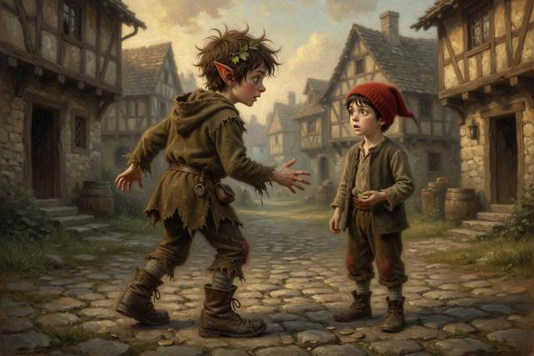
“Yes,” said Hopsi, very quietly. “He did.”
Scally stood there. His ears had gone red, and then white. He went down on his knees in the snow, quite slowly, in front of Pip, who was wrapped in a coat the size of a tent and had stopped shaking, and who looked back at him with enormous, tired, round eyes.
“I am sorry,” said Scally. “I am the biggest idiot in the world. I am sorry.”
Pip thought about it. “That ice was like a big window,” he said, in a hoarse voice. “I could see the fish.”
“I know.”
“It was a very surprised fish.”
“It was,” said Scally.
“You owe me,” said Pip.
“Anything. Anything you want.”
“You owe me a sock,” said Pip. “Wen got one.”
For a moment nobody moved. Then Hal’s mother made a very odd noise, and Titch lifted her face from her knees and began to laugh, with the tears still running down it, and then everybody was laughing, the shaky laughing of people who have been very frightened and have found out it was all right. Scally pulled off a boot. He pulled off a sock, and held it out, and Pip took it and put it on his hand like a mitten.
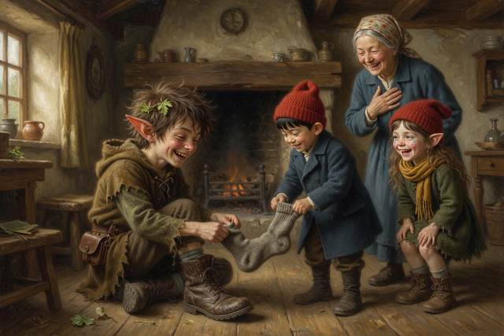
“I will wash it,” said Scally. “I promise. I will wash it twice.”
“Do not,” said Pip. “It is a better sock this way.”
Dr. Liang arrived ten minutes later at a run, with her black bag banging against her knee. She knelt in the snow and checked Pip from top to toe, his fingers and toes, his lips, his color, and said that he was perfectly fine, and a little cold, and that she would prescribe a cup of hot cocoa and a warm bed. Then she stood up, and looked at the pond, and at the black hole in the middle of it, and at the rope, and at a tall, thin, quiet boy standing next to it with a knitting needle in his hand.
“Who stayed on the shore?” she said.
“Everybody,” said Hal. “Except Pip.”
“And who told them to?”
“Wen,” said four voices at once.
Dr. Liang looked at her son. She did not say anything. She put her hand on his head, very lightly, for a moment, the way you might put your hand on a clock that you loved.
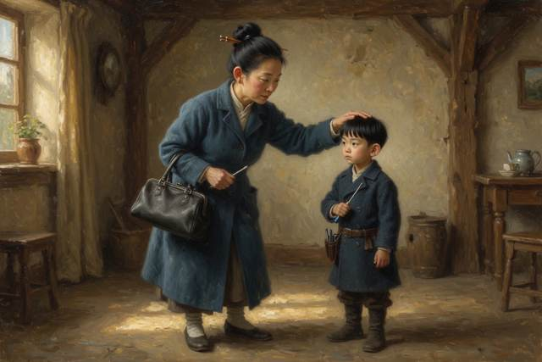
On the way home, Wen walked beside Hal, with the needle in his pocket. “It is odd,” he said. “Water is odd. Almost everything gets smaller when it freezes. Water gets bigger. About one part in eleven. That is why ice floats, and why pipes burst in winter, and why a bottle of water left outside will crack. It is the only thing I know that does that.”
“Why does it?” said Hal.
“I do not know,” said Wen. He sounded surprised and pleased, as if he had found a coin in his pocket. “I will find out.”
That night, Hal wrote on his slate under the day’s date: WATER GETS BIGGER WHEN IT FREEZES. THAT IS WHY ICE FLOATS. AND: NEVER GO ON ICE ALONE. NEVER TRUST A SIGN. And at the bottom, in smaller letters: WEN WAS RIGHT.
Out in the dark, beyond the village, a very long way off, something went tick-tick-tick, in the cold.
↑ Contents

Chapter 4. The Hill That Clicks
The ice melted, and froze again, and melted again, and in the third week of December the hill began to click in earnest.
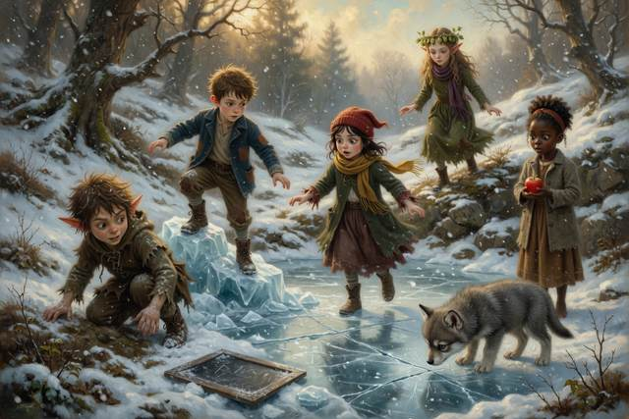
You could not hear it in the daytime. Nobody heard it at all except Gucci, who lay at the foot of Hal’s bed with his ears pointed at the window and his whole gray body trembling, and Wen, who heard it in the dark in his small crooked house by the bridge, a faint, quick, ticking sound like a nest of tiny clocks. They compared notes on the mill step.
“It is the same every night,” said Wen. “It starts at dusk. It stops at dawn. It comes from the hill behind the village, the one with the rocks.”
“Hanger Hill,” said Tabitha. “My gran says the old people called it that. Nobody remembers why.”
“It is not a clock,” said Wen. “I have checked. I checked every clock in the village.”
“You did not,” said Titch.
“I did. All eleven. And the church tower, from the outside.” He frowned. “It is not coming from a clock.”
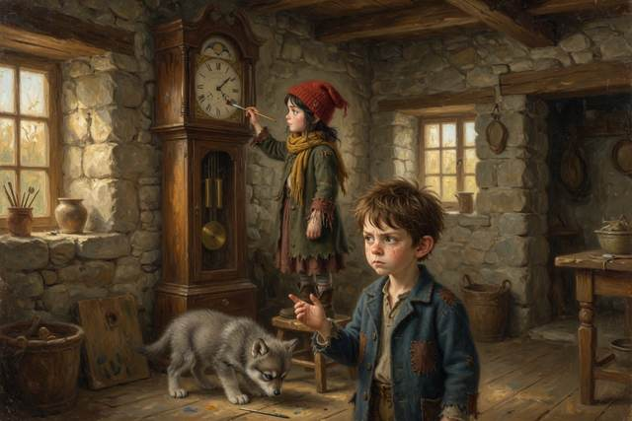
“Then it is a ghost,” said Scally. He was sitting on the top step with his boots swinging and his hands behind his head, in the pose of a person who has seen everything. “Obviously. A hill ghost. A ticking ghost. A ghost with a clock in his stomach. I will go up there tonight and charm him.” He hummed, quite softly, a little tune with words in it. Just a little, just a bit, who will ever notice it? “And if I charm him,” he added, “it is worth a nickel a head to come and look.”
“Scally,” said Hal.
“Everybody is going to want to see him.”
“Just a little, just a bit,” said a small voice at the bottom of the steps. It was Pip, with a crust in each fist, sitting on the bottom step with his chin on his knees. He said the next line in exactly the same tune, as if it were a song in school. “Who will ever notice it?” He looked up at Scally, with round and earnest eyes. “I will.”
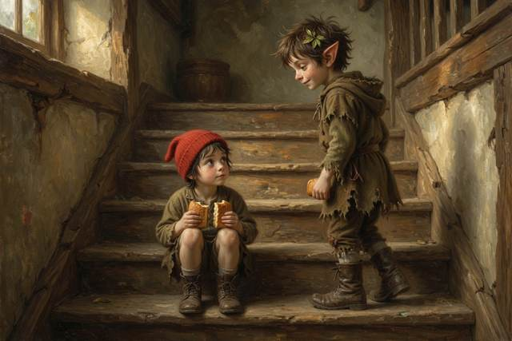
Scally’s mouth opened. He shut it. His ears began to turn pink, slowly, from the top.
“He has noticed,” said Hopsi. She was sitting on the stump with her scarves, and she did not look up from the bowl in her lap. “Pip noticed, and so did I, and so did everybody on this step. It is a very catchy tune.”
“I am only—” said Scally.
“You hum it every time,” said Pip. “Every single time. Before the frost. Before the ice. I counted.”
“You cannot have counted,” said Scally, but without much conviction. He pulled his boots up under him and looked out across the yard. “All right. No ghost charm. No nickels. I will just come and look.”
“That,” said Hopsi, “is the best thing you have said all week.”
They did it properly, because Hal knew how.
First, Hal asked his mother. She was at the kitchen table, with a bowl of pickled onions and a very large knitting project that she had not yet explained, and she looked at him over the top of the needles for a long moment. “Where?” she said.
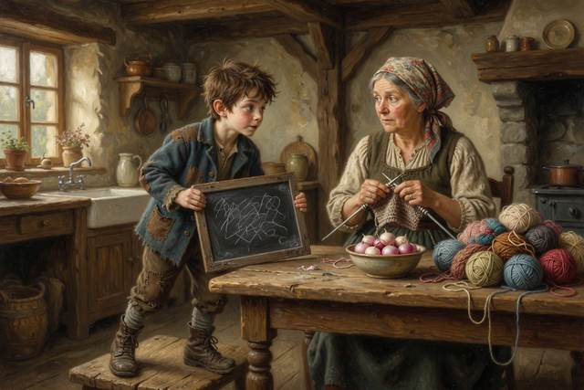
“The big rocks on Hanger Hill. There is a cave. Wen thinks the clicking comes from there. We want to look.”
“Daylight only. Back by three, before the light goes. Go in pairs, and stay together, and tell somebody where you are.” She took a breath. “And you take Gucci.”
“Yes, Mom.”
So Hal wrote it on his slate, in his small neat hand: GONE TO HANGER HILL, THE CAVE. SEVEN CHILDREN, ONE WOLF. BACK BY THREE. HAL. He hung it on the mill door, where anyone could read it. Dr. Liang, who happened to be passing, read it through twice and nodded, and said that a person who left a note like that would always be easy to find, which is the first rule of any kind of adventure.
It was a long hill, and a cold one. The sun, which was low in the sky all winter, lay along the frozen fields in long white stripes. They walked in pairs: Hal and Wen at the front, with the lantern, because Wen had said that if there was going to be dark, he would rather carry the light himself; Titch and Tabitha behind them; Pip with Scally, because nobody trusted either of them alone. Hopsi came last, with Gucci, and she was not talking. She was looking at the hill the way Hal had seen her look at the stream in the fall, as though it might be going to say something.
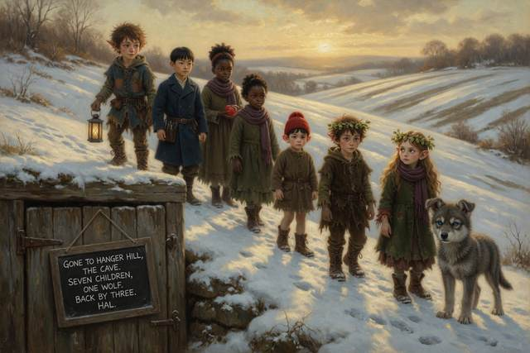
Gucci did not growl. He walked up the last slope with his tail low and his ears forward, very quietly, as if somebody had asked him to be polite to a person who was sleeping.
The cave was a low crack in the face of a gray rock, about the height of a boy and the width of a barrel, half hidden by dead bracken and a tangle of icy roots. Out of it came a thin gray breath of cold, and a smell of wet stone and old leaves and something else, something faintly warm and animal, like the inside of a pocket.
Wen stopped.
“It is very dark,” he said.
“Yes,” said Hal.
“I am not,” said Wen, “a person who likes the dark.” He said it all in one breath, in a rather flat, dry voice. He was holding the lantern in both hands, and his knuckles were white. “I thought I should mention it, in case I do something strange.”
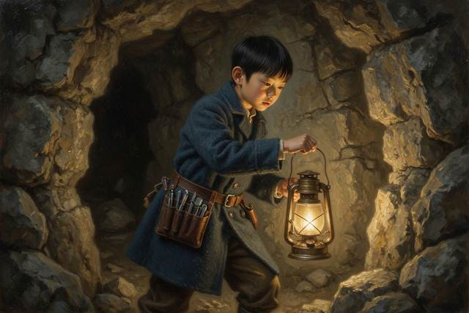
“What kind of strange?” said Titch.
“I do not know. I have never been in a cave.”
“Hold on to my sleeve,” said Hal, “and I will go first. Pip, you stay behind Titch, and Titch, you stay behind Tabitha. Hopsi, you stay at the back. Scally goes in the middle, where I can see him.”
“I am an excellent cave explorer,” said Scally.
“That is why.”
They went in one at a time, bent double. The cold folded round them like a blanket. For a little way they could still see daylight over their shoulders, a thin pale gray slice of sky, and then the passage turned, and there was nothing but the lantern, a small gold light that threw their shadows up the walls and across the roof in great, lurching shapes. Water dripped somewhere. A long way off, something went tick.
Wen’s hand found Hal’s sleeve, and held on.
The passage opened out suddenly into a chamber, about the size of the mill kitchen, with a roof so high that the lantern light did not reach the top. The floor was wet and sandy. And all across the ceiling, and down the walls in long uneven rows, hung small brown bundles, hundreds and hundreds of them, close together, quite still.
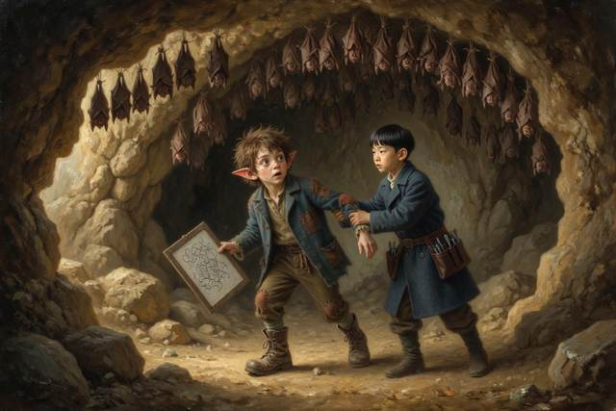
They looked like socks.
That was what Pip said. “Socks,” he whispered, in a voice of the purest wonder. “Somebody has hung up all their socks.”
“Do not touch them,” said Wen. His voice had gone small and tight. He had stopped being afraid. He had simply stopped everything, the way a clock stops, and gone very still, with his head tipped back and the lantern held out at arm’s length. “Look at them. They are not socks. They are folded.”
Each bundle had a head, no bigger than a thumb, tucked down against a small furry chest. Each one had two tiny ears and a pair of folded, leathery arms wrapped round itself like a cloak. They hung by their feet, upside down, from the stone, in rows and rows, and every one of them was asleep.
“Bats,” said Tabitha.
She had said it quite softly, with her face tipped up and her eyes very wide. “My gran has them in the sea caves, by her house. She calls them the sleepers. They hang by their toes. She says if you are very quiet in winter they will stay asleep, and if you wake them, they have to burn their food to stay warm, and then they run out before spring.”
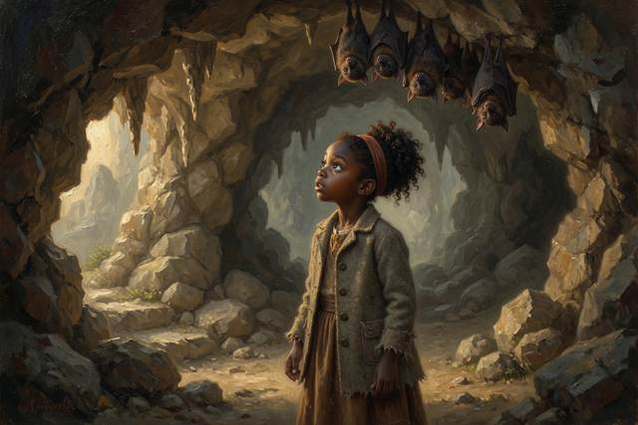
“Is that true?” said Hal.
“I think so,” said Tabitha. “It is what she says.”
“I do not know,” said Hopsi. She had come up to the front at last, and she stood with her hands folded, looking up at the great hanging ceiling, quite still. Her voice was very low. “I did not know there were so many. I did not know they were here. I think Tabitha is right. I think so, but I do not know.” She turned to Wen. “Do you have your mother’s stethoscope?”
“I did not ask to borrow it,” said Wen, and then stopped. “It is in my pocket. How did you know?”
“It is a lump,” said Hopsi.
He took it out, slowly. It was not easy for him. He put the cold silver disc to the air, a foot from the nearest sleeper, not touching it at all, and held his breath. “I cannot hear it,” he said. “It is too far. It is too small.”
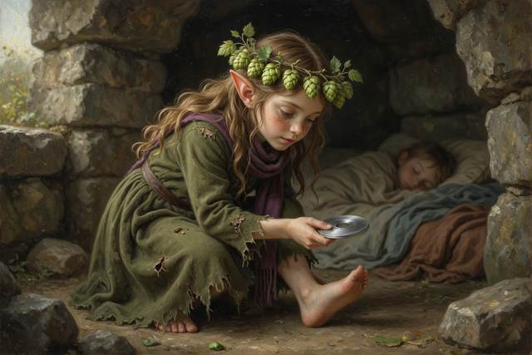
“Then do not,” said Hopsi. “We know they are alive, because they are hanging on. We do not have to prove it by waking one.”
“Dr. Liang says a bat’s heart slows right down in winter,” said Wen, very quietly, “to about the beat of a slow clock. She says they are not really asleep. She says it is called hibernating. It is more like a very long pause.”
They stood in the cold light of the lantern and looked at the sleepers. Nobody wanted to say anything. It was the quietest place Hal had ever been, a quiet that went all the way down. Gucci had lain down on the sandy floor with his nose between his paws. Even Scally, who talked in his sleep, had not said a word.
Then, high up on the left, one of the bundles unfolded.
It did it slowly. A small black wing opened, thin as a leaf, and a tiny face turned, with a nose like a crumpled button, and two enormous ears that went round, and round, listening. It opened its mouth. It made no sound that any of them could hear. But Wen, who was holding the lantern, felt the whole air hum, very faintly, against his face, and from somewhere up in the dark came the little, quick, dry noise he had heard every night for a month.
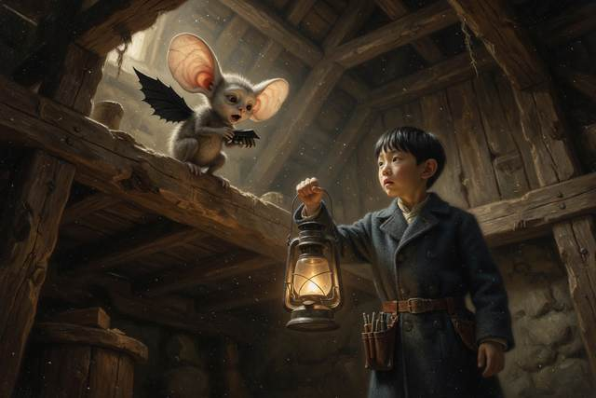
Tick-tick-tick-tick.
“It is talking,” whispered Wen. “It is the clicking. It is the bat.”
The wing folded. The head tucked down. The tiny creature went still again, and the cave filled up with ordinary silence.
“We should go,” said Hopsi, after a long time. “We have looked. That is enough. If we stay, we will make them wake, and they cannot spare it.”
They went out the way they had come, in the same order, in silence. Hal went first with Wen’s hand on his sleeve, and at the bend in the passage, where daylight showed ahead like a gray door, Wen let go and walked out by himself, and stood in the open air with his eyes closed, breathing, for a very long time.
“I was afraid,” he said at last.
“I know,” said Hal.
“And I stayed.”
“I know.”
“I am going to put that in my notebook,” said Wen, “in ink.”
It was just past two in the afternoon. They were on their way down the hill, tired and quiet and very pleased, when Titch, who was walking ahead, stopped in the path.
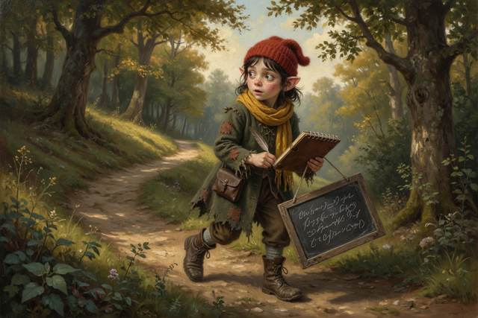
Somebody had been there before them. In the snow at the cave mouth, there were fresh boot prints, big ones, a grown man’s, and beside them, driven into the frozen ground on the slope, a short wooden stake with a bright red rag tied to the top. A square of paper had been nailed to it, and on the paper, in large, round, important letters, somebody had written:
PROPERTY OF THE MAYOR.
FUTURE CHEESE CELLAR.
THIS CAVE TO BE SEALED.
“Sealed,” said Tabitha.
“With the bats inside?” said Pip.
Nobody answered him. Behind them, in the quiet hill, a single tiny sound ticked, and was still.
↑ Contents

Chapter 5. The Mayor’s Cheese Cellar
The trouble with a rumor is that it runs faster than the people who start it.
By the next morning the whole village knew about the bats. Nobody knew exactly what they knew, which is the usual way with a rumor. Mrs. Crumb had heard that there were a thousand of them. The butcher had heard there were ten thousand, and that they were the size of dogs. Somebody’s uncle, who had once seen a bat in a barn in another valley, had heard they got tangled in your hair and could not be got out.
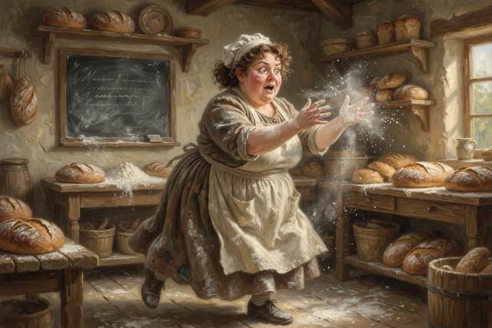
“That is not true,” said Hal, on the mill step. “They are the size of my thumb. They were asleep. We only looked.”
“Well, they are in the hair now,” said Titch. “Mrs. Crumb says she is not going out without a scarf.”
Scally said nothing at all.
He had been very quiet since the cave. He sat at the end of the step with his chin on his knees and a faraway look on his face, and he did not hum. Hopsi, who noticed everything and said very little, glanced at him twice, and went on eating her hops.
Down in the village, a small crowd had gathered in front of the baker’s shop, and in front of the crowd stood a very small table, and on the table was a pile of pointed hats made of brown paper. Over the pile hung a sign, in careful writing:
BAT-PROOF HATS
FIVE CENTS EACH
KEEPS BATS OUT OF YOUR HAIR. GUARANTEED.
“How many has he sold?” said Hal.
“Thirty-one,” said Pip, who had counted. “And two scarves.”
It was the first thing Hopsi had said all morning. “It was a very good idea,” she said, in a low voice, “for a person who knows that bats do not get in your hair.”

“I did not mean—” said Scally.
He stopped, because a bell had begun to ring.
It was the Mayor’s bell, a big brass hand bell with a wooden handle, and the Mayor himself was ringing it, standing on a barrel in front of the baker’s shop in his best waistcoat and his gold chain. Mr. Pomfrey was a round, pink, shiny man who had never been wrong in his life and never once checked. He had a very large mustache that lifted at the corners when he was pleased with himself. It was lifting now.
“Neighbors!” he cried. “Friends! Citizens! I have important news!”
Everybody turned. A good many of them were wearing brown paper hats.
“As you know,” said the Mayor, “this village has many fine things. We have a mill. We have a bridge. We have the finest bread for twenty miles. And what we have not got,” and here he flung out one arm, “is a proper cheese cellar!”
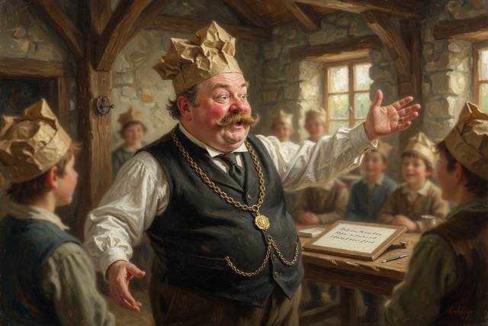
There was a murmur. Mrs. Crumb said that she did not know the village had ever wanted one.
“It has not,” said the Mayor. “Until now. I, Reginald Pomfrey, have found the perfect place. A cave, in Hanger Hill. Cold. Dry. Out of the wind. Fifty degrees, winter and summer, which is exactly what a cheese likes. Every great cheese town in the world has a cave. Now we shall have one.” His mustache lifted. “I have staked it. And on the first warm evening of spring, when the snow has gone and the road is clear, we shall seal the entrance with stone and put in a door.”
“What about the bats?” called somebody.
“Ah,” said the Mayor. “Yes. The bats.” He lowered his voice, and every person in the crowd leaned forward. “I am told they are filthy. I am told they carry disease. I am told they fly into your hair, and bite, and make a nest. It is high time somebody did something. And I,” he said, thumping his chest, “am that somebody.”

There was a loud, relieved cheer. Several people clapped. A man at the back threw his brown hat into the air, and caught it, and put it on again.
On the edge of the crowd, Hal felt a tug at his sleeve. It was Wen. He had not said a word. His face was very pale and very set.
“We have to check,” said Wen, very low. “He has not checked. He says they carry disease, and get in your hair, and are filthy. Is it true?”
“I do not know,” said Hal.
“Then somebody should find out. Before the rock goes over the door.” He looked at the Mayor, standing on his barrel, and then at the paper hats, and then, slowly and thoughtfully, at the boy who sold them. “And somebody,” he added, “who knows a lot about hats.”
Scally was standing very still. All the color had gone out of his face. His hand was on the edge of the table, and the paper hats beneath it had begun to tremble, very slightly, from the shaking of the table.
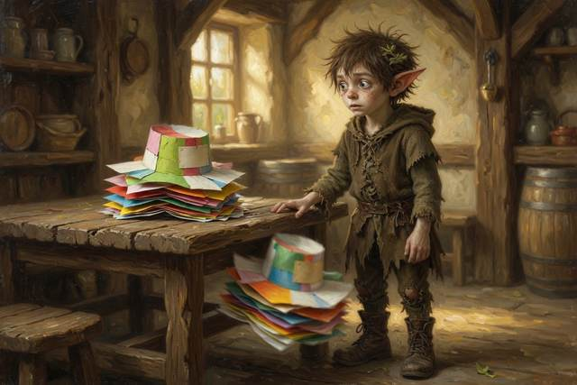
“I started it,” he said.
Nobody heard him except Hal and Wen and Hopsi, who had come up quietly on the other side.
“I started it,” said Scally. “I only said it to sell hats. I said, ‘Watch out, they get in your hair.’ I said it to a few people, and it was just a little thing. Just a little, just a bit.” His voice broke on the last word. “And now the Mayor is using it to seal up the cave. With all of them in it. They are asleep, and they cannot get out.”
“Yes,” said Hopsi.
“I did that.”
“You started something,” said Hopsi. “It has grown. That is not the same as doing all of it. But it is yours to put right.” She said it very gently. “I do not think anybody can do it for you.”
“Everybody will be furious.”
“Probably,” said Hopsi.
For a long moment, Scally did not move. Then he took a very deep breath, climbed up onto the baker’s step with the sign in his hand, and said, in a voice that carried over the whole crowd, “Excuse me!”
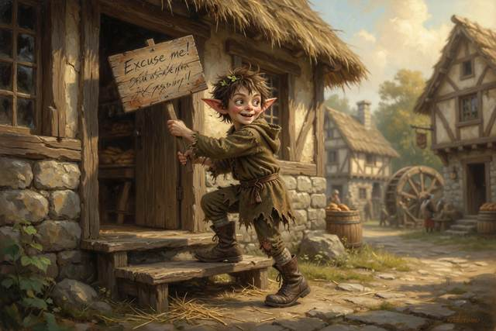
Nobody noticed. He said it again. Gucci, who was sitting beside the table, said it for him in a deep bark that rolled across the square like a drum.
“Excuse me,” said Scally. “I have something to say.” All the faces turned. The Mayor’s mustache drooped, a little. “Bats do not get in your hair.”
A beat went by.
“They do not,” said Scally. “I made it up. I made it up so I could sell you a hat. They are the size of a thumb. They hang upside down and sleep. They are in the cave right now, hundreds of them, and I saw them, and they are not filthy, and they are not dangerous. They are only asleep, and cold, and small, and if you put a rock over the door, they will not get to wake up.” His voice shook. “I am sorry. Your hats are free. I will give you all your money back. I will give you all your nickels.”
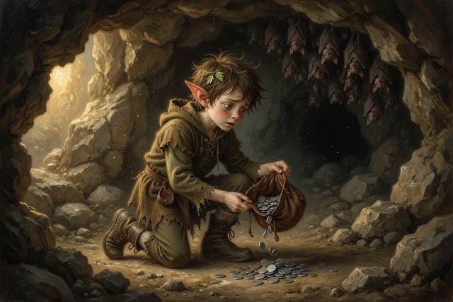
Somebody laughed. It was a short, startled laugh, and then somebody else laughed, and in a moment half the crowd was laughing, not unkindly, the way people laugh when somebody has surprised them by telling the truth. A woman in the front took off her brown hat, looked at it, and put it on the Mayor’s head.
“I did not,” said the Mayor, hotly, “need a hat.”
“No, you did not,” said Dr. Liang.
She had come up behind them, quite quietly, with her black bag in her hand, and she stood at the edge of the step with her coat open and her scarf over one shoulder. She did not raise her voice. She did not need to. The whole crowd turned to look at her, and the laughter faded away into a quiet in which a person could have heard a cheese drop.
“The boy is right,” said Dr. Liang. “I am a doctor, and I will tell you what I know, and I will tell you what I do not. Bats do not get tangled in hair. They are very good at flying, and they can see and hear perfectly well. A few bats, in the whole world, carry a disease called rabies, and that is why you must never, ever touch one. Never pick one up, not even a sleeping one, not even a hurt one. If one is on the ground, you tell a grown-up and you stay away. But a bat that is left alone will not hurt you. They are not filthy. They keep themselves very clean. And they eat,” and here she looked at the Mayor, “an enormous amount of insects. Mosquitoes, and moths, and the beetles that eat your cabbages. A little brown bat can eat a thousand a night in summer. Your farmers would pay good money for them.”
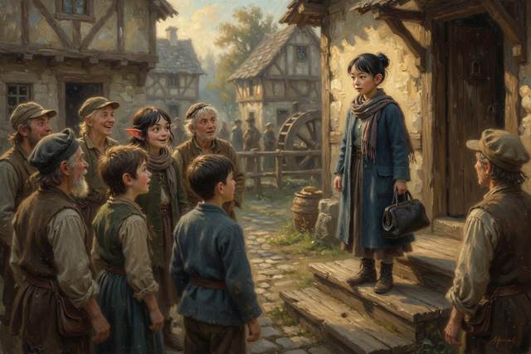
The Mayor’s mouth opened and closed, like a fish.
“I did not,” he said, “know that.”
“No,” said Dr. Liang kindly. “You did not check.”
There was a long silence in the square.
“Well!” said the Mayor at last. “Well, well. That is a very interesting point.” He went a rich, deep pink, from the collar up. “I am a reasonable man. I am always open to correction. But I have a cellar to fill, and cheeses waiting, and I have announced it to the whole village.” He looked round, and found that he was standing on a barrel in a brown paper hat, in front of two hundred people. He took it off, quite slowly. “Very well. I shall make a bargain. If somebody can show me, with their own eyes, and before the first warm evening of spring, that these bats of yours are worth more to this village than a hundred wheels of the finest cheddar in the county, I will take down the stake, and find another cave. If not,” and his mustache rose, a little uncertainly, “I seal it. That is fair.”
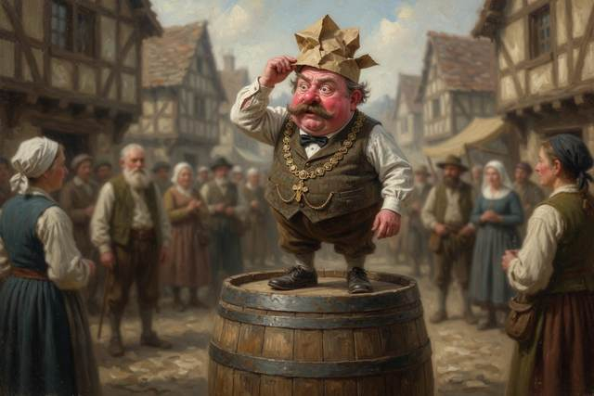
“That is fair,” said Hal, before he could stop himself.
“And no more hats,” said the Mayor.
“No more hats,” said Scally.
It was a grim and thoughtful group that walked home across the snow. Nobody said much. At the top of the hill, Pip took Scally’s hand without being asked, and held on, and Scally let him.
“You did not sell the thirty-second hat,” said Pip, kindly. “I would have counted.”
“I know,” said Scally.
“That is something.”
“I know,” said Scally. He looked at the sky. Behind the hill, the sun was sinking in a long streak of orange, and the first star had come out, and from somewhere in the cold air over Hanger Hill, a very long way up, there came a sound too high for any of them to hear.
↑ Contents

Chapter 6. Wen’s Listener
“We need to hear them,” said Wen.
It was the third night after the village meeting, and the five of them, with Hopsi and Gucci, were sitting on the floor of Dr. Liang’s back room, among a heap of bits and pieces that Wen had been collecting all week. There was a funnel from Mrs. Crumb’s kitchen. There was a long brass spring from the broken clock in the church tower. There was a small silver bell, four copper wires, a cork, three buttons, an old pocket watch with no hands, and a tin whistle that Scally had won off a peddler.
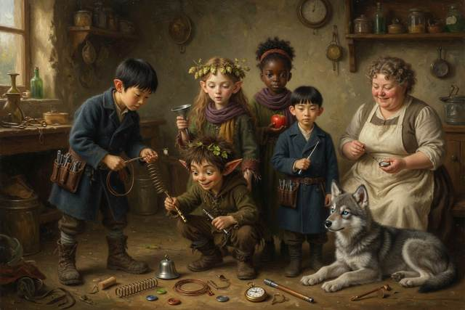
“Why?” said Tabitha.
“Because the Mayor says we must show him. And the only thing the bats do is hang there. If we want to prove they are worth something, we have to see them do what bats do.” Wen turned the funnel over in his hands. “But they only come out at night, when it is warm enough, and they fly very fast, and when they talk, it is too high for people to hear.”
“Too high?” said Pip.
“Sound has a pitch,” said Wen. “High or low. A tuba is low. A whistle is high. A mouse squeak is higher. And above that, there are sounds so high that human ears cannot catch them at all. My mother calls that ultrasound. Dogs can hear some of it. That is why Gucci howls.” He tapped his own ear. “Bats talk in it. They make a squeak, much too high for us, and they listen for it to come back.”
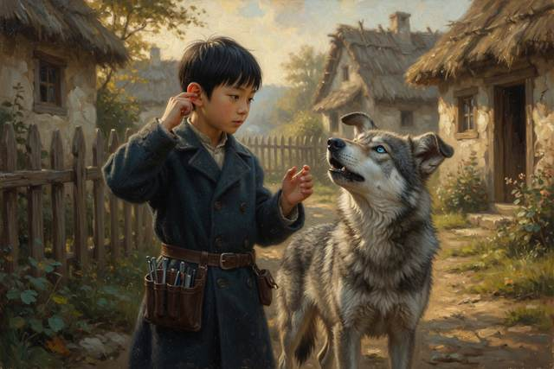
“Come back?” said Hal.
“From the things around them. The way your shout came back off the cliff. You told me about the cliff.”
Hal sat up straight. “The echo! Two counts there and back, and the wall was a fifth of a mile away. Count the time, and you know the distance.”
“Exactly,” said Wen. “They do that, too. Only faster. They squeak, and listen, and from the time it takes, they know how far away a moth is. How big it is. Which way it is going. They see with their ears.” He frowned. “That is not quite the right word. They can see with their eyes as well. People say ‘blind as a bat,’ but that is wrong. A bat has perfectly good eyes. It just has a second way of finding things that is better in the dark.”
“I thought they were blind,” said Hopsi, quietly. “I have thought so for a very long time.”
“Everybody does.”
“That is why,” said Hopsi, “I am glad you checked.”
Wen picked up the funnel. “So I have built a listener.”
He held it out, rather shyly, and they all looked at it.
It was the strangest thing Hal had ever seen. The funnel had been fixed to a bent length of copper pipe, with the brass spring wound round it and the bell hung from the narrow end. The pocket watch was strapped to one side, its ticking face turned inward. There were three buttons along the top, and a small cork stopper sat at the very end. It looked like a trumpet that had been taken apart and put back together by somebody who had only heard of trumpets from a friend.
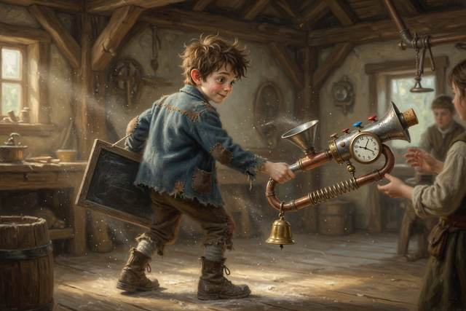
“What does it do?” said Pip.
“It listens,” said Wen. “The funnel collects the sound. The spring catches the squeaks that are too high, and slows them down, the way a long spring slows down a ripple. And the bell rings the squeaks out again, so slowly that a person can hear them.” He took a breath. “I think.”
“Do you know that it works?” said Tabitha.
“No,” said Wen. “I have never tried it. I do not know if it will.”
Everybody looked at Hopsi, who had gone quiet and thoughtful, the way she did when something was not quite right.
“I should say,” said Hopsi, slowly, “that I do not think it can work the way you say. A bat’s squeak is very high, and a spring cannot slow it down. A real machine for hearing bats uses electricity. It listens with a small wire, and turns the high sound into a lower one, with a kind of box.” She looked at the listener, and at Wen’s face, and made up her mind. “But this is a story. A story can have something in it that is not quite true, if it says so. I am saying so. This listener is a storybook machine. In real life, you would need a different one. But here, I think we can try it.”
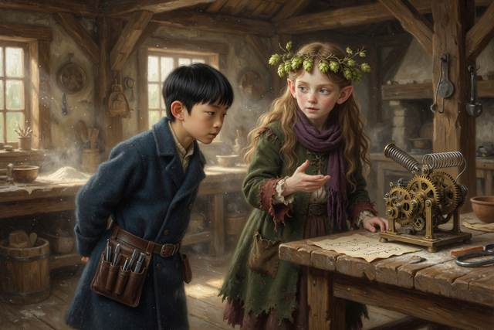
“I thought you would say it did not work,” said Wen.
“I said it is magic,” said Hopsi. “I did not say it will not.”
Wen went red to the ears, and smiled for the first time in several days.
They tried it on the fifth warm night, which came early in January, after three days of thaw. The snow had gone gray and soft. The creek ran again. And at dusk, with the sun going down red behind the hill, and the first stars coming out, seven children and a wolf crept up the long slope to Hanger Hill, with Dr. Liang a few steps behind them in her long coat, carrying her bag, and a thermos of hot cocoa, and a lantern that she had turned very low.
They stopped a good way from the cave mouth. Dr. Liang had said that was the rule: quiet, and far enough away to give the sleepers room, and no lights shone at the cave. They crouched in the bracken. They waited. Pip fell asleep for a few minutes on Scally’s shoulder, and woke up, and said he had not.
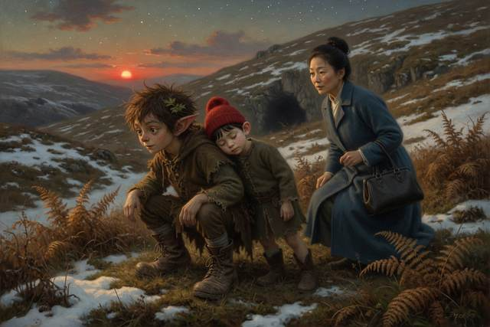
The sky turned green. The hill turned black. Nothing happened.
“Maybe they are not coming,” whispered Titch.
“Shh,” said Wen.
Then Gucci’s head came up.
He did not make a sound. He lifted his great gray muzzle toward the cave mouth, and his whole body went rigid, from nose to tail, and his ears came round like two cupped hands.
“There,” breathed Wen. He lifted the listener to his eye, and then to his ear, and turned the cork, very gently, a quarter of a turn.
For a moment there was nothing. Then, from the copper funnel, came a faint, thin, silvery little noise, like somebody flicking a wet finger along the rim of a glass.
Tik. Tik-tik. Tik-tik-tik-tik-tik.
“Is that it?” whispered Hal.
“That is it,” said Wen, in an awed voice. “That is a bat. Listen.”
He held out the funnel, and all of them listened, one by one, with their heads close together. And they heard it: a small, dry, quick, rapid ticking, that sped up, and slowed, and sped up again, and finally rushed together into a long, soft, running buzz.
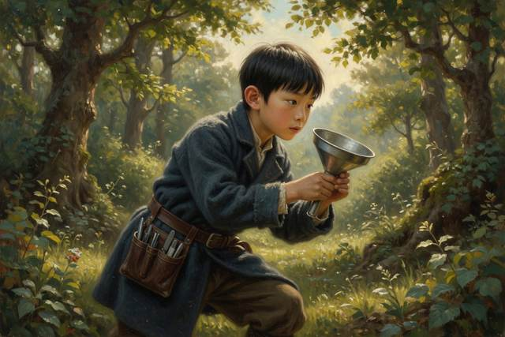
“What is that?” breathed Tabitha.
“It has found a moth,” said Dr. Liang quietly, from behind them. “That is called the feeding buzz. The squeaks come faster and faster as the bat gets closer. Each one is shorter than the last, so it can tell, almost to the inch, where the moth is, until it catches it.” She was smiling, in the dark. “That is one of the oldest tricks in the world.”
Over the hill, against the last green light, a small dark shape flickered out of the cave mouth, circled, once, twice, and was gone, as quick as a thought. Then another. Then another, a dozen, a hundred, in a whirling, fluttering river of tiny wings, pouring out of the hill and into the evening air, swooping and diving above the creek, over the bare hedges, round the church tower, and out across the fields to the village.
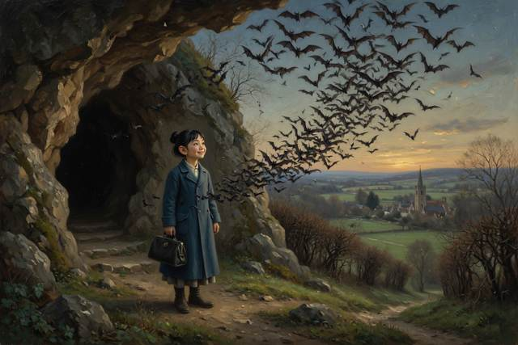
A long hush fell over the room.
“They woke up,” whispered Pip.
“A few,” said Dr. Liang. “On warm winter nights, a few of them wake and go out to feed. Then they go back to sleep. They have just enough fat to last till spring.” She took a quiet breath. “That is why we must be so careful. Every time one of them wakes up, it burns some of its food.”
“And if the Mayor seals the cave,” said Hal.
“Then they cannot come out,” said Wen, “and they cannot go back. And there will be no bats. There will be no moths eaten. There will be no more of the quiet clicking.” His voice went very small. “There will be only cheese.”
Scally, kneeling in the bracken with his arms round his knees, had said nothing at all. His face was turned up to the sky. The last of the bats were wheeling high overhead, black as scraps of burnt paper, in front of a sky full of stars, and in their path a cloud of moths went whirling up and up.
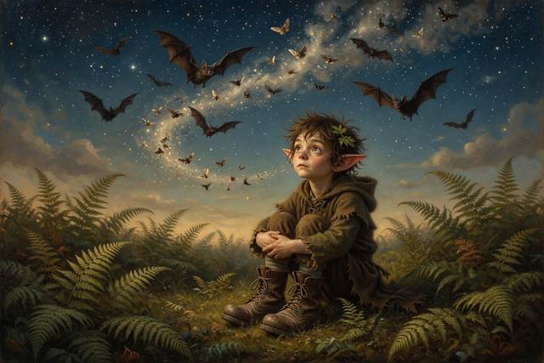
“They are the best thing I have ever seen,” said Scally.
“Yes,” said Hopsi.
“I am going to save them.”
“We,” said Hal.
“We,” said Scally, after a moment, and his ears had gone pink. “I am going to save them with all of you. If it is all right.”
“It is all right,” said everybody.
And on the way down the hill, in the quiet dark, Wen held the listener close against his coat, as if it were something alive. “I think,” he said, to nobody in particular, “that I am not afraid of the dark any more. I think I am only afraid of not hearing what is in it.”
↑ Contents

Chapter 7. The Picture of the Baby
“Today,” said Dr. Liang, “we are going to see with sound.”
It was a gray Saturday in the middle of January, and the whole back room of the little blue-doored house had been cleared. The table stood against the wall. The skeleton in the hat had been moved to the corner, where he looked on, politely, with his empty eyes. In the middle of the floor stood a high narrow bed with a white sheet on it, and beside the bed, on a wheeled cart, stood a machine.
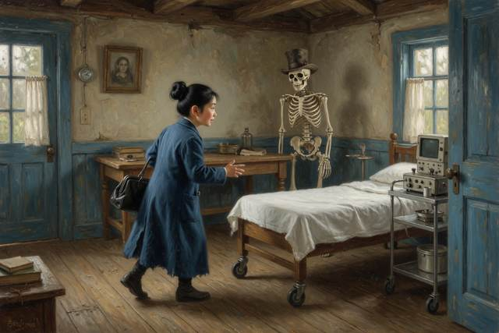
It was a sort of box, the size of a bread oven, made of brass and dark wood, with a small gray glass window set into the front, and a hand crank at one side. From the box ran a coiled cord to a smooth silver wand, about as big as a bar of soap. Nobody had ever seen anything like it in the village. Pip said it looked like a very serious toaster.
“It is a listening lantern,” said Dr. Liang. “It makes a sound too high for you to hear. It sends the sound in. The sound bounces off whatever it hits, and comes back, and the machine turns the echoes into a picture.” She smiled. “It is the same trick the bats use, and the same trick Hal used on the cliff. Sound goes out. Sound comes back. And from the time between, you can tell what is there.”
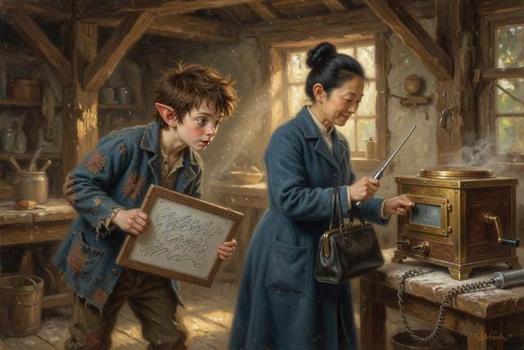
“That is very clever,” said Hal.
“I should say,” said Hopsi, from the corner, with her scarves up to her chin, “that I do not think real doctors have a machine with a crank. I think real ones plug into the wall. I think this one is a story. I am marking it, so that nobody is confused.”
“Marked,” said Dr. Liang gravely. “Thank you, Hopsi. In a real hospital, a real machine does exactly this, but it is smaller, and it has a screen, and nobody has to turn a handle.”
“Whose picture are we taking?” said Titch.
“Your mother’s,” said Dr. Liang. “If she is still willing.”
Titch’s mother had been sitting in the best chair with her hands folded on top of her round stomach, looking, for the first time that winter, a little nervous. She was a small, brisk, freckled woman, usually, with a voice that could be heard from the mill to the church. She said now, in a rather small voice, “I would like the children to see. It is a family thing.”
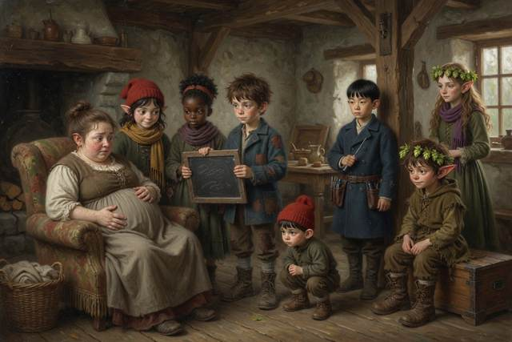
“Then lie back,” said Dr. Liang, “and tell me if I am too cold.”
She spread something on Titch’s mother’s stomach out of a small blue bottle. Pip said it was goo. Dr. Liang said it was gel, and that it helped the sound get in. She laid the silver wand on the gel, and moved it, very slowly, in a long, gentle curve. Wen turned the crank, with his tongue between his teeth.
At first there was nothing in the gray glass window but a gray storm, a moving mist of dark and light, like snow blowing in the dark. Everybody leaned in. Pip stood on a stool.
“I cannot see anything,” said Pip.
“Wait,” said Dr. Liang. “Listen.”
And from the box, very faintly, there came a sound. It was fast and soft and fluttering, like a bird’s wing against a window, a quick, small, busy swish-swish-swish-swish. It went on and on.
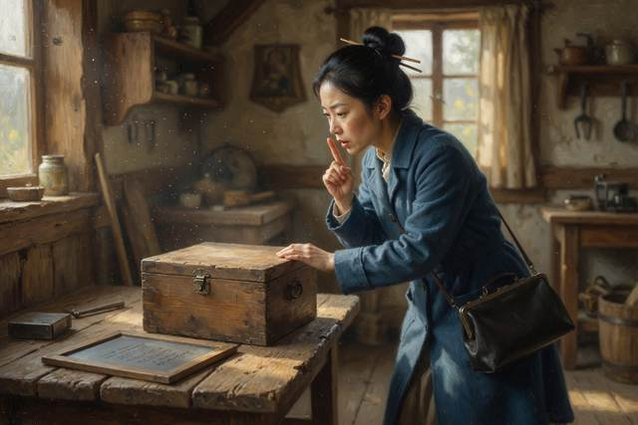
“What is that?” whispered Tabitha.
“That,” said Dr. Liang, “is a heartbeat.”
Everybody went quiet. Titch’s mother put her hand over her mouth.
“It is very fast,” said Hal.
“Twice as fast as yours,” said Dr. Liang. “Over a hundred and forty beats a minute. That is exactly right for a baby that size.” She moved the wand a little, and the storm in the window cleared, and a shape came up out of the gray, curved like a bean, with a round head and a small, clear line of a nose and one tiny fist held up beside its face.
“There,” she said. “That is your baby.”
Nobody said anything at all.
Titch’s mother was crying a little, in an extremely happy way. Titch had gone very still, and then she reached out and took her mother’s hand, and held it hard. Wen had stopped turning the crank, and a very small light had come into his face, as though he had just seen the first clock that ever worked.
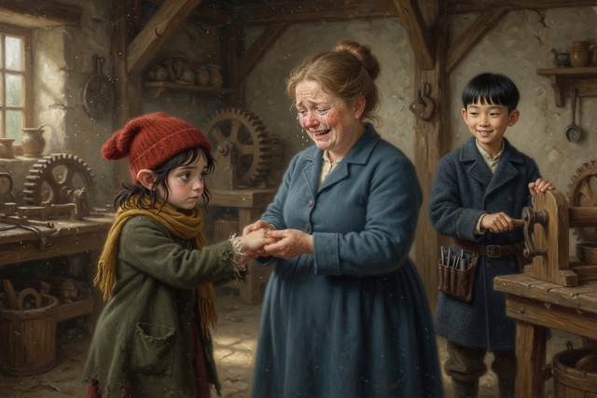
“He is waving,” said Pip.
The tiny fist in the window had opened. It was open, a small starry thing, with five distinct fingers, and then it closed again, and moved up and down.
“He is saying hello,” said Pip, in a voice full of awe. “He is saying hello to me.” He stared at the picture with enormous eyes. “He looks like a biscuit.”
“A biscuit?” said his mother.
“A biscuit with a nose,” said Pip. “A round one. A warm one.” He turned round, bursting with it. “That is what he looks like. A biscuit. That is what we should call him.”
“We do not know it is a he,” said Titch.
“It is a he,” said Pip firmly. “I decided.”
“I do not tell people what they are having,” said Dr. Liang, in an amused voice, “unless they ask me. And I do not,” she added, “say anything about biscuits.”
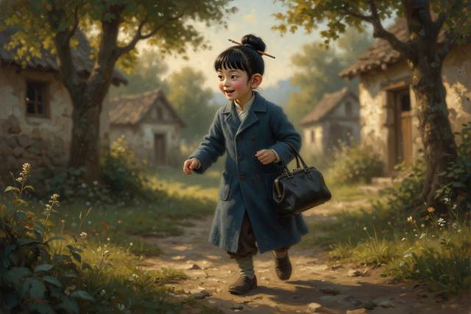
“I would like to be surprised,” said Titch’s mother, wiping her eyes. She was laughing. “But I think that biscuit is going to stick.”
“Biscuit,” said Pip, and began to hum. He did not hum Scally’s tune. It was a new one, and he made it up as he went along, standing on the stool with his hands behind his back, as he did when he was being solemn.
“Biscuit, biscuit, warm and round, when will you come out and be found? I will teach you how to climb, and you will come in just in time.”
Nobody knew what he meant by that last line, and nobody asked.
They all had a turn at the window, to look at the picture. Gucci was allowed to put one huge paw on the edge of the cart, and sniff, and look stunned. Scally, who had been standing at the back with his hands in his pockets, said in a low voice that it was the best thing he had ever seen, even better than the bats. “That is a person,” he said. “In there. A person that nobody has met.”
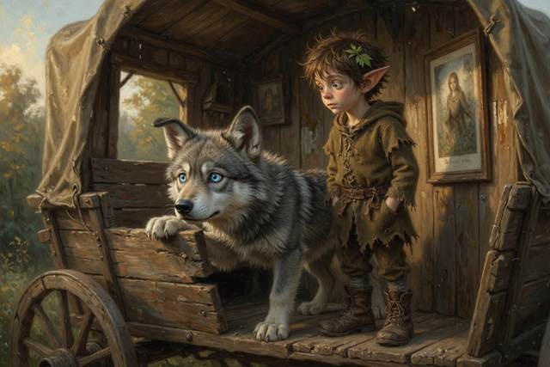
“That is a very good way to put it,” said Dr. Liang.
Then she did a thing that Hal would think about for a long time afterward. She wiped the silver wand with a cloth, and she wound up the cord, and she looked at the door. Hal’s mother was standing in it. She had come in a few minutes before with a covered dish of pie, as a present for the doctor, and she had stood quietly at the back, with her shawl over her arms, watching.
“Mrs. Millersen,” said Dr. Liang pleasantly. “Would you mind staying for a few minutes? I have a small question to ask you. It will not take long.”
“Of course,” said Hal’s mother.
Her voice was light and ordinary. But Hal, looking up, saw that her face had gone quite pink, and her hand was resting flat on the front of her dress.
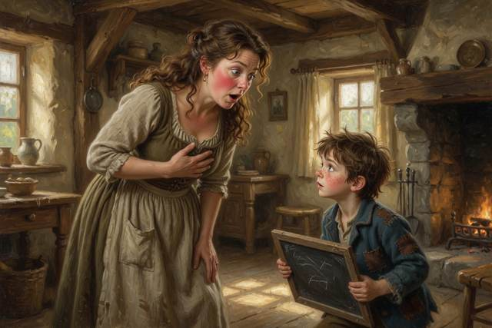
“Children,” said Dr. Liang, “into the kitchen, please. Wen, there is cocoa. Hal, you may take your slate.”
“Why?” said Hal.
“Because I would like to talk to your mother about her dizzy spells,” said Dr. Liang gently. “And because I think she would rather you were not worried. Out you go.”
They went. The kitchen was warm and small and smelled of cocoa. Hal sat at the table with his slate in his hands, and said nothing, and listened to the sounds from the back room. There was the hand crank. There was a long, soft murmur of two voices. Then, through the wall, very distinctly, he heard his mother laugh. It was a short, astonished, helpless laugh, and then it stopped, and for a while, there was no sound at all, and then he heard a small noise, like someone drawing a long, shaky breath, and the sound of his mother saying, in a voice he did not know, “Oh.”
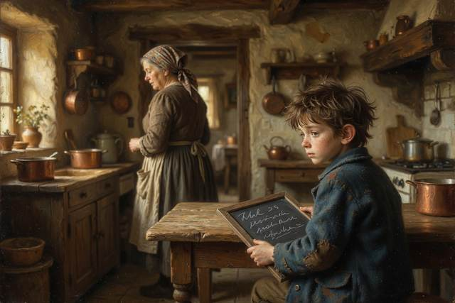
“Is she all right?” said Hal.
“I think she is very all right,” said Wen. He said it carefully, with his hands round his cup. “My mother says a doctor keeps other people’s news until they are ready to give it out. She is very good at it. She has never once told me anything I should not know.” He paused. “I did not know you could tell, from the sound of a laugh.”
“It was a happy laugh?”
“I think it was a very happy laugh,” said Wen.
When the door opened, Hal’s mother came out with her eyes shining and her cheeks pink, and her hand on her middle. She walked straight over to the table and put her other hand on the top of Hal’s head, and stood there, quite still, looking down at him.
“Everything is perfectly fine,” she said. “I am healthy, and Dr. Liang says I am as strong as a horse. I will tell you all about it, my love. Soon. When I am ready. Is that all right?”
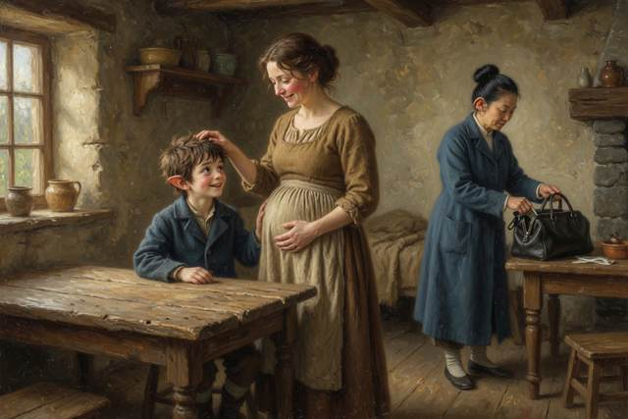
“Acceptable,” said Hal, in a small voice.
“Thank you.” She bent down and kissed him on the top of the head, and smelled of pickled onions and bread and something else, something new, like a window opened on a spring day. Then she picked up the covered dish of pie and took it out to the table, and Dr. Liang came out of the back room, wiping her hands, and looked at nobody in particular.
That evening, on the mill step, Hal opened his slate to the page that said THINGS I DO NOT UNDERSTAND YET. It was very long. It said:
WHY DID MOM LAUGH? WHY DOES MOM WANT PICKLED ONIONS? WHAT IS THE KNITTING FOR? WHAT DID DR. LIANG SAY? WHY DID MOM SAY “OH”?
He looked at it for a long time. Then he took the chalk and added, at the bottom, in very small letters:
I THINK IT IS GOOD.
↑ Contents

Chapter 8. The Sledding Day
The big snow came the first week of February, and it came the way a very large dog comes into a room: all at once, and licking everything.

It had been dry and cold for days, with the sky as hard as an enamel bowl. Then, in the night, soft and quiet and without any wind, the snow began. It fell for twelve hours, in big, slow, silent flakes the size of quarters, and by morning, the mill had a hat of white on its roof, the wheel was frozen solid in a cloak of ice, and the whole valley lay under a deep, smooth, shining blanket, with nothing in it but the tops of the fence posts.
“Sledding,” said Titch, from the bottom of Hal’s bed, in a voice of deep, reverent joy.
There was no argument.
The long hill behind the mill was the best in the valley. It started up by the old oak, ran down a gentle slope, steepened in the middle, and finished in a long, sweet, flat run across the field, where a wall of hay bales had been stacked every winter for as long as anyone could remember. Beyond the bales was the village lane. Past the lane was the pond. Hal’s father had stood at the top of the hill that morning, with his cane, and said in a very firm voice that anybody who went past the bales would answer to him.
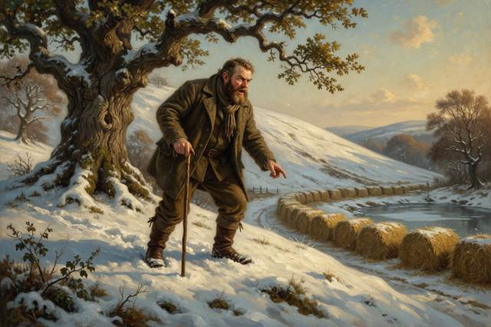
By ten o’clock the whole village had turned out.
The grown-ups sat in a long row at the top, wrapped in quilts, with Mrs. Crumb’s big pot of hot chocolate steaming between them and a plate of marshmallows that were being eaten faster than they were put out. Hal’s mother sat in the middle, very upright, with a thick blanket tucked round her and her knitting in her lap. Titch’s mother sat next to her, on a kitchen chair somebody had carried up the hill, with her feet on a stool and an expression of great, patient, enormous peace.
“You are all right?” said Hal’s mother.
“I have had a funny little ache all morning,” said Titch’s mother. “It is nothing. It comes and goes. I am sure it is the cold.”
“Hmm,” said Dr. Liang, from her other side. She said nothing else. But she took out a small notebook, and wrote something in it, and put it back.
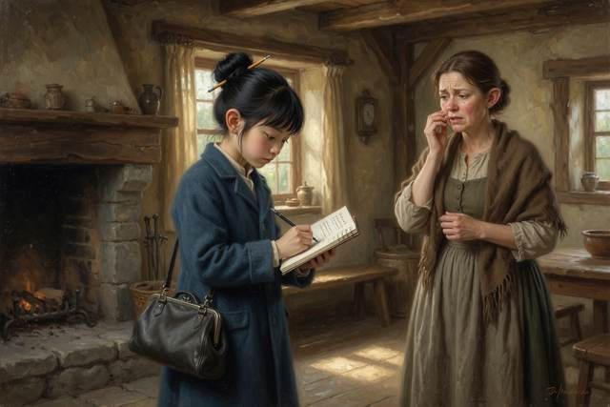
On the snow below, the children were getting ready.
Everybody had a sled. Hal had his father’s old wooden one, long and narrow, with iron runners. Titch had made hers out of a barrel stave and a dishpan, and had named it the Crumb Express. Tabitha had a flat wooden toboggan, with a curled front, that her gran had sent from the sea. Pip had a washtub, which nobody had the heart to refuse him, and Hopsi, wrapped in so many scarves that she looked like a round striped turnip, had not brought one at all. She stood at the top with her hands in her sleeves and her chin in her collar, and gave the impression of a very polite hedge.
Wen had built his.
It was a long, low, handsome sled, made of pale wood, with two runners as smooth as glass. On the front he had fitted a small brass bell. At the back, he had attached, by a hinge, a long wooden stick, and a rope that ran up to the handlebar.
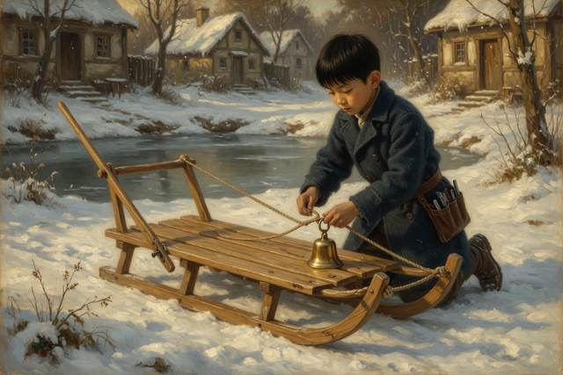
“What is that?” said Scally.
“A brake,” said Wen. “You pull the rope, and the stick digs in, and the sled stops. It is not a very good brake. It is better than none.” He sat down on it, straight as a ruler, and adjusted his scarf. “I tested it on the lane yesterday, going slowly.”
“Slowly,” said Scally, with enormous scorn. “Nobody tests a sled slowly. The whole point is to go fast.”
“The whole point,” said Wen, “is to get to the bottom, and then be able to get up again.”
“That is the dullest thing I have ever heard.”
“Race you,” said Wen.
It was the first time anyone had ever heard him say it. For a moment Scally was too astonished to answer. Then he put his boots on the baker’s big flat tray, which was his sled, and his eyes began to shine. He hummed, almost without noticing, under his breath: Just a little, just a bit—
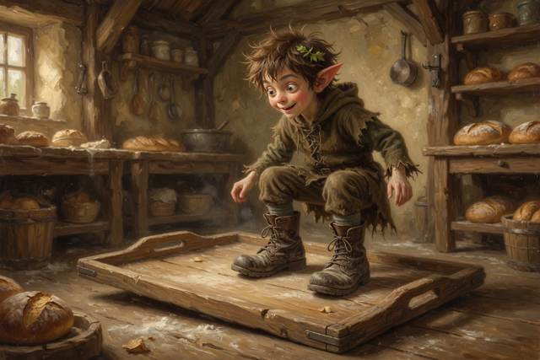
“I heard that,” said Pip, from his washtub.
“I was only humming.”
“You are going to start early.”
“I would never.”
“You always do,” said Pip, with the ruthless candor of the very young. “It is the rule.”
They lined up, side by side, with a line scratched in the snow by Hal’s boot. Tabitha counted. “Three,” she said. “Two.” Scally’s tray, quite by accident, slid six inches forward. “One,” said Tabitha, looking at it. “Go.”
“That was not,” said Scally, “a true go.”
“Go again,” said Tabitha, calmly.
They went again. Scally, on the baker’s tray, with his hat over his eyes and his arms spread wide, went down the hill like a sailor on a ship in a storm, screaming with joy. Wen, on the Brass Bell, went smoothly and exactly in a long, quiet curve, steering with his heels, tinkling gently. Scally reached the bottom first. He kept going, straight over the bump, off the end of the tray, into the hay bale wall, and into the soft snow behind it, headfirst, with his legs sticking up. Wen arrived four seconds later, pulled the rope, and stopped one foot from the bales, with a small bell sound.
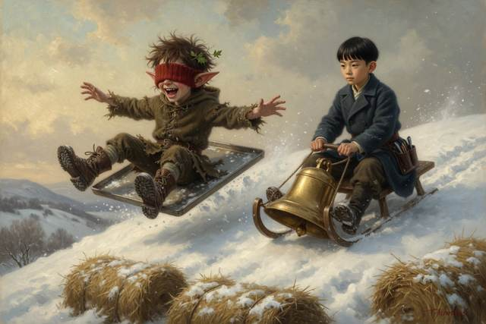
“I won!” said a muffled voice from the snow.
“You were upside down,” said Wen. “That is not winning.”
“Technically I was first!”
“Technically,” said Wen, and for the first time anyone had ever seen, he laughed, a quick, startled, silvery laugh, as though a clock had begun to strike, and then he went red and looked at his gloves.
After that there was no stopping any of them.
They went down on their backs and on their stomachs. They went down in pairs, and in threes, and in a long train of five sleds tied together, which Hal’s father made them untie again, saying that it was how people broke their legs. They built a jump out of packed snow, with Titch and Hal pounding the sides with shovels, and Pip stood at the top in his washtub, with his red cap pulled down to his ears.
“I am going to fly,” he said.
“You are going to go over the little bump,” said Titch, “and land in the soft part. And you are going to put your feet out in front of you, and not stand up, and not look back.”
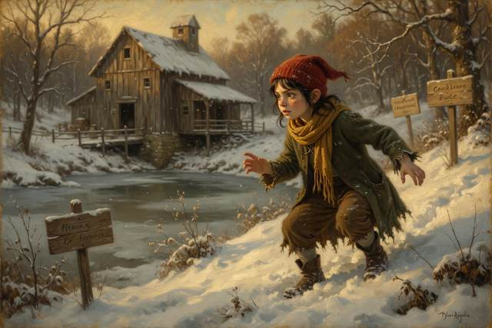
“Fly,” said Pip, firmly, “is the plan.”
“Hold on to the sides.”
“Flying,” said Pip, with dignity, “is what I do.”
“Yes,” said Titch. “All right.”
She pushed. The washtub rolled, and gathered speed, and shot up the little ramp, and for one wonderful, perfect, silent second Pip and his washtub were airborne against a bright blue sky, with his red cap streaming and his mouth wide open in a shriek of joy that rang across the whole valley. Then they landed, in the soft part, with a thump and a spray of white, and spun twice, and stopped. Pip lay on his back in the snow, with his arms flung out, looking at the sky.
“I flew,” he said, in a small, glorious voice.
“You did,” said Titch. She sat down in the snow beside him, quite suddenly, and put her arm round him.
The rest of the morning went by in a happy blur. They built a fort, with walls as high as Hal’s chest, and a snowman beside it, which was meant to be tall and noble, and turned out short and lumpy, with a carrot nose that Gucci ate at once. They had a snowball fight, which Tabitha won, because she threw like a farmer. They were given hot chocolate, and a great many marshmallows, and Mrs. Crumb inspected all of them for frostbite, and found nothing.
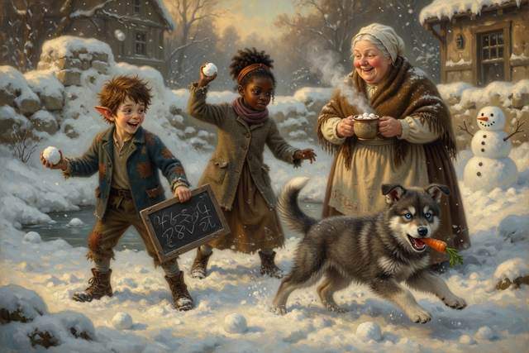
Late in the morning, while they sat in the fort drinking cocoa, Scally began the story.
“I once,” said Scally, in a low, confiding voice, leaning back against the snow wall with his hands behind his head, “made the biggest snowball in the world.”
“How big?” said Pip.
“As big as the church tower. I rolled it all by myself, in one night. It got so big it rolled down the hill on its own, and it picked up the whole forest, and three cows, and a very surprised goat. It rolled all the way to the sea.” He took a sip of cocoa. “It is still there. The whales use it as a bench.”
“Is that a story,” said Pip, “or a lie?”
“A story,” said Scally, at once. “A story. A big, fat, beautiful one.”
“Good,” said Pip, and settled back, satisfied. “I like it. Do the part with the goat again.”
“I would like to say,” said Hopsi, from under her scarves, “that I like it, too.”
Everybody looked at her.
“It is the best one so far,” said Hopsi. “I do not believe a word of it. It is true that he told it.” She gave one of her very small smiles. “I should not say that is a lie. That would not be fair.”

“High praise,” said Scally, and bowed from the waist, sitting down.
It was nearly noon, and the whole fort was full of laughter, when Hal’s mother stood up at the top of the hill, and looked at the sky.
It had changed. The brilliant blue had gone, and in the west a long, low, dark, purple-gray bank of cloud had crept up behind the hill, and the air had gone very still, and the light had a thick, yellowish, strange look, like the light in a bruise.
“Children!” she called. Her voice was calm, but it carried. “Time to come in. Everybody home. It is going to snow again, and a great deal.”
“Already?” said Pip.
“Right now,” said Dr. Liang, and stood, and put a hand on Titch’s mother’s shoulder. Titch’s mother had gone quiet. She was holding the arms of her chair, quite tightly, and breathing out slowly through her mouth.
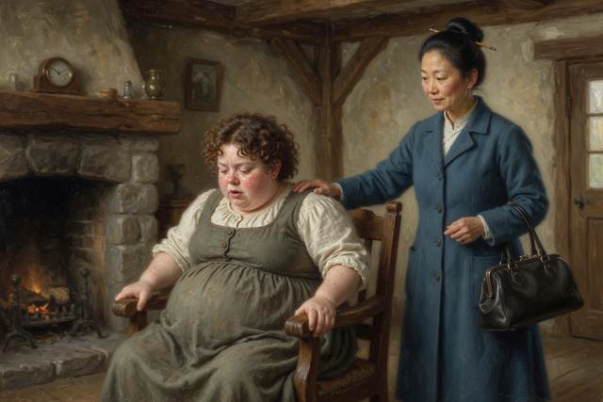
“Doctor,” she said.
“Yes,” said Dr. Liang.
“I think,” said Titch’s mother, in a most surprised voice, “that the ache has changed its mind.”
↑ Contents

Chapter 9. The Night of the Big Snow
Nobody ever agreed afterward how quickly it came.
Hal always said that the first flake fell just as his father set Titch’s mother in the Crumb Express and tucked a quilt round her. Wen always said it was a few minutes later, when they were already halfway across the yard. Pip, who had been made to ride on the back with his washtub, said the sky fell in all at once, like a white blanket pulled off a bed. They all agreed on one thing: by the time Titch’s mother was settled in her own front room, with a fire lit and her feet on a stool, the world had gone.
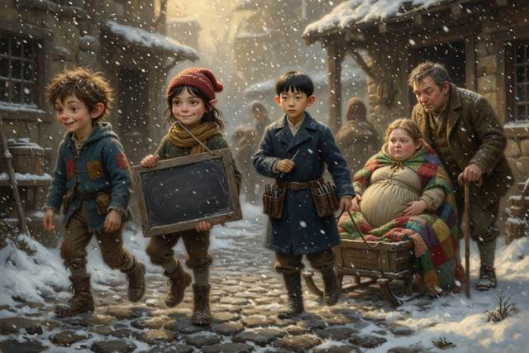
It was not snow as they had known snow. It was a wall. It came down out of the purple-gray bank in the west, in thick, driving, sideways sheets, and it swallowed the oak, and the hay bales, and the lane, and the mill itself. You could not see your own hand held out at arm’s length. The wind had come with it, a low steady roar, and under the roar the whole valley had gone quiet, as though it were holding its breath.
“Right,” said Mrs. Crumb.
She had come over from the hill at a run, with her sleeves already rolled, and she stood in the middle of Titch’s front room, with her fists on her hips, like a general. She was a big, floury, comfortable woman, and she had been born in the village and had helped half of it into the world. “Nobody panic. Millie, you sit right there, and breathe like I showed you. Mr. Mitchel, you boil water. Mrs. Millersen, you are going to fetch every clean towel in this house, and you are going to sit down in between.” She turned. “Doctor, your bag?”
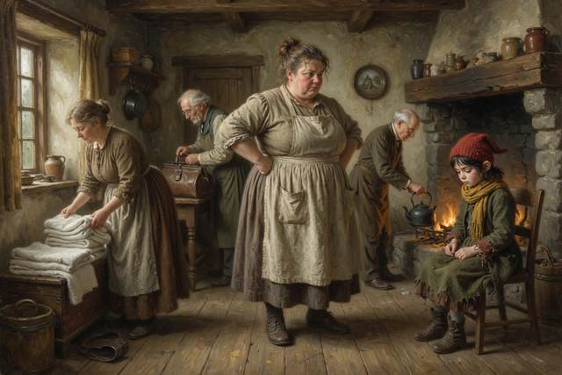
“It is at my house,” said Dr. Liang.
For the first time that day, her face changed.
“By the bridge?” said Mrs. Crumb.
“By the bridge. I was going to send for it. I did not think.” She looked out of the window, at the white. “It is seven minutes away, and I know the way with my eyes shut. It is early, and Millie is well, and I do not believe there is any danger. But I would like to have what I need. I will go and come back. Wen, stay here with Hal. Do not go outside for any reason.”
“Mom,” said Wen.
“I will be back in fifteen minutes.” She put on her coat and wound her scarf round her face, and her eyes, above it, were very steady. “That is a promise. I keep them.”
She went out into the white. The door shut. And that was the last any of them saw of Dr. Liang for a very long time.

At first it was only like waiting for a pot to boil. Hal’s father had strung a rope from the mill door across the yard to the Mitchels’ door, a long, taut, hand-over-hand lifeline that you could follow with your eyes shut. “Nobody,” he said, in his voice that was not to be argued with, “leaves the rope. Not for a hat. Not for a dog. Not for your own mother. Anybody who lets go of that rope in this will be lost in ten steps. Do you understand?”
“Yes, sir,” said everybody.
The men went out in a chain, tied together by the waist, to look for the doctor, and came back twenty minutes later, covered in white, shaking their heads. They could not find the bridge. They could not even find the lane. The wind had blown the snow into drifts as high as a man’s chest, and in the dark and the swirl, there was nothing to hold on to at all.
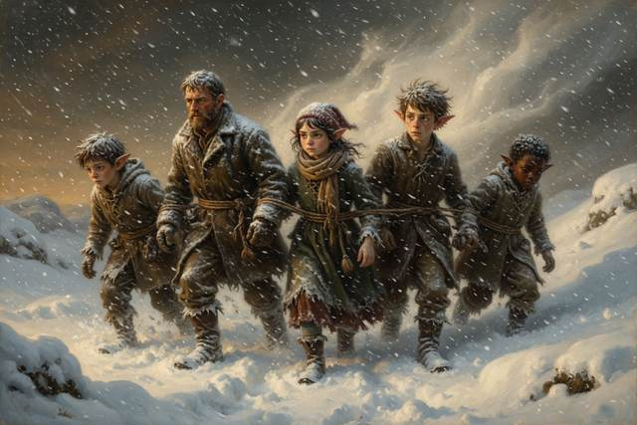
In the front room, Titch’s mother had gone very quiet. Her breathing had changed. Mrs. Crumb was counting under her breath, and Hal’s mother, with a towel in each hand and a blanket round her shoulders, had stopped saying “It is perfectly all right,” and was just holding Titch’s mother’s hand.
Wen stood by the window. He had been standing there since the door closed. He had not spoken once. He had his hands folded in front of him, very tightly, and his eyes on the white glass, and every few seconds he took out his pocket watch, the one with no hands, and looked at its blank face, as if it could tell him anything.
“She said fifteen minutes,” he said at last, in a flat voice.
“I know,” said Hal.
“It has been fifty.”
Nobody answered.
“A person who is lost in snow should stop,” said Wen. “She knows that. She told me so herself. Stop where you are, and stay still, and make a noise. But she has no whistle. She has no light. She cannot see the house. She cannot hear it.” He swallowed. “She cannot hear anything.”
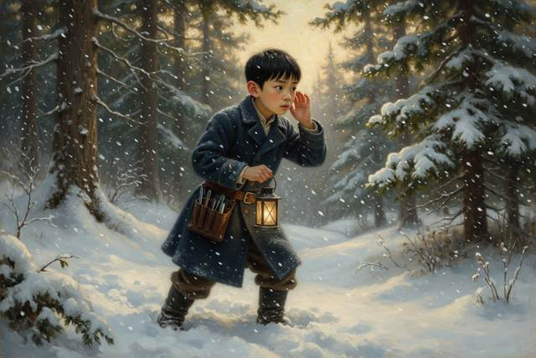
He said it quite slowly. Then, all at once, his whole face changed. He turned round. “The clock,” said Wen.
“What?”
“The clock. On the mill. It strikes the hour, and it carries all across the valley. You heard it, the first day. It rang right across the frost. If somebody were lost out there, in the white, and could hear it, they could walk toward the sound.” He was talking fast now, in a low, intense rush. “It only strikes once an hour. We need it every half minute. We need somebody to climb up, and ring it by hand.”
“It is in the loft of the mill,” said Hal. “In the gable.”
“I can do it.”
“You cannot go alone.”
“I know. I know the rule.” His voice shook. “Will you hold the ladder?”
They went to Hal’s father, who listened in silence, and looked at the white window, and said, “Show me.”
It was the strangest scene any of them ever remembered. They climbed to the dim loft above the mill, where the sacks were stacked, and the great wheel of the clock stood, with its gears and weights and pendulum, behind a little door in the gable. Hal’s father held the ladder. Hal held the lantern. Wen climbed up into the little dark space with a hammer and, with a face of terrible concentration, hit the great bell as hard as he could.
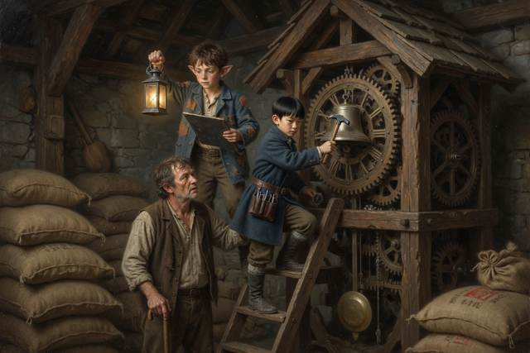
BONG.
It rang out into the storm like a great round iron note, and the wind took it, and carried it away into the dark.
“Again,” said Hal’s father.
BONG.
They counted. Thirty seconds. BONG. Thirty seconds. BONG. Down below, Scally, who had been told he could not climb a ladder, ran up and down the rope to Titch’s house in the dark, over and over, bringing news in both directions, in the fastest, steadiest, most careful run of his whole life, with one hand on the rope the whole way. “Still no sign,” he panted, the first time. “Mrs. Crumb says the baby is coming faster.” The second time: “Still no sign. Titch is holding her mother’s hand. She is not crying. She says she is not.” The third: “Hopsi says she thinks the doctor went west.”
“Why west?” said Hal, from the foot of the ladder.
“She says it is where the wind was coming from. She says people walk into the wind without knowing.” He stopped for breath. “She says she thinks so. She does not know.”
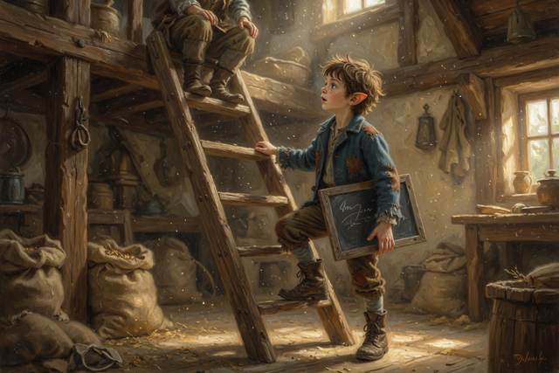
BONG.
Gucci had not moved from the door in all that time. He stood with his nose pressed to the crack, and his whole big gray body shaking, as he had shaken the first night, in November, when nobody else could hear what he heard. Now, quite suddenly, his head went up. His ears went forward. He gave one short, sharp, tearing bark.
“What is it?” said Hal.
Gucci hit the door with both front paws. It flew open, and a swirl of snow blew in, and before anyone could grab his collar, he had gone, a great gray shape vanishing into the white, with his tail high.
“Gucci!” screamed Hal. He dived for the doorframe. Hal’s father caught him by the back of his sweater and held on.
“No,” said Hal’s father. “Not you. Not the rope. He is a wolf. He knows snow better than any of us. Let him go.”
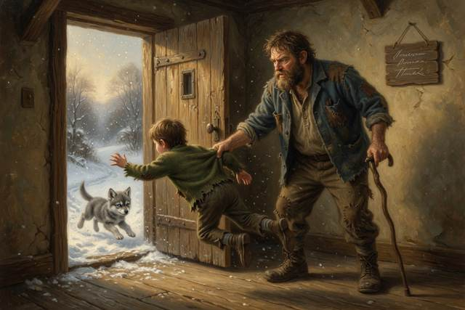
“He heard something,” said Wen from the top of the ladder, in a cracked voice. “He heard her. He is going the wrong way.”
“What way?” said Hal.
“East,” said Wen. “Hopsi said west. Everybody thought west. He is going east.”
“Maybe he is wrong,” said Scally, white-faced, from the door.
“Maybe,” said Hopsi.
She had come over from the Mitchels’ and stood in the doorway in her scarves, with snow on her eyelashes. She did not look as if she meant to say anything. Then she did.
“I said west,” said Hopsi. “I said it because the wind is from the west. I was not sure. Gucci heard her. Gucci is right, and I am wrong, and I am very glad.” She took a long breath. “Ring the bell.”
BONG.
It was a very long ten minutes. Nobody spoke. Wen rang, and rang, with his arm aching and his lip bitten white, thirty seconds, thirty seconds, and the wind went on howling, and the great bell rolled out into the white night with a sound like the heart of the valley.
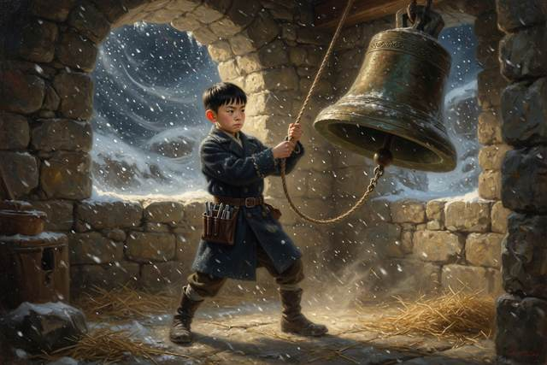
And then, from somewhere out in the storm, very faintly, there came a bark.
“There,” breathed Tabitha.
It came again. Closer. A big, hoarse, delighted wolf bark. And over it, a voice, small and cracked and cold, but quite steady: “Wen! Wen, is that you?”
Wen dropped the hammer.
He went down the ladder in about three rungs. He did not stop to take the lantern. The door of the mill was open, and out of the white, along the fence, hand over hand, with her coat covered in snow from collar to hem, and her scarf frozen stiff, and her black bag clutched in one hand, came Dr. Liang. At her side, pressed close to her knee, with ice in his fur and a look of great and smug competence, trotted Gucci.
“I stopped,” said Dr. Liang. She was shaking all over, and she was laughing. “I did what I tell everybody to do. I found a fence, and I stood still, and I held on. And I heard a bell.” She looked up at the little dark window high in the gable. “I could not see anything. But I could hear the bell, and the bell said, this way, this way. And then the dog came out of the snow like a gray ghost, and took my sleeve in his teeth.”

“You said fifteen minutes,” said Wen. He was crying, quite openly, and did not seem to notice.
“I am so sorry,” said Dr. Liang. “I am two hours late.” She took his face in both hands. “I will never be late again. Not by a minute. And if I am, I will stay by the fence.” She kissed the top of his head, hard, and then straightened up, and her face changed. “Where is Millie?”
“In there,” said Hal.
Dr. Liang ran. She ran across the yard, along the rope, in her stiff, frozen coat, with the black bag swinging, and the door of the Mitchels’ house opened for her and closed again. And behind it, over the howling of the wind, over the slow, steady stroke of the bell, which Wen had just been told he could stop ringing, there rose a small, thin, furious sound that none of the children had ever heard before.
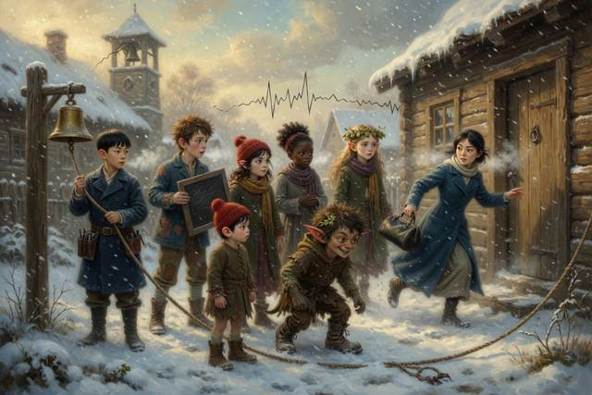
It was a baby, crying.
↑ Contents

Chapter 10. The Baby
It was a boy.
Mrs. Crumb came out of the little front room at ten minutes past midnight, with a dish towel over one shoulder. She had one big hand on the door frame, and she was smiling so widely that her whole face seemed to be in danger. “A boy,” she said. “Seven pounds, near enough. Ten fingers, ten toes, and the loudest lungs in the valley. Mother and baby are fine. Fine, and tired. Nobody is to go in for five minutes.”

There was a silence. Then a noise went up in the kitchen of the Mitchels’ house like the roof coming off.
They had all gathered there, in the end, with the storm still howling at the windows. Hal’s father was there, with his cane across his knees, and Titch’s father, a large, quiet man with soot in the creases of his hands, who had boiled water for hours, and been told, and had sat down in a chair, put his face in his hands, and not said a word since. Wen sat on the hearth, with his mother’s black bag between his feet, and a blanket round his shoulders. Tabitha was asleep on the sofa with her head on Hopsi’s knee, and Hopsi was sitting very straight and not moving at all, so as not to wake her.
Pip had gone to sleep on the floor under the table, with his washtub for a pillow. He woke up all at once at the noise, and sat up, and banged his head on the table, and said, “What?”
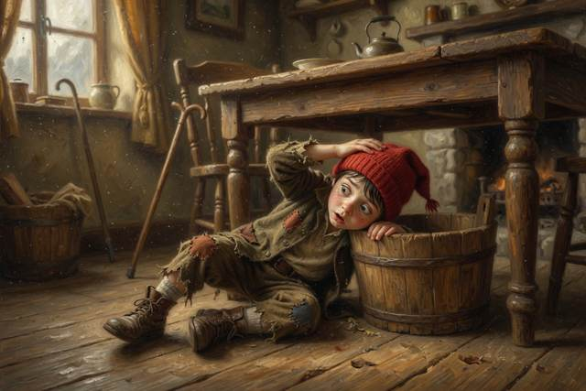
“You have a brother,” said Titch.
She had been holding her mother’s hand for hours, and she had stayed with her through all of it, and she looked very tired, and very much older, and very, very pleased.
Pip crawled out from under the table. He looked at her. He looked at the closed door. He stood up, slowly, and his whole small face did something extraordinary: it filled, from the bottom up, like a glass of water.
“Biscuit,” he said.
“His real name is going to be Beau,” said Titch. “Mom and Dad decided. Beau Mitchel.”
“I know,” said Pip. “That is his name for the grown-ups.” He said it with great seriousness. “Biscuit is his name for us. He can have two. I have got two.”
“You have not got two.”
“I have got Pip, and Little Man, and Pipsqueak. That is three.” He put his shoulders back. “I am a big brother.”
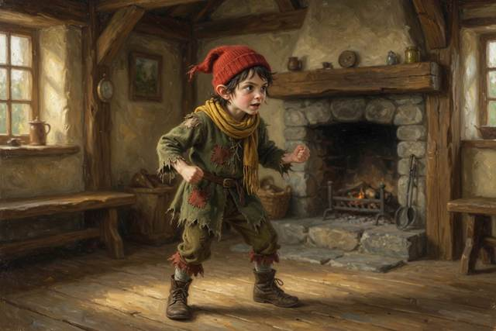
They were let in, in the end, one at a time, in their stocking feet.
It was a small, warm, firelit room, with the curtains drawn against the storm, and a lamp turned low. Titch’s mother lay propped up in the big bed with her hair all over the pillow, looking exhausted, and radiant, and about nineteen years old. And in the crook of her arm, wrapped in a flannel blanket that had once been somebody’s shirt, there was a very small, very red, very cross person, with a flat nose, and a creased forehead, and a fringe of dark hair that stood straight up.
“Say hello,” said Titch’s mother, quietly.
Pip climbed up onto the bed. He put his elbows on the quilt and his chin on his hands, and looked, for a very long time, at the baby, a foot from his own face. The baby opened its eyes. They were dark, and cloudy, and unfocused, and wandered about the room, and finally came to rest, quite by accident, on Pip’s nose.
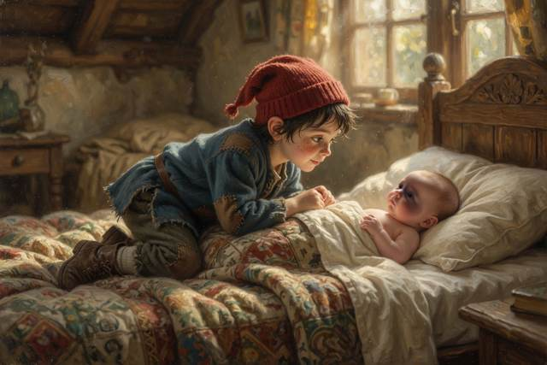
“He is looking at me,” whispered Pip.
“He is,” said his mother.
“He knows who I am.”
“I think he does.”
“I am the one who said biscuit.”
“You are,” said Titch’s mother. “And he is. It is exactly right.”
One by one they came in. Hal stood by the door with his hands behind his back, and said that he thought it was very good, and that the baby had a very good nose. Tabitha, who was still sleepy, put a finger very gently on a small curled fist and was gripped. Wen was last.
He had his mother’s stethoscope in his pocket. He held it up, rather shyly, and looked at Titch’s mother, who nodded.
He put the cold silver disc against the front of the flannel, and held very still.
“Swish,” said Wen, in a whisper. “Swish-swish-swish-swish.” His eyes grew round. “It is the same. It is the same one. It is going just as fast as it did in the picture.”
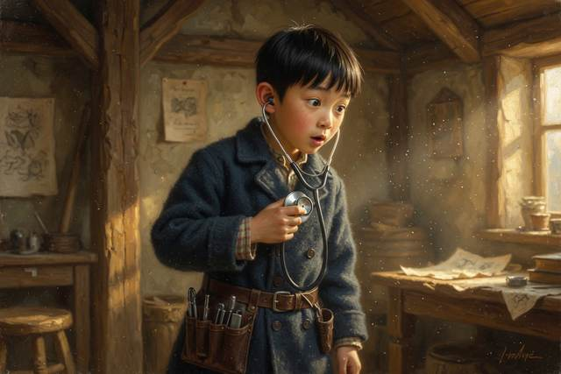
“Of course,” said his mother, from the door. She was standing quite still, with her sleeves rolled to the elbow, and her hair a damp mess, and her arms folded, and there was something proud and quiet in her face. “It is the same person. He just came out.”
Scally was the last to come in. He had hung back at the end of the line, with his hands in his pockets, and his shoulders up round his ears, and he had said all evening that he was perfectly happy to stay in the kitchen. Now Titch’s mother turned her head and looked at him, quite calmly, over the top of the baby’s fuzzy head.
“Come here,” she said. “Scally.”
“I am not good with babies.”
“Neither was I, once. Come here.”
He crossed the floor as though it were made of glass. “I will drop him.”
“Sit down on the end of the bed,” said Titch’s mother, “and hold out your arms.”
Scally sat. He held out his arms, rigidly, the way a person holds out a tray, and Titch’s mother laid the flannel bundle in them. For a long minute nobody breathed. The baby grunted, and squirmed, and settled, and opened his dark unfocused eyes and looked up at Scally’s face, and Scally, who had never in his life been quiet for more than eight seconds together, did not say a single word.
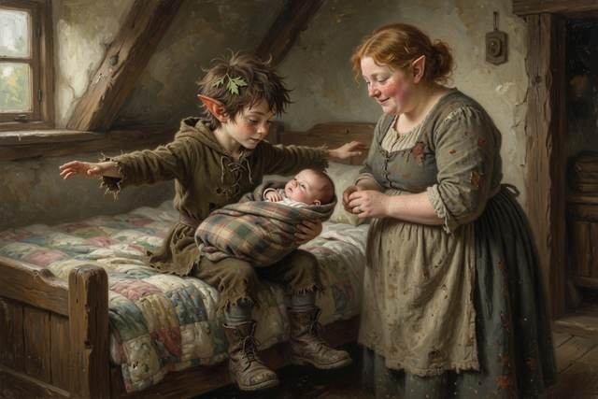
“He is so small,” he said at last, very softly.
“He is.”
“He is so warm.” He bent his head. “Somebody gave him to me to hold. Somebody just handed him over.” His voice cracked. “Nobody has ever just handed me anything.”
Nobody said a word. It was Pip who put a hand on his knee.
“You can hold him again tomorrow,” said Pip. “He will not mind. He is very trusting. He is a biscuit.”
Hopsi was the last to give her present.
She had thought about it all evening, in the kitchen, in the quiet, while the others had been talking, and she had come to the conclusion that there was no true sentence in the world that was big enough. She could have said, “Welcome.” She could have said, “I hope you will be happy.” She could not say either of those, because she did not know. So she did what an elf does when the words are not allowed. She took something out of her sleeve, very quietly, and put it on the quilt, beside the baby’s tiny fist.
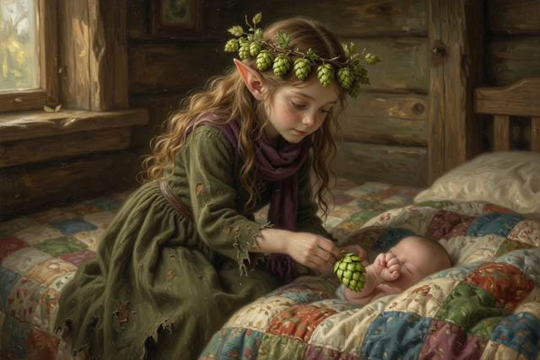
It was a small, smooth, white stone, no bigger than a walnut.
“It is one of three,” said Hopsi. “I put them across a path, a long time ago, to keep the way back open. I have thought of him all night. This is for the door.” She looked at Titch’s mother, a little anxiously. “It does not do anything. It is just a stone. But it has never failed me.”
Titch’s mother looked at the small white stone for a long moment. Then she looked at Hopsi, and her eyes were very bright.
“It is the best present he will ever get,” she said.
“It is the shortest true thing I know,” said Hopsi. “That is all.”
Outside the wind had begun to drop. The storm that had come like a giant dog was going away over the hills, slowly, with a sigh. In the east, over the long black ridge of Hanger Hill, the sky had begun to go gray, and then pink, and in the still, white, shining world a single clear star was shining low over the horizon.

Hal stood at the window with the curtain held back, and looked at it, and thought about nothing at all. He felt very tired, and very light, and rather strange.
“Hal,” said his mother quietly, beside him.
“Yes?”
She said nothing. She stood there, with her hand on his shoulder, and her other hand flat against the front of her dress, looking out at the pink sky, with the baby crying behind them and the whole village waking up. And Hal, who was nine and a half, and knew a great many things, and had a long list of things he did not know yet, thought that perhaps, in the morning, there would be one less.
↑ Contents

Chapter 11. The First Warm Evening
The snow went home in April, all in one afternoon, like a guest who has suddenly remembered the time.
It ran off the roofs in little silver waterfalls. It slid off the mill wheel, which woke up with a groan and began, slowly, to turn. It left the fields in great brown patches, and the creek came down loud and brown and bubbling, carrying twigs, and there were snowdrops under the hedge, and a robin on the gatepost, and a smell in the air that was half mud and half something sweet, which was spring.

On the first warm evening, which was a Thursday, the Mayor came up Hanger Hill with a wheelbarrow of stones.
He had brought four men, a bucket of mortar, a trowel, a measuring stick, and an enormous round wheel of yellow cheese, which he carried himself, in both arms, like a baby. He had meant it as a celebration. It was to be put in the cave first, the very first cheese in the very first cellar. He walked up the slope ahead of his men, with his mustache lifted, and his best waistcoat buttoned, and a look on his face of great and settled happiness.
He stopped at the top.
There were forty people sitting on the hillside in the dusk, in neat rows on the damp grass, and nobody was talking.
They had brought blankets. They had brought thermoses, and sandwiches, and small children, and one very large wolf. In the middle of the front row, on a folded quilt, sat Hal and Wen and Titch and Tabitha, and Pip, who was holding the washtub, and Scally, and Hopsi in a single scarf for the first time that year. Titch was holding a small bundle. Behind them sat Dr. Liang with her black bag at her feet, and Hal’s father, and Mrs. Crumb, and the farmers, and the butcher, and a great many people who had said that they would come only for a minute.
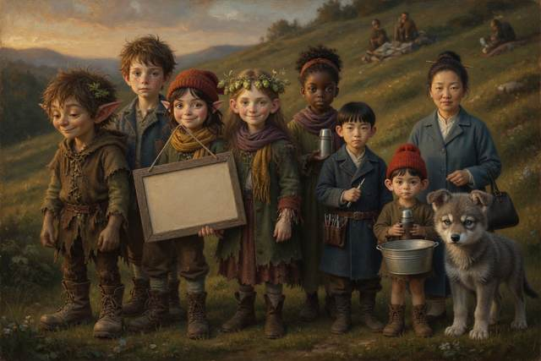
“What,” said the Mayor, “is this?”
“It is the proof,” said Hal.
He had stood up. He had his slate in one hand, and he was holding it quite steadily, though his knees felt like water. “You said that if we could show you, with our own eyes, before the first warm evening, that the bats were worth more than a hundred cheeses, you would take down the stake. We have been working on it since January. This is the first warm evening. This is the evidence.”
The Mayor looked at the forty people on the hill. They looked back at him. Not one of them was wearing a brown paper hat.
“Very well,” said the Mayor stiffly. He set down his wheel of cheese on the grass, and folded his arms. “Proceed.”
Hal cleared his throat. “We went into the cave in December,” he said, “with permission, and in daylight, and we did not touch anything. We looked. We counted. It took us three visits, because you cannot count four hundred bats at once.”
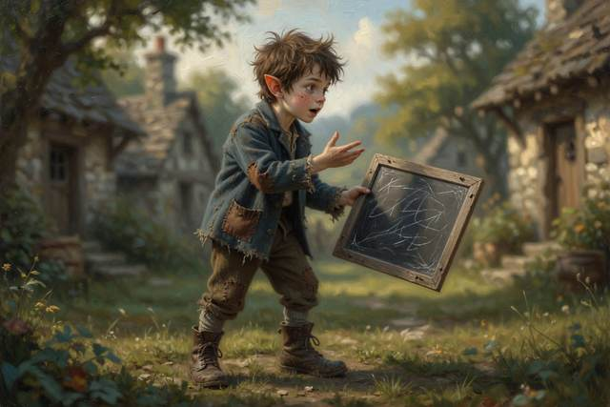
“Four hundred?” said the butcher.
“Four hundred and twelve,” said Hal. “That is our best estimate. We did not count them one at a time, because we would have woken them up. We counted all the bats in a square the size of a tablecloth, and then we measured how many tablecloths there were. It is called an estimate. It is not exact. But it is close.” He consulted his slate. “Dr. Liang says that a bat this size can eat five hundred small insects in an hour. Moths. Mosquitoes. Beetles. That is two hundred thousand insects a night, for four hundred bats. In a summer, that is more than twenty million.”
A murmur went round the crowd.
“The cabbage moth is the worst pest in this valley,” said Hal, “and everybody knows it. Every year it eats a third of the cabbages, and it lays eggs in the granary, and in the flour. My father has lost whole sacks of grain to it, in the mill.” He looked at his father, who nodded, once. “The bats eat the moths. They do not eat the cabbages. They do not eat the flour. They do not charge a nickel.” He swallowed. “That is what we found out. And that is only what we can count.”
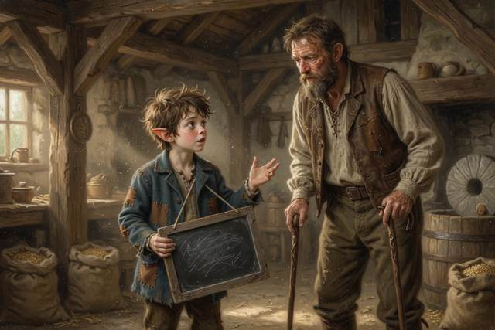
“Quiet,” said Wen. “It is time.”
The sun had gone down. The sky had gone from gold to green to a deep clear violet, and low over the hill, a single star had come out. In the long grass, a cricket began to sing.
Wen had the listener in both hands. He did not need to say anything. He turned the small cork, one quarter turn, and held out the copper funnel toward the dark mouth of the cave.
And out of the horn, very soft and very clear, for everyone to hear, came the sound.
Tik. Tik-tik. Tik-tik-tik-tik-tik.
Somebody gasped. A baby, in a blanket, said something that sounded like “Ba!” And then the first one came out of the cave.
It came out low, and quick, and so small that nobody was sure they had seen it. A little dark scrap, no bigger than a leaf, flittered up and round, in a loop, against the violet sky. Another followed. And another. Then, with a rush, like smoke from a chimney, like ink poured into water, like a long black ribbon unrolling from the rock, a hundred of them came pouring out of Hanger Hill together, whirling and twisting and flickering in the dusk, over the heads of the astonished crowd.
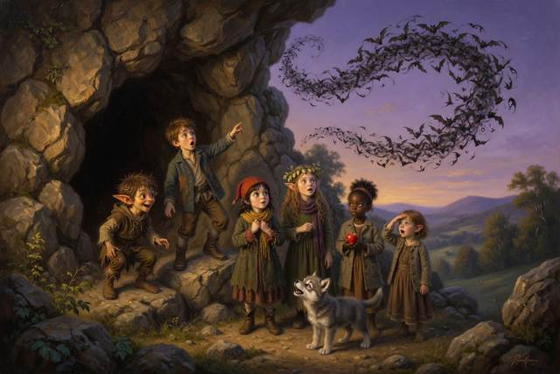
They did not touch anyone. They went over them, round them, between them, so close that Hal felt the air move on his cheek, and so quiet that you could hear nothing but the soft, dry, tiny rustle of wings, and the clicking, a hundred clicks, a thousand, rising into a steady, silvery, whispering shimmer of sound, that shook the whole twilight like a shaken bell.
They flew out over the village, and over the creek. They swooped low over the fields, and rose, and dived, and curved, and in the pale air above the mill, where the grain moths had gathered, they fed.
Not one of them spoke. Hopsi sat very still, with her face turned up and her lips parted. Pip had stopped whispering. Scally, beside him, was gazing up, with a look of awe, and a smile that he had forgotten was on his face.
“Socks,” said Pip, in a voice full of wonder. “The socks can fly.”
“Yes,” said Scally. “They can.”
The Mayor had not moved.
He stood in the grass, with his wheel of cheese at his feet and his hat in his hand, looking up. He looked for a very long time. A bat came down, and passed so near his head that his mustache ruffled. He did not flinch. His mouth was a little open, and the gold chain on his chest rose and fell with each breath.
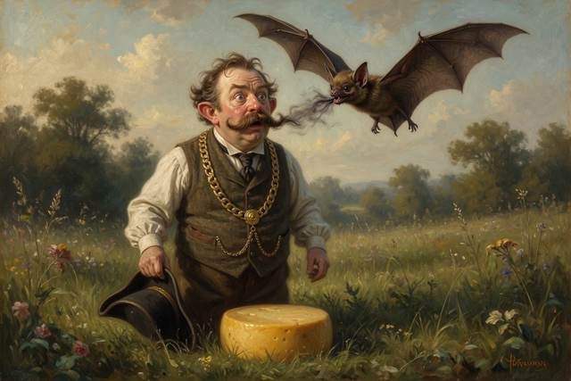
“I did not,” he said at last, in a hoarse voice, “check.”
Nobody said anything.
“I did not check. I said they were filthy. I said they got in your hair. I have been an old fool, and a loud one, and I have been wrong in front of the entire village.” He drew a long breath. “That boy,” and he looked at Scally, “sold me a hat. And then he stood on a step in front of everyone he knew, and told the truth, and it cost him. I did not know a person could do that. I thought a person had to be right all the time to be a mayor.”
He bent, quite slowly, and picked up the cheese.
“There is another cellar,” he said. “It has been there for forty years. It is under my own kitchen. It is cold, and dry, and it holds a hundred cheeses, and I have never once thought to look in it, because I had my eye on something grander.” He turned to the four men. “Take the stones home. Pull up the stake. This cave,” and his voice shook, “is the property of the bats.”
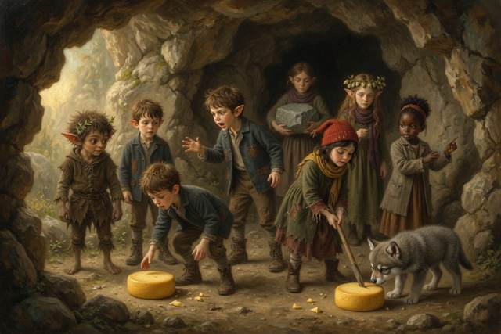
Nobody cheered at first. They were too astonished. Then somebody started to clap, and then everybody did, and Mrs. Crumb threw her scarf in the air, and Gucci howled, a long, glad, full-throated wolf howl that went rolling out across the valley, and Hanger Hill, for the first time in its history, seemed to howl back.
“Mr. Mayor,” said a small, clear voice.
It was Hopsi. She had stood up. She stood very straight, with her hands folded, in front of the whole village.
“I would like to say something,” she said. “It is true. I have only said true things, my whole life, and I have never once said that I was proud of a person. It seems to me that it would be the wrong thing to say, because I could not be sure. But I am sure now.” She looked at Scally, and then at Wen, and at Hal, and at the whole row of faces, one at a time. “I am proud of every one of you. I think so, and I know so. That is all.”
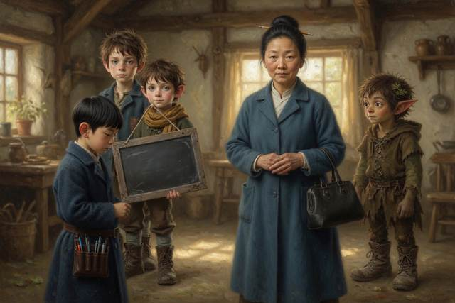
It was the longest speech she had ever made. Nobody breathed.
Then Pip, who had been sitting on the grass with his washtub in his lap, looked up at Scally and hummed, in a small, flat, cheerful voice, the first notes of the old tune: Just a little, just a bit—
“Wait,” said Scally. He had gone pink. “That one is not for now. That is the one for scams.”
“Does it have words?” said Pip.
“Not this time,” said Scally. “It is only a song.”
“Good,” said Pip, and went on humming, without words, all the way down the hill.
That night, the little house by the mill was very quiet.
Hal sat at the kitchen table with his slate in front of him, though he was not writing on it. The fire had burned low. His father had gone to bed, with a mug of tea, and a look of great peace, and the cane propped against the wall. The kettle was singing gently on the stove. On the table, at his mother’s elbow, was a plate of pickled onions.
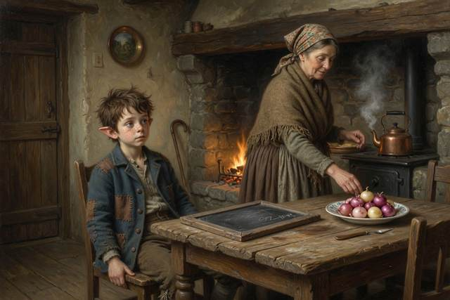
“Hal,” said his mother.
“Yes?”
She had put down her knitting. It was a very small, very soft, yellow sweater, with a collar, and a row of tiny buttons, and she smoothed it flat on the table with both hands, and looked at him over the top of it.
“I have something to tell you,” she said. “I have been waiting until I was sure. Dr. Liang is sure. I am sure. I wanted you to hear it from me.” She took a deep breath. “Early in the summer, in June, you are going to have a brother or a sister.”
He sat quite still.
The fire ticked. The kettle sang. Outside the window, in the warm, spring dark, a bat went flickering by, a tiny, quick scrap of black against the stars, and was gone.
“I know,” said Hal, at last.
“You know?”
“I did not know,” said Hal. “But I wrote it down, and I think I had worked it out.” He looked at his slate. “It was the pickled onions. And the knitting. And the way Dr. Liang looked. And you said ‘Oh.’” He took a very long breath. “It is a baby. It is going to be a baby. Like Biscuit, only mine.”
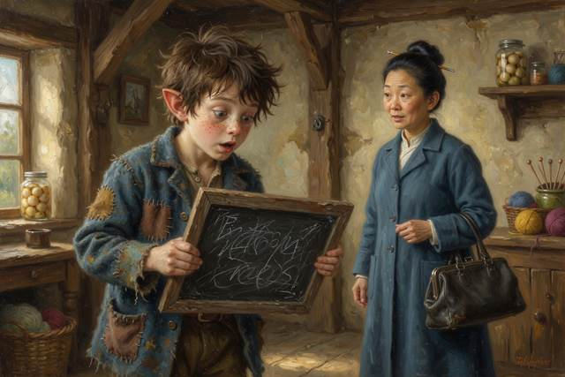
“Only ours,” said his mother, in a shaky voice. “Are you all right?”
He thought about it carefully, as he thought about everything. He thought about the little warm weight of the baby in the flannel, and the tiny fist, and the heartbeat that went swish-swish-swish. He thought about the cold green light of the pond, and the bats pouring out of the hill. He thought that it was, quite possibly, the largest and most surprising thing that had ever happened to him, and that he had been, in a manner of speaking, ready for it for nine and a half years.
“Acceptable,” said Hal.
His mother laughed, quite helplessly, with tears running down her face.
“No,” said Hal. “Wait.” He stood up. He went round the table, and put his arms round her, and his face in her shoulder, which smelled of onions and bread and wool. “It is better than acceptable.”
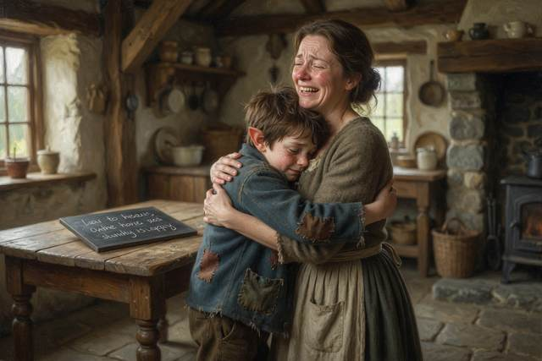
“It is?”
“It is,” said Hal. He swallowed. “It is a very good thing. It is—” He stopped, and tried again, for he had a great many words, and none of them seemed to be the right one. “It is the best thing I know.”
Out in the yard, in the soft April dark, a strange sound drifted along the lane, from the direction of the village. It was a loud, cheerful, tuneless whistle, and under it, steady and unhurried, the creak of boots.
Someone was walking along the road toward the mill in the starlight, a very long way off. It was a girl, a stranger, very tall for her age, with hair the color of a struck match, and a long wooden ladder over one shoulder, which she was carrying as easily as another person carries an umbrella. She stopped at the old stone gate. She looked up at the hill, and at the last few bats wheeling black against the stars, and at the little yellow window where a mother and a boy stood together in the lamplight.
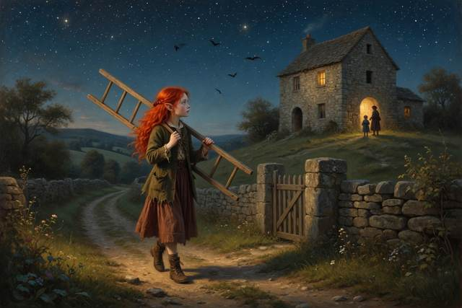
“Excuse me,” said the girl, to nobody and the whole valley. “Is this the hill with the hanging socks?”
The End
↑ Contents

Hal’s Slate: What We Found Out
Hal looked, counted and tested, and wrote it all on his slate. Here it is, with things you can try. Where Hopsi is not sure, she says, “I think.” The magic is marked as magic. You do not have to read them all at once: one a night is plenty.
1. Bats see with sound as well as with their eyes. A bat makes a squeak, listens for the echo, and works out where things are. It is called echolocation. Try it: clap in a big empty room and listen for the echo.
2. Ultrasound is sound too high for people to hear. Dogs and wolves can hear some of it. Bats use it to talk and to hunt. Real bat detectors turn it into sounds we can hear, using electricity. Wen’s listener, made of a funnel and a spring, is a storybook machine.
3. Bats hibernate in winter. Their hearts beat very slowly, and they live on the fat they stored up in the fall. Every time one wakes, it uses up some of that fat. That is why we never go into a bat cave in winter, and never shine a light on sleeping bats.
4. Never touch a bat, or any wild animal that seems tame or hurt. A very few bats carry a disease called rabies, and it is serious. If you see a bat on the ground, stay away and tell a grown-up.
5. Bats eat insects. A small bat can eat hundreds of mosquitoes and moths in an hour. Farmers like bats because they eat the insects that eat crops.
6. Ice safety. Ice has to be at least four inches thick to walk on, and clear ice is stronger than white, cloudy ice. Ice over moving water is thinnest. Never go on ice alone, and never trust somebody who says it is safe unless they checked. If somebody falls through, reach or throw: hold out a branch, a rope or a scarf. Do not go out after them. If the ice cracks under you, lie flat like a starfish and crawl back.
7. Water gets bigger when it freezes, by about one part in eleven. That is why ice floats, and why pipes burst in winter, and why a full bottle of water left outside will crack. Almost nothing else does this.
8. Your heart pumps blood all day and all night. Put your ear against a friend’s chest, or use a toy stethoscope, and count the beats for one minute. A baby’s heart before it is born beats about twice as fast as a grown-up’s.
9. An ultrasound scan. A doctor sends sound into the body. It bounces back, and a machine turns the echoes into a picture. It is the same trick as the bats and as Hal’s echo on the cliff. Real scanners use electricity and screens. The one with the crank is a storybook machine.
10. Medicine is not candy. Never take any medicine, pill, or pink bottle unless a grown-up you know well gives it to you. Some medicine tastes sweet on purpose, and too much of it can make a child very sick.
11. If you are lost in snow, stop. Stay where you are, find a fence or a wall if you can, and make noise. Do not wander. If a storm is coming, stay inside, and use a rope from door to door if you must go out. Always tell somebody where you are going, and go in pairs.
12. Sledding safety. Sit or lie feet first. Go down hills that end in a flat, open field, never toward a road or water. Do not tie sleds together. Wear a hat.
13. Do not make a promise you cannot keep. Scally’s frost insurance could not work, because if the frost came, it came to everyone at once, and he could never have paid.
14. A story is not a lie when everybody knows it is a story. A lie is when you want somebody to believe something that is not true.
15. “Check first” is a scientist’s rule. Before you say that something is true, find out. If you were wrong, say so out loud. Then somebody can help you put it right.
↑ Contents

For Parents and Teachers
This is a fantasy adventure to read aloud from about age 6 and for children to read themselves at 7 to 10. Younger children can follow the whole story from the pictures alone (a “picture walk”: turn the pages and ask what is happening). Every fact Hopsi states is true, and the magic is marked as magic. The Book 3 gadgets, Wen’s listener and the scanner with a crank, are storybook machines; real ones use electricity.

The habits of a scientist in the story
“Check first.” Wen measures the ice before anyone steps on it, and asks whether the Mayor’s claims about bats are true before the rock goes over the door.
Say you were wrong. Hopsi says “I was wrong” about white ice and about which way the doctor went, and is glad she said it out loud.
Count and estimate. Hal counts a patch of bats and multiplies, and calls it an estimate, not an exact number.
Honesty. Scally hums a little tune before each trick. When a lie hurts someone, he tells the truth, even though it costs him.
Ask what you cannot hear. Gucci can hear sounds people cannot. Wen asks what he is hearing, and builds a way to find out.

What each chapter teaches
The First Frost: a promise you cannot keep (frost insurance), and safe ladder habits.
The Doctor’s Bag: how a doctor listens to a heartbeat, why medicine is never candy, and why we do not put our heads into things.
Ice on the Pond: how thick ice must be to hold you, why white ice is weaker, why ice floats, and reach or throw.
The Hill That Clicks: bats, hibernation, why we never wake sleeping animals, and telling a grown-up where you are going.
The Mayor’s Cheese Cellar: rumors, checking facts, telling the truth when it costs you, and what bats eat.
Wen’s Listener: sound too high to hear, how bats find their way with echoes, and a scientist’s “I do not know.”
The Picture of the Baby: how an ultrasound scan works, a baby’s heartbeat, and a gentle way of knowing a family secret is coming.
The Sledding Day: sledding safety, a fair race, and the difference between a story and a lie.
The Night of the Big Snow: what to do when lost in snow (stop, stay, make noise), staying on the rope, and using sound to find your way home.
The Baby: a welcome, a new brother, and giving a present when words are not enough.
The First Warm Evening: estimating numbers, what bats do for a village, changing your mind, and a new baby in the family.

Staying safe: what this book models
Ice. Ice must be at least four inches thick to walk on, and clear ice is stronger than white ice. Ice over moving water is thinnest. Never go on ice alone, and never trust a claim that it is safe unless someone checked. If someone falls in, reach or throw; do not go out after them. If the ice cracks under you, lie flat and crawl back. Please check your local guidance.
Wild animals. Never touch a bat or any wild animal that seems tame or hurt, and tell a grown-up. A few bats carry rabies. Never wake hibernating animals.
Medicine. Never take any medicine unless a grown-up you know well gives it to you. Some medicine tastes sweet on purpose.
Snow and cold. If you are lost in snow, stop, stay where you are, find a fence if you can, and make noise. In a blizzard, stay inside, and use a rope between buildings if you must go out. Tell someone where you are going and go in pairs.
Sledding. Go feet first, down hills that end in a flat open field, away from roads and water. Do not tie sleds together.
Ladders. Somebody holds the bottom, every time.

Talk about it
Why does Scally hum a little tune before he tricks someone? How could you tell, if you were Pip?
Wen was afraid of the dark and went into the cave anyway. What did he do to feel braver?
Hopsi says “I was wrong” more than once. Is that easy or hard to do? How did people react?
What do you think a new baby in a family feels like for a big brother or sister? What do you think Pip and Hal feel?
What would you do if you were lost in the snow, or if someone said ice was safe and you were not sure?

Words to grow
echo, ultrasound, hibernate, estimate, insurance, friction, scan, heartbeat, pitch, expand.

A note for adults
The science is simplified for ages 7 to 10. Bats make very high calls, listen for the echoes, and build a sound picture of the space around them; they can also see. Hibernating bats live on stored fat, and each time one wakes it uses some of it. A medical ultrasound scan uses the same kind of echo to make a picture, and doctors use it to look at an unborn baby; the baby ’s heart beats about twice as fast as an adult’s. Water expands by roughly one eleventh when it freezes. The book mentions pregnancy lightly and without detail, and a new baby in the family can be a good moment to talk about feelings of being left out. Bats are protected in many places; please never disturb a roost.
↑ Contents

About the Author
Anneliese Tauber is a mother of four. When her children were small she read them a great many fairy tales, and she noticed that the best ones answered the questions children ask, and never needed to bend the truth. The Step Stories are for curious children and the grown-ups who read to them.
If your child enjoyed this book, a short, kind review on Amazon helps other curious families find it. Thank you.
↑ Contents

Also by Anneliese Tauber
The Wee Scallywag and the Gentle Elf
The Step Stories, Book 1. Where Scally first met Hal, Hopsi and a ghost in a mill.
Scally and the Sleepless Stream
The Step Stories, Book 2. Hal, Scally and Hopsi follow the stream to find where the water goes.
Book 4 of The Step Stories is coming soon.
Bavarian Cooking Made Simple
Classic dishes from a Bavarian kitchen, written so that any cook can enjoy a taste of Bavaria.
↑ Contents
Typeface in the e-book edition: Comic Neue, © The Comic Neue Project Authors, used under the SIL Open Font License 1.1.

