**CSCE A385 Programming Assignment Final**

Computer Graphics

Shanan Almario

**Program Notes**

IDE: Visual Studios 2015

**Problem 1 Code Description**

The code outputs a little town made up of 4 houses, 3 mountains, and a tree that had been instanced so that there are many of them. The town has roads and a patch of water on the right, and the town sits on a green square plane. All objects described have been textured, and some lighting was implemented in the scene.

**Interaction:**

*Keyboard*:

x: will move the space counter clockwise on the x-axis

X: will move the space clockwise on the x-axis

y: will move the space counter clockwise on the y-axis

Y: will move the space clockwise on the y-axis

z: will move the space counter clockwise on the z-axis

Z: will move the space clockwise on the z-axis

V/v: toggle view so that it is flying over car or above car

Up: move forward

Down: move backward

Right: move right

Left: move left

**Program Notes:**

* Car will only function properly when moving with directional arrows. I was unable to make the car turn with the eye.
* Collision detection not implemented

**Low Level : Travel component**

The assignment was to use texture mapping, tinted transparent vehicle windows, and instancing to make forests. The vehicle was supposed to have two spotlights, and it shouldn’t be allowed to go through walls or trees.

This assignment was structured very similarly to Assignment 3. Texture mapping, instanced forest, toggle view, and a skybox have been implemented, but I was unable to implement the transparent vehicle windows, the spotlights, and the collision detection.

The sky box heavily references the skybox code provided by the instructor. Texture mapping and lighting is done exactly like it was done in assignment 5.

*Program Details:*

Build functions create the vertices, set the normal, and the vertices for texture mapping. These functions are all placed in a buildInit() function which gets called first in the main. Some build functions have a triangle function that will put the vertices inside the buffer and calculate the normal. The only exception is the cylinder shaped items. In each build function is a v[] array that will hold all the vertices so that the triangles can be called in an organized way.

Draw functions set up the lighting and calls the draw method for the objects. This function gets called in the initScene node which structures the scene tree.

The Init function prepares the instancing buffer, loads the images and initializes them, loads the shaders, and binds the VAOs and buffers for each object.

The Display function displays the skybox and then it traverses through the nodes and displays the scene tree. It is also here where the toggle happens whenever v/V is pressed.

Moving is made so that the car will not fly or go through the ground. This implementation was thanks to Banky.

*Assignment Overview:*

Creating and building the objects and placing them where they need to be took the longest time. Much time was lost on making the windshield appear, and it never appeared, and I do not know what is wrong with it. It is “implemented” in the scene, but doesn’t show up. The original idea for the windshield is to use a simple shader that doesn’t implement lighting, similar to that of assignment 3, and draw a transparent windshield. However, there might be something wrong with the build function because the windshield doesn’t appear at all.

Trying to figure out how to move the car took some time to figure out, but I received helped from Levi and Banky as to how they moved their car. I was unable to figure out how to make the car turn, which took up the rest of my time.

There is also one mystery texture map that doesn’t want to show up for the road. I had the water be an extension of it, but it isn’t mapping properly, but there wasn’t enough time to fix it.

*Scene Structure Tree*

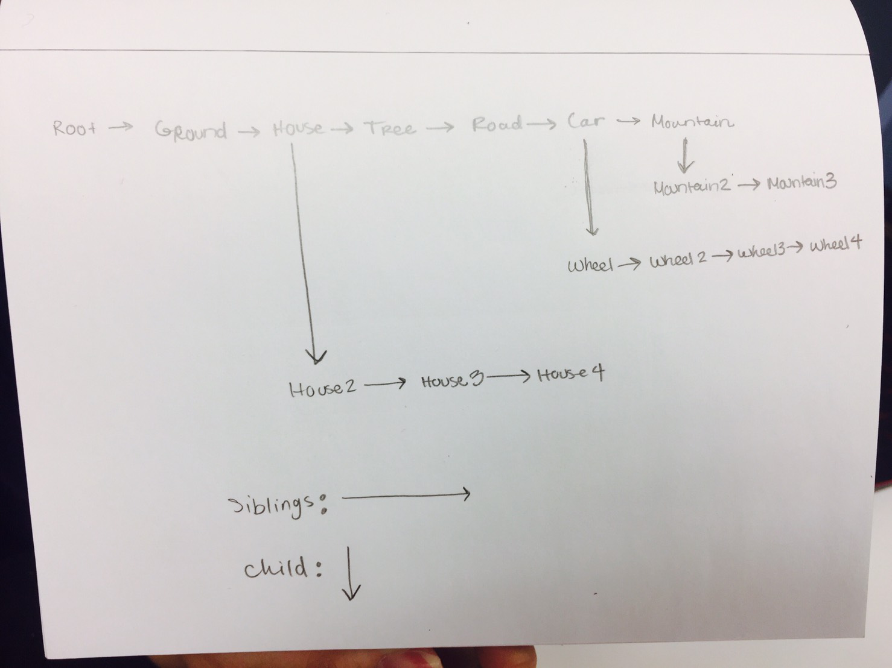

*Build Functions*

Note: These are the same as seen in Project 3, except House2 structure was not implemented

*House1 and House2 Structures*

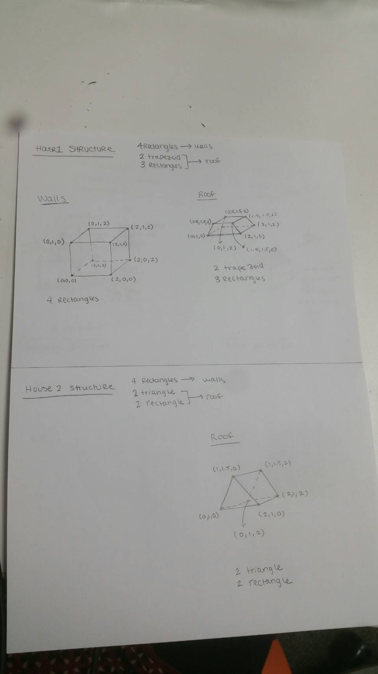

*Mountain, Tree Structures*

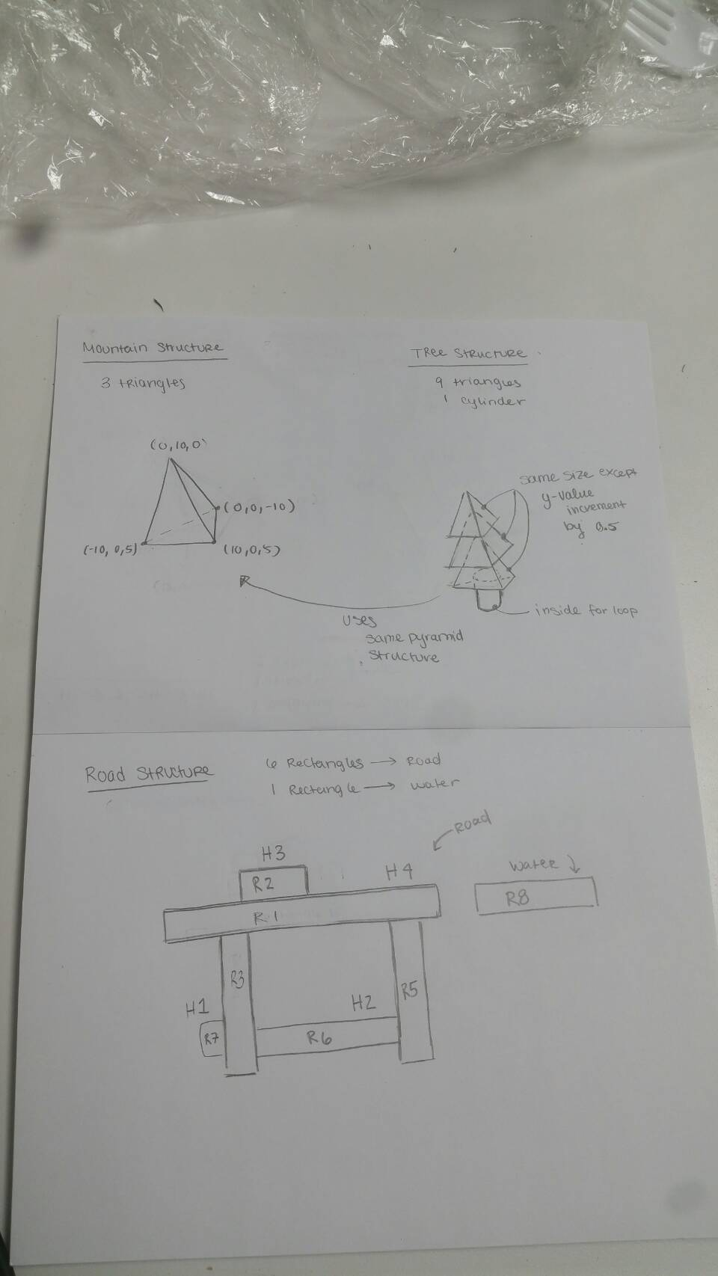

*Problem 1*

*Inside Car View*

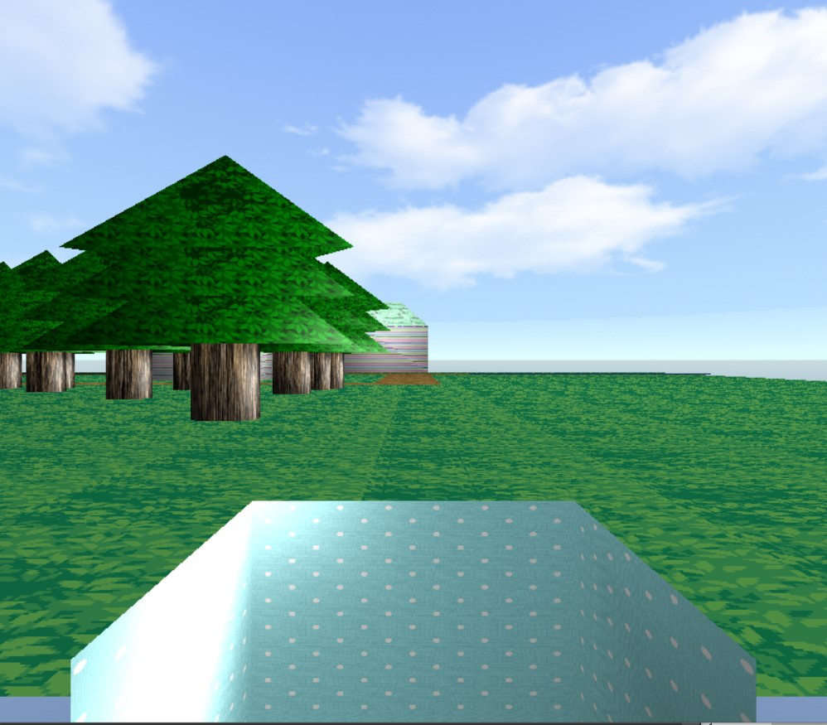

*Oustside Car View*

